AN ABSTRACT OF THE THESIS OF

Daniel W. Braunworth for the degree of Honors Baccalaureate of Science in Electrical and Electronics Engineering presented on June 4, 2007. Title: Vox comm: Product Development and Program Management.

Abstract approved: _____________________________________________
David Hackleman

Vox comm is a digital wireless, voice-operated personal communicator developed as an electrical engineering Senior Design project. It is designed to provide a method for hassle-free, short-range communication. The product platform boasts of low power and small size for a host of usage models. This thesis details the product design as well as the development process for a group of young engineers. The purpose is to highlight the product and relate the program management experience associated with its development. It gives an overview of the entire project, details the product development, and describes the author’s program management experience including team dynamics.

Key Words: Vox comm, communicator, product development, program management, engineering

Corresponding e-mail address: braunwod@engr.orst.edu

© Copyright by Daniel W. Braunworth
June 4, 2007
All Rights Reserved

Vox comm: Product Development and Program Management
by
Daniel W. Braunworth

A PROJECT
submitted to
Oregon State University
University Honors College

in partial fulfillment of
the requirements of the
degree of

Honors Baccalaureate of Science in Electrical and Electronics Engineering

Presented on June 4, 2007
Commencement June 2003
Honors Baccalaureate of Science in Electrical and Electronics Engineering project of Daniel W. Braunworth presented on June 4, 2007.

APPROVED:

Mentor, representing Electrical and Electronics Engineering

Committee Member, representing Electrical and Electronics Engineering

Committee Member, representing Electrical and Electronics Engineering

Director, School of Electrical Engineering and Computer Science

Dean, University Honors College

I understand that my project will become part of the permanent collection of Oregon State University, University Honors College. My signature below authorizes release of my project to any ready upon request.

Daniel W. Braunworth, Author
TABLE OF CONTENTS

PROJECT OVERVIEW 9
Design Team 11
Product Description 12
Product Usage and Target Market 1
Future Development 4

PRODUCT DEVELOPMENT 7
Using the Communicator 7
Technical and Physical Specifications 13
Hardware Description 17
Software Overview 33

PROGRAM MANAGEMENT AND TEAM LEADERSHIP 37
Design Team Dynamics 37
Organization and Scheduling 39
Hurdles and Challenges 42
Project Completion and Presentation 48

References 54
APPEnDIX 55
LIST OF FIGURES

Figure 1: Senior Design team – Daniel Braunworth, Tim Chou, Jules Dake,
and Keith Prickett (from left to right) 11
Figure 2: The VOX comm. Personal Communicator prototype photo 12
Figure 3: Comparison of a prototype form to a small matchbox 6
Figure 4: Power Source Selector Switch 7
Figure 5: Button operation and layout 9
Figure 6: Graphical Representation of the Variable Noise Threshold and Compression Ratio. From the Analog Devices SSM2167 datasheet 11
Figure 7: Potentiometers for adjusting the noise threshold
and compression ratio 11
Figure 8: Physical dimensions of the communicator without the speaker 15
Figure 9: Component placement on the Freescale™ evaluation board 16
Figure 10: Component placement on the daughter board that sits above and connects to the Freescale™ evaluation board. Speaker not shown 16
Figure 11: System block diagram 17
Figure 12: System interfacing diagram 18
Figure 13: System electrical schematic 18
Figure 14: Microcontroller programming process data flow 21
Figure 15: Input/output pin map 22
Figure 16: Audio input circuitry basic view 22
Figure 17: Typical Microphone Frequency Response Curve 23
Figure 18 a & b: Preamplifier pin configuration and typical circuit.
From Analog Devices SSM2167 datasheet 24
Figure 19: Compression ration adjustment graph and typical values table 26
Figure 20: Noise-gate adjustment graph and typical values table 26
Figure 21: Audio input digital noise filter 28
Figure 22: Audio output circuitry basic view 29
Figure 23 a & b: Digital-to-analog converter pin configuration and typical circuit.
From Analog Devices AD7302 datasheet 30
Figure 24 a & b: Audio amplifier pin configuration and typical circuit.
From Texas Instruments TPA2005D1 datasheet 31
Figure 25: Communicator System Modes state machine diagram 35
Figure 26: VOX Mode Operation state machine diagram 36
Figure 27: Push-to-talk Mode Operation state machine diagram 36
LIST OF TABLES

Table 1: VOX comm Personal Communicator specifications 14

Table 2: Preamplifier specifications quick reference.
From Analog Devices SSM2167 datasheet 25

Table 3: DAC specifications quick reference.
From Analog Devices AD7302 datasheet 30

Table 4: Audio amplifier specifications quick reference.
From Texas Instruments TPA2005D1 datasheet 32

LIST OF APPENDIX FIGURES

Appendix Figure 1: Fall term schedule 56
Appendix Figure 2: Winter term schedule 57
Appendix Figure 3: Spring term schedule 58
Appendix Figure 4: Brochure outside 219
Appendix Figure 5: Brochure inside 220

VOX comm: Product Development and Program Management

PROJECT OVERVIEW

Practical experience is paramount to an excellent education. Being able to learn by application is an enormous benefit of an engineering education at Oregon State University. The following document is a synopsis and review of an electrical engineering Senior Design project accomplished by my design group throughout the 2005-2006 school year. It includes a project summary, product development overview, and program management synopsis. This thesis will effectively describe our product development process through the Senior Design project with respect to the system level design and team management aspects of the project.
The intent of the Senior Design project is to give real-world design experience to engineering students before graduation. This is vital for career readiness and for the application of knowledge gained throughout the engineering program. It gives students an opportunity to face realistic engineering challenges in a controlled environment. The program is designed accordingly with the incorporation of schedules, timelines, realistic requirements, budgets, documentation, and presentation. Groups of 4-6 students are formed to provide a teamwork structure. Each group chooses a project at the beginning of the academic year and carries it through the entire development process over the course of the senior year. Projects are tailored to the appropriate engineering field and should be sufficiently challenging while being feasible enough to have something working to show at the end of the year. Proper documentation must be presented with the project and progress is reported throughout the design process.
My group chose a project sponsored by Dr. David Hackleman, Linus Pauling Chair of the OSU Chemical Engineering Department. This project is a voice-operated, wireless communicator. Its purpose is to provide easy, hand-free communication using a device that could unobtrusively attach to a shirt lapel or pocket. We chose this project due to its projected success, given our timeline, and our interest in the nature of the technology. We noticed the opportunity to work with audio, microcontrollers, radio, and communications through both analog and digital hardware with the inclusion of software development in the project. It appeared to be an interesting, broad-based project.
With direct relation to the described design project, this thesis is written as a review of the project as a whole. It will take the reader through the product overview, design development, and program management. The goal is to accurately describe both the technical and social elements of the design and development process. The hope is that the reader understands the project development process from the point of view of a young designer along with the technical design of the product.

Design Team


Our design team consisted of four engineers under the direction of the group sponsor, Dr. David Hackleman.
Tim Chou and Jules Dake (electrical engineers) were the hardware designers, Keith Prickett (computer engineer) was the software designer, and I (Daniel Braunworth, electrical engineer) was elected team leader. The group was number 16 and titled “VOX comm”, after the name given to the product. The team was mentored by Dr. David Hackleman, the group sponsor.
Figure 1: Senior Design team – Daniel Braunworth, Tim Chou, Jules Dake, and Keith Prickett (from left to right)
We also had industry support from Freescale™ Semiconductor, a division of Motorola. They generously donated the development boards which we used as a platform for the rest of the design. They provided a programming dongle for the microcontroller and IDE (integrated development environment) tools along with helpful technical support.

Product Description

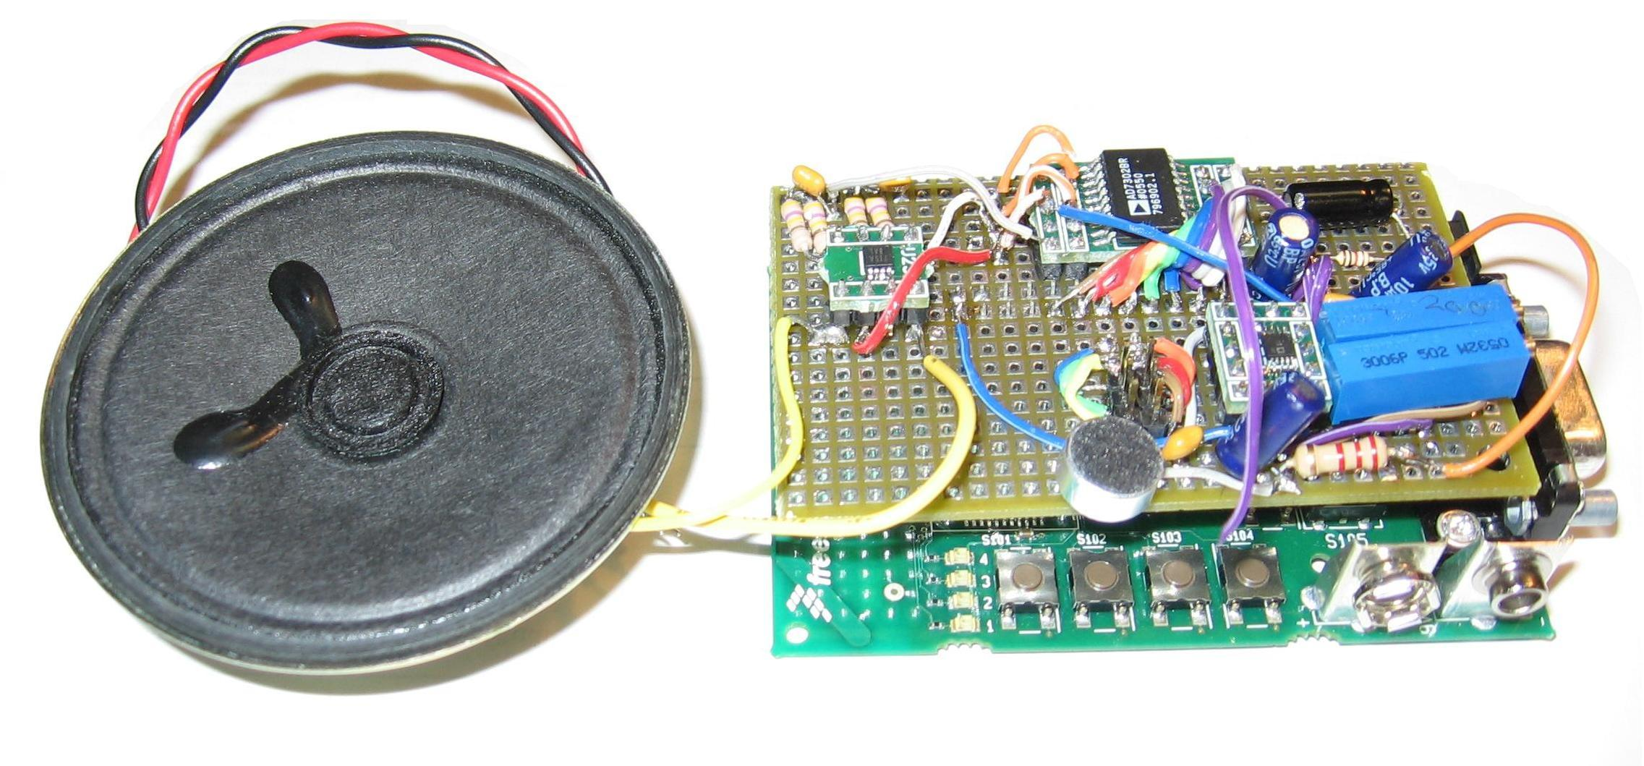
Figure 2: The VOX comm. Personal Communicator prototype photo

Above is a photo of the product prototype known as the “VOX comm Personal Communicator.” The concept for this project was to develop a wireless, short-range, low-power personal communicator similar to those seen on the TV show Star Trek®. The idea is to facilitate a two way conversation essentially hands-free, where the conversation is initiated by a single button press. The VOX comm Personal Communicator applies basic building blocks to provide the user a small, light weight, easy-to-operate device while enabling a future developer the customizability to expand the product’s feature set and capabilities.

The VOX comm product includes the following features:
- Two Modes of Operation
  - Voice Operation Mode
  - Push-to-Talk Mode
- Low Power Consumption: full operation on a single battery for an entire day
- 100 Meter Range
- Small, lightweight form-factor
- Digital wireless transmission at 2.4GHz yielding low interference and noise
- Customizability for many future features and updates

Product Usage and Target Market

At the beginning stages, the team realized that there should be a good reason for developing such a product. It should fill a need or be marketable. During the design and development of the VOX comm Personal Communicator, the team developed some exciting ideas for product use in selected markets.
The VOX comm Personal Communicator is small, consumes very little power, and can be operated essentially hands free. Thus, it is useful in any application where communication is necessary without the assistance of your hands. A few of our ideas are below:
- Department Store Employees
- Emergency Response Applications
- Star Trek® Novelty

Department Store Employees:
Most employees at large retail chains (such as Target® or Wal-Mart®) carry around large, cumbersome walkie-talkies attached to their belts. In order to communicate, the person must have at least one hand free for the duration of the communication, often forcing the person to stop what he or she is doing. The VOX comm Personal Communicator would allow an employee to communicate and respond without interrupting his or her current task or process. The communicator could be incorporated into the employee’s name badge where it would be fairly unnoticeable and completely unobtrusive. In the system’s voice operation mode, he or she can respond to any incoming communication simply by talking back without pressing any buttons.
With future development, a bright LCD display could be added to the communicator. This would allow the employee’s name and other information to be simply uploaded to the display when an employee’s shift begins, therefore reducing the necessary number of communicators the company would need to have on hand.

Emergency Response Applications:
The VOX comm Personal Communicator could also be very helpful for emergency responders. There are many occasions where it is difficult or even life threatening for police and firemen to interrupt what they are doing to use a conventional walkie-talkie. The communicator would make it easy to respond to the operator or call for backup. Additional range may be necessary, but the basic operation and features of the communicator are incorporated in the current design. An additional benefit of the digital technology is the easy encryption of transmissions to protect privacy in these circumstances.

Star Trek® Novelty:
The TV show Star Trek® actually provided the basis for the VOX comm Personal Communicator project idea. By applying the same technology to the Star Trek® badge form, one could easily market the product to Star Trek® fans as a novelty item.

Future Development

Ideally, full development of the VOX comm Personal Communicator project would yield a marketable, consumer-ready product; however, that level of development is outside the scope of the Senior Design project and this thesis. The steps that would need to be taken to achieve a marketable solution include technological improvements, functional completeness (based on usage models), and packaging. Effective marketing would be required along with market research in order to build the product according to specified customers’ needs.
Firstly, the team realized several areas of design improvement which were not feasible in the schedule of the project yet would be necessary for consumers. Although the device uses a relatively small amount of power, further exploration into power savings would be essential in providing a solution that can operate on a single battery all day. Consumers demand long battery life, and most of the circuitry could utilize controllable shutdown features. This would allow the device to control power usage to specific operating conditions. Furthermore, the design currently uses a 9-volt battery. A properly chosen 3-volt lithium-ion battery could provide sufficient charge and reduce the amount of power circuitry on the board.
Secondly, there could be further noise reduction and audio quality enhancements made to the design to provide cleaner transmissions. The team realized that the circuitry would need further design improvements to satisfy customers’ expectations, although large improvements were made during this initial development. Even the way that the microcontroller handles the data could be further streamlined.
Another improvement to seamless transmissions would be a redesign of the onboard antenna. The design currently uses the printed onboard antenna on the evaluation board. Research by Freescale™ showed that an ‘F’ style antenna boasts more range and better results. While the design attained the range specified, our tests showed that the reception is somewhat directional. A new antenna design could help the device to operate better in a full 360-degree directional range, which would be necessary for customers. Furthermore, the transmission power could fairly easily be adjusted to provide a better range while still operating within a defined power budget.
Of course, one of the goals of the project and demands of many customers is compact size. Due to schedule limitations and undeveloped design improvements, the current design did not include a new PCB layout to combine both boards and minimize excess circuitry. In fact, since the original design, Freescale™ has launched a new product that integrates the ZigBee™ radio module into the microcontroller. While the current design uses two chips, the new Freescale™ product would reduce size, cost, and overall complexity of the communicator.
While the current user interface design is effective, further market research could be done to improve the usability of the product. For example, the entire front panel of the device could be used as the “begin transmission” button with the inclusion of a hidden speaker. Such research could also illuminate feature improvements or additions, easily implemented using the microcontroller’s flexibility.
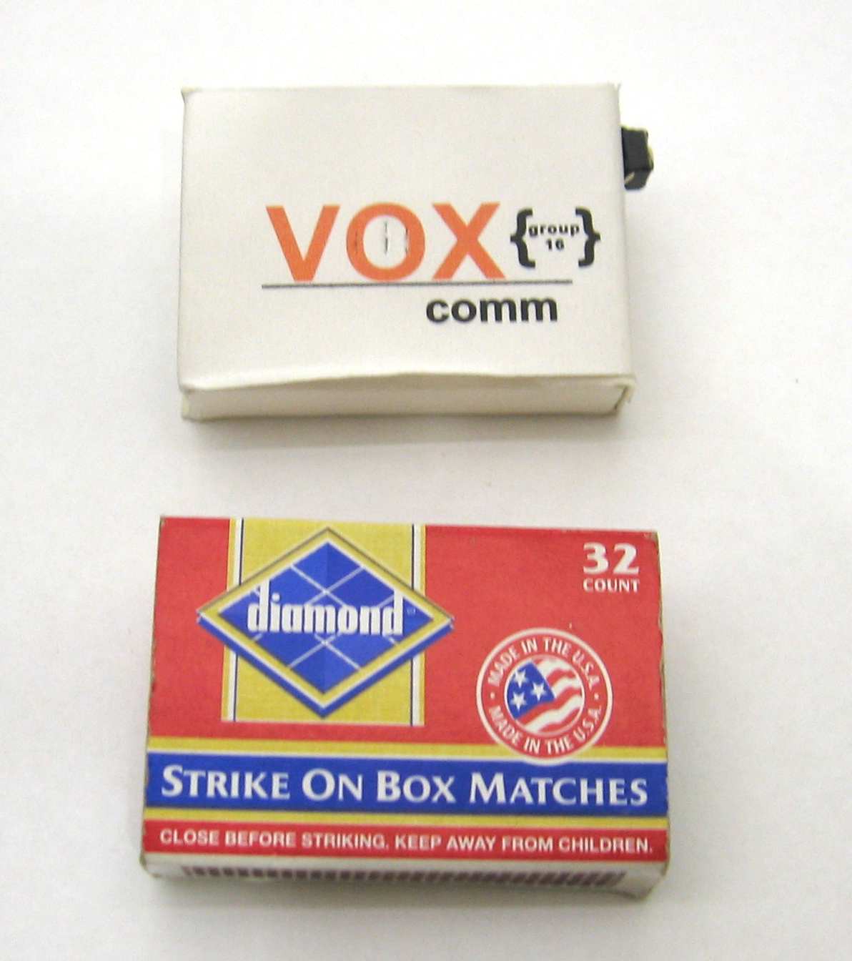
The prototype form would never be marketable, but some exploration has been done in possible marketable forms including the one shown here. It shows that the circuitry could be designed into the size of a small matchbox with the inclusion of a thin, appropriately chosen battery.
A new design based on the old but including these new developments would bring the communicator much closer to becoming a marketable product. Considerations for low power and improved transmission would benefit the design, while interface developments, feature improvements and additions, and compact size would benefit the customers. Such further developments could make the product more viable in the wireless electronics market.
Figure 3: Comparison of a prototype form to a small matchbox

PRODUCT DEVELOPMENT

The following section outlines the design of the communicator from its user interface, hardware and software design, and physical prototype. The following technical and design information was the main focus of the Senior Design development. It details the design and product development from a technical approach.

Using the Communicator

Power
Firstly, there are two options for powering the prototype communicator as described here.
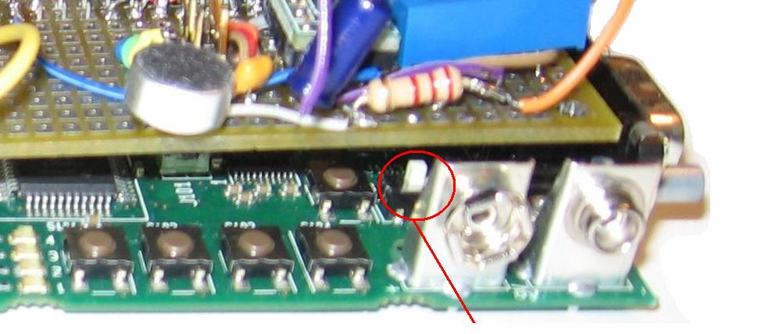
OPTION 1 - Wall Wart
- Locate the wall wart connector in the back-right corner of the board.
Figure 4: Power Source Selector Switch
- Plug the wall wart into a standard outlet and connect the board.
- Move the “Power Source Selector Switch” shown above to the far right position, in order to select the wall wart as the power source.
OPTION 2 – Battery Operation
- Locate the 9-volt battery connector in the front-right corner of the board.
- Plug in the battery.
- Move the “Power Source Selector Switch” shown above to the far left position, in order to select the battery as the power source.

General Operation
The communicator has two distinct modes of operation. The first is the voice activation (VOX) mode. This is the default mode of the communicator upon power up. The second mode is the Push-to-Talk mode. The operation in this mode is similar to that of a standard walkie-talkie. The following steps will acquaint you with the different modes.
- Select the mode of operation to be Push-to-Talk by pressing the second button from the left of the four located along the front of the board. This is the “Mode Select Button.” See figure below.
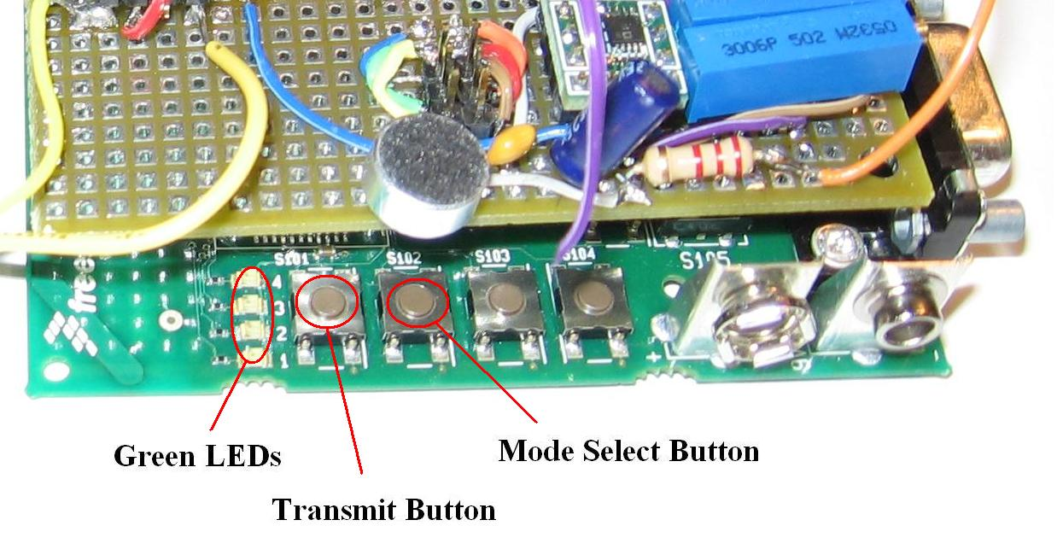
Figure 5: Button operation and layout
NOTE: When the communicator is in VOX mode, one green LED (#3) will be on. In Push-to-Talk mode, two LEDs (#2 & #3) will be lit.

- Now press and hold the “Transmit Button” to send a voice transmission and release when you are ready to receive. This is standard walkie-talkie operation and is useful when you are in a noisy environment.
- After becoming comfortable with Push-to-Talk mode, press the “Mode Select Button” again to return to VOX mode.
- When you are ready to transmit, briefly press the “Transmit Button.” Then release button and begin speaking.
- As soon as you are finished talking, the communicator will enter a waiting mode by recognizing your silence.
- To send another transmission you can just speak into the microphone. You can also receive a message from any other communicator at this time. Your communicator will automatically switch between transmit and receive modes based on the detection of direct voice or sound.
- After 3 seconds of silence on both ends, the communicator will enter sleep mode.
- To wake the communicator up from sleep mode and begin another conversation, press the “Transmit Button” again and repeat steps 4-7.

NOTE: If another unit initiates a conversation with you, you do not have to press any buttons. In this case you may respond by just talking into the microphone.

Communicator Adjustments
The VOX comm Personal Communicator has variable noise threshold and compression ratio adjustments. By adjusting these, you can control the sensitivity of the communicator as well as the transmission of low volume sounds. The figure below provides a graphical representation.
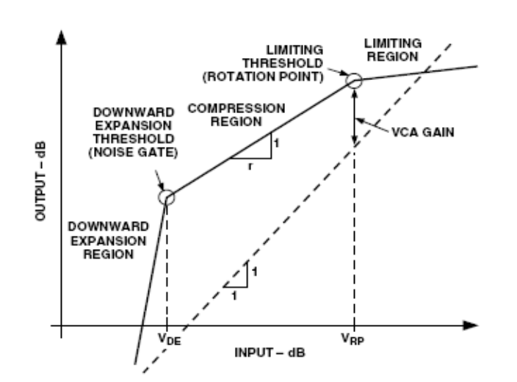
Figure 6: Graphical Representation of the Variable Noise Threshold and Compression Ratio. From the Analog Devices SSM2167 datasheet

The communicator is currently adjusted to provide good performance over a wide range of operating environments. The steps below will guide you through the process of customizing the noise and compression levels.
- Locate the 5 kΩ and 200 kΩ blue potentiometers (used as variable resistors, see system schematic) which are positioned in the front, on the right side of the board. See figure below.
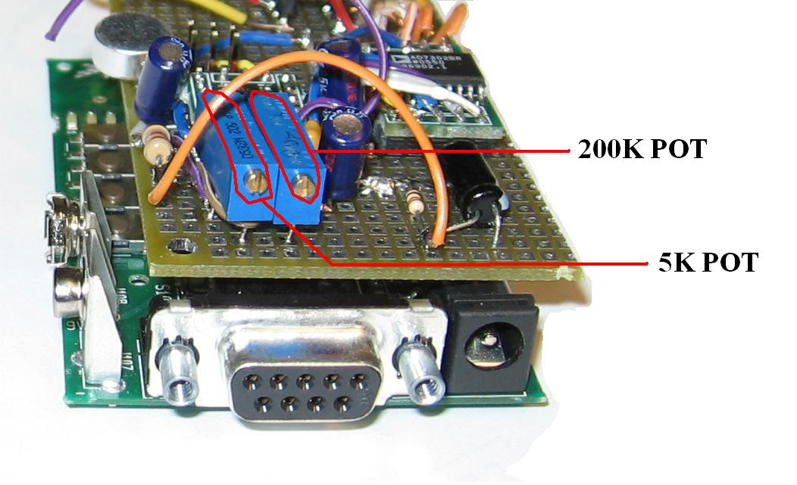
Figure 7: Potentiometers for adjusting the noise threshold and compression ratio

- To increase the sensitivity of the microphone, turn the 5K potentiometer clockwise with a small slotted screwdriver. By doing so, you increase its resistance.
- To decrease the sensitivity, turn the 5K potentiometer counter-clockwise.
- To increase the compression ratio, turn the 200K potentiometer clockwise. This will reduce the amplification of low volume sounds. This can be useful in noisy environments.
- To decrease the compression ratio, turn the 200K potentiometer counter-clockwise.

Technical and Physical Specifications

The VOX comm Personal Communicator applies basic building blocks to provide the user a small, light weight, easy to operate device while enabling a future developer the customizability to expand the products feature set and capabilities. The following are the key features useful to both the user and developer:
- Two Modes of Operation
  - Voice Operation Mode (default)
  - Push-to-Talk Mode
- Low Power Consumption
  - Full work-day operation on a single 3V battery
  - Components with shutdown options
- 3V supply voltage option
- 100 Meter Range with room for increase
- Small, lightweight form-factor with PCB fabrication possibilities
- Digital wireless transmission using a Freescale™ ZigBee™ (802.15.4) radio at 2.4GHz
  - Low interference and noise
  - Up to 250Kb/s transfer rates
  - Direct-sequence spread spectrum
  - Addressable transmission
- Easily Programmable HCS08 Microcontroller
  - Onboard A/D converter
  - Background-Debug Module for easy USB debugging and programming
- Low power preamplifier with controllable pick-up threshold and compression rate
- 8-bit parallel interface DAC with output buffer
- High efficiency filter-free class-D audio power amplifier

The communicator was designed for optimum range, power consumption, and small size. It is expected to perform appropriately under the following operation conditions and according to the below measured results.

Table 1: VOX comm Personal Communicator specifications
Parameter | Range/value | Unit | Comments
Supply voltage | 2.5 - 3.6 | Volts | Note 1
Transmission range | 100 | meters | Note 2
Audio sampling rate | 16 | KHz | Software configurable
Quiescent current | 72 | mA | Note 3
Average transmitting current | 57.5 | mA
Average receiving current | 59.5 | mA
Max current draw | 90 | mA
Average power consumption | 180 | mW | at continued use
Max battery lifetime  at average power operation | < 9.8 | Hours | using 540mA Li-ion rechargeable battery
Max battery lifetime  at max power operation | < 6.0 | Hours | using 540mA Li-ion rechargeable battery

Note 1: This is the supply voltage applied directly to the 3V positive rail. The Freescale™ evaluation board includes the correct voltage regulator so that the 9V battery or “wall-wart” supplies can be used safely. This voltage regulator may not be included on a minimum sized product.

Note 2: The range of 100m is not absolute. Outdoor, line-of-sight range will exceed this measurement. Many factors may decrease range such as solid obstacles, heavy radio frequency traffic, and low power conditions. We noticed some directionality in the antenna reception: the best reception occurs between +/- 135° from direct alignment with the transmitter. Also, the transmission power is software controllable, which affects transmission range. There is also a hardware option for a Low-noise Amplifier for improved antenna reception.

Note 3: We measured this “standby” current to be higher than average transmission or reception current. Consideration should be taken to lower this value significantly in future updates. We were unable to identify the source of this extra power consumption. Several remedies include software control of the microcontroller’s sleep state when no activity is present and incorporation of the shutdown functionality of each IC via software control.

Physical Dimensions
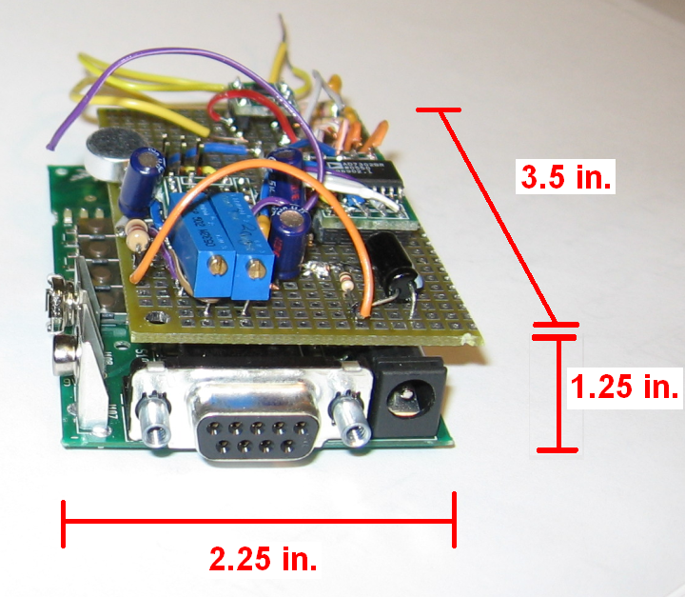
Figure 8: Physical dimensions of the communicator without the speaker
Component Placement
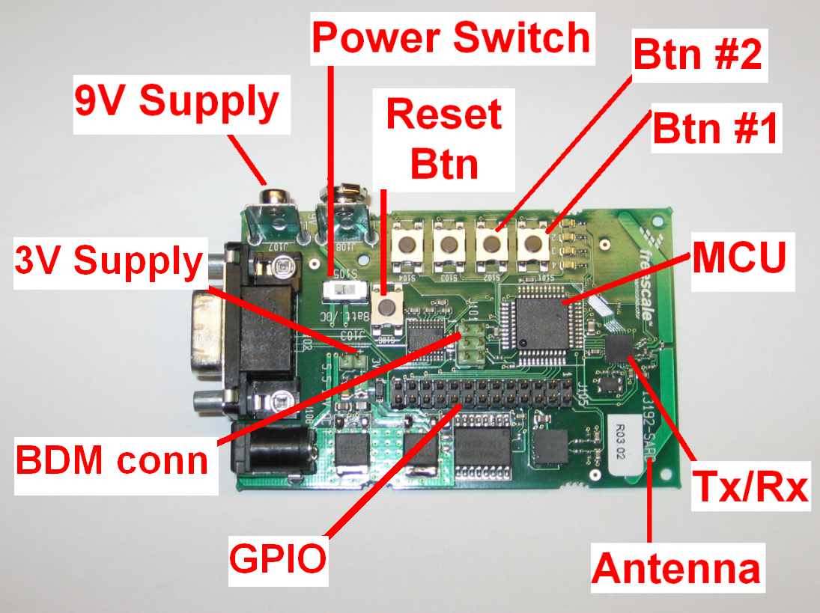
Figure 9: Component placement on the Freescale™ evaluation board
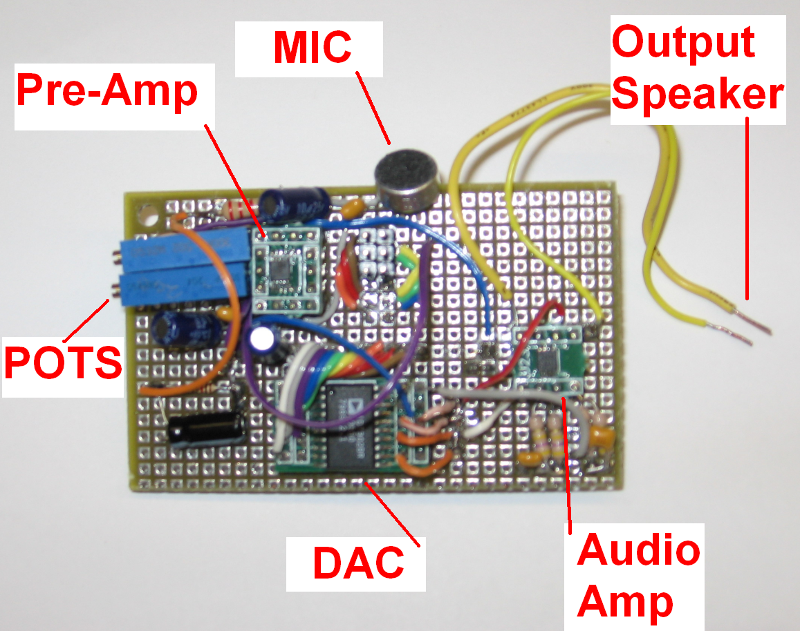
Figure 10: Component placement on the daughter board that sits above and connects to the Freescale™ evaluation board. Speaker not shown

Hardware Description

Block Diagram and Interfacing

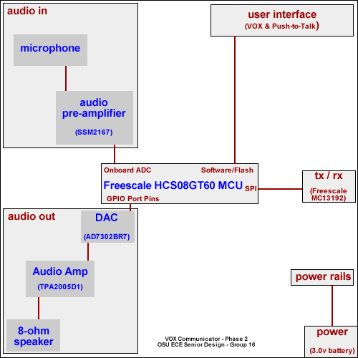
Figure 11: System block diagram

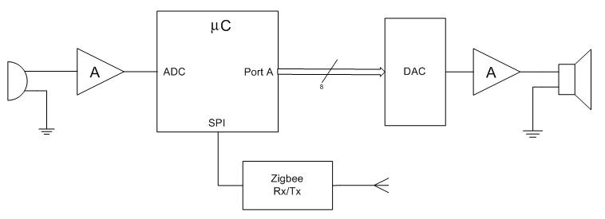
Figure 12: System interfacing diagram

Electrical Schematic
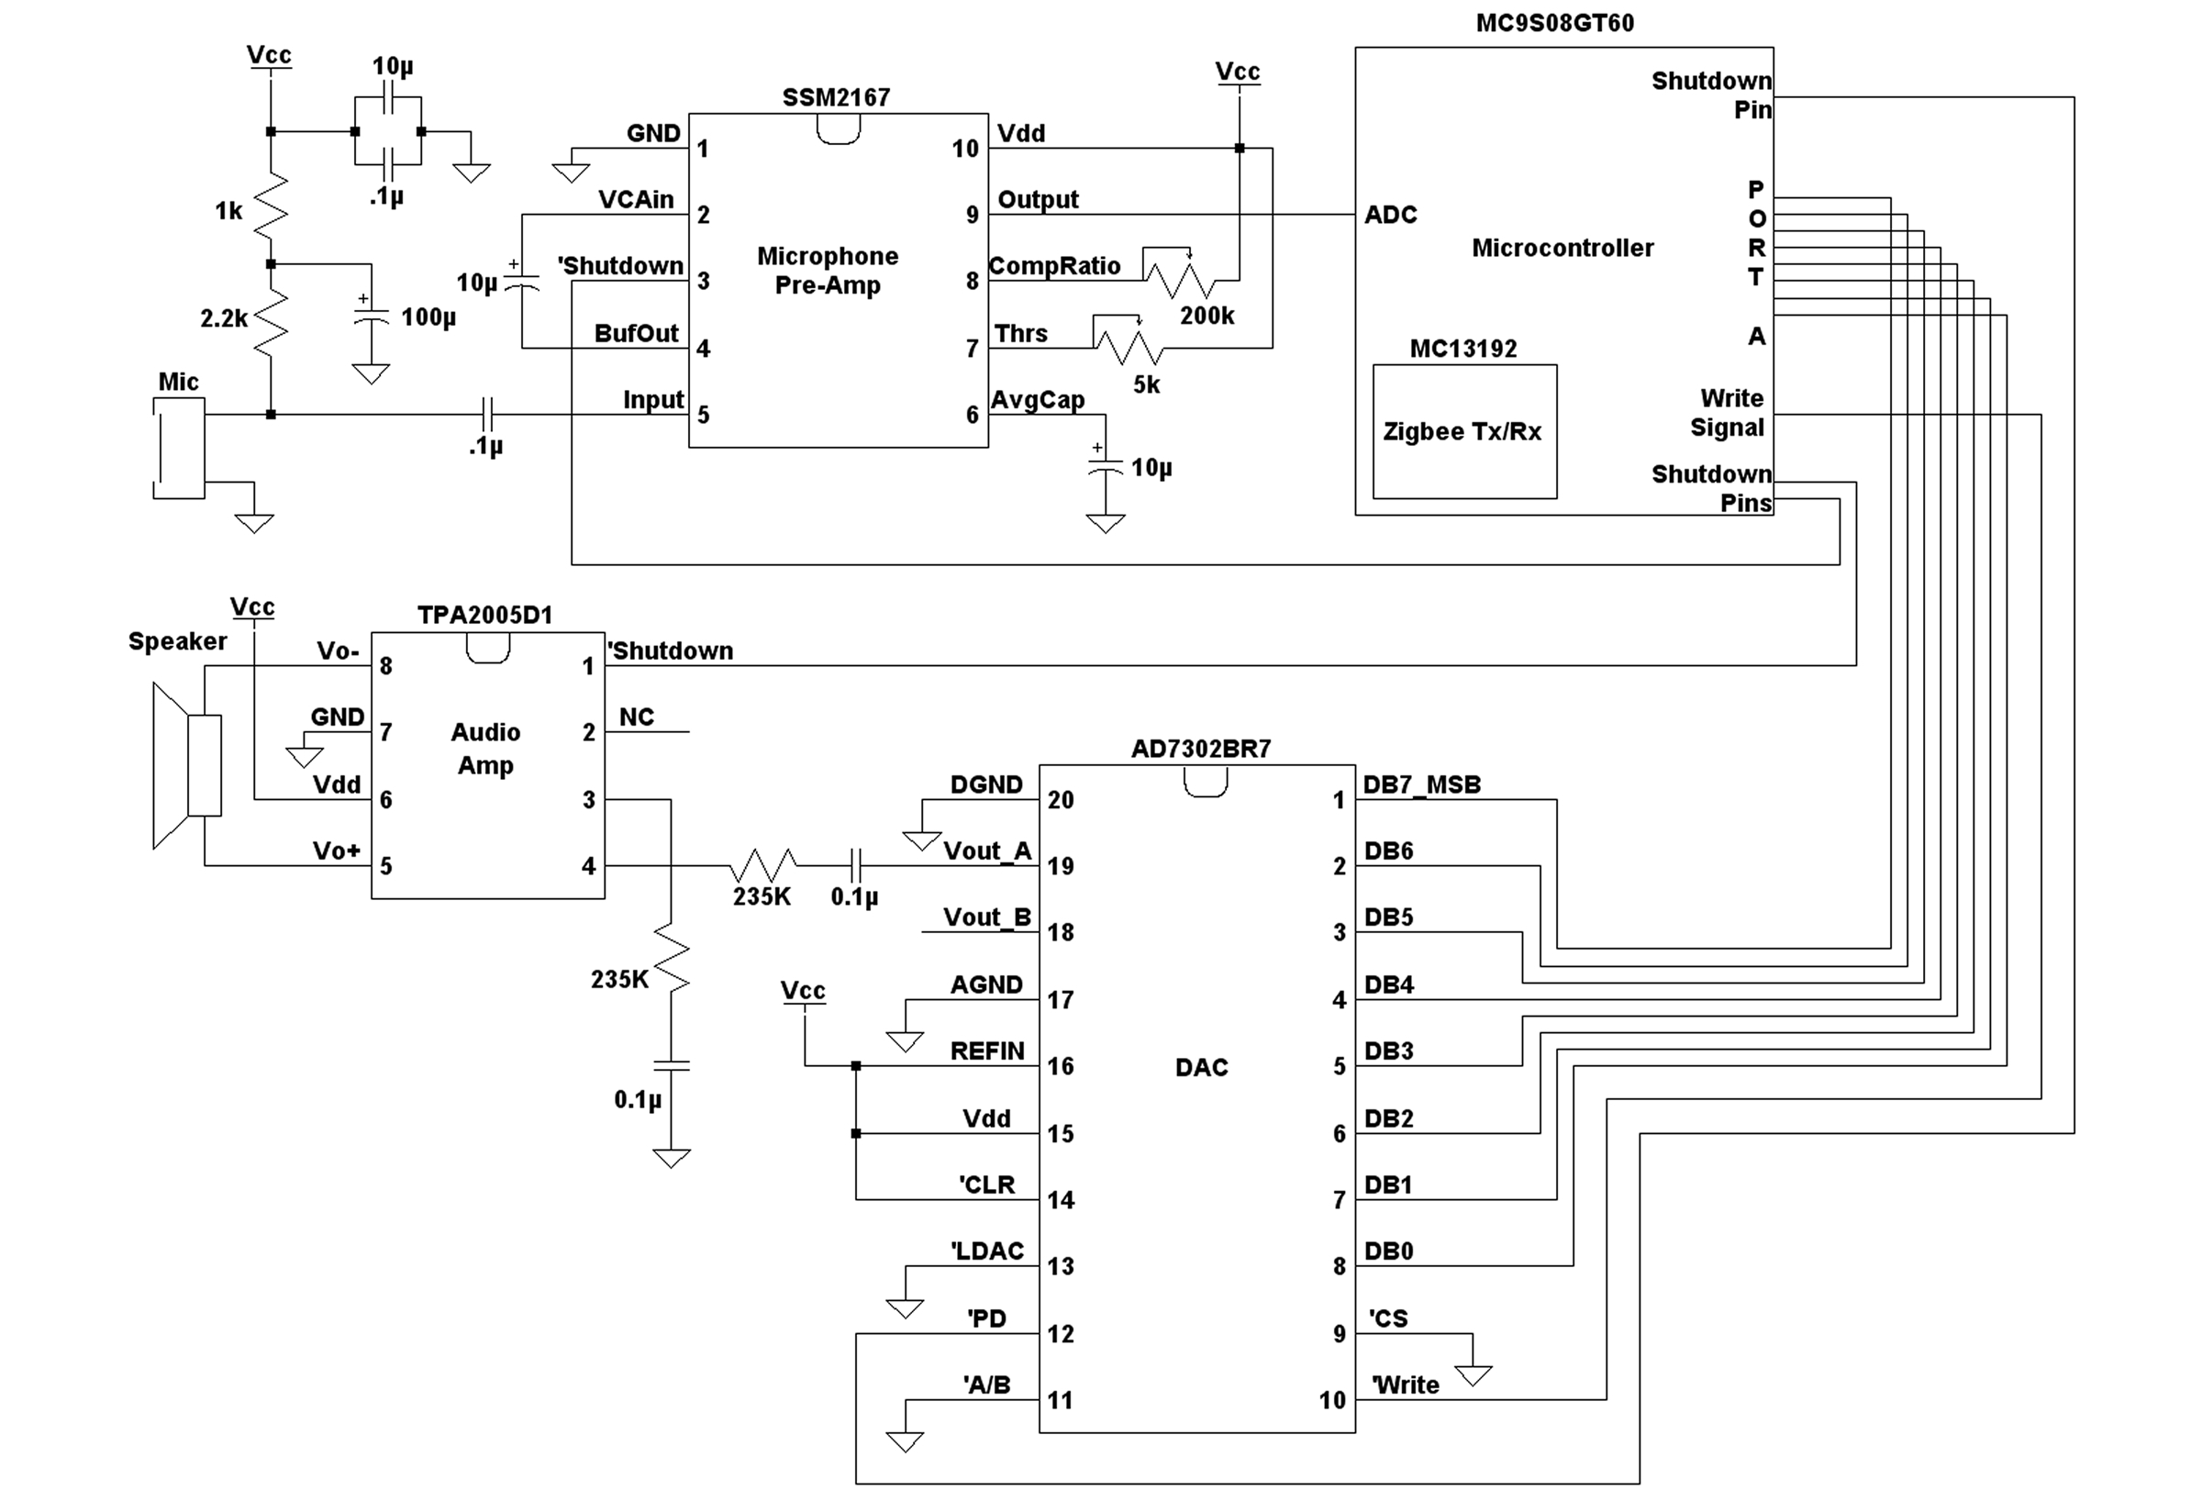

Figure 13: System electrical schematic

Freescale™ Evaluation Board

The Freescale™ 13192DSK Evaluation Board is the basis for this product. Complete board schematics and other pertinent documentation can be found on the Freescale™ website under their ZigBee™ wireless solutions at http://www.freescale.com/webapp/sps/site/prod_summary.jsp?code=13192DSK

Microcontroller -- MC9S08GT60
The MC9S08GT60 microcontroller is a member of the low-cost, high-performance HCS08 family of 8-bit microcontroller units (MCUs). All MCUs in the family use the enhanced HCS08 core and are available with a variety of modules, memory sizes and types, and package types.
The HCS08 family is an extension of the HC08 family, offering extended battery life with maximum performance down to 1.8 V, industry-leading Flash technology and innovative development support.
The microcontroller is capable of running off a 1.8 V to 3.6 V supply. Our design operates at 3.3 V. More details about the microcontroller can be found at the following website: http://www.freescale.com/webapp/sps/site/prod_summary.jsp?code=MC9S08GT60
Some highlighted features of the microcontroller include:
- 60Kb re-programmable flash memory
- Background-Debug Module (BDM - used for debugging and programming through USB)
- 32Mhz/16Mhz Clock speed
- Synchronous serial peripheral interface module (SPI)
- 36 General Purpose Input/Output Pins (GPIOs)
- Internal 8-channel, 10-bit analog-to-digital converter (ADC)

ZigBee™ Radio -- MC13192
We decided to use the ZigBee™ platform from Freescale™ due to ZigBee™’s capabilities including:
- Low power usage
- Respectable range rated at about 100m
- 250kbps data transfer rate
- 2.4Ghz RF transceiver
The ZigBee™ radio included on the Freescale™ evaluation board receives and transmits data through an SPI connection with the microcontroller.

Programming the MC9S08GT60
Programming the microcontroller is accomplished through a USB interface to a 6-pin Background-Debug Module (BDM) connection on the microcontroller. Using Freescale™ Codewarrior™ Integrated Development Environment (IDE), the BDM cable, and the programmer (a built-in application with IDE), the microcontroller can be programmed using the C programming language. Programming is fast through USB and only takes a few seconds for the entire firmware to upload onto the flash memory. The microcontroller can also be programmed through a serial cable and other software included with the microcontroller. More details on this can be found on the webpage mentioned above.
The diagram below shows a graphical representation of the programming process data flow.

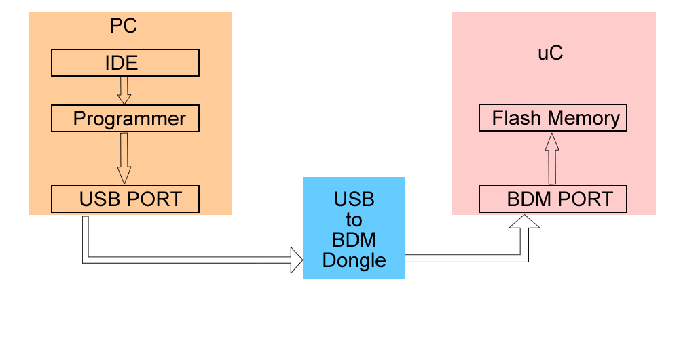
Figure 14: Microcontroller programming process data flow

Input/Output Map
The diagram below maps the microcontroller pins to the header pins in our design. Alternative use of each port is listed as the third item. Refer to the data sheet for more information.

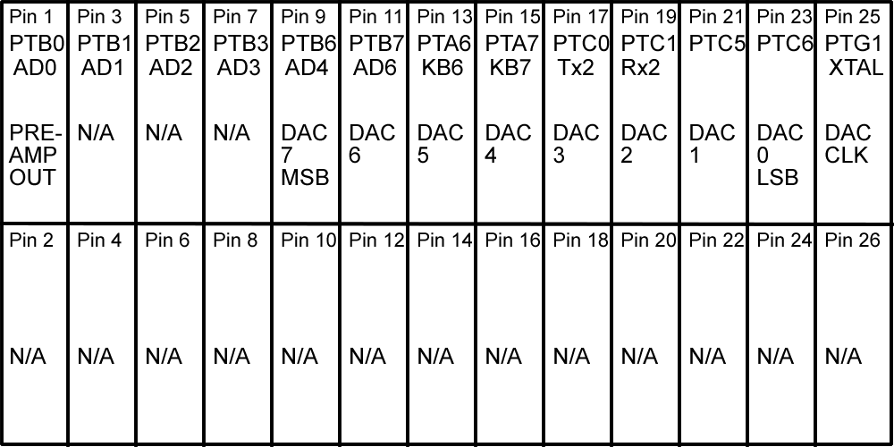
Figure 15: Input/output pin map

Audio Input Circuit

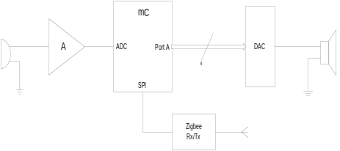The audio input circuitry consists of an electret microphone and a pre-amp which feeds into the MCU’s internal analog-to-digital converter. This is a very useful feature of the microcontroller for the audio circuitry design. Our design uses a single channel of the internal ADC at 8-bit resolution. The basic circuit design is shown here:

Figure 16: Audio input circuitry basic view

Microphone
There are many choices when selecting a microphone, and we did not perform an extensive search. The microphone used is an omnidirectional electret condenser microphone from Horn, product number EM9745. There may be a microphone that better suits this use, but we knew that this would work for our prototype. The typical frequency response curve for a microphone of this type is shown below.
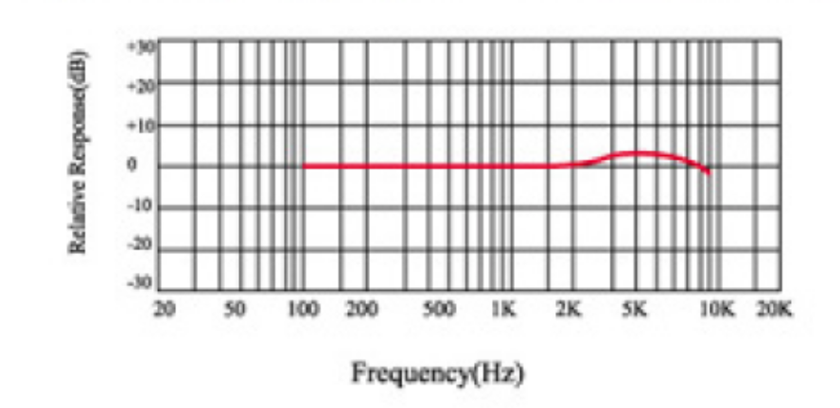

Figure 17: Typical Microphone Frequency Response Curve

Preamplifier
The preamplifier the design uses is the SSM2167 from Analog Devices. It is designed for use with personal electronic and computer audio systems. The variable noise threshold control allowed us to adjust the sensitively of the input. This is very useful for VOX operation. It makes a good fit for this project and has many great features including those below:
  - 3-volt supply operation
  - Low shutdown current < 2µA
  - Adjustable noise-gate threshold
  - Adjustable compression ratio
  - Low noise and distortion
  - 20 kHz bandwidth
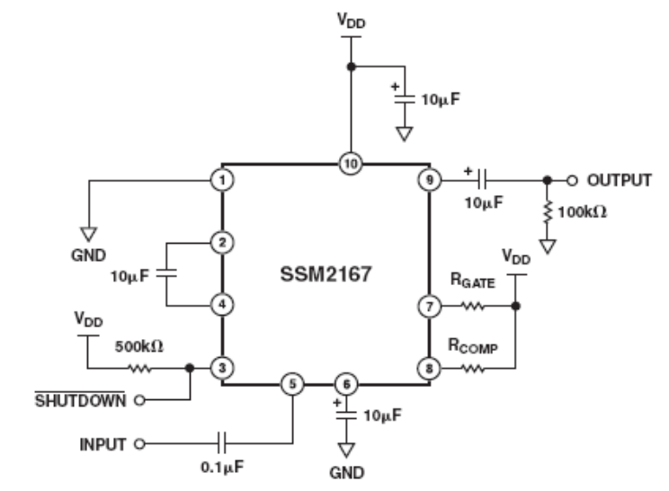
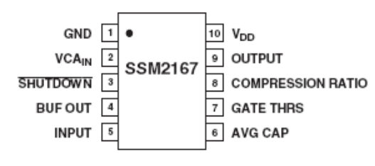

(b)Typical Circuit
Figure 18 a & b: Preamplifier pin configuration and typical circuit. From Analog Devices SSM2167 datasheet
(a) Pin Configuration

Table 2: Preamplifier specifications quick reference. From Analog Devices SSM2167 datasheet
Parameter | Symbol | Conditions | Min | Typ | Max | Unit
AUDIO SIGNAL PATH
Input Impedance | Z_{IN} |  |  | 100 |  | kΩ
Output Impedance | Z_{OUT} |  |  | 145 |  | Ω
Gain Bandwidth Product |  | 1:1 Compression, VCA G = 18 dB |  | 1 |  | MHz
CONTROL SECTION
VCA Dynamic Gain Range |  |  |  | 40 |  | dB
VCA Fixed Gain |  |  |  | 18 |  | dB
Noise Gate Range |  | Maximum Threshold |  | -40 |  | dBV
POWER SUPPLY
Supply Voltage* | V_{SY} |  | 2.5 |  | 5.5 | V
Supply Current | I_{SY} |  |  | 2.3 | 5 | mA
Shutdown Current | I_{SY} |  |  | 2 | 8 | uA
*Absolute Max = 6 V
(at V_{S} = 3.0V, f = 1 kHz, R_{L} = 100 kΩ, T_{A} = 25ºC, V_{IN} = 100 mV rms, R_{GATE} = 2 kΩ)

Tuning and Adjustments
Instead of inserting fixed values for the resistors R_{GATE} and R_{COMP}, we used potentiometers. We selected a 200 kΩ potentiometer for R_{COMP} and a 5 kΩ potentiometer for R_{GATE}, which are the maximum values for each. With these, we were able to adjust for all possible compression ratios and noise thresholds.
This was very helpful for tuning the VOX operation mode. We were able to adjust the sensitivity so that the speaker’s voice would be picked up but not background noise. The variable compression region also allowed us to reduce the amplification of the low volume sounds. Below are some figures that show the general idea of these operations and some tables of typical values. If we were to produce the VOX Communicator, the potentiometers would be replaced by resistors with optimum values that have relatively low tolerance percentages.
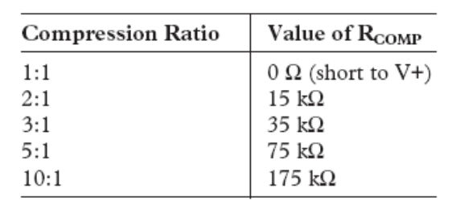
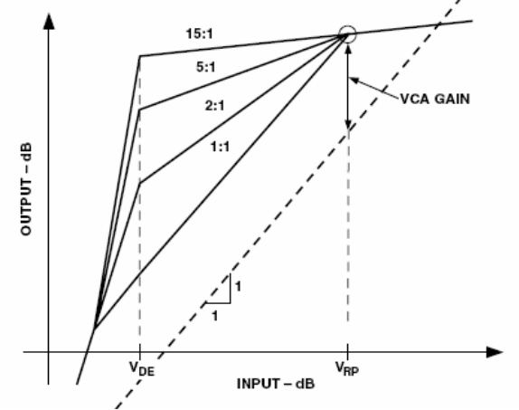
Figure 19: Compression ration adjustment graph and typical values table

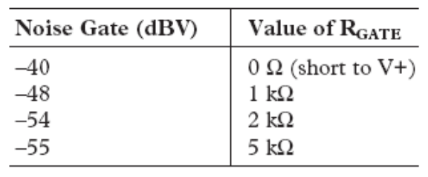
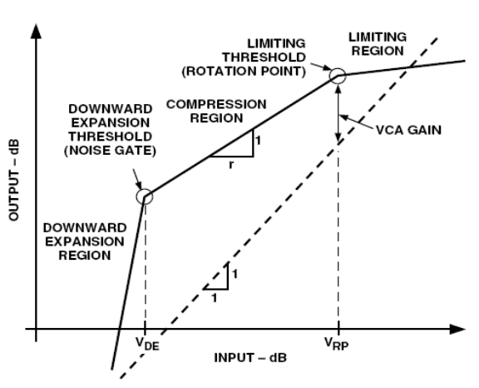
Figure 20: Noise-gate adjustment graph and typical values table

For additional information, see the SSM2167 pre-amp datasheet.

Noise Filtering
One big challenge to overcome was combining the sensitive analog components on one board with the digital noise of a microcontroller. To accomplish this, we needed a really quiet reference signal for our input. The filter below was added to the supply of the microphone and eliminated the majority of the input noise problem.
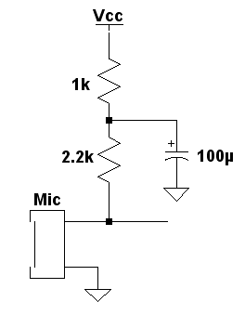
The cut-off frequency for this low-pass supply filter is approximately 2 Hz. This is low enough to cut out any digital noise. We did not add any filtering to the power supplies of the other analog components, but it would be a good idea in the next revision of the design.
Figure 21: Audio input digital noise filter

Audio Output Circuit

The audio output portion of the project consists of a digital-to-analog converter (AD7302BR7) and an audio amplifier (TPA2005D1). The digital signal from the microcontroller gets converted to an analog signal in the DAC. Then, the signal is amplified so it can be outputted and heard through the 8 ohm speaker.
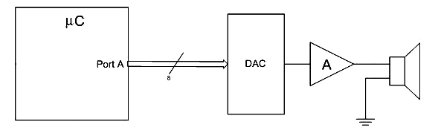
Figure 22: Audio output circuitry basic view

Digital-to-analog Converter
The digital-to-analog converter used in the circuit was chosen over an R2R network for its precise timing and easy programmability vie the microcontroller. The one chosen is especially compatible with the type of microcontroller used. The AD7302BR7is a selectable dual 8-bit DAC. It features a parallel input interface, and an on-chip output buffer for rail-to-rail output swing. We tied the LDAC and A/B pins to ground, to give the microcontroller timing control over the DAC. Thus, the bits are processed on the rising edge of the WR pin, and this ensures that only one DAC is in operation.
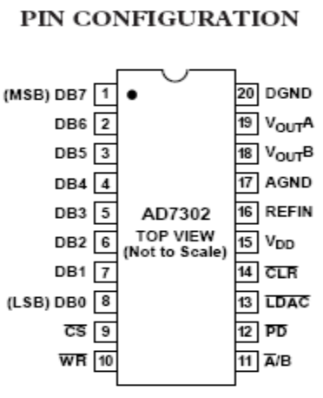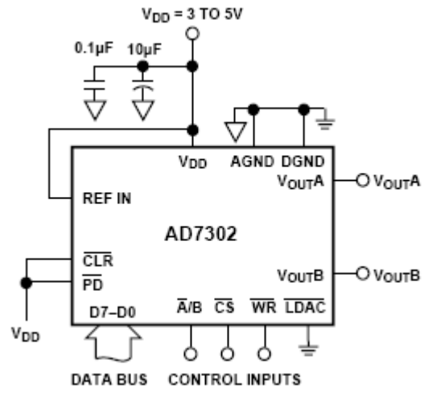
(a) Pin Configuration
(b)Typical Circuit

Figure 23 a & b: Digital-to-analog converter pin configuration and typical circuit. From Analog Devices AD7302 datasheet

Table 3: DAC specifications quick reference. From Analog Devices AD7302 datasheet
Operating Voltage | 2.7V to 5.5V
Average Power Consumption (at Vdd = 3.3V) | 10mW
Shutdown Power Consumption | 3uW

Audio Amplifier
The TPA2005D1 is a 1.4-W high efficiency filter-free class-D audio power amplifier from Texas Instruments and provides a good fit for the design because of its low power consumption, small size, and efficiency. The amplifier features shut-down options to conserve power and fully differential operation for low noise, high efficiency amplification without many external components.

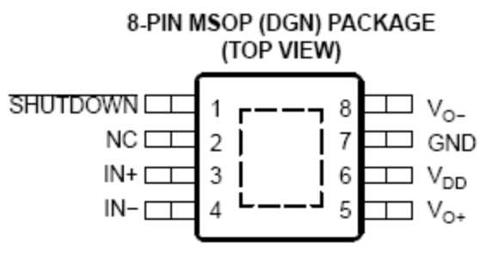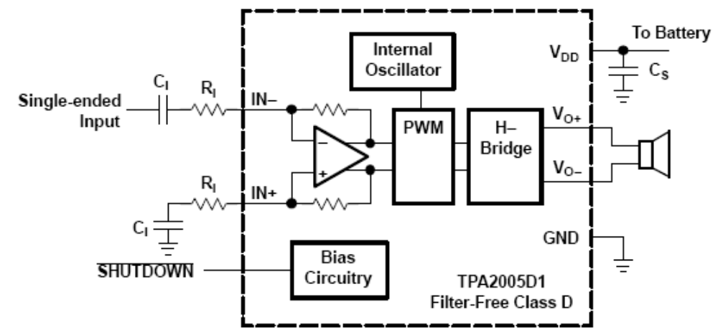
(a) Pin Configuration
(b)Typical Circuit
Figure 24 a & b: Audio amplifier pin configuration and typical circuit. From Texas Instruments TPA2005D1 datasheet

Note that there is a thermal relief pad on the bottom side of the package. In a following design revision, this pad should be soldered to a no-connect pad on the PCB for effective heat relief for the part. The prototype design was not built on a PCB, so instead we elevated the whole package for increased air flow to the thermal pad.
Regarding the signal gain, the DAC is designed to output full range signals, so there is minimal level amplification necessary. According to the datasheet, 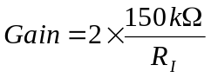. Therefore, we set the gain to 1.3 using a 235k ohm resistor. This amplifier is primarily used to efficiently step up the power level for use with the speaker.

Table 4: Audio amplifier specifications quick reference. From Texas Instruments TPA2005D1 datasheet
Supply Voltage | 2.5V to 5.5V
Quiescent current (at Vdd = 3.6V) | 2.8mA
Shutdown Current | 0.5uA
Output Power (at Vdd = 3.6V) | 0.58W
SNR | 97dB

Software Overview

The software portion of the project was designed and implemented by Keith Prickett. Along with the core control of the various blocks, the software implements the user interface design into the controls. The design of the user interface was decided by the group, while the state machines were designed by Keith with support from Jules and Daniel. Some portions of the code were leveraged from reference projects posted on the web by Freescale™ designers for developer reference.

Code Layout and Description
Software, also called firmware, for this project can be split into these four main ideas:
- Microcontroller initialization (including transceiver)
- Transceiver processing
- Data structures
- Main program loop

Microcontroller Initialization
During microcontroller initialization each needed port pin is configured for data direction and initial values. The clock source is set and speed is chosen for both the microcontroller and transceiver. A few other items that are initialized during this period include: the watchdog timer (disabled), the timer counters, SPI (serial peripheral interface bus), the IRQ (interrupt request), and the transceiver registers and ports (via SPI).

Transceiver processing
The transceiver processing portion of code including the PHY (physical layer), interrupt control, and SPI packet transferring was written by Freescale™ Semiconductor. This portion of the code could be relatively easily written from scratch utilizing information in the MC13192 Reference Manual, the microcontroller data sheet and the SPI port.
In order to transfer and receive data we utilized the protocols established by the Freescale™ code. A global data structure is used to determine the state of the application and the transceiver. Another structure is used for receiving packets, and yet another is used to transmit packets. Transmission is accomplished by filling an array of data and calling a function (which in turn utilizes the SPI port). Receiving is accomplished by implementing a specific function with application specific code. The receive function is called via an interrupt when a packet is received.

Data Structures
In order to sample audio and transmit (on the transmitting side) as well as receive packets and play them back (on the receiving side), data structures were needed to buffer the data. A circular queue (buffer) was used as the data structure for this purpose. Freescale™ provided the implementation for this buffer. This structure could also be implemented from scratch with only a few lines of C code.

Main program loop
The main program loop implements the application specific portion of the firmware. Within the program loop, button presses are detected and handled, audio is sampled and transmitted, and audio packets are received and played back. A state machine also handles control at each state as detailed in our state machine diagrams.

State Machine Design

Communicator System Modes
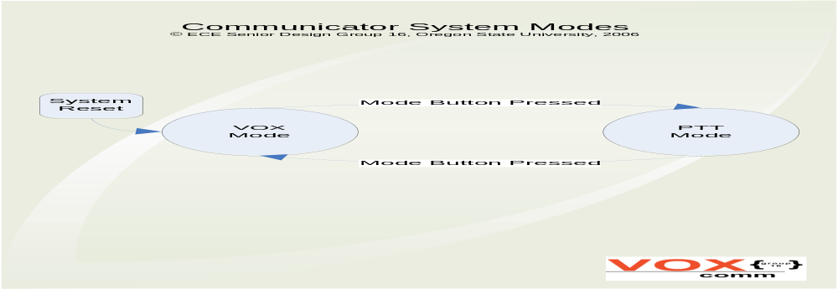
Figure 25: Communicator System Modes state machine diagram

VOX Mode Operation
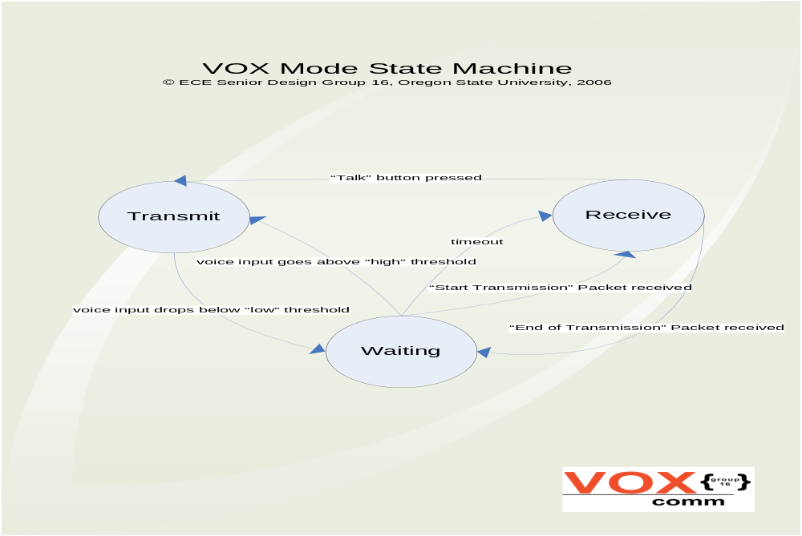
Figure 26: VOX Mode Operation state machine diagram

Push-to-talk Mode Operation
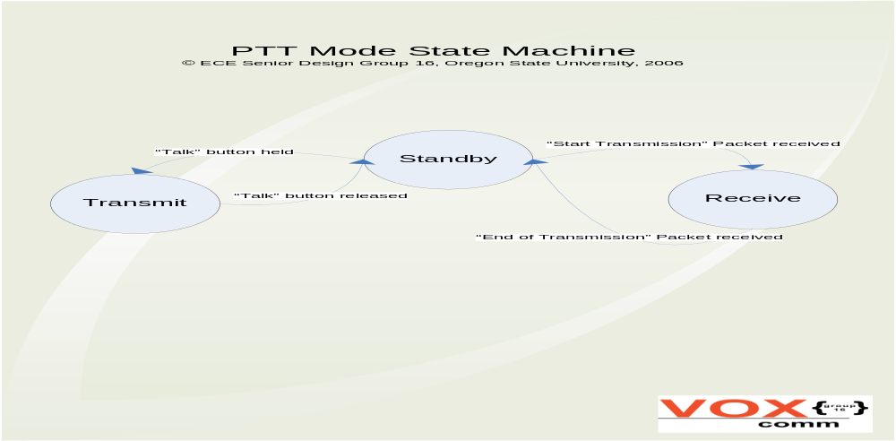
Figure 27: Push-to-talk Mode Operation state machine diagram

PROGRAM MANAGEMENT AND TEAM LEADERSHIP

Other than the technical design experience, the experience of working with a design team is paramount to the Senior Design program. Students get a chance to learn so much more than circuit design; the project provides an opportunity to experience teamwork, leadership, scheduling, organization, presentation, and more life-applicable skills. This section describes some of the dynamics and challenges face by a team of first-time designers.

Design Team Dynamics

Even before the design project was chosen, the team was formed and we began organizing ourselves. We came to the realization that an effective project is accomplished through an effective team. Early on, we chose roles and responsibilities for each member. I was elected team leader as I had taken charge to see that we began organizing the team and the project. The team structure was defined according to roles and responsibilities as follows:

Administrative Roles

Daniel
- Team Leader
- Schedule Manager
- Public Relations

Tim
- Treasurer
- Resource Manager

Jules
- Secretary
- Document Manager

Keith
- Webmaster
Responsibilities

- Update schedule
- Communication with sponsor
- Organize & run team meetings
- Manage team members’ responsibilities

- Manage money
- Order parts for team
- Maintain availability of parts

- Keep meeting minutes
- Maintain PDS document
- Maintain overall documentation
- Reside over presentation creation

- Maintain website according to course guidelines
- Keep website unified

After defining team structure, project blocks were assigned as follows:
- Daniel – Radio/wireless module
- Tim - Audio Out and Power modules
- Jules - Audio In and User Interface modules
- Keith – Microcontroller and Software modules

The definition and structuring of the team was essential to providing responsibility and ownership to each team member. Once this structure was established, it promoted quicker forward progress and accountability for each team member.

Organization and Scheduling

After choosing a design, we immediately defined a project schedule. This helped keep the team on track with respect to project completion. Setting the schedule required continued foresight, something usually unfamiliar to beginning designers. To help get the teams going, the Senior Design class was broken down into three terms with specific deliverables for each term. In the first term, the teams were required to choose projects, research them, write white papers corresponding to the project, and begin designs. The second term was designated for the design and build stages with regular progress updates required throughout the term. The third term was primarily intended for project completion through documentation and presentation, although it was found that many of the teams were still completing large portions of design, build, and test in the third term. The discovery that things always take longer than expected was commonplace. This made schedules less concrete for most teams.
We found it important to define the specific design stages and keep track of the progress made in each stage. The design stages for this project were defined as follows:
- choosing the project
- organizing the team with roles and responsibilities
- choose a technical solution and block diagram
- research modules and choose components
- procure materials
- build hardware and design software
- test hardware and incorporate software
- test, debug, modify, and validate
- compile and complete documentation
- present completed design with working prototypes

It was decided that the team should have weekly meetings to discuss progress, tackle technical problems, work together, and plan next steps. We also chose to have monthly update meetings with the sponsor to provide project status and receive feedback on progress.
As the project began to move forward, I realized that managing the team and establishing organization for the project required significantly more time than I had anticipated. Thus my role shifted from having an equal share of design work to spending far more time administrating, organizing, and planning. I discussed this shift with the team, and everyone agreed that my time and efforts were effective in management. I made sure that they did not feel that I was shirking my responsibilities but that they supported my administrative efforts.
This shift towards management helped provide the team with constant direction and organization. I was able to help promote effective communication within the group and serve as a “glue” between the various efforts within the project and more importantly, between the members of the team. Furthermore, I made sure that all the details associated with the project as a whole were attended to. I assisted with everything from ordering parts to rescheduling meetings. The ability to be detail oriented while maintaining a big-picture view of the project smoothed our whole process.
Over the course of the project, there were several times that we had to modify the schedule. What we had idealized early on always took more time than expected. Being inexperienced designers, we could only make educated guesses on how long things would take to complete. For instance, we had hoped that after our schematics were complete, it would take only one week to find, order, and ship parts. This was supposed to happen around the third week of the second term. We finally had all the parts in hand about three weeks before the end of the term and found that it ended up taking about 3-4 weeks to find and order all the parts. Furthermore, the designs took longer on the front end which needed to be completed before we could order any parts. This is just one of many examples of schedule stretching that occurred over the three terms. The reason that we were able to achieve success is that our original scheduling was fairly aggressive, because our instructors had warned us that things take longer than we expect. Our final schedule for each term can be found in the appendix.
The organization and scheduling portion of the experience provided the most valuable learning experience for me personally. Being able to organize and motivate a team according to a schedule proved a challenge that enabled me to more fully understand the project management role. It takes excellent communication and interpersonal skills along with enough foresight to plan each step with regard to the scope of the entire project. I quickly learned to oversee each design stage, manage a changing schedule, and guide the team through an otherwise unfamiliar process to achieve project success. I know that these management skills are what I will carry forward most proudly.

Hurdles and Challenges

As with any difficult project, the team encountered hurdles and roadblocks throughout the process. Most of the big ones were not design problems but more so time challenges and team dynamics. Although we did not allow such challenges to impede our success, these types of challenges were found to be consistent throughout the entire process. We found that an effective team is able to face such challenges and grow from them while maintaining forward progress.
Initially, the product concept was not clearly defined, and the project had no exact specifications. This gave us the flexibility to define these ourselves, yet this presented the challenge of choosing realistic goals. After brainstorming and conversing with the sponsor, we decided upon a short-range, low power, small size solution. We defined the concept of using digital transmission and a microcontroller in order to achieve the high-level goals of the project. Based on the research we had done, we chose specifications that would satisfy the project goals while taking into account our expertise, technology used, and timeline. We agreed with the sponsor on some concrete specifications and features. Then we discussed other options and features that we would like to implement if time and resources allowed. Once expectations were clearly defined, the team was able to go to work with confidence that we could accomplish what we set out to do. The important thing we discovered was the ability to define useful specifications that we could achieve in the time available for the project. Looking back, we were grateful for our sponsor’s flexibility in allowing us discover this for ourselves.
Along with defining the product concept, one of the initial hurdles the team and project encountered was to define the purpose of the product. We realized that we needed to create more than just a gadget; this product should be useful to somebody, have a defined purpose, and therefore be marketable. The technology was intriguing, but the application of that technology is what would make a product viable to produce. We began by brainstorming about the usefulness of our chosen technology and proposed product. Once we determined how it could be useful, we established a target market and customized the feature set that we considered essential to the usage model we expected for the product. From there, we began developing these applications and features into reality. Each facet presented its own challenges, yet our finished prototype accomplished the goals associated with the defined purpose.
As demonstrated from the schedule changes, time management for the project was a continuing challenge. Being that we did not have an accurate understanding of how long each step in the process would take, timing and scheduling expectations were tested via a trial and error method. As discussed, a specific example was the ability to procure parts in a timely manner. Furthermore, we initially wanted to incorporate more features, fine-tune the design, and lay out our own printed circuit board if time had allowed. However, through these time related challenges, we learned to make tradeoffs that are routinely made in the design industry. Although it always seems that there is one more feature to add or design to modify, time is finite and appropriate choices must be made. I believe that a big portion of our success was due to the team’s ability to asses which challenges we could effectively tackle in the amount of time we had available.
In the procuring of parts, time was not the only hurdle that we faced. We encountered challenges ranging from availability to manufacturability. Once the designs were complete, each designer had to choose the appropriate parts and order the right quantities. Fortunately we had no stipulations on which vendors we were able to use, but availability of some parts did arise as an issue. On the forefront, finding the right microcontroller and radio pair was difficult; but once we found them, Freescale™ was exceedingly helpful and quick in getting us started. The rest of the discrete components took effort in finding also; we had to be sure to find parts with compatible voltage supply ranges, correct interfacing, small size, and appropriate packaging. In one case we found a preamplifier with all the correct specifications that was manufactured in an extremely small package making soldering very difficult. Because that was the part we needed and the only packaging option offered, we improvised by soldering it under a magnifier with a very fine-pitch solder tip to a small fan-out board that allowed us to have easy access to each pin. Furthermore, this part has a thermal pad on the bottom which created a new challenge. The part needed cooling, so our solution was to raise it slightly to provide a gap for air to flow through to cool the part. If we had time to build our own printed circuit board, we would have solved these problems more elegantly. Overall, we found that simply finding, ordering, and receiving the parts took more time and effort than we expected.
During the procurement of parts, cost was a constant consideration. The microcontroller and radio board itself could have easily consumed our $500 budget. Luckily, the very set we chose as our best option was built by Freescale™ Semiconductor who generously gave us the boards, programming equipment, and software (IDE) as an academic donation. Furthermore, we were able to sample several of the other ICs used, free of charge. This allowed us to keep the expenses low for our prototypes. Although we saved money this way, market price for the components was still a consideration. We needed to maintain a low total bill-of-materials cost, so that future production would be cost effective and profits possible.
As with any technical project, we faced the challenges of debugging and troubleshooting our designs. Fortunately, our designs were fairly clean, and we did not encounter too many problems. However we did face many common hardware and software bugs. Our first goal in debugging was to determine if the issue was hardware or software related. Being able to keep these relatively separated sped up the process, although we did have to combine hardware and software to solve some of the more complicated problems. On the software side, we encountered issues with data acquisition and data transfer. Keith was very successful with troubleshooting the software and solved most of the problems alone. Our hardware faced usual issues including noise problems, bad solder joints and confused wiring, and the possibly dead component. Through the hardware debugging, we learned a lot about digital noise and double checking connections. We also learned how to break problems down by examining and isolating one circuit at a time. At times, we had to connect problem circuits from one device to known working circuits on another to isolate the problem. We were ultimately able to debug and fix all mission-critical problems, although we would have continued to tweak and fine-tune some portions if more time was available.
One of the biggest set of challenges any team faces is the issue of dealing with people. People, including those close to you, have differing expectations and differing ways of interacting, communicating, and thinking, as well as the propensity to change their minds. Good leadership and teamwork is marked by being able to deal with these challenges over the course of a project while maintaining the unity of the team and forward progress of the project.
We encountered each of these challenges as a team and successfully navigated through each of them, although some took more effort and caused more strain than others. Our interactions were friendly and open because we were all friends before the project began, yet we saw the importance of a proper approach to such challenges through the stressful periods. As group leader, I promoted open and clear communication within the team and modeled the valuing of each member’s opinions and ideas; and each teammate proved very responsive to this approach. It allowed us to work together as equals with differing roles and responsibilities rather than as subordinates. Occasionally we encountered a change of mind on something that we previously had established. In these instances, we generally verified the acceptability of the change with each person who had interest in the matter.
At times our differences of opinions, ideas, and thinking became evident at points of decision. In one instance, we were trying to decide on the most effective way to implement one of the audio circuits. The designer of that module had a contrasting approach to what I believed to be best for the design as a whole, and the rest of the team had varying opinions and ideas to add to the mix. To solve the problem quickly and get back on track, I used part of our team meeting as an avenue to make a team decision. Because there was initial disagreement, I asked each team member to voice his opinion giving special priority to the particular designer whose circuit the decision affected. Then we proceeded to address the concerns associated with each option with regard to the designer himself and the project as a whole. Once each option was made clear, there was much better understanding among the team members; and we proceeded to make a decision together as a team, making sure that the specific designer of the circuit was satisfied with the outcome and our design priorities were met.
At the conclusion of the project, we agreed that our approach to interpersonal challenges was very effective. Furthermore, the team asserted that my leadership style was effective and conducive to our group dynamic. This teamwork and leadership piloted us to personal and team successes. However, I realize that there is no single way to effectively lead a group. My leadership style had to be dynamic and sensitive to meeting the needs and personalities of each team member. I noticed how I interacted differently yet fairly and consistently enough with each person to bring continuity to the group which yielded success for the whole team.

Project Completion and Presentation

As with any realistic design project, success may be determined by measuring deliverables at deadlines. For this project, success meant that the team had a working prototype to display at the school design exposition near the end of the third term. Furthermore, the project required complete documentation as well as an oral and visual presentation.
For our group specifically, we measured our success by completion of our design objectives along with the working prototype. Although our design objects had been somewhat flexible, success was dependent on reaching the specifications we agreed to meet and implementing the features deemed essential. By choosing these objectives as the project deliverables, we were able to effectively measure the success of the project. As it turned out, we met nearly 100% project success. Our grades and presentations confirmed this. Unlike many other groups, we accomplished everything we committed to. Again, this was due to excellent teamwork, realistic expectations, and good management.
Another more abstract aspect of success that we achieved included the social aspect of the project and process. As stated, the teamwork, expectations, and management aspects proved effective for our team. The team was motivated and unified as we worked towards completion; and importantly, the relationships within the team held strong and grew throughout the process. We realized that meeting project specifications is only a part of a successful project; the way that a project is carried out and completed defines another portion of that success. Hence teamwork, expectations, management, relationships, and other such aspects are all important characterizations of success throughout the entire process.
Furthermore, we measured project success by our ability to face and conquer the challenges discussed previously. Although some of these challenges were directly related to meeting specifications, the social aspect of working through any challenge as a team was another aspect of success. Our ability to tackle problems together rather than blame-shift stood out as a high level of teamwork, which I consider to be a huge success of the team.
As with most projects, there were plenty of things that had to get accomplished right before the deadline. We encountered last-minute tasks ranging from hardware and software bugs to presentation preparation. Most of the engineering related tasks were fairly minor yet required lab time, focus, and troubleshooting skills. Fortunately none of these problems were too complicated to solve in the time remaining. As expected, the majority of the documentation and presentation preparation happened in the last few weeks. Because of wise scheduling, the team was left with enough time to complete all the final tasks before the exposition and was able present a quality project as a whole. We did put more hours into the project in the last days and weeks, but that is to be expected. The important thing we learned was that the final tasks always take longer than expected; so future teams should plan to finish early and reserve time for unexpected or otherwise last-minute tasks.
As stated, presentation and documentation was one of the final portions of the project; although preparations and note taking were present throughout the entire project. Our written documentation was a binder consisting of the following elements: full project description, user manual, project outlook, technical manual, PCB jumpstart support, bill-of-materials, and related data sheets of the components used. The other presentation related components were a poster, a brochure, a physical model, and the working prototype. In conjunction with the large quantity of printed information, we had to prepare oral explanations, having each team member knowledgeable about the entire scope of the project. Since everyone had worked closely over the months, oral preparation was easy, but collaboration on all the printed materials took significant time and preparation.
The presentation format for OSU Electrical Engineering Senior Design projects includes the following: formal presentation to faculty for grading followed by general presentation to the public at the design exposition. During the exposition, judges also grade the projects for a departmental competition. Both the formal and general presentations required a full poster, brochure (as shown in the appendix), working prototype, and personal explanation. Of course, the technical depth of discussion was more stringent at the formal presentation. The binder containing final documentation was present and available at the exposition and was submitted for grading immediately afterwards. The project overall and the team’s presentation were both exceptional. The team was awarded Second Place in the departmental competition at the exposition, and our final grade proved the team’s success. We were very pleased with the results of our year of hard work.
These final presentations were the culmination and completion of our portion of the project; however, as with most design projects, a working prototype is not the end of the project. In fact, it is just the beginning of a typical commercial production cycle. The future of our work is still to be completely determined, but there is interest in completing the development of the product. Our design efforts were sustainable in that they included foresight into further development. The team considered aspects including marketing, additional features and upgradeable specifications, usable form and interface, PCB layout, updated component possibilities, and cost. With consideration of such items, future development and commercialization of the product would be made easier and more possible. In fact, the group sponsor, Dr. Hackleman, has shown interest in continuing development of the product. Although the team has dispersed upon graduation, we would be excited to see the project become a commercially marketable product. If this does occur, we will be proud to have been the initial designers and developers.
The entire Senior Design project characterizes the engineering process that we are grateful to have learned through this experience. The team is pleased with the success we achieved with our first full-scale design project. Completing such an experience is invaluable to young designers. We know that we will continue to build on this experience and the knowledge gained through it in the future of each team member.

REFERENCES

Contributing Authors: Tim Chou, Jules Dake, and Keith Prickett

Data sheets:
- Analog Devices™ AD7302 - 2.7 V to 5.5 V, Parallel Input Dual Voltage Output 8-Bit DAC
- Analog Devices™ SSM2167 - Low Voltage Microphone Preamplifier with Variable Compression & Noise Gating
- Freescale™ MC13192 - 2.4 GHz Low Power Transceiver for the IEEE® 802.15.4 Standard Datasheet
- Freescale™ MC13192 - Radio Reference Manual
- Freescale™ MC9S08GT60 – Microcontroller
- Texas Instrument™ TPA2005D1 - 1.1W Mono Filter-Free Class-D Audio Power Amplifier

Use of knowledge gained from Electrical and Computer Engineering classes at Oregon State University

APPENDIX

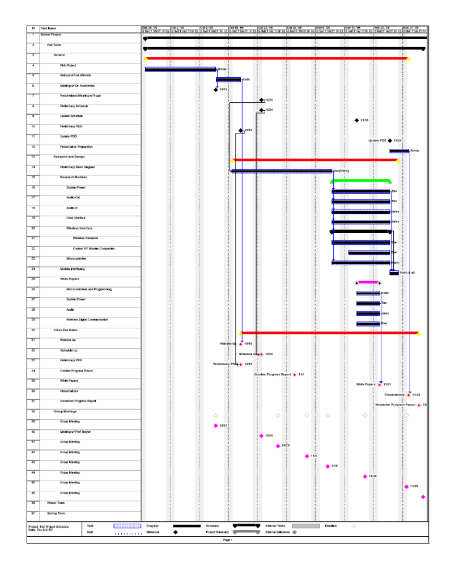
Appendix Figure 1: Fall term schedule
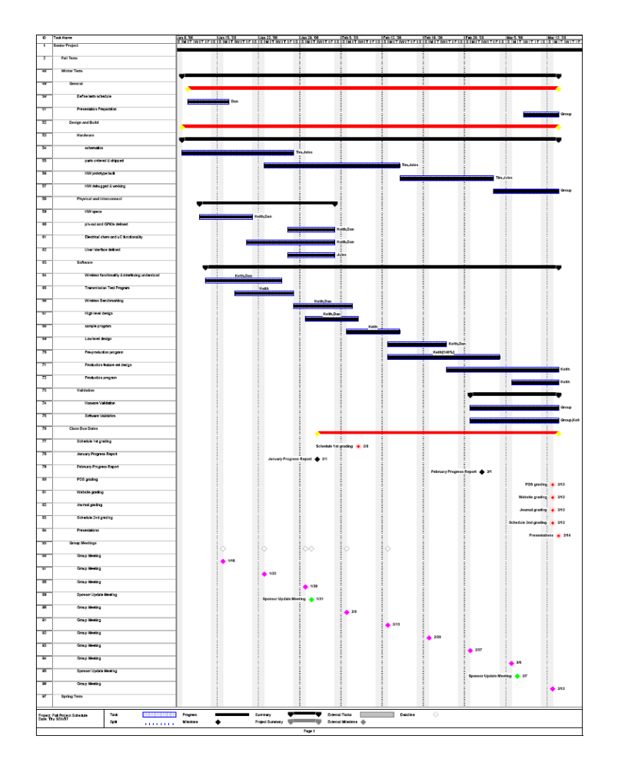
Appendix Figure 2: Winter term schedule

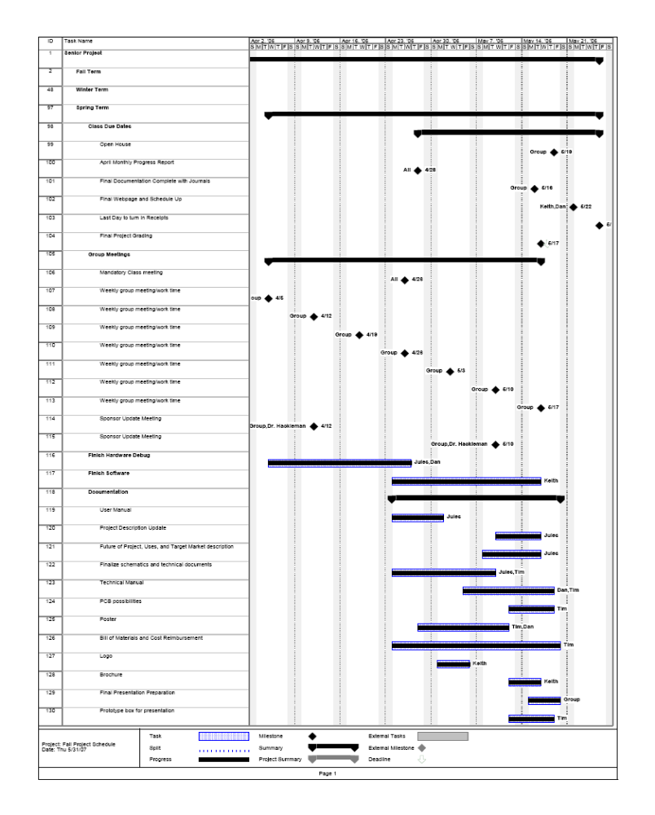
Appendix Figure 3: Spring term schedule


Appendix Figure 4: Brochure outside
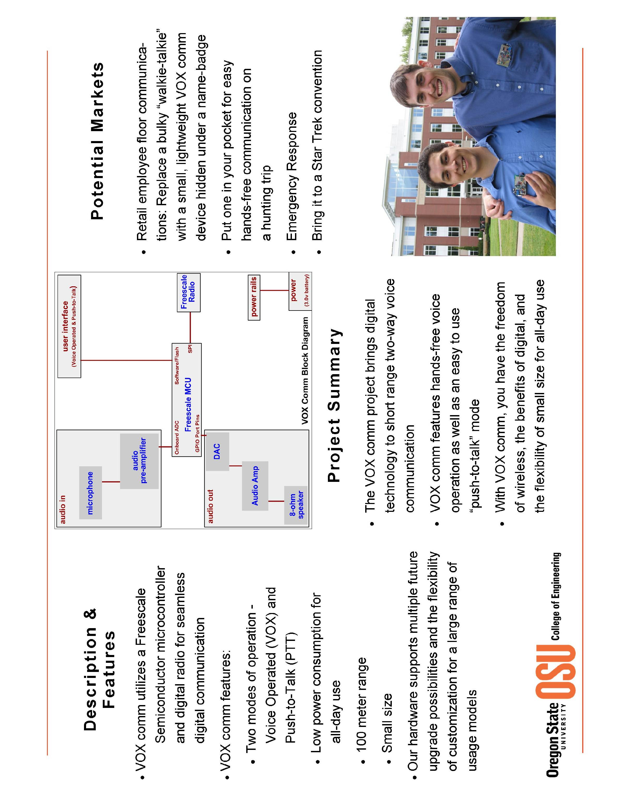
Appendix Figure 5: Brochure inside

