AN ABSTRACT OF THE THESIS OF

Matthew Wenning for the degree of Baccalaureate of Science in Bioresource Research, Toxicology Option, presented on September 21st, 2007.
Title: Developing the Zebrafish (Danio rerio) As a Model to Evaluate the Toxicity of Chlorinated and Non-Chlorinated Solvents

Abstract approved:
________________________________________________________________________
Robert L. Tanguay Ph.D., Department of Environmental and Molecular Toxicology

Chlorinated and non-chlorinated solvents are used in a variety of industrial processes and as a consequence, they have become environmental contaminants as well. Because of this, they lead to both occupational and environmental exposures. Exposure to these compounds can potentially result in various forms of neurological damage with a wide array of possible mechanisms that are responsible for the resulting neurological deficit. Previous models employed to evaluate these compounds have been the rodent model or studying humans who have been continuously exposed via their occupation. However, these models have their disadvantages so other models need to be explored as possible alternatives to investigate these chemicals. One such model that has been proposed to meet this challenge is the zebrafish (Danio rerio). The zebrafish provides numerous advantages over the other models that have been used in previous research and this project utilized these advantages to study these solvents. The purpose of this study was to determine the validity of the zebrafish as a model to investigate the toxic properties of these solvents. In this study we conducted experiments where zebrafish embryos and adults were exposed to waterborne concentrations of varying concentration and different lengths of time looking at both lethal and sub-lethal effects. We evaluated two chlorinated solvents and three non-chlorinated solvents. All but one of the solvents, 1,2-diacetylbenzene (1,2-DAB), were found to be toxic only at high concentrations.

© Copyright by Matthew Wenning
September 21st, 2007
All Rights Reserved
Developing the Zebrafish (Danio rerio) As a Model to Evaluate the Toxicity of Chlorinated and Non-Chlorinated Solvents

By
Matthew Wenning

A THESIS

Submitted to

Oregon State University

Bioresource Research

In partial fulfillment of
the requirements for the
degree of

Baccalaureate of Science in Bioresource Research,
Toxicology

Presented September 21st, 2007
Baccalaureate of Science in Bioresource Research, Toxicology
Thesis of Matthew Wenning
Presented on September 21st, 2007

APPROVED:

Robert L. Tanguay Ph.D., Mentor, Department of Environmental and Molecular Toxicology

David E. Williams Ph.D., Committee Member, Department of Environmental and Molecular Toxicology

Katharine G. Field Ph.D., Director of Bioresource Research, Department of Microbiology

I understand that my project will become part of the permanent collection of Oregon State University, Bioresource Research. My signature below authorizes release of my project and thesis to any reader upon request.

Matthew Wenning, Author Date
ACKNOWLEDGEMENTS

I am sincerely grateful to Dr. Robert L. Tanguay for mentoring me throughout the project, to Ms. Jane La Du for her technical assistance, and to the rest of the people in the Tanguay laboratory for their support. I would like to thank Dr. Katharine G. Field and Dr. David E. Williams for serving as members on my committee. I would thank Ms. Demaris Garceau M.A. for contributing so much of her time to help me write this paper. I am also especially appreciative of Ms. Wanda Crannell M.S. for devoting her time and energy in helping me achieve my successful completion of Oregon State University’s Bioresource Research (BRR) Bachelor’s of Science degree. I would also like to thank my family and friends who have supported me, thereby allowing me to me meet the demands of my academic career throughout this whole process.
TABLE OF CONTENTS

Section | Page
1. Introduction…………………………………………………………………. | 1
1.1 Chlorinated Solvents....................................................................................... | 2
1.2 Non-Chlorinated Solvents............................................................................... | 4
1.3 The Model....................................................................................................... | 6
2. Methods and Materials……………………………………........................... | 7
2.1 The Water........................................................................................................ | 7
2.2 The Animals.................................................................................................... | 8
2.2a The Adults..................................................................................................... | 8
2.2b The Embryos................................................................................................. | 10
2.3 The Chemicals................................................................................................. | 10
2.4 Embryo Exposures.......................................................................................... | 11
2.4a Embryo Exposures to Trichloroethylene (TCE)........................................... | 11
2.4b Embryo Exposures to Dichloroacetic Acid (DCA)....................................... | 11
2.4c Embryo Exposures to 2,5-Hexanedione (2,5-HD)........................................ | 11
2.4d Embryo Exposures to 1,2-Diacetylbenzene (1,2-DAB)................................ | 12
2.4e Embryo Exposures to 1,3-Diacetylbenzene (1,3-DAB)................................ | 12
2.5 Adult Exposures to 1,2-Diacetylbenzene (1,2-DAB)..................................... | 12
3. Results……………………………………………………………………….. | 13
3.1 Trichloroethylene (TCE)................................................................................. | 13
3.2 Dichloroacetic Acid (DCA)............................................................................ | 14
3.3 2.5-Hexanedione (2,5-HD)............................................................................. | 15
3.4 1,2-Diacetylbenzene and 1,3-Diacetylbenzene Embryo Data......................... | 17
3.5 1,2-Diacetylbenzene (1,2-DAB) Embryo Data............................................... | 18
3.6 1,2-Diacetylbenzene (1,2-DAB) Adult Data.................................................. | 19
4. Discussion……………………………………………………………………. | 20
5. Bibliography.................................................................................................... | 24

1. Introduction

The use of both chlorinated and non-chlorinated solvents in various industries has led to occupational hazards as well as environmental contamination. The purpose of this project is to determine the developmental neurotoxicity of chlorinated and non-chlorinated solvents using the zebrafish as a model. While these compounds have been tested for their toxicity in other animal models and in humans, the use of the zebrafish is being explored because of some advantages it has over other models, particularly in developmental studies. A major advantage is that the embryo is transparent, which allows for easy evaluations of toxic effects in the early stages of development. Another advantage of using this model is that in the early stages of development the processes are the same, or similar, in all vertebrates, so if we can establish a deleterious effect at a specific stage of development in the zebrafish, then we can say that effect is likely be seen in humans as well. This then allows us to make decisions regarding the regulation of that particular compound. This study was conducted as a screening process first to see if any toxic effects could be observed and secondly, to determine what concentrations were required to produce the effects if they did occur. If no effect was observed, that would allow us to say that for this particular compound the zebrafish is not an appropriate model to use for a toxicological study. That would not mean that the compound has no toxicity, only that the zebrafish should not be used to investigate the toxic properties of that compound. If, however, there is a toxic effect, we could then determine what concentrations were required to produce these effects and compare them to concentrations that we know occur in the workplace or out in the environment. If these concentrations were substantially higher than those that occur in the workplace or in the environment then we could say that although there are toxic effects associated with the compound, they are not high enough to be of concern and that it is not necessary to spend the money needed to conduct a study investigating it.

1.1 Chlorinated Solvents
Trichloroethylene (TCE) is a major Superfund contaminant that occupies position #16 in the ATSDR 2005 Priority List of Hazardous Substances. This compound is one of the most used industrial organic solvents and is widely distributed in surface water, rainwater, well water and drinking water from various sources. Given its widespread use in occupational settings, significant information is available on the acute toxicity of TCE. However, little information exists on the neurotoxic effects of chronic exposure in humans and animal models, particularly at lower concentrations.
Acute exposure to high levels of TCE in humans has been associated with cranial nerve damage and residual neurological deficits. There are also reports that intermediate chronic exposure in the workplace has been associated with damage to the cranial nerves in several cases [1-3]. Cranial neuropathy is characterized by facial numbness, jaw weakness and facial discomfort (indicating damage to cranial nerves V and VII), which can persist for several months [4, 5]. Other reported effects of intermediate chronic exposure include memory loss [6, 7], mood swings [2, 8], trigeminal neuropathy [2, 7, 9, 10], cranial nerve VII damage and decreased psychomotor function [11], and impaired acoustic-motor function [12]. Among the human studies, Ruijten and coworkers demonstrate changes in trigeminal nerve function [13]. These findings correspond to reports of trigeminal and cranial nerve damage at shorter-duration exposure to high concentration of TCE. In addition, this study noted slight reductions in the sensory nerve conduction velocity and sensory refractory period of the sural nerve, consistent with preclinical peripheral neuropathy and with corresponding reports from experimental studies. The report by Rasmussen found a highly significant dose-response relationship between solvent exposure and clinical signs of motor dyscoordination in a historical cohort study of metal degreasers with TCE exposure. Although no significant cranial nerve dysfunction was found, histologically verified symmetrical sensory-motor peripheral neuropathy was reported [14]. In contrast to these studies, some reports suggest that the neuropathic effects of TCE appear to be specific to the trigeminal nerves, facial nerves [15], olfactory nerves [14], rather than generalized [9, 16]. For instance, chronic exposure to TCE resulted in no change in conduction velocity measured in the radial and ulnar nerves [17]. Sympathetic nerve activity, as measured by changes in serum dopamine-β-hydroxylase activity, was normal in workers exposed to TCE of about 22ppm [18].
Consistent with reports in humans, signs of neurotoxicity and neuropathology in rats have also been observed in response to high doses of TCE. Exposures of 10 weeks (5 days/week) to 2500 mg/kg/day TCE orally resulted in altered myelin thickness in the rat mental nerve, a branch of the trigeminal nerve [19]. Effects of similar exposures on the rat trigeminal nerve included decreased fiber diameter and altered fatty acid composition in total lipid extracts, indicative of demyelination, but without conclusive evidence of axonal degeneration [20]. Some experimental studies claimed that low level of TCE exposure might produce abnormalities of the blink reflex, a good measure for detection of subclinical intoxication [9]. However, this is not supported by other human studies [21, 22]. To date, few experimental studies examining the effects of chronic exposure to TCE have been reported.
As the current literature indicates, TCE has a wide array of effects on the nervous system that may involve different mechanisms of action. For instance, the neurotoxicity of TCE may be mediated by peroxidation of cell membrane lipids [23] or by specific effects on regulation of membrane fatty acid composition [24]. The effect of TCE may also result from disturbed physical and chemical properties of nerve membrane [25], or from an increase in the activity in one or more of the phosphoinositide-linked neurotransmitter systems [26]. Animal studies clearly indicate that administration of TCE produces a loss of myelin in the brain stem, affects myelin sheaths in the temporal and occipital cortex as well as in the spinal cord [27], and modifies lipid content of the trigeminal nerve [20]. Although the detailed mechanism underlying TCE peripheral neuropathy is still not clear, a role was noted for the TCE metabolite such as dichloroacetic acid (DCA) in eliciting these effects.
Cytochrome P450 (CYP) 2El was the most important isozyme involved in metabolizing TCE to chloral hydrate in rat liver [28]. Consistent with this finding, Lipscomb and colleagues studied the P450-dependent metabolism of TCE in hepatic microsomal fractions from 23 humans. They conclude that CYP2El was the predominant form responsible for the metabolism of TCE and the human variability in metabolism of TCE via P450-dependent pathways was within a 10-fold range, which might explain the susceptibility of human exposure [29]. The principal metabolites of TCE in humans and rodents are conjugated trichloroethanol, trichloroethanol and trichloroacetic acid (TCA) [30-33]. Minor urinary metabolites are monochloroacetic acid [34] and DCA [35]. DCA is also formed as a by-product during the chlorine disinfection process of drinking water. Studies on the neurotoxicity of DCA in humans have demonstrated a strongly supported association between DCA exposure and distal symmetrical peripheral neuropathy [36].
Viewed together, existing human and animal studies suggest a highly possible association between TCE exposure and peripheral neuropathy. However, current information collected from human populations is not convincing because it often relies on estimated rather than actual concentrations of exposure, making it difficult to evaluate risk to health. In addition, much of the literature related to TCE exposure in humans also includes discussions of exposures to mixtures of solvents, so it is difficult to evaluate the specific contribution of TCE and its metabolites to health outcomes. This study will help determine whether or not the zebrafish is a valid model to help assess the effects of these chlorinated solvents, by comparing the data collected with the existing data gathered from other studies in other animal models.

1.2 Non-Chlorinated Solvents
Non-chlorinated aliphatic solvents with neurotoxic potential (n-hexane or 2-hexanone) are found in >17% of EPA’s National Priorities List sites, where airborne and skin exposure are potential routes of entry into the human body. Prolonged exposure to n-hexane produces a characteristic peripheral neuropathy associated with distal, retrograde degeneration of long and large sensory and motor axons in peripheral nerves and spinal cord (central-peripheral distal axonopathy). The neuropathological hallmarks of aliphatic hexacarbon neuropathy include axonal atrophy, focal axonal swellings filled with neurofilaments, paranodal demyelination and remyelination and wallerian-like degeneration [37-40].
The neurotoxic mechanism of n-hexane has been extensively studied since the first major outbreaks of human neuropathy in the early 1970s. Although hypotheses have been proposed to explain this phenomenon and many aspects of the mechanism have been clarified, the molecular determinants and pathological significance of axonal degeneration remain unclear [41]. Mechanistic hypotheses on n-hexane neuropathy generally fall into two categories: those that propose neurofilament protein polymerization and cross-linking as the critical target site [42-44] and those that suggest direct effects on other axonal components such as microtubule-associated proteins and motor proteins, or metabolic process and enzymes involved in supplying energy for the axonal transport [45-47]. There is, however, general agreement that neurotoxicity is dependent upon metabolism of n-hexane or 2-hexanone to 2,5-hexanedione (2,5-HD), a γ-diketone that reacts with neuroproteins resulting in axonal degeneration in the CNS and PNS [37, 41, 48, 49].
Cytochrome (CYP) P450 enzymes are known to be involved in several steps of n-hexane biotransformation. n-Hexane is hydroxylated at different positions of carbon atoms by P450 isozymes such as CYP1A1 and 1A2, and is metabolized to 1- or 3-hexanol, 4,5-dihydroxyl-2-hexanone and other compounds. This leads to detoxification [50, 51]. The proximal neurotoxic metabolite, 2,5-HD, is formed via sequential hydroxylation at the 2- and 5-positions by CYP2E1 and 2B [51-53], followed by oxidation of the hydroxyl function by alcohol dehydrogenase [54]. Continuously daily n-hexane treatment resulted in an increased urinary level of 2,5-HD in wild type mice but not in 2E1-/- mice [55]. Pretreatment with the inducer of CYP2E1 increased 2,5-HD formation in rats administered n-hexane [56], suggesting that CYP2E1 is the predominant P450 responsible for the biotransformation of n-hexane to 2,5-HD.
Although occupational exposure is a major risk factor for n-hexane peripheral neuropathy [57], epidemiological studies have shown that only a small fraction of workers exposed to n-hexane develop neuropathy. This raises the possibility that genetic factors such as variations in metabolic genes for n-hexane are involved in the developing of n-hexane neuropathy [58]. Consistent with this hypothesis, a recent epidemiological study from China suggests that CYP2E1 gene polymorphism might modulate susceptibility to n-hexane-induced peripheral nerve damage [59].
Non-chlorinated aromatic hydrocarbon solvents such as 1,2-diethylbenzene (1,2-DEB) and certain related aromatic compounds are also commonly found at Superfund sites with an undefined health hazard. These compounds cause electrophysiological changes consistent with sensory-motor neuropathy in rodents, but the underlying mechanisms and pathogenesis are unclear. Recent studies show that 1,2-diacetylbenzene (1,2-DAB), a metabolite of the aromatic solvent 1,2-DEB, is a γ-diketone with high neurotoxic potency [60]. Rats treated with 1,2-DAB develop limb weakness and exhibit more proximal but otherwise similar motor and sensory nerve damage to 2,5-HD. By contrast, the non-protein reactive isomers of these agents, 1,3-DAB and 2,3-HD, lack neurotoxic properties [48, 60].

1.3 The Model
Numerous biological models have been employed for toxicological evaluations. In vitro techniques, such as cell culture, are often preferred because they are both cost- and time-efficient. While these studies are useful, direct translation to a human health risk is often difficult to infer. In vivo (whole animal) studies, on the other hand, can provide improved prediction of the biological response in intact systems. However, these studies often employ rodent models which make assessments expensive, time-consuming and require extensive facilities for housing experimental animals. Cost, labor, time and infrastructure requirements can be significantly reduced by replacing traditional rodent models with the zebrafish model. Cost savings are complimented by inherent advantages of the zebrafish model for mechanistic and hypothesis-driven research that could prove to be an essential part of an overall integrated approach to evaluate solvent toxicity. Like many models, much of the anatomy and physiology of fish is highly homologous to humans [61, 62]. Zebrafish are well-established as a model for studying developmental biology and wound-healing, as well as for toxicity and efficacy screening of chemicals, pharmaceuticals and pesticides [63-72]. A remarkable similarity in cellular structure, signaling processes, anatomy and physiology exists among zebrafish and other high-order vertebrates [62, 73-77]. Zebrafish possess all of the classical sense modalities, including vision, olfaction, taste, touch, balance and hearing; and their sensory pathways share an overall homology with humans. Cognitive behavioral tests suggest that anatomic substrates of cognitive behavior are also conserved between fish and other vertebrates. Thus, similar to observations of hippocampus lesions in mammals, lesions of the structural homolog of the hippocampus in fish selectively impair spatial memory [78].
A major advantage of zebrafish is that the embryos develop externally and are optically transparent. Thus, using simple microscopic techniques, it is possible to resolve individual cells in vivo across a broad range of developmental stages or throughout the duration of an experimental exposure. Resolution of specific cell populations can be increased by using transgenic zebrafish models that express fluorescent reporter genes in cell types of interest [79, 80]. Several additional features of zebrafish biology, including small size, rapid embryonic development and short life cycle (reviewed in [62, 81, 82]) make this model system logistically attractive to rapidly evaluate environmental-biological interactions. Females produce hundreds of eggs weekly, so large sample sizes are easily achieved for statistically powerful dose-response studies [83]. This abundant supply of embryos also makes it possible to simultaneously assess the toxicity of a large number of chemicals in a short period of time. Such features also make genetic screens feasible for identifying genes and pathways that are involved in creating biological responses to solvent exposure [84-86]. High throughput chemical screens have proven feasible in zebrafish and have been used to effectively identify novel developmentally active small molecules [64, 87-89]. Finally, assay volumes using the zebrafish model are small; thus, only limited amounts of chemicals are needed to assess solvent-biological interactions.

2. Methods and Materials
2.1 The Water
Water for the lab undergoes filtration by reverse osmosis. Once the water has been filtered Instant Ocean (Aquarium Systems, Mentor, Oh.) is added until the conductivity reaches 500µS ± 50µS. The water is maintained at pH 7.2 ± 1 and stored at 25 ºC. Water that is referred to as system water from this point on will be water that has been through this treatment and meets the criteria that has been described in this section. Differences in any of these parameters will be mentioned when appropriate.

2.2 The Animals
This study involved experiments using both adult zebrafish and zebrafish embryos. These animals were raised and reared in compliance with the Institutional Animal Care and Use Committee guidelines at Oregon State University.

2.2a Adults
Adult zebrafish were kept in a 2.0L polycarbonate tank (Fig. 2.1) and these tanks were on a recirculating system (Fig. 2.2) utilizing system water with the temperature maintained at 29 ºC ± 1.5 ºC and pH 7.2 ±1. The fish were fed two times daily, once with flake food (prepared in the lab) in the morning, and once with brine shrimp (INVE Aquaculture Systems, Salt Lake City, Ut.) in the afternoon.
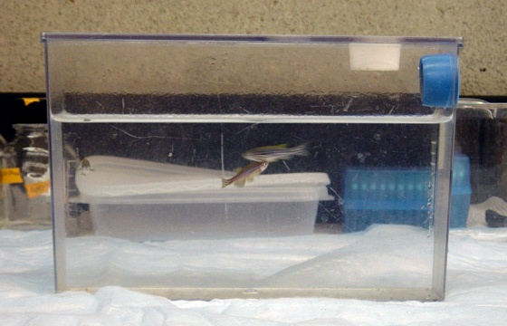
Figure 2.1. 2.0 L polycarbonate tank with an anti-jumper (white piece) and a overflow piece with wire-mesh (blue piece) to keep fish inside tank.
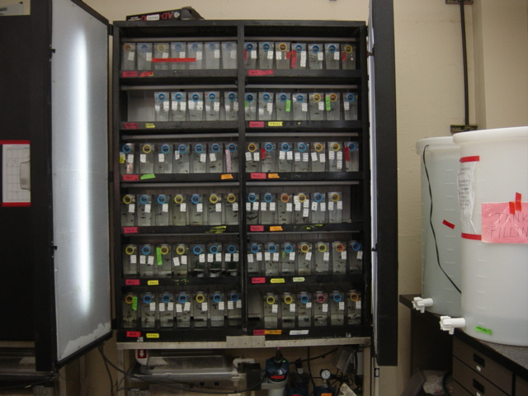
Figure 2.2. Fish in polycarbonate tanks placed on the Z-mod system with recirculating water.

Adults used for spawning were transferred to a clean polycarbonate tank. Inside the tank was a polycarbonate basket that had a wire mesh bottom (Fig. 2.3) and a piece of nylon mesh (Fig. 2.4) inside of it. This is placed on top of two pieces of plastic mesh (Fig. 2.5) and two anti-jumpers (Fig. 2.6). The spawning setup (Fig. 2.7) is done 15–17 hours prior to the time the exposure is to begin. Once set up for spawning the tanks were placed back on the recirculating system (Fig. 2.2). Spawning adults were not fed again until after embryos were collected.
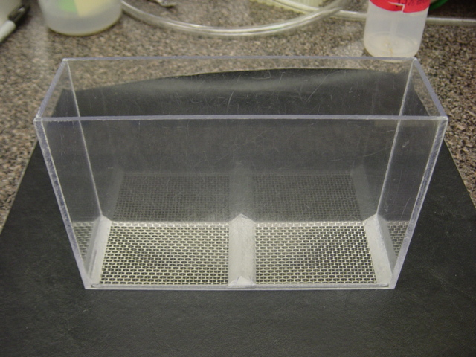
Figure 2.3. Polycarbonate basket with wire-mesh bottom.
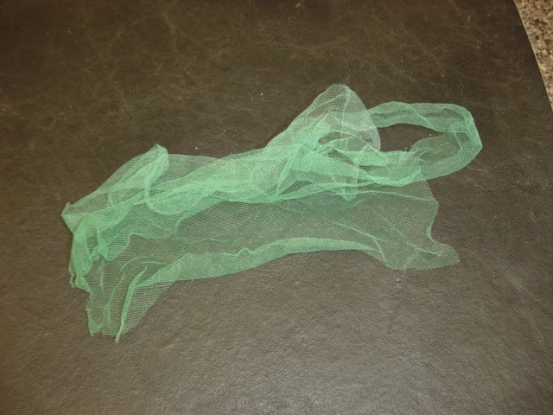
Figure 2.4. Nylon mesh for fish to hide in.

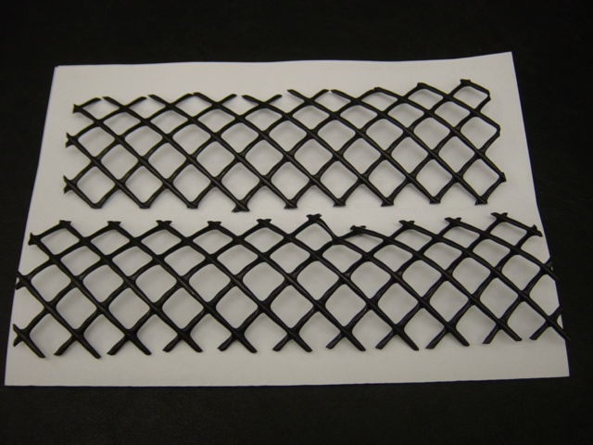
Figure 2.5. Plastic mesh pieces
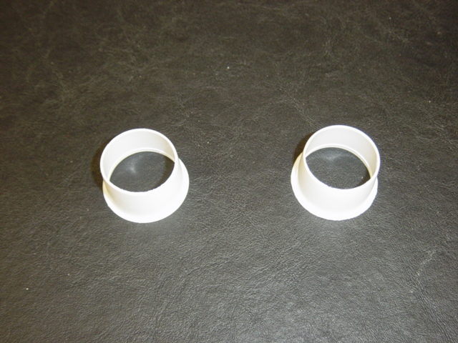
Figure 2.6. Anti-jumpers

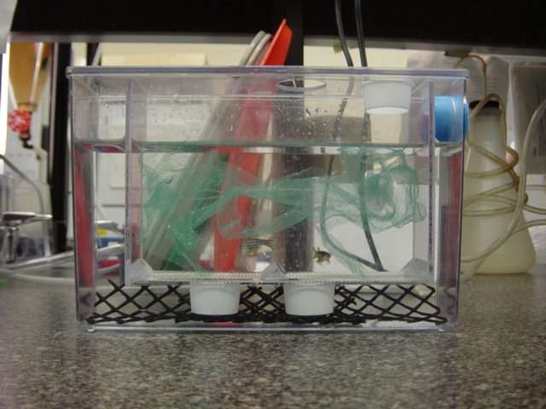
Figure 2.7. Spawning setup with wire-mesh bottom polycarbonate basket containing fish and nylon mesh placed inside 2.0 L polycarbonate tank plastic on top of two anti-jumpers which are placed on top of plastic mesh pieces.

2.2b Embryos
Embryos were collected at 6-8 hours post fertilization (hpf). Embryos collected for exposures were poured out of the tank through a fine mesh screen, rinsed with system water and then placed in a 150x25mm petri dish containing water. A visual inspection was then conducted to separate viable embryos from non-viable embryos. Embryos were determined as viable by looking at the color. If the embryo’s corion was transparent and the yolk was yellow in color then it was deemed viable. Embryos were deemed non-viable if the corion was cloudy in appearance or the yolk was darkened appearing brown to black in color. Non-viable embryos were discarded. After embryos were selected for an exposure they remained in the petri dish and were placed on an incubating plate at 29ºC ± 1 until they were transferred to a 96-well plate (Becton Dickinson Labware, Franklin Lakes, N.J.)(Fig. 2.8).
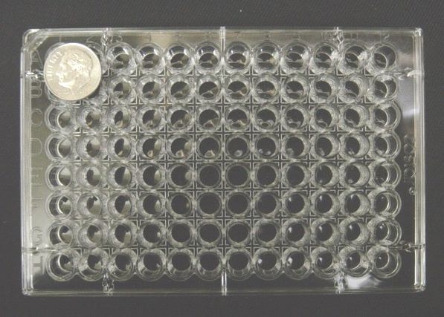
Figure 2.8. Becton Dickinson 96-well plate

2.3 Chemicals
10M trichloroethylene (TCE), 12M dichloroacetic acid (DCA), and 8.35M 2,5-hexanedione (2,5-HD) were generously provided by Dr. Peter Spencer of the Center for Research on Occupational and Environmental Toxicology (CROET) at the Oregon Health and Science University (OHSU) in Portland, Oregon. All chemicals provided by Dr. Spencer were 98% pure or higher. The chemicals 1,2-diacetylbenzene (1,2-DAB) and 1,3-diacetylbenzene (1,3-DAB) were provided in crystal form, 3-aminobenzoate ethyl ester methanesulfonate salt (tricaine) was provided as a powder, dimethylsulfoxide (DMSO) was provided as a pure liquid and were purchased through Sigma-Aldrich Company (St. Louis, Mo.). Sodium hydroxide was purchased in crystal form from Fisher Scientific (Fair Lawn, N.J.)

2.4 Embryo Exposures
All exposures were set up with 24 embryos exposed at each concentration evaluated, in solution volumes of 100 µl and one embryo per well. A control group of 24 was also used in each trial. For all exposures the statistical data collected for this project was based on percent mortality at 48- or 72-hpf, depending on the chemical being investigated. Standard deviation was calculated with Sigma Plot.

2.4a Trichloroethylene (TCE)
10M TCE (Spencer) was diluted to 1M. A series of serial dilutions starting with the 1M stock were performed to make exposure solutions of 10.0mM, 1.0mM, 0.1mM, 0.01mM and 0.001mM concentrations. DMSO was required to solvate the TCE so the exposures were also 0.1% DMSO. The control group consisted of 24 embryos evaluated in a 0.1% solution of DMSO. The exposures were terminated at 48hpf.

2.4b Dichloroacetic acid (DCA)
12.0M. DCA (Spencer) was diluted in system water to make exposure solutions of 100.0mM, 10.0mM and 1.0mM. The DCA solution was neutralized using NaOH and the pH was raised to 7.0-7.5. The exposures were terminated at 48hpf. DMSO was not used to solvate the DCA so the control group consisted of 24 individuals with one individual exposed in 100 µL of system water per well. The exposures were terminated at 48hpf.

2.4c 2,5-Hexanedione (2,5-HD)
8.35M. 2,5-HD (Spencer) was diluted to 100mM and then a series of serial dilutions was performed to make exposure solutions of 100.0mM, 10.0mM, and 1.0mM. DMSO was not required to solvate the 2,5-HD. The control group consisted of 24 individuals with one individual exposed in 100 µL of system water per well. The exposures were terminated at 48hpf.

2.4 d 1,2-Diacetylbenzene (1,2-DAB)
An initial stock solution was prepared at 2000 parts per billion (ppb) from dissolved crystals. A set of serial dilutions was then performed with a dilution factor of 50 % with each consecutive dilution. The concentration range was from 62.5 ppb – 500 ppb. The final dosing solution at each concentration was also 0.1 % DMSO. A 0.1 % DMSO solution served as the control group concentration.

2.4e 1,3-Diacetylbenzene (1,3-DAB)
An initial stock solution was prepared at 2000 ppb and then a set of serial dilutions was performed with a dilution factor of 50 % with each consecutive dilution. The concentration range was from 62.5 ppb – 500 ppb. The final dosing solution at each concentration was also 0.1% DMSO. A 0.1 % DMSO solution was used as the control group concentration.

2.5 Adult Exposures to 1,2-Diacetylbenzene
The adults in this study were exposed to 1,2-DAB in two trials at concentrations of 100 ppb and 1000 ppb for 52 days and 6 days respectively. The final dosing solution was also 0.1 % DMSO. The control group was exposed in a 0.1 % DMSO solution. Each trial contained eight fish total. For each trial, four fish served as a control group and four fish served as the exposure group. Each fish was placed in its own plastic tank with a wire-mesh bottom (Fig. 2.9) that was placed inside another plastic tank with 600 ml of control solution or dosing solution (Fig. 2.10).
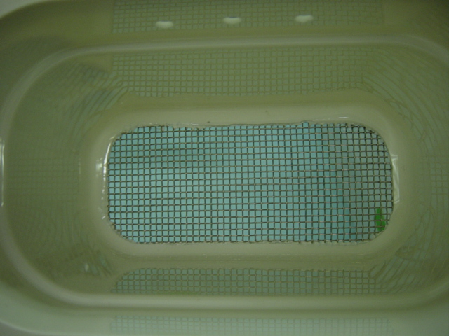
Figure 2.9. Top view of tub with wire-mesh bottom which houses the fish.
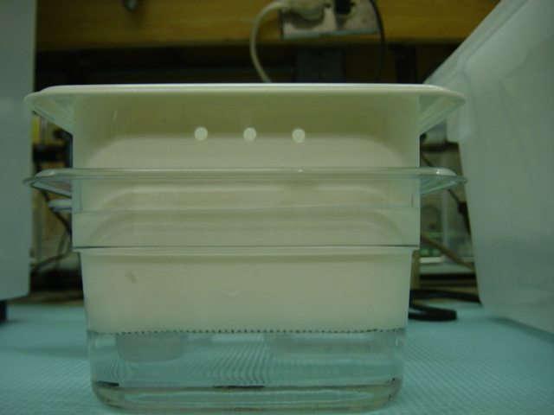
Figure 2.10. Side view of tub with wire-mesh bottom placed inside second tank which contains the dosing solution.
This allowed for changing the water with minimal stress on the animal as it was transferred from one tank to another. Both the control and the dosing solutions were changed daily throughout each trial. Each day an new batch of both dosing and control solutions were prepared 3000 ml at a time using system water maintained at 29 ºC ± 1º in an incubator. After the water change was completed a plastic lid was placed over the individual tank and then it was placed back into the larger tub containing all eight of the tanks (fig. 2.11). A lid was then also placed over the large tub to help prevent water loss due to evaporation (fig. 2.12). In each trial, all eight tanks of fish were placed in a larger tub filled with water maintained at 29 ºC ± 1º with a water heating element. An air hose with a continual stream of air was also placed in the tank to help maintain an even water temperature throughout the tub.
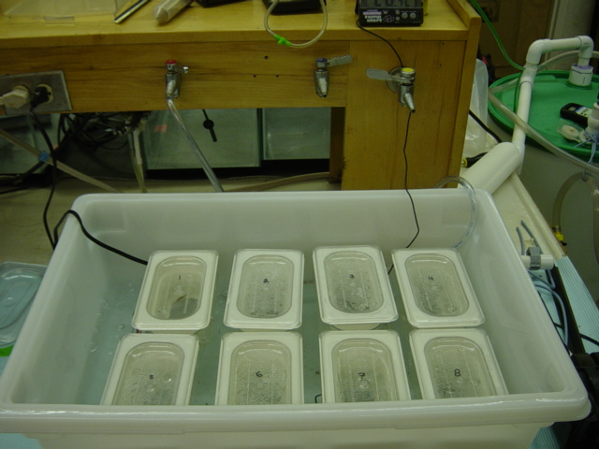
Figure 2.11. Smaller tubs with one fish per tub placed in larger tub with water, a heating element and air hose to maintain an even temperature throughout the water in the tub.
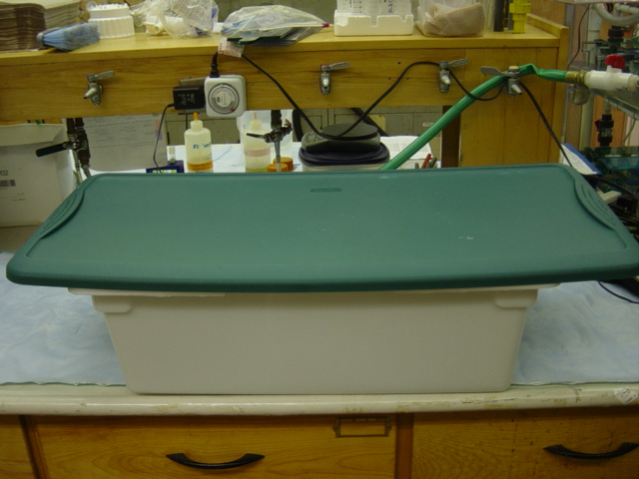
Figure 2.12. Large tub with a lid placed over it to help reduce water loss due to evaporation.

3. Results

3.1 Trichloroethylene (TCE)
In order to determine the toxicity of TCE in developing zebrafish, embryos were exposed to TCE solutions at concentrations between 0.0mM and 100mM. There was no significant difference in the mortality between any of the exposure groups observed (Fig. 3.1). Embryos exposed to TCE at concentrations of 0.10 mM and higher also exhibited yolk sac edema, a sub-lethal effect. These results indicate that TCE, while it is not 100% lethal at concentrations as high as 10mM, it is toxic to zebrafish in the early stages of development.
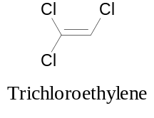
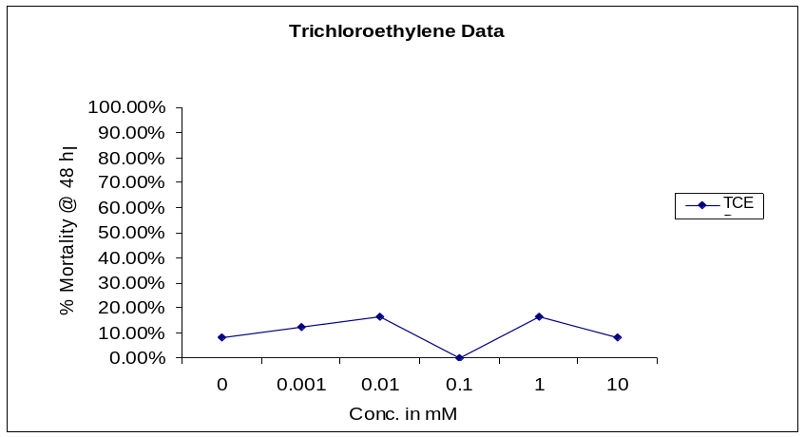
Figure 3.1. Individual embryos were exposed at the indicated concentrations with 24 embryos per concentration. Percent mortality was observed at 48 hpf.

3.2 Dichloroacetic Acid (DCA)
Dichloroacetic acid (DCA) is a major metabolite of trichloroethylene (TCE). Zebrafish embryos were exposed to DCA at concentrations between 1.0mM and 100.0mM. There were no overt signs of toxicity at concentrations between 1mM and 10mM (Fig. 3.2). However, at 100mM there was an increase in embryonic mortality indicating that DCA is toxic only at high concentrations. Embryos at the 100.0mM concentration showed pericardial edema. While embryos in the control group had a normally inflated swim bladder, those in the 100.0 mM exposure group did not (Fig. 3.3).
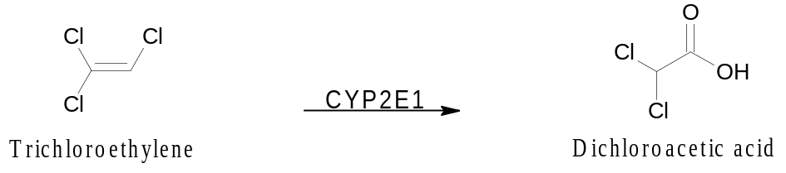
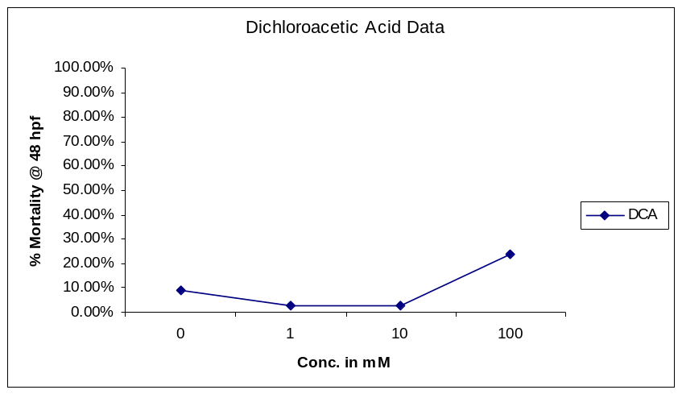
Figure 3.2. Individual embryos were exposed at the indicated concentrations with 24 embryos per concentration. Percent mortality was observed at 48 hpf.

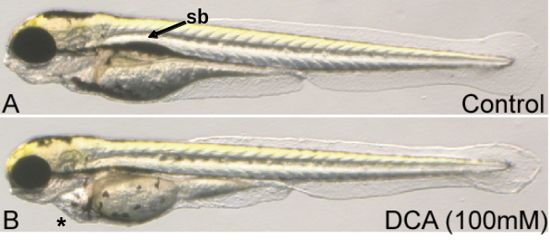
Figure 3.3. Representative images of (A) control and (B) 100 mM DCA exposed embryos. The DCA exposed larva exhibits mild pericardial edema (*) and unlike the control animals the swim bladder (sb) is not inflated.

3.3 2,5-Hexanedione (2,5-HD)
In order to determine the developmental toxicity of 2,5-HD, a metabolite of n-hexane, embryos were exposed at concentrations of 1.0mM, 10.0 mM and 100.0mM. There was no significant difference in results of those exposed at the 1.0 mM and 10.0 mM concentrations with mortality approximately 10% at 48 hpf. We observed that when the concentration was raised from 10mM to 100mM there was a 43 % increase in embryonic mortality.

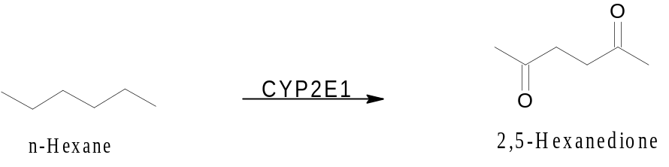
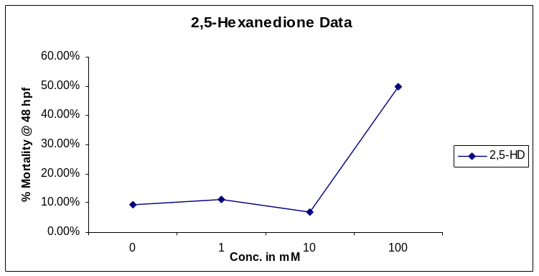
Figure 3.4. Individual embryos were exposed at the indicated concentrations with 24 embryos per concentration. Percent mortality was observed at 48 hpf.
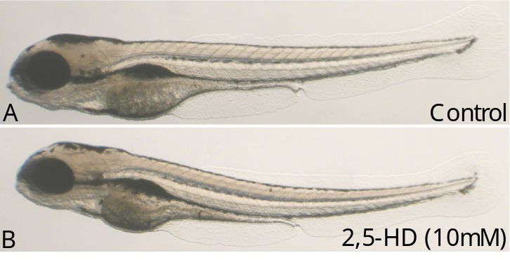
Figure 3.5. Representative images of (A) control and (B) 10 mM 2,5-HD exposed embryos.

3.4 1,2-Diacetylbenzene (1,2-DAB) and 1,3-Diacetylbenzene (1,3-DAB) Embryo Data
Table 3.1. ppb to mM conversions
ppb | mM
40 | 0.00025 = 2.5 x 10⁻⁴
400 | 0.0025 = 2.5 x 10⁻³
4000 | 0.025 = 2.5 x 10⁻²

An initial study was conducted with exposures at 0 ppb, 40 ppb, 400 ppb and 4000 ppb for both 1,2-DAB and 1,3-DAB (For ppb to mM conversions see table 3.1). There was no significant difference between zebrafish exposed at 0, 40 and 400 ppb for both compounds. However, at 4000 ppb 1,2-DAB was shown to be 100 % lethal at 48 hpf. In contrast, the mortality of zebrafish in the 1,3-DAB exposure group at 4000 ppb was only 10 %, indicating that even at very high concentrations the 1,3- isomer is not developmentally toxic to zebrafish (Fig. 3.6).
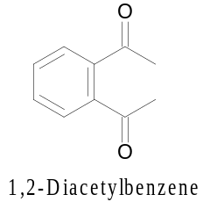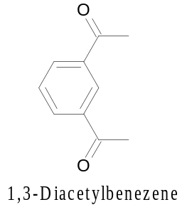

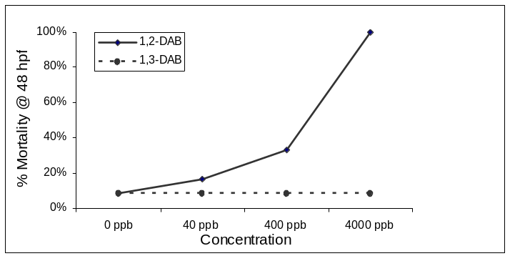
Figure 3.6. 1,2-DAB, but not 1,3-DAB, is developmentally toxic to zebrafish. Cumulative mortality was collected for 2 days (48 hpf). A total of 24 animals were assessed for each chemical.

3.5 1,2-Diacetylbenzene Embryo Data
Table 3.2. ppb to mM conversions
ppb | mM
62.5 | 0.000390625 = 3.9 x 10⁻⁴
125 | 0.00078125 = 7.8 x 10⁻⁴
250 | 0.0015625 = 1.6 x 10⁻³
500 | 0.003125 = 3.1 x 10⁻³

Because results from the initial study established that 1,3-DAB was not developmentally toxic, the compound was not investigated any further. Although there was no significant difference between the zebrafish exposed to 1,2-DAB from 0 ppb to 400 ppb, we observed a marked difference between 400 ppb and 4000 ppb (For ppb to mM conversions see Table 3.1). In order to obtain better information about 1,2-DAB’s toxicity we modified the concentration range of the exposures and tested at 0, 62.5, 125, 250 and 500 ppb (For ppb to mM conversions see Table 3.2) to define a concentration-dependent response curve to 1,2-DAB. There was very little difference in the fish in the control groups to those exposed at 125 ppb but mortality increased by 65 % when the concentration was increased from 125 to 250 ppb, and embryonic mortality was 100 % at 500 ppb (Fig. 3.7).
Embryos exposed to 1,2-DAB exhibited multiple sub-lethal effects from the chemical as well. First was the chromogenic effect, where the embryo had a blue discoloration. Chromogenicity was the first indicator of exposure that could be seen and was observed within 24 hpf at the highest concentration of 500 ppb, and was eventually seen in all of the exposed animals after 72 hpf. This was the first sign that 1,2-DAB was reacting with some component of the zebrafish; however, this was not the primary effect of concern. The effects of greater concern included yolk sac edema, pericardial edema and a decrease in the heart rate of the embryos because this indicates disruption in the developmental process (Fig. 3.8).

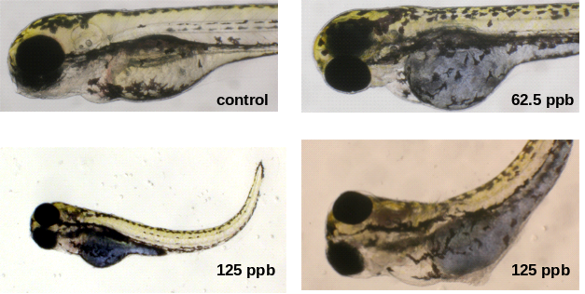
Figure 3.8. 1,2-DAB developmental toxicity. Representative images of a control and 1,2 DAB exposed embryos. Note the development of cardiovascular edema, curved body axis and the characteristic “blue” appearance.
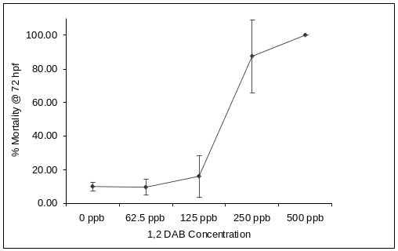
Figure 3.7. 1,2-DAB developmental toxicity. Cumulative mortality was collected for 3 days (72 hpf). A total of 24 animals were assessed for each chemical, and the experiment was repeated 3 times. Error bars represent the standard deviation.

3.6 1,2-Diacetylbenzene Adult Data
Table 3.3. ppb to mM conversions
ppb | mM
100 | 0.000625 = 6.25 x 10⁻⁴
1000 | 0.00625 = 6.25 x 10⁻³

Because most neuronal effects have been observed in adults 1,2-DAB experiments were conducted in adult zebrafish as well. In order to determine if 1,2-DAB exhibited toxicity in adult zebrafish, two trials were performed with adults exposed at 100 ppb (trial 1) and 1000 ppb (trial 2) for 52 and 6 days respectively (For ppb to mM conversions see Table 3.3). Fish were monitored daily and checked for mortality and abnormal behavior. Fish in the first trial were temporarily removed from their exposure tanks and placed in a 10-gallon tank on day-59 of the trial. Fish from the control group were put into a separate tank than those in the exposure group. They were given an hour to acclimate to the new tank and then observations of their behavior were made. Fish that were exposed to the 1,2-DAB exhibited abnormal behavior which included swimming in the corner of the tank and swimming into the glass wall of the tank. The chromogenic effect was also observed in the first adult exposure (Fig. 3.9). We therefore repeated the experiment with a ten-fold increase in the concentration and the effects observed at the lower concentration were also observed at this concentration in a much shorter period of time.

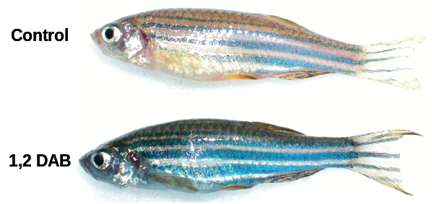
Figure 3.9. Control (top) and 1,2-DAB (bottom) adult fish image three days post exposure. It was a dramatic blue appearance of the 1,2 DAB exposed fish. The appearance of the blue correlated with behavioral and motor deficits.

4. Discussion

The purpose of this study was to determine the developmental neurotoxicity of chlorinated and non-chlorinated solvents using the zebrafish model. Results varied between the five solvents evaluated in this study. These variations can be attributed to the differences in the physical and chemical properties of the solvents themselves. These differences in properties can affect factors such as bioavailability of the compound to the cell and how the compound is metabolized once inside the cell.
We also observed differences in our results compared to those in other animal models previously used to evaluate these compounds. One major difference between the zebrafish model and others used in the past is that in previous studies animals were given a dose. In contrast, the zebrafish is exposed via waterborne concentrations. With a dose, the exact amount of the chemical present in the animal can be quantified by relating the mass of chemical per mass of the organism’s body weight (i.e. µg/kg, mg/kg etc.). Another method of quantifying a dose is by relating the mass of chemical per unit of body surface area such as mg/cm². Previous studies using other animal models have employed various routes of exposure such as putting the chemical in food, by gavage, or by injection therefore making it a dose. However, in this study we exposed zebrafish through waterborne concentrations and therefore quantifying the exact amount of chemical present in the body by relating the mass of chemical per mass of body weight cannot be done.
The primary factor that inhibits our ability to determine the exact amount of the chemical present in the zebrafish is the permeability of the epidermis to a given chemical. Permeability of the epidermis to a chemical will determine the chemical’s ability to enter the zebrafish and therefore it cannot be assumed that the total sample of the chemical in the water is able to enter the zebrafish.
Once the chemical has entered the zebrafish other factors may contribute to the differences in results from other models compared to zebrafish model. One possibility is that the zebrafish is lacking one or more of the enzymes in the metabolic pathway responsible for the detoxification and elimination of the compound or, that it produces the same enzymes, but the enzymes in the zebrafish are structurally different enough from those in other organisms that their actions are not the same. In this study zebrafish embryos and adults were exposed via waterborne concentrations.
Trichloroethylene (TCE) has been shown to display various signs of toxicity in other models such as rodents. Humans who have been exposed to TCE through their occupation have also been studied. Results from these studies show that these effects require doses as high as 2500mg/kg/day in order to be observed [19]. We observed that there was no significant difference in mortality between zebrafish embryos in the control group and those exposed at 10mM. These results are consistent with those from the rodent studies and the studies investigating humans exposed to TCE through their occupation suggesting that TCE is toxic only at high concentrations.
Dichloroacetic acid (DCA) has been identified as a minor urinary metabolite of TCE [35]. Therefore, we conducted experiments testing the neurotoxic effects of DCA in zebrafish. Hassoun and colleagues have shown DCA to produce developmentally toxic effects when administered at high concentrations ranging from 900 to 2400 mg/kg/day in rodents during gestation days 6-15. Exposure resulted in embryonic resorption, reductions in body weight and length, and production of soft tissue malformations, especially those of the cardiovascular system [90]. However, we found that DCA to be developmentally toxic to zebrafish only at high concentrations. These results are consistent with those in the Hassoun study.
Because occupational exposure is a major risk factor for n-hexane peripheral neuropathy [57], it is a chemical of concern. However, we were unable to conduct experiments to evaluate toxicity of n-hexane to zebrafish via waterborne exposures. Due to extremely low solubility of n-hexane in water, 0.000747g/100 ml, we were unable to prepare solutions of n-hexane for waterborne exposures. The proximal neurotoxic metabolite of n-hexane metabolism, 2,5-HD, is formed via sequential hydroxylation at the 2- and 5-positions by CYP2E1 and 2B [51-53], followed by oxidation of the hydroxyl function by alcohol dehydrogenase [54]. We therefore conducted experiments to evaluate the developmental toxicity of 2,5-HD. We found that 2,5-HD is toxic only at high concentrations.
Because we observed no overt signs of toxicity for these compounds we have concluded that the zebrafish is not a suitable model to evaluate them. However, in contrast to the data obtained from the studies evaluating these chemicals, results from the study of 1,2-DAB showed that concentrations much lower than those of the other chemicals resulted in toxic effects making 1,2-DAB a chemical that would be well suited to be studied using the zebrafish model.
Non-chlorinated aromatic solvents can also be found at Superfund sites. Among these solvents are 1,2-diethylbenzene (1,2-DEB) and its structural analog 1,3-DEB but their impacts on health have not yet been established. These compounds are oxidized to 1,2-diacetylbenzene (1,2-DAB) and 1,3-DAB respectively. These metabolites in their oxidized form have been shown to have much higher potency in their neurotoxic effects than their parent compounds in rodent models previously used to evaluate these compounds. It has also been shown that 1,2-DAB, a γ-diketone, has neurotoxic properties. In contrast, 1,3-DAB, a δ-diketone, has been shown to be relatively non-toxic at the same concentrations as its structural analog 1,2-DAB. We therefore conducted experiments to determine if this would be observed in the zebrafish as well. We found that our results were consistent with those in previous studies using different animal models. Rodents treated systemically with 1,2-DAB develop blue discoloration of the skin, eyes, internal organs, including the brain and spinal cord and greenish urine [91] [92]. We observed discoloration in both the embryos and the adults as well in this study. We also observed behavioral changes in the form of erratic swimming. These results are consistent with previous studies and support the need for further investigations into the toxicity of 1,2-DAB. Because 1,2-DAB and 1,3-DAB are structural analogs, they have the same chemical formula, but they differ from each other in their three-dimensional structures. These data indicate that the three-dimensional structure plays a key role in the toxicity of the compound.
This study was a preliminary procedure to determine if any of these solvents would exhibit toxicity either to zebrafish embryos in early stages of development or to adult zebrafish. Therefore, comparing specific details of the various mechanisms of detoxification, elimination and toxicity was not possible. However, because the data from this study has shown that results from our experiments are similar to results using other models in some cases; this provides a justification for using the zebrafish to evaluate these solvents. In the cases where the results were not similar to those in previous studies the methods that will be used with the zebrafish can be modified to better suit the model. Possible modifications could include changing the route of exposure to micro injections when the chemical has low solubility, varying the concentrations, and also varying the length of exposure. In this study we focused primarily on the metabolites of many solvents but future studies should also include an evaluation of the parent compound as well. Future studies should also utilize the advantages of the zebrafish in order to investigate how the chemicals produce their toxicity.
Bibliography

1. Bardodej, Z. and J. Vyskocil, The problem of trichloroethylene in occupational medicine; trichloroethylene metabolism and its effect on the nervous system evaluated as a means of hygienic control. AMA Arch Ind Health, 1956. 13(6): p. 581-92.
2. Barret, L., et al., Chronic trichloroethylene intoxication: a new approach by trigeminal-evoked potentials? Arch Environ Health, 1987. 42(5): p. 297-302.
3. Cavanagh, J.B. and P.H. Buxton, Trichloroethylene cranial neuropathy: is it really a toxic neuropathy or does it activate latent herpes virus? J Neurol Neurosurg Psychiatry, 1989. 52(3): p. 297-303.
4. Buxton, P.H. and M. Hayward, Polyneuritis cranialis associated with industrial trichloroethylene poisoning. J Neurol Neurosurg Psychiatry, 1967. 30(6): p. 511-8.
5. Feldman, R.G., Facial nerve latency studies in man: effects of trichlorethylene intoxication. Electromyography, 1970. 10(1): p. 93-100.
6. Grandjean, E., et al., Investigations into the effects of exposure to trichlorethylene in mechanical engineering. Br J Ind Med, 1955. 12(2): p. 131-42.
7. Smith, G.F., Trichlorethylene: a review. Br J Ind Med, 1966. 23(4): p. 249-62.
8. Milby, T.H., Chronic trichloroethylene intoxication. J Occup Med, 1968. 10(5): p. 252-4.
9. Feldman, R.G., et al., Blink reflex measurement of effects of trichloroethylene exposure on the trigeminal nerve. Muscle Nerve, 1992. 15(4): p. 490-5.
10. Mitchell, A.B. and B.G. Parsons-Smith, Trichloroethylene neuropathy. Br Med J, 1969. 1(5641): p. 422-3.
11. Konietzko, H., [Health hazards of trichloroethylene: an epidemiologic and clinical-experimental study]. Fortschr Med, 1979. 97(14): p. 671-4.
12. Rasmussen, K., H.J. Jeppesen, and S. Sabroe, Psychometric tests for assessment of brain function after solvent exposure. Am J Ind Med, 1993. 24(5): p. 553-65.
13. Ruijten, M.W., M.M. Verberk, and H.J. Salle, Nerve function in workers with long term exposure to trichloroethene. Br J Ind Med, 1991. 48(2): p. 87-92.
14. Rasmussen, K., P. Arlien-Soborg, and S. Sabroe, Clinical neurological findings among metal degreasers exposed to chlorinated solvents. Acta Neurol Scand, 1993. 87(3): p. 200-4.
15. Feldman, R.G., et al., Long-term follow-up after single toxic exposure to trichloroethylene. Am J Ind Med, 1985. 8(2): p. 119-26.
16. White, R.F., et al., Hazardous waste and neurobehavioral effects: a developmental perspective. Environmental Research, 1997. 73(1-2): p. 113-124.
17. Triebig, G., T. Reichenbach, and K.A. Flugel, [Biochemical examinations and measurements of conduction velocity of trichloroethylene exposed persons (author's transl)]. Int Arch Occup Environ Health, 1978. 42(1): p. 31-40.
18. Nagaya, T., N. Ishikawa, and H. Hata, No change in serum dopamine-beta-hydroxylase activity in workers exposed to trichloroethylene. Toxicol Lett, 1990. 54(2-3): p. 221-7.
19. Barret, L., et al., A morphometric evaluation of the effects of trichloroethylene and dichloroacetylene on the rat mental nerve. Preliminary results. Neurosci Lett, 1991. 131(2): p. 141-44.
20. Barret, L., et al., Morphometric and biochemical studies in trigeminal nerve of rat after trichloroethylene or dichloroacetylene oral administration. Neurotoxicology, 1992. 13(3): p. 601-14.
21. Lash, T.L. and L.C. Green, Blink reflex measurement of effects of trichloroethylene exposure on the trigeminal nerve. Muscle Nerve, 1993. 16(2): p. 217-20.
22. Laureno, R., Trichloroethylene does not cause trigeminal neuropathy. Muscle Nerve, 1993. 16(2): p. 217.
23. Cojocel, C., et al., Lipid peroxidation: a possible mechanism of trichloroethylene-induced nephrotoxicity. Toxicology, 1989. 55(1-2): p. 131-41.
24. Kyrklund, T. and K.G. Haglid, Brain lipid changes after organic solvent exposure. Ups J Med Sci Suppl, 1990. 48: p. 267-77.
25. Juntunen, J., Occupational toxicology of trichloroethylene with special reference to neurotoxicity. New Concepts and Developments in Toxicology, ed. P.G. P. L. Chanmers, F. Sakai. 1986, Amsterdam: Elsevier. 189-200.
26. Subramoniam, A., et al., Influence of trichloroethylene treatment on phosphoinositides in rat brain. Toxicol Lett, 1989. 49(1): p. 55-60.
27. Isaacson, L.G., S.A. Spohler, and D.H. Taylor, Trichloroethylene affects learning and decreases myelin in the rat hippocampus. Neurotoxicol Teratol, 1990. 12(4): p. 375-81.
28. Nakajima, T., et al., A comparative study on the contribution of cytochrome P450 isozymes to metabolism of benzene, toluene and trichloroethylene in rat liver. Biochem Pharmacol, 1992. 43(2): p. 251-7.
29. Lipscomb, J.C., C.M. Garrett, and J.E. Snawder, Cytochrome P450-dependent metabolism of trichloroethylene: interindividual differences in humans. Toxicol Appl Pharmacol, 1997. 142(2): p. 311-8.
30. Cole, W.J., R.G. Mitchell, and R.F. Salamonsen, Isolation, characterization and quantitation of chloral hydrate as a transient metabolite of trichloroethylene in man using electron capture gas chromatography and mass fragmentography. J Pharm Pharmacol, 1975. 27(3): p. 167-71.
31. Nomiyama, K. and H. Nomiyama, Metabolism of trichloroethylene in human. Sex difference in urinary excretion of trichloroacetic acid and trichloroethanol. Int Arch Arbeitsmed, 1971. 28(1): p. 37-48.
32. Muller, G., M. Spassovski, and D. Henschler, Metabolism of trichloroethylene in man. II. Pharmacokinetics of metabolites. Arch Toxicol, 1974. 32(4): p. 283-95.
33. Muller, G., M. Spassowski, and D. Henschler, Metabolism of trichloroethylene in man. III. Interaction of trichloroethylene and ethanol. Arch Toxicol, 1975. 33(3): p. 173-89.
34. Soucek, B. and D. Vlachova, Excretion of trichloroethylene metabolites in human urine. Br J Ind Med, 1960. 17: p. 60-4.
35. Dekant, W., M. Metzler, and D. Henschler, Novel metabolites of trichloroethylene through dechlorination reactions in rats, mice and humans. Biochem Pharmacol, 1984. 33(13): p. 2021-7.
36. Kaufmann, P., et al., Dichloroacetate causes toxic neuropathy in MELAS: a randomized, controlled clinical trial. Neurology, 2006. 66(3): p. 324-30.
37. Spencer, P.S., et al., The enlarging view of hexacarbon neurotoxicity. Crit Rev Toxicol, 1980. 7(4): p. 279-356.
38. Spencer, P.S., M.S. Kim, and M.I. Sabri, Aromatic as well as aliphatic hydrocarbon solvent axonopathy. Int J Hyg Environ Health, 2002. 205(1-2): p. 131-6.
39. LoPachin, R.M. and A.P. DeCaprio, gamma-Diketone neuropathy: axon atrophy and the role of cytoskeletal protein adduction. Toxicol Appl Pharmacol, 2004. 199(1): p. 20-34.
40. Lopachin, R.M., et al., Gamma-Diketone central neuropathy: quantitative analyses of cytoskeletal components in myelinated axons of the rat rubrospinal tract. Neurotoxicology, 2005. 26(6): p. 1021-30.
41. DeCaprio, A.P., n-hexane, metabolites and derivatives. Experimental and Clinical Neurotoxicology, ed. H.H.S. P.S. Spencer. 2000, New York: Oxford. 633-648.
42. Graham, D.G., et al., Studies of the molecular pathogenesis of hexane neuropathy. II. Evidence that pyrrole derivatization of lysyl residues leads to protein crosslinking. Toxicol Appl Pharmacol, 1982. 64(3): p. 415-22.
43. Genter St Clair, M.B., et al., Pyrrole oxidation and protein cross-linking as necessary steps in the development of gamma-diketone neuropathy. Chem Res Toxicol, 1988. 1(3): p. 179-85.
44. Pyle, S.J., et al., The role of pyrrole formation in the alteration of neurofilament transport induced during exposure to 2,5-hexanedione. J Neuropathol Exp Neurol, 1992. 51(4): p. 451-8.
45. Sabri, M.I., In vitro effect of n-hexane and its metabolites on selected enzymes in glycolysis, pentose phosphate pathway and citric acid cycle. Brain Res, 1984. 297(1): p. 145-50.
46. Sabri, M.I., C.L. Moore, and P.S. Spencer, Studies on the biochemical basis of distal axonopathies--I. Inhibition of glycolysis by neurotoxic hexacarbon compounds. J Neurochem, 1979. 32(3): p. 683-9.
47. Graham, D.G., Neurotoxicants and the cytoskeleton. Curr Opin Neurol, 1999. 12(6): p. 733-7.
48. Spencer, P.S., M.C. Bischoff, and H.H. Schaumburg, On the specific molecular configuration of neurotoxic aliphatic hexacarbon compounds causing central--peripheral distal axonopathy. Toxicol Appl Pharmacol, 1978. 44(1): p. 17-28.
49. Couri, D. and M. Milks, Toxicity and metabolism of the neurotoxic hexacarbons n-hexane, 2-hexanone, and 2,5-hexanedione. Annu Rev Pharmacol Toxicol, 1982. 22: p. 145-66.
50. Morohashi, K., et al., Position specificity in n-hexane hydroxylation by two forms of cytochrome P-450 in rat liver microsomes. J Biochem (Tokyo), 1983. 93(2): p. 413-9.
51. Toftgard, R., et al., Rat lung and liver microsomal cytochrome P-450 isozymes involved in the hydroxylation of n-hexane. Biochem Pharmacol, 1986. 35(21): p. 3733-8.
52. Crosbie, S.J., P.G. Blain, and F.M. Williams, Metabolism of n-hexane by rat liver and extrahepatic tissues and the effect of cytochrome P-450 inducers. Hum Exp Toxicol, 1997. 16(3): p. 131-7.
53. Jenner, P., Oxidative mechanisms in nigral cell death in Parkinson's disease. Mov Disord, 1998. 13 Suppl 1: p. 24-34.
54. Frommer, U., V. Ullrich, and S. Orrenius, Influence of inducers and inhibitors on the hydroxylation pattern of N-hexane in rat liver microsomes. FEBS Lett, 1974. 41(1): p. 14-6.
55. Iba, M.M., J. Fung, and F.J. Gonzalez, Functional Cyp2e1 is required for substantial in vivo formation of 2,5-hexanedione from n-hexane in the mouse. Arch Toxicol, 2000. 74(10): p. 582-6.
56. Robertson, P., Jr., E.L. White, and J.S. Bus, Effects of methyl ethyl ketone pretreatment on hepatic mixed-function oxidase activity and on in vivo metabolism of n-hexane. Xenobiotica, 1989. 19(7): p. 721-9.
57. Wang, J.D., et al., An outbreak of N-hexane induced polyneuropathy among press proofing workers in Taipei. Am J Ind Med, 1986. 10(2): p. 111-8.
58. Chang, C.M., et al., N-hexane neuropathy in offset printers. J Neurol Neurosurg Psychiatry, 1993. 56(5): p. 538-42.
59. Zhang, Y., et al., Association between metabolic gene polymorphisms and susceptibility to peripheral nerve damage in workers exposed to n-hexane: a preliminary study. Biomarkers, 2006. 11(1): p. 61-9.
60. Kim, M.S., et al., 1,2-diacetylbenzene, the neurotoxic metabolite of a chromogenic aromatic solvent, induces proximal axonopathy. Toxicol Appl Pharmacol, 2001. 177(2): p. 121-31.
61. Ackermann, G.E. and B.H. Paw, Zebrafish: a genetic model for vertebrate organogenesis and human disorders. Front Biosci, 2003. 8: p. d1227-53.
62. Rubinstein, A.L., Zebrafish: from disease modeling to drug discovery. Curr Opin Drug Discov Devel, 2003. 6(2): p. 218-23.
63. Lele, Z. and P. Krone, The zebrafish as a model system in developmental, toxicological and transgenic research. Biotechnology Advances, 1996. 14: p. 57-72.
64. Mathew, L.K., et al., Glucocorticoid receptor activation prevents regeneration by an inflammation-independent mechanism. Nat Chem Biol, Submitted.
65. Mathew, L.K., E.A. Andreasen, and R.L. Tanguay, Aryl hydrocarbon receptor activation inhibits regenerative growth. Mol Pharmacol, 2006. 69(1): p. 257-65.
66. Hill, A.J., et al., Zebrafish as a model vertebrate for investigating chemical toxicity. Toxicol Sci, 2005. 86(1): p. 6-19.
67. Levin, E.D., et al., Chlorpyrifos exposure of developing zebrafish: effects on survival and long-term effects on response latency and spatial discrimination. Neurotoxicol Teratol, 2003. 25(1): p. 51-7.
68. Parng, C., et al., Zebrafish: a preclinical model for drug screening. Assay Drug Dev Technol, 2002. 1(1 Pt 1): p. 41-8.
69. Reimers, M.J., M.E. Hahn, and R.L. Tanguay, Two zebrafish alcohol dehydrogenases share common ancestry with mammalian class I, II, IV, and V alcohol dehydrogenase genes but have distinct functional characteristics. J Biol Chem, 2004. 279(37): p. 38303-12.
70. Reimers, M.J., A.R. Flockton, and R.L. Tanguay, Ethanol and acetaldehyde-mediated developmental toxicity in zebrafish. Neurotoxicol Teratol, 2004. 26(6): p. 769-81.
71. Rogers, J.M. and B.D. Abbott, Screening for developmental toxicity of tobacco smoke constituents. Toxicol Sci, 2003. 75(2): p. 227-8.
72. Seidel, S.D., et al., Ah receptor-based chemical screening bioassays: application and limitations for the detection of Ah receptor agonists. Toxicol Sci, 2000. 55(1): p. 107-15.
73. Blechinger, S.R., et al., Developmental toxicology of cadmium in living embryos of a stable transgenic zebrafish line. Environ Health Perspect, 2002. 110(10): p. 1041-6.
74. Brent, R.L., Utilization of juvenile animal studies to determine the human effects and risks of environmental toxicants during postnatal development. Birth Defects Research (Part B), 2004. 71: p. 303-320.
75. Levin, E.D., et al., Developmental chlorpyrifos effects on hatchling zebrafish swimming behavior. Neurotoxicol Teratol, 2004. 26(6): p. 719-23.
76. Rasooly, R.S., et al., Genetic and genomic tools for zebrafish research: the NIH zebrafish initiative. Dev Dyn, 2003. 228(3): p. 490-6.
77. Spitsbergen, J. and M. Kent, The state of the arte of the zebrafish model for toxicology and toxicologic pathology research - advantages and current limitations. Toxicological Pathology, 2003. 31: p. 62-87.
78. Rodriguez, F., et al., Spatial memory and hippocampal pallium through vertebrate evolution: insights from reptiles and teleost fish. Brain Res Bull, 2002. 57(3-4): p. 499-503.
79. Amsterdam, A., et al., Requirements for green fluorescent protein detection in transgenic zebrafish embryos. Gene, 1996. 173(1 Spec No): p. 99-103.
80. Higashijima, S., et al., High-frequency generation of transgenic zebrafish which reliably express GFP in whole muscles or the whole body by using promoters of zebrafish origin. Dev Biol, 1997. 192(2): p. 289-99.
81. Wixon, J., Featured organism: Danio rerio, the zebrafish. Yeast, 2000. 17(3): p. 225-31.
82. Dodd, A., et al., Zebrafish: bridging the gap between development and disease. Hum Mol Genet, 2000. 9(16): p. 2443-9.
83. Kimmel, C., et al., Stages of embryonic development of the zebrafish. Developmental Dynamics, 1995. 203: p. 253-310.
84. Haffter, P., et al., The identification of genes with unique and essential functions in the development of the zebrafish, Danio rerio. Development, 1996. 123: p. 1-36.
85. Mullins, M.C., et al., Large-scale mutagenesis in the zebrafish: in search of genes controlling development in a vertebrate. Curr Biol, 1994. 4(3): p. 189-202.
86. Amsterdam, A. and N. Hopkins, Mutagenesis strategies in zebrafish for identifying genes involved in development and disease. Trends Genet, 2006. 22(9): p. 473-8.
87. Peterson, R.T., et al., Small molecule developmental screens reveal the logic and timing of vertebrate development. Proc Natl Acad Sci U S A, 2000. 97(24): p. 12965-9.
88. Peterson, R.T., et al., Chemical suppression of a genetic mutation in a zebrafish model of aortic coarctation. Nat Biotechnol, 2004. 22(5): p. 595-9.
89. Shafizadeh, E., R.T. Peterson, and S. Lin, Induction of reversible hemolytic anemia in living zebrafish using a novel small molecule. Comp Biochem Physiol C Toxicol Pharmacol, 2004. 138(3): p. 245-9.
90. Hassoun, E., C. Kariya, and F.E. Williams, Dichloroacetate-induced developmental toxicity and production of reactive oxygen species in zebrafish embryos. J Biochem Mol Toxicol, 2005. 19(1): p. 52-8.
91. Zhan, C.G., P.S. Spencer, and D.A. Dixon, Computational insights into the chemical structures and mechanisms of the chromogenic and neurotoxic effects of aromatic γ-diketones J Phys Chem, 2003. 107(12): p. 2853-2861.
92. Kim, M.S., et al., Amino acid and protein targets of 1,2-diacetylbenzene, a potent aromatic gamma-diketone that induces proximal neurofilamentous axonopathy. Toxicol Appl Pharmacol, 2002. 183(1): p. 55-65.

