The New Rural America: Demographic, Industry, and Land Use Changes in the John Day Region of Oregon.
By: Leslie Urban
B.S. Geography, GIS Certificate from Oregon State University

Mentor: Dr. Laurence Becker, College of Earth, Ocean, and Atmospheric Science, Oregon State University
Written in part of an undergraduate senior research project. Sponsored by the Chris and Marguerite Hunt Memorial Undergraduate Research Scholarship, Geoscience Department, Oregon State University.

8 June 2012
Across the United States rural communities are facing drastic shifts in their economies, their demographics, and the way they use their land. Many rural areas are traditionally agriculture, ranching, or forestry communities that in recent years have become economically depressed while losing their younger population. These communities are looking for ways to keep their community, culture, and industries alive. In order to better plan for the future of these areas, the reasoning behind these shifts needs to be understood. The purpose of this research is to examine the John Day Region of eastern Oregon and the forces that created a region shifting its economy from one of nearly entirely agriculture and natural resources, to a more service orientated economy. What were the choices land stakeholders made in order to create the current environment? An aging population, an influx in tourism and absentee landowners, and both federal and state legislation have all contributed to the economic shifts of the region and have serious implications for the future.
The John Day Region in Eastern Oregon is a prime example of a traditional agricultural centric rural region experiencing demographic, industrial, and land use shifts. For the purpose of this study, four counties make up the John Day Region: Sherman, Gilliam, Wheeler and Grant. The John Day River flows through the counties, emptying on the Northern edge of the region into the Columbia River. 95% of the region is zoned for agriculture and forestry, while only 0.3% of the land is classified at “urban” (Columbia-Blue Mountain 25). With a low population, the area has only a few towns that were traditionally sawmill towns or provided agriculture support services for the extensive farmland in the area (Columbia Blue Mountain 24). The majority of the region is flat semi-arid land, with some variation in Grant and Wheeler counties. These two counties have fossil beds and badlands, and the Strawberry Mountains are located on the eastern edge of the region. Both Wheeler and Grant counties contain National Forests that originally supported a large timber industry. Ranching and farming is prevalent through the whole region, with wheat and other cereal grains as the primary crop. The northern portions of Sherman and Gilliam counties have the most fertile land, but the region is generally semi-desert shrubland. (Anderson; Hunt Palazo). Some irrigation occurs along the John Day River, however in recent years the protection of salmon in the Pacific Northwest has brought these management practices into question. The stark landscape, the rural setting, and a minimal population make the John Day Region vulnerable to economic shifts.
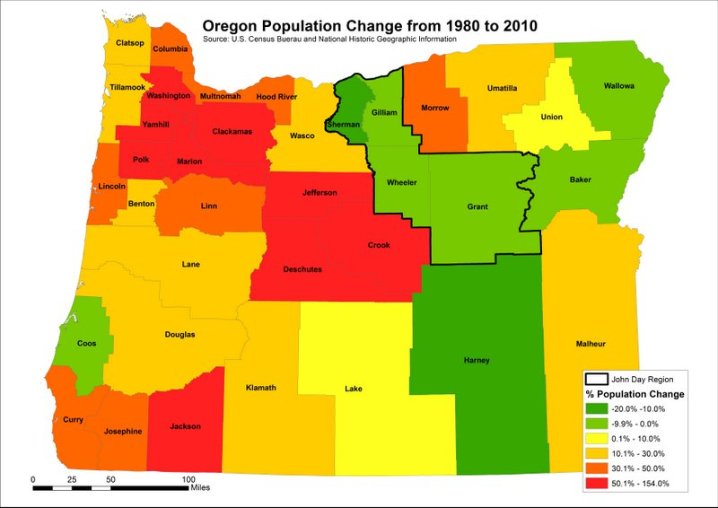In recent years, the population of Oregon has boomed. From 1980 to 2010 the majority of counties in Oregon experienced at least a 10% population increase and some counties, especially in Western Oregon, experiencing more than 100% increase (Minnesota Population Center). This is seen in Figure 1. In contrast to the majority of Oregon counties, the John Day Region experienced a decline in population over these two decades. This decline in population is complemented by the median age of the region steadily increasing over the same time period as seen in Figure 2. Today the median age for all four counties is approximately 50 years old. This is about 10 years older than the majority of other Oregon counties. (Minnesota Population Center). One the reasons for the aging population is young people are leaving the community. There are few opportunities for higher education in the region and as land prices increase, young people are moving away from the area to find jobs, affordable land, and an education. One resident tells the story of the 21 high school graduates in 2000 in which only one has since returned to the area after college (Anderson).
Figure 1: Population change of counties in Oregon from 1980 to 2010. Bold area is the John Day Region.
Figure 2: Median age of population in counties of the John Day Region from 1950 to 2010.
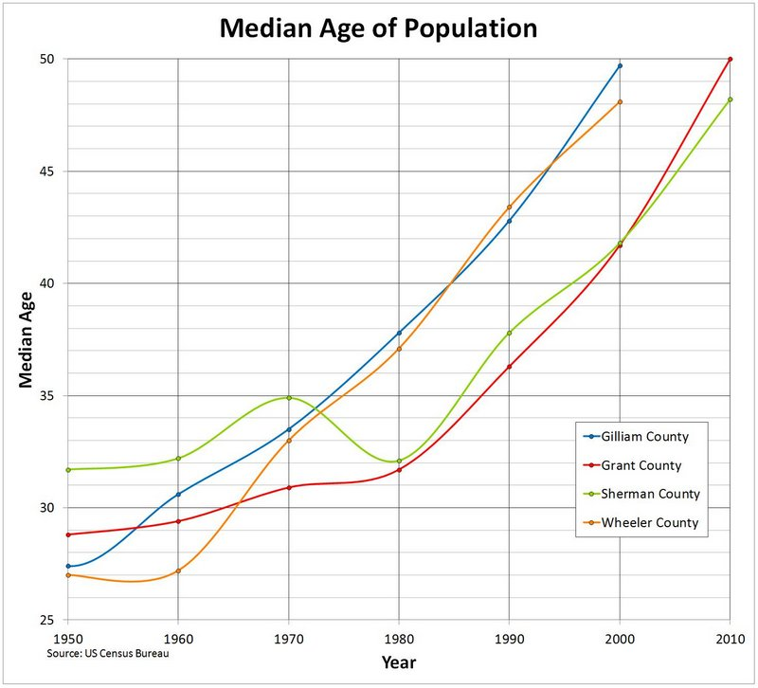As well as the shift in demographics, there has been a shift in the industries employing residents in the region. As seen in Figure 3, the number of people employed in 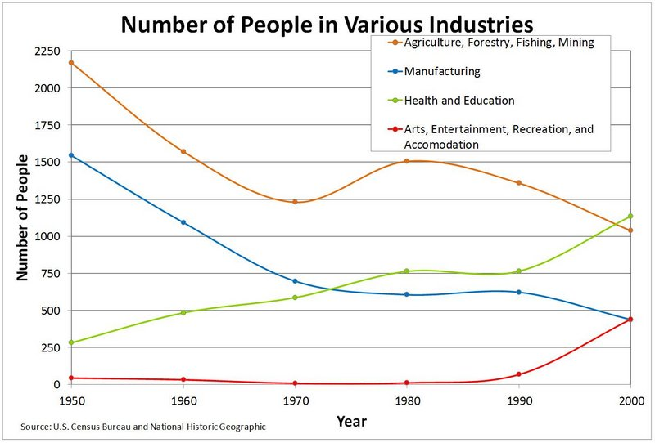the “agriculture, forestry, fishing, and mining” and “manufacturing” industries have fallen drastically since 1980. As these industries suffer, the “arts, entertainment, recreation, and accommodation” and “health care and education” industries are exploding. Since 1980, the number of people employed in the agriculture industries has dropped 30% across the region, while the arts industries has boomed from only 9 people in 1980 to over 400 people in 2000 (Minnesota Population Center). As farmers grow older, they sell off their land, decreasing the number of people employed in “agriculture, etc.” industries. Often times the land is bought by people from outside the local community. Many of these outsiders are absentee landowners who are using the land as their second home for vacation and recreation (Mendham and Curtis). Absentee landowners often buy the land, not to produce commodities, but for the aesthetic surroundings and to have an idyllic rural lifestyle (Daniels and Nelson). One study found that most Americans want to live in a small town and envision a quiet, less complex 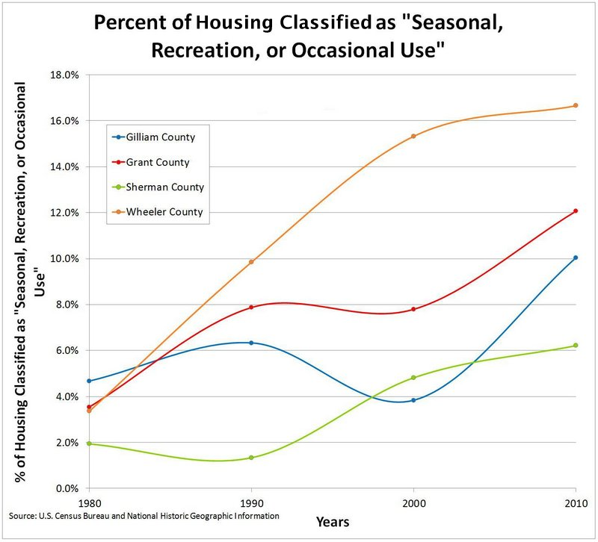lifestyle when living in the country (Daniels and Nelson). Therefore, the appeal of the John Day Region is understandable since the majority of its land classified as “rural” and has a classic American West landscape. The absentee landowners seeking a rural lifestyle are less likely to be employed as farmers, as reflected in the decrease of people employed in the “agriculture, forestry, fishing, and mining” industries (Mendham and Curtis 665). However, absentee landowners using the land for recreation increase the amount of tourism to the area and the number of people employed in the “entertainment, recreation, etc.” industries. This increase in number of absentee owners using the land as a recreation destination is seen in Figure 4 with the drastic increase in percentage of housing units classified as “Seasonal, Recreation, or Occasional Use” housing since 1980. All four counties’ housing units classified as “Seasonal…” have at least doubled, with Wheeler County having the largest increase by nearly quadrupling (Minnesota Population Center).
Figure 3: Number of people employed in various industries of the John Day Region as reported to the U.S. Census Bureau from 1950 to 2000.
Figure 4: Percent of housing classified as “seasonal, recreation, or occasional use” housing in the counties of the John Day Region as reported to the U.S. Census Bureau from 1980 to 2010.
As absentee landowners buy land for recreation, the proportion of land in farms is decreasing as seen in Figure 5, however, the total number of farms has increased as seen 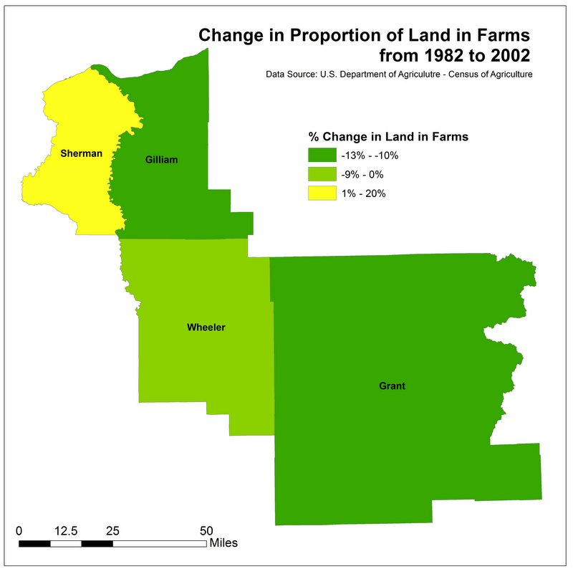in Figure 6 (Census of Agriculture). The increase in the number of farms can be explained by the increase in people not using the land for full-time farming or ranching operation, but instead by outsiders buying land for amenity or hobby farms. 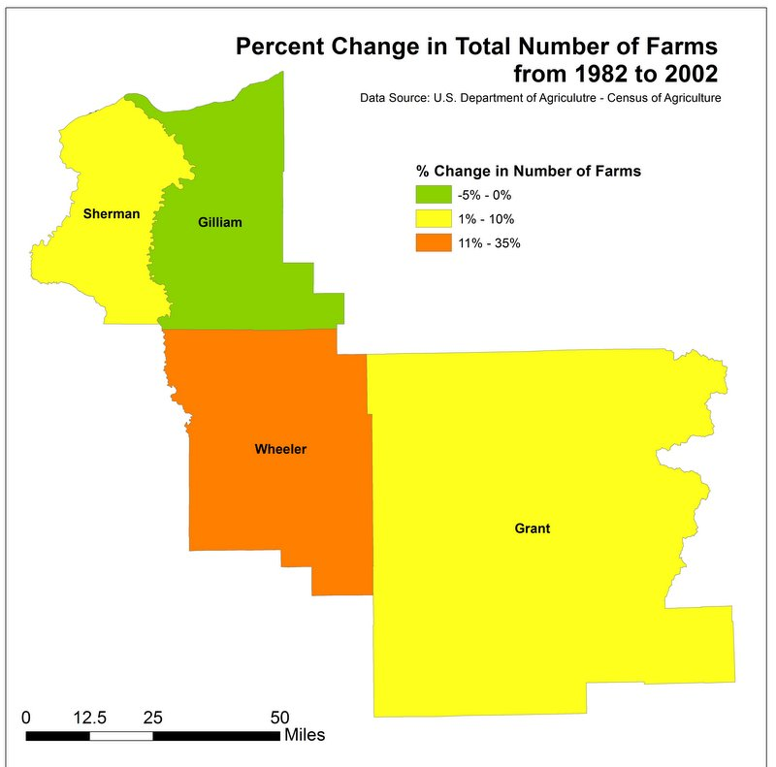Hobby farms are farms whose primary goal is not to produce commodities; instead the owner is using the land to “consume the aesthetically pleasant surroundings” (Daniels and Nelson 23). Often times small scale farming or grazing is occurring on the land, but at not the scale that puts all the land to productive use. Land is either subdivided or left unused for agriculture purposes (Daniels and Nelson 23). The subdividing of land increases the total number of farms but does not increase the total acreage of farmland. Hobby farms fragment the land, limiting the scale at which farmers can operate (Columbia Blue-Mountain 27). The more fragmented the land, the harder it is for farming operations to consolidate land parcels and expand their operations (Daniels and Nelson 23). Fragmentation and consolidation is a complex issue. On one hand, the fragmentation due to hobby farms limits the number of large scale farming operations. Large-scale farming operations bring much need economic stimulus to the region. However, consolidation of farms limits the number of people employed in the agriculture sector (Columbia Blue-Mountain 29).
Figure 6: Percent change in the total number of farms in the counties of the John Day Region from 1982 to 2002.
Figure 5: Change in proportion of land in farms in the counties of the John Day Region from 1982 to 2002.
As locals retire and land is sold, absentee owners buying the land for recreation and hobby farms are often willing to spend more than the assessed value of the land (Columbia Blue-Mountain 29). The land becomes worth more than the commodities produced by it; consequently young people cannot afford the land to start farming and active neighboring farms do not have the capital to expand. Susie Anderson, Gilliam County Planner, says “We have to see [the land] go to recreation…we can’t turn down the money.” For those owners that can afford to buy the land, the fragmentation of working farmland created by the formation of hobby farms, generates an additional challenge when creating larger scale farming operations (Daniels and Nelson 23).
Absentee owners are changing the way agriculture is conducted in the region. Under the Oregon Land-Use Planning System the “Exclusive Farm Use” zone restricts the parceling of land and limits housing construction on farmland to areas where they will not hinder farm operations (Gustafon et al.). The John Day Region is almost entirely rural with the majority of its land being zoned for agriculture. Often the land absentee owners are buying is zoned as “Exclusive Farm Use.” Absentee owners utilize land zoned as “exclusive farm use” by continuing some farming or ranching on the land just on a much smaller scale. This is changing the landscape of the farmland. For example, it is much easier for absentee owners to only raise one or two crops on the land instead of the traditional multiple rotating crop operations (Anderson). Often times the owners will hire a local to care for the crops. One county planner tells the story of one man who operates 10,000 to 15,000 acres of farmland for multiple absentee landowners. The absentee owners only plant a crop or two, making it possible for one man to maintain multiple farms (Anderson). Some absentee owners also run cattle on their land in order to keep their land zoned as “exclusive farm use,” however not on a scale nearly as large as it once traditionally was.
The increased tourism and the influx of outsiders to the area has created tensions throughout the region. Local farmers and ranchers struggle with the shifts occurring in their community. Locals are also frustrated with absentee landowners using the land for vacation purposes instead of living there fulltime, since the community does not benefit overall. They do not bring the day-to-day business to the towns or keep the schools populated. School classes that used to be 12 to 15 people are now only 1 to 7 people (Hunt Palazo).
As the agriculture landscape of the area changes and the young people no longer stay in the community, there is wide spread recognition that the tourism and recreation industries in the region are now vital. With that recognition, long-standing traditions are being challenged. Environmental concerns are given precedent over economic concerns. When one group views the land as vital for their livelihood while the other group views the land as a place for enjoyment, tensions can arise. One local resident said, “It’s a playground to them” when asked about how the absentee landowners viewed the land (Anderson). The region traditionally depends on cultivating the land and often feels the increased emphasis on tourism is limiting their ability to use the land. “We’d love for them to come spend their tourism dollars, but then don’t go back to Portland and vote against us using our land. We don’t make a living off people coming and visiting once a year,” says Wheeler County Planner, Robin Hunt Palazo.
This tension between the local community and newcomers is shown in the way Oregonians feel about the Oregon Land-Use Planning System. This system is designed to preserve farmland by creating urban growth boundaries around cities and zoning all parcels of land. When buying or building on land, the owner must keep the land in the proper zone or else apply for an exemption or zone change. Ideally, the system should benefit the farming community by making it tougher for farmland to be used for any purpose besides agriculture, however the strict control of land use creates class conflict. One study found that the more affluent the community, the stronger their support for controlled development under the Oregon Land Use Planning System was (Medler and Mushkatel 349). The John Day Region is economically depressed region trying to develop and grow. Restrictions on development are seen as an impediment to this growth. The majority of Oregon’s voting population live on the western side of the Cascade Mountains where the majority of fertile agriculture land and the major urban areas are located. Many eastern Oregonians feel like they do not have the political clout to have legislation work to their advantage. Ideally the Land Use system should benefit them by protecting farmland, however the system is being imposed on them from the outsiders who are now coming into their community.
The fight for salmon conservation in the Pacific Northwest and the Endangered Species Act is another example of local residents feeling constricted with what they can do with their land. The John Day River is part of the salmon’s natural run, and also is an ideal river for recreation, as boating and fishing are popular in the area. As tourism and recreation become more important to the region, farmers and ranchers are feeling the pressure to adjust their practices. Most of the John Day River is bordered by agriculture. Studies have shown that agriculture and grazing activity can have harmful effects on river’s ecosystem (Ganskopp and Bohnert 110). Water withdrawal for agriculture lowers water levels and water temperature, making streams inaccessible or inhospitable to salmon. Stream channelization and flow modification projects designed to help improve crop production in the drier areas of the region has drastically altered the riparian ecosystem of the John Day River (Wu, Adams, and Boggess 400). As the pressure to preserve the salmon increases, long-standing traditions are being challenged. Locals feel there is a shift in thinking to environmental concerns outweighing potential economic benefits (Dake). “They want us to keep a pristine playground for them,” says a Wheeler County resident. (Robin) Often residents feel threatened by these new philosophies on how the land should be used.
With the new increased focus on environment from outside the area and the influx of newcomers to the area, locals often feel their long-standing knowledge is being pushed aside or forgotten (Mendham and Curtis 665). For example, cattle grazing on public land is being debated. Cattle grazing has traditionally been conducted on both private and public lands (Dake). Locals have been maintaining the land for generations; there is a deep understanding and respect for the land and farming. However, environmentalist are calling on the U.S. Forest Service to better regulate this practice, citing grazing as detrimental to the threatened steelhead and bulltrout populations in the public lands’ streams (Dake). Ranchers argue that they would have to cut their cattle operations by half if they could not graze their cattle on National Forest land. There is a shifting in priority as to what public lands should prioritize. One environmentalist’s argument shows the shift to a more environmental focus:
It goes back to this underlying question of what is the primary and best use of our public lands. And I think for well over a century, grazing has been the priority use for public lands in the West. And I think changing social values recognizing preserving and restoring healthy fish populations is something we value our public land for…I would hate to…presume that just because it's historically been a priority, we assume it's a priority use in the future. (Dake)
Local residents view this shift in priority as a threat to their way of live that is already struggling to survive. A community member said, “We do what we’re forced to do” when asked about the pressure to adjust practices to have a more environmental focus (Hunt Palazo).
The National Forests are not just used for grazing; the timber industries have traditionally played a major role in the economic well being of Grant and Wheeler counties. Traditionally the US Forest Service harvested off these public lands, however the timber industries in Wheeler County and Grant County have almost completely disappeared as various federal legislation has been passed limiting the amount of logging. It has been well noted that community stability is dependent on continued timber harvest on federal land (Freudenburg, Wilson, and O’Leary 4). Robin Hunt Palazo, Wheeler County Planner, says, “We’re in dire straights now because they’re not logging on federal land…We’re having a hard time getting them to do anything on the federal land.” The Wilderness Act of 1964 protected 9.1 million acres of National Forest in the United States, including Oregon, and since the 1990s more restrictions have come up on how to use the land. In the 1990s, the Spotted Owl became protected under the Endangered Species Act limiting old growth harvesting (Freudenburg, Wilson, and O’Leary). The 2001 Roadless Areas Conservation Rule decreased access to logging in National Forests further, limiting logging activity while opening up the areas for recreation activities such as hiking (Aarons 1294). The loss of logging limits the lumber product industries that have traditionally helped maintain some John Day Region towns. In 1978, Kenzua Mill in Wheeler County shut down. As the mill shut down, the majority of town residents lost their jobs. Most of the people moved outside the counties to bigger towns such as Hepter or Prineville (Hunt Palazo).
Along with the timber industries, the cattle industries in the John Day Region have also shifted a lot in recent years. Traditionally many wheat farmers also raised cattle, grazing the cattle on a combination of public and private land. The cattle countered the changing wheat prices and vice versa (Susie). In the last 15 years, as wheat prices became more stable due to government subsidizing and technology that made larger scale wheat operations feasible, the fences designed to manage grazing have been removed thus limiting the amount of grazing occurring. Feed lots and beef processing does not occur in the John Day Region. “The beef starts out here but it’s only on the ground for a short while before it’s moved on to the feed lots,” says a resident of the region, “It’s hard to make money at it when they’re not here long.” Also, the cattle compact the soil and spread weeds as they graze; as farms shift to single operations the cattle can hinder more than help (Ganskopp and Bohnert 111). Sheep herding also used to occur on the land, but the demand for lamb has dropped significantly making sheep herding no longer profitable (Johnson 75; Hunt Palazo).
The future of the John Day Region is complex. The region is working to develop new industries. There has been some focus on renewable energy—wind and solar power—particular in Sherman and Gilliam counties. These operations are seen as way to bring in jobs, young people, and economic stimulus. A community college in a neighboring county offers a Renewable Energy Technician degree with the intention to encourage younger people to stay in the community.
The region is also working to mitigate the effects of an aging population. The aging population has helped increase the health care industry of the region. According to the U.S. Census the health and education industries have increased by nearly 400 people from 1980 to 2000 (Minnesota Population Center). The majority of these jobs are in the health sector, not the education. In Sherman County in particular, a lot of the recent job growth has been focused on health care for the aging population. In Moro, OR a senior home and community center have recently been built (Metta). A multi-county public transportation plan is being formed to better service senior living in rural areas (Metta).
With the influx of newcomers to the area there is an increased push to make the tourism industry more robust. Wheeler County recognizes the appeal of their natural areas such as the Painted Hills and the Fossil Beds. They also understand the desire people have to move to rural areas but not necessarily run a fulltime ranch or farm. Many of the land parcels for sale are large lots that don’t attract families looking for a quiet rural life. According to one county resident, Wheeler County is working on creating smaller tracts of land to attract families. Area marketing desires to increase tourism visibility of the area, but there are not abundant amounts of money available for advertising. Attractions are being created that introduce bring in the tourist while at the same time introduce the area’s history and culture to the visitors. Sherman County has opened a historical museum run about over 70 volunteers, while Wheeler County is pushing to create more guest ranches. The guest ranches will provide an opportunity for tourists to experience the traditional ranching lifestyle and will hopefully help create some understanding between the two groups of locals and tourists.
In the future, the agriculture, timber, and grazing industries of the John Day Region will have to continue to adapt to the changing cultural and political climate. The tensions that arise between the newcomers and the local residents are unavoidable as these shifts are unavoidable. The local residents of the region acknowledge that in order to survive some changes are going to have to occur. When asked what was pivotal for the future of the area, one long term resident summed it up well saying, “We hope to bring families in, bring kids and new life into the community.”
References:
Aarons, Kyle J. “The Real World Roadless Rules Challenges.” Michigan Law Review 109.7 (2011): 1293-1324.
Anderson, Susie. Personal Interview. 7 May 2012.
Cho, Seong-Hoon, JunJie Wu, Ralph Alig. “Land Development Under Regulation: Comparison Between the East and West Sides of the Cascade Range in Oregon, Washington, and California.” RURDS 17.1 (2005): 1-17.
Columbia-Blue Mountain Resource Conservation & Development Area. John Day Subbasin Revised Draft Plan. Northwest Power and Conservation Council. 15 March 2005. Web.
Dake, Lauren. "Should private cattle graze on public lands?" The Bulletin (Bend, OR) 19 Nov. 2009: Newspaper Source. Web. 6 Nov. 2011.
Daniels, Thomas L. and Arthur C. Nelson. “Is Oregon’s Farmland Preservation Program Working?” Journal of American Planning Association 52.1 (1986): 22-32.
Freudenburg, William R., Lisa J. Wilson, Daniel J, O’Leary. “Forty Years of Spotted Owls? A Longitudinal Analysis of Logging Industry Job Losses.” Sociological Perspectives 41.1 (1998): 1-26.
Ganskopp, David C. and David W. Bohnert. “Landscape Nutritional Patterns and Cattle Distribution in Rangeland Pastures.” Applied Animal Behaviour Science 116 (2009): 110-119.
Gustafson, Greg C., Thomas L. Daniels, and Rosalyn P. Shirack. “The Oregon Land Use Act: Implications for Farmland and Open Space Protection.” Journal of American Planning Association 48.3 (1982): 365-373.
Hunt Palazo, Robin. Personal Interview. 14 May 2012.
Johnson, Bill. “The Central Oregon Range War, 1896-1906.” Journal of Shaw Historical Library 18 (2004): 75-84.
Lankford, Samuel V. “Attitude and Perceptions Toward Tourism and Rural Regional Development.” Journal of Travel Research (Winter 1994): 35-43.
Medler, Jerry and Alvin Mushkatel. “Urban-Rural Class Conflict in Oregon Land-Use Planning.” The Western Political Quaterly 32.3 (1979): 338-349.
Mendham, Emily and Allan Curtis. “Taking Over the Reins: Trends and Impacts of Changes in Rural Property Ownership.” Society and Natural Resources: An International Journal 23 (2010): 653-668.
Metta, Jessica. Personal Interview. 7 May 2012.
Minnesota Population Center. National Historical Geographic Information System: Version 2.0. Minneapolis, MN: University of Minnesota 2011.

Nie, Marting. “Administrative Rulemaking and Public Lands Conflict: The Forest Service’s Roadless Rule.” Natural Resources Journal 44.3 (2004): 687-742.
Starrs, Paul F. Let the Cowboy Ride: Cattle Ranching in the American West. Baltimore: Johns Hopkins UP, 1998.

Wu, JunJie, Richard M. Adams, and William G. Boggess. “Cumulative Effects and Optimal Targeting of Conservation Efforts: Steelhead Trout Habitat Enhancement in Oregon.” American Journal of Agricultural Economics 82.2 (2000): 400-413.

