AN ABSTRACT OF THE THESIS OF

Tony T. Tong for the degrees of Honors Baccalaureate of Science in Chemistry and Honors Baccalaureate of Science in Biochemistry and Biophysics presented on March 14, 2007. Title: Aging and Oxidative Damage to Mitochondrial Membrane Proteins.

Abstract Approved:
_____________________________________________________

Dr. Claudia S. Maier

_____________________________________________________

Dr. Jan Frederik Stevens

Mitochondria provide energy for biological cells to function, but this process is also a source of oxygen radicals that are capable of damaging nearby proteins. Mitochondrial protein damage can eventually lead to cell death, especially in the case of heart cells, where mitochondria are present in the highest concentrations. As a result, this process is believed to be a cause of many cases of heart disease. In this project, methods for the sensitive detection, isolation and characterization of oxidatively damaged proteins were developed. In the first approach, blue-native polyacrylamide gel electrophoresis (BN-PAGE) was used in combination with liquid chromatography-electrospray-tandem mass spectrometry for efficient isolation and detection of the electron transport chain complexes from mouse heart mitochondria. For the detection of oxidatively damaged proteins, BN-PAGE in conjunction with a hydrazide isotope coded affinity tag (HICAT) was tested. Unfortunately, so far, our findings regarding the use of BN-PAGE in combination with the HICAT probe remain inconclusive. As a second approach for the isolation of oxidatively modified peptides, an alternative strategy was developed which is based on avidin affinity chromatography for the enrichment of biotinylated peptides. This approach was validated with thioredoxin (TRX) as a model protein and led to the identification of the TRX His-6 residue as the primary in vitro adduction site of the lipid peroxidation product 4-hydroxy-2-nonenal (4-HNE).

Key Words: protein oxidation, mass spectrometry, affinity chromatography

Corresponding e-mail address: tony.tong@lifetime.oregonstate.edu

©Copyright by Tony T. Tong
March 14, 2007
All Rights Reserved
Aging and Oxidative Damage to Mitochondrial Membrane Proteins

by

Tony T. Tong

A PROJECT

submitted to

Oregon State University

University Honors College

in partial fulfillment of
the requirements for the
degrees of

Honors Baccalaureate of Science in Chemistry (Honors Associate)
Honors Baccalaureate of Science in Biochemistry and Biophysics (Honors Associate)

Presented March 14, 2007
Commencement June 2007, for degrees awarded Winter term 2007

Honors Baccalaureate of Science in Chemistry and Honors Baccalaureate of Science in Biochemistry and Biophysics project of Tony T. Tong presented on March 14, 2007.

APPROVED:

Co-Mentor, representing Chemistry

Co-Mentor, representing Pharmaceutical Sciences

Committee Member, representing Chemistry

Dean, University Honors College

I understand that my project will become part of the permanent collection of Oregon State University, University Honors College. My signature below authorizes release of my project to any reader upon request.

Tony T. Tong, Author
ACKNOWLEDGEMENT

First of all, I would like to thank my mentors, Dr. Claudia Maier and Dr. Fred Stevens for the opportunity to work in their labs. Their guidance over the past several years has been invaluable, and I wish them the best of luck in their future research pursuits. Special thanks to Brian Arbogast for not only being on my committee, but also for providing an enormous amount of technical assistance with ESI-Q-TOF analysis. Lilo Barofsky and Mike Hare have also provided much technical assistance with MALDI-TOF-TOF analysis, and they deserve many thanks as well. I’d also like to thank Duane Mooney for his invaluable advice, as well as Juan Chavez and the rest of the Maier lab members for their support as well. Another special thanks goes to Dr. Emily Ho and her lab for providing the mouse hearts. The sacrifices made by those mice in the name of science will not be forgotten.
On a more personal note, I want to thank my parents for their unending support (and the money!) to put me through college, even though they probably have no clue what I’m talking about in this thesis. Also, my roommates Trung Nguyen, Miki Tsukamoto, and John Lim have been great friends, and believe it or not, I am going to miss being their unofficial chauffeur.
I doubt anyone has done this, but I’d also like to acknowledge Steven P. Jobs and his team at Apple Inc. for making such great computers, one of which was used to write the majority of this thesis.
I’d also like to recognize Dr. Christine Pastorek for referring me to work with Dr. Maier, as well as making possible the incredible experience that is called E-Chem. Last but far from least, an infinite bundle of appreciation goes out to Dr. Kevin Ahern. He has done so much for me and his many other students that I don’t even know where to begin.

Funding for this thesis was partially provided by the Oregon State University Research Office through the Undergraduate Research, Innovation, Scholarship & Creativity (URISC) program and the OSU Howard Hughes Medical Institute (HHMI) Summer Undergraduate Research Program.

If there is anyone I’ve missed, I’d like to thank them too, so I’ll just thank the entire world.

TABLE OF CONTENTS

Page

1. INTRODUCTION 1
1.1. Mitochondria and the Electron Transport Chain 1
1.2. Origin of Reactive Oxygen Species in Mitochondria 2
1.3. Oxylipid Adduction to Proteins 3
1.4. Mass Spectrometry 4
2. LC-ESI-MS/MS ANALYSIS OF MITOCHONDRIAL MEMBRANE PROTEINS ISOLATED BY BLUE-NATIVE GEL ELECTROPHORESIS 11

2.1. Introduction 11
2.2. Experimental 12
2.3. Results and Discussion 16
3. MS ANALYSIS OF in vitro HNE-modified THIOREDOXIN ISOLATED
BY AFFINITY CHROMATOGRAPHY 22

3.1. Introduction 22

3.2. Experimental 23

3.3. Results and Discussion 25

4. CONCLUSION 28

BIBLIOGRAPHY 29

LIST OF FIGURES

Figure Page

1. General scheme of oxidative phosphorylation in mitochondria 1

2. Lipid peroxidation product formation from linoleic acid 3

3. Modification of nucleophilic amino acids by the LPO product 4-HNE 4

4. The electrospray ionization process 6

5. The MALDI process 7

6. Linear and reflectron modes of a TOF mass analyzer 8

7. Schematic of a quadrupole mass analyzer 9

8. Peptide fragmentation patterns in CID MS/MS experiments 10

9. Overview of BN-PAGE/Western blotting experimental methods 12

10. Location of BN-PAGE gel excisions for ESI-Q-TOF analysis 16

11. Western blot of mouse heart mitochondrial proteins separated by BN-PAGE and reacted with HICAT and NeutrAvidin 19

12. Overlay of Western blot and BN-PAGE gel of mouse heart mitochondria 19

13. ESI-Q-TOF-MS/MS spectrum of a Complex IV subunit II peptide

encompassing the partial sequence ILYMMDEINNPVLTVK 20

14. Coverage of Complex IV detected by ESI-Q-TOF-MS/MS 21

15. The chemical structure of N’-aminooxymethylcarbonylhydrazino D-biotin 23

16. The chemical structure of HNE-ARP adducted to thioredoxin at His-6 24

17. Amino acid sequence of oxidized thioredoxin recombinantly expressed in E. coli 27

18. MALDI-TOF-MS spectrum of nonlabeled peptide elution fraction 27

19. MALDI-TOF-MS spectrum of labeled peptide elution fraction 28

LIST OF FIGURES (continued)

Figure Page

20. ESI-Q-TOF-MS spectra of a tryptic digest of thioredoxin reacted with HNE and ARP 28

21. ESI-Q-TOF-MS/MS spectrum of the peptide IIHLTDDSFDTDVLK 29

LIST OF TABLES

Table Page

1. Composition of BN-PAGE stacking and separating gels 14

2. Composition of buffers used in BN-PAGE 14

3. Number of ETC polypeptide subunits with peptides detected by

ESI-Q-TOF-MS/MS 22

LIST OF ABBREVIATIONS

4-HNE – 4-hydroxy-2-nonenal

APS – ammonium persulfate

ARP – aldehyde reactive probe

BN-PAGE – blue-native polyacrylamide gel electrophoresis

BSA – bovine serum albumin

CID – collision induced dissociation

Cu/Zn-SOD – copper/zinc superoxide dismutase

ESI – electrospray ionization

ETC – electron transport chain

HICAT – hydrazide isotope-coded affinity tag

His – histidine

HPLC – high performance liquid chromatography

HRP – horseradish peroxidase

LC – liquid chromatography

LPO – lipid peroxidation

MALDI – matrix-assisted laser desorption/ionization

MS – mass spectrometry

MS/MS – tandem mass spectrometry

m/z – mass-to-charge ratio

Q – quadrupole

PBS – phosphate buffered saline

ROS – reactive oxygen species

LIST OF ABBREVIATIONS (continued)

SDS – sodium dodecyl sulfate

TBS – tris-buffered saline

TCA – tricarboxylic acid

TEMED – tetramethylethylenediamine

TOF – time of flight

TRX - thioredoxin

Aging and Oxidative Damage to Mitochondrial Membrane Proteins

1. INTRODUCTION

1.1. Mitochondria and the Electron Transport Chain

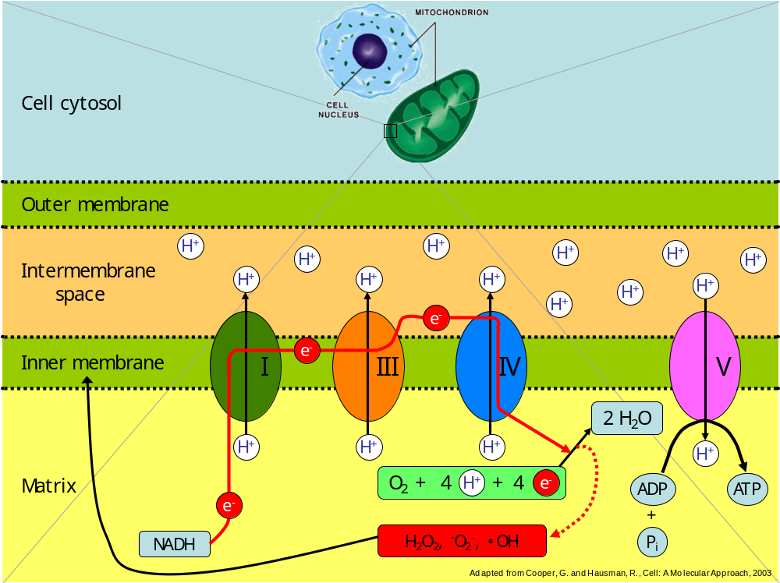
Mitochondria are organelles found inside most eukaryotic cells. Their main function is to help provide energy to power the cell’s various functions by synthesizing adenosine triphosphate (ATP) from adenosine diphosphate (ADP) and a phosphate group. However, mitochondria are also a source of reactive oxygen species (ROS), such as hydrogen peroxide (H₂O₂), superoxide (·O₂⁻), and the hydroxyl radical (·OH) (Figure 1).

Figure 1. General scheme of oxidative phosphorylation in mitochondria
These species are capable of causing oxidative damage throughout the body, and because mitochondrial concentrations are highest in cardiac cells, ROS are widely thought to be a contributor to certain cases of heart disease, especially congestive heart failure¹ as well as the aging process in general.²

1.2. Origin of Reactive Oxygen Species in Mitochondria

The origin of ROS in mitochondria lies in the electron transport chain (ETC), which is a collection of protein complexes in the inner membrane. The last protein complex in this chain, ATP synthase (Complex V), catalyzes the synthesis of ATP from ADP and phosphate. However, ATP synthase requires a flow of protons through it from the intermembrane space into the matrix for it to work. This proton gradient is achieved when three other complexes (Complexes I, III, and IV) pump protons from the matrix and
into the intermembrane space. This pumping only occurs when electrons from nicotinamide adenine dinucleotide (NADH) flow through these complexes.
In optimal conditions, Complex IV combines an oxygen molecule (O₂), four protons, and four electrons to make two water molecules at the end of the ETC, completing a process known as aerobic respiration. However, sometimes this oxidative process is incomplete, and ROS’s can leak out. These are then capable of reacting with the nearby lipids that comprise the inner mitochondrial membrane, such as linoleic acid, and form lipid peroxidation (LPO) products such as 4-hydroxy-2-nonenal (4-HNE) and 4-oxo-2-nonenal (4-ONE) (Figure 2).^{2, 3}

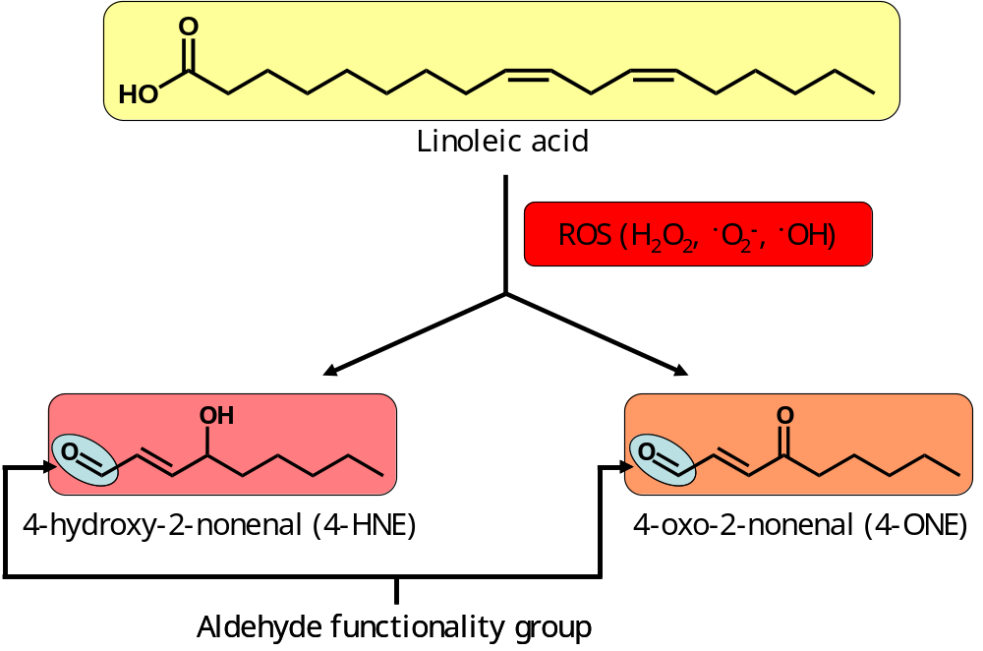
Figure 2. Lipid peroxidation product formation from linoleic acid. Common LPO products include 4-hydroxy-2-nonenal (4-HNE) and 4-oxo-2-nonenal (4-ONE).

1.3. Oxylipid Adduction to Proteins
LPO products often contain α,β-unsaturated aldehyde/keto functionality groups, which make them susceptible to attack by nucleophilic groups on amino acids at the C-3 site of the LPO product (Figure 3).³ The three most nucleophilic amino acids are cysteine, histidine, and lysine, and we will assume that most oxylipid adductions will involve these three amino acids.

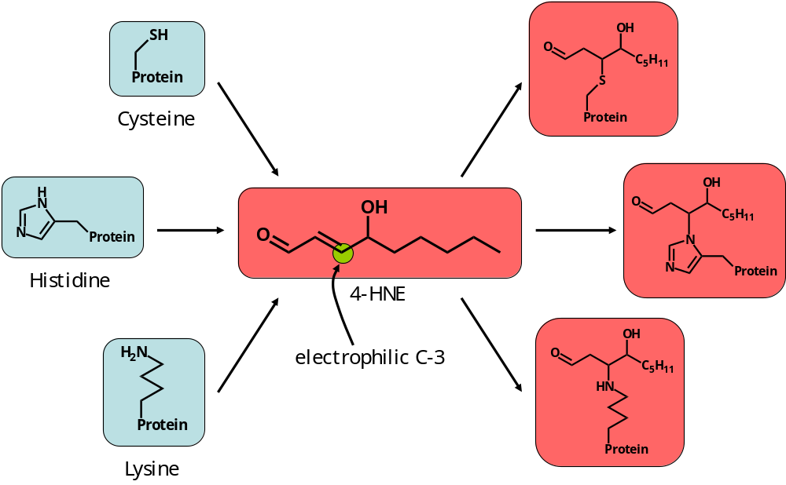
Figure 3. Modification of nucleophilic amino acids by the LPO product 4-HNE. Cysteine, histidine, and lysine are the most nucleophilic amino acid residues; thus they are most likely to react with LPO products, such as 4-HNE, at the carbon-3 site by Michael-type addition.
1.4. Mass Spectrometry
1.4.1. Introduction to Mass Spectrometry

To determine exactly where and what types of adduction are taking place in oxidatively damaged proteins, we used mass spectrometry. Mass spectrometry (MS) allows for the relatively accurate determination of mass-to-charge (m/z) ratio of ions. Each protein has a unique sequence of amino acids, and because there are twenty standard amino acids, it is highly unlikely that a unique peptide as obtained through proteolysis by trypsin will have come from completely different proteins. The exact sequence of a peptide can then be determined by using tandem mass spectrometry, a method to be described later in this text. If an analyte peptide detected by tandem mass spectrometry is part of a protein that has been sequenced, it can then be identified as belonging to that protein. However, the analyte must be in the gas phase and hold a charge to be analyzed. Two ionization methods commonly used in protein and peptide mass spectrometric analysis were used: electrospray ionization⁴ and matrix-assisted laser desorption/ionization⁵.

1.4.2. Ionization Methods
1.4.2.1. Electrospray Ionization
Electrospray ionization (ESI) requires the analyte to be in solution, which flows through a metal nozzle or metal-coated glass capillary. In positive ESI, a positive voltage on the order of a few kV is applied to the nozzle or capillary. This results in the formation of a Taylor cone at the tip of the capillary and droplets of solvent containing positively charged analyte ions are emitted at the tip of the cone as they travel towards the counter electrode, which is simply a plate positioned in front of the capillary and usually held at ground potential. A nebulizing gas may be used to help evaporate the solvent. As the solvent evaporates, the droplets shrink, and the positively charged proteins will start to repel each other up to the point that the droplet breaks up. This continues until solvent in the smallest droplet possible evaporates and ionized peptides and other biomolecules are transferred into the gas phase (Figure 4).

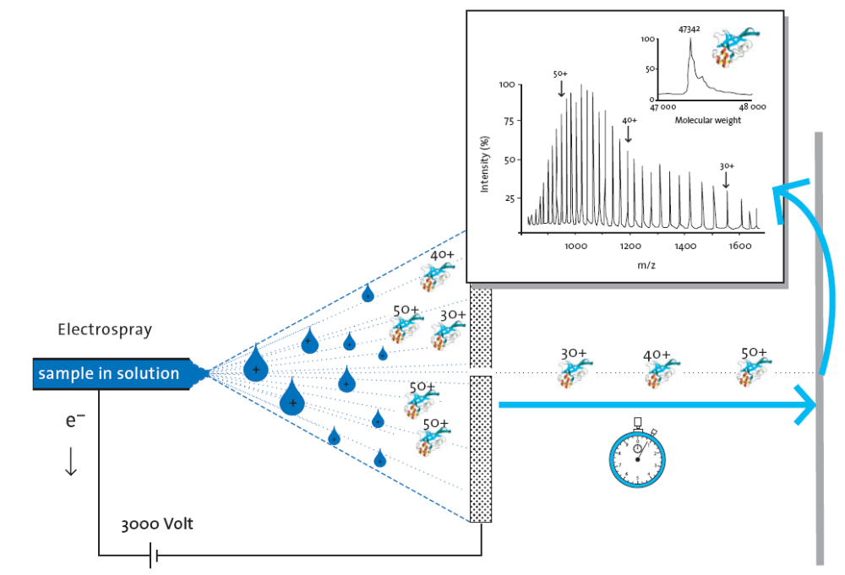
Figure 4. The electrospray ionization process.⁶ In this example, a positive voltage of 3000 V is applied to the nozzle, resulting in Taylor cone formation and emission of droplets of solvent containing analyte ions. As the solvent evaporates, analyte ions in the same droplets repel each other until the droplets break apart, eventually resulting in the evaporation of the smallest possible droplet and multiply-charged ions are transferred to the gas phase to be analyzed.

In ESI, peptide or protein ions usually contain multiple charges due to multiple protonations, and ions in different charge states are typically observed. This provides additional data to allow for more precise mass determination.

1.4.2.2. Matrix-assisted Laser Desorption/Ionization
Contrary to ESI, matrix-assisted laser desorption/ionization (MALDI) methods require the analyte to be in the solid phase. The analyte is crystallized along with a matrix, such as α-cyano-4-hydroxycinnamic acid. The matrix is first mixed with the analyte in solution, and then ‘spotted’ onto a MALDI plate. After the solvent has completely evaporated, the plate is placed into the MALDI MS instrument. A UV laser light is emitted onto the sample, and the matrix absorbs the laser light, causing it to vaporize along with the analyte ions (Figure 5).

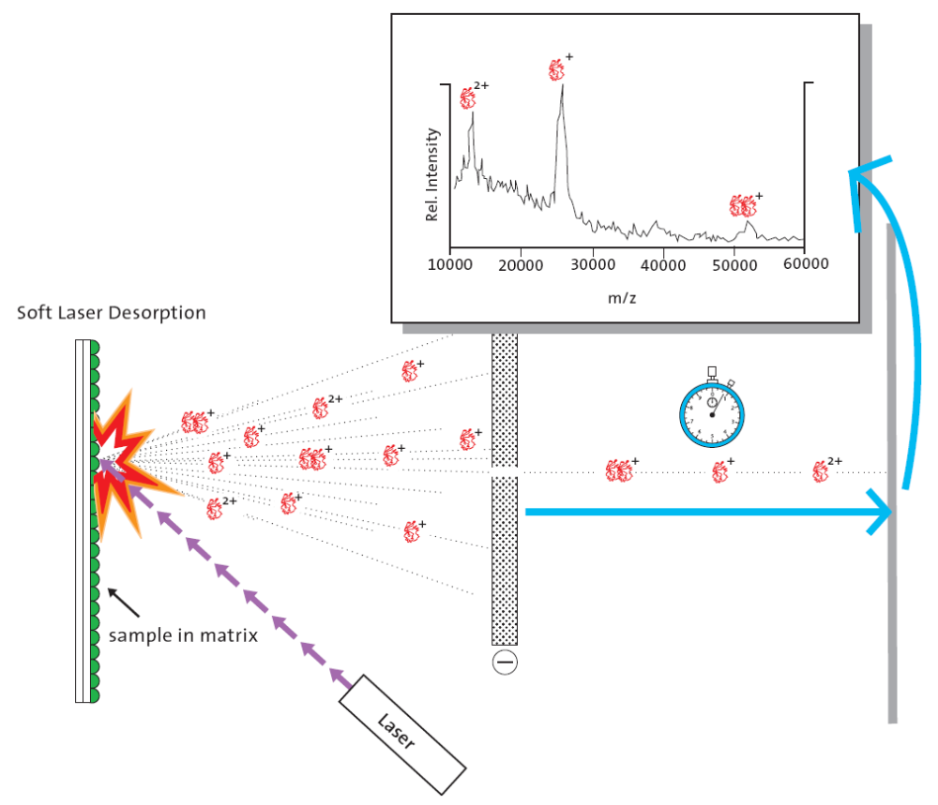
Figure 5. The MALDI process.⁶ Analyte is mixed in solution with a matrix and applied onto a plate. After the solvent has evaporated, a laser is emitted onto the sample, which causes the matrix to vaporize along with the analyte ions to be analyzed.

1.4.3. Mass Analyzesrs
1.4.3.1. Time-of-Flight
The time-of-flight (TOF) mass analyzer works on the basic principle that given the same kinetic energy, lighter objects will travel faster than heavier objects. TOF uses this principle by measuring the amount of time it takes for an ion to travel to the detector. This time is then calculated to give a mass value based on the traveling distance and initial kinetic energy of the ion. Resolving power can be increased by utilizing a reflector that effectively increases the traveling distance by using an electric field to reflect ions towards a second detector (Figure 6).
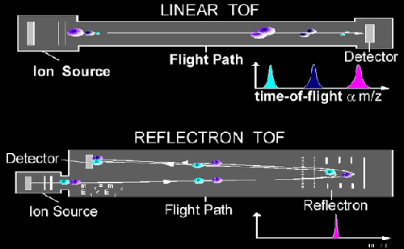

Figure 6. Linear and reflectron modes of a TOF mass analyzer.⁷ In linear mode, analyte ions travel a straight path to the detector, with ions of lower m/z arriving first. In reflectron mode, the ions are reflected toward a second detector by an electric field to ensure that ions of identical mass but different kinetic energy arrive at the detector at the same time. This effectively increases the instrument’s resolving power.
1.4.3.2. Quadrupole
The quadrupole (Q) mass analyzer is somewhat more complicated. It involves the use of four parallel rods, where opposing rod pairs are electrically charged similarly. An alternating radio frequency (RF) voltage is applied to each pair and a direct current voltage is superimposed onto the RF voltage. The ratio of these voltages allows only ions of a certain m/z value to pass through to the detector. All other ions will have trajectories that will either go out of or hit the quadrupoles (Figure 7).

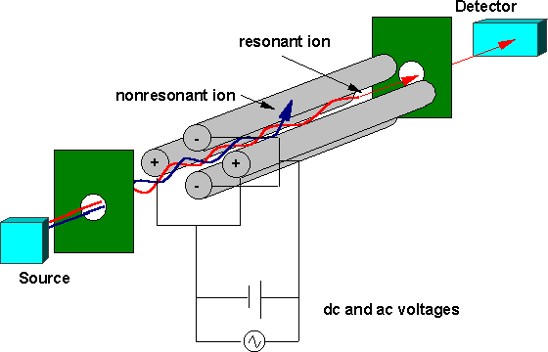
Figure 7. Schematic of a quadrupole mass analyzer.⁸ Opposing rod pairs are electrically charged similarly with an alternating RF voltage and a DC voltage superimposed onto the RF voltage. The ratio of the voltages only allows ions of a certain m/z value to pass thru to the detector.

1.4.4. Tandem Mass Spectrometry
Tandem mass spectrometry (MS/MS), involves two mass analyzing steps. Between each step is usually a method of breaking apart the ion, called collision-induced dissociation (CID). CID collides parent ions with neutral gas molecules such as nitrogen or argon, resulting in daughter ions. This is useful when analyzing peptides, as CID can break peptide bonds, resulting in a set of mass values that can be calculated to determine a peptide’s sequence.⁹ MS/MS experiments can be performed using Q-TOF and TOF-TOF type instruments, where the first mass analyzer selects parent (precursor) ions of a particular mass, and the second mass analyzer analyzes the daughter (product) ions.
In a peptide fragmentation experiment, the main purpose is to determine the peptide sequence. Usually, peptide bonds are broken by CID, resulting in b-ions and y-ions, as shown in Figure 8.^{10, 11} The formation of a-, c-, x-, and z-ions are possible as well, but these occur less often. Search engines such as Mascot (Matrix Science, London, UK) calculate trypsin digestions of proteins in silico, or by computer simulation, to generate a list of theoretical peptides that are then matched to the experimental data from the MS instrument.

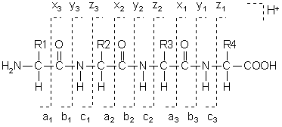

Figure 8. Peptide fragmentation patterns in CID MS/MS experiments
2. LC-ESI-MS/MS ANALYSIS OF MITOCHONDRIAL MEMBRANE PROTEINS ISOLATED BY BLUE-NATIVE GEL ELECTROPHORESIS

2.1. Introduction
2.1.1. Blue-Native Gel Electrophoresis
Blue-native polyacrylamide gel electrophoresis (BN-PAGE) allows proteins and protein complexes to remain in their native state,¹² which will be useful for tagging in a subsequent experiment. The proteins are separated on a basis of size, shape, and charge.

2.1.2. Western Blotting
Western blotting electrically transfers the proteins in a BN-PAGE gel onto a nitrocellulose membrane, and after reacting with chemiluminescence reagents and a molecular tag, exposure to X-ray film allows for visualization of the bands on the gel that contain oxidized proteins (Figure 9). The tag, designed and synthesized in the Maier and Stevens labs and termed hydrazide isotope-coded affinity tag (HICAT), contains a hydrazide group that reacts with the aldehyde functionality group in LPO products. It is not expected that aldehydes are naturally present in mitochondrial membrane proteins.
The HICAT tag also contains a biotin group that will readily bind to avidin. In our experiments, NeutrAvidin from Molecular Probes (Eugene, OR) was used, and was purchased in a form that was conjugated with horseradish peroxidase (HRP), allowing for visualization of oxylipid modified proteins by SuperSignal West Pico Chemiluminescent Substrate from Pierce (Rockford, IL). This substrate was obtained as two solutions – a
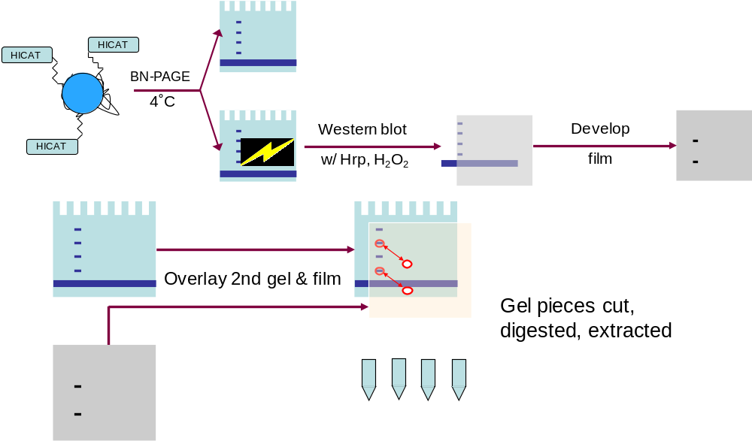
Figure 9. Overview of BN-PAGE/Western blotting experimental methods

peroxide solution, containing hydrogen peroxide and a hydroxide salt, and a luminol solution. HRP catalyzes the decomposition of hydrogen peroxide to water and molecular oxygen (O₂). This allows for luminol to react with hydroxide and O₂ to form a compound in an energized state that quickly loses the excess energy in the form of a photon, resulting in light given off.

2.2. Experimental
2.2.1. Sample Preparation
Heart mitochondria were isolated from four groups: mice with a combination of zinc adequate or deficient diets, plus wildtype (+/+) or overexpressed (+++) Cu/Zn-SOD (superoxide dismutase) gene. Samples taken for analysis contained approximately 200 µg of protein as determined by Bradford assay. Each sample was centrifuged at 10,000 g for 10 min at 4˚C, and the supernatant was removed after centrifugation. The pellets were
resuspended in 60 µL of 10 mM sodium phosphate, pH 5.5 on ice, and then 7.5 µL of 10% dodecyl maltoside and 2 µL of 10 mM HICAT were added to each sample. The samples were kept in ice for 20 min with periodic mixing, then 70 µL of gel buffer (1.5 M aminocaproic acid, 150 mM BisTris, pH 7.0) was added followed by another 20 min of incubation in ice with periodic mixing. The samples were then centrifuged at 14,000 g for 10 min at 4˚C, and then 8 µL of sample buffer (0.5 M aminocaproic acid, 50 mM BisTris, 5% w/v Coomassie Brilliant Blue G-250 dye, pH 7.0) was added to each sample.

2.2.2. Blue-Native PAGE
Two 1.5 mm thick blue-native gels were made according to Table 1 with a Mini-PROTEAN 3 system from Bio-Rad (Hercules, CA). The 9% separating gel was poured first, with n-butanol added on top to ensure a straight interface with the stacking gel. After the separating gel polymerized, the n-butanol was poured out and the stacking gel was poured on top of the separating gel with a 5-well comb.
The procedure as follows was derived from those of Schagger and Brookes.^{12, 13} Buffers were made according to Table 2. Initially, electrophoresis was performed with the anode buffer and cathode buffer 1 at 40 V for 1 hr, then cathode buffer 1 was exchanged for cathode buffer 2. Electrophoresis continued at 110 V for 2 hr, then 160 V for 2 hr, at which time the dye front had progressed to the bottom of the gels. After disassembling the gel apparatus, one gel (Gel A) was destained by incubation with 20% isopropanol/5% acetic acid and kept for mass spectrometric analysis, while the other gel (Gel B) was used for Western blotting.

Component | Stacking gel | Separating gel
40% acrylamide/ bisacrylamide (37.5:1) | 0.45 mL | 2.25 mL
Deionized water | 2.55 mL | 1.0 mL
Gel buffer | 1.5 mL | 3.33 mL
50% glycerol | - | 3.4 mL
APS | 7 mg | 6.6 mg
TEMED | 9 µL | 10 µL

Table 1. Composition of BN-PAGE stacking and separating gels

Component | Anode buffer | Cathode buffer 1 | Cathode buffer 2
BisTris | 50 mM | 15 mM | 15 mM
Tricine | - | 50 mM | 50 mM
Coomassie Brilliant Blue G-250 | - | 0.02 % w/v | 0.002 % w/v

Table 2. Composition of buffers used in BN-PAGE

2.2.3. Western Blotting and Chemiluminescence Reaction
Gel B was soaked in SDS to eliminate the aminocaproic acid, then washed with 1x PBS, pH 5.5 for 10 min. A nitrocellulose membrane was used for the Western blotting, and a 150 mA current was applied for 2 hr to transfer the proteins from the gel to the membrane.
The membrane was then soaked in 2 mL of 1x TBS, pH 5.5, to which 30 µL of 10 mM HICAT had been added. This was then allowed to react for 1.5 hr with rocking to evenly distribute the solution. The membrane was blocked for 2 hr in 25 mL of 1% BSA, 1x TBS, then 1.5 hr with 25 mL of 1% BSA, 1x TBS, 0.1% Tween-20, and 1 µL of 1mg/mL NeutrAvidin-HRP. The membrane was washed twice for 5 min with 25 mL 1x TBS and 0.1% Tween-20, and washed again four times for 5 min with 25 mL 1x TBS.
Five mL of each chemiluminescence reagent (luminol and peroxide solutions) was added to the membrane, and after a 10 min reaction time, the membrane was immediately developed, with exposure times of 1 min, 10 min, 1 hr, and ~13 hr.

2.2.4. Protein Extraction for Mass Spectrometric Analysis

After destaining overnight, ten blue bands were excised from each lane from Gel A (Figure 10). The pieces were washed twice for 15 min by vortexing with enough deionized water (DI H₂O) to submerge the pieces. The water was removed, then the pieces were washed with 50% acetonitrile/50% 50 mM ammonium bicarbonate (v/v) twice for 30 min, and then with 100% acetonitrile for 20 min. All the liquid was then removed, and the pieces were placed in a vacuum centrifuge until completely dry.
Using sequencing-grade modified trypsin from Promega (Madison, WI), a 12.5 ng/µL trypsin solution with 25 mM ammonium bicarbonate was prepared, and 20 µL of this solution was added to each gel piece and allowed to incubate on ice for 45 min. The excess solution was then removed and 25 mM ammonium bicarbonate added. After a 6 hr incubation period at 37˚C, the samples were frozen at -20˚C overnight.
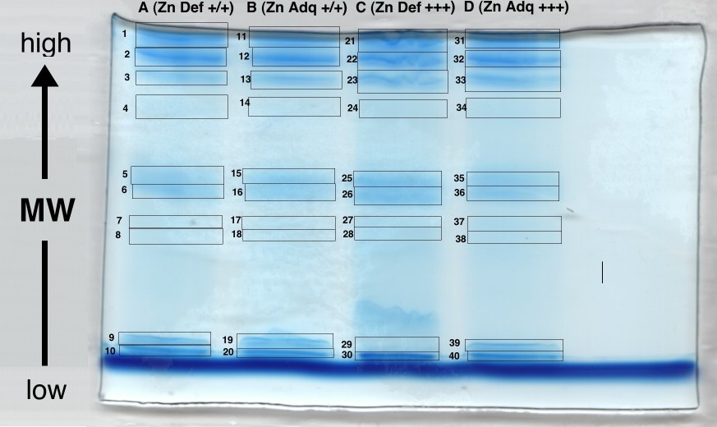
Figure 10. Location of BN-PAGE gel excisions for ESI-Q-TOF analysis. Samples A-D were obtained from four different mice bred as follows: Zn Def and Zn Adq refer to mice fed with a zinc deficient and adequate diet, respectively, and +/+ and +++ refer to the wildtype and overexpressed forms of Cu/Zn-SOD gene, respectively. Proteins toward top of the gel are generally of higher molecular weight than those toward the bottom. Dark blue bands represent the presence of protein, except for the large dye front at the bottom of the gel.

After defrosting, the samples were vortexed with 50% acetonitrile/50% 50 mM ammonium bicarbonate (v/v) twice for 15 min, removing and saving the liquid each time. The samples were vortexed again with 100% acetonitrile for 15 min. All three liquid solutions were combined and concentrated to approximately 5 µL using a vacuum centrifuge. Each sample was then concentrated and purified using a ZipTip_{C18} pipette tip from Millipore (Billerica, MA) following the manufacturer’s instructions, resulting in a 5 µL sample in 0.1% trifluoroacetic acid/50% acetonitrile.

2.2.5. ESI-Q-TOF-MS/MS Analysis
Samples were analyzed using a quadrupole orthogonal time-of-flight mass spectrometer (Q-TOF Ultima Global Micromass/Waters, Manchester, UK) coupled to a nanoAcquity Ultra Performance LC (Waters, Milford, MA).
The Mascot search was used to aid in the interpretation of tandem mass spectral data. Searches were performed using the SwissProt (taxonomy mus musculus) database. Trypsin was selected as the digesting enzyme allowing for the possibility of up to one missed cleavage site. The following variable peptide modifications were allowed: oxidation (M), HICAT-HNE (CHK), HICAT-DDE (CHK) for the BN-PAGE samples and HNE (CHK), oxidation (M), oxidation (HW), ARP-HNE-Cys, ARP-HNE-HIS, ARP-HNE-LYS for the affinity chromatography samples. Mass tolerances were set to ±0.2 Da for the precursor ion and ±0.2 Da for the fragment ions.
Peak list files (pkl files) were created using MassLynx software (Waters, Milford, MA, USA) using a function that smoothes and calculates centroids of the data. Mascot calculates a Mowse score as a basis to validate the peptide identification. This score is based on the probability (p) that a peptide identified from the experimental fragment matches a peptide in a protein database, and is calculated as: Mowse score=−10×log (p). A random match will have a high probability value and low Mowse score, while a valid match will have a low probability value and a high Mowse score. Only MS/MS spectra that obtained a peptide score greater than 30, or less than a 0.1% probability of a random match were considered to be positive hits.

2.3. Results and Discussion
In collaboration with Dr. Emily Ho’s lab at Oregon State University, mice bred under four different conditions had hearts removed for mitochondrial protein analysis. It was hypothesized that the zinc-adqeuate mice and the mice with the overexpressed Cu-Zn-superoxide dismutase gene should have lower levels of oxidative damage, as zinc is required for Cu/Zn-SOD to convert superoxide to hydrogen peroxide. As seen in Figure 10, similar amounts of protein were used in each lane, as the Coomassie Blue dye is nonspecific. However, Figure 11 indicates that lane D has the darkest bands, so it has the most biotinylated, thus theoretically the most oxidatively damaged, proteins which come from zinc-adequate and overexpressed Cu/Zn-SOD mice. We would expect that lane A (zinc-deficient, wildtype Cu/Zn-SOD gene) should have the darkest bands, but this does not appear to be true.
Images of the destained gel (Figure 10) and developed film of the Western blotted membrane (Figure 11) were scaled and superimposed over each other (Figure 12), resulting in corresponding bands on both the gel and membrane. According to the data obtained from ESI-Q-TOF analysis, most of the bands were found to be associated with certain mitochondrial ETC protein complexes (Figure 12). The lower set of bands were found to contain a mixture of proteins, including cytochrome c, actin, and hemoglobin. Additionally, Complex V subunits were found in bands throughout the gel, as well as various cellular proteins such as those involved in the TCA cycle and ß-oxidation.

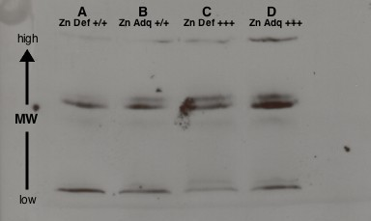

Figure 11. Western blot of mouse heart mitochondrial proteins separated by BN-PAGE and reacted with HICAT and NeutrAvidin. Dark bands represent the presence of biotin. Exposure time to the film was 1 hr. Arrangement and samples are the same as in Figure 10. Zn Def and Zn Adq refer to mice fed with a zinc deficient and adequate diet, respectively, and +/+ and +++ refer to the wildtype and overexpressed forms of Cu/Zn-SOD gene, respectively.

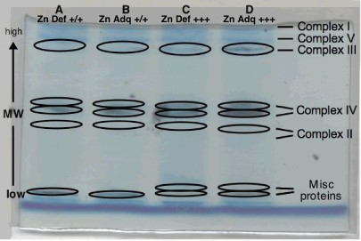

Figure 12. Overlay of Western blot and BN-PAGE gel of mouse heart mitochondria. Bands that were observed on the Western blot are circled. The lower unlabeled bands were found to contain a mix of cytochrome c, actin, hemoglobin, and other proteins. Arrangement and samples are the same as in Figure 10. Zn Def and Zn Adq refer to mice fed with a zinc deficient and adequate diet, respectively, and +/+ and +++ refer to the wildtype and overexpressed forms of Cu/Zn-SOD gene, respectively.
The most intense signal in the Western blot stained with HICAT-HRP, possibly an indication that it contains the highest concentration of oxylipid modified proteins, was found to contain peptides from Complex IV. Figure 13 shows an ESI-Q-TOF-MS/MS spectrum of a peptide from Complex IV, subunit II. Peptides from six other Complex IV subunits (I, III, IV, Va, Vb, VIIa) were found, and are shown in Figure 14. Polypeptide subunits were also detected from the four other ETC complexes, as shown in Table 3. Of the 90 known polypeptide subunits of the ETC complexes¹⁴, 54 were detected in our experiments.
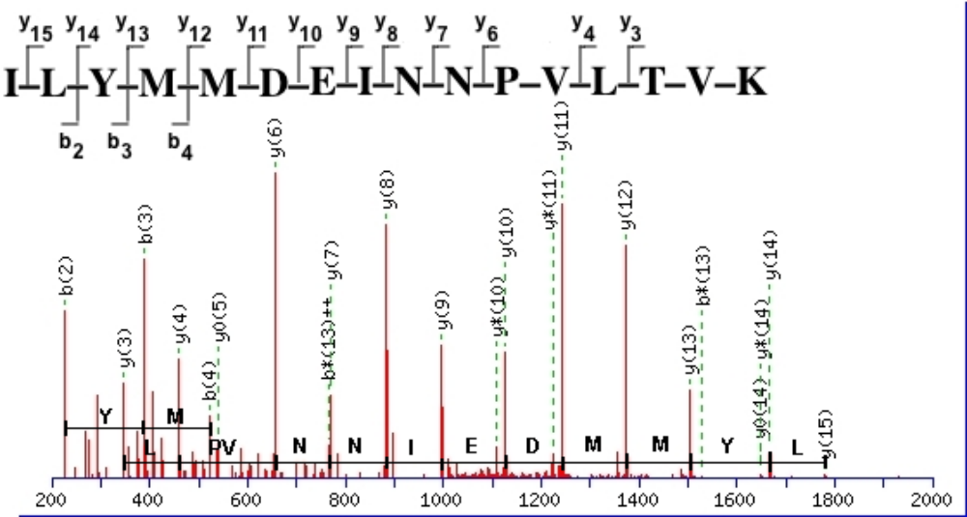

Figure 13. ESI-Q-TOF-MS/MS spectrum of a Complex IV subunit II peptide
encompassing the partial sequence ILYMMDEINNPVLTVK. The precursor ion used was the doubly charged ion of the peptide ([M+2H]²⁺ m/z 947.0). The b* and y* ions indicate loss of NH₃, y⁰ ions indicate loss of H₂O, and the b*(13)²⁺ ion indicates it is doubly charged, with a loss of NH₃. This spectrum was reconstructed by the Mascot search engine, and represents a close approximation of the original data. Sequences of the detected b and y-ions are shown above the spectrum.

Although a positive result was obtained with the Western blot experiment, subsequent experiments performed with a control (no HICAT probe added) also yielded visible bands on the developed film. Other experiments in which the HICAT probe was with replaced with biocytin and N’-aminooxymethylcarbonylhydrazino D-biotin yielded results similar to those using the HICAT probe. Furthermore, none of the MS/MS experiments have shown oxylipid modification to any protein from a BN-PAGE gel. A possible explanation is that the number of oxylipid modifications is extremely low relative to the mass of unmodified peptides, or that naturally biotinylated proteins exist in the mitochondrial protein samples. Thus, the results obtained are inconclusive.

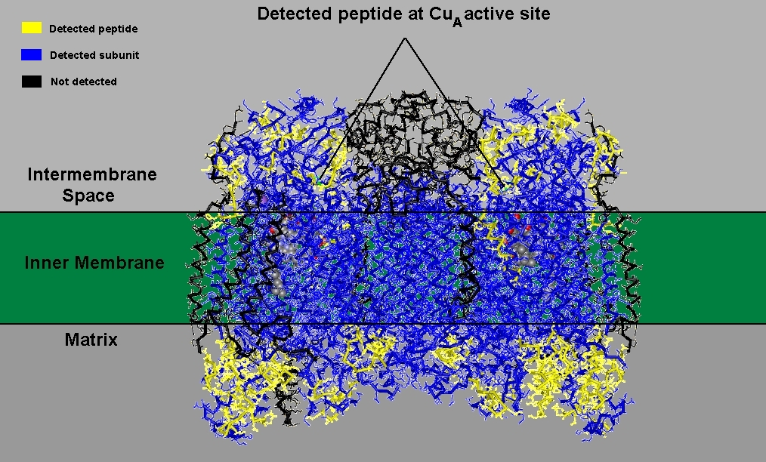
Figure 14. Coverage of Complex IV detected by ESI-Q-TOF-MS/MS. Yellow areas indicate peptides directly detected by ESI-Q-TOF-MS/MS, blue areas indicate subunits belonging to these peptides, and black areas indicate subunits not detected. Of note is the detection of a peptide near the Cu_{A} active site, which receives electrons from cytochrome c. Image created using DeepView/Swiss-PdbViewer (GlaxoSmithKline, Swiss Institute of Bioinformatics), PDB ID 2OCC (bovine heart cytochrome c oxidase)
Complex | # of Subunits Found (Theoretical)
I | 25 (46)
II | 3 (4)
III | 7 (11)
IV | 7 (13)
V | 12 (16)
Total | 54 (90); 60%

Table 3. Number of ETC polypeptide subunits with peptides detected by ESI-Q-TOF-MS/MS
3. MS ANALYSIS OF in vitro HNE-modified THIOREDOXIN ISOLATED BY AFFINITY CHROMATOGRAPHY

3.1. Introduction
N’-aminooxymethylcarbonylhydrazino D-biotin (Figure 15) is an aldehyde reactive probe (ARP) that reacts with aldehyde/keto functionality groups in LPO products.¹⁵ The oxime derivative produced with 4-HNE is shown in Figure 16. In this experiment, UltraLink-immobilized monomeric avidin from Pierce (Rockford, IL) was used as a packing material for affinity chromatography. Avidin and biotin have a strong affinity for each other, allowing for enrichment of biotin-tagged peptides.
In this experiment, thioredoxin (TRX) was used as an in vitro model for tagging oxidatively modified mitochondrial proteins. TRX is a small protein that is 108 amino acids long. There are two cysteines that are disulfide-linked; thus they are not available for oxylipid modification. However, there is one histidine residue that is exposed at position 6.
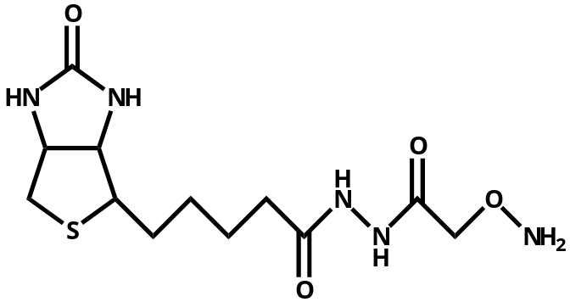
Figure 15. The chemical structure of N’-aminooxymethylcarbonylhydrazino D-biotin

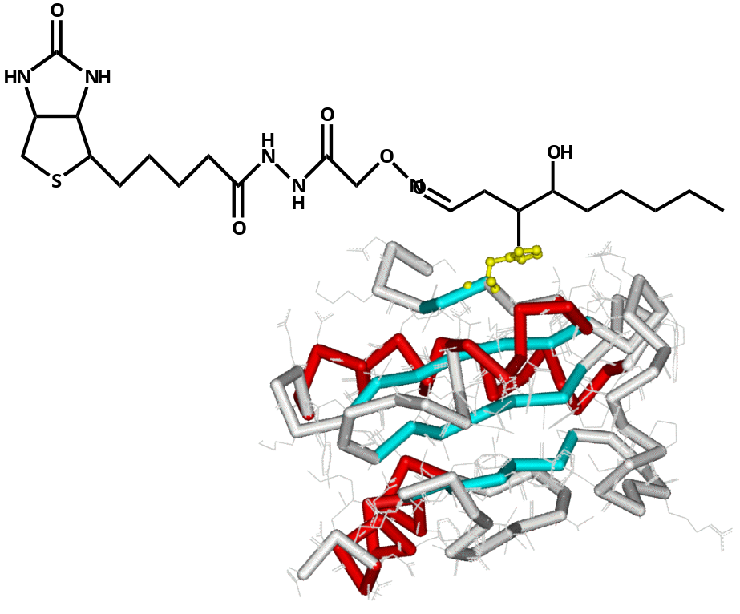

Figure 16. The chemical structure of HNE-ARP adducted to thioredoxin at His-6. Image created using iMol (Rotkiewicz, P.), PDB ID 2TRX (Escherichia coli thioredoxin)

3.2. Experimental
3.2.1. Sample Preparation
Escherichia coli thioredoxin from Promega (Madison, WI) was obtained in dry form, and 1 mg (82 nmol) was dissolved into 1 mL of 10 mM sodium phosphate, pH 7.4. A ten-fold molar excess (13 µL) of 10 mg/mL HNE was added and allowed to react at 37˚C for 2 hr. The product was purified from unreacted material by HPLC using a C₄ column (Vydac, 10 x 250 mm, 5 µm) and then lyophilized.
TRX-HNE was then labeled with ARP from Dojindo Laboratories (Kumamoto, Japan) by adding 250 µL of 10 mM ARP to 750 µL of reconstituted TRX-HNE in 10 mM sodium phosphate, pH 7.4. The reaction was allowed to incubate at 37˚C for 3.5 hr, then purified by HPLC and lyophilized as before. The final product was digested with trypsin at a 1:50 ratio at 37˚C for 18 hr.

3.2.2. Affinity Chromatography
A glass Pasteur pipet was plugged with glass wool, and 100 µL of UltraLink monomeric avidin was added. After equilibration to room temperature, the column was washed with five column volumes of PBS buffer. Irreversible binding sites (multimeric avidin) were blocked with three column volumes of 2 mM D-biotin, and then excess biotin was removed from the reversible sites (monomeric avidin) with five column volumes of 0.1 M glycine, pH 2.8. After reequilibration with five column volumes of PBS buffer, 100 µL of the tryptic digest was added and allowed to incubate for 1 hr.
After incubation, nonlabeled peptides were eluted with 10 column volumes of PBS buffer and collected in five equal fractions. Labeled peptides were eluted with 10 column volumes of 0.3% formic acid and collected in the same manner to minimize diluting the peptides. Both sets of fractions were then analyzed by both ESI-Q-TOF and MALDI-TOF-TOF mass spectrometry instruments.

3.2.3. MALDI-TOF-TOF-MS/MS Analysis

Samples were analyzed by MALDI-TOF-TOF-MS/MS using an ABI 4700 Proteomics Analyzer (Applied Biosystems, Inc., Framingham, MA). Analytes used in this MS/MS experiment were not present in sufficient concentrations for Mascot to identify any peptides; thus identification of peptides was performed manually by comparing the MALDI-MS data with the molecular weights of expected tryptic TRX peptides.

3.3. Results and Discussion
By using the Mascot search engine, various TRX peptides were detected by ESI-Q-TOF-MS/MS and MALDI-TOF-TOF-MS/MS (Figure 17). As expected, no labeled peptides were detected in the unlabeled peptide elution fraction (Figure 18). The TRX peptide IIHLTDDSFDTDVLK (P1) was found to have reacted with HNE and ARP, as shown in the obtained spectra (Figures 19 and 20). The similar relative intensities of the ARP-labeled and unlabeled peptide peaks in Figure 18 indicate that the ARP labeling reaction could be optimized further. However, at least a sufficiently large amount of ARP-labeled peptides appear to have been isolated by affinity chromatography so that no ARP-labeled peptides were detected in the nonlabeled peptide fraction (Figure 18). Some P1 was found without any modification in the nonlabeled peptide fraction, indicating that the HNE reaction was incomplete. Also, avidin peptides were detected by MALDI-TOF-MS (Figures 19 and 20). This may indicate that active trypsin remains in the digest upon application to the column, and the immobilized avidin is being digested.
Data from ESI-Q-TOF-MS/MS experiments show that adduction of HNE and HNE-ARP takes place at the His-6 residue, indicated by the presence of the b₂ ion at m/z 227.1 and the b₃ ion at m/z 833.5. The m/z difference of these two ions corresponds to the m/z of HNE-ARP added to histidine. The sequence of the peptide was verified as most of the b-ions and y-ions were observed in the MS/MS mass spectrum (Figure 21).

SDKIIHLTDD SFDTDVLKAD GAILVDFWAE WCGPCKMIAP ILDEIADEYQ GKLTVAKLNI₆₀ DQNPGTAPKY GIRGIPTLLL FKNGEVAATK VGALSKGQLK EFLDANLA₁₀₈
*
*
*
*

Figure 17. Amino acid sequence of oxidized thioredoxin recombinantly expressed in E. coli. Underlined and italicized amino acid residues indicate those detected by MALDI-TOF-MS and ESI-Q-TOF-MS/MS, respectively. The bolded histidine-6 was the only detected location of HNE-ARP adduction. Of note are the disulfide-linked cysteines at positions 32 and 35, which are protected by the disulfide bridge from adduction by LPO products.

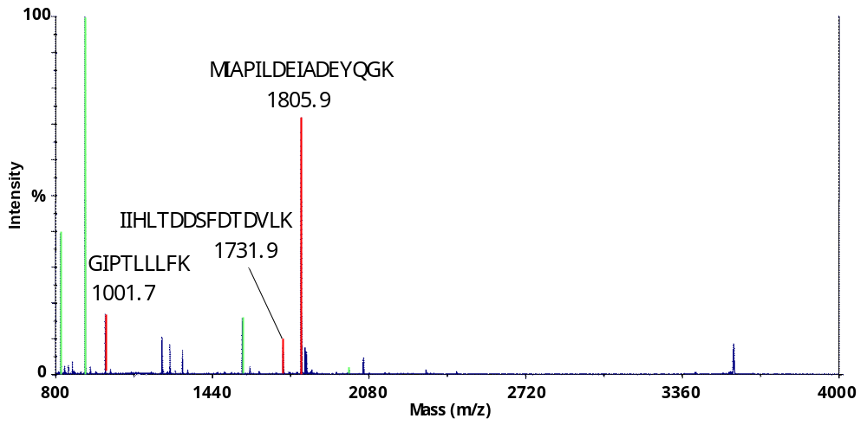

Figure 18. MALDI-TOF-MS spectrum of nonlabeled peptide elution fraction. TRX peptide peaks are shown in red, avidin peptide peaks are shown in green.

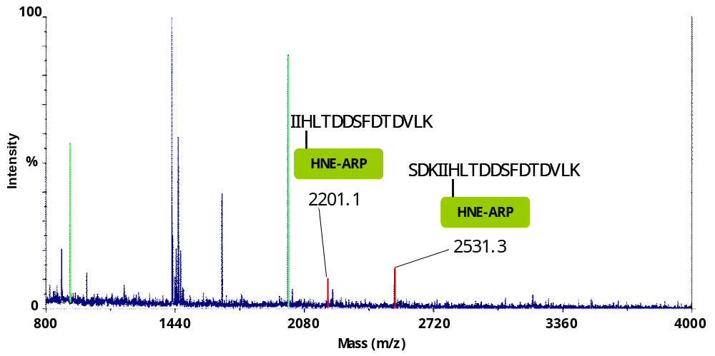

Figure 19. MALDI-TOF-MS spectrum of labeled peptide elution fraction. TRX peptide peaks are shown in red, avidin peptide peaks are shown in green.

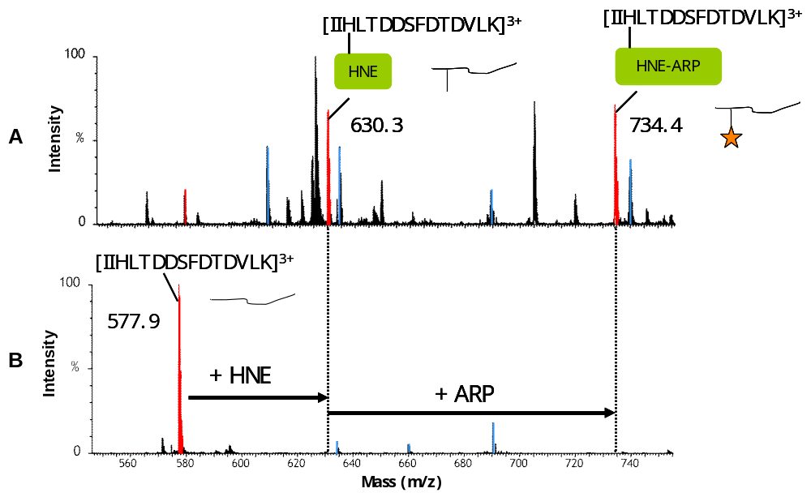

Figure 20. ESI-Q-TOF-MS spectra of a tryptic digest of thioredoxin reacted with HNE and ARP. Spectra shown are (A) with and (B) without HNE and ARP modifications. Other TRX peptides unreactive with HNE and ARP are shown in blue.

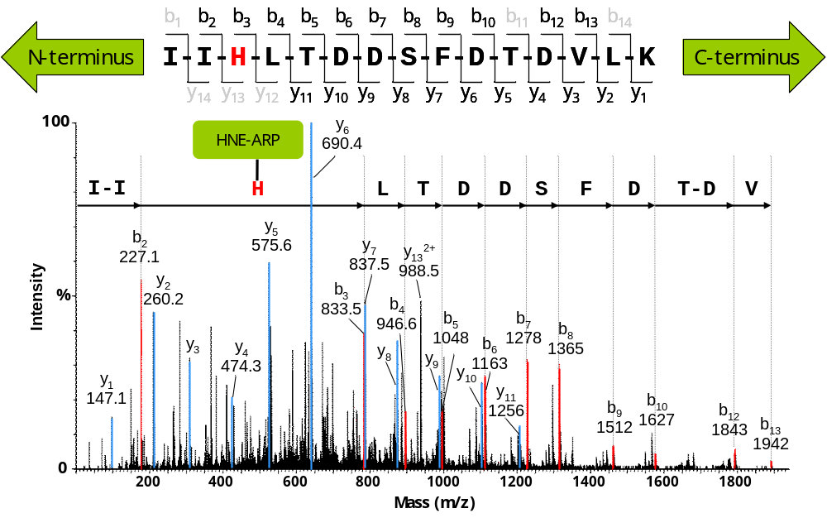

Figure 21. ESI-Q-TOF-MS/MS spectrum of the peptide IIHLTDDSFDTDVLK. This peptide encompasses residues 10 to 18 of thioredoxin. Adduction to His-6 by HNE was determined by comparing the m/z difference between the b₂ and b₃ fragment ions. B-ion peaks are shown in red, y-ion peaks are shown in blue. The precursor ion used was the triply charged ion of the peptide ([M+3H]³⁺ m/z 734.4).
4. CONCLUSION

We have successfully separated and identified the mitochondrial electron transfer chain complexes using a combination of BN-PAGE and liquid chromatography-tandem mass spectrometry. However, at this point, data from the blue-native gel experiments regarding the detection of oxidatively modified proteins using hydrazine-based biotinylation reagents in combination with Western blotting and avidin affinity staining remain inconclusive because positive staining was observed in presence and absence of biotinylation reagents. The presence of a signal in the control experiments indicates that further work remains to be done in this set of experiments. A possibility is to excise a band from the BN-PAGE gel and perform a second dimension of SDS-PAGE to separate the protein complexes into their component subunits.
The model studies performed using TRX show that the ARP label can be used to tag proteins that have been oxidatively modified. One issue that remains is the digestion of the immobilized avidin, which may be solved by altering some of the parameters of the experiment, such as the column pH, temperature, or perhaps the addition of a trypsin inhibitor. Future studies will involve developing an approach that can be effectively applied to mitochondrial membrane proteins. In doing so, a method of isolating and identifying oxidative damage to mitochondria would be established. The data from such experiments could potentially lead to the development of new drugs aimed to prevent or hold oxidative damage to mitochondria, possibly reducing the risk of congestive heart failure and aid in therapeutical strategies for other oxidative stress-related diseases.¹⁶
BIBLIOGRAPHY
1. H. Tsutsui, Intern Med., 2006, 45, 809-813.

2. G. Spiteller, Experimental gerontology, 2001, 36, 1425-1457.

3. L. J. Marnett, J. N. Riggins and J. D. West, The Journal of clinical investigation, 2003, 111, 583-593.

4. M. Yamashita and J. B. Fenn, J Phys Chem, 1984, 88, 4451-4459.

5. M. Karas, D. Bachmann, U. Bahr and F. Hillenkamp, Int J Mass Spectrom Ion Proc, 1987, 78, 53-68.

6. K. Markides and A. Gräslund, Advanced information on the Nobel Prize in Chemistry 2002, http://nobelprize.org/nobel_prizes/chemistry/laureates/2002/
chemadv02.pdf, Accessed Dec 15, 2006.

7. A. R. Bottrill, Time-of-flight Mass Spectrometry., http://www.jic.bbsrc.ac.uk/
SERVICES/proteomics/tof.htm, Accessed Dec 15, 2006.

8. B. M. Tissue, Quadrupole mass spectrometry, http://www.chem.vt.edu/chem-ed/ms/quadrupo.html, Accessed Dec 15, 2006.

9. H. Steen and M. Mann, Nature reviews, 2004, 5, 699-711.

10. P. Roepstorff and J. Fohlman, Biomed Mass Spectrom, 1984, 11, 601.

11. R. S. Johnson, S. A. Martin, K. Biemann, J. T. Stults and J. T. Watson, Anal Chem, 1987, 59, 2621-2625.

12. H. Schagger and G. von Jagow, Analytical biochemistry, 1991, 199, 223-231.

13. P. S. Brookes, A. Pinner, A. Ramachandran, L. Coward, S. Barnes, H. Kim and V. M. Darley-Usmar, Proteomics, 2002, 2, 969-977.

14. K. B. Choksi, W. H. Boylston, J. P. Rabek, W. R. Widger and J. Papaconstantinou, Biochimica et biophysica acta, 2004, 1688, 95-101.

15. H. Ide, K. Akamatsu, Y. Kimura, K. Michiue, K. Makino, A. Asaeda, Y. Takamori and K. Kubo, Biochemistry, 1993, 32, 8276-8283.

16. G. Aldini, I. Dalle-Donne, R. M. Facino, A. Milzani and M. Carini, Med Res Rev, 2006.

