Title: A Little About a Short Study- Abroad Course in Barcelona, and Everything You Always Wanted to Know about US Librarians
Laurie Bridges, Oregon State University Instruction and Outreach Librarian
Kelly McElroy, Oregon State University Student Engagement and Community Outreach Librarian
Kenya Juarez, Oregon State University Undergraduate Student

Introduction

[Kelly Speaks]

My name is Kelly McElroy, and I’m the student engagement and community outreach librarian at Oregon State University, and with me is my co-teacher, Laurie Bridges, and she is the instruction and outreach librarian at my university. We are here today because we are two US librarians teaching a university course, “Information and Global Social Justice.” We live in a town called Corvallis, in the state of Oregon. You may have heard of it, or not. It is located in the Northwest of the United States, just north of California. Our university is public and has approximately 29,000 students. The town our university is located in has about 60,000 residents. Interesting fact: For the past several years Oregon has been the number one destination for people who are moving within the US, between states. (Find out more about Oregon at traveloregon.com)

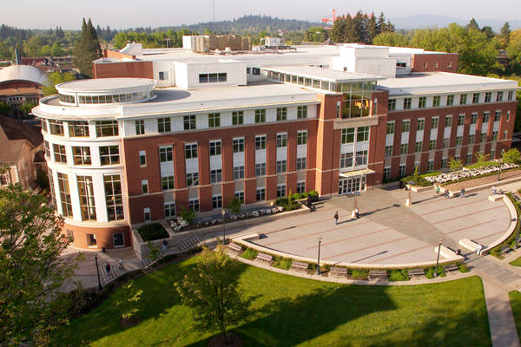
(Image: Oregon State University’s Valley Library)

So, this past weekend we flew from our beautiful state of Oregon to your beautiful city of Barcelona along with seven students from our university, ages 19 to 21. Yes, it is a small group, but this is our first time traveling with students and teaching this class, so we are happy with the small number.

We have been planning and developing this class for over a year, while also trying to explain to many of our international librarian colleagues what, exactly, it is we are doing. Eventually we came to the conclusion, “Maybe all these questions indicate that librarians are interested in what we are doing, and we could give a presentation about our class to librarians while we are in Catalonia.” So, we reached out to Carme Fenoll, who agreed to coordinate this presentation -- thank you Carme.

We both enjoy networking with and learning from other librarians, so feel free to ask questions at the end of our presentation. Although neither Laurie nor I speak Catalan or Spanish, today we have brought one of our students with us, Kenya Juarez, who speaks Spanish and she can help us with your questions. Also, at the end of our presentation we’ve asked Kenya to say a few words, in Spanish, about her experience in this class.

So, here we are, ready to tell you all about our study abroad class. But, before we can tell you the story, we need to tell you a few other things first.

Before we can launch into a discussion about our study abroad class, we think it’s important to tell you a bit about academic librarianship in the US. Of course there are many similarities between university librarians in Catalonia and the US, but there are also significant differences. And, to really understand our study abroad class, you will need to have a better understanding of academic librarianship in the US.

[Laurie Speaks]

However, before we can tell you about academic librarianship in the US, we need to tell you about how people become librarians in the US, since it differs quite a bit from other places.

We will quickly get to the story of academic librarianship in the US and the story about our study abroad class, but, we must start here because it is truly the beginning of our story. If you do not know any librarians in the US, then you may be unaware of the educational path to librarianship in the US, which is very different than in Catalonia and many other places.

In the United States, when students are transitioning from high school to university, they do not take a national exam. Instead, their university entrance is based on several factors. First is the student’s academic record from high school. Second is the student’s past experience and involvement with clubs, athletics, community service, and the list goes on. Third, is a short exam, which is quite different than the exam in Catalonia, and can be taken and retaken multiple times throughout high school.

The importance of each of these three factors depends on the selectivity of the university or college. Traditional age students (students going directly from high school to university) usually begin thinking about where they would like to go to university or college during their last two years of high school.

As an example, when I was applying to universities almost 25 years ago, I applied to two public universities, one in my home state of Nebraska, and one in the state of Montana. I could not afford private college and I my grades from high school would not have been high enough to get scholarships. Sometimes students choose where they want to go to university based on what they want to study, but I did not. I considered the university in my home state because it was close to my family and I considered the second one because it was in the mountains. I was accepted to both universities and chose the one closer to my family, about a 60 minute drive.

In my first year at the University I declared my major, which was English literature and writing. In the US students often begin their education at the university with no idea what they want to major in and they change their major many times while in the university. It is often said that “the average university student in the US changes their major three times.”

Now, you may be wondering, “Why is she telling us she got an English degree?” I’m telling you because I could not get a bachelor’s degree in library science. In the US, most students cannot get a bachelor’s degree, which is the the 4-year degree after high school, in library science. Also, please note that a student who is pursuing their bachelor’s degree is referred to as an “undergraduate” in the US. There are a few programs for undergraduates in LIS, but if a person wants to be a librarian in the US, they must get a Master’s degree, in a program accredited by the American Library Association (Find out more about ALA MLIS programs at http://www.ala.org/accreditedprograms/home). The Master’s degree is the 2-year degree after the bachelor’s degree. This means that the majority of librarians in the US usually do the following: Get a Bachelor’s degree in any discipline at all > get a job after graduation > after a few years decide they don’t like their job/career/profession > get a Master’s degree in library science > become a librarian. For example, before becoming a librarian, I worked in marketing and university student affairs; I started my MLIS at the age of 34 and I already had a Master’s degree in another field. This is typical, although it is changing -- when Kelly completed her MLIS in 2011, many of her classmates had enrolled directly after finishing their Bachelor’s. It is also worth noting that there are not many LIS programs in the United States -- in fact, in our home state of Oregon, there are none.

The fact that nearly all US librarians have a degree in some field other than LIS gives you a sense of the breadth of experience we bring to the profession.

[Kelly Speaks]

Now that you know how people become librarians in the US, we want to tell you another story, about academic librarianship in the US.

Both Laurie and I are academic librarians. And, at Oregon State University, we are at the same rank as other faculty. So, Laurie is an associate professor at our university and I am an assistant professor. Normally, professors have a doctorate degree, but at our university, librarians are professors with a Master’s degree, which is seen as the terminal degree for practitioners. We should tell you this is not the same at every university and college in the US -- in some universities, librarians are tenure-track faculty, in others, they are non-tenured faculty, and in others yet, they are staff, not faculty. In some ways, it doesn’t change the work that academic librarians do, but as we will describe, being professors does affect some of what we can do.

I’m sure that Laurie and I do many of the same things as university librarians in Catalonia. We are both teaching librarians, so we teach “one-shot” lessons to help students learn research skills. We both put together research guides about different subjects and topics. We meet one-on-one with faculty and students to help them with their research. We organize events in our library. Because of our rank as faculty, in addition to teaching one-shot lessons, we can also teach standard credit-bearing university courses. Laurie taught a university orientation class several years ago, and I have taught several courses as well.

However, there are some things we do that may be different. We work at a research university, which is a university where research is a central focus. While that may seem obvious, in the Unites States, many students attend liberal arts colleges where the focus is almost entirely on teaching. Liberal arts colleges are dedicated to the four-year undergraduate bachelor’s degree; usually emphasis is not on graduate degrees and most liberal arts colleges do not offer Master’s or PhD’s. In addition, liberal arts colleges almost always have a smaller number of students than a research university and also smaller class sizes. (For more on the classification of institutions of higher education in the US, see http://carnegieclassifications.iu.edu/index.php) In contrast, a research university like ours has many graduate programs, Master’s and PhD’s, and at all levels everyone is expected to engage in significant research. In fact, some faculty at our university engage only in research, with no teaching responsibilities. Considerable funding for the university comes from grants from the government and private companies for research conducted by faculty. At a research university many undergraduate classes at the lower levels are taught by graduate students.

Because we are professors at a research university we are required to do our own research and publish articles, books, or book chapters. For example, recently Laurie and I co-authored an article about access to information as a human right in higher education. Currently, I am co-editing two books about critical pedagogy in library instruction and Laurie is working with a librarian in Nigeria to write a conference paper about sister library partnerships for IFLA. We are encouraged to derive our research from our primary work assignments, so we explore issues that arise from librarianship. In total, 15-20% of our working time is spent on “Research and Scholarship.”

[Laurie Speaks]

And now that we have given a brief explanation of academic librarianship in the US, we are finally ready to tell you the story about the class we are teaching, Information and global social justice: Barcelona. (Find out more about our class at http://studybarcelona.weebly.com)

In the fall of 2014 I was attending a faculty workshop at OSU about study abroad because I am the library’s liaison for international programs and services. During the workshop I found out our university was attempting to launch more faculty-led short-term study-abroad classes. When the workshop concluded I left with an idea, “We (librarians) can lead students on short-term study abroad!”

While exchange programs like Erasmus, where students take courses at a foreign university, are popular in Europe, most US students who seek out an international university experience do so with programs that have links to their college or university in the US. Some US universities have locations abroad, or work with third-party providers, or help students enroll in university classes in the host country. When Kelly studied in Italy as an undergraduate she attended one term through Syracuse University, which has an outpost in Florence, and one term in Milan through IES, a third-party provider based in the US. However, over the past decade, faculty-led short-term study abroad has quickly become the most popular type of study abroad in the US, with over 60% (Fast Facts Open Doors, 2015) of students who study abroad doing so on these shorter, immersive, academic trips that last from a week to a term and are led by professors from the student’s university.

Kelly and I began planning in 2014 with a long-term goal in mind: to lead this short-term study abroad every year, for at least five years. This year Kelly and I are launching the class together by co-developing, co-teaching and co-leading--and obviously our location is Barcelona. However, next year Kelly will lead a group of students to Italy, and the following year I will be back in Barcelona. In each of the upcoming trips we will travel and co-lead with a different librarian. The class has taken an immense amount of planning, even more than we had expected, so we hope that by alternating every-other-year we can avoid overload and keep the class going into the future.

Now, a little bit more about the class, which is titled, “Information and Global Social Justice”. The easiest way to introduce you to the topic of the class is to read the first two paragraphs of our class description, as it appears on our course website, in our syllabus, and in all the promotional materials we gave to students.

“In preparing for any trip, many questions come up. How you answer these questions depends on the information available to you. In this course we will ask ourselves questions, from the simple to the more complex: What should I pack? How do I plan an international trip? What do I need to know to get around and talk with people? What information do we get about Barcelona and Spain in the US? What are the current social issues in Barcelona? How are these issues reported in the US? How do I know what I know? This course aims to help you explore the answers to these questions while building your confidence to travel and learn internationally. You will leave this class with a greater understanding of what it means to participate in a global society.

We will begin our research in class at Oregon State University and continue on location. In Spain you will live with a host family, participate in a service-learning activity, visit museums and galleries, explore cultural and historic locations, attend lectures, and talk with locals. While seeking answers to our questions we will reflect on the forces (politics, access, linguistic, economic, etc.) that affect the information available to us in the US.”

Our class is specifically designed for students going on their first trip abroad. As you may be aware, we Americans don’t travel outside of our country as much as Europeans do. Currently, approximately 1 in 3 Americans holds a passport, and this is way up compared to just 1989, when the number was 1 in 30 (Patiño, 2014). However, we should point out that it’s only been within the last fifteen years that Americans needed a passport to travel to Canada and Mexico, which may partially explain the rise in numbers. However, the proportion of Americans who hold a passport is still significantly lower than in Canada, where 2 in 3 people hold a passport (Livingston, 2015). In line with these figures, the numbers of US students studying abroad is not very high. About 10% of US university students study abroad during their undergraduate degree, and to a relatively small part of the world: 50% of US students who study abroad do so in Europe. Spain is the third most popular host country (Fast Facts Open Doors, 2015). In our class we have seven students, only one of whom has traveled overseas, and that was when he was 12 years old to visit family in Hong Kong. Three of our students have traveled to Mexico, also to visit family. We are excited and privileged to be traveling with such an intelligent and curious group of students as they all travel to Europe for the first time.

As we have already explained, there are no LIS programs in Oregon, so none of our students are studying to become librarians. Our seven students are studying various majors including finance, English, ethnic studies, human development and family science, communication, engineering, and one student who is undecided. Our undecided student has just completed her first year at the university and is hopeful this class will help her decide what she wants to study.

So, what are our students hoping to learn in this class? We think this is best explained by reviewing the learning objectives for the course:

- Build your own self-awareness, particularly your cultural self-awareness.
- Develop a deeper understanding of social justice in a global society.
- Deconstruct assumptions, describe how assumptions are formed, and challenge assumptions through critical reflection and by considering new perspectives.
- Locate and synthesize knowledge/information from a variety of sources to research a global social justice issue.
- Analyze some key similarities/differences between US and Spanish/Catalan cultures

These learning outcomes reflect our belief that information literacy can be woven into all areas of study and experience. The leading organization for academic librarians in the US is the Association of College and Research Libraries. Last year they published a new “Framework for Information Literacy” to replace the previous Standards, which outlined skills and tasks of successful university students. The framework is divided into six frames, and each frame consists “of a concept that is central to information literacy.” The link between the six concepts and what students experience and learn during an immersive faculty-led study abroad is undeniable. Here they are:
- Authority Is Constructed and Contextual
- Information Creation as a Process
- Information Has Value
- Research as Inquiry
- Scholarship as Conversation
- Searching as Strategic Exploration

For our course topic, you can see that issues of social justice and human rights fit squarely within several of these frames. For example, the Frame “Information Has Value” applies to our course conversations about the availability of information about global social justice issues to us in the United States. As supposedly “free” Internet news proliferates, and paid opportunities for trained journalists decline, how does that affect the amount and quality of international news available? For monolingual English-speakers, what information is available about the Catalan independence movement? These topics also require students to challenge their own assumptions about how authority is created and understood. For example, Americans who see that 77% of Spaniards identify as Catholic (International Religious Freedom Report 2006) might assume that there would be broad resistance to gay, lesbian, and bisexual rights; on the contrary, Spain of course legalized same-sex marriage long before it became legal across the United States. We hope that this course will help our students build their skills to find information about challenging topics, synthesize with their existing knowledge and beliefs, and take action.

[Kelly Speaks]

Now, we want to share with you more information about the class structure, travel, and assignments. However, we must admit -- in order to give Carme time to translate this presentation into Catalan, we had to write this before the course began! So we will leave specifics of what has happened so far to the question and answer period.

Before we left for Barcelona, we met every day for five days, two hours each day. Our activities focused on three major areas: building rapport between our group of students, introducing major concepts of global social justice, and helping students with their final preparations for the trip. This included a guest lecture by Dave Prats, who is from Girona and teaches Spanish at our university. Dave discussed Catalan culture and the independence movement with us. Students also did two assignments examining news available about Barcelona: from US newspapers and Spanish newspapers, including La Vanguardia.

After our week of class at OSU, we arrived in Barcelona on Monday. Our students are staying in homestays with local families. It was important to us that students have a chance to live with Barcelonans while they are here, for a more immersive experience. This week we have had class two hours a day and have had several field trips; we are working with CIEE (Council on International Education Exchange) here in Barcelona to coordinate all the logistics.

Each day in class, we begin with a five-minute quiet guided meditation, then ask students to journal about their experiences since the last class. We recognize that our students are learning all kinds of things during their time outside of class, as they eat dinner with their host families, learn to ride the bus, go down to the beach, and do all the other simple activities that make travel so stimulating and rich. One of our course learning objectives is focused on self-awareness, and these activities help students build practices of reflection and self-care that will serve them well beyond this course.

We want to conclude this portion of our presentation by telling you about the final project for the class. As part of our preparation while we were still at home, each student identified a social justice topic they wanted to examine in greater detail: for example, immigration, language, or prison and incarceration. They started with some reflection on their assumptions about the topic in their community at home and here in Spain: how do they expect Spain and the US to be similar or different? They have done some research already, and will continue throughout their time here, including talking with people, observing in public as appropriate, and of course reading. Each student will then contribute a chapter synthesizing their research and reflections to an interactive ebook using the Scalar platform. This project is a way for students to share what they have learned in a public forum, so that they can share it with their friends and family, as well as potential employers, and so we can show the impact of the class. We have a sign-up sheet -- if you would like to receive a link once we get everything up online, please sign up at the end of our presentation.

In Conclusion
In many ways, two weeks is such a short time. We are almost halfway through our time here, and we suspect our students are already getting used to hearing both Catalan and Castilian Spanish, riding public transportation in a large city, eating late dinners, and walking on the crowded Ramblas. However, this course is not intended as any type of conclusion -- rather, we hope that this experience serves as a catalyst for lifelong learning, and our students will continue to explore opportunities internationally.

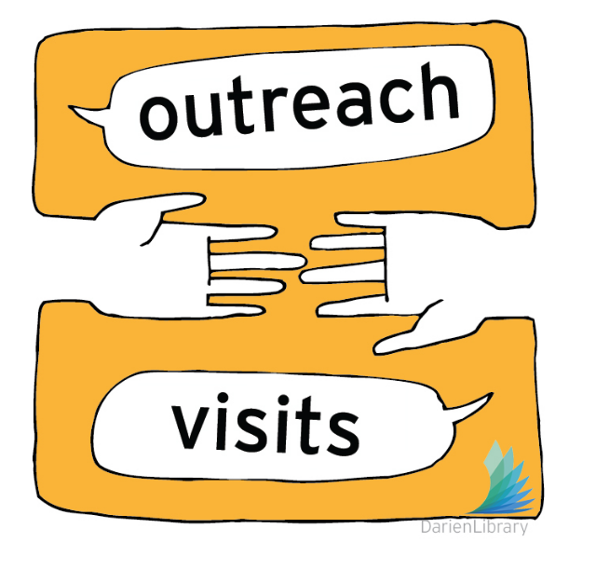
(Image: Used with permission from Lisa Nowlain)

We also hope that leading this class and speaking about our experiences, will inspire other librarians to think big when it comes to teaching the skills of information literacy. Librarians all over the world are experts in research and information-finding and we have the skills needed to educate and teach students, not just how to do research in a library, but for lifelong learning.

While Laurie and I are in Barcelona, the two of us are meeting with both public and academic librarians, to discuss librarianship and find inspiration from the libraries and librarians here. We are interested in how you work with collections and patrons across multiple languages; how you connect with immigrant patrons and foreign visitors; how you incorporate new digital resources into your work; how scholarly publishing is changing; and how you connect and do outreach with students or other users groups. Just as our students are comparing and contrasting social justice issues, we are looking for points of difference and similarity to learn from.

We welcome your comments and questions, thank you for listening.

References

Bernasek, A. (2014, August 26). Record Number of Americans Now Have Passports. Newsweek. Retrieved May 18, 2016, from http://www.newsweek.com/2014/09/05/record-number-americans-now-have-passports-266347.html

Livingston, I. (2015, February 21). Americans are Finally Traveling Abroad. USA Today Travel. Retrieved May 18, 2016, from https://usattravel.wordpress.com/2015/02/21/this-infographic-shows-the-percentage-of-americans-with-passports-is-up-35/

Open Doors. (2015). 2015 Fast Facts. Retrieved May 18, 2016, from http://www.iie.org/~/media/Files/Corporate/Open-Doors/Fast-Facts/Fast-Facts-2015.pdf?la=en

U.S. Department of State / Spain International Religious Freedom Report, 2006 (Rep.). (n.d.). Retrieved May 18, 2016, from Bureau of Democracy, Human Rights, and Labor website: http://www.state.gov/j/drl/rls/irf/2006/71409.htm

