RECYCLING POTENTIAL OF SEQUENTIAL HYDROTHERMAL LIQUEFACTION AQUEOUS CO-PRODUCT USING CHLORELLA VULGARIS

By

WILLIAM JACOB WALLACH

An Undergraduate Thesis Submitted to

Oregon State University

In partial fulfillment of

the requirements for the

degree of

Baccalaureate of Science in BioResource Research,

Bioenergy and Biotechnology Options

October 16, 2016

**APPROVED:**

 _____________________________________________________       _______________

 Faculty mentor, department                           Date

 _____________________________________________________       _______________

Secondary mentor, department                           Date

 _____________________________________________________       _______________

Katharine G. Field, BRR Director                         Date

                                   © Copyright by William J. Wallach, March 13, 2017.

I understand that my project will become part of the permanent collection of the Oregon State University Library, and will become part of the Scholars Archive Collection for BioResource Research. My signature below authorizes release of my project and thesis to any reader upon request.

**_______________________________________________________ ____________**

**William Jacob Wallach Date**

TABLE OF CONTENTS

Acknowledgements vi

Abstract vii

Highlights vii

Keywords vii

1. Introduction 1

1.1 biofuels for sustainable energy 1

1.2 algae as Feedstock 1

1.3 hydrothermal liquefaction 2

1.3.1 Microalgae in Hydrothermal Liquefaction 3

1.3.2 Novel Sequential Hydrothermal Liquefaction 4

1.4 primary aqueous co-product recycling 4

2. Materials and Methods 5

2.1 primary aqueous co-product production 5

2.2 algae cultivation 6

2.2.1 Growth Media 6

2.2.2 Inoculation 6

2.2.3 Photobioreactor Conditions 7

2.3 growth analysis 7

2.3.1 Hemocytometric Analysis 7

2.3.2 Gravimetric Analysis 8

2.4 elemental analysis 8

2.5 statistical analysis 8

3. Results 8

3.1 algal growth 8

3.1.1 Treatment Means and Deviation 9

3.1.2 Incremental Growth Rates 10

3.1.3 Gravimetric Weight Analysis 11

3.2 statistical analysis 12

3.3 elemental analysis 13

4. Discussion and Conclusions 14

4.1 growth analysis 14

4.1.1 Growth Curve Interpretations 14

4.1.2 Toxicity and Nutrient Reserves in the Primary Aqueous Co-Product 15

4.1.3 Statistical Interpretation 16

4.1.4 Dry Weights 17

4.2 carbon and nitrogen tracking 17

4.3 commercial application 18

4.3.1 Direct Recycling 18

4.3.2 Partial Nutrient Recycling 19

4.3.2 Limitations 19

4.3.4 Future Direction for Research 20

5. Appendices 21

5.1 photobioreactor photographs 21

5.2 raw data 23

6. References 23

# 

# Acknowledgements

I am deeply grateful to Dr. Ganti Murthy for his guidance and teaching as my mentor and for giving me the opportunity to conduct research in his laboratory. I would also like to thank my research committee, particularly Dr. Kate Field, for providing me direction and support as I wrote my dissertation, and the graduate students in the Biological and Ecological Engineering Department who have continually given me support and feedback throughout both the research and the writing stages of my project. This research was funded and supported by the Agriculture and Food Research Initiative Competitive Grant No. 2011-68005-30407 from the USDA National Institute of Food and Agriculture.

# Abstract

Bio-oil from hydrothermal liquefaction (HTL) represents a promising fuel source due to large higher heating values and compatibility with current energy infrastructure. For bio-oil production to become commercially viable, novel methods of co-product recycling must be explored.

The aims of this study were to culture *Chlorella* *vulgaris*, a common HTL feedstock, in various concentrations of the effluent wastewater produced from a novel method of hydrothermal liquefaction. This process, known as nutrient recycling, was used to explore the possibility of improving net efficiency by reducing fertilizer and water inputs while simultaneously investigating the toxicity of the effluent wastewater. Results indicated that *C.* *vulgaris* was able to grow in all concentrations of the wastewater, though growth was partially stunted if no prior dilution occurred. Growth of *C*. *vulgaris* was optimized between 25% and 50% concentration of the effluent wastewater compared to a growth media control. With no dilution of the wastewater, C*. vulgaris* was able to reach a biomass concentration of 1,100,000 cells/mL suggesting that a partially closed-loop reactor in a commercial setting is plausible. Further research is needed to determine whether this process is scalable.

# Highlights

► A partially closed loop Sequential HTL reactor is proposed.

► Growth of *C. vulgaris* is optimized between 25% and 50% dilution of the effluent wastewater. ► Toxicity of the undiluted effluent wastewater forced *C. vulgaris* into an early stationary phase.

# Keywords

Sequential Hydrothermal Liquefaction; *Chlorella vulgaris*; Nutrient Recycling; Bio-oil; Aqueous Co-Product

# 1. Introduction

## 1.1 Biofuels for Sustainable Energy

The inevitable depletion of earth’s petroleum reserves and the effects of greenhouse gases on the environment highlight the need for technological improvements in the biofuel sector. Biofuels are solid, liquid or gaseous fuels derived from organic matter. Compared to other forms of renewable energy, biofuels allow easier storage of solar energy and are compatible with pre-existing engines and transport infrastructure [1]. Burning biofuels releases roughly the same amount of carbon into the atmosphere as the feedstock sequestered while growing, enabling biofuels to be a carbon neutral source of energy [2]. Still, biofuels are not without drawbacks. First generation biofuels are derived from edible crops and compete with agriculture for usable food. Second generation biofuels are derived from nonedible oils or from lignocellulosic feedstocks and require large areas of land and freshwater for production. In contrast, third generation biofuels are derived from algae and offer advantages over the former options [3].

## 1.2 Algae as Feedstock

Algae are relatively simple aquatic organisms that can exhibit various metabolic patterns including photoautotrophy, photoheterotrophy, organoheterotrophy and mixotrophy [4]. There are currently over 44,000 identified species of algae ranging from large macroalgae such as seaweeds to unicellular microalgae [5]. The useful components of algal biomass include proteins, lipids and carbohydrates. Microalgae have higher lipid and lower carbohydrate concentrations compared to macroalgae, making microalgae a more attractive feedstock for biodiesel production [6]. In addition, microalgae have several inherent advantages over terrestrial sources of biofuel, including: 1) non-seasonal growth, allowing for year round harvesting; 2) the ability to use sources of water unfit for agricultural production, like sewage or agricultural runoff; 3) the ability to be farmed in areas unfit for agricultural production; 4) significantly higher lipid contents than other feedstocks (70% by mass in certain strains); and 5) useful co-products, particularly algal polysaccharides which are widely used in food, textile, painting and cosmetic industries due to their water retention and film forming properties [7], [8], [9].

## 1.3 Hydrothermal Liquefaction

Despite these advantages, technological and economic constraints limit the commercialization of algal-derived fuel. Two major concerns that must be addressed to make algal-derived fuel more commercially viable are: 1) more efficient conversion of algal cells to biofuel; and 2) identifying uses for co-products created by conversion processes [10]. Bio-oil production from microalgae is a particular area of increasing interest due to the similarity of upgraded bio-oil to petroleum fuel. Bio-oil is created by the thermal processing of lipid rich biomass using processes such as hydrothermal liquefaction (HTL) [11]. Hydrothermal liquefaction is the thermochemical conversion of biomass into bio-oil using hot, pressurized water to degrade biomass in a closed reactor. HTL conditions vary from 200 C° to 400 C°, with pressures ranging from 5-25 MPa [12].

Due to changes in its density and dielectric constant, water begins to first act like an acid and then like an organic solvent as temperature and pressure increase [13]. In a single phase environment, these property changes solubilize the reactor contents and cause biological polymers to degrade and repolymerize to form four main products: 1) bio-oil; 2) aqueous co-product; 3) residual gases; and 4) bio-char. Bio-oil created from the HTL process is the most commercially attractive product due to petrol-like properties [14]. Residual gasses created from HTL mainly consist of carbon monoxide and carbon dioxide and are created in quantities that are of little economic use. Bio-char is the residual solids from HTL and has a high nitrogen content making it an attractive fertilizer [15]. The aqueous co-product (ACP) is created as an effluent wastewater from HTL and is the second most attractive product created from the HTL process. The ACP is formed from the breakdown of polysaccharides and nitrogenous compounds that are not converted to bio-oil or bio-char. Elliot et al. tabulated forty-eight different compounds commonly identified in the ACP of most biomasses after HTL [16]. These compounds include toxins and environmental contaminants such as ammonia, toluene, phenol, aziridine, benzene and 2-methylarizidine, which are formed from the breakdown of the nitrogenous organic compounds in the biomass. Ammonia is produced via pyrolytic deamination of cellular proteins and acts as a catalyst to further degrade these commercially attractive nitrogenous organic compounds into a more toxic form [17]. These toxins complicate the prospects of using the ACP as a potential source of income due to treatment costs.

### 1.3.1 Microalgae in Hydrothermal Liquefaction

Microalgae are well suited for HTL. Their small particle size (3-30 μm diameter) removes the need for grinding, milling or other forms of preprocessing to break down the biomass further [18].Bio-oil created from HTL processing of microalgae has a large higher heating value because the non-lipid components of the microalgae can be converted into bio-oil.Dote et al. demonstrated this using an algal feedstock that contained 50% natural oil by mass, then converting it to a bio-oil mixture that contained 64% oil by mass using HTL with a sodium carbonate catalyst [14]. Certain catalysts have been shown to increase the overall bio-oil yields in small concentrations. However, the use of catalysts is outside the scope of this review and is not mentioned further. The high moisture content of algae is beneficial to the HTL process because it reduces water inputs. Using water as the green solvent allows for a direct feed of wet biomass into the reactor and bypasses an expensive heat-drying pretreatment process [19]

### 1.3.2 Novel Sequential Hydrothermal Liquefaction

A novel type of HTL, sequential hydrothermal liquefaction (SEQHTL), was developed at Washington State University in 2012. This two-stage process uses a subcritical water extraction to recover useful products at a lower temperature (160 C°) and then uses a higher temperature HTL (240 C°) to extract the bio-oil from the remaining biomass [20]. The first stage at a lower temperature serves to break down the algal cell wall, requiring a much lower energy input in the second stage to achieve a similar bio-oil yield compared to conventional HTL. This vastly reduces the overall energy input during production. Carbohydrate removal in the first stage increases contact between the lipids and the water in the second stage, further improving the overall bio-oil yield. The first stage creates a primary aqueous co-product (PACP) as an additional product compared to conventional HTL [21].

## 1.4 Primary Aqueous Co-Product Recycling

The novelty of SEQHTL makes extensive characterization of the PACP a relatively unexplored area of study. The first stage at lower temperatures removes some of the carbohydrate and protein components prior to their conversion to toxic compounds [22]. It could be conjectured that with these toxic compounds in lower concentrations in the PACP, the potential for direct nutrient recycling may be greater. Direct nutrient recycling of the ACP is another benefit of using microalgae as a feedstock at the commercial level. To reduce the overall inputs of a hypothetical commercial reactor, the nutrients in the PACP could be used to grow more feedstock, thus improving the efficiency of the process. Significant reserves of usable nitrogen, phosphorus and organic carbon, as well as micronutrients such as K, Fe, Ca and Mg, exist in conventional ACP [23]. Previous work by Jena et al. demonstrated that at least tenfold dilutions are needed to cultivate microalgae in the ACP from conventional HTL due to its toxicity [18]. The goal of this research was to determine the degree to which PACP must be diluted for optimization as a microalgae cultivation media and to measure the toxicity and nutrient reserves in the PACP to determine the viability of a hypothetical SEQHTL plant with reduced water and fertilizer inputs.

# 2. Materials and Methods

## 2.1 Primary Aqueous Co-Product Production

Powdered *Chlorella vulgaris* was purchased from Shaanxi Guanjie Technology Co. as a feedstock*.* The feedstock was stored at -20 C˚ until further use. The primary stage of SEQHTL was carried out in 60 mL Swagelok stainless steel reactors. Each reactor contained 36 grams of deionized water and 4 grams of feedstock algae to form a 10% solids content. This solids content was chosen based on work conducted by Chen et al. demonstrating that bio-oil production at the second stage of SEQHTL is optimized when using this solids content during the first stage [20]. A fluidized sandbath (SBL-20, Techne Calibration, Staffordshire, United Kingdom) was used to heat the reactors to 160 C˚ for 20 minutes. These temperatures and residence times have been demonstrated to optimize the residual solids for the second stage of SEQHTL,making these conditions ideal in a commercial setting. The PACP was separated from the residual solids via centrifugation at 1000 rpm for 10 minutes and stored for later elemental analysis. Sterility of the PACP could not be guaranteed. Prior to inoculation, the pH of the PACP was raised to 13 using NaOH then lowered to seven using HCL for sterilization purposes before being stored at 0 C˚. This process is known as liming and was performed on the PACP because it has also been demonstrated to reduce the toxicity of certain wastewater streams [24].

## 2.2 Algae Cultivation

The algae strain used in this experiment was *Chlorella* *vulgaris* (Strain No. 2714) obtained from the Culture Collection of Algae at the University of Texas, Austin (Austin, TX, USA).

### 2.2.1 Growth Media

A modified Bristol’s medium composed of 0.75 g/L NaNO3, 0.025 g/L CaCl2·4H2O, 0.075 g/L MgSO4·7H2O, 0.15 g/L K2HPO4, 0.225 g/L KH2PO4, 0.025 g/L NaCl and 1.0 g/L NaHCO3 was prepared to dilute the PACP. Growth media were autoclaved at 120 C˚ for 20 minutes prior to mixing. Carbonate was chosen over an organic source of carbon to reduce the possibility of contamination by heterotrophic microbes. The pH-adjusted PACP was diluted using the modified Bristol’s medium to concentrations of 0%, 25%, 50%, 75% and 100%. Three replicates of each concentration were added to 250 mL screw-cap media bottles to be used as photobioreactors. The total volume was brought to 140 mL before inoculation. Table 1 presents the dilution schemes and photobioreactor designations.

|  |
| --- |
| Table 1.  Experimental dilutions of Primary Aqueous Co-Product. Three replicates of each dilution were created for this experiment. |
| |  |  |  |  | | --- | --- | --- | --- | | Designation | 1° Aq. Phase added | Growth Medium Added | 1° Aq. Phase Concentration | | Positive Control | 0 mL | 150 mL | 0% | | Heavy Dilution | 35 mL | 105 mL | 25% | | Mid Dilution | 70 mL | 70 mL | 50% | | Light Dilution | 105 mL | 35 mL | 75% | | Negative Control | 140 mL | 0 mL | 100% | |

### 

### 2.2.2 Inoculation

Fifteen five mL samples of the culture were centrifuged at 100 rpm for two minutes to form algae pellets. The pellets were decanted, then added to each of the fifteen photobioreactors.

### 2.2.3 Photobioreactor Conditions

The photobioreactors were kept on a shaker table moving at 50 rpm in an incubator room at 25 C˚. Each photobioreactor was maintained under a 24-hour light outputting 50.38 PAR of cool white fluorescent light. A handheld pH probe was used to measure the pH of each individual photobioreactor. The pH was adjusted via CO2 distributed to each photobioreactor using an 18-valve gas distributor. One half mL of Tween-80 polysorbate surfactant was added to each photobioreactor to prevent a buildup of pressure with the addition of CO2.

## 2.3 Growth Analysis

Growth in the 15 photobioreactors was measured using a spectrophotometer (Spectronic Genesys 10 Bio, Thermo Fisher Scientific, Ontario, Canada). Cell growth was monitored by measuring absorbance at 650 nm. Samples for spectrophotometric analysis were taken prior to inoculation and at 0, 24, 48, 72, 96, 120, 144 and 168 hours after inoculation. The absorbance data was used to construct growth curves. Each treatment was averaged at each sampling interval and a standard deviation was calculated. The derivative of each treatment mean was taken with respect to the sampling interval to yield incremental growth rates for each treatment at each interval. Hemocytometry was used to correlate optical density (OD) with cell density to measure the cell concentration (cells/mL).

### 2.3.1 Hemocytometric Analysis

The algal strain used in this experiment was diluted to five dilutions with decreasing optical densities. Cell suspension was pipetted onto a hemocytometric grid and the number of cells per grid were counted under a microscope [25]. A linear equation was constructed to give the cell density in total cells per milliliter as a function of the OD.

### 2.3.2 Gravimetric Analysis

Gravimetric analysis was performed using one milliliter samples of the inoculum and photobioreactors at the conclusion of the experiment. Samples were deposited onto glass filter paper after the filter papers had been weighed and the difference in weight was measured after the samples had spent 24 hours in a hot air convection oven (VWR 1300U, Sheldon Manufacturing Inc., Cornelius, OR) at 105 C˚. The differences in weight for the inoculum and photobioreactor samples were multiplied appropriately to estimate the total starting algal mass in each sample and the final algal mass in each sample.

## 2.4 Elemental Analysis

An elemental analyzer (ThermoQuest NC2500 Elemental Analyzer, Thermo Fisher Scientific, Waltham, MA) was used to perform a carbon and nitrogen analysis on the undiluted aqueous phase before inoculation, the feedstock algae, the biochar produced from the experiment, the culture algae and the negative control after the experiment had concluded. This data was used to track the changes in nitrogen and carbon concentrations throughout the experiment.

## 2.5 Statistical Analysis

The data was processed using GraphPad Prism V7.0 [26]. The significance of the difference between the growth in each treatment mean was calculated using a repeated measure one-way ANOVA Test. The p-value was calculated to four significant digits and a threshold value of 0.05 was used to determine significance. A threshold of 5.312 was used for the F-statistic.

# 3. Results

## 3.1 Algal Growth

The objective of this study was to evaluate the effect of media composition on algal growth. Three replicates of five dilutions were created to test for an optimized growth media. Growth was determined by monitoring the cell concentration over a seven-day period. As denoted by gravimetric analysis on the UTEX culture, each photobioreactor was inoculated with approximately 10.5 mg of live algae. Hemocytometric analysis for the UTEX *Chlorella* *vulgaris* yielded an approximate cell density of 966,500 cells/unit of absorbance. Dividing the absorbance of algal samples of known volume and density by the total cells per unit of absorbance allowed the growth curves and biomass concentrations to be measured in cells/mL and mg/mL per unit of absorbance respectively.

### 3.1.1 Treatment Means and Deviation

*Chlorella vulgaris* was able to grow in all three replicates of the five dilutions (Appendix 5.1). Figure 1 shows the growth curves of each treatment mean in cells/mL. All treatments followed a similar pattern of growth during the first two days of the experiment before the means began to diverge. No treatment appeared to enter a death phase before the final stage of the experiment*.* Growth in the negative and positive controls slowed during the last two days of measurement, indicating these treatments may have been entering a stationary phase [27]. Excluding the controls, the final biomass concentration increased with decreasing concentration of the PACP. At the conclusion of the experiment, the positive control had a higher biomass concentration than the negative control. Final cell concentrations varied considerably, ranging from 2.52 mg/mL to 1.1 mg/mL.

|  |
| --- |
|  |
| Fig. 1.  Mean growth of *C. vulgaris* in each treatment determined by optical density and hemocytometry |

### 3.1.2 Incremental Growth Rates

The mean biomass concentration in each treatment, presented in Table 2, was derived with respect to the sampling interval. This yielded incremental growth rates, which are presented in Table 3. This allowed the change in biomass concentration between sampling intervals to be compared. The mid dilution treatment was the only treatment that displayed a negative change in growth. This occurred between the first and second days of sampling. With the exception of the negative control, all treatments had their largest increases in cell density between the fourth and fifth day of sampling. The largest change in growth for the negative control treatment occurred between the first and second days.

|  |
| --- |
| Table 2.  Mean biomass concentration for each treatment in mg/mL |
| |  |  |  |  |  |  | | --- | --- | --- | --- | --- | --- | | Day | Negative Control | Light Dilution | Mid Dilution | Heavy Dilution | Positive Control | | 0 | 0.036 | 0.042 | 0.051 | 0.100 | 0.147 | | 1 | 0.315 | 0.058 | 0.031 | 0.128 | 0.169 | | 2 | 0.345 | 0.086 | 0.204 | 0.307 | 0.278 | | 3 | 0.516 | 0.271 | 0.364 | 0.608 | 0.365 | | 4 | 0.791 | 0.403 | 0.463 | 0.983 | 0.590 | | 5 | 0.978 | 1.210 | 1.330 | 1.728 | 1.029 | | 6 | 1.022 | 1.472 | 1.435 | 2.130 | 1.306 | | 7 | 1.102 | 1.701 | 1.981 | 2.521 | 1.338 | |

|  |
| --- |
| Table 3.  Derivatives for the mean cell count in mg/mL with respect to the sampling interval. Note that “day” signifies the sampling interval from which the cell count was derived |
| |  |  |  |  |  |  | | --- | --- | --- | --- | --- | --- | | Day | Negative Control | Light Dilution | Mid Dilution | Heavy Dilution | Positive Control | | 1 | 0.279 | 0.016 | -0.020 | 0.028 | 0.022 | | 2 | 0.030 | 0.029 | 0.173 | 0.178 | 0.110 | | 3 | 0.171 | 0.185 | 0.160 | 0.302 | 0.087 | | 4 | 0.275 | 0.131 | 0.100 | 0.375 | 0.225 | | 5 | 0.187 | 0.807 | 0.867 | 0.745 | 0.438 | | 6 | 0.044 | 0.262 | 0.105 | 0.402 | 0.278 | | 7 | 0.080 | 0.229 | 0.546 | 0.391 | 0.032 | |

### 3.1.3 Gravimetric Weight Analysis

Calculations were performed to approximate the total biomass in each photobioreactor at the conclusion of the experiment (Fig. 2). Although the positive control and low dilution treatments had moderate internal variation, the final biomass concentrations had an observable linear correlation with the concentration of the PACP.

|  |
| --- |
|  |
| Fig. 2.  Graphical representation of the results of the gravimetric analysis |

## 3.2 Statistical Analysis

The raw data used for statistical analysis is available in Appendix 5.2. A repeated measure one-way ANOVA test was performed using the mean biomass concentrations of each treatment over seven days. The threshold of significance for the p-value was set at 0.05. The degrees of freedom generated by the ANOVA software was 1.236 over 8.653, yielding a threshold of 5.312 for the F-statistic. Testing generated a p-value of 0.0601, providing weak evidence that a difference did not exist between the mean of each treatment and the grand mean. The F-statistic generated simultaneously with the p-value was 4.442, also providing weak evidence for insignificance. No outliers existed within any of the treatments. The ANOVA table generated from PRISM 7 is shown on Table 4.

|  |
| --- |
| Table 4.  Condensed results from the repeated measure one-way ANOVA test and corresponding F-statistic on the mean cell density in each treatment performed by PRISM 7 (DF= degrees of freedom, SS = Sum of Squares, MS = Mean Squares.) |
| |  |  |  |  |  |  |  |  | | --- | --- | --- | --- | --- | --- | --- | --- | | *Repeated measures ANOVA summary* | |  |  |  |  |  |  | | F-Statistic | 4.442 | |  |  |  |  |  | | p-value | 0.0601 | |  |  |  |  |  | | p-value summary | Not significant | |  |  |  |  |  | | Statistically significant  (p < 0.05)? | No | |  |  |  |  |  | | Geisser-Greenhouse's epsilon | 0.309 | |  |  |  |  |  | | R square | 0.3882 | |  |  |  |  |  | | ANOVA table | SS | | DF |  | MS | F (DFn, DFd) | | Treatment (between columns) | 1022858128092 | | 4 |  | 255714532023 | F (1.236, 8.653) | | Number of treatments (columns) | 5 | |  |  |  |  | | Number of subjects (rows) | 8 | |  |  |  |  |  | |

## 3.3 Elemental Analysis

Carbon and nitrogen analysis of the PACP, feedstock algae, biochar, culture algae and the negative control after the experiment are presented in Table 5 below. Both the feedstock and the culture *C. vulgaris* contained high carbon and nitrogen contents. The PACP had a carbon content of 27.51% by mass and a nitrogen content of 13.5% by mass. After heat drying, the biochar contained 5.88% and 1.46% of carbon and nitrogen by mass, respectively. The PACP underwent a sharp decline in both its carbon and nitrogen fractions after seven days of being used as a growth medium, experiencing a decrease from 27.51% to 12.52% in carbon content and a decrease from 9.44% to 1% in nitrogen content.

|  |
| --- |
| Table 5.  Distribution of carbon and nitrogen in the product streams of SEQHTL and the culturing products. |
| |  |  |  |  | | --- | --- | --- | --- | | Sample | C % | N % | Molar Fraction | | Feedstock Algae | 47.33 | 10.60 | 5.2 | | Biochar | 5.88 | 1.46 | 4.75 | | PACP | 27.51 | 13.5 | 9.05 | | Culture Algae | 51.12 | 9.44 | 6.35 | | Negative Control after Seven Days | 12.52 | 1.00 | 14.55 | |

# 4. Discussion and Conclusions

## 4.1 Growth Analysis

*Chlorella vulgaris* was able to grow in all three replicates of the five treatments. Internal variation between triplicates contributed to the standard deviation seen in Figure 1. Random factors such as unequal distribution of cells in the inoculum or photobioreactor could have contributed to these differences in standard deviation.

### 4.1.1 Growth Curve Interpretations

The treatment mean biomass concentrations and incremental growth rates presented in Table 2 and Table 3 can be used to characterize the growth phases each treatment experienced. Excluding the negative control, the mean growth curves were similar among treatments. Although these treatments began to diverge from one another two days after inoculation, each remained in a lag phase until entering into an exponential phase on the fourth day, as seen by their respective incremental growth rates. The negative control followed a different pattern, having its largest incremental growth rate between the first and second day. Such a significant increase in biomass concentration is unusual during the first day following inoculation and can likely be attributed to the clumping of *C. vulgaris* due to oligosaccharide secretions [28]. These secretions occur at higher cell densities like the conditions present in the UTEX culture and are likely to distort spectrophotometric readings at lower biomass concentrations. This phenomenon is also likely responsible for the negative incremental growth rate measured in the mid dilution treatment between the first two sampling intervals. If this initial incremental growth rate is ignored, the negative control followed a similar pattern of growth as compared with the other treatments except that the largest incremental growth rate occurred between the third and fourth day. It is worth noting that the largest incremental growth rates for the negative control were small when compared to the growth rates for the other treatments during their exponential phase. No treatment entered a death phase during the experiment, indicating nutrient reserves were never fully depleted. The slowing growth in the biomass concentrations of the positive and negative control treatments during the final days of the experiment suggest the beginning of a stationary phase. Although both controls began to enter a stationary phase around the same time, the causes are likely to differ. Comparison of the dilution treatments to the positive control suggests that the beginning of a stationary phase was due to the onset of starvation as the positive control had the lowest final biomass concentrations of all treatments that contained growth media. The onset of the stationary phase in the negative control was likely due to the toxicity of the PACP, which was tolerable but lowered the threshold for maximum biomass concentration.

### 4.1.2 Toxicity and Nutrient Reserves in the Primary Aqueous Co-Product

Growth of *C*. *vulgaris* in the negative control indicates that the concentration of toxins in the PACP is tolerable for microalgae. The treatments containing 25% and 50% PACP by volume reached the highest cell densities, suggesting the optimized dilution for a PACP containing growth media falls between these two percentages. The negative control exhibited the lowest yield among all treatments. Two trends in the data set suggest that this was due to the presence of toxins rather than a lack of nutrients: 1) all dilution treatments had higher incremental growth rates during their exponential phase and higher biomass concentrations at the conclusion of the experiment when compared to the positive control. Assuming the growth medium contained all the necessary nutrients, this would only occur if greater nutrient reserves existed in the PACP than in the growth medium; and 2) the trend of growth increasing with decreasing concentration of the PACP similarly supports the idea that toxins exist in the PACP but that their effects were reduced with dilution.

### 4.1.3 Statistical Interpretation

A repeated measure one-way ANOVA was used to test the significance between each treatment. The significance thresholds for the p-value and F-statistic were 0.05 and 5.512 respectively. Low thresholds were selected to reduce the chance of a Type I statistical error. The ANOVA test generated a p-value of 0.0601 and an F-statistic of 4.442. The proximity of both values to their respective thresholds of significance provided weak evidence that the concentration of the PACP had no effect on *C. vulgaris.* This challenged the other results produced in this study as Figure 1 and Table 2 presented observable differences between treatment means. This discrepancy can be attributed to two influences on the ANOVA test. First, the ANOVA test was run on five treatments, resulting in low degrees of freedom, which can cause the p-value to be overstated or understated [29]. Second, the similarities in the biomass concentration of the treatment means during their lag phase could cause the p-value to inflate. Conversely, performing the ANOVA test on the final biomass concentrations generated a p-value and F-statistic of 0.0462 and 4.092 respectively, providing weak evidence for rejection of the null hypothesis, which better aligned with the other findings in this study.

### 4.1.4 Dry Weights

As seen in Figure 2, the dry weight increased independently of the cell density. The glass filter paper used for this analysis is designed to only retain particles larger than 1.5 μm in diameter. The sample dry weight from each photobioreactor was expected to vary proportionally to its final biomass concentration. The dry weight was instead only contingent on the concentration of the PACP in the treatment it was taken from. Two explanations have been identified for this: 1) the PACP was contaminated with an unknown microbe that showed no absorbance at 650 nm and grew with *C. vulgaris* during the experiment, ultimately becoming responsible for the increase in weight; or 2) the PACP retained some of the larger cellular pieces created from the HTL process. The notion that the PACP remained contaminated after liming seems unlikely. Instead, the PACP likely retained a concentration of cellular pieces after centrifugation that was significant enough to explain this trend. Whether due to contamination by microbes or cellular pieces, this trend makes it difficult to draw any conclusions from this analysis.

## 4.2 Carbon and Nitrogen Tracking

Although both the feedstock and culture *C. Vulgaris* contained high carbon and nitrogen contents, both were within literature ranges [30]. The distribution of carbon from the feedstock algae to the PACP followed a similar pattern found in another study involving SEQHTL [31]. The PACP contained approximately half of the carbon and one third of the nitrogen by mass as the feedstock algae contained originally. The values for the biochar were expected to be higher due to the presence of ammonia and short chain lipids, which later would go onto to form the bio-oil in the second stage. However, the heat drying process needed prior to the elemental analysis likely caused these compounds to volatilize out of the solid, accounting for the lower percentages of carbon and nitrogen and preventing a complete mass balance from being calculated. The sharp decline in the carbon and nitrogen content of the PACP during culturing was expected. The decrease in both elements supports the idea that the dissolved organic carbon and nitrogen in the PACP are usable nutrients for *C. vulgaris*. The residual carbon and nitrogen contents in the negative control were likely the organic nitrogenous toxins responsible for the onset of the stationary phase.

## 4.3 Commercial Application

The PACP was produced for the experiment in a manner that optimized the biomass for peak bio-oil production in the second stage. This imitates the conditions that would likely be used in a commercial setting. *Chlorella vulgaris* was selected for this study because of its robust growth and high lipid content (70%) [32]. These properties make *C. vulgaris* ideal for bio-oil production and bioremediation, and thus ideal for use in a hypothetical closed-loop SEQHTL plant.

### 4.3.1 Direct Recycling

Although microalgae are able to grow in undiluted PACP, substandard growth rates and earlier entry into a stationary phase make PACP an undesirable media for commercial feedstock production. Even if the toxins were present in lower concentrations, dilution would eventually be needed to prevent toxic buildup, as the toxins would become more concentrated after a number of cultivation cycles. Production of PACP presents another issue with direct recycling. Assuming that a commercial plant used a 10% solids content and that the same volume of water could be recovered as PACP, the volume of recovered PACP would be insufficient to cultivate a usable amount of feedstock. This makes direct recycling implausible regardless of the toxin concentration or biomass production.

### 4.3.2 Partial Nutrient Recycling

The superior growth of *C. vulgaris* in any of the dilution treatments relative to the positive control suggests a partially closed-loop system for commercial hypothetical SEQHTL is plausible. Further research must be conducted to determine an ideal dilution ratio. Optimizing cultivation while reducing inputs is a tradeoff in agricultural production. Fertilizer is a significant cost in agriculture and is measured against production on a curve of diminishing returns [33]. It is likely that the same tradeoffs would have to be made for a commercial SEQHTL plant. Although biomass production is optimized between 25-50% dilutions of the PACP, financial constraints on fertilizer cost could cause a commercial plant to forgo optimization and use lighter dilutions of PACP.

### 4.3.2 Limitations

This research is a proof of concept in a controlled laboratory environment. As such, certain parameters of the experiment do not match what would typically be found in a commercial setting. One such example is the screw-cap media bottles used as photobioreactors, which are unlike commercial photobioreactors that can autonomously regulate pH, light and nutrient content to optimize growth [34]. As evidenced by the results of the ANOVA testing, the number of replicates for each treatment was low, causing a contradiction between the statistical analysis and other findings of the study. The length of the study also served as a limitation. A length of seven days was chosen due to the time constraints, but did not allow enough time to fully observe a stationary or death phase in every treatment. Such information is important for understanding the method and timing of cultivating and harvesting when using a novel source of nutrients. Due to these limitations, this experiment must be repeated using several replicates grown in commercial photobioreactors and examined over a longer period of time before further commercial application can be considered.

### 4.3.4 Future Direction for Research

Certain limitations prevent the findings of this study to be fully applied to a commercial setting. In addition to refinements of the previous methods, other areas of experimentation will improve the ability for the findings to be applied towards commercialization. In this study, dilution was performed using growth medium. Dilution with water is another direction that could have been followed but was not pursued in this study. Although it would reduce to total amount of dissolved nutrients, using water as a diluent could reduce the toxicity of the PACP for cultivation at a much cheaper cost. Modifying the reactor to match a commercial reactor is also needed before scaling can occur. SEQHTL was performed in a batch reactor for this study. Although most reviews explore HTL using a batch reactor as a proof of concept, continuous or semi-continuous reactors represent another possibility for a SEQHTL plant and have a number of commercial benefits over batch reactors. Continual production is ideal for a commercial setting as it allows for continuous modification to optimize the reactor outputs. Other studies have demonstrated that heat recovery is greater when using a continuous reactor, minimizing the energy input as well [35]. Measuring the change in media composition during culturing would also provide a means to optimize the outputs of a pilot plant. Several different economically valuable compounds are expected to exist in the PACP, and discovering which nutrients are specifically consumed by the algae could prompt the extraction and sale of the other valuable compounds in solution. Although certain limitations and further areas of exploration exist, the information gathered in this study offers future directions for further research and supports the viability of commercial scaling.

# 5. Appendices

## 5.1 Photobioreactor Photographs

## Presented in order of decreasing PACP concentration.

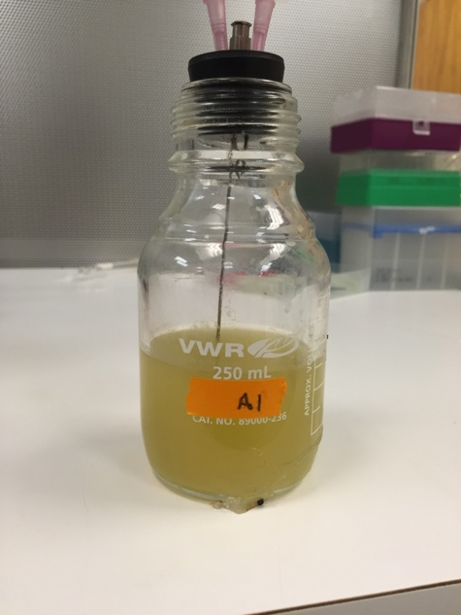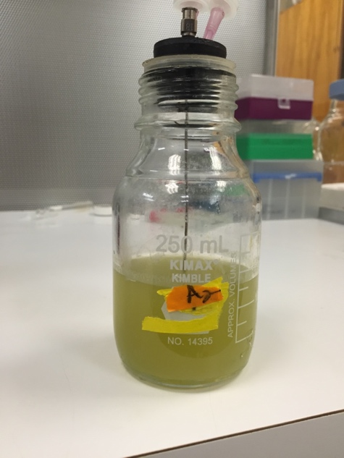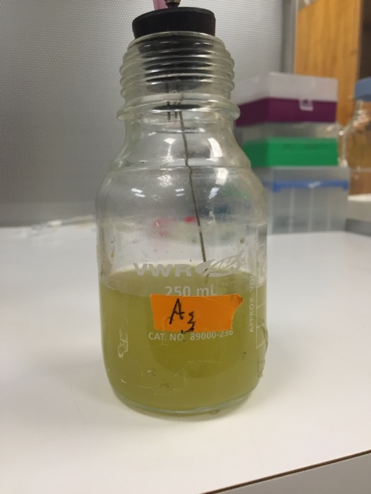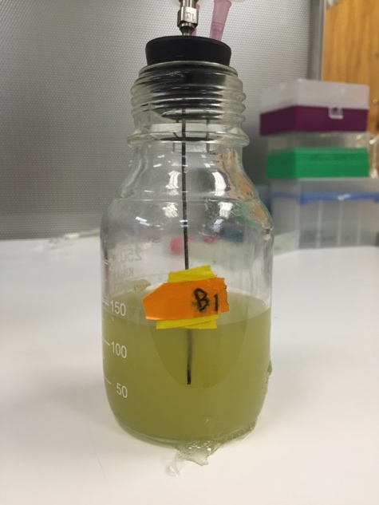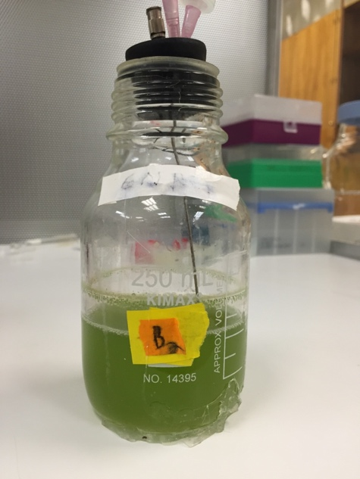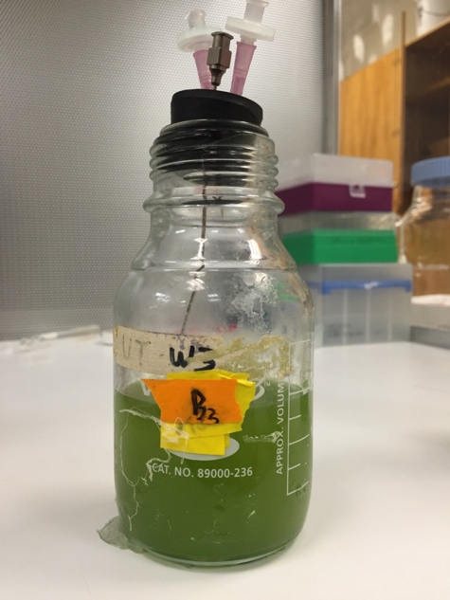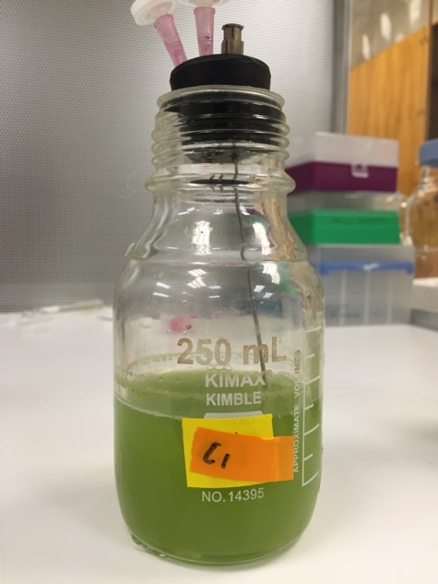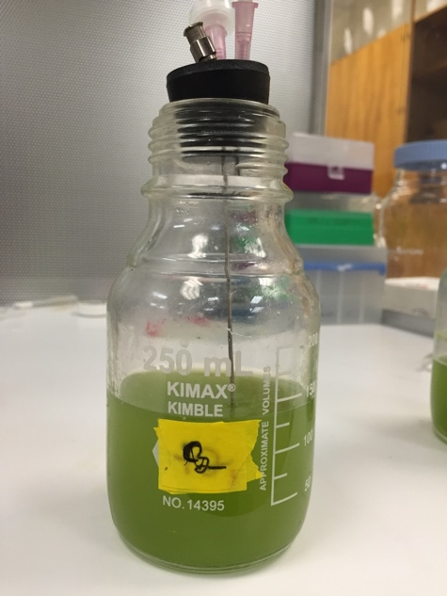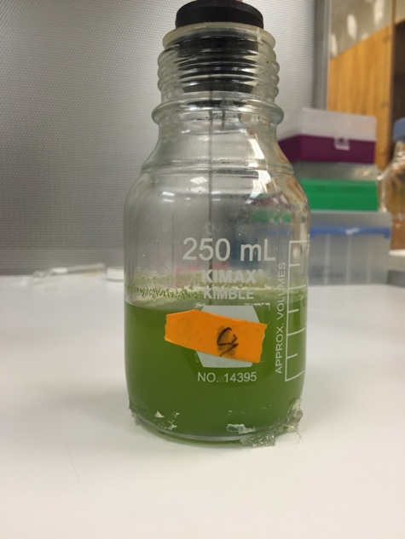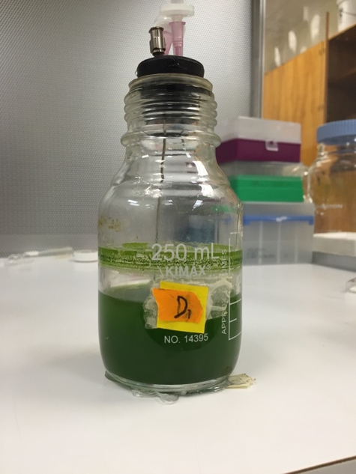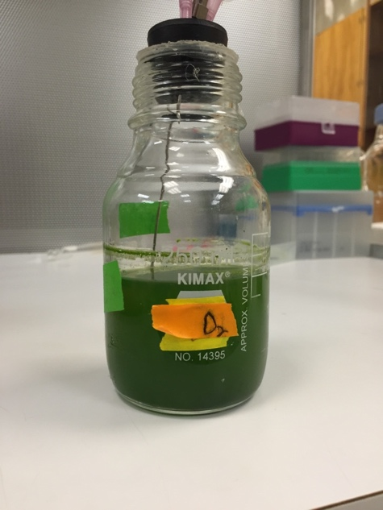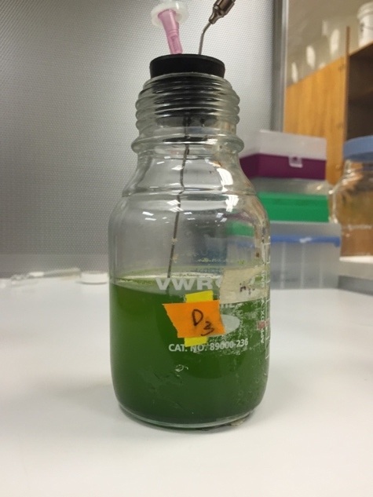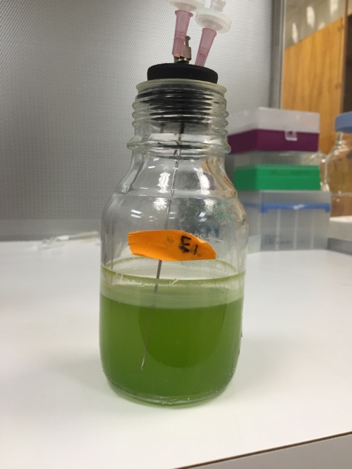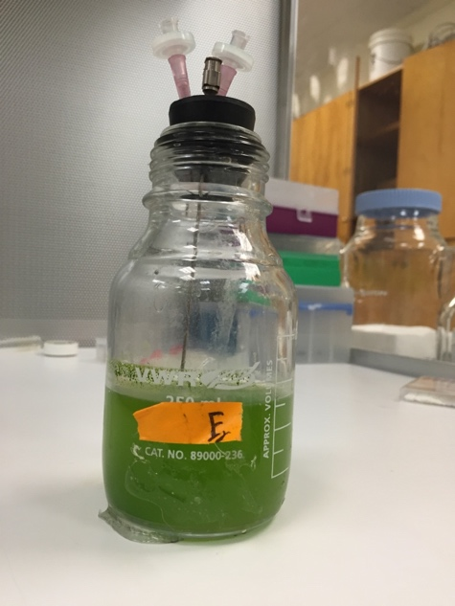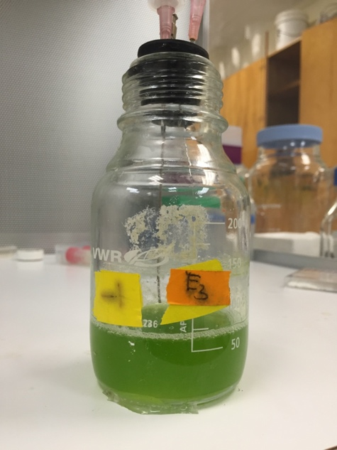

## 5.2 Raw Data

## Presented in biomass concentration (mg/mL).

# 6. References

1. Granda, Cesar B, Li Zhu, and Mark T Holtzapple. “Sustainable Liquid Biofuels and Their Envionmental Impact.” *Environmental Progress* 26.3 (2007): 233–250. Web.

2. Sartori, Fabio et al. “Potential Soil Carbon Sequestration and CO2 Offset by Dedicated Energy Crops in the USA.” *Critical Reviews in Plant Sciences* 25.5 (2006): 441–472. Web.

3. Lee, R. A., and J.-M. Lavoie. “From First- to Third-Generation Biofuels: Challenges of Producing a Commodity from a Biomass of Increasing Complexity.” *Animal Frontiers* 3.2 (2013): 6–11. Web.

4. Chojnacka, Katarzyna, and Andrzej Noworyta. “Evaluation of Spirulina Sp. Growth in Photoautotrophic, Heterotrophic and Mixotrophic Cultures.” *Enzyme and Microbial Technology* 34.5 (2004): 461–465. Web.

5. Guiry, Michael D. “How Many Species of Algae Are There?” *Journal of Phycology* 2012: 1057–1063. Web.

6. Hossain, Sharif et al. “Biodiesel Fuel Production from Algae as Renewable Energy.” *American Journal of Biochemistry and Biotechnology* 4.3 (2008): 250–254. Web.

7. Priyadarshani, Indira, and Biswajit Rath. “Commercial and Industrial Applications of Micro Algae – A Review.” *Journal of Algal Biomass Utilization* 3.4 (2012): 89–100. Print.

8. Li, et al. “Biofuels from Microalgae.” *Biotechnology progress* 24. April 2008 (2008): 815–820. Web.

9. Dragone, Giuliano et al. “Third Generation Biofuels from Microalgae.” *Current Research, Technology and Education Topics in Applied Microbiology and Microbial Biotechnology* (2010): 1355–1366. Web.

10. Greenwell, H C et al. “Placing Microalgae on the Biofuels Priority List: A Review of the Technological Challenges.” *Journal of the Royal Society, Interface / the Royal Society* 7.46 (2009): 703–726. Web.

11. López Barreiro, Diego et al. “Hydrothermal Liquefaction (HTL) of Microalgae for Biofuel Production: State of the Art Review and Future Prospects.” *Biomass and Bioenergy* 53 (2013): 113–127. Web.

12. Brand, Steffen et al. “Supercritical Ethanol as an Enhanced Medium for Lignocellulosic Biomass Liquefaction: Influence of Physical Process Parameters.” *Energy* 59 (2013): 173–182. Web.

13. Yu, G et al. “Hydrothermal Liquefaction of Low Lipid Content Microalgae into Bio-Crude Oil.” *American Society of Agricultural and Biological Engineers* 54.1 (2011): 239–246. Web.

14. Dote, Yutaka et al. “Recovery of Liquid Fuel from Hydrocarbon-Rich Microalgae by Thermochemical Liquefaction.” *Fuel* 73.12 (1994): 1855–1857. Web.

15. Galinato, Suzette P., Jonathan K. Yoder, and David Granatstein. “The Economic Value of Biochar in Crop Production and Carbon Sequestration.” *Energy Policy* 39.10 (2011): 6344–6350. Web.

16. Elliott, D C. *Evaluation of Wastewater Treatment Requirements for Thermochemical Biomass Liquefaction*. N.p., 1992. Print.

17. Sato, Nobuaki et al. “Reaction Kinetics of Amino Acid Decomposition in High-Temperature and High-Pressure Water.” *Industrial & Engineering Chemistry Research* 43.13 (2004): 3217–3222. Web.

18. Jena, Umakanta et al. “Evaluation of Microalgae Cultivation Using Recovered Aqueous Co-Product from Thermochemical Liquefaction of Algal Biomass.” *Bioresource Technology* 102.3 (2011): 3380–3387. Web.

19. Show, Kuan Yeow et al. “Microalgal Drying and Cell Disruption - Recent Advances.” *Bioresource Technology* 2015: 258–266. Web.

20. Chen, S., Chakraborty, M. and Chao, M., Washington State University, 2012. *Sequential Hydrothermal Liquifaction (SEQHTL) for Extraction of Superior Bio-Oil and Other Organic Compounds from Oleaginous Biomass*. U.S. Patent Application 14/353,823.

21. Chakraborty, Moumita et al. “Concomitant Extraction of Bio-Oil and Value Added Polysaccharides from Chlorella Sorokiniana Using a Unique Sequential Hydrothermal Extraction Technology.” *Fuel* 95 (2012): 63–70. Web.

22. Chakraborty, Moumita et al. “An ??-Glucan Isolated as a Co-Product of Biofuel by Hydrothermal Liquefaction of Chlorella Sorokiniana Biomass.” *Algal Research* 2.3 (2013): 230–236. Web.

23. Biller, P. et al. “Nutrient Recycling of Aqueous Phase for Microalgae Cultivation from the Hydrothermal Liquefaction Process.” *Algal Research* 1.1 (2012): 70–76. Web.

24. Andersson, Stefan, S. Ingvar Nilsson, and Peter Saetre. “Leaching of Dissolved Organic Carbon (DOC) and Dissolved Organic Nitrogen (DON) in Mor Humus as Affected by Temperature and pH.” *Soil Biology and Biochemistry* 32.1 (2000): 1–10. Web.

25. Phelan, M C, and G Lawler. “Cell Counting.” *Current Protocols in Cytometry* Appendix 3 (2001): Appendix 3A. Web.

26. Prism, GraphPad. "Version 7.01." *GraphPad Software Inc.: San Diego, CA, USA* (2015).

27. Kolter, R, D. a. Siegele, and a Tormo. “The Stationary Phase of the Bacterial Life Cycle.” *Annual review of microbiology* 47 (1993): 855–874. Web.

28. Wotton, R S. *The Essential Role of Exopolymers (EPS) in Aquatic Systems*. Vol. 42. N.p., 2005. Print.

29. Westfall, Peter H. “Resampling-Based Multiple Testing:” *North* (1989): 1359–1364. Web.

30. Yu, Guo et al. “Distributions of Carbon and Nitrogen in the Products from Hydrothermal Liquefaction of Low-Lipid Microalgae.” *Energy & Environmental Science* 4.11 (2011): 4587–4595. Web.

31. Miao, Chao et al. “Sequential Hydrothermal Fractionation of Yeast Cryptococcus Curvatus Biomass.” *Bioresource Technology* 164 (2014): 106–112. Web.

32. Pragya, Namita, Krishan K. Pandey, and P. K. Sahoo. “A Review on Harvesting, Oil Extraction and Biofuels Production Technologies from Microalgae.” *Renewable and Sustainable Energy Reviews* 24 (2013): 159–171. Web.

33. Tilman, David et al. “Agricultural Sustainability and Intensive Production Practices.” *Nature* 418.6898 (2002): 671–7. Web.

34. Pulz, O. “Photobioreactors: Production Systems for Phototrophic Microorganisms.” *Applied Microbiology and Biotechnology* 2001: 287–293. Web.

35. Jazrawi, Christopher et al. “Pilot Plant Testing of Continuous Hydrothermal Liquefaction of Microalgae.” *Algal Research* 2.3 (2013): 268–277. Web.