Examination of estrogen receptor isoforms involved in differential regulation of hypothalamic kisspeptin expression.

Jessica Alfonzo¹, Dakota Jacobs², Patrick Chappell Ph.D³
Bioresource Research, College of Agricultural Science¹, Environmental and Molecular Toxicology, College of Agricultural Science², Biomedical SciencesCollege of Veterinary Medicine³, Oregon State University, Corvallis OR 97331

Abstract:
The hypothalamic neuropeptide kisspeptin (Kiss-1) acts as a central component of the reproductive axis. A critical factor in pubertal progression and normal reproduction, this peptide is an afferent stimulator of gonadotropin-releasing hormone (GnRH). Kiss1 expression exhibits a sexually dimorphic expression pattern, found in neurons of the arcuate (Arc) nuclei in both male and female rodents, and in the anteroventral periventricular (AVPV) nuclei only in females. In females, estradiol (E₂) differentially regulates kiss1 expression in arcuate and AVPV Kiss-1 neurons, inhibiting kiss1 expression in the arcuate, while inducing it in the AVPV. Both characterized nuclear receptor subfamily isoforms, ER-α (esr1) and ER-β (esr2), have been localized to Kiss-1 neurons. Previous in vivo studies implicate ERα as crucial for the stimulatory effect of E₂ in the AVPV, while multiple mechanisms may act to inhibit kiss1 expression in the arcuate. To explore in more detail the respective contribution of ER-α and ER-β on expression of kiss1, our laboratory has generated two immortalized cell lines from an adult female mouse, KTaR-1 and KTaV-3, representative models of the arcuate and AVPV Kiss-1 populations, respectively. Preliminary results indicate that that basal expression of esr1 is higher in KTaR-1 cells relative to KTaV-3, whereas esr2 basal expression is not different between the two lines. Quantitative PCR reveals that both the ER –β selective agonist (2,3-bis(4-Hydroxyphenyl)propionitrile (DPN)) and the ER-α selective agonist (propylpyrazole triol (PPT)) in KTaR-1 cells suppress kiss1 expression after 4 hours, with a return to baseline after 24 hours, with a far more potent repression by the ER-α ligand. Both DPN and PPT exhibited stimulatory effects on the kiss1 expression of KTaV-3 cells after 4 hours, however, the ER –β selective agonist, DPN, influenced a more prominent increase in expression. These results implicate ER-α as the predominant nuclear receptor isoform responsible for the repressive effects of E₂ in Kiss-1 arcuate neurons, and ER –β as the predominant isoform responsible for the stimulatory effect of E₂ in Kiss-1 AVPV neurons. Samples were also probed for changes in esr1 and esr2 expression. KTaR-1 results for esr1 and esr2 expression suggested that there is no correlation between esr1/esr2 abundance and kiss1 expression. KTaV-3 results for esr1 and esr2 were undetermined.

Introduction:
GnRH and HPG Axis Regulation
The Hypothalamic-Pituitary-Gonadal axis, otherwise known as the HPG axis, plays a critical role in the reproductive regulation and development of mammals. The HPG axis includes the hypothalamus, pituitary gland, and gonads as a system. Gonadotropin-releasing hormone is produced in the hypothalamus from gnrh expressing neurons. The GnRH that is produced travels to the anterior pituitary via a system of blood vessels in the brain called the hypophyseal portal system. The fenestrated capillaries in the system support quick transport between the two areas with fast exchange that allows for a precise effect on the anterior pituitary without having to travel through the entire circulatory system first. GnRH binds to its receptors on gonadotropes of the anterior pituitary to produce Luteinizing Hormone and Follicle Stimulating Hormone for transport to the blood stream.
The onset of puberty begins with pulses of GnRH that stimulate the release of LH and FSH. In males, LH binds to receptors on the Leydig cells of the testes causing the synthesis and secretion of testosterone. FSH is an important component of spermatogenesis, as it activates Sertoli cells that support developing sperm throughout spermatogenesis. In females, LH and FSH stimulate the ovaries to produce estrogen in order to regulate the ovarian and menstrual cycles. FSH begins and aids in follicular growth. An acute rise, or surge, of LH triggers ovulation, which releases the egg from the follicle and converts that follicle into a corpus luteum that then produces progesterone to prepare the endometrium for implantation. When an egg is released and implantation does not occur, the empty follicle accumulates progesterone that inhibits the hypothalamus, and thus the pituitary, ending the estrogen feedback loop. Elevated blood levels of estrogen or testosterone induce negative feedback to GnRH neurons (Clarkson, 2008). GnRH neurons in females express estrogen receptor alpha that responds to increased estrogen levels by decreasing GnRH secretions, preventing further gonadotropin releasing activity (Smith, 2005). The activity of GnRH neurons involves complex modulation to direct specific reproductive processes. This modulation occurs through a number of different surrounding neuronal populations, including kisspeptin.
Kisspeptin and HPG Axis Regulation
It has not yet been determined the mechanism by which the initial pulsatile secretion of GnRH occurs, however, it is known that Kisspeptin plays a critical role. It is hypothesized that Kiss-1 neurons act as central processors in receiving endocrine signals from various sources, particularly sex steroid hormone signals from the gonads. The successive release of Kiss-1 acts in the modulation of GnRH secretion and subsequent HPG axis activity. In pre-pubertal rodents, GnRH secretion remains dormant until they reach sexual maturity. Rodent models that have yet to reach sexual maturity and do not have functional kiss1/kiss1r system, either by mutation in kiss1 or KISS1R antagonist action, do not begin puberty due to inadequate blood gonadotropin concentrations (Clarkson, 2008). Additionally, sexually mature rodents in which kisspeptin or its receptor on GnRH neurons were knocked out exhibit defective gonadotropin secretion. This suggests that Kisspeptin is crucial to puberty, sexual development, and reproduction.
Sex Steroid Hormone Effects on Kisspeptin Expression
Testosterone produced in the testes negatively regulates kiss1 expression in the arcuate nucleus. However, estrogen produced by the ovaries effects Kiss-1 neurons differentially. Kiss1 expression, and consecutive HPG axis activity, is stimulated by estrogenic exposure of the AVPV Kiss-1 neurons. In the arcuate nuclei, Kiss1 expression and its following HPG axis activity are repressed. Appropriate for involvement in steroid hormone feedback, almost all Kiss1 neurons contain nuclear estrogen receptors: ER-α and ER-β encoded by the genes esr1 and esr2, respectively. E2 can bind these ligand-inducible transcription factors, resulting in modulation of gene expression. It has been well characterized that E2 inhibits Kiss1 expression in arcuate cells, and induces it in AVPV cells, but exactly how the different receptor subtypes ER-α and ER-β influence the expression of Kiss1 has not yet been fully determined.
Data from a study of Kisspeptin-specific ER-α knockout mice shows a marked acceleration in pubertal onset followed by an inhibited pubertal maturation that demonstrates the actions of ER-α in Kiss-1 neurons in regulation of pubertal progression (Mayer, 2010). Selective antagonism of ER-α in female rats reduces LH sensitivity to kisspeptin, eradicates the preovulatory LH increase, and prevents ovulation (Roa, 2008). Conversely, blocking ER-β does not elicit significant differences in the LH surge and ovulatory rate (Roa, 2008). These results suggest that ER-α is the predominant receptor isoform acting to regulate kiss1 expression, and pubertal onset and maturation.

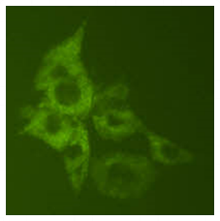
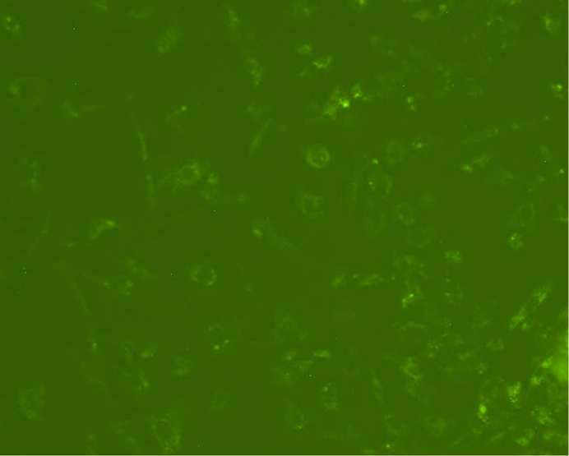
AVPV No E₂
Arc No E₂
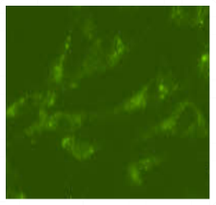
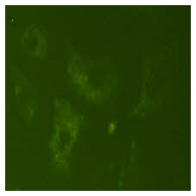
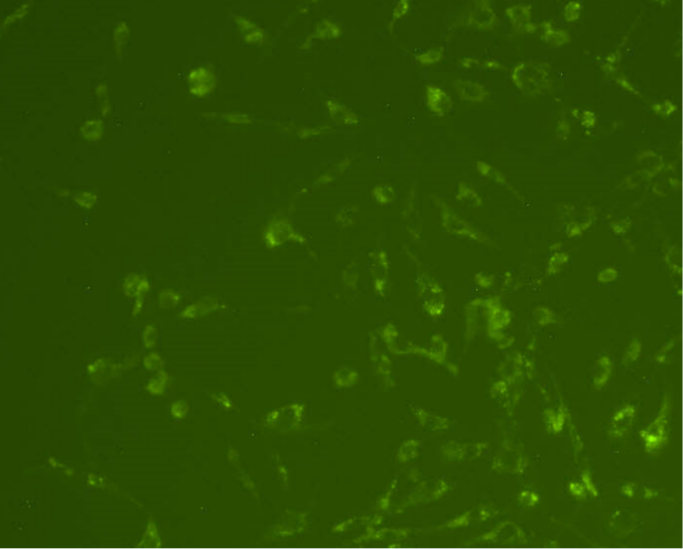
AVPV + E₂
Arc + E₂

Figure 1A (Top left): AVPV neurons expressing kiss1-before treatment with 100 pM estrogen (E2). Figure 1B (Bottom left): AVPV neurons exhibit increases in GFP fluorescence) after 20 minutes following 100 pM E2 treatment. Figure 1C (Top right): Arcuate neurons expressing both kiss1-before with 100 pM E2. Figure 1D (Bottom right): Arcuate neurons display a decreased GFP fluorescence of kiss1 expression after four hours when treated with 100 pM E2.
(Photos from Dakota Jacobs and Patrick Chappell)

Generation of new in vitro tools to explore molecular regulation of kiss1 expression
Two immortalized neuronal cell lines were generated in our laboratory to simulate in vivo conditions-- KTaV-3 and KTaR-1 cells, representative of AVPV and Arcuate Kiss-1 neurons, respectively. Cell lines were immortalized from postpubertal female Kiss1-GFP (Kiss1-hrGFP) mice. Data previously generated in our lab using these cell lines, shows that when KTaV-3 cells were treated with 25pM E2, kiss1 expression increased at 4 hours and decreased towards baseline at 24 hours. When KTaR-1 cells were treated with E2, kiss1 expression decreased at 4 hours, and increased towards baseline at 24 hours. When treated with vehicle, arcuate cells exhibited an increase in kiss1 expression at 4 hours and a decrease towards baseline at 24 hours (Figure 4). Examination of estrogen receptors in each cell lines show that esr1 is expressed at a higher abundance in KTaR-1 cells in comparison to KTaV-3 cells, and esr2 was expressed in similar abundance in both cell lines (Figure 2). (Jacobs, 2016). These results confirm that AVPV cells repress kiss1 expression, and arcuate cells stimulate kiss1 expression. They also suggest that esr1, or ERα, is the primary regulator of kiss1 expression in the KTaR-1 cell line. To explore the respective contributions of each estrogen receptor subtype involved in the regulation of Kisspeptin expression in these two neuronal populations, we treated each cell line with ERα and ER-β agonists, separately, to probe for changes in kiss1 expression.
This project will examine how kiss1 expression is affected by selective activation of ER-α and ER-β in the AVPV and arcuate nuclei. We will explore this through treating our model cell lines KTaR-1 and KTaV-3, with specific receptor agonists and probing for changes in kiss1 expression.

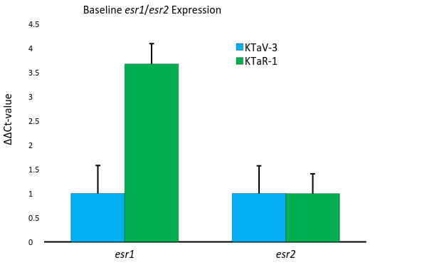
Figure 2: esr1 (left) and esr2 (right) expression in KTaV-3 (blue bars) and KTaR-1 (green bars) cells grown in normal growth media. Expression is depicted as a comparison to KTaV-3 esr1 levels, normalized to ppia.

Figure 3: kiss1 expression in KTaR-1 cells grown in normal growth media, treated with vehicle (solid blue bars) and estrogen (striped blue bars). Expression is depicted as a comparison of estrogen treated to vehicle treated cells, normalized to ppia (Jacobs, 2016).

Figure 4: kiss1 expression in KTaV-3 cells grown in normal growth media, treated with vehicle (solid bars) and estrogen (striped bars). Expression is depicted as a comparison of estrogen treated to vehicle treated cells, normalized to ppia (Jacobs, 2016).

Methods:
Cell culture and drug treatments
This study used two immortalized neuronal cell lines generated in our laboratory- KTaV-3 and KTaR-1 cells, representative of AVPV and Arcuate Kiss-1 neurons, respectively. Cell lines were immortalized from 9-13 week old female Kiss1-GFP (Kiss1-hrGFP) mice. Cells were cultured in 10% Fetal Bovine Serum in Dulbecco’s Modified Eagle Medium incubated at 37° C with 5% CO₂. Previous studies examining Kiss1 expression when treated with 17β-E2 have already been done in both cell lines, and after treatment for 24 hours Kiss1 expression was in the AVPV neurons and decreased in the arcuate. In order to determine the respective roles of ER-α and ER-β, specific receptor agonists were used. The ER-β selective agonist 2,3-bis(4 Hydroxyphenyl) propionitrile, (DPN), and Propylpyrazole triol, (PPT), the ER-α selective agonist, were used to differentiate the roles of each ER subtype on the regulation of kiss1 expression. Cultures of KTaV-3 and KTaR-1 cells were treated with vehicle, or 25 picomolar 17β-E2 , DPN, or PPT. Cells were then collected in Trizol reagent at 0, 4, and 24 hours after serum synchronization with 50% DMEM and 50% FBS.
RNA isolation and quantification
Samples collected in Trizol solution were treated with chloroform and centrifuged in order to separate phases. The aqueous phase was then used for RNA Isolation. Samples were precipitated with Isopropanol and centrifuged to produce a RNA pellet. The pellets were then washed with EtOH and left to purify overnight in a mixture containing glycogen, sodium acetate, water, and EtOH. After purification, the samples were centrifuged to form a pellet which was resuspended in water. The samples were then analyzed on the Nanodrop ND2000 spectrophotometer to determine the concentration of RNA per microliter. Appropriate calculations were done to aliquot the same concentration of RNA per sample into cDNA using reverse transcription and PCR. All cDNA were then checked for quality against Peptidlyprolyl Isomerase A (PPIA) as reference as reference gene, and gel electrophoresis. If any discrepancies in the gel were noted ie: differences in band size indicating different concentrations of RNA, the process was repeated from the nanodrop step forward.
cDNA was then used for real-time polymerase chain reaction (qPCR) to monitor the amplification of kiss1 in comparison to that of PPIA resulting from contamination or inaccurate pipetting. The values given by qPCR were analyzed using the delta delta CT analysis to examine the fold change between kiss1 expression in each of the 4 treatments over the 24 hour time points. Three trials were done for each cell type, and the delta delta CT values were averaged into one expression of fold change per treatment group over the allotted time.
cDNA from the three trials of each cell type were then used for real-time PCR to examine the expression level of esr1 and esr2 at each time point. Values were compared to previous PPIA results from each trial, and were used for delta delta CT analysis. Results were shown as averages of fold change in expression per treatment group over time.
Statistical analysis:
Delta delta CT values were analyzed for significance using single factor ANOVA in Microsoft Excel. Statistical significance was determined with respect to the zero hour, vehicle treated cells of each group.
Results:
ER-α and ER-β activation represses kiss1 expression in Arcuate cells
In the KTaR -1 cell line, kiss1 expression increased at 4 hours and returned to near baseline at 24 hours when left untreated. When treated with E2, kiss1 expression decreased at 4 hours and increased towards baseline at 24 hours. When treated with DPN, an ER-β selective agonist, or PPT, an ER-α selective agonist, kiss1 expression was repressed. However, a more significant inhibition was seen in cells treated with PPT. After 24 hours, both treatment groups showed a kiss1 expression that trended towards baseline (Figure 5).

*
*
Figure 5: kiss1 expression in KTaR-1 cells grown in normal growth media, treated with vehicle (SF, blue bars), estrogen (orange bars), DPN (grey bars), or PPT (yellow bars). Expression is depicted as a comparison to vehicle at 0 hours, normalized to ppia. Statistical significant was determined via ANOVA single factor analysis compared to vehicle at 0 hours. Vehicle treated cells at 4 hours have p=6.14E-7 (left asterisk), and PPT treated cells at 4 hours have p=4.15E-9 (right asterisk).
*
Figure 6: kiss1 expression in KTaV-3 cells grown in normal growth media, treated with vehicle (SF, blue bars), estrogen (orange bars), DPN (grey bars), or PPT (yellow bars). Expression is depicted as a comparison to vehicle at 0 hours, normalized to ppia. Statistical significant was determined via ANOVA single factor analysis compared to vehicle at 0 hours. At 4 hours, cells treated with E2 have p>0.05, DPN have p=0.0004 (asterisk), and PPT have p>0.05.

In the KTaV-3 cell line, kiss1 expression stayed relatively the same at 4 hours and decreased at 24 hours when treated with vehicle. These results differ from previous data generated in the Chappell Lab, that shows in increase in kiss1 expression at 4 hours. When treated with E2, kiss1 expression increased nearly 8-fold at 4 hours and decreased toward baseline at 24 hours when treated with E2, as was expected (Figure 3). When treated with DPN, an ER-β selective agonist, or PPT, an ER-α selective agonist, kiss1 expression was also stimulated after 4 hours. However, a more significant increase was seen in cells treated with DPN. After 24 hours, both treatment groups displayed decreases toward baseline kiss1 expression levels (Figure 6).
Esr1 and esr2 expression levels in arcuate and AVPV cell lines
In order to investigate whether receptor abundance plays a role in kiss1 expression modulation, we examined relative fold change in expression of esr1 and esr2. In KTaR-1, esr1 expression at 4 hours remained similar to zero hour levels. A slight increase was seen in the expression of esr1 in the PPT treatment group, and a slight decrease was seen in esr1 expression levels of the DPN treatment group. At 24 hours, all treatment groups showed an increase in esr1 expression, with the most significant elevation seen in PPT treated cells. E2 and DPN treated cells showed the smallest increase in expression levels (Figure 7).
Esr2 expression at 4 hours stayed similar to zero hour levels in both DPN- and PPT-treated KTaR-1 cells. A slight increase in esr2 expression was seen in vehicle-treated cells, and a slight decrease was seen in cells treated with E2. At 24 hours, all treatment groups displayed an increase in esr2 expression, with the most significant increase seen in vehicle-treated cells and the least significant increase seen in E2-treated cells. DPN and PPT treated cells had similar esr2 levels, with DPN at a slightly higher level of expression (Figure 8).
KTaV-3 cells were also probed for changes in esr1 and esr2 levels, however, many of the delta delta CT values from real time PCR were unable to be read by the machine, rendering the data inconclusive. This could have been due to defects in the primers used, or error in the real-time process. As seen, there was a greater variability with the KTaV-3 cell line, which could also explain the high levels of error.

*
Figure 7: esr1 expression in KTaR-1 cells grown in normal growth media, treated with vehicle (SF, blue bars), estrogen (orange bars), DPN (grey bars), or PPT (yellow bars). Expression is depicted as a comparison to vehicle at 0 hours, normalized to ppia. Statistical significance was determined via ANOVA single factor analysis compared to vehicle at 0 hours. At 24 hours PPT has a p=0.03.

*

Figure 8: esr2 expression in KTaR-1 cells grown in normal growth media, treated with vehicle (SF, blue bars), estrogen (orange bars), DPN (grey bars), or PPT (yellow bars). Expression is depicted as a comparison to vehicle at 0 hours, normalized to ppia. Statistical significance was determined via ANOVA single factor analysis compared to vehicle at 0 hours. At 24 hours, vehicle treated cells have p=0.01.

Conclusions:
To explore the respective contributions of the two classical nuclear ER types, we examined our two neuronal cell lines for changes in kiss1 and estrogen receptor expression when treated with ER-α and ER –β agonists.
E2 represses kiss1 expression in arcuate Kiss-1 neurons using both alpha and beta receptors
KTaR-1 cells exhibited a decrease in kiss1 expression at 4 hours when treated with E2. When treated with vehicle kiss1 expression increased at 4 hours and decreased towards baseline at 24 hours. These results reinforce previous data generated in the Chappell Lab (Figure 4), and are consistent with previous results in vivo (Mayer, 2010). Both DPN and PPT treatment groups also displayed a repression of kiss1 expression at 4 hours, suggesting that both ERα and ERβ are involved in kiss1 repression. The greater inhibition occurred through treatment with PPT, suggesting that ER-α is the predominant nuclear receptor isoform responsible for the repressive effects of E₂ in Kiss-1 arcuate neurons. This is supported by the fact that at baseline, KTaR-1 cells have a greater baseline expression of esr1 that encodes estrogen receptor alpha (Figure 4). Previous studies show that in ER-α knockout mice there is a significant advancement of pubertal onset followed by a lack of pubertal maturation. This suggests that the repression of kiss1 in arcuate cells, and stimulation of kiss1 in AVPV cells, are both mediated by ER-α (Mayer, 2010). Results generated by the Chappell lab both support and contradict this, as shown above. Kiss1 expression is still repressed in KTaR-1 cells when treated with an ER-β agonist, suggesting that activation of ER-β can also exert a repressive effect on kiss1 expression even in the absence of activation of ER-α. While the greater repression due to PPT suggests that ER-α is the predominant receptor isoform acting to repress kiss1 expression, repression due to PPT implies that ER-α may not be the only isoform acting. Interestingly, treatment with E2, which is capable of activating both ER-α and ER-β, was not as effective in repressing kiss1 expression as either of the two specific ligands alone, suggesting that antagonism between the receptors could be occurring.
E2 stimulates kiss1 expression in arcuate Kiss-1 cells using both alpha and beta receptors
KTaV-3 cells exhibited an increase in kiss1 expression at 4 hours when treated with E2, as expected from earlier data from our lab (Figure 3) and previous results in vivo (Mayer, 2010). Intriguingly, increases in kiss1 expression were also observed following treatment with either DPN or PPT. While both DPN and PPT treatments resulted in an increase in kiss1 expression, a greater stimulatory effect occurred through treatment with DPN. These results suggest that ER-β may the predominant isoform responsible for the stimulatory effect of E₂ in Kiss-1 AVPV neurons. These results are novel, as previous research in vivo suggests that ER-β is not obligatory for LH surge generation (Mayer, 2010). These results contradict what has been seen in other experiments. In vivo studies have reported a lack of estrogenic feedback in ER-α knockout mice, but not in ER-β knockout mice, suggesting that feedback is primarily modulated by receptor alpha (Glidewell-Kenney, 2007). My data would imply that this is not the case, as the activation of both the alpha and beta estrogen receptors elicited an increase in kiss1 expression. This could mean that both receptors play a role in kiss1 stimulation. However, it is possible that there is no significant difference between the stimulatory effects of DPN vs PPT. These differences could also be due to the fact that these results were found through in vitro experimentation and other literature results come from in vivo experimentation. In vitro experimentation does not account for the other parts of the body that could be affecting results. For example, this experiment looked at receptors alpha and beta but did not account of the membrane bound estrogen receptor that exists in vivo. Differences in results could be due to the fact that the membrane bound estrogen receptor plays a large role in kiss1 expression.
To further explore the role of estrogen receptors in kiss1 expression, we proceeded to probe our samples for changes in esr1 and esr2 that encode for receptors alpha and beta. Perhaps differences in my results and previous in vivo models could be explained by the effects of ER-specific ligands on the expression levels of the receptors themselves, which could then exert modulatory effects on kiss1 expression.
Esr1 and esr2 expression levels in arcuate and AVPV cell lines
In order to investigate whether receptor abundance plays a role in kiss1 expression modulation, we examined relative fold change in expression of esr1 and esr2. In KTaR-1 cells, esr1 expression at 4 hours remained similar to expression levels at the zero hour in all four treatment groups. Treatment with DPN yielded a slight decrease in expression, and treatment with PPT yielded a slight increase in expression. We had expected to see changes in esr1 levels at 4 hours, since that is the time point that the greatest changes in kiss1 expression occurred. This implies that changes in esr1 expression may not play a significant role in kiss1 expression at 4 hours, and only activation of existing translated ER-α peptide is required. At 24 hours, esr1 expression increased in all treatments, with the most predominate stimulation occurring in the PPT treated cells. While it makes sense that there was an increase in esr1 expression in PPT treated cells, as PPT is an ER-α agonist, we were not expecting this increase to occur at 24 hours when kiss1 levels were trending towards baseline. This could be due to rhythmic kiss1 expression not being modulated by circadian clock oscillations but instead being mediated by estrogen receptor activation combined with intracellular clock function (Jacobs, 2016). To further explore this, we would need to look beyond just the 24 hour time point.
Esr2 levels in KTaR-1 cells stayed similar at four hours to levels at the zero hour. Cells treated with E2 showed slightly decreased expression levels, and cells treated with vehicle showed slightly elevated expression levels. DPN and PPT treatments yielded esr2 expression levels at similar levels. Again, these results were not as expected, as the most significant changes in kiss1 expression occurred at 4 hours. This would imply that esr2 expression may not play a significant role in the changes in kiss1 at 4 hours. At 24 hours, all treatment groups yielded elevated expression levels with the most significant increase seen in vehicle treated cells. Cells treated with DPN had slightly elevated concentrations of esr2 compared to cells treated with PPT. As kiss1 expression is trending toward baseline at 24 hours, we did not expect to see increases in esr2 at that time. These data are the first to demonstrate changes in ER expression levels in Kiss-1 neurons over time, and suggest that activation of ER subtypes by E2 and specific ligands can modulate the expression of these receptors. The timing of changes in expression levels of these receptors, however, suggest that the estrogen receptor abundance does not play a role in kiss1 expression.

Discussion:
As previously noted, KTaR-1 cells show greater baseline expression of esr1 and KTaV-3 cells show greater expression esr2, at baseline. It is important to note that these results are at baseline levels, meaning that these levels could change throughout exposure to estrogen. While our results show kiss1 expression levels at the 4 and 24 hour time points, they do not show any fluctuations between 0 and 4 hours or 4 and 24 hours. It is possible that over time the receptor that is the predominant mediator of expression, fluctuates between alpha and beta. In both cell types, DPN and PPT exhibit the same effects, the only difference is the degree of effectiveness. This contradicts the current belief that ER-α is the predominant mediator of estrogenic effects on kiss1 expression. Our results indicate that the receptors could be working together to elicit the observed kiss1 levels. Previous receptor knockout studies could have error in how each receptor was “knocked out”, causing inaccurate results. There are limitations to both previous studies and this study, as previous studies looked only at receptor knockouts and this study only looked at specific receptor use through agonists. This study only had 3 trials of each cell line, which could also account for variability among results. Three trials were done of each cell type. As the zero hour cell samples are not serum synchronized and are meant to be measured at baseline, there is possibility for variability among the trials. Kiss1 expression levels were increased from known baseline in the 1st and 3rd trial of the KTaV-3 cells, in the estrogen, DPN, and PPT samples. As all trials were done at the same time, with the same cells and methods, those values should theoretically be the same; so for the purpose of this study, those values were replaced with the zero hour values from trial #2.
To further support the kiss1 expression results, we probed our cDNA for changes in esr1 and esr2 expression.
KTaR-1 cells showed no significant changes in esr1 or esr2 expression at 4 hours, where we expected changes to be seen. Elevations in expression were seen at 24 hours, which is unexplained. It appears receptor expression does not coordinate with kiss1 expression. When KTaV-3 cells were probed for changes in receptors, the results were inconclusive. The real-time PCR results were undetermined for many samples making the results unusable.
It is clear that Kisspeptin plays a vital role in the onset of puberty, reproduction, and development. A greater understand of the role estrogen receptors alpha and beta play in the modulation of kiss1 expression would give insight into the entire reproductive process. Our results challenge what is currently hypothesized about estrogen receptor involvement in kisspeptin regulation. To further explore these new possibilities, future studies include increased number of trials and expanded time points to observe any fluctuations in expression levels not previously seen, as well as confirming results with receptor antagonists as well as agonists. Kisspeptin expressing neurons are also effected by more than just estrogen, so future studies will include the effects of other stimuli on the modulation of kiss1 expression. As crucial processes such as pubertal onset and development require kisspeptin, dysfunctions in the kisspeptin system or its regulation are likely involved in current health issues like early onset puberty, infertility, and other reproductive disorders. Use of these cell lines to probe the direct effects of endogenous hormones or exogenous endocrine-disrupting compounds could greatly enhance our knowledge of how to treat reproductive disorders resulting from alterations in kisspeptin neuronal function over development.
References:
- Clarkson J., Moreno A.S., Colledge W.H., Herbison A.E. Kisspeptin-GPR54 signaling is essential for preovulatory gonadotropin-releasing hormone neuron activation and the luteinizing hormone surge. Journal of Neuroscience, 28, 8691–8697 (2008).
- Glidewell-Kenney C., Hurley L.A., Pfaff L., Weiss J., Levine J.E., Jameson J.L. Nonclassical estrogen receptor α signaling mediates negative feedback in the female mouse reproductive axis. Proceedings of the National Academy of Sciences of the United States or America, 104(19), 8173-8177 (2007).
- Jacobs D.C., Veitch R.E., Chappell P.E. Evaluation of immortalized AVPV- and arcuate-specific neuronal Kisspeptin cell lines to elucidate potential mechanisms of estrogen responsiveness and temporal gene expression in females. Endocrinology, (2016).
- Ko, C. H., Takahashi, J. S. Molecular Components of the Mammalian Circadian Clock. Human Molecular Genetics, 271-277 (2006).

Mayer C., Acosta-Martinez M., Dubois S.L., Wolfe A., Radovick S., Boehm U., Levine J.E. Timing and completion of puberty in female mice depend on estrogen receptor alpha-signaling in kisspeptin neurons. Proceedings of the National Academy of Sciences of the United States or America, 107(52), 22693-22698 (2010).
- Oakley, A. E., Clifton, D. K., Steiner, R. A. Kisspeptin Signaling in the Brain. Endocrine Review, 713-743 (2009).
- Roa, J., Vigo, E., Castellano, J. M., Gaytan, F., Navarro, V. M., Aguilar, E., Tena-Sempere, M. Opposite roles of estrogen receptor (ER)-α and ERβ in the modulation of luteinizing hormone responses to kisspeptin in the female rat: implications for the generation of the preovulatory surge. Endocrinology, 149(4), 1627-1637 (2008).
- Smith, J. T., Cunnigham, M. J., Rissman, E. F., Clifton, D. K., Steiner, R. A. Regulation of Kiss1 Gene Expression in the Brain of the Female Mouse. Endocrinology, 3686-3691 (2005).

