- You will be “helping” half of the room (~5 participants) navigate the tasks in our study by:
  - answering some questions, avoiding others, and preventing misbehavior.
- Arrive 30 minutes before study time
- Set up the room in accordance to the ROOM SETUP and MACHINE SETUP directions
- Approach questions and wrist slapping by following RUNNING THE STUDY directions
- Support post-task questionnaire in accordance with the ENDING THE STUDY directions
- After participants have left, clean up by following the TEAR DOWN directions

Bring with you/Get from lab
- Bring printout of this script + Red pen
- Get scratch paper, for observations (include participant ID + your name)
- Get clipboard
- Post-Task questionnaires (for the correct treatment)
  - Write the participant ID on each.
- Receipts
- Cheat sheets (printed in color)

Workstation Setup
- Pen
- Scratch paper (2 pieces + workstation #)
- Work station number tent
- Cheat sheet (for correct treatment)

Room Setup
- Post-task questionnaires and receipts beside the tutorializer
- Each workstation needs the following items:
  - A pen (that writes)
  - Scratch paper (minimum 2 sheets)
  - Sheet giving Participant ID

- Check what treatment we are running from the whiteboard behind the projector screen.
  - These are the mappings from name to number:
    - Control = “0”
    - Saliency = “1”
    - Rewards = “2”
    - Saliency + Rewards = “3”

Machine Set up
- Open File Explorer
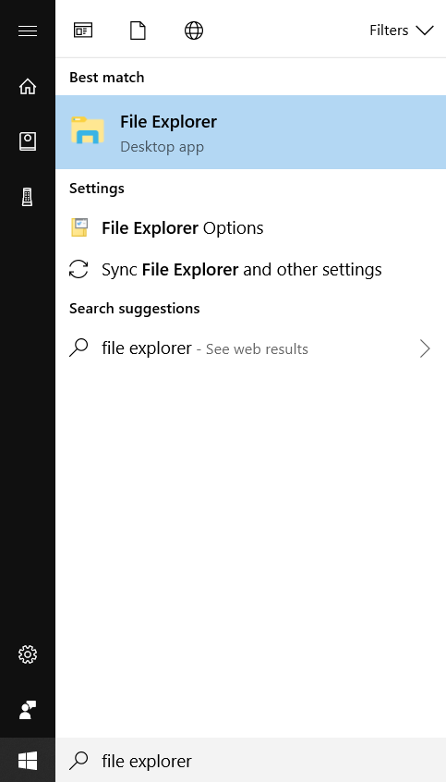
- Go to C:\\Users\anderan2\.scaii\replays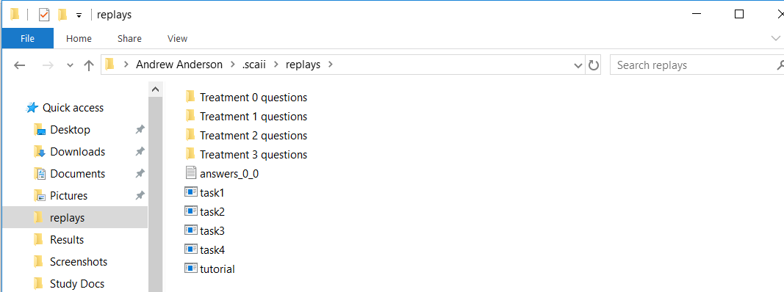
- From the treatment name, you know the number, go into that folder (for example, for Control, go into Treatment 0 questions)
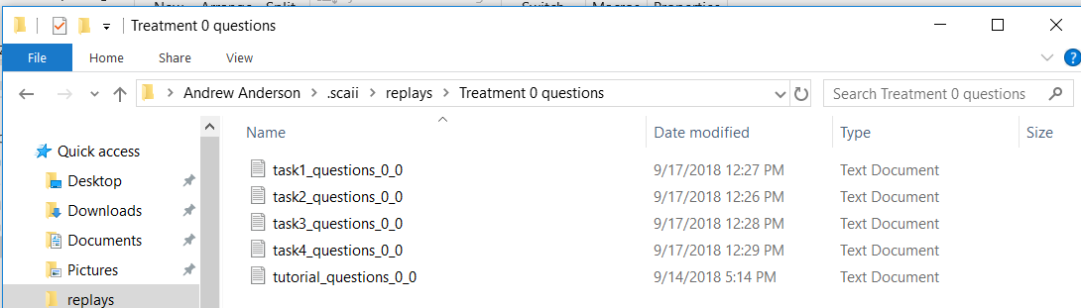
- Check the whiteboard behind the projector for the participant ID range in use for this session, then make sure that the Participant ID (PID) is correct on ALL of these question files. If it is not written there yet, check: https://docs.google.com/spreadsheets/d/1SkmPUeoMEhgeSnIwozmmch9wmxIDpJ2EvKUFogKhzCE/edit#gid=0
- select ALL of the files (can hold control and click on the files)
  - EX: Suppose their PID is listed as 9181603. Make the changes to reflect this.
- Now, pull ALL of these files into the replays folder 1 level up.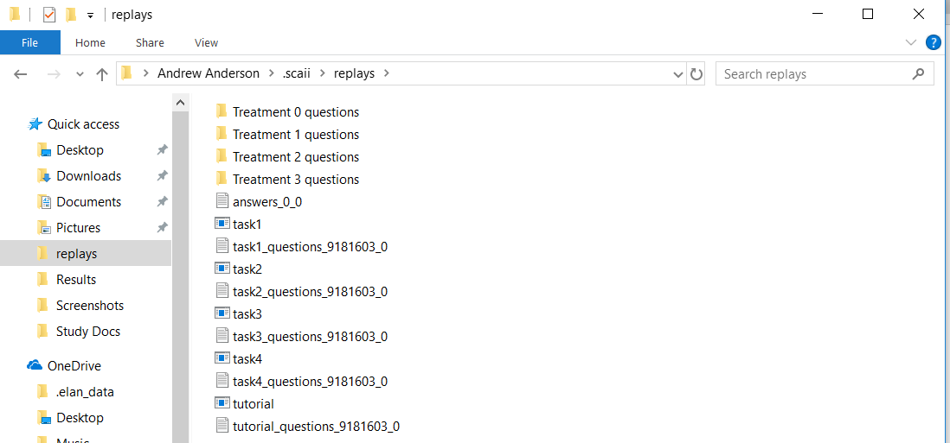

- Now, we’re going to set git up
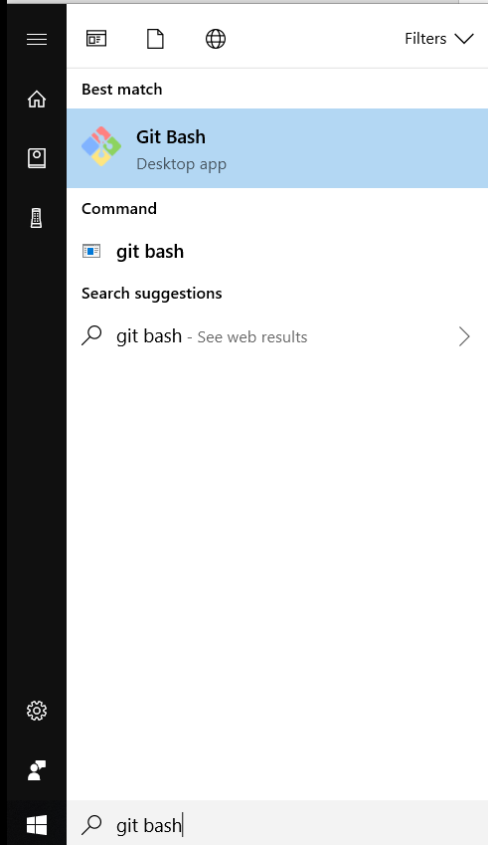
- Open TWO instances of git bash
- Snap them to the side, so it can fill the whole screen
- In both sides, type in: “cd .scaii/git/SCAII/core” and hit enter
- In the left hand side, type “cargo run webserver” and hit enter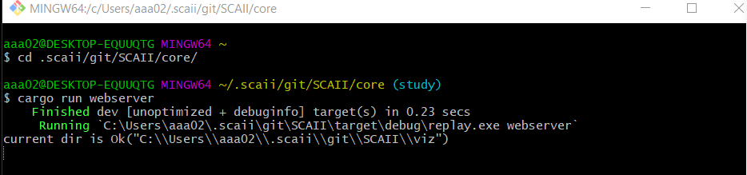
- In the right hand side, type “cargo run file” and hit enter
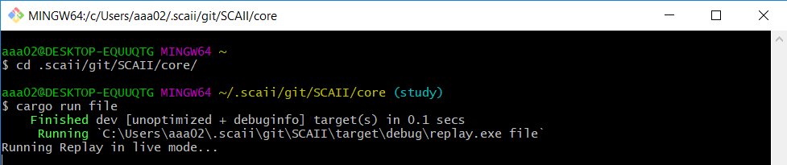

- Google chrome should launch at this point, and you’ll see a tab open up in the middle of the screen. Click ok to make it go away and press the start button beside the play button.
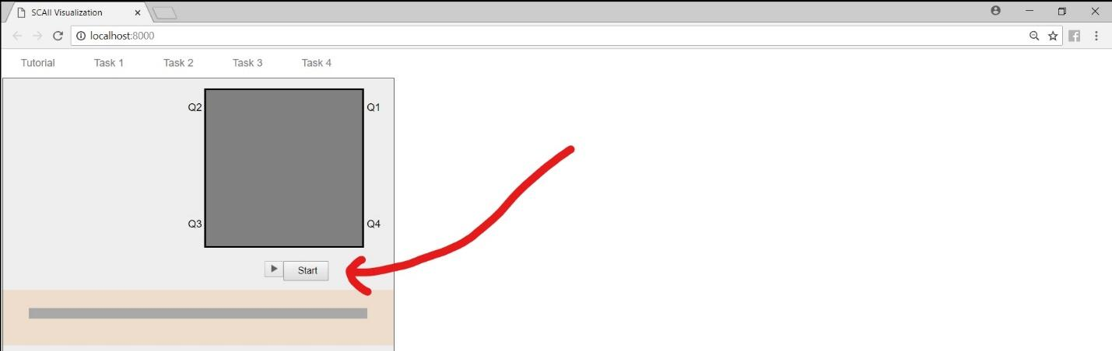
- Now, you’ll see
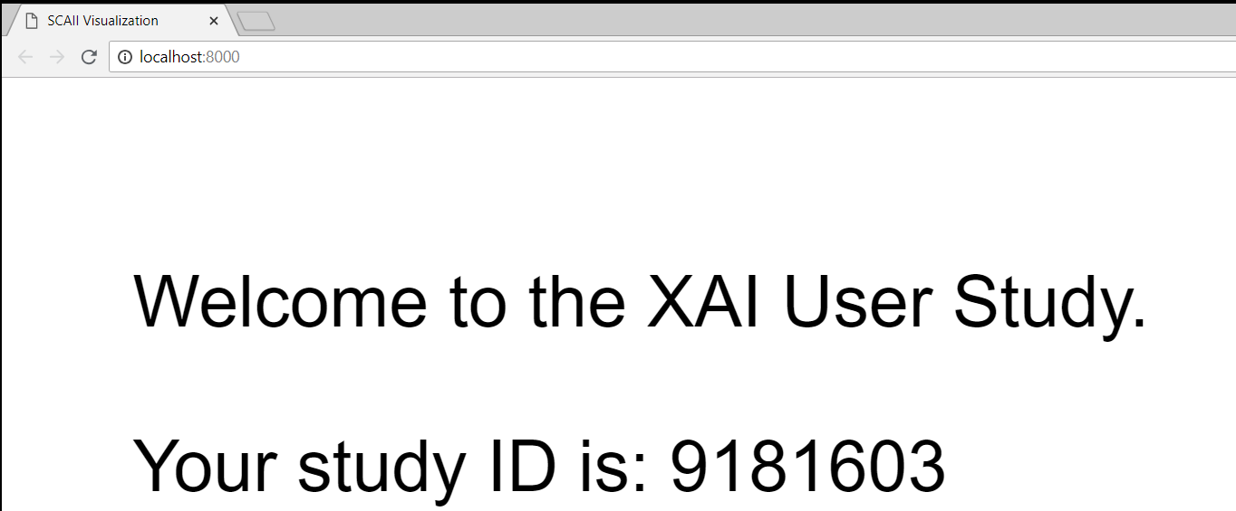
- Verify Participant ID.
- Open Camtasia (windows key and type in “Camtasia”)
  - Then click on the “record screen” in the top-left. It should bring up a small widget.
    - Turn the audio off
    - Make sure the widget appears in the lower right
- Go back to Google chrome
- *IMPORTANT* Hit f11 to full screen

Running the Study (with this page showing)
  - Remember to bring the lights back up after tutorial
  - Walk around and don’t chat with the participants
  - Try to stand/walk where you can observe your group of participants
    - After your group of participants finishes, give a thumbs up to the tutorializer so they know they are done
    - CONTINUE to observe after they have finished the tasks
  - When answering questions try to be as nice and supportive as you can
  - Ask for clarifying questions
  - Make requests, not demands
  - Participants are not allowed food/drink, avoid consuming them during sessions

Participent Misbehaviors:
  - No using phones (make sure they are off)
  - No talking to other participants (everyone needs to work alone)
  - No clicking ahead
  - Participants may leave at any time for any reason (payment requires completion)

Can answer any questions that:
  - Are answered on the cheat sheet
  - Relate to what Andrew has said
  - That were ALREADY answered in the tutorial

Can NOT answer any questions that relate to:
  - Strategy/how to answer the question on the screen
  - Off task questions
  - Turn the question back to them in an encouraging way, by saying things like:
  - Q: “how do you suggest that I figure out…”
    - A: “Do the best you can”
    - “Answer the question to the best of your ability”
    - “Interesting, take note of that thought it might be useful later”
  - Emotions/frustration/feedback: Just reassure them, don’t actually provide info.
    - Q: “I have no idea how to do this”. OR “I’m not very good at this.” OR Q: “This interface is really hard to figure out. What I need is…”
      - A: “that’s very helpful info, be sure to include it in one of the text boxes when you feel that way”.
- Common issues:
  - Can’t read some text: control + scrolling can zoom
  - Screen is all white: They have scrolled down too far, have them scroll up
  - They have code inspector on right side of screen: Press F12
  - Bringing up a new tab: Have them close the tab (NOT the window!!!)
- Person needs to go to the bathroom:
  - A: “Please wait until the end of this decision point.” <Alert the tutorializer, who will have the whole room wait while the person uses the restroom>
- Timeout protocol
  - For all questions with a typing answer, type in “Timeout <<Insert your initials>>”.
  - For all click questions, click on the tank object (game map), tank saliency map (saliency maps), or the largest negative reward bar for the action NOT taken.
  - Take note of which participant it was and what time so we can check the logs afterwards.
- Catastrophic failure recovery strategy:
  - Alert the tutorialiser IMMEDIATELY. Tutorialiser will tell everyone to turn their monitors off and keep their hands off, pausing the timer.
  - If the system has totally crashed, go to the Git Bash that was running the command “cargo run file” and type in “cargo run file” (skip 2 bullet points down)
  - Once it is up, follow the Timeout Protocol until you reach the correct task
- Ejection from the study
  - If you feel a participant should be ejected, discuss with tutorializer between tasks
    - If the participant is intentionally ruining things, we will axe them
      - (e.g. turning off the computer power)
    - Other misbehaviors will be given a few strikes
    - ONLY the tutorializer will make the call to remove participants

Ending the Study
- Pick up the Doorperson packet, which they will have slid under the door
- Hand out the post-task questionnaire and receipt when the tutorializer indicates it is time
- Participants will bring up filled out questionnaires and receipts.
  - Validate questionnaires (every question answered & participant # written on it)
  - Put any marked scratch paper into the questionnaire packet
  - Press F10 to stop the recording on workstations after the participant leaves

Tear Down
- Go through each questionnaire packet and tag each scratch paper with the participant ID
- For each workstation:
  - Hit f11 to exit full screen mode
  - Save the screen recording by:
    - Rewind to the start of the recording then pause - Note PID in video
    - Click save on the bottom right hand corner
    - Rename the file to the PID
  - Close bash by clicking on its window and press control + C
    - Do the same on the other bash screen
  - Drag the answer files to the “ScreenCaptures” network drive (left column of finder window under “This PC”
  - Move ALL .txt files back to the treatment question

