Creation of Western Oregon University Weather Ballooning Program: GPS Tracking, Heating Circuitry, and Balloon Filling Procedure

Justin Schepige

Janet Tate, William Schoenfeld

Submitted to the Department of Physics in partial fulfillment
of the requirements for the Degree of
Bachelors of Science in Physics

OREGON STATE UNIVERSITY

2013

Abstract: The addition of a weather ballooning program at Western Oregon University creates research opportunities for the Science Department, allows for projects in professional development for in-service teachers, fosters a partnership with Oregon Space Grant, and creates another option for students participating in the Program for Undergraduate Research Experiences. As the ballooning program is successfully constructed, a launch will be performed to assess functionality. The primary goal of the launch is to demonstrate effectiveness of the ballooning program by taking data on cosmic ray flux, temperature, pressure, and humidity as a function of altitude. The design and implementation of the GPS tracking system, heating circuitry and balloon filling procedure are explained from conceptualization to utilization during launch. These systems function to allow for a successful launch, data acquisition, and recovery. The GPS tracking system functioned properly and allowed for a successful recovery, though the WinAPRS software used functioned poorly and a recommendation that Google Earth be used in future launches is made. The heating circuits functioned properly and a small consideration of what type of battery should power them is discussed. The balloon filling procedure functioned properly, though ways to streamline the process and remove opportunities for human error are suggested. The cosmic ray and pressure data taken during the flight was unusable due to malfunctions in the data sensing equipment, but the temperature, humidity, and altitude data was collected properly and a comparison to the corresponding known properties about the Earth’s atmosphere confirmed its accuracy. The successful establishment of the ballooning program now allows for more student led balloon launches to occur with less preparation and overall less cost per launch. The data sensing equipment can be modified to sample a large variety of different quantities for various projects, and further improvements to the program could also be good research opportunities for science education.
Table of Contents
Abstract ii
Table of Contents iii
List of Figures vi
Section 1: Introduction 1
Section 2: Heisnberg-1 Balloon System Layout 3
2.1 Basic Design 3
2.2 Atmospheric Weather Balloon 4
2.3 Anchor Ring 4
2.4 Parachute 5
2.5 Payload Capsule 7
2.6 Command Capsule 8
2.7 Power/Batteries 10
2.8 Antenna 10
Section 3: Balloon Tracking Information 11
3.1 General Information 11
3.2 Flight Equipment 11
3.3 Ground Tracking Equipment 12
Section 4: Balloon Tracking Setup 15
4.1 General Information 15
4.2 TM-D700 15
4.3 TH-D7G 15
4.4 Garmin E-trex 17
4.5 WinAPRS 17
Section 5: Heating Circuits 19
4.1 General Information 19
4.2 Design and Construction 20
Section 6: Launch Procedures 24
6.1 General Information 24
6.2 Balloon Information 24
6.3 Balloon Filling Procedures 35
6.4 Balloon Tracking Procedure 27
6.5 Payload Preparation 28
6.6 Final Attachment and Launch 28
Section 7: Tracking System and GPS Data Results 30
7.1 Hardware 30
7.2 Software 30
7.3 GPS Data 31
Section 8: Heating Circuitry Results 33
Section 9: Launch Procedure Results 33
Section 10: Sensor Data Results 34
10.1 Pressure Data 34
10.2 Temperature Data 34
10.3 Humidity Data 35
10.4 Cosmic Ray Data 35
Section 11: Camera Results 37
Section 12: Tracking System and GPS Data Analysis 38
12.1 Hardware 38
12.2 Software 38
12.3 GPS Data 39
Section 13: Heating Circuit Analysis 40
Section 14: Launch Procedures Analysis 41
14.1 Balloon Filling 41
14.2 Payload Preparation 41
14.3 Payload Preparation and Launch 41
Section 15: Sensor Data Analysis 43
15.1 Pressure Data 43
15.2 Temperature Data 43
15.3 Humidity Data 46
15.4 Cosmic Ray Data 47
Section 16: Camera Analysis 48
Section 17: Assessment of Balloon Program Based on Data 48
Section 18: Conclusion 49
Works Cited 50
Appendix A 51
Appendix B 55

List of Figures

Figure 2.1– Heisenberg-1 balloon system profile (general overview): page 3.
Figure 2.2 – Profile of anchor ring: page 5.
Figure 2.3 – Parachute: attachment to balloon: page 6.
Figure 2.4 – Parachute: attachment to wooden ring and payload capsule: page 6.
Figure 2.5 – Cross section of payload capsule, showcasing the design: page 8.
Figure 2.5 – Cross section of command capsule, showcasing the design: page 9.
Figure 5.1 – Temperature vs. altitude in the Earth’s atmosphere: page 19.
Figure 5.2 – Operational temperature of resistor versus load in watts by percent: page 21.
Figure 5.3 – Basic circuit diagram showing the heating circuit design: page 23.
Figure 6.1 – Profile of balloon filing device: page 25.
Figure 6.2 – Layout of balloon filling setup: page 26.
Figure 7.1 – Altitude data from the flight plotted against 72 second time intervals: page 31.
Figure 7.2 – Balloon altitude data and data from the chase vehicle mapped together in 3-D.
Labeled pins (from left to right): launch site, last APRS packet, truck (road end),
and landing site: page 32.
Figure 10.1 – Temperature (blue), humidity (green), and pressure (black) data as a function of
Time: page 35.
Figure 10.1 – Radiation counts versus time for the first 15,000 vertical meters of the flight: page
36.
Figure 11.1 – Picture of Earth near the apex of the flight at 90,000ft (27km): page 37.
Figure 15.1. – Altitude versus air pressure for Earth’s atmosphere (Russell): page 43.
Figure 15.2 – Temperature in °C (blue), humidity in % (green), and pressure in mb (black) as a
function of time: page 44.
Figure 15.3 – Temperature vs. altitude in the Earth’s atmosphere: page 45.
Section 1: Introduction

The primary purpose of weather balloons is to measure or evaluate conditions in the Earth’s upper atmosphere. There are also a variety of other advanced data acquisition techniques that achieve this same task, two examples being high flying aircraft and height finding radar. These alternative methods to weather balloons, although very accurate, are very expensive to implement. Weather balloons are an inexpensive way to send scientific instruments high into the earth’s atmosphere, with little compromise to the integrity of the data collected. Because weather balloons provide accurate data at a much lower cost compared to other data acquisition methods, they have retained their relevance in evaluating conditions in the earth’s upper atmosphere.
The process of weather ballooning is conceptually simple: a large latex balloon filled with helium is equipped with scientific instruments and is allowed to float upward until it explodes at a predetermined height, at which time the scientific instruments descend back to earth, typically with the aid of a parachute so they can be found and reused. This thesis expands upon this simple concept and describes in detail the methods used to achieve a successful launch and collect accurate data on cosmic ray flux and other variables in the earth’s atmosphere.
Western Oregon University does not currently have a weather balloon program, but could benefit from one. A weathering ballooning program at Western could: create research opportunities for the Science Department, allow for projects in professional development for in-service teachers, foster a partnership with Oregon Space Grant, and create another option for students participating in the Program for Undergraduate Research Experiences. Weathering ballooning offers an inexpensive and accessible opportunity for undergraduates to collect accurate data relevant to a specific experiment, as well as opportunities for graduate students or professors to work on project management or development in the context of education.
Once the ballooning program has been established, the cost of successive balloon flights is and the time needed to prepare for a flight is reduced. A new balloon and more helium must be purchased for every launch, but otherwise all other equipment can be reused. The simplicity of reusing an established system allows the process to be taught quickly and repeated accurately. This minimized investment of resources and relative ease of use solidify weathering ballooning as an ideal program for undergraduate research. Once the ballooning program is in place, future Western students can easily get acclimated and use the program to conduct their own research.
The tasks outlined in this thesis detail the creation and implementation of the main systems necessary for a successful balloon launch and recovery. My main tasks in establishing the program were: designing a GPS tracking system that allowed for the payload to be recovered, designing and building heating circuits to keep the instruments from freezing, and outlining the physical launch procedures. The effectiveness of each system is analyzed post recovery of the payload, and improvements to each system are suggested for future launches.
To check the validity of the ballooning program, data on cosmic ray flux, temperature, pressure, and relative humidity are taken as a function of altitude. Using the currently accepted data body as a reference, the accuracy of our ballooning program can be confirmed by a simple comparison between the collected and accepted data.

Section 2: Heisenberg-1 Balloon System Layout
2.1 Basic Design
The Western Oregon University Heisenberg-1 balloon system was created based on BOREALIS, the design used by the Montana Space Grant Consortium. The BOREALIS design can be found in Appendix B. The design profile used for Heisenberg-1 is shown in Figure 2.1
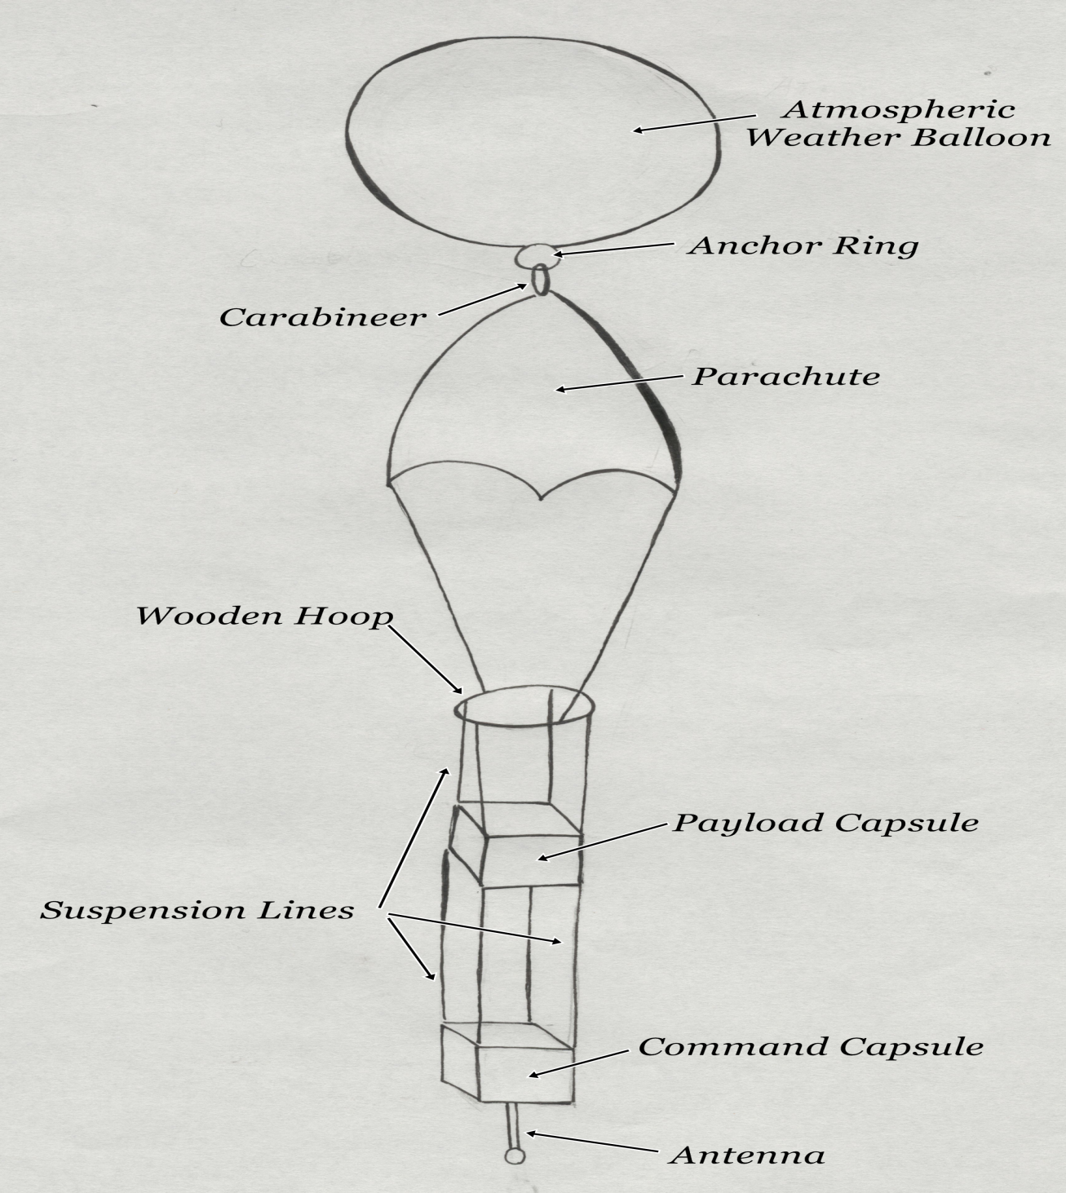
Figure 2.1 – Heisenberg-1 balloon system profile (general overview).
2.2 Atmospheric Weather Balloon
The function of the atmospheric weather balloon is to send the Heisenberg-1 balloon system over 27,000 meters into the atmosphere. Conceptually, the weather balloon is the ‘engine’ of the balloon system. How the balloon functions during launch is discussed in more detail in Section 6.
2.3 Anchor Ring
The balloon must be tied off and attached to the payload after it has been properly filled. When choosing a ring, the goal should be to find one strong enough such that it will not break under force between the balloon in the payload (which can become large in high winds), but not so heavy such that it will add unneeded weight to the balloon. Because the lines and chords used to tie the payload together must have a maximum test of 50lbs (meaning, the line must break when 50lbs of force is applied), it is recommended to find a ring that can withstand at least twice this amount. The ring we chose was steel 0.25m diameter by 0.05m thickness.
The anchor ring is attached to the balloon by a piece of rope. The rope is tied to the anchor ring using a non-slip mono knot. The rope is attached to the balloon by taping and folding over the excess latex located at the fill opening of the balloon. This attachment process is covered in more detail in section 6.5.
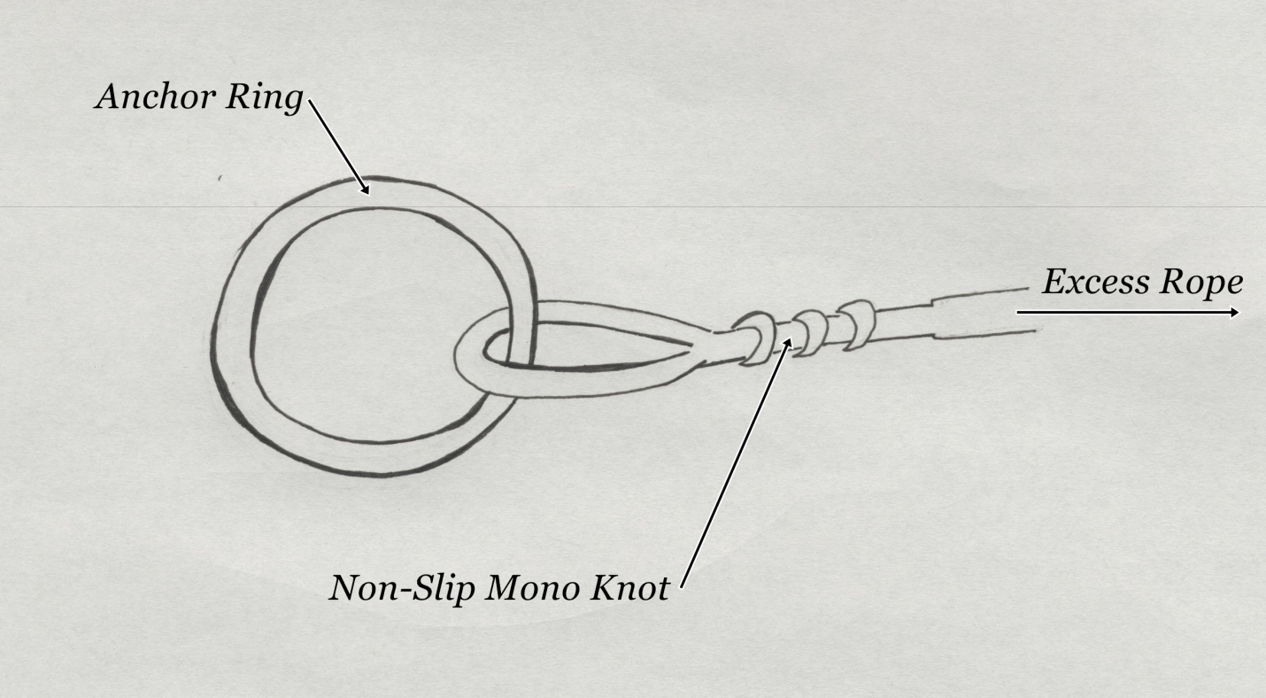
Figure 2.2 – Profile of anchor ring.
2.4 Parachute
The function of the parachute is to safely return the payload to earth. A descent rate of more than 20 ft/s runs a high risk of damaging the payload. The payload can be no more than 12-lbs and the size of the parachute is calculated using this maximum weight. A parachute 9ft in diameter is chosen and yields a 16 ft/s rate of descent (Starting Student Space, pg 7-16).
The BOREALIS design suggested using leader lines, lanyard lines, and guide rings to attach the balloon to the payload capsule. However, the use of all these extra lines could very easily create a tangle and cause the parachute to remain closed during descent. The parachute chosen has a loop on the top center, so the anchor ring is clipped to the hoop with a steel carabineer (carabineer should have a similar strength rating as the anchor ring). Federal Aviation Regulations Part 101 requires that any lines used in the balloon system be able to hold no more than 50-lbs of force. The nylon straps on the balloon comply with this.

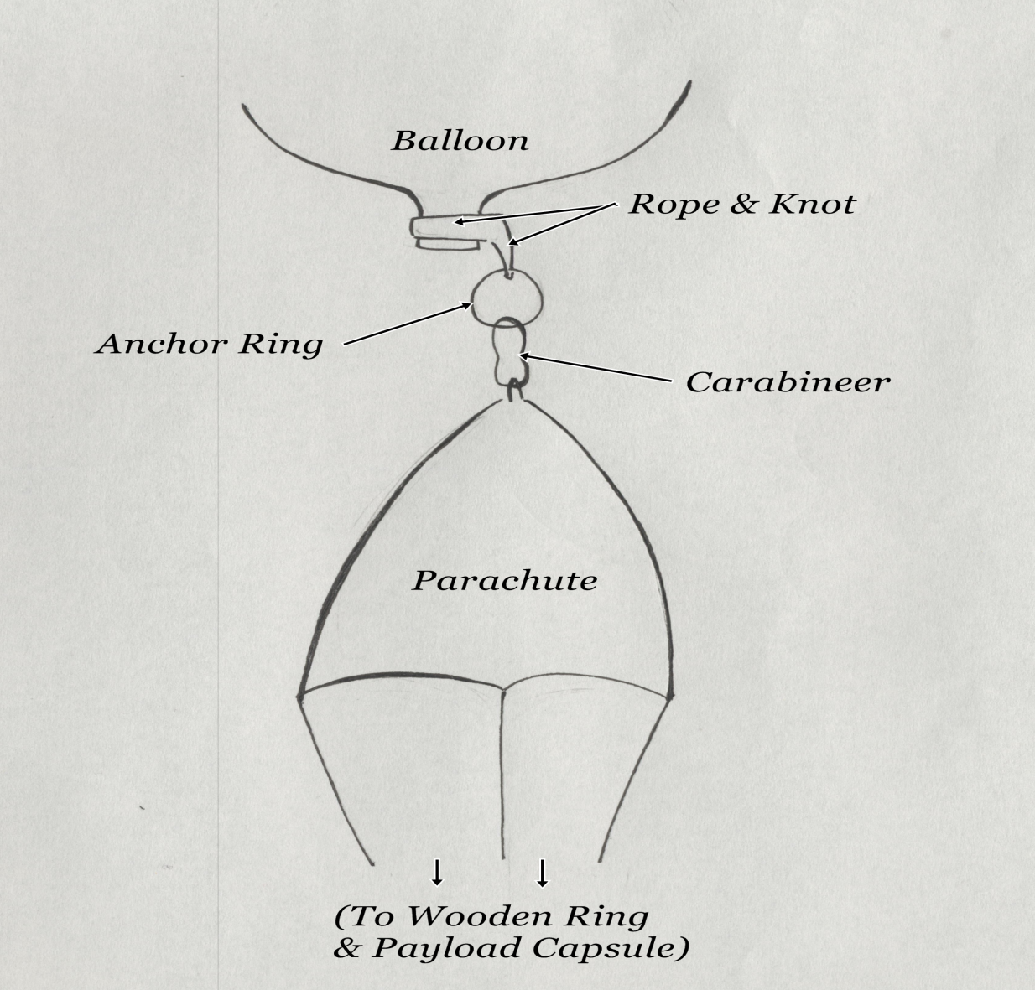
Figure 2.3 – Parachute: attachment to balloon.
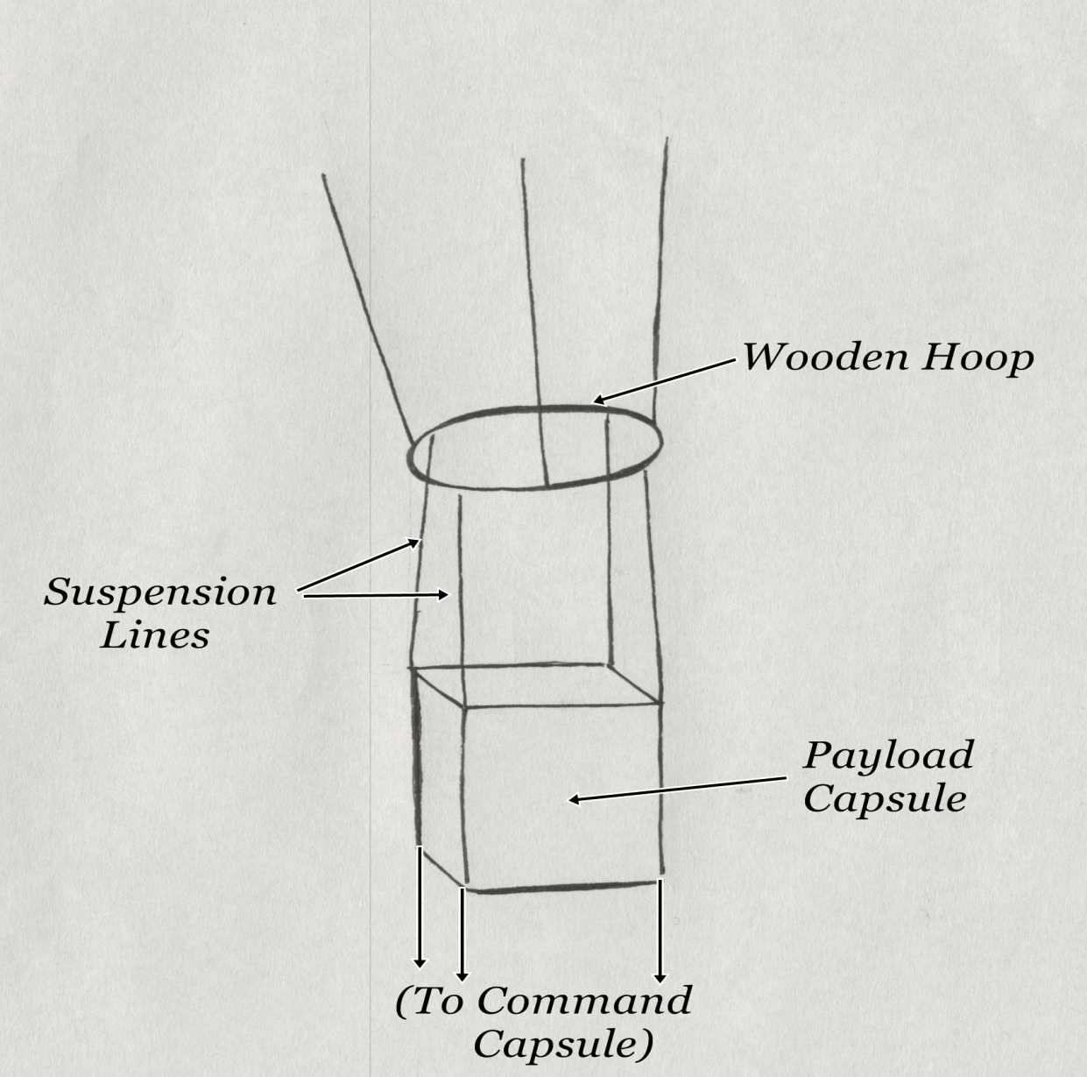
Figure 2.4 – Parachute: attachment to wooden ring and payload capsule.
2.5 Payload Capsule
The function of the payload capsule is to carry and protect all data gathering instruments. The instruments on Hiesenberg-1 are as follows: one temperature sensor, one pressure sensor, one humidity sensor, and one Geiger counter. The temperature, pressure, and humidity sensors are controlled using a central data logger (brand: Hobo). The central data logger will actively store data for all three sensors simultaneously with respect to time. The Geiger will log data separately for the sole purpose that a Geiger counter was not available as an attachment for the data logger.
The data gathering instruments must be protected from extreme low temperatures and possible jarring forces upon landing. The payload capsule is encased in insulating foam and all open spaces are fitted with rigid foam so the instruments do not freeze. Because of the extremely cold temperatures in the Earth’s upper atmosphere, a heating circuit is added to the capsule. The instruments are attached securely to the inside of the payload capsule, and the foam should cushion any jarring forces and keep the instruments from shifting around.
The payload capsule can be physically divided into three main categories: the outer shell, the inner shell, and the storage space. The outer shell is made of an insulated lunch box with a nylon shell. The inner shell is made entirely of Styrofoam and is much thicker than the outer shell. The storage space is filled with all the equipment necessary for the capsule, and the air gaps between the equipment are packed with foam. The payload capsule is fastened to the wooden hoop by the suspension lines (50lb test kite string) which attach at four points on the ring and four points on the outside of the nylon shell.

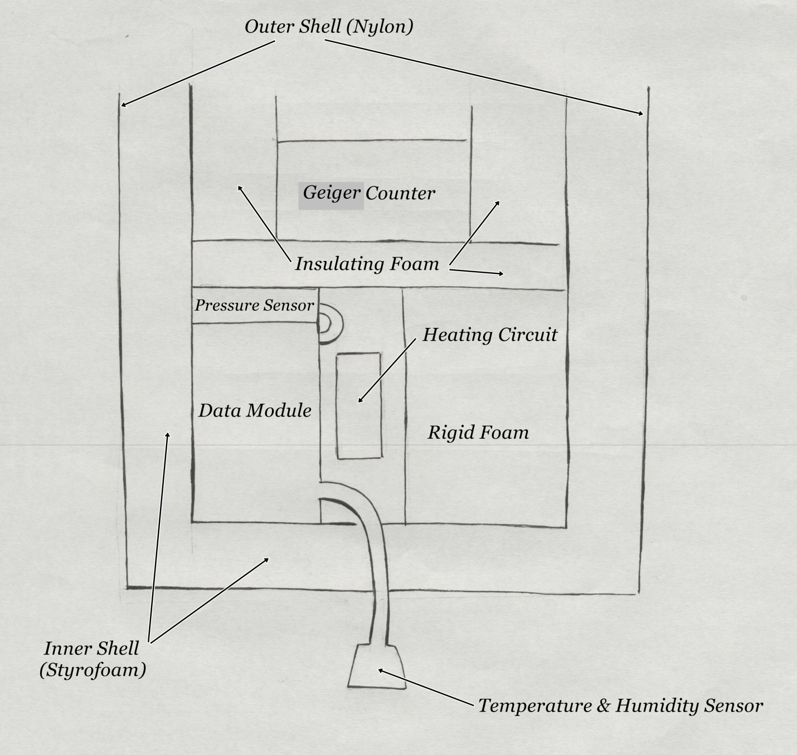
Figure 2.5 – Cross section of payload capsule, showcasing the design.
2.6 Command Capsule
In order to recover the payload after the flight, tracking equipment must be fitted to the balloon system. The function of the command capsule is to carry the balloon tracking equipment. The balloon tracking system consists of a Garmin GPS 18x LVC, a Kenwood TH-D7G radio, and a Garmin Astro 220 dog tracker. How the tracking system functions is explained in Section 3: Balloon Tracking. The command capsule also houses the GoPro camera, which will take 1 photo every 30 seconds during the flight. The camera is nestled into the side of the foam capsule and a hole is cut through the outer lining of the capsule so the lens can see out.
The command capsule uses the same 3 layer and foam packing design as payload capsule, and an identical heating circuit. The command capsule is fastened to the payload capsule using four suspension lines, one attached to each of its four corners.
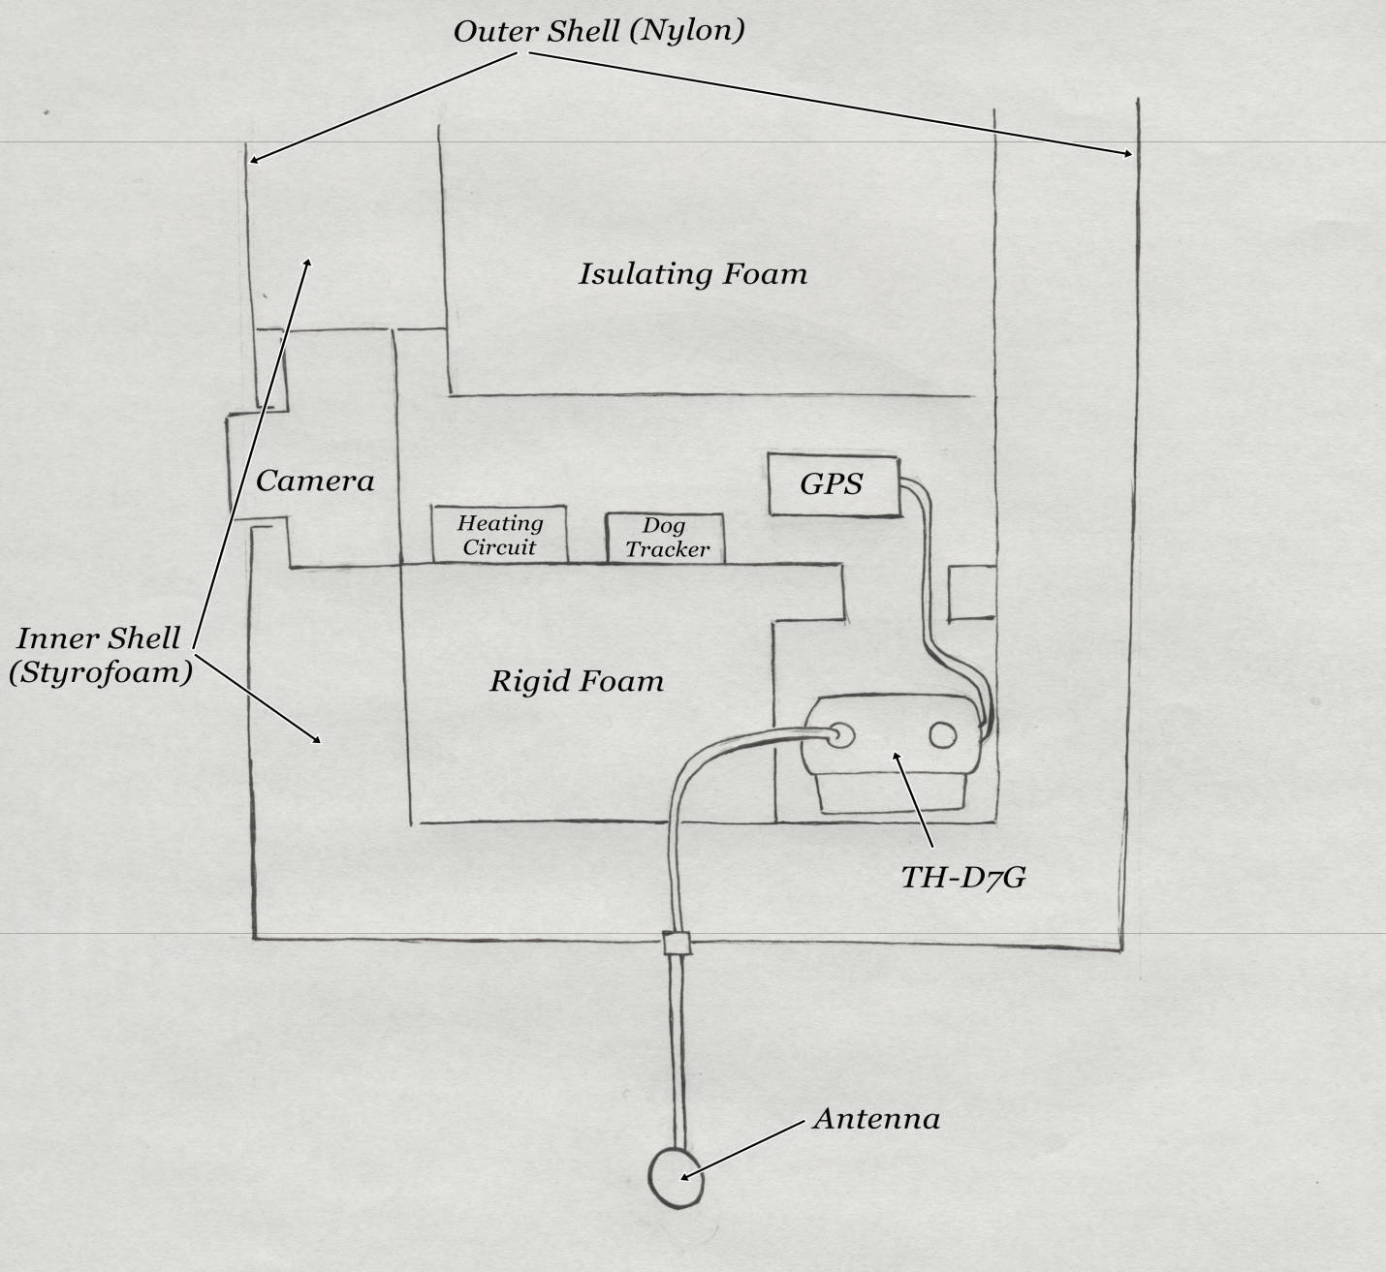
Figure 2.5 – Cross section of command capsule, showcasing the design.

2.7 Power/Batteries – (not shown in diagram)
Many of the systems onboard the Heisenberg-1 one require electricity to operate. It is possible to build an inverter and run all systems off of a central power source, but this option was not implemented due to complexity. Instead, each system that needs power is powered by its own set of batteries. The disadvantage to powering each individual system with its own set batteries is additional weight when compared to using a central power source.
Some systems, like the central data logger, have to be powered by AA batteries due to their physical design. Most AA batteries are alkaline, but a major drawback to using alkaline batteries is that they fail at temperatures below 32°F. Because of this property, single use lithium batteries are used instead. Not only do lithium batteries perform well under a larger range of temperatures, but they last longer and discharge at more consistent voltage. All the batteries used in the Hiesburg-1 balloon system, with the exception of the heating circuits, are lithium.
2.8 Antenna
The function of the antenna is to link the balloon tracking equipment with the ground tracking equipment. Ideally, the antenna would be oriented horizontally; antennas transmit by moving electrons up and down their vertical length, hence the electromagnetic radiation is emitted perpendicular to the vertical axis. However, the antenna is oriented downward because physically it is much more stable to attach the antenna in this way. By orientating the antenna downward, the risk of damage or separation is greatly reduced. Because the antenna is sending signals in the downward direction, it is the lowest hanging item on the balloon system. The antenna is very light, and simply sticks out of the bottom of the command capsule.

Section 3: Balloon Tracking Information
3.1 General Information
The purpose of the Heisenberg tracking system is to allow for the recovery of the payload after a successful flight into the upper atmosphere. The Heisenburg-1 tracking system uses an Automated Packet Reporting System (ARPS) to transmit GPS location data. APRS is an open system that uses unconnected AX.25 type packets to transmit and collect data (Martens & Rasmussen, Slide 8).
Martens & Rasmussen outline a simple concept map of how the GPS location data gets from a GPS satellite to mapping software on a computer. The GPS data is encoded to discrete APRS packets for mainly efficiency purposes: whenever an individual transmits over a given frequency band, the entire band is unusable until the transmission has been completed. APRS packets are a great way to transmit a large amount of data in a very short time period, thus allowing the airwaves to be shared.
3.2 Flight Equipment
The in-flight balloon tracking system consists of a Garmin GPS 18x LVC, a Kenwood TH-D7G radio, and a Garmin Astro 220 dog tracker.
The purpose of the Garmin GPS 18x LVC is to transmit the location of the balloon payload so that it can be tracked and recovered after launch. The Garmin GPS 18x LVC was chosen specifically due to its light weight: 104.9 grams. Only 3.5-5.0V DC is required to power the receiver, so the additional 3 AA batteries do not add much weight. The Garmin GPS 18x LVC is not capable of long distance data transmission on its own, so a Kenwood TH-D7G handheld radio is used. The TH-D7G was chosen for its balance of transmission power, weight, and battery life. The TH-D7G is powerful for its size and has a sufficiently large transmission range such that the tracking signal won’t be lost, even if the balloon travels up to 50 miles from the launch point. The TH-D7G is light enough such that when combined with the other tracking equipment in the command capsule the total weight is still less than 6 pounds, as per regulation. Lastly, the TH-D7G is equipped with TNC (terminal node controller, necessary for decoding APRS packets) and can use APRS, which is necessary for the GPS communications.
The Garmin GPS 18x LVC is only so accurate, and can potentially misrepresent a position of the payload. Also, when the payload is descending, there is a good chance that the last APRS data packet containing the location of the payload will be transmitted over 500 meters above the ground. Because the exact location of the payload may not be obtainable by using GPS satellite tracking, a Garmin Astro 220 dog tracker is used. The dog tracker has a maximum range of 1.5 km. The Garmin GPS 18x LVC is used to get close to the balloon payload such that the Garmin Astro 220 can be used to exactly locate and recover the payload.
3.3 Ground Tacking Equipment
The ground tracking equipment functions to receive transmissions from the balloon tracking equipment in the command capsule. Two chase vehicles are outfitted with Kenwood TM-D700A radios and Garmin E-trex Legends in order to track the balloon system over long distances (the balloon system will travel approximately 30 miles horizontal distance during flight). The incoming packets from the TM-D700A and the Garmin E-trex are processed by a mapping program WinAPRS and mapped together in real time. The payload is most likely not going to land on a road, so it will need to be tracked on foot, at which point the Garmin Astro 220 dog tracker will be used.
The Kenwood TM-D700A was chosen because it is a good match for communications with the TH-D7G. The main function of the TM-D700A is to receive the radio transmissions from the TH-D7G. The TM-D700A has a serial output, which is a necessary feature for connecting to WinAPRS on a laptop. Also, the TM-D700A is designed to fit nicely in an automobile, which is a necessary quality for use in a chase vehicle. The TM-D700A is large, but weight is not a consideration in the ground tracking equipment.
The Garmin E-trex Legend is a standard, reasonably priced GPS tracking unit that has gotten favorable product reviews since it was released. The main purpose of the E-trex is to track the location of the chase vehicle and place the location in real time on the mapping program. Seeing the balloon and the chase vehicle on the mapping program at the same time makes recovering the payload much easier because the maps displayed in the program don’t always look like you would expect in the real world. There are a number of other great GPS products that could serve the same purpose as the E-trex, but the E-trex seemed like a good balance of reliability and price.
A laptop is used to map the incoming GPS coordinates. The WinARPS software program is used to decode the APRS packets and place both the position of the balloon and the chase vehicle onto a map in real time. WinAPRS represents the current standard in tracking software and is also very easy to use. The default maps are generally very accurate, and other map packages can be added to the program as needed (including Google Maps). WinAPRS is also free to use.
Another option to properly map and track the balloon is a website, aprs.fi. This is a free service offered by Google that tracks and plots all APRS data packages that have been picked up by other HAM operators. The main advantage of aprs.fi is all the APRS packets from the balloon will be picked up, while when using WinAPRS packets can be missed because they must be picked up by the TM-D700A in the chase vehicle. Another advantage of aprs.fi is the use of Google maps, which are far superior to the default map package provided in WinAPRS. The main disadvantage of aprs.fi is an internet connection is necessary to use the application. For this project, aprs.fi was prepared as a backup plan in case WinAPRS did not function correctly.

Section 4: Balloon Tracking Setup
4.1 General Information
The settings for each piece of equipment must be configured specifically in order for the tracking system to work. The criteria is bulleted because it does not matter in which order the settings are configured; regardless, I have arranged the bullets with a logical, linear flow. The procedure for tacking the balloon during the flight is explained in section 6.4.
4.2 TM-D700A
- The TM-D700A has 2 frequency bands: band A will be used for APRS data transmission while band B could be used for communication between chase vehicles, or not used at all. Set the frequency for band A to 144.390, the public APRS frequency. Use menu 1-6-1 to select band A.
- Make sure the TM-D700A is set to TNC PKT mode. To do this, hold the function button to bring up the options menu, then select “TNC.”
- Make sure the baud rate over the airwaves is set to 1200. This is not to be confused with the baud rate being sent to the computer, which should be set to 9600. These settings are default.
- Set the minimum signal volume (called squelch). Squelch can be set by using the large knob dedicated to band A. Set the squelch by turning the knob clockwise until static is no longer heard.
- If any transmissions will be made, enter a valid call sign under menu 3-1. A valid call sign will correspond to a valid HAM radio license.
4.3 TH-D7G
- Enter a valid HAM call sign for legal data transmission under menu 2-1.
- The TH-D7G has two frequency bands: select band A as the primary transmission channel under menu 2-M. Then, set band A to 144.390 to match the TM-D700A.
- Press the TNC button to enter ARPS mode.
- Under menu 2-2 select NMEA. This will set the TH-D7G to accept incoming baud rate from the Garmin GPS 18x LVC. NMEA is standard for most GPS setups.
- Under menu 2-8, set the station icon. In this case, it would make the most sense to set the icon to a balloon, which should be an option in the icon bank. This will let other HAM operators know that the transmitting radio is most likely in a weather balloon.
- Make sure ambiguity is OFF. Ambiguity rounds the position data and will result in inaccurate transmissions of location data.
- Make sure the baud rate over the airwaves is set to 1200. This setting is default.
- Set amount of APRS sent to maximum. Maximum for the TH-D7G is one packet every 0.2 minutes.
- Set the packet transmission to auto-transmit under menu 2-C.
- Set the packet path to either wide 1-1 or wide 2-2.
- Assign the identification icon to be a balloon, such that the data transmission can be easily identified as a weather balloon.
- Set the position comment to “off duty.”
- Turn off beep (sound alert for incoming data packets) to save battery.
- Optional: A status message can be set to transmit. The status TX option will dictate how often the status message is transmitted.
- Reminder: lock the keypad before launch.

4.4 Garmin E-trex
- Make sure the datum is set to WGS-84 under the setup menu. This is the map the GPS device will use and WGS-84 is the accepted standard and is reasonably accurate.
- Change the default baud rate from 9600 to 4800 under the setup menu.
- Allow the GPS to acquire satellites and get positive lock on its location.
4.5 WinAPRS
- Connect the TM-D700A to a computer with WinAPRS installed by using a serial connection (if your computer is without a serial port, use a serial to USB converter cable). Then, under the device manager (on a windows computer), check what comm port the TM-D700A is listed as being plugged into.
- Connect the E-trex to a computer with WinAPRS installed by using a serial connection (if your computer is without a serial port, use a serial to USB converter cable). Then, under the device manager (on a windows computer), check what comm port the E-trex is listed as being plugged into.
- Go to Settings, then Station and enter a valid call sign as well as your current lat/long position information. The WinAPRS map software will not interpret data until this has been completed.
- Go to Settings, then Serial Port, then assign the proper comm. port to both the radio input (VHF) and the GPS input in the Number input box.
- For the E-trex, the input baud rate must be set to 4800, which is not default. To change this go to Settings, then Serial Port, and then change the baud rate in the Speed input box.
- Under the TNC menu, select Kenwood DC, which is the appropriate setting for connecting the TM-D700A.
- Set the position report rate to maximum for the radio (VHF). This will allow the map to update as quickly as possible.

Section 5: Heating Circuits
5.1 General Information
Heating circuits are added to both the command capsule and the payload capsule to keep the data instruments and radio transmission equipment from malfunctioning at low temperatures. The temperature versus altitude for Earth’s atmosphere is shown in Figure 5.1.

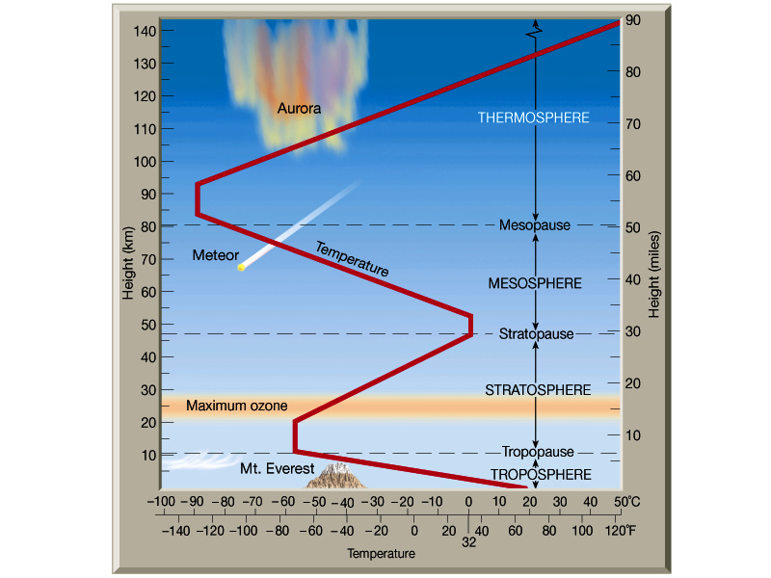

Figure 5.1 – Temperature vs. altitude in the Earth’s atmosphere (Structure of the Earth’s Atmosphere).

In accordance with Figure 5.1, temperature as a function of altitude in the Earth’s atmosphere is not linear. The distinct layering that exists in the atmosphere causes the temperature to shift dramatically over 10km distances. At the anticipated peak of the flight, 90,000 feet (about 27 km), the temperature of the earth’s atmosphere is approximately -50°C. The coldest it will get during the flight is about -70°C, though this temperature will only be experienced for a short period of time. The lithium batteries will only function down to -20°C, so a prolonged exposure to temperatures that exist between about 5km and the peak of the flight could shut down or destroy most of the equipment and the payload would most likely not be recovered.
Although the batteries will function down to -20°C, it would be ill advised to get too close to the extreme end of their expected operating range. The goal will be to keep the inside of the capsule above freezing for the duration of the flight. On the off chance the flight takes longer than expected, having a short period of time where the capsules are below freezing will not cause any equipment to fail.
Conceptually the heating circuits are incredibly simple: they consist of a battery, a resistor, and a switch to turn the circuit on and off. How much heat is deemed necessary will dictate the size and values of the components. Placing the capsules in a freezer and testing their heat loss over time would be the best way to judge how much heat would be necessary, but due to time constraints this test was not performed. Instead, the amount of heat used in the flight is determined by weight constraints and operational temperature.
5.2 Design and Construction
To keep the heating circuits light two 9V batteries were used. This generates an 18V total. The Duracell alkaline batteries used for testing are rated at 565 mAh. Because the average time of the flight is assumed to be 3 hours, the heating circuit will be designed to last 3 hours as well. Towards the tail end of the battery life the overall heat output will decrease due to decreased voltage, but during that time the balloon should be at an altitude where the outside temperature is above freezing and thus does not pose a concern. Equation 5.0 determines a good estimate for the amount of current that should be drawn from the batteries for the circuit to be powered for 3 hours.
$\frac{2*565mAh}{I}= 3h,$ I$=376.6mA$ 5.0
The resistors used for the circuit are 50 ohms, rated at 10watts. Pulling up the resistor spec sheet, the operational voltage versus heat output and Celsius can be seen
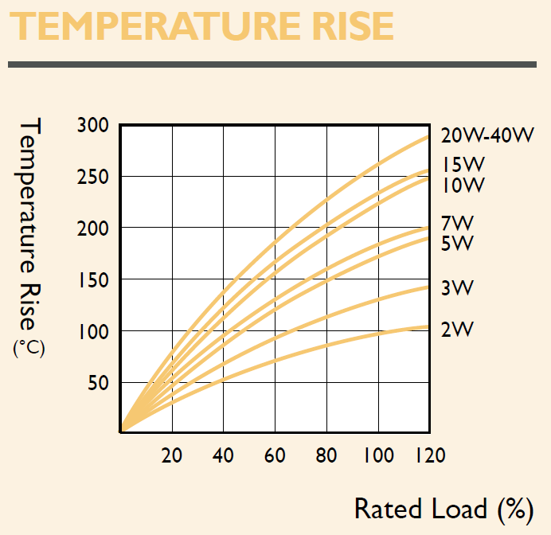
Figure 5.2 – Operational temperature of resistor versus load in watts by percent (Yageo, pg 1)

Any sustained temperature over 70°C poses a risk to damaging other equipment in the capsule, so the circuit will be designed to load the resistor at 70°C or less. To run at 70°C, the amount of current drawn should be approximately 180 mA. Equation 5.1 shows the revised calculation for the expected duration of the heating circuit and confirms that the proposed current draw will allow the circuit to heat for the full duration of the flight.
$\frac{2*565mAh}{180mA}= t,$ $t=6.3h$ 5.1
Equation 5.2 determines the resistance needed to achieve a 180 mA current draw.
$R=\frac{V}{I},$ $R=\frac{18V}{0.18A}=100Ω$ 5.2
The resistance of 100Ω is easily achieved by wiring two of the 50Ω resistors in series. The rating of 10W per resistor will give a 10W total rating when 2 10W resistors are wired in series (wattages do not add). Equation 5.3 confirms that the power dissipated across the resistors is less than 10W.
$P=\frac{V^{2}}{R},$ P$=\frac{{(18V)}^{2}}{100Ω}=3.24W$ 5.3
All the necessary calculations have been made to fully design the circuit. The final circuit design is shown in Figure 5.3.
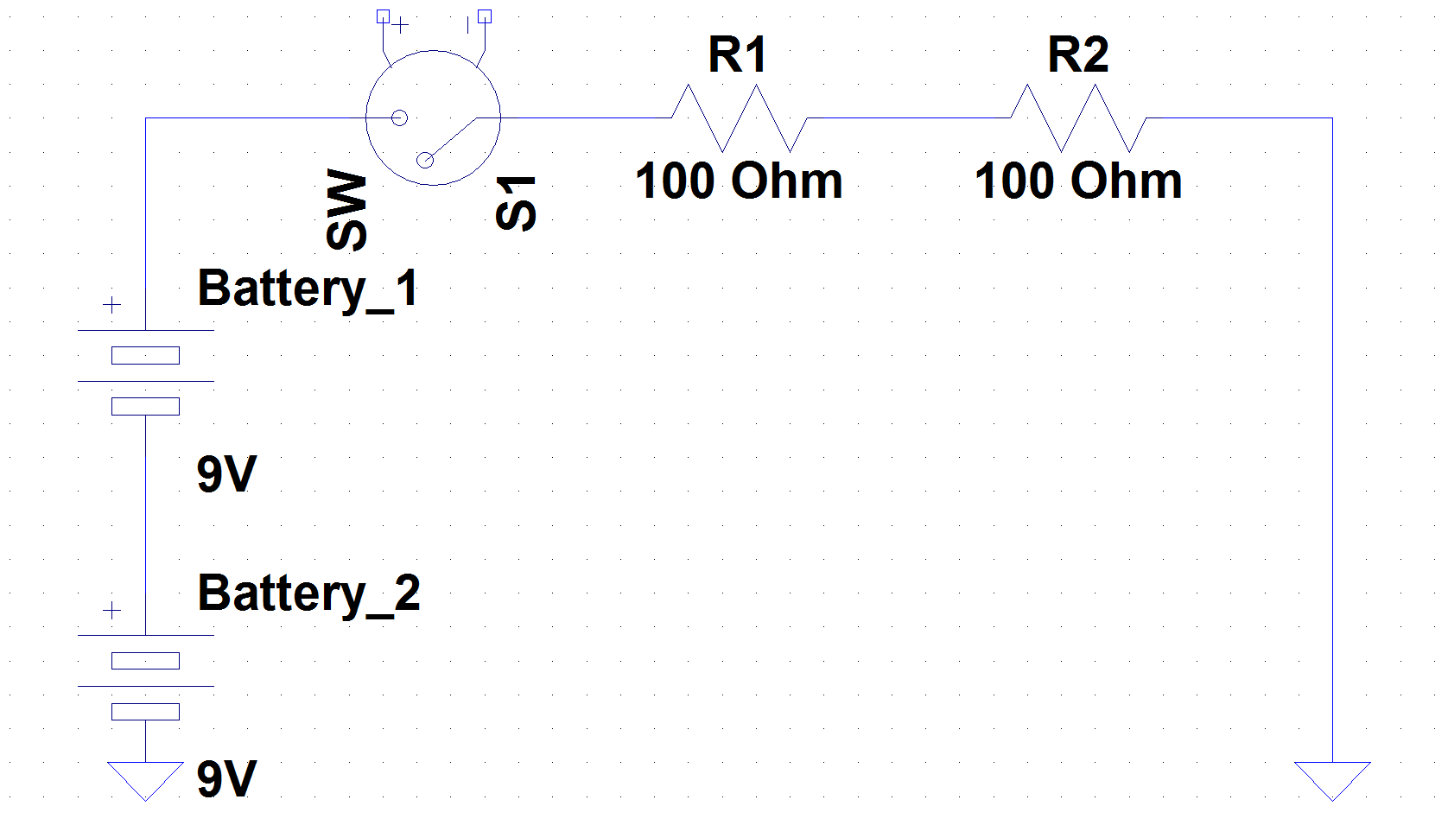
Figure 5.3 – Basic circuit diagram showing the heating circuit design.
To save space, the circuit comments of the circuit are placed as close as possible to each other. The heating circuit will be positioned within the capsule alongside the GPS equipment.

Section 6: Launch Procedures
6.1 General Information
Before a launch it is advisable to create two lists to assure you have completed all the necessary tasks: a materials list and a pre-flight checklist. The materials list is a comprehensive itemization of all things used in and needed for a successful launch; use this as a checklist when packing all of the equipment so nothing is forgotten. The pre-flight list consists of all the necessary tasks needed to be performed before and during the launch procedure so that nothing is overlooked or executed improperly. The lists created for the first flight of the Heisenberg-1 balloon system can be found in Appendix A.
6.2 Balloon Information
The weather balloon is made of latex and measures two meters in diameter un-inflated and will expand to about 10 meters in diameter before exploding at the peak of the flight. The balloon will be filled with 99.99% pure helium. The helium is added to the balloon from a helium tank by means of a regulator, a hose, PVC nozzle coupling device.

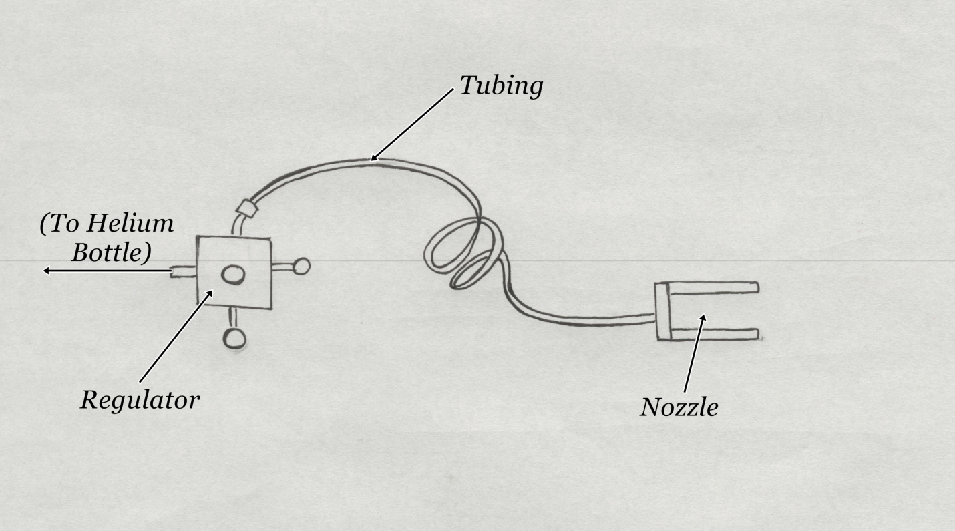
Figure 6.1 – Profile of balloon filing device.
The volume of helium added to the balloon determines the altitude of the flight as well as the overall flight time. The more helium is initially added the sooner the balloon explodes, thus (when a standard explosion volume is assumed) the balloon explodes at a smaller vertical height and begin its descent sooner, reducing the overall time of the flight. Unfortunately, at which volume a latex weather balloon will burst is by no means an exact science, so the calculation of how much helium should be added is at best an approximation (calculation in Stringer’s paper).
6.3 Balloon Filling Procedure
Find a large flat spot on the ground a place a tarp at least 8x10 ft in size; if possible, choose a spot that is sheltered from potential wind gust as wind will make things difficult later in the filling process. Weight the corners of the tarp down with brick such that the tarp doesn’t move. Put on latex or nitril gloves and remove the balloon from its packaging. Warning: do not touch the balloon with your bare hands, as the oils on your hands may cause weakness in the latex resulting in a premature flight end. Lay the balloon down on the tarp and lay a second tarp of equal or larger size over the top; this tarp will keep the balloon from flying around when it has enough helium to become buoyant in the air. Make sure the tarps are weighted down with bricks or a similar weight type in the corners. At the end of this part of the procedure the setup should look like Figure 6.2.

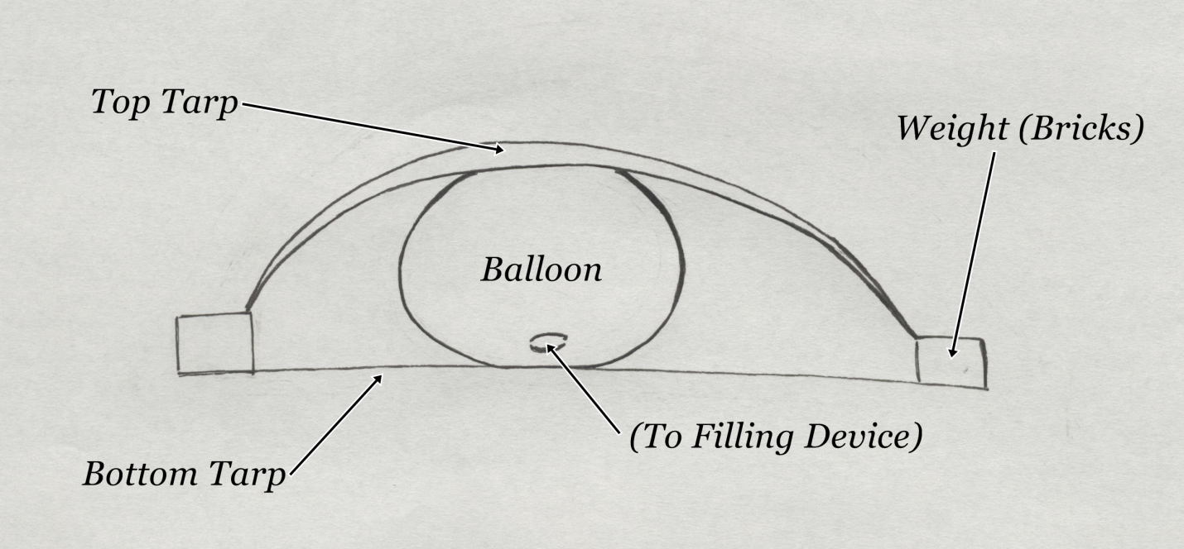

Figure 6.2 – Layout of balloon filling setup.

Once the balloon has been properly positioned the filling can commence. Place the PVC nozzle into the opening of the balloon, then fold the excess latex over itself and pull tightly. While keeping pressure on the folded latex, duct tape the latex in place so it won’t slide off or leak. It is also a good idea to use an appropriately sized hose clamp to provide extra pressure; only use the hose clamp over a spot with duct tape to avoid punching a hole in the latex. Once the PVC nozzle has been properly attached begin filling the balloon with helium. The actual filling process takes a long time, so filling the balloon is a great first item on the launch timeline.
6.4 Balloon Tracking Procedure
While the balloon is filling the tracking system can be setup. Unlike the general setup in section 4, the order of operations for the tracking procedure does matter. The steps are ordered chronologically.
- Power up the GPS 18x LVC and give it at least 5 minutes to properly acquire the GPS satellites.
- Power up the Kenwood TH-D7G radio. Make sure the settings have been configured in accordance with section 4.
- Plug the GPS 18x LVC into the GPS port on the Kenwood TH-D7G and hit the ‘pos’ button. This will bring up the lat/long coordinates. If the degree symbols are blinking the TH-D7G is receiving data from the LVC and things are functioning normally. If there are issues will this step, turn off both the 18x LVC and the TH-D7G before plugging the 18x LVC into the GPS port, then turn both devices on once again.
- Turn on the Kenwood TM-D700A radio. Make sure the setting have been configured in accordance with section 4.
- Plug the laptop into the Kenwood TM-D700A with the appropriate cables. Turn on the laptop and open the WinAPRS program. Configure WinAPRS as detailed in section 4.
- WinAPRS should now be mapping all GPS transmissions in the local area. Whatever call sign is being used for the TH-D7G should now be present on the map.
- Turn on the dog collar. Make sure the red LEDs on the collar are flashing.
- The tracking equipment is now properly configured and can be packed into the command capsule.
- WARNING: Do not launch the balloon if the GPS equipment is not properly transmitting. If there are issues with receiving or mapping, the balloon may still be launched and the payload successfully recovered. Refer section 4 or to Section 12.2 for alternate methods of tracking the balloon.
6.5 Payload Preparation
While the balloon is filling, all of the equipment used in the payload must be fitted into its appropriate capsule and configured such that it is ready for the flight (consult your pre-flight checklist to make sure you don’t forget anything!). The necessary setup procedures for all the equipment used in the payload have been covered in sections 1-5 of this paper, or have been covered in Stringer’s paper. The batteries in GPS equipment will last long enough such that it does not matter when they are configured, but wait as long as possible to turn on the heating circuits and the data sensing equipment.
6.6 Final Attachment and Launch
Before the balloon can be launched the payload and parachute must be attached properly. All the capsules must be tied together using the suspension lines. It is recommended to keep the capsules at least a 0.5 meters from each other and 1.0 meters from the parachute. After tying everything together, lay out the payload as described in Figure 2.1, only horizontally along the ground.
Now that the payload is ready, the flight can begin as soon as the balloon is done filling. The calculation in Stringer’s paper gave a good approximation of how much helium would need to be added to the balloon to provide adequate lift. At this point, the balloon will want to take off and will be very hard to hold down. A good judge of when the balloon is ready is how difficult it is to hold in place.
When the balloon has been filled with enough helium the filling nozzle can be removed. If a hose clamp was added, first remove the hose clamp. Then, with at least one other person holding onto the nozzle, remove the tape that was holding the latex neck tight against the nozzle. Once the tape has been removed the nozzle can also be removed, however at least one person must grab the balloon above the nozzle to prevent helium from escaping.
Once the nozzle has been removed the anchor ring can be attached. First, fold over the excess latex on the neck and use plenty of duct tape to keep the seal tight. Next, thoroughly tape the rope attached to the anchor ring to the balloon. Finally, fold over the length of the latex neck over the rope and once again thoroughly tape everything together.
The balloon is now ready for the payload. It may be good to check the lift of the balloon in producing by attaching a fish scale to the anchor ring. However, at this point in the procedure it would be very hard to reattach the fill nozzle and add more helium. All that remains at this point is to attach the payload to the balloon. Clip the carabineer on the top of the parachute to the anchor ring and let go!

Section 7: Tracking System and GPS Data Results
7.1 Hardware
Due to a pre-launch mishap, the extension cable that allowed the antenna to point out from the bottom of the command was unusable. Because another cable could not be obtained in time, the antenna was forced to stick out of the side of the capsule instead. Although the positioning was awkward, conceptually this allows for a better signal transmission because the radio waves are emitted perpendicular to the antenna. There were no issues with receiving the packets on the TM-D700A (when the software was working) and aprs.fi also received and mapped all of the packets.
Broken extension cable aside, all equipment used for the GPS tracking system functioned as anticipated and allowed for a successful launch and recovery. Also, all equipment used in the launch was undamaged and fully functional upon recovery, so it can be reused during future launches.
7.2 Software
The software used for the GPS tracking functioned poorly was not able to be used effectively. Instead, aprs.fi was implemented. There was no internet available while in the chase vehicle, so a phone call was placed to someone who had internet and could access the website. Once it had been confirmed that the most current data packet was the final data packet and the balloon had landed, the coordinates were recorded on a piece of paper. Using the final coordinates, a waypoint was created on the E-trex, and the balloon was tracked without further use of software.

7.3 GPS Data
The altitude data for the flight was taken from the GPS information. An APRS data packet set to transmit from the Kenwood TH-D7G every 12 seconds for the full duration of the flight. The total time of the flight from launch to landing was 112 minutes and 30 seconds (found by using the internal timers on the data sensors). Dividing by the number of packets received, the average time between packets was found to be 72 seconds, which is far longer than the expected 12 seconds. The data analysis in section 12.3 is done with the assumed 72 second interval, and the resulting calculations fall within expected tolerances. The altitude data is graphed in Figure 7.1.

Figure 7.1 – Altitude data from the flight plotted against 72 second time intervals.
Alternately, the GPS altitude data was downloaded as a .kmz Google Earth file. This allowed the altitude data to be plotted not only in 3 dimensions, but with accurate positioning on and above the Earth’s surface. The GPS data from the chase vehicle was also exported and plotted along with the balloon flight (chase vehicle track does not leave the surface of the map, so it is easily distinguished from the balloon path). The launch site, last APRS data packet received, end of the road, and final landing site are labeled for clarity, and to help better describe the physical tracking procedure. A picture of the Google Earth representation is shown in Figure 7.2.
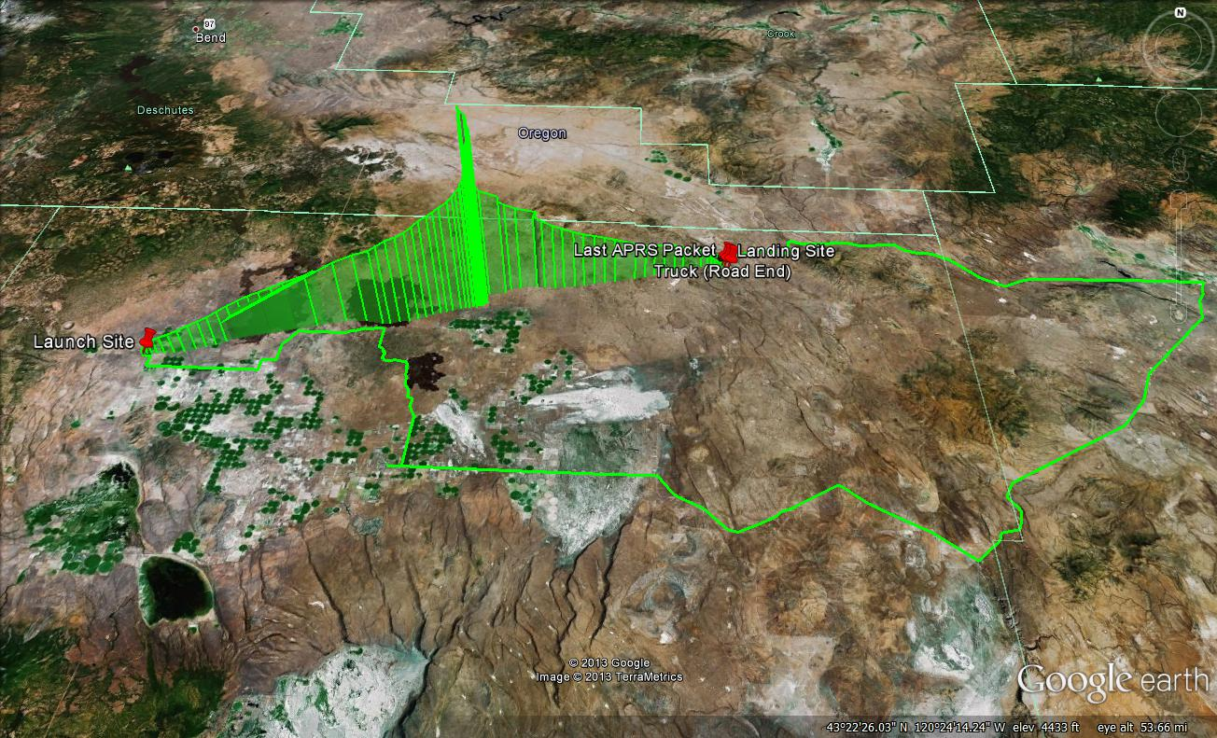
Figure 7.2 – Balloon altitude data and data from the chase vehicle mapped together in 3-D. Labeled pins (from left to right): launch site, last APRS packet, truck (road end), and landing site.

Section 8: Heating Circuitry Results
The heating circuitry design was deemed to be a success because none of the flight equipment failed due extremely cold temperatures. As a secondary consideration, it is possible that the heating circuits could have been too hot, but it was also confirmed that none of the flight equipment failed due to excess heat either.

Section 9: Launch Procedures Results
The launch was successful as nothing was damaged, unfinished, or forgotten due to the methods used during the procedure. The overall success of the flight serves to reinforce this point. However, the launch could have gone much smoother, so ways to improve the procedure are discussed in section 14.

Section 10: Sensor Data Results
10.1 Pressure Data
No pressure data obtained from balloon flight is usable for analysis. Once the pressure dropped below 650 mb, which is early in the flight at about 5,000 meters, the sensor no longer functioned and no data was taken. The pressure data can be seen in Figure 10.1 (the black line) and is useful for identifying the beginning and end of the balloon flight. Also, it can be seen that the pressure is lower upon landing, which is consistent with the elevation of the recovery site being higher than that of the launch site.
10.2 Temperature Data
The temperature sensor functioned properly and took data for the duration of the flight. The temperature data is taken against time and not elevation; this is a limitation of the data sensing equipment. The temperature data is plotted in Figure 10.1 (the blue line).
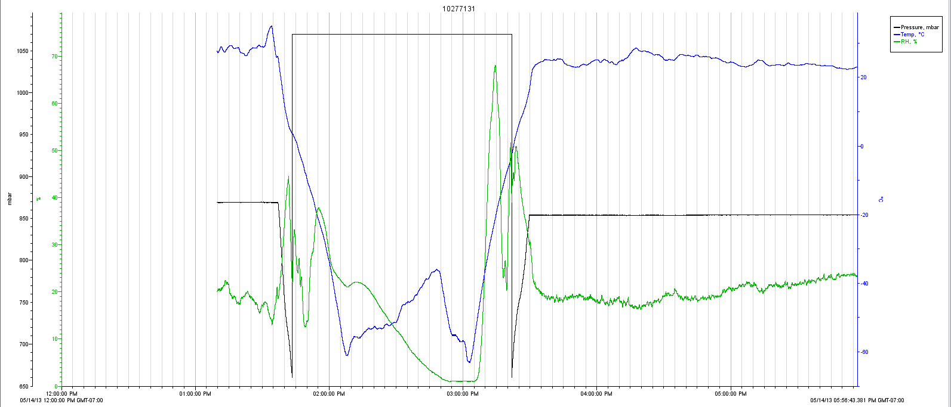
Figure 10.1 – Temperature (blue), humidity (green), and pressure (black) data as a function of time.
10.3 Humidity Data
The humidity sensor functioned properly and took data for the duration of the flight. The humidity data is taken against time and not elevation; this is a limitation of the data sensing equipment. The humidity data is plotted in Figure 10.1 (the black line).
10.4 Cosmic Ray Data
An unknown error caused the Geiger counter in the balloon the stop taking accurate data at an altitude of about 15,000 meters. After 15,000 meters all of the counts flat lined at 0 and remained that way until the Geiger counter was recovered. Almost all of the data collected at lower altitudes showed less than 100 counts per second. Right before the counter stopped taking data, the number of counts/second increased dramatically with the last number being 35,409 counts per second. The graph of all the non-zero data points is shown in Figure 10.1.

Figure 10.1 – Radiation counts versus time for the first 15,000 vertical meters of the flight.

Section 11: Camera Results
The GoPro camera that was fitted into the side of the command capsule successfully took pictures for the over three-quarters of the duration of the flight. One of these pictures is shown below in Figure 11.1.
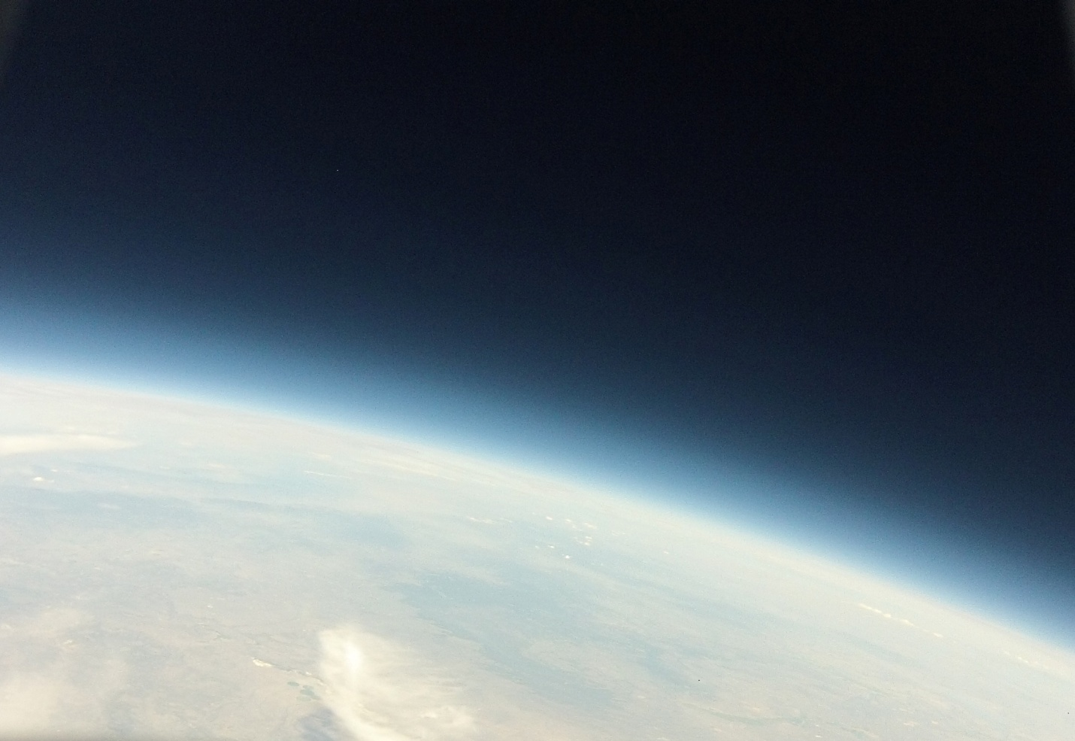
Figure 11.1 – Picture of Earth near the apex of the flight at 90,000ft (27km).

Section 12: Tracking System and GPS Data Analysis
12.1 Hardware
The hardware worked very well and no major changes are recommended. Although the antenna sticking out of the side of the capsule functioned just fine, it is advisable to replace the broken extension cable and once again allow the antenna to point down.
12.2 Software
WinAPRS was a very poor choice of software and functioned so poorly it was almost entirely unusable. During the launch procedure, WinAPRS functioned as anticipated and was able to confirm that the TH-D7G was broadcasting APRS packets that accurately represented the launch location. The E-trex was also routed into the computer properly and real time changes in the location of the chase vehicle were plotted accurately on the map. However, once the balloon was launched, WinAPRS was unable to map the changes in real time. To see the changes required the program to be reopened, and because the program does not save settings, an entire reconfiguration was required every time this happened. After each reboot the previous data packets were not saved, so before proceeding a packet would have to be picked up by the TM-D700A. Any panning on the map display caused the program to freeze up, again requiring the program to be reopened. Overall, WinAPRS did not perform its intend task and will not be used again in the future.
Because of internet considerations and the in ability to plot chase vehicles on a map, aprs.fi is still recommended as a backup plan. While analyzing the data, it was found that Google Earth has the capability to plot GPS coordinates in real time. A quick test confirmed that the E-trex was compatible and could map the chase vehicle without any trouble. Although it was unable to be confirmed due to time constraints, Google Earth should also be able to receive APRS packets from the TM-D700A. A good future project would be to finalize a software setup that uses Google Earth instead of WinAPRS.
12.3 GPS Data
As seen in Figure 7.1, the balloon system is traveling fastest after the balloon has exploded. The parachute is fully deployed at this point, but the atmosphere is so thin is does not do much to slow the decent rate. In comparing the up and the down slopes towards the beginning and end of the flight it seems that the decent rate was actually faster than the ascent rate. A quick look at the average values during the tail end of the descent suggests the payload was traveling at about 22.5 ft/s downward. This is slightly faster than was anticipated, but because none of the equipment was damaged no recommendation to change the parachute will be made.
Figure 7.2 seems to tell a different story than Figure 7.1, suggesting that the balloon ascended and descended most quickly in proximity to the apex of the flight. The excel spreadsheet was exported directly from aprs.fi in the same manner than the Google Earth .kmz file was. What caused this discrepancy seems to be the 3-D features of Figure 7.2. The balloon did not travel directly east for the entire flight, and spiraled a bit near the apex of the flight. Although it is more believable that the balloon would both ascend and descend quicker near the apex of the flight due to the reduced density of the atmosphere at higher altitudes.

Section 13: Heating Circuit Analysis
No major modifications are suggested for the heating circuit design, but a consideration of what batteries are used needs to be made. Although the calculations in section 5 were based on specifications for an alkaline 9V, lithium 9Vs were planned to be used as the battery type. A lithium 9V battery has a capacity that is on average over twice that of an alkaline battery, so planned use of lithium 9Vs was to guarantee that the heating circuits lasted for the duration of the flight. During the launch procedure it was discovered that only 3 lithium 9Vs were available for use in the heating circuits, so the heating circuit in the payload capsule was forced to use an alkaline 9V. Upon recovery of the payload it was found that a large hole had been melted in a piece of the foam used inside of the command capsule. Because the lithium 9Vs provided a better power source, the heating circuit in the command capsule produced more heat and for a much longer time than expected. In the future, it is recommended to use only alkaline batteries for the heating circuits to avoid damaging any equipment from excess heat.

Section 14: Launch Procedures Analysis
14.1 Balloon Filling
The 8x10 10mm tarp used to cover the top of the balloon worked well at first, but was not large enough to be effective towards the end of the filling process. A larger tarp of thinner thickness is recommended for the top tarp. Make sure the tarp has holes in the corners so rope can be tied there if necessary. The rope will allow the tarp to rise higher off the ground while still being weighted down by bricks.
14.2 Payload Preparation
The main issue with the payload during the launch procedure was the timing when starting the data sensors and heating circuit. It is possible to move the switches for the heating circuit to the outside of the capsules, but nothing can be done about the data sensing equipment; the payload capsule must be open for the data sensing equipment to be engaged. The best thing to do to make sure this part of the launch goes smoothly is to design the capsules such that everything fits in neatly and easily so they can be packed quickly. Section 14.3 offers a partial solution to this problem by reduce the time stress on this part of the procedure.
14.3 Final Attachment and Launch
After the balloon had been fully filled and the anchor ring had been attached, there was a big rush to finish the launch. The main reason for this was that people were holding the balloon down, and that becomes strenuous after a while. This predicament rushed the attachment procedure of the payload, and although nothing important was forgotten, it did result in the camera lens being partially blocked by the shell of the command capsule. To create a less stressful launch environment at this critical point in the procedure it is recommended to look into having something of which to hook the balloon. Once the anchor ring has been properly attached, the balloon can be hooked onto a large stake in the ground, or perhaps a hook protruding from a car bumper. This setup would allow the payload to be attended to directly before launch without fear of the balloon flying off with no payload. Not only would the heating circuit and data sensing equipment be engaged at the last possible moment, but a last minute check could prevent mishaps with the flight equipment.

Section 15: Sensor Data Analysis
15.1 Pressure Data
No pressure data obtained from the balloon flight was usable for analysis due to an unexpected limitation of the hardware. The pressure sensor chosen, and the only pressure sensor available for the HOBO Data Logger, is only good for higher pressures and cannot read pressures below 650 mb. The pressure in the Earth’s atmosphere drops below 650 mb at about 5,000 meters, and at the peak of the flight of the flight was well below 100 mb. Figure 15.1. showcase the relationship between altitude and pressure that should have been obtained had the pressure sensor functioned as anticipated.

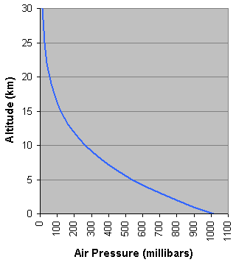
Figure 15.1. – Altitude versus air pressure for Earth’s atmosphere (Russell).
15.2 Temperature Data
Figure 15.2 is a magnified version of Figure 10.1, which displays the temperature, humidity, and pressure as a function of time. The standard accepted values for the temperature of the Earth’s atmosphere are plotted in Figure 15.3.
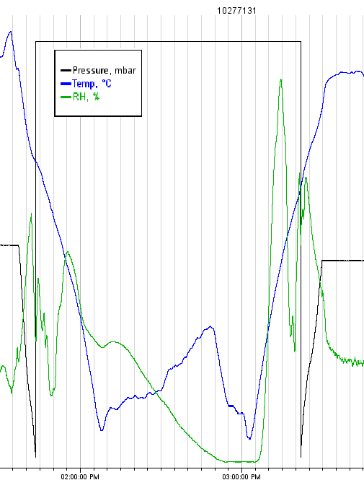
Figure 15.2 – Temperature in °C (blue), humidity in % (green), and pressure in mb (black) as a function of time.
Figure 15.3 – Temperature vs. altitude in the Earth’s atmosphere (Structure of the Earth’s Atmosphere).
Referring to Figure 10.1 for units, it can be seen that the temperature is coldest at both 2:07PM and 3:03PM, where is it approximately -60°C. Using the corresponding time stamps results against Figure 15.3, the data seems to align well. Figure 15.3 suggests a slightly higher temperature than -60°C, but only differs by a few degrees. The temperature at 27km in Figure 15.3 is between -30°C and -40°C, which is consistent with the -35°C at 27km in Figure 15.2 (after again comparing the time stamps). The maximum height of the flight was about 27km, and given that the initial descent rate was noticeably faster than the ascent rate, the overall shape of the temperature graph in figure 15.2 aligns very well with the temperature curve presented in figure 15.3.
15.3 Humidity Data
No accepted or professionally gathered humidity data was able to be found. The humidity of the Earth’s atmosphere is not a property that is studied over a large range of altitudes. There are two likely reasons why this may be the case: humidity may be highly variable from day to day or season to season, thus making it an insignificant study; or, humidity is a property that is already accounted for in the atmospheric density, something that has been studied profusely. A good point of future research may be to investigate the relevancy of humidity as a function of altitude.
The humidity results in Figure 15.2 (units in 10.1) do function as one would expect from a conceptual analysis. In the beginning of the flight (less than about 5km) there are generally a much higher number of clouds, or at least areas of higher humidity that may become clouds in the near future. This effect can be seen in Figure 15.2 on both the left and right sides of the graph. As the sensor rose higher the humidity became more related to temperature; air holds less humidity at lower temperatures, and as the air got colder the humidity decreased as well.
An abnormality in the data can be seen when the humidity does not increase with the rising temperature at 2:50-3:05PM. This may have been caused be some sort of latency in the sensor, but more likely it was due to the increased velocity of the descent of the payload. As the payload picked up speed, the humidity sensor may have read a lower humidity value due to evaporation (much like how standing in front of a fan will dry you off). This abnormality could be investigated during future balloon flights.

15.4 Cosmic Ray Data
It is unclear if the poor data displayed in Figure 10.1. was caused by a malfunction in the equipment, was an expected value from the increased altitude representing a trend that would have continued, or was an outlying data point that occurred from the inherent randomness in radiation.

Section 16: Camera Analysis
Although the picture shown in Figure 11.1 looks great, said picture was actually cropped to a much smaller size than initially taken by the camera. The hole cut in the outer shell of the command capsule was not cut large enough, and during the flight the shell shift and blocked parts of the lens. Approximately 1/2 of the total lens was blocked, with the shell blocking parts of the sides and most of the bottom half of the lens. This problem can be fixed by simply cutting a larger hole in the outer shell of the capsule.

Section 17: Assessment of Program Based on Data
Very few conclusions can be drawn about the validity of the ballooning program based on the data collected by the sensors. The pressure sensor did not work, though that would have been insignificant had the Geiger counter functioned properly for the full duration of the flight. The Geiger counter was the most important sensor in the balloon because the radiation counts could have still been analyzed as a function of altitude and compared to temperature and humidity. The comparison between the collected data and the accepted data on temperature and humidity versus altitude confirmed that the accuracy in the collected data was definitely good enough to be used for analysis in any number of future projects at Western that would involve atmospheric data.

Section 18: Conclusion
Overall, the establishment of the weathering ballooning program at Western Oregon University was a success. The addition of a weather ballooning program at Western Oregon University creates research opportunities for the Science Department, allows for projects in professional development for in-service teachers, fosters a partnership with Oregon Space Grant, and creates another option for students participating in the Program for Undergraduate Research Experiences. The GPS tracking system functioned properly and allowed for a successful recovery, though the WinAPRS software used functioned poorly and it is recommended that Google Earth be used for future tracking instead. The heating circuits functioned properly and it was determined that alkaline batteries, not lithium batteries, should be used to avoid producing too much heat. The balloon filling procedure went as expected, though ways to streamline the process and remove opportunities for human were suggested for future launches. The cosmic ray and pressure data taken during the flight was unusable due to malfunctions in the data sensing equipment, but the temperature, humidity, and altitude data was collected properly and a comparison to the corresponding known properties about the Earth’s atmosphere confirmed its accuracy. The successful establishment of the ballooning program now allows for more student lead balloon launches to occur with less preparation and overall less cost per launch. The data sensing equipment can be modified to sample a large variety of different quantities for various projects, and further improvements to the program could also be good research opportunities for undergraduates.
Works Cited

Colorado Space Grant. (2006, July). Starting Student Space Programs V: A How To Handbook.
Starting Student Space Programs V: Workshop.

Oregon Institute of Technology. (2005, August). Journey to the Edge of Space: Balloon Satellite
Workshop Handbook. Journey to the Edge of Space: Workshop.

Martens, M. Rasmussen, M. (2010). APRS in Wisconsin. Retrieved from
wisconsinaprs.net/documents/aprs/APRS_Presentation_2010.ppt

Russell, R. (2009, July). How Pressure Changes With Altitude In Earth’s Atmosphere. Retrieved
from http://www.windows2universe.org/earth/Atmosphere/pressure_vs_altitude.html

Yageo Corporation. Leaded Resistors.

Structure of the Earth’s Atmosphere. Retrieved June 1, 2013, from
http://www.ux1.eiu.edu/~cfjps/1400/atmos_struct.html

Appendix A

Materials Checklist
- 2 Helium tanks
- Balloon
  - Regulator & fittings (fittings are attached to regulator)
  - Regulator manual
  - Fill nozzle
  - 20ft tubing
  - Latex Balloon
  - Rope with iron ring
  - Latex gloves
- Ground Tracking Equipment
  - Astro 220 Dog Tracker (handheld unit only, no collar)
  - 2 Garmin E-trex Legends
  - 3 Garmin GPS 72’s
  - 2 Garmin E-trex to serial cables
  - 5 serial to USD cables
  - 3 fm/fm serial
  - 2 walkie talkies
  - USB extension cable
  - 1 E-trex manual
  - 1 GPS 72 manual
  - Kenwood TM-D700 manual
  - Kenwood TH-D7G manual
- Flight Equipment
  - Garmin GPS 18x (for balloon)
  - Kenwood TH-D7G HAM radio
  - 2 Kenwood antennas
  - Spare battery for TH-D7G
  - Astro 220 tracking collar
  - 1 heating circuit
- Eric
  - Serial to 3.5mm cable
  - HOBO serial key
  - HOBO manual
  - Geiger counter manual
  - Temp sensor manual
  - Pressure sensor manual
  - 2 laminated ID cards
  - USB to 3.5mm cable
  - 4 GPS 72 manual
  - HOBO data logger
  - Temperature/RH sensor
  - Pressure sensor
  - Geiger Counter
  - 1 heating circuit

- Batteries & Tape
  - Alkaline 9V (4+)
  - Alkaline AA (8+)
  - Lithium 9V (4+)
  - Lithium AA (16+)
  - Lithium camera battery 3V (4+)
  - Duck tape (1 roll +)
  - Metal weather tape (1 roll +)
  - Electrical tape (2 roll +)
  - Masking tape (1 roll +)
- Capsules & Parachute
  - Command Capsule & fitted foam inserts
  - Payload Capsule & fitted foam inserts
  - Parachute & wooden ring w/ 4 attached carabineers
  - 4 large steel carabineers
  - 4 small aluminum carabineers
  - Leader line bisection bracket (sheet metal bracket)
  - Kite line
  - Pull scale
  - Iron ring w/ rope
- Hardware, Software, & Accessories
  - WOU Laptop with DC attachments & WinAPRS installed
  - Eric’s laptop
  - Justin’s laptop
  - 12V DC to AC converter
- Accessories
  - 2 10mm 8x10ft tarps
  - Weights for tarps
  - 2 cigarette lighter y-joint extension cords
  - Tool box with large variety of tools
  - Caulking gun w/ silicon (to seal camera)
  - Antenna & radio for 2nd chase vehicle
  - Flash lights
  - Digital camera
  - Binoculars
  - 2 headlamps
  - Scissors
  - 3 Exacto knives
  - 2 Binders
  - Cooler with food and extra water

Pre-flight Checklist
- Charge all batteries
- Check all materials list
- Pack chase vehicles

- Lay down tarps
- Begin filling balloon
- Turn on Garmin GPS 18x, let it acquire satellites
- Turn on both Garmin E-trex, let acquire satellite
- Turn on and set up Kenwood TH-D7G
- Turn on and set up Kenwood TM-D700
- Turn on laptops with and configure tracking software
- Check that radios are transmitting and chase vehicles are receiving
- Turn on and setup dog tracker
- Place the “Call Bill” cards in modules
- Configure sensors
- Explain how to track the balloon
- Setup Parachute
- Attach lines to capsules
- Activate data logger/ Geiger counter
- NOTE THE TIME
- Turn on heating circuits
- Assemble capsules
- Balloon Filled
- Check parachute
- Check lines
- NOTE THE TIME
- Launch!

Appendix B

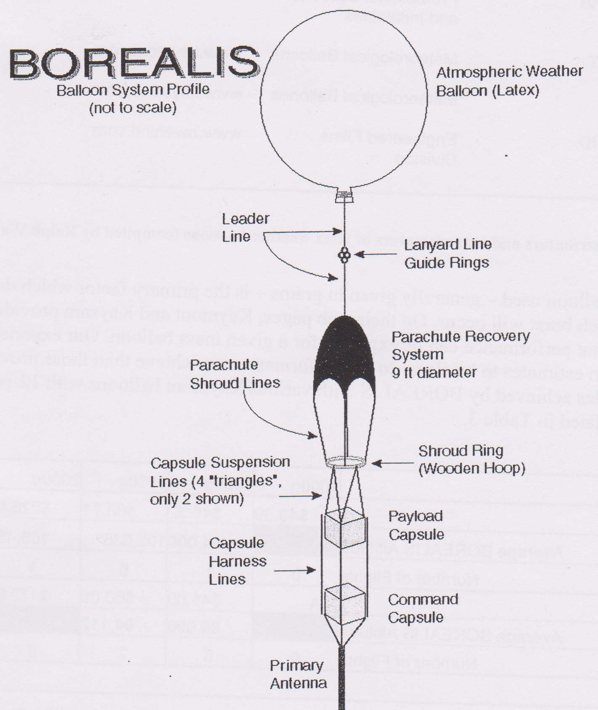

Taken From Starting Student Space, pg 7-13.

