AN ABSTRACT OF THE PROJECT OF

Andrea Therese Peters Albright for the degree of Master of Science in Ocean, Earth, and Atmospheric Sciences presented on March 27, 2014.

Title: Modeling Eddy Correlation Biases Created by Velocity Sensitivities of Clark-type Oxygen Microelectrodes Under Waves.

Field deployments, flume experiments, and a 2D wave model have been used to identify the characteristics of Clark-type oxygen microelectrodes and measurement parameters that could possibly bias eddy correlation (EC) flux measurements made under waves. Eddy correlation is a technique adapted from atmospheric sciences that couples concurrent and co-located velocity and oxygen measurements in order to calculate how much oxygen is being taken up by the sediment in aquatic environments. Field deployments made with two co-located microelectrodes suggest that individual sensor sensitivities to changes in the velocity field under wave conditions are biasing the EC calculation. Experiments performed in two different flumes illustrate the non-linear response of microelectrodes to changes in velocity and the individual nature of each microelectrode’s performance based on the shape and placement of the sensing cathode. Long, thin cathodes that are offset slightly from the membrane seem to have the necessary response time for EC measurements and also minimize the velocity effect.
Furthermore, a 2D wave model was used to test the sensitivity of the EC flux determination to various parameters specific to the wave conditions and to the microelectrode response. The model demonstrates that most parameters do not directly affect the flux, as long as both the velocity and oxygen time series are in phase temporally with the exception of a non-zero mean vertical velocity. The mean horizontal velocity can also greatly affect the flux if there is a delay in the microelectrode response or a spatial separation between the sampling volumes for the ADV and microelectrodes that results in a time lag between the velocity and oxygen time series. The results from the model suggest that correctly aligning the oxygen and velocity time series is extremely important and that non-zero mean vertical velocities may be biasing the flux calculation in some instances.

©Copyright by Andrea T. Albright
March 27, 2014
All Rights Reserved
Modeling Eddy Correlation Biases Created by Velocity Sensitivities of Clark-type Oxygen Microelectrodes Under Waves

by
Andrea T. Albright

A PROJECT

submitted to

Oregon State University

in partial fulfillment of
the requirements for the
degree of

Master of Science

Presented March 27, 2014
Commencement June 2014

ACKNOWLEDGEMENTS

I would like to thank the NSF for providing funding during this research (Grant# OCE-1061218) and the support of many people throughout my tenure in graduate school. First and foremost, I would like to thank Clare Reimers for taking a chance on me - and never giving up. Clare supported my research interests and let me make this project my own. She gave me the incredible opportunity to go out to sea on three separate research cruises and allowed me to design my own flume experiments. I have learned how much effort goes into making a successful research project work, and how to take excellent notes during the process! She always made it look effortless, which is a skill in-of-itself.
I would also like to thank the other members of my committee. Thanks to Tuba Özkan-Haller for teaching me about wave theory and providing the seeds to many of the ideas presented here. Tuba was never too busy to give me 15 minutes of her time to look over my MATLAB code. Thanks to Peter Berg for pioneering the eddy correlation technique and generously sharing data sets that helped me to better understand the groundwork that has already been laid.
I owe a big thank you to the other people who also work for Clare, namely Kristina McCann, Rhea Sanders, and Paul Schrader. Kristina, thanks for always having a smile on your face and giving me encouragement when I was down. Rhea, you pushed me to write the best MATLAB code and helped me to understand how much work goes into preparing for an ocean voyage. Paul, thanks for lending a hand or an ear whenever it was needed. I also want to thank other members of our lab group, including Cody Doolan, Shelby LaBuhn, and Peter Chace. This research would also not have been possible without the help of faculty research technicians and marine technicians: Katie Watkins-Brandt, Margaret Sparrow, Dave O’Gorman, and thanks to the captains and crews of the R/V Elakha and R/V Oceanus.
To my colleagues here at CEAOS thank you so much for being a friend to me, both during working hours and beyond. Thanks to especially to my OEB cohort for surviving the coursework with me: Elizabeth Brunner, Iria Giménez, Fabian Gomez, Dave Cade, Colleen Wall, April Abbott, Caren Barcelo, Amy Smith, and Marisa Litz. Thanks to my other colleagues, including Sarah Strano, Kate Adams, Saskia Madlener, Stephanie Smith, Colin Duncan, Michelle Fournet, Becky Mabardy, Amelia O’Conner, Mike Ewald, Katie Wollven, Arwen Bird, Rosie Gradoville, Alejandra Sanchez, Cale Miller, Morgaine McKibben, Aurelie Moulin, Jenny Thomas, Martine Hoecker-Martinez, and Allison Einolf.
A super big thank you to my friends in Corvallis for making sure that I see the sun occasionally: Leah Tai, Elsa Gustavason, Tim Hemphill, Kim Greene, and Sarah Goff. And thank you to my friends outside of Corvallis for supporting me from afar: Britt McNamara, Tess Cohen, Dena Rennard, Azul Freedom, Anna Gilbert, Sam Gault, Ben Archer, Jess Cheney, Jaimie Stomberg, Ted Cooper, Tom Baldwin, Liza Brost, Caroline Beranek, Timur Ender, Emily Wax, Miranda Paley, Alisha Saville, and Clare Patterson. Thanks also to my family for their unending support: Elizabeth Peters, Ben Albright, John & Carol Albright, Kathy & Peter Gorski, and Gladys & Ron Horvath.

TABLE OF CONTENTS

Page
1 INTRODUCTION 1
2 METHODS 3
2.1 Oxygen Microelectrodes 4
2.2 Eddy Correlation Setup 4
2.3 Study/Experimental Sites 5
2.4 EC Data Processing 6
2.5 Wave Model 8
3 RESULTS 11
3.1 Field Deployments 11
3.2 Large Wave Flume Experiment 13
3.3 Small Recirculating Flume Experiments 14
3.4 Wave Model 15
3.5 Parameter Analysis 16
4 DISCUSSION 17
4.1 Field Deployment Analysis 17
4.2 Sensor Evaluation 18
4.3 Flume Experiments & Wave Model 19
7 CONCLUSION 20
6 BIBLIOGRAPHY 43
7 APPENDICES 45
7.1 Wave Model Code – without O₂ gradient……...…….………..…….…...……45
7.2 Wave Model Code – with O₂ gradient……...…….………..………..…...……49
7.3 Non-linear Sensor Output Function……...…….………..…………..…...……53

LIST OF TABLES

Table Page

Table 1 Microelectrode Sensor Properties...…………………………….. 22

Table 2 Model Parameters …...………………...………………………... 23

LIST OF FIGURES

Figure Page

Figure 1 Side view of a Clark-type O₂ microelectrode..……….……...………24

Figure 2 Sampling Setup..……………………………………….……...…..…25

Figure 3 Small recirculating flume experiment design...……....……...………26

Figure 4 Orientation of microelectrodes……………………………………....27

Figure 5 Field deployment at Heceta Head….………………….……...……...28

Figure 6 HH45 Example 1 …………………..………………….……...……...29

Figure 7 HH45 Example 2 ………………..…………………….……...……...30

Figure 8 HH45 Example 3 ……………………..……………….……...……...31

Figure 9 Large wave flume (LWF) experiment example …...….……...……...32

Figure 10 Close up of from the LWF experiment example ...…………….........33

Figure 11 Small wave flume (SWF) variable velocity experiment ……..……...34

Figure 12 SWF variable velocity experiment results for each position ...……...35

Figure 13 SWF variable velocity experiment results for each sensor .…….…...36

Figure 14 Wave model for LWF experiment example – no O₂ gradient…….....37

Figure 15 Wave model for LWF experiment example – with O₂ gradient...…...38

Figure 16 Wave model flux calculations ……………………………………….39

Figure 17 Wave model parameter analysis: Period …..………….……...……...40

Figure 18 Wave model parameter analysis: Mean horizontal current…...……...41

Figure 19 Wave model parameter analysis: Mean vertical current ……..……...42

LIST OF APPENDIX FIGURES

Figure Page

Figure 1 Wave model parameter analysis: Amplitude 1……….……...………54

Figure 2 Wave model parameter analysis: Amplitude 2……….……...………55

Figure 3 Wave model parameter analysis: Amplitude 3……….……...………56

Figure 4 Wave model parameter analysis: O₂ gradient strength ………...…....57

Figure 5 Wave model parameter analysis: Alpha……...……….……...……...58

Figure 6 Wave model parameter analysis: ΔC ……………….………..……...59

INTRODUCTION

Coastal oceans encompass many dynamic environments where the burial and remineralization of organic matter plays a significant role in connecting the carbon and oxygen biogeochemical cycles (Hedges and Keil 1995; Hartnett and Devol 2003). Oxygen is the final electron acceptor for aerobic respiration, and the oxidation of reduced products in the sediment, and therefore oxygen consumption rates can be used as a proxy for benthic remineralization rates (Canfield and Thamdrup 2005; Glud, Berg et al. 2007). Benthic oxygen consumption rates are difficult to measure however; previous methods rely on core incubations, benthic chambers, and oxygen microprofiles and are often disruptive to natural hydrodynamic conditions and/or offer poor temporal and spatial resolution (Tengberg, Hall et al. 2005; Berg, Glud et al. 2009). Eddy correlation, adapted from atmospheric science for aquatic environments in the last decade (Berg, Røy et al. 2003), is a non-invasive technique that allows for longer measurements and integrates the spatial/temporal heterogeneity of the benthic environment.
Aquatic eddy correlation (EC) combines high frequency measurements of flow velocities and oxygen concentrations in order to assess turbulent fluxes between the water column and the seafloor. The method assumes a mass balance within a control volume whose lower boundary is an area of the seafloor and whose upper boundary is a plane including the measurement point. Other assumptions are that the sediment is the dominant source/sink of oxygen, there is negligible oxygen consumption in the control volume, no horizontal oxygen gradient is present, and that the long-term ensemble-averaged flow is horizontally homogeneous (Lorrai, McGinnis et al. 2010; Holtappels, Glud et al. 2013). This technique has been very successful in environments where oxygen concentrations and velocity fields are in near steady-state (Kuwae, Kamio et al. 2006; Brand, McGinnis et al. 2008; Hume, Berg et al. 2011; Long, Berg et al. 2013), but a lack of advanced evaluation criteria obscures the interpretation of field data under the dynamic conditions found in wave-dominated benthic boundary layers (Reimers, Özkan-Haller et al. 2012). In addition, it has been observed that the Clark-type microelectrodes used in most EC studies for measuring oxygen respond not only to changes in oxygen, but also to changes in the velocity field around the sensor tip (Gust, Booij et al. 1987), a so called ‘stirring effect’ (Hale 1983).
Clark-type microelectrodes are frequently used in EC studies for two reasons: (1) their small size does not interfere with acoustic measurements in the sampling volume, and (2) their fast response times allow for high resolution oxygen concentration measurements under dynamic conditions (Oldham 1994). Each sensor consists of an electrolytic cell where current passes between a silver/silver chloride anode and a gold-plated, platinum sensing cathode poised at approximately -0.8V. Under steady-state flow conditions, O₂ from the water surrounding the sensor tip (where the concentration = C_{w}) moves across a narrow diffusion zone outside the tip and then through a water-impervious silicon membrane to be consumed at the cathode (Figure 1). One consequence is the formation of an O₂ gradient between the cathode tip and the well-mixed water outside the sensor (usually depicted using the O₂ partial pressure (P) to reflect differences in solubility of O₂ in aqueous phases and in the membrane). As long as these diffusion distances are constant, current is proportional to C_{w}. Under non-steady flow conditions, the diffusion layer thickness will vary and the sensor response may increase with velocity.
This so-called ‘stirring sensitivity’ is a known problem for microelectrodes (Gust, Booij et al. 1987); it is usually less than a few percent of overall sensor signals and is proportional to C_{w} (Glud, Gundersen et al. 2000). Eddy correlation relies on exact measurements of oxygen fluctuations associated with turbulent water movement, so this effect could potentially bias the results of a deployment with variable velocities created by wave motions. In order to understand how much these sensors are responding to changes in velocity under waves and how a velocity sensitivity may affect the EC-determined fluxes, a 2D model has been built that will be used to mimic real sensor data collected under waves and to qualitatively assess the impacts of this effect, hereafter referred to as the microelectrode’s “velocity effect.” The model uses established wave theory (Dean and Dalrymple 1991) to create a theoretical framework for re-creating microelectrode output using parameters extracted from data sets collected during field and flume deployments to help assess the impact of such conditions on flux measurements.
METHODS
Oxygen Microelectrodes
The purpose of this study is to evaluate a potential biasing of the eddy correlation technique caused by microelectrode artifacts that are accentuated under flow conditions produced by waves. Oxygen microelectrodes are delicate sensors, and their performance is part of what determines the accuracy of benthic flux measurements. These sensors were constructed by Kristina McCann-Grosvenor at Oregon State University according to methods developed by (Revsbech 1989). This methodology is quite specific; nonetheless, there are still small variations in the sensor dimensions that create unique response characteristics for each sensor. The sensors used in the following experiments have been catalogued (Table 1), and for each set of experiments two or three sensors were used. One intent is to compare the responses of individual sensors in order to identify the characteristics that result in sensors that perform better than others.
Eddy Correlation Setup
During this study a Benthic OXygen Exchange Rate (BOXER) lander was used for field and wave flume deployments. Although bulkier than other EC frames, this lander was specifically designed to withstand the variable and highly energetic conditions on the continental shelf off the coast of Oregon (Reimers, Özkan-Haller et al. 2012). An Acoustic Doppler Velocimeter (ADV) (Vector, Nortek, Norway) was mounted on the lander so that the Vector head was oriented vertically downward to measure velocity in 3D in a 1.5 cm x 1.5 cm x 1.5 cm measuring volume situated 15-30 cm above the sediment. Two Clark-type microelectrodes with In Situ Amplifiers (Unisense A/S, Aarhus Denmark) were placed so that the sensor tips were just outside the measuring volume of the ADV (Figure 2). These sensors were all connected to a common controller (Unisense A/S) and sampled continuously at 64 Hz. The microelectrodes were dipped in a solution of chilled 10% solution of 1 M sodium ascorbate and 0.5 M sodium hydroxide (Andersen, Kjær et al. 2001) before and after each deployment to determine zero-O₂ sensor readings for calibration purposes. Bottom water oxygen concentrations were verified with an Aanderaa O₂ optode (model 4175) mounted at the same height as the microelectrodes.

Study/Experimental Sites
For illustrative examples, this study uses results from a July 2013 field deployment off the coast of Oregon near Heceta Head near the 45 meter isobath at approximately 43.92° N, 124.19° W, along with data from a series of flume experiments conducted in the Oregon State University O.H. Hinsdale Wave Laboratory large flume (length 104 m, width 3.7 m, depth 4.6 m) in March 2012. Alternate estimates of benthic O₂ fluxes were obtained using in situ measurements of dissolved O₂ microprofiles across the sediment-water interface (Reimers, Fischer et al. 1986), or from core incubations during both studies. At the wave flume, a wave generator was used to make defined irregular waves of a set period and amplitude in a fresh water medium. Sand mixed with fish food was used to line the bottom of the flume to mimic the natural morphology of permeable sediments and create a sink for oxygen in the sediment.
Another set of flume experiments took place in a smaller recirculating flume, which consisted of a plastic pipe cut in half lengthwise, 18 cm in depth and 39 cm across the top. A Vectrino (Nortek, Norway) was used in place of the Vector due its smaller-sized head. Before each experiment a well-mixed oxygen concentration equal to air saturation values was created by circulating the fresh water for tens of minutes. The microelectrodes were placed in front of the other instruments so as to have an unobstructed flow path; then the Vectrino head and lastly an optode were positioned (Figure 3). Three different orientations were tested to see if the orientation of the sensor with respect to the movement of the water made a difference in the output of the electrode (Figure 4). The sensitivity of the microelectrodes was tested by allowing the well-mixed water to come to a complete stop and then resuming the circulation while the instruments were recording, in order to capture the change from no-flow to fast-flow conditions. These so-called variable velocity experiments were repeated several times for each sensor, for each orientation, and for two flow speeds (low ~10 cm/s, high ~25 cm/s).
EC Data Processing
EC time-series data collected using the Unisense system in the field were trimmed to exclude the beginning and end of the deployment. Velocity measurements were first filtered by percent coherence reported by the instrument, typically 50%. Velocity and oxygen measurements were then despiked using the method developed by Goring and Nikora (2002) and all removed points were replaced using a cubic spline interpolation. The oxygen microelectrode output was calibrated using a two-point calibration from the zero value recorded after the deployment, and optode measurements taken in situ at the mid-point. The sampling rate was reduced from 64 Hz to 16 Hz by averaging every four points.
The entire vertical velocity and oxygen time series were then detrended using a frequency cutoff to remove significant flux contributions that occur on time scales longer than can be attributed to waves and turbulence (Reimers, Özkan-Haller et al. 2012). In our group, most often a frequency cutoff of 0.005 Hz is used, which allows for an accurate description of the energies contributed by waves and turbulence that are of most interest to the EC, while removing longer term changes that could otherwise bias the flux measurement.
After the data were detrended, they were split into 15-minute bursts and then rotated to create an accurate reference frame. In contrast, many previous EC studies have sampled in burst-mode where ~15-minute bursts were separated by brief periods of no data collection. We separated our datasets into 15 minute bursts to make our calculations comparable to other datasets.
The reference frame was rotated to account for any tilt in the Vector, since one of the core assumptions of EC is that the control volume is aligned parallel to the sea floor. First, the reference frame is rotated around the z-axis to maximize the horizontal velocities in the x-direction; this technique indicates the direction of the predominant current. Second, the frame is rotated around the y-axis to minimize the amplitude of the orbital velocities in the vertical direction. It is assumed that the velocities in the z-direction are only recording the movement perpendicular to the seafloor without any contribution from the horizontal currents, and that the correction of the vertical angle effectively remains constant throughout the deployment.
The large wave flume data example was processed similarly to the field data, except that it was trimmed to show only one 15 minute burst extracted from a 30 minute wave session programmed to have irregular 4 second periods and a 0.5 meter significant wave height. The small recirculating flume velocity and oxygen data files were collected and processed separately, and then combined, since the goal was not to make flux measurements, but rather to describe the behavior of the microelectrodes. The velocity and oxygen measurements were filtered, despiked, and calibrated using the same methods listed above. The beginning and end of each ramp of the flume were visually assessed, and two seconds worth of data during ‘no flow’ and ‘high flow’ conditions were averaged to assign baseline values. A positive percent increase in signal denotes the change from no flow to high flow conditions, and a negative percent increase denotes the change from high flow back to no flow conditions.
Wave Model
The wave model was constructed based on realistic progressive coastal wave conditions and dissolved O₂ concentrations. For simplicity, waves are modeled in two dimensions; established wave theory states that the horizontal velocity can be modeled using a cosine curve and the vertical velocity can be modeled using a sine curve (Dean and Dalrymple 1991). The amplitudes (u₀, w₀) of u and w are set using values extracted from original time series data, and each velocity component must necessarily have the same period (σ = 1/period). The model shown here assumes that the effect of turbulence on velocities is negligible, thereby isolating the wave velocities.
$u=u_{0}\cos\left(-σt\right)$ (1)
$w=w_{0}\sin\left(-σt\right)$ (2)
The model creates a velocity effect in the oxygen signal (defined as the concentration of C) by assuming a non-linear relationship between current output of the microelectrode and flow velocity (Gust, Booij et al. 1987). A hyperbolic tangent equation is used, which requires two separate parameters: a proportional response factor (α), and the expected change in output between no-flow and fast-flow conditions (ΔC).
$C=C_{w}+∆C\tanh\left(α\left|V_{tot}\right|\right)$ (3)
$V_{tot}=\sqrt{u^{2}+w^{2}}$ (4)
$Flux= \overline{C^{'}w^{'}}$ (5)
The velocity effect is a function of both the absolute magnitude of the velocity (V_{tot}), and the steady-state oxygen concentration (C_{w}) because ΔC is assumed to be a fixed percentage of C_{w}. Finally, the flux is calculated by taking the average of the product of the variance in the modeled vertical velocity and the oxygen to find the eddy correlation flux. The model does not impose a flux, and therefore any deviations from zero are assumed to be a biased result of the velocity effect or other model constructs.
$C_{grad}= {C_{w} }_{ }\left(1-m\cos\left(-2σt\right)\right)$ (6)
$C=C_{grad}+∆C\tanh\left(α\left|V_{tot}\right|\right)$ (7)
As a separate case for further comparison, a second model case assumes there is an oxygen gradient (C_{grad}) in the water column due to consumption in the sediment (Holtappels, Kuypers et al. 2011) that is compressed and expanded due to horizontal wave motion. When the horizontal velocity is at its maximum, regardless of direction, the oxygen gradient is compressed and the local oxygen concentration around the fixed sensor tip increases. When a wave moving past the sensor is at its inflection point – at the minimum vertical velocity – the gradient is assumed to extend vertically upwards from the sediment, and the local oxygen concentration encountered by the sensor decreases (Eqn 3). For modeling purposes, this gradient equation is then substituted into the hyperbolic tangent function from above. The presence of an oxygen gradient implies that there is some net consumption of oxygen in the sediment that is resupplied by diffusion, but the model is designed to report fluxes only due to the wave motions.
The wave model was parameterized initially using the values extracted from the wave flume dataset itself. The amplitudes were determined by finding the maximum amplitude for a given 40 second data piece. The predominant currents in the horizontal and vertical directions were found by averaging the x- and z-velocities. The period was set to 4 seconds, based on the program used to generate the waves in the flume. C_{w} was found by taking the average optode measurement. ΔC was found by averaging visually assessed shifts in the oxygen signal due to waves. Parameter α was chosen by visual assessment to match the shape of the oxygen model output.

RESULTS
Field Deployments
Field deployments were executed off the coast of Oregon in order to quantify benthic oxygen fluxes on the continental shelf. Figure 5 is an example of a 12-hour deployment with two side-by-side microelectrodes on the Oregon shelf at 45 meters depth. Figure 5a illustrates 15 minute average current speeds and the 16Hz velocities in three dimensions for the whole deployment. Figure 5b displays pressure readings from the Vector, and the deployment has a mean significant wave height of 0.85 m and mean wave period of 8.61 seconds. Figure 5c shows the microelectrode and optode responses throughout the deployment where both microelectrodes are calibrated relative to the optode reading in the middle of the deployment. Sensor 297 matches the optode readings more closely than Sensor 293 over the first part of the deployment. Sensor 293 (S293) has a dramatic shift in its baseline around hour 5 that is probably due to either a shift in the amplifier ground or some particle hitting or adhering to the sensor tip. Afterwards the sensor signal remained stable and had a similar response to the optode. Figure 5d displays the flux averages for each 15 minute segment throughout the deployment with a mean of -2.00 ± 9.19 mmol/m²/day for S297 and -5.62 ± 18.33 mmol/m²/day for S293. In comparison, diffusive fluxes derived from microelectrode profiles were only -0.6 to -1.2 mmol/m²/day.
The three vertical red lines indicate three examples where the fluxes are either both positive (Figure 6), deviate in sign from each other (Figure 7), or are both negative (Figure 8). Figure 6 is a 100-second example of data from the seventh burst, where both records have large positive fluxes. We note that since these measurements were made at night and at 45 meters water depth, positive fluxes are not expected under the assumption of steady state conditions. Figures 6A and 6B demonstrate the difference between the original and the rotated reference frame for the velocities in three dimensions. The significant wave height and wave period for this 15 minute burst, 0.91 m and 7.96 seconds are similar to the mean for the deployment (Figure 6D). For comparison, the oxygen variance is reported in these examples, since the calibrations for each sensor have displaced the mean oxygen signal, and for eddy correlation purpose the variance is the main concern. Wave-dominated variations in the x-velocity (Figure 6B) and pressure (Figure 6D) are reflected in the oxygen signals for S297 and S293 (Figure 6E), especially under large waves occurring between the 6030 second and 6050 second mark. S293 begins to show a large positive cumulative oxygen flux during this period (Figure 6F). Both sensors are shown to have a positive flux throughout this 15-minute burst, 8.84 mmol/m²/day and 31.27 mmol/m²/day for S297 and S293, respectively.
Figure 7 is an example from the fourteenth burst, where the sensors have divergent fluxes i.e. S297 has a negative flux and S293 has a positive flux. The significant wave height and wave period for this 15 minute burst, are 1.16 m and 7.96 seconds, respectively (Figure 7D). The two sensors both show a sinusoidal response with similar amplitudes. At the 13865 second mark, there is a mismatch between the phase overlap of each sensor i.e. when S297 is trending down, S293 is trending up, and vice versa.
Figure 8 is an example from the twenty-sixth burst, where the sensors both have negative fluxes that are relatively similar. The significant wave height and wave period for this burst are 1.16 m and 7.96 seconds, respectively (Figure 8D), and the derived fluxes for S297 and S293 are -4.55 mmol/m²/day and -1.96 mmol/m²/day, respectively (Figure 8F). The oxygen signals from both microelectrodes match the optode output (Figure 8E), which is expected for a burst close to the in situ calibration point at the midpoint of the dataset. Both sensor outputs look quasi-sinusoidal, and the oscillations in the sensor output are mostly anti-correlated with the z-velocity, as expected for a negative flux into the sediment.
Large Wave Flume Experiment
The next step was to investigate under more controlled conditions how a velocity effect in the microelectrode signal may bias the EC flux calculations such as those portrayed in the field example, an experiment from a large wave flume, was performed in the OSU Hinsdale Wave Lab, and is shown in Figure 9. In the original velocity panel (Figure 9a), the magnitudes of the velocities in the x- and y-directions are of similar magnitudes, whereas the rotated velocity panel (Figure 9b) has the reference frame now oriented along the x-axis, and the high magnitude velocities are in the x-direction. Two microelectrodes (S199 and S196) were again used and are compared. S199 (Figure 9c, b) produced a negative trend in the oxygen signal and does not match the simultaneous optode readings as closely as S196. The derived fluxes for both sensors are extremely high, -354 mmol/m²/day and -86.8 mmol/m²/day for S199 and S196, respectively, and do not agree with the estimates from incubated sand cores taken from the flume bottom (-10.4 ± 3.0 mmol/m²/day). Figure 10 is a close-up of 60 seconds of data from this data set to better illustrate the character of each time series being discussed. Figure 10a and 10b illustrate the effectiveness of the reference frame rotation as the wave signal is now mostly in the x-direction. Variations in the z-velocity (Figure 10c) remain small and appear mostly due to high-frequency turbulence rather than waves. The oxygen microelectrode output (Figure 10d) is reported as the variance to allow for a direct comparison between the two oxygen signals. Both microelectrodes are responding to increases in velocity when compared with the waves in Figure 10b. S199 demonstrates a velocity sensitivity to waves that is twice the magnitude of the velocity sensitivity of S196.
Small Recirculating Flume Experiments
Another set of experiments took place in a small recirculating flume to further investigate the microelectrode response to changes in velocity. Figure 11 demonstrates a variable velocity experiment, where the flume circulates for several seconds, allowed to relax entirely, and then repeated. The velocity measurements (Fig 11a) demonstrate the two flow conditions in the flume: high flow (~25 cm/s) and no flow (0 cm/s). The responses of two microelectrodes, S277 and S274 (Figure 11b) are both remarkably similar to the changes in velocity, and even relatively small changes in velocity (<5 cm/s) produce an effect on the microelectrode signal.
Figures 12 and 13 aggregates all of the variable velocity experiments’ responses to changes in velocity from no-flow to flow conditions (positive %O₂) and the relaxing of the signal from flow conditions to no-flow conditions (negative %O₂). Figure 12 reports these responses as a function of sensor orientation to the flow (into, perpendicular, away from). For each orientation the microelectrode changes its signal by as much as 6%. Sensors oriented into the flow and perpendicular to the flow respond in an unpredictable way between 0% and 6%. In comparison, sensors oriented away from the flow respond consistently between 4% and 6%. Figure 13 uses the same data, but organizes by individual rather sensor than sensor orientation. S274 and S275 both have variable changes in response, between 0% and 6%, whereas S277 changes between 0% and 2%.
Wave model
The wave model was used to re-create the velocity and oxygen time series for a 40 second piece of data from the large wave flume experiment using the parameters in Table 2. Figure 14 illustrates the ability of the model to mimic a real velocity and oxygen time series. Figure 15 introduces an oscillating oxygen gradient to the wave model, and uses the same parameters as the previous model except for a change in the normalization parameter α from 0.1 to 0.12 (Table 2). This version of the model adds an oscillating oxygen gradient (0.33 µM/cm, Holtappels et al 2011), which is large considering that the waves in this flume experiment were quite energetic, and the water in the flume was probably well-mixed. The oscillating gradient introduces a small asymmetry to the model output, but does not dramatically change the fit of the model output to the actual oxygen signal. Both wave model examples have a non-zero flux, -24.0 mmol/m²/day and -28.5 mmol/m²/day for the non-oscillating gradient and oscillating gradient examples, respectively. The cause of the flux and other contributing factors will be discussed in the next section.

Parameter Analysis
A parameter analysis was performed for each model input in order to assess how changes in that parameter can cause a flux bias. Each parameter was assessed using a range of values, and then the oxygen and vertical velocity time series were shifted past each other in time in order to re-create the effect that a time lag would have on the flux calculation. The time lag analysis was first using time series predictions from the wave model (Table 1), and the fluxes calculated at each time step ranged from zero up to ±150 mmol/m²/day (Figure 16). The magnitude of the flux is not necessarily indicative of a real flux bias since the model does not capture all of the complexities of a real time series, but it serves to illustrate how much an offset between the oxygen and velocity times series can affect the flux calculation.
The parameters tested were the period, wave amplitude, O₂ gradient strength, α, ΔC, predominant horizontal current, and predominant vertical current. The predominant current is defined as the mean velocity that the waves oscillate around in both the horizontal and vertical directions. Figure 17 is the parameter analysis for the period where the model predicts a flux bias of zero if the velocity and oxygen time series are perfectly aligned, and a maximum flux bias of ± 50 mmol/m2/day for a misaligned time series (Figure 17a-b). Figure 17c demonstrates that the maximum flux bias changes by 2 mmol/m²/day as a function of the wave period. The period was chosen as an example of the typical sensitivity demonstrated by most of the model parameters. The other parameter analyses are reported in the Appendix.
The two parameters that had the most significant effect on the flux calculation in the wave model were the horizontal and vertical predominant currents. The predominant horizontal current did not affect the flux when the times series were perfectly aligned, but any time lag caused large changes in the flux calculated (Figure 18). The predominant vertical current was the only parameter that created a flux bias even when there was no offset between the time series (Figure 19).

DISCUSSION
Field Deployment Analysis
Time-series EC measurements made with two side-by-side microelectrodes on the Oregon shelf at 45 meters depth did not yield consistent O₂ measurements or fluxes throughout a 12-hour deployment (Figure 5). A likely explanation for these differences is that the sensors had unequal sensitivity to velocity effects and/or that the steady-state assumptions for this section of data were not applicable. For example, when both sensors were reporting positive fluxes (Figure 6F), S293 had more pronounced deviations from the mean oxygen signal than S297 (Figure 6E), which could contribute to that sensor having a larger flux for this burst. However, the fact that both sensors indicated positive fluxes might also indicate that the system was not in steady-state, and the control volume assumptions that are necessary for eddy correlation would not be in effect. Figure 7 illustrates an example of a burst when the two fluxes deviate from each other in sign, which indicates a difference in the properties of the two microelectrodes. There is different phase overlap between S293 and S297 and the fluctuations in the z-velocity, which could indicate two different time lags between the oxygen and velocity time-series.
Sensor Evaluation
Based on the results of the small recirculating flume experiment, sensor output does seem to be somewhat dependent on the sensor’s orientation with respect to the flow. However, there is not a particular sensor orientation that appears to be superior to others. The sensor responses at the ‘into the flow’ and ‘perpendicular to the flow’ orientations appear to be the least reproducible, whereas sensors pointed away from the flow demonstrate velocity effects of similar magnitude, but the response is more reproducible.
The sensors themselves appear to be highly individual – some sensors clearly perform better than others – that is, they respond less to changes in velocity, probably because of the sensors’ respective internal geometry. One example of different geometries involves sensors 293 and 297 from the field deployment. S297 has a more variable signal and larger velocity effect relative to S293, which may contribute to its larger flux estimates. The plated cathode for S297 was long and thin (17.1 µm x 1.9 µm) and the tip opening was very small (1.9 µm), factors that both contribute to the sensors better performance (Table 1). In contrast, S293 had a rounder plated cathode (7.6 µm x 9.5 µm) and a larger tip opening (5.7 µm).
These results indicate that better performing sensors appear to have long, thin cathodes and have smaller tip openings. Lesser performing sensors have shorter, rounder cathodes and may be, but not always, set further back from the membrane. Long, thin cathodes have a larger surface area that can react with oxygen permeating across the membrane, which would prevent any build up of oxygen in the electrolyte fluid between the cathode and the membrane.
Flume Experiments & Wave Model
Experiments performed in the small recirculating flume suggest that the sensor response is hyperbolic tangent in nature and that most of the change in sensor response occurs when the sensor conditions change from no flow to 3 cm/s (Figure 11c). This means that the velocity effect will be most felt when the water is changing direction rapidly and there is no predominant current to keep the velocity from crossing through the zero velocity. The hyperbolic tangent function employed by the wave model re-creates the velocity effect in a theoretical oxygen time series.
The parameter analysis demonstrates that the period, amplitude and other tuning parameters, apart from the predominant current, have a negligible effect on the flux bias. The period and amplitude analysis indicate that the speed and size of the wave fluctuations have only a minimal effect on the flux calculation, and are significant only when there is an offset between the velocity and oxygen time-series. The oscillating oxygen gradient affects the asymmetry of the resultant oxygen time-series, and the α-normalization parameter affects the shape of the ‘humps’ seen in field and flume deployment time-series.
The two parameters that have the most significant effects on the flux bias are the predominant currents in the horizontal and vertical directions. A horizontal predominant current introduces no flux bias as long as there no time lag between the velocity and oxygen time-series, but even small delays can introduce very large biases, ±1500 mmol/m²/day (Figure 18). A non-zero vertical predominant current is the only parameter that introduces a flux bias even when the oxygen and velocity time-series are perfectly aligned (Figure 19). One implicit mass balance assumption of the control volume is that the water that moves in and out is conserved, and therefore a vertical predominant current would suggest some disturbance in the flow field caused by either the ripples in the sediment surface or by the instrumentation itself. It is also unclear whether this flux bias is true for in situ data sets or if it is an artifact of the model. This would also suggest that flux biases will be greater at shallower depths where the pressure of the water has not attenuated the vertical motion of the waves as much as in deeper water.

CONCLUSION
A combination of flume and field deployments has shown that the performance of an individual microelectrode can significantly bias the flux calculation under wave conditions. This flux bias can be minimized if in addition to waves there is a steady horizontal current that will keep the microelectrode from experiencing flow conditions that oscillate through zero. More work needs to be done to evaluate the performance of individual sensors, and to optimize their internal geometries. Experiments show that the size and shape of the plated cathode (long and thin), and a small tip opening are crucial for producing fast-responding sensors with a minimal velocity effect.
Other studies have had promising results using microoptodes, which do not exhibit the same velocity effects as Clark-type microelectrodes (Chipman, Huettel et al. 2012), since they do not consume oxygen. There is a question of whether these sensors can be built to respond as quickly microelectrodes, since oxygen must equilibrate across a membrane before its quenching effects on the optical properties of the sensor’s film could be measured. Two microelectrodes are usually employed during deployments to insure accurate measurements, and adding a microoptode would add another degree of certainty to EC measurements in the future.
Table 1. Sensor properties of microelectrodes used during large wave flume experiments (LWF) in the O. H. Hinsdale Wave Laboratory, small wave flume experiments (SWF), and during field deployments aboard the R/V Oceanus in July of 2013 (OC1307A).

Sensor | Reaction time (s) | Cathode tip diameter (µm) | Length of gold plating (µm) | Cathode to tip (µm) | Cathode to membrane, Z_{e} (µm) | Membrane length, Z_{m} (µm) | Tip diameter (µm) | Calibration Slope  (µM/mV) | Location, Experiment/Event #, Channel #
196 | 0.1 | 1.9 | 9.5 | 9.5 | 5.7 | 3.8 | 2.85 | 0.498 | LWF, E12T1,CH2
199 | -- | 1.5 | 8.6 | 9.5 | 0.9 | 8.6 | 3.8 | 0.317 | LWF, E12T1, CH1
274 | 0.8 | 5.7 | 7.6 | 11.4 | 7.6 | 3.8 | 9.5 | 0.071 - 0.087 | SWF, E21-49, CH2
275 | 0.1 | 5.7 | 5.7 | 10.5 | 4.8 | 5.7 | 1.5 | 0.260 - 0.509 | SWF, E1-20,35-49, CH1
276 | 0.1 | 1.9 | 7.6 | 5.7 | 0 | 5.7 | 3.8 | 1.81 - 9.52 | SWF, E1-20, CH2
277 | 0.1 | 1.9 | 9.5 | 7.6 | 0 | 7.6 | 3.8 | 0.054 - 0.089 | SWF, E21-34, CH1
297 | 0.2 | 1.9 | 17.1 | 7.6 | 1.9 | 5.7 | 1.9 | 0.383 | OC1307A, HH45, E50, CH1
293 | 0.1 | 7.6 | 9.5 | 7.6 | 1.9 | 5.7 | 5.7 | 0.041 | OC1307A, HH45, E50, CH3

Table 2. Wave model parameters used to generate Figure 14 and 15. U₀ and w₀ are the amplitudes of the wave equations. Mean u and w are the predominant currents. C_{w} is the steady-state oxygen concentration. M is a parameter used in the construction of the oscillating oxygen gradient – it comes from creating a gradient that changes by 0.33 µM/cm (Holtappels, Kuypers et al. 2011). α is a parameter used in the construction of the oxygen signal. ΔC is the expected change in the oxygen signal given a steady-state velocity field.

Parameter | No Gradient (Fig 14) | O₂ Gradient (Fig 15)
Wave period (s) | 4 | 4
u₀ (cm) | 41 | 41
w₀ (cm) | 4.1 | 4.1
Mean u (cm/s) | -1 | -1
Mean w (cm/s) | -0.6 | -0.6
C_{w} (µM) | 336 | 336
m | -- | 0.001
α | 0.1 | 0.12
ΔC (µM) | 6.7 | 6.7

Figure 1. Side view of a Clark-type O₂ microelectrode (adapted from Glud, R., J. Gundersen, et al. 2000, In situ monitoring of aquatic systems: chemical analysis and speciation, p. 26). The diffusion sphere illustrates the radial nature of the diffusion path into the microelectrode tip.

Figure 2. Sampling setup: two O₂ microelectrodes are mounted just outside the Vector sampling volume

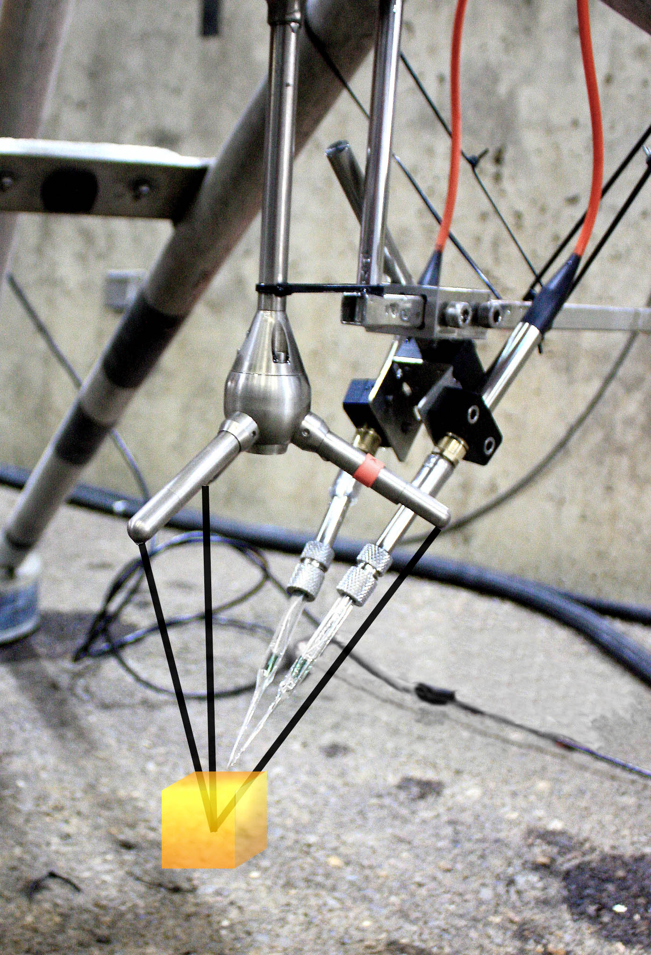

Figure 3. Small recirculating flume experiment design

Figure 4. Orientation of microelectrodes during small recirculating flume experiment: a) sensor oriented perpendicular to the flow, b) three different flow directions tested

Figure 5. Field deployment at Hecata Head at 43.92° N, 124.19° W at 45 meters depth, called HH45. The red lines indicate the examples in the next three figures.

Figure 6. HH45 Example 1 – 100 s piece of field deployment data from a burst 7 with large positive fluxes

Figure 7. HH45 Example 2 – 100 s piece of field deployment data from a burst 14 with divergent fluxes (in both magnitude and direction)

Figure 8. HH45 Example 3 – 100 s piece of field deployment data from a burst 26 with reasonable, negative fluxes

Figure 9. Large wave flume experiment example – 15 min piece of data from a 30-minute deployment under 4-sec period waves with a significant wave height of 0.5 m.
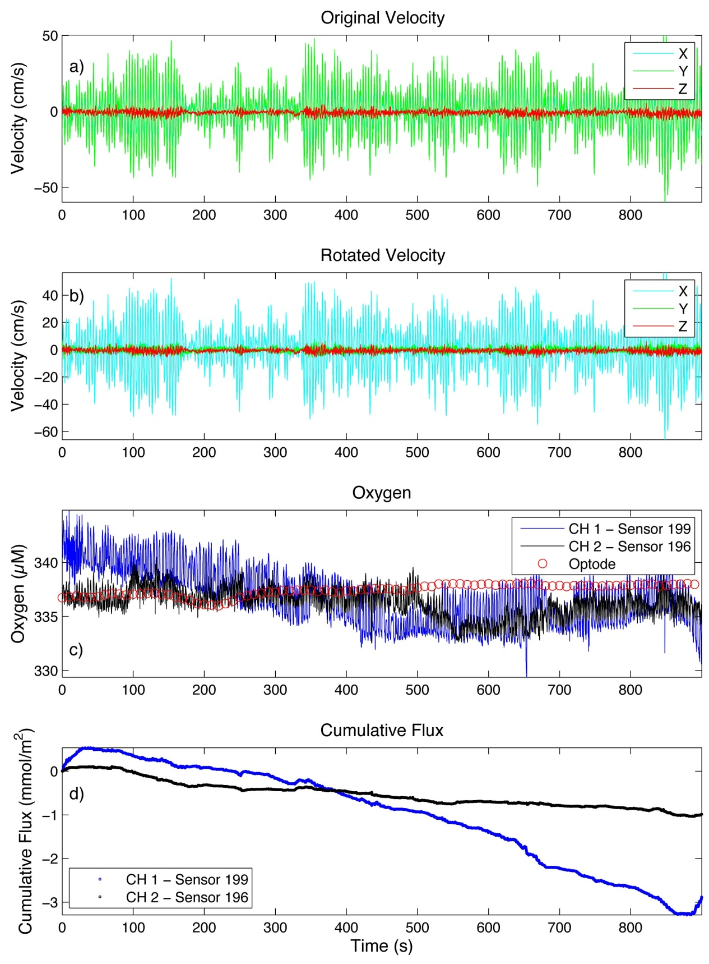
Figure 10. Close up of from the large wave flume experiment example

Figure 11. Small wave flume variable velocity experiment - sensor pointed into the flow of the water, where a) is the velocity measured by the Vectrino, b) is the oxygen measured by sensor 277 and sensor 274, and c) plots the oxygen vs. velocity for the red dots indicated on the velocity plot and the blue dots indicated oxygen.
Figure 12. Small wave flume variable velocity experiment results for each position. The blue error bars indicate the mean in each direction. A positive change indicated the sensor response from no flow to high flow conditions, and vice versa.
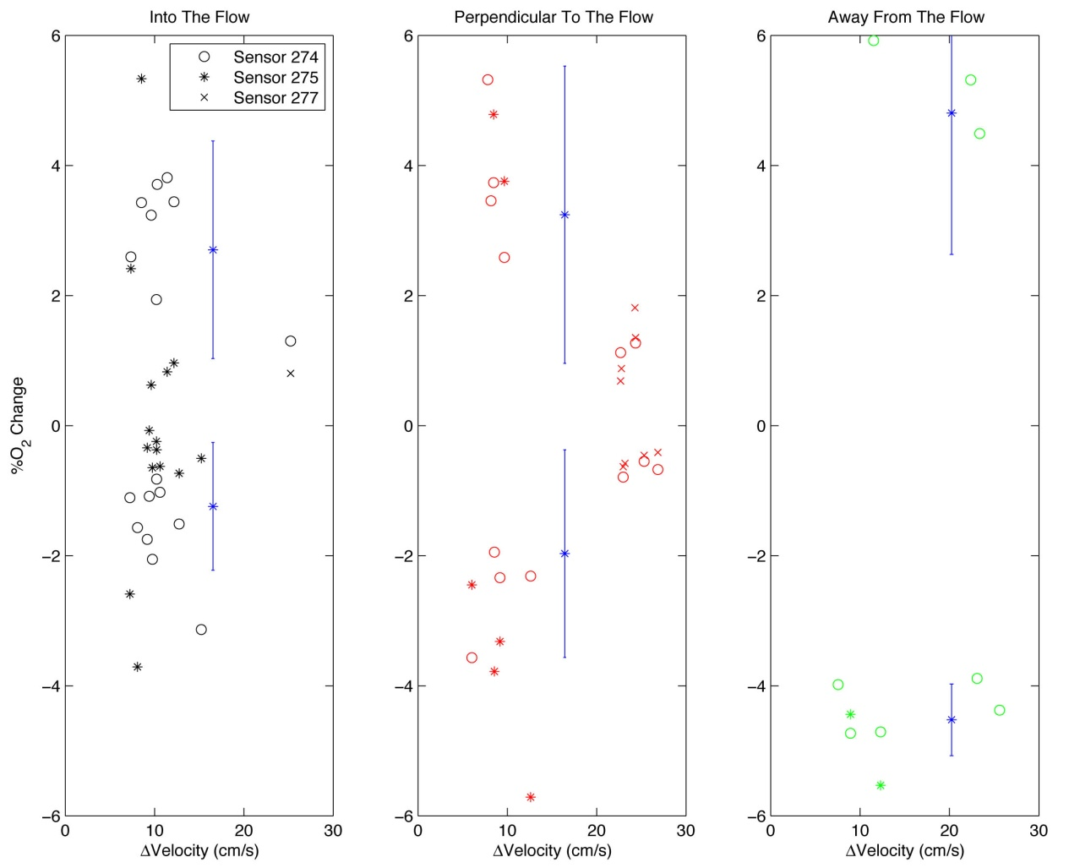
Figure 13. Small wave flume variable velocity experiment results for each sensor. The blue error bars indicate the mean in each direction.
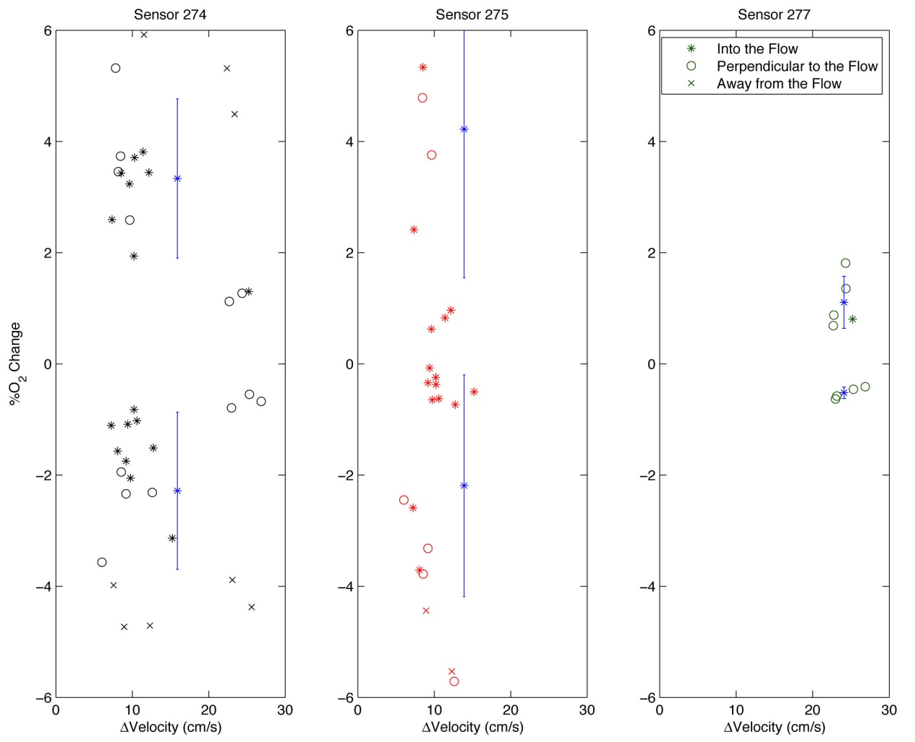
Figure 14. Wave model for large wave flume experiment example – no oxygen gradient

Figure 15. Wave model for large flume experiment example – with an oscillating oxygen gradient

Figure 16. Wave model flux calculations – shifted through an entire wave period

Figure 17. Wave model parameter analysis: Period
Figure 18. Wave model parameter analysis: Mean horizontal current
Figure 19. Wave model parameter analysis: Mean vertical current

REFERENCES

Andersen, K., T. Kjær, et al. (2001). "An oxygen insensitive microsensor for nitrous oxide." Sensors and Actuators B: Chemical 81(1): 42-48.
Berg, P., R. N. Glud, et al. (2009). "Eddy correlation measurements of oxygen uptake in deep ocean sediments." Limnol. Oceanogr.: Methods 7: 576-584.
Brand, A., D. F. McGinnis, et al. (2008). "Intermittent oxygen flux from the interior into the bottom boundary of lakes as observed by eddy correlation." Limnology And Oceanography 53(5): 1997-2006.
Canfield, D. E. and B. Thamdrup (2005). Aquatic geomicrobiology, Gulf Professional Publishing.
Chipman, L., M. Huettel, et al. (2012). "Oxygen optodes as fast sensors for eddy correlation measurements in aquatic systems." Limnology and Oceanography: Methods 10: 304-316.
Dean, R. G. and R. A. Dalrymple (1991). "Water wave mechanics for engineers and scientists."
Glud, R., J. Gundersen, et al. (2000). "Electrochemical and optical oxygen microsensors for in situ measurements." In situ monitoring of aquatic systems: chemical analysis and speciation.: 19-73.
Glud, R. N., P. Berg, et al. (2007). "Effect of the diffusive boundary layer on benthic mineralization and O~ 2 distribution: A theoretical model analysis." Limnology And Oceanography 52(2): 547.
Goring, D. G. and V. I. Nikora (2002). "Despiking acoustic Doppler velocimeter data." Journal of Hydraulic Engineering 128(1): 117-126.
Gust, G., K. Booij, et al. (1987). "On the velocity sensitivity (stirring effect) of polarographic oxygen microelectrodes." Netherlands Journal of Sea Research 21(4): 255-263.
Hale, J. (1983). Factors influencing the stability of polarographic oxygen sensors. Polarographic oxygen sensors, Springer: 3-17.
Hartnett, H. E. and A. H. Devol (2003). "Role of a strong oxygen-deficient zone in the preservation and degradation of organic matter: A carbon budget for the continental margins of northwest Mexico and Washington State." Geochimica et Cosmochimica Acta 67(2): 247-264.
Hedges, J. I. and R. G. Keil (1995). "Sedimentary organic matter preservation: an assessment and speculative synthesis." Marine Chemistry 49(2): 81-115.
Holtappels, M., R. N. Glud, et al. (2013). "Effects of transient bottom water currents and oxygen concentrations on benthic exchange rates as assessed by eddy correlation measurements." Journal of Geophysical Research: Oceans 118(3): 1157-1169.
Holtappels, M., M. M. Kuypers, et al. (2011). "Measurement and interpretation of solute concentration gradients in the benthic boundary layer." Limnology and Oceanography: Methods 9: 1-13.
Hume, A. C., P. Berg, et al. (2011). "Dissolved oxygen fluxes and ecosystem metabolism in an eelgrass (Zostera marina) meadow measured with the eddy correlation technique." Limnol. Oceanogr 56(1): 86-96.
Kuwae, T., K. Kamio, et al. (2006). "Oxygen exchange flux between sediment and water in an intertidal sandflat, measured in situ by the eddy-correlation method." Marine Ecology Progress Series 307: 59-68.
Long, M. H., P. Berg, et al. (2013). "In Situ Coral Reef Oxygen Metabolism: An Eddy Correlation Study." PLoS ONE 8(3): e58581.
Lorrai, C., D. F. McGinnis, et al. (2010). "Application of Oxygen Eddy Correlation in Aquatic Systems." Journal of Atmospheric and Oceanic Technology 27(9): 1533-1546.
Oldham, C. (1994). "A fast-response oxygen sensor for use on fine-scale and microstructure CTD profilers." Limnology And Oceanography 39(8): 1959-1966.
Reimers, C. E., K. M. Fischer, et al. (1986). "Oxygen microprofiles measured in situ in deep ocean sediments."
Reimers, C. E., H. T. Özkan-Haller, et al. (2012). "Benthic oxygen consumption rates during hypoxic conditions on the Oregon continental shelf: Evaluation of the eddy correlation method." Journal of Geophysical Research: Oceans 117(C2): C02021.
Revsbech, N. P. (1989). "An oxygen microsensor with a guard cathode." Limnology And Oceanography 34(2): 474-478.
Tengberg, A., P. Hall, et al. (2005). "Intercalibration of benthic flux chambers: II. Hydrodynamic characterization and flux comparisons of 14 different designs." Marine Chemistry 94(1): 147-173.

APPENDICES
Wave Model Code – without O₂ gradient
% WaveModel_Progressive_E12T1CH1.m

%% Parameters

%Constants
omega=pi()/2; %wave phase
period=2*pi()/omega; %wave period
A=41; %U amplitude
B=4.1; %W amplitude
C=-1.0; %predominant horizontal current
CC=-0.6; %predominant vertical current
%CC=0;

%Time
%t=0:0.0625:40-0.0625;
t=0:0.001:40-0.001;

%Wave equations
u=A*cos(-omega*t)+C; %X-direction
w=B*sin(-omega*t)+CC; %Z-direction
uw=sqrt(u.^2+w.^2);

%Oxygen
cz=336; %arbitrary ambient oxygen concentration

%Pressure
depth=2.3;
D=0.2;
press=depth*(1-0.1*D*cos(-omega*t-pi));

%Sensor Response Parameters
b1=1.00;
b2=1.00;
a=0.01;
delC=6.7;

newU=u;
newU(find(sign(u)<0))=u(find(sign(u)<0)).*b1;
newU(find(sign(u)>=0))=u(find(sign(u)>=0)).*b2;
uw=sqrt(newU.^2+w.^2);
signU=ones(1,length(u));
signU(find(sign(u)<0))=-1;
uw=uw.*signU;

%Time shift
shift=0:0.001:period;

%% Stirring Effect - Symmetric Response - Progressive Wave - Nonlinear assumption
w=w-mean(w);
[c,cpp,cpz]=sensorOutputNonlinear_noGrad(cz,a,delC,uw);
answer=mean(cpp.*w)*864; %flux due to progressive wave
str=[', Flux_A_R_I_T_H = ',num2str(answer)];
str1=[', Flux_A_M_B = ',num2str(mean(cpz.*w)*864)];

%%
figure(1)
subplot(511)
plot(t,u,'b',t,w,'r')
ylabel('Velocity (cm/s)'),xlabel('Time (s)')
title(['Progressive Waves (U - blue & W - red), Period = ',num2str(period),' sec'])
subplot(512)
plot(t,cz,'--g')
ylabel('O_2 (µM)'),xlabel('Time (s)')
title('Average O_2 concentration (green)')
axis tight
subplot(513)
plot(t,press,'m')
ylabel('Depth (m)'),xlabel('Time (s)')
title('Oscillations in water depth due to surface wave motion')
axis tight
subplot(514)
plot(t,c,'c')
ylabel('O_2 (µM)'),xlabel('Time (s)')
title(['Sensor velocity sensitivity: b=',num2str(b2),' for (+)U, b=',num2str(b1),' for (-)U'])
axis tight
subplot(515)
[AX,H1,H2] = plotyy(t,cpp,t,w);
set(get(AX(1),'Ylabel'),'String','O_2 (µM)')
set(get(AX(2),'Ylabel'),'String','Velocity (cm/s)')
xlabel('Time (s)')
title(['Progressive Wave - C prime (blue), W prime (green)',str,str1])

%%

for ii=1:length(shift);

s=shift(ii);

%Oscillating oxygen concentration
[c,cpp,cpz]=sensorOutputNonlinear_noGrad(cz,a,delC,uw);

%Time shift
backEnd=[c;cpp;cpz];
frontEnd=[u;w;press];
[newT,frontEnd,backEnd]=timeShift_waveModel(s,t,frontEnd,backEnd);
newU=frontEnd(1,:);
newW=frontEnd(2,:);
newPress=frontEnd(3,:);
newC=backEnd(1,:);
newCpp=backEnd(2,:);
newCpz=backEnd(2,:);

answer(ii)=mean(newCpp.*newW)*864; %flux due to progressive wave
str=[', Flux_A_R_I_T_H = ',num2str(answer(ii))];
str1=[', Flux_A_M_B = ',num2str(mean(newCpz.*newW))];
end

figure(1)
subplot(511)
plot(newT,newU,'b',newT,newW,'r')
ylabel('Velocity (cm/s)'),xlabel('Time (s)')
title(['Progressive Waves (U - blue & W - red), Period = ',num2str(period),' sec'])
axis tight
subplot(512)
plot(newT,cz,'g')
ylabel('O_2 (µM)'),xlabel('Time (s)')
title('Average O_2 concentration (green), Oscillation of O_2 due to vertical wave motion (black)')
axis tight
subplot(513)
plot(newT,newPress,'m')
ylabel('Depth (m)'),xlabel('Time (s)')
title('Oscillations in water depth due to surface wave motion')
axis tight
subplot(514)
plot(newT,newC,'c')
ylabel('O_2 (µM)'),xlabel('Time (s)')
title('Sensor velocity sensitivity')
axis tight
subplot(515)
[AX,H1,H2] = plotyy(newT,newCpp,newT,newW);
set(get(AX(1),'Ylabel'),'String','O_2 (µM)')
set(get(AX(2),'Ylabel'),'String','Velocity (cm/s)')
xlabel('Time (s)')
title(['Progressive Wave - C prime (blue), W prime (green)',str,str1])

figure(3)
subplot(211)
plot(shift,answer)
axis tight
xlabel('Time shift (seconds)'),ylabel('Flux (mmol/m^2 d)')
%printCurrentFig(1,'timeShift.pdf',cd)

%% Final Comparison

ch1=load('E12T1_CH1_allclean.dat');
ch2=load('E12T1_CH2_allclean.dat');
ch1Rot=load('data_E12T1CH1.dat');

tt=ch1(:,1);
interval=find(tt>1420 & tt<1460);
ch1=ch1(interval,:);
ch2=ch2(interval,:);
ch1Rot=ch1Rot(interval,:);

tt=ch1(:,1);
tt=tt-tt(1);
o21=ch1(:,5);
o22=ch2(:,5);
press=ch1(:,6);
rotX=ch1Rot(:,2);
rotZ=ch1Rot(:,4);

figure(1)
subplot(311)
plot(t,u,'c',tt,rotX,'b')
ylabel('Velocity (cm/s)','Fontsize',12)
legend('Model','Waveflume')
title('Velocity - x direction','Fontsize',13)
axis tight
subplot(312)
plot(t,w,'m',tt,rotZ,'r')
ylabel('Velocity (cm/s)','Fontsize',12)
title('Velocity - z direction','Fontsize',13)
legend('Model','Waveflume')
axis tight
subplot(313)
plot(t,c,'g'),hold on, plot(tt,o22,'Color',[0 0.5 0.2])
ylabel('O_2 (µM)','Fontsize',12)
xlabel('Time (s)','Fontsize',12)
legend('Model','Waveflume')
title('Oxygen','Fontsize',13)
axis tight

figure(2)
subplot(211)
plot(shift,answer)
xlabel('Time shift (seconds)','Fontsize',12)
ylabel('Flux (mmol/m^2/d)','Fontsize',12)
axis tight

Wave Model Code – with O₂ gradient
% WaveModel_Progressive_w_Grad_E12T1CH1.m

%% Parameters

%Constants
omega=pi()/2; %wave phase
period=2*pi()/omega; %wave period
A=41; %U amplitude
B=4.1; %W amplitude
C=-1.0; %predominant horizontal current
CC=-0.6; %predominant vertical current
%CC=0;

%Time %12 Seconds for shorter interval
t=0:0.0625:40-0.0625;

%Wave equations
u=A*cos(-omega*t)+C; %X-direction
w=B*sin(-omega*t)+CC; %Z-direction
uw=sqrt(u.^2+w.^2);

%Oxygen
cz=336; %arbitrary ambient oxygen concentration
cn=cz*(1-0.001*cos(-2*omega*t));

%Pressure
depth=2.3;
D=0.2;
press=depth*(1-0.1*D*cos(-omega*t-pi));

%Sensor Response Parameters
b1=1.00;
b2=1.00;
a=0.012;
delC=6.7;

newU=u;
newU(find(sign(u)<0))=u(find(sign(u)<0)).*b1;
newU(find(sign(u)>=0))=u(find(sign(u)>=0)).*b2;
uw=sqrt(newU.^2+w.^2);
signU=ones(1,length(u));
signU(find(sign(u)<0))=-1;
uw=uw.*signU;

%Time shift
shift=0:0.1:period;

%% Stirring Effect - Symmetric Response - Progressive Wave - Nonlinear assumption

w=w-mean(w);
[c,cpp,cpz,cp]=sensorOutputNonlinear(cz,cn,a,delC,uw);
answer=mean(cpp.*w)*864; %flux due to progressive wave
str=[', Flux_A_R_I_T_H = ',num2str(answer)];
str1=[', Flux_A_M_B = ',num2str(mean(cpz.*w)*864)];

%%
figure(1)
subplot(511)
plot(t,u,'b',t,w,'r')
ylabel('Velocity (cm/s)'),xlabel('Time (s)')
title(['Progressive Waves (U - blue & W - red), Period = ',num2str(period),' sec'])
subplot(512)
plot(t,cz,'-g',t,cn,'--k')
ylabel('O_2 (µM)'),xlabel('Time (s)')
title('Average O_2 concentration (green)')
axis tight
subplot(513)
plot(t,press,'m')
ylabel('Depth (m)'),xlabel('Time (s)')
title('Oscillations in water depth due to surface wave motion')
axis tight
subplot(514)
plot(t,c,'c')
ylabel('O_2 (µM)'),xlabel('Time (s)')
title(['Sensor velocity sensitivity: b=',num2str(b2),' for (+)U, b=',num2str(b1),' for (-)U'])
axis tight
subplot(515)
[AX,H1,H2] = plotyy(t,cpp,t,w);
set(get(AX(1),'Ylabel'),'String','O_2 (µM)')
set(get(AX(2),'Ylabel'),'String','Velocity (cm/s)')
xlabel('Time (s)')
title(['Progressive Wave - C prime (blue), W prime (green)',str,str1])

%%

for ii=1:length(shift);

s=shift(ii);

%Oscillating oxygen concentration
[c,cpp,cpz]=sensorOutputNonlinear(cz,cn,a,delC,uw);

%Time shift
backEnd=[c;cpp;cpz;cn];
frontEnd=[u;w;press];
[newT,frontEnd,backEnd]=timeShift_waveModel(s,t,frontEnd,backEnd);
newU=frontEnd(1,:);
newW=frontEnd(2,:);
newPress=frontEnd(3,:);
newC=backEnd(1,:);
newCpp=backEnd(2,:);
newCpz=backEnd(3,:);
newCz=backEnd(4,:);

answer(ii)=mean(newCpp.*newW)*864; %flux due to progressive wave
str=[', Flux_A_R_I_T_H = ',num2str(answer(ii))];
str1=[', Flux_A_M_B = ',num2str(mean(newCpz.*newW))];
end

figure(1)
subplot(511)
plot(newT,newU,'b',newT,newW,'r')
ylabel('Velocity (cm/s)'),xlabel('Time (s)')
title(['Progressive Waves (U - blue & W - red), Period = ',num2str(period),' sec'])
axis tight
subplot(512)
plot(newT,cz,'g',newT,newCz,'--k')
ylabel('O_2 (µM)'),xlabel('Time (s)')
title('Average O_2 concentration (green), Oscillation of O_2 due to vertical wave motion (black)')
axis tight
subplot(513)
plot(newT,newPress,'m')
ylabel('Depth (m)'),xlabel('Time (s)')
title('Oscillations in water depth due to surface wave motion')
axis tight
subplot(514)
plot(newT,newC,'c')
ylabel('O_2 (µM)'),xlabel('Time (s)')
title('Sensor velocity sensitivity')
axis tight
subplot(515)
[AX,H1,H2] = plotyy(newT,newCpp,newT,newW);
set(get(AX(1),'Ylabel'),'String','O_2 (µM)')
set(get(AX(2),'Ylabel'),'String','Velocity (cm/s)')
xlabel('Time (s)')
title(['Progressive Wave - C prime (blue), W prime (green)',str,str1])

figure(3)
plot(shift,answer)
axis tight
xlabel('Time shift (seconds)'),ylabel('Flux (mmol/m^2 d)')

%% Final Comparison

ch1=load('E12T1_CH1_allclean.dat');
ch2=load('E12T1_CH2_allclean.dat');
ch1Rot=load('data_E12T1CH1.dat');

tt=ch1(:,1);
interval=find(tt>1422 & tt<1462);
%interval=find(tt>1436 & tt<1448);
ch1=ch1(interval,:);
ch2=ch2(interval,:);
ch1Rot=ch1Rot(interval,:);

tt=ch1(:,1);
tt=tt-tt(1);
o21=ch1(:,5);
o22=ch2(:,5);
press=ch1(:,6);
rotX=ch1Rot(:,2);
rotZ=ch1Rot(:,4);

figure %(1)
subplot(311)
plot(t,u,'c',tt,rotX,'b')
ylabel('Velocity (cm/s)','Fontsize',12)
legend('Model','Waveflume')
title('Velocity - x direction','Fontsize',13)
axis tight
subplot(312)
plot(t,w,'m',tt,rotZ,'r')
ylabel('Velocity (cm/s)','Fontsize',12)
title('Velocity - z direction','Fontsize',13)
legend('Model','Waveflume')
axis tight
subplot(313)
plot(t,cp,'g'),hold on, plot(tt,o22,'Color',[0 0.5 0.2])
ylabel('O_2 (µM)','Fontsize',12)
xlabel('Time (s)','Fontsize',12)
legend('Model','Waveflume')
title('Oxygen','Fontsize',13)
axis tight

% sensorOutputNonlinear.m
function [c,cpp,cpz,cp]=sensorOutputNonlinear(cz,cn,a,delC,uw);

%Inputs:
%cz (scalar): ambient oxygen concentration
%cn (vector): oscillating oxygen concentration under wave conditions
%m (vector): velocity sensitivity gradient (can be symmetric or asymmetric)
%u (vector): velocity in the X-direction
%delC (scalar): expected change in oxygen signal

%Outputs
%c: stirring effect
%cpp: ideal flux using arithmetic mean
%cpz: ideal flux using ambient O2 mean

%Sensor output
c=cz+delC*tanh(a*abs(uw));%model stirring effect
cp=cn+delC*tanh(a*abs(uw));%oscillating oxygen gradient superimposed on symmetric stirring effect
cpp=cp-mean(cp); %remove arithmetic mean
cpz=cp-cz; %remove ambient oxygen concentration

end

Figure 1. Wave model parameter analysis: Amplitude. Amplitudes for u and w are both increased.

Figure 2. Wave model parameter analysis: Amplitude. Amplitude of u is increased, while w is kept constant.

Figure 3. Wave model parameter analysis: Amplitude. Amplitude of w is increased, while u is kept constant.

Figure 4. Wave model parameter analysis: O₂ gradient strength

Figure 5. Wave model parameter analysis: Alpha

Figure 6. Wave model parameter analysis: ΔC

