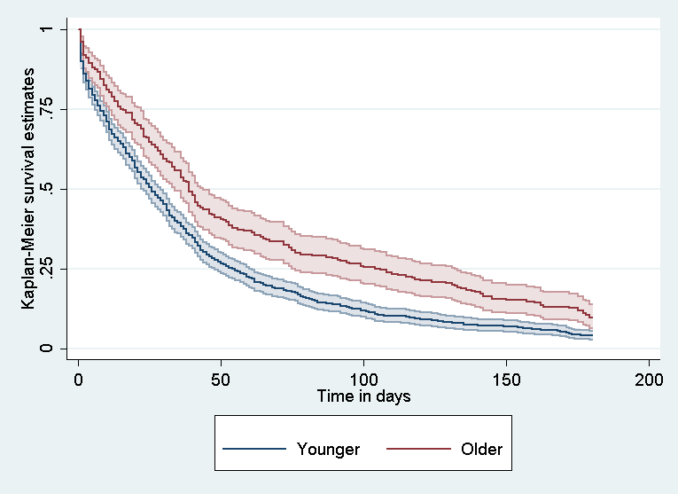Figure 1. Graph of the survivor function for shelter stay across older and younger homeless male clients.

