Evaluating relocation extent versus covariate resolution in habitat selection models across spatiotemporal scales
Peter R. Nelson ^{a,b,*} , Kyle Joly ^{c}, Carl A. Roland ^{c} and Bruce McCune ª
ª Department of Botany and Plant Pathology, 2082 Cordley Hall, Oregon State University, Corvallis, Oregon, USA
^{b} University of Maine-Fort Kent, 23 University Drive, Fort Kent, Maine, 04743, USA.
^{c} National Park Service, 4175 Geist Road, Fairbanks, Alaska, 99709, USA.
* Corresponding author. Email address: peter.nelson@maine.edu (P. R. Nelson)
Abstract
Many habitat selection studies have focused on the importance of spatiotemporal scales and sample size, yet often hidden within is a trade-off between using more animal locations versus more predictive covariates. Few have evaluated the outcome of choosing between these two different paths even though the trade-off can have significant impacts on the conclusions drawn from habitat modeling. We evaluated the covariate resolution versus relocation trade-off across multiple spatiotemporal scales by building habitat selection models using a data-mining approach with 22 years of VHF collar data from the Denali Caribou Herd. We asked whether caribou selected winter habitat based on forage resources after accounting for snow depth. Habitat selection models at three temporal scales (decadal, inter-annual and intra-annual) provide correlative evidence of active selection for winter forage. Based on model performance and predicted occupancy, we found that acquiring appropriate covariate layers is critical and likely even more important than using more animal locations. Based on analyses that utilized more covariates, caribou predominantly selected high graminoid cover, their second most important winter food, over areas with high lichen cover, their primary winter food, at all spatial scales implying a need to balance food quality and accessibility. However, habitat selection differed between temporal scales. Two years in a row, caribou switched to flatter areas with higher lichen cover and low shrub cover while intra-annual variation in habitat selection showed caribou congregated in areas of higher lichen cover and lower snow depths as winter progressed. We conclude that large patches of tussock tundra are high-use areas for wintering caribou in Denali at decadal scales while lichen-rich areas were used at inter-annual and intra-annual temporal scales. Lower snow levels in the future may allow heavier use of lichen woodlands but increased wildfire activity and shrub encroachment may counteract increased lichen availability in woodlands.
Keywords: Caribou, Denali National Park and Preserve, graminoids, lichen, non-parametric multiplicative regression, winter

1. Introduction
Highly mobile animals, such as caribou (Rangifer tarandus), often range outside or between a primary management unit and adjacent lands under different uses. Crossing human imposed border presents risks to wildlife but also impacts managers ability to implement conservation. This situation could lead to a failure of conservation when some fraction of the animal’s range is outside the primary management unit where most of the habitat use occurs. Prior to the widespread availability of GPS technology, acquiring a sufficient amount of animal relocations (sample size) was paramount to robust habitat selection studies that would address this dilemma. As GPS technology has advanced, researchers have had access to unprecedented amount of data therefore animal relocations are now rarely limiting for habitat selection studies (Hebblewhite and Haydon 2010). In contrast, the quality or resolution of habitat covariates to interpret selection may be limiting researchers because two adjacent land units may have very different levels of information on habitat. In order to understand habitat selection across the entire range of an animal, acquiring even more relocations for an animal population may not be needed. Rather, it makes sense to generate more habitat covariates to improve the resolution of the understanding of the biology and movement of the animal. Here we explored of the choice researchers make to emphasize either more animal relocations (extent) or more habitat information (covariate resolution) in a habitat selection analysis. To do this, we modeled winter caribou habitat selection over 20 yrs from a herd that lives mostly, but not entirely, within Denali National Park and Preserve, Alaska.
Caribou select winter habitat based on food and snow at multiple spatial scales, including, from finest to coarsest, feeding sites, travel routes between patches, patches of feeding sites and the home range (Johnson et al. 2001, Mosnier et al. 2003, Mayor et al. 2009). Spatiotemporal scale and sample size have been extensively explored as important dimensions in habitat selection models (Rettie and Messier 2000, Johnson et al. 2001, Johnson et al. 2002, Stockwell and Peterson 2002, Hernandez et al. 2006, Mayor et al. 2007). One conclusion of many spatiotemporal habitat selection studies is to emphasize the importance of accounting multiple scales and levels of habitat use in space and time (McGarigal et al. 2016). However, it is often assumed, or unstated, that the same habitat variables are available for all animal relocations at all scales. Our study attempts to address what we are calling the relocation extent vs. covariate resolution question through multiple spatiotemporal scales of habitat selection analysis of the Denali caribou herd.
The answer to relocation extent vs. covariate resolution question almost certainly varies with spatiotemporal scale. Habitat variables at coarse spatial scales are thought to be more important in measuring habitat selection at long time scales, whereas fine-grained variables are more important at short time scales (Holling 1992). Feeding sites or patches at a fine spatiotemporal grain were found to have more food and better visibility/shelter whereas travel routes had less snow and proximity to good feeding patches (Johnson et al. 2002). Habitat selection at coarser spatiotemporal scales is driven by fire history (Joly et al. 2009) and inter- and intra-specific competition (Cumming et al. 1996, James et al. 2004, Joly et al. 2012). If resource managers are to anticipate risks to caribou, whether moving across boundaries or responses to changing vegetation and changing snow conditions, then long-term studies are essential to project how environmental changes may influence how caribou use across spatiotemporal scales.
We focused our exploration of the relocation extent vs. covariate resolution question on habitat variables likely influential on caribou movement in the winter. Lichens are the primary winter food for caribou to survive in environments where most plant material has senesced and snow modulates access to food for caribou and inhibits travel between patches of higher quality forage, complicating the process of forage selection because of increased energetic costs of searching for food (Fancy and White 1985, Fancy and White 1987, Collins and Smith 1991). While high in digestible energy, lichens consumed by caribou are low in crude protein (Person et al. 1980). Caribou offset this nutrient deficiency by consuming other forage items, such as graminoids and shrubs (Storeheier et al. 2002a, Storeheier et al. 2002b). As a population increases, animal density may also change foraging patterns by forcing individuals to search out lower quality but more available foods (Rosenzweig 1981). In extreme cases, caribou can exist in areas without lichens (Nagy and Forsythe 1995), such as the high arctic subspecies (Rangifer tarandus pearyi) or insular ecotypes (Mallory and Hillis 1996), where predators are largely absent. Here, their diet is mostly graminoids (Heggberget et al. 1992). Understanding habitat selection based on forage choices will help managers anticipate impacts of vegetation change and conserve habitats in arctic and boreal regions that likely will be much warmer in the future (Comiso and Hall 2014). We also add another data point in the debate on if and when food, specifically lichen type, amount and availability, is related caribou movement.
Changes in global climate may affect the availability and quality of caribou winter habitats through the reduction of terricolous lichen cover and altered snow conditions in the boreal and arctic zones (Cornelissen et al. 2001, Stone et al. 2002, Joly et al. 2009). Warmer summer temperatures drive increases in wildfire frequency and extent as well as shrub expansion; both of which decrease terricolous lichen abundance. Terricolous lichens can take decades to more than a century to recover to pre-fire abundance and shrub encroachment into lichen-rich areas may represent a permanent shift to a new vegetation community (Jandt et al. 2008, Joly et al. 2010). Since lichens are the primary winter food for most caribou populations (Boertje 1984, Heggberget et al. 1992, Joly et al. 2015), decreases in lichen abundance may negatively impact caribou fitness and population numbers. Simulations of downscaled climate models indicate this observed decrease in lichen cover to continue under even conservative CO₂ emission scenarios (Joly et al. 2012, Gustine et al. 2014), making this a high priority issue for land managers and subsistence hunting communities. Recent work also points to potential connection between the rate of caribou movement and lichen volume variation through time (Rickbeil et al. 2017).
Here we present the results of one of the world’s longest-term radiotelemetry studies of caribou while addressing relocation extent vs. covariate resolution question. Our goals were to 1) assess the trade-offs between utilizing more explanatory covariates with fewer usable caribou relocations versus using fewer covariates with a greater number of caribou relocations and 2) assess winter habitat selection by caribou at multiple spatiotemporal scales in relation to snow and forage. We studied a caribou population with many forage choices over a long period of time to examine winter habitat selection in a study area with minimum development (e.g., roads, pipelines). We hypothesized that the number of caribou relocations was, typically, no longer limiting habitat selection studies and that the utilization of predictive, but spatially-limited, explanatory covariates would improve modeling efforts. Further, we hypothesized that if caribou select winter habitat based on food, then areas near caribou relocations will have a higher lichen cover and lower snow depths in comparison to random locations. We explicitly included the interactions between snow and food across multiple spatiotemporal scales in a population where density dependence was likely not factor and used variable determinations of availability that integrated habitat characteristics across multiple spatial scales.

2. Methods
2.1 Study Areas
We used two different study areas, one nested inside the other, to assess whether using more habitat covariates with fewer caribou relocations versus fewer habitat covariates with more relocations changed the conclusions of our analyses. Denali National Park and Preserve (hereafter “Denali N.P.P.”) was the smaller study area with more habitat data but fewer caribou relocations because many of them fell outside this study area. Two adjacent Landsat scenes (hereafter “Landsat”), encompassing Denali N.P.P. and some surrounding areas, comprised the larger study area. Landsat covered a larger extent, thus contained more caribou relocations, but had fewer available habitat covariates because many of those were limited to the spatial extent of Denali N.P.P..
Denali N.P.P. covers 24,500 km² in central Alaska (Fig. 1), with elevations ranging from 275 m in the low, flat boreal forests in the north to the highest mountain in North America, also known as Denali (6,190 m), in the middle of the park. In the northern portion of the park, the terrain is mostly flat alluvial terraces deposited by numerous north-flowing rivers originating in the Alaska Range intermixed with eolian deposits that mantle low hills formed by schist bedrock. Between the lowlands and the high elevations of the Alaska Range lie a series of low mountains formed primarily from highly weathered metamorphic material. The Alaska Range bisects the park along a northeast/southwest line, forming a high spine of mostly igneous rocks capped by glaciers or permanent snowfields.

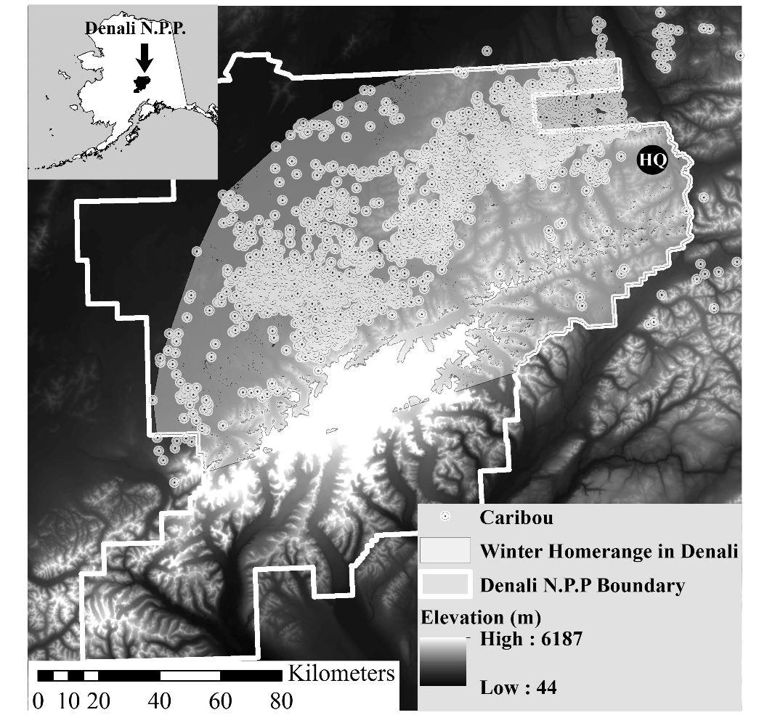
Figure 1: Map of elevation in Denali N.P.P. with winter caribou locations from 1985-2007. Black circle in upper right quadrant with “HQ” indicates approximate location of park headquarters.
Vegetation in Denali N.P.P. varies from lowland taiga with black spruce (Picea mariana), tussock tundra, and lichen woodlands to middle elevations dominated by shrubs terminating in rock and ice in the large foothills and Alaska Range (Roland et al. 2013). Lowland taiga dominates in the Landsat scene outside Denali N.P.P. with some white spruce (Picea glauca) and hardwoods in well-drained, warmer soils. Average monthly winter temperatures at park headquarters ranged from -28 to 2˚C with an average maximum monthly snow pack ranging from 14 to 129 cm (Appendix 1 Fig. A1).

2.2 Caribou population and relocations
The Denali Caribou Herd (DCH) is composed of approximately 2000 caribou, fluctuating between 1800 and 3300 animals over the last 20 years (Adams and Roffler 2010). In the winter, the herd has primarily been found north of the Alaska Range in one of two areas: the eastern wintering grounds in the tussock tundra of the northeast corner of the park and the western wintering ground in the boreal forests in the west-central portion of the park (Boertje 1985a). Our study primarily focuses on the variation in use in these wintering areas.
Between November and March from 1984-2007, 282 female caribou (≥1 year old) were captured and collared with very high frequency (VHF) radio collars and relocated 4225 times using fixed wing aircraft (Adams and Roffler, 2010). Individual animals were relocated only once per early, mid and late winter segment. Since we focused on winter habitat selection, animal relocations were divided into early (Nov. 5-Dec. 15), mid (Jan. 7-Feb.11), and late winter (Mar.6-31) seasons for each biological year. Relocations were divided into those that fell within Denali N. P. P. (n = 3780, hereafter the Denali Park) and the Landsat scene (n = 4101), with all Denali Park relocations falling within the Landsat scene (Fig. 1). Throughout our study, we refer to this division between Denali and Landsat datasets.

2.3 Habitat covariates
Environmental covariates used in most previous caribou habitat studies divide the landscape into coarse (categorical or thematic) environmental variables, such as polygons or pixels, assigned to a vegetation class (e.g., Johnson et al. 2002, Gustine and Parker 2008, Joly 2011). Our study improved on previous caribou habitat selection studies by using a new set of continuous, high-resolution (30 m pixels) vegetation models of caribou diet items (Nelson et al. 2013). Vegetation covariates included percent cover of conifer (Picea spp.), deciduous trees, shrubs, graminoids, and two lichen groups: lichens with a pale yellow pigment called usnic acid (usnic lichens) and usnic + light colored lichens (usnlite; Nelson et al. 2013).
Snow persistence was estimated using satellite imagery based on now-free dates built using the Snowmap algorithm (Hall et al. 2001). Scenes from Landsat 5 and 7 (30 m pixels) from April 1 to August 31 from 1985-2009 were corrected to top-of-the-atmosphere reflectance in the Landsat Ecosystem Disturbance Adaptive Processing System (LEDAPS, Masek et al. 2006); clouded portions of images were not included in analyses. We used the Normalized Difference Snow Index (NDSI): NDSI = (VIS – SWIR) ÷ (VIS + SWIR) to identify the presence of snow in pixels (Hall et al., 2001). Where VIS was the top-of-atmosphere reflectance in a visible wavelength (approx. 0.55 μm) and SWIR was the top-of-atmosphere reflectance in a short-wavelength infrared (approx. 1.64 μm). The Julian snow-free date across images was done with a binary classification tree (rpart; R Development Core Team 2009).
We also modeled aspects of physiography and climate to be included as covariates. Slope (degrees), aspect off 180º (measures how much as slope faces south), and elevation (m) were estimated from a 30 m digital elevation model in a geographic information system (ArcGIS 10; ESRI, Redlands, CA). Terrain ruggedness was calculated at two spatial scales (3 x 3 pixel and 90 x 90 pixel windows, both with 30-m pixels) using the Vector Ruggedness Measure (VRM) python tool for ArcGIS (Sappington et al. 2007). Climate data (temperature and snow depth) at park headquarters were acquired from the National Park Service. Daily climate observations were aggregated to monthly averages for mean, maximum, and minimum temperature, and maximum snow depth for early, middle and late winter seasons. In total, there were ten and thirteen habitat covariates available for modeling caribou habitat selection in the Landsat and Denali Park study areas, respectively (Table 1). Finally, we also added the year caribou were relocated as a covariate to see if a single time categorical variable could account for temporal variation in habitat selection.
Table 1: Habitat variables used in analyses with units of measures. Predictors only available in Denali Park are indicated by “*”. Denali Park and Landsat columns are p-values (p < 0.05 in bold face) from ANOVAs testing for differences between years in habitat values using 4000 m datasets. Bolded names of habitat variables are significantly different (p < 0.05) between bouts based on ANOVAs in both Denali Park and Landsat 4000 m datasets.

Habitat variable | Units | F-stat | Denali  Park | F-stat | Landsat
Usnic lichens | % cover | 4.5 | <0.001 | 4.0 | <0.001
Picea | % cover | 4.0 | <0.001 | 4.1 | <0.001
Shrub | % cover | 5.9 | <0.001 | 4.4 | <0.001
Deciduous tree* | % cover | 3.7 | <0.001 | n/a | n/a
Usnic + light lichens* | % cover | 6.8 | <0.001 | n/a | n/a
Graminoid* | % cover | 6.1 | <0.001 | n/a | n/a
Snow-free Date | Julian date | 9.5 | 0.067 | 6.4 | 0.202
Aspect off 180 | Degrees | 3.0 | 0.334 | 2.5 | 0.371
Terrain ruggedness (Fine) | Unitless | 3.0 | 0.002 | 3.0 | 0.158
Terrain ruggedness (Coarse) | Unitless | 2.7 | 0.003 | 2.7 | 0.427
Elevation | Meters | 2.0 | 0.025 | 1.9 | 0.036
Slope | Degrees | 3.0 | 0.001 | 3.0 | 0.001
Snow depth | Centimeters | 5.3 | 0.083 | 5.3 | 0.083

2.4 Spatial datasets
The DCH’s overall winter home range defined the spatial extent within which habitat selection was presumed to operate (Garshelis 2000). We used a minimum convex polygon (MCP) home range estimator generated in the Geospatial Modeling Environment (GME) (Beyer 2012) using all winter relocations across all years. To exclude areas at high elevation caribou were unlikely to use, we clipped the home range by the maximum elevation within all winter relocations (2000 m). Including rock, ice and water inside the study area, the Denali MCP was 14,957 km² and the Landsat MCP was 19,173 km².
To assess habitat selection at different spatial scales, caribou relocations were buffered by circular windows with radii of 150, 300, 600, 1000, 2000, 4000 and 10,000 m. The finest scale was set at 150 m because that is the error associated with VHF radiotelemetry (Garshelis 2000). The coarsest scale was set at 10,000 m based on other studies that indicated habitat selection is correlated with environmental variables at or below a 13-km radius from the animal (Leblond et at. 2011, Mayor et al. 2007, 2009). We extracted summary statistics (maximum, minimum, mean, median, standard deviation and pixel count) for the habitat variables (Table 1) within each buffer size for each caribou relocation. Each habitat covariate map had small areas of missing data, meaning no value for that covariate. We excluded relocations with less that <50% of the pixels for a given covariate for a given buffer size for a given caribou relocation. As the buffer radius increased, more relocations passed this threshold (Table 2). Most years for most buffer radii had between 150-250 usable caribou relocations (Appendix 2, Table A1).

Table 2. Number of caribou locations plus random points with at least 50% of all pixels with data for all habitat variables (Table 1), sorted by window size and geographic area. Minimum pixel count is 50% of pixels for a given window size.

 | Radii window sizes
 | 150m | 300m | 600m | 1km | 2km | 4km | 10km
Minimum pixel count | 40 | 159 | 634 | 1752 | 6989 | 27937 | 174553
Locations in Denali Park (caribou+random) | 6280 | 6396 | 6696 | 6826 | 7058 | 7082 | 5690
Locations in Landsat (caribou+random) | 7570 | 7682 | 7834 | 7962 | 8084 | 8114 | 8090
Difference in sample size (Landsat-Denali Park) | 1290 | 1286 | 1138 | 1136 | 1026 | 1032 | 2400

We generated a set of 6000 - 8000 thousand random relocations; one set for each window size (150, 300, 600, 1000, 2000, 4000 and 10,000 m radii) for each study area. To maintain separation of used and random datasets, random points of a given buffer size could not fall within the window of another random point nor within the buffer of the caribou relocations for a given window size. Random points were buffered by the same radii as caribou relocations. We then extracted covariates in the same way as the caribou relocations, omitting buffered random points with <50% of pixels with data for all covariates for a given window size. We randomly sampled the random locations for each buffer size to equal the number of caribou relocations for that same window size. See Appendix 1 Fig. A2 for a visual diagram of this process.

2.5 Temporal datasets
We generated MCPs home ranges for each season/year combination to assess temporal variation in habitat selection. We selected random points that fell outside that season/year MCP but inside the overall winter homerange (MCP all year pools). For each season/year MCP, we selected random points equal in number to the count of buffered caribou relocations within that season/year MCP. We only used random locations (and caribou relocations) with >50% data for all predictors in that season/year MCP. Each random point was then attributed with climatic data from park headquarters for that season/year (Fig. 1, Appendix 1 Fig. A1). We compiled the random and caribou relocations into similar habitat and presence/absence matrices as the strictly spatial dataset except the habitat matrix had climate data from park headquarters and the selection of random points had embedded temporal structure.

2.6 Multivariate Analysis of Caribou Relocations Versus Random Locations
To validate the random point generation process, we tested for differences in habitat covariates between random locations and caribou relocations (the grouping variable) using both the 4000 m Denali Park and Landsat datasets in a multiple response permutation procedure (MRPP) in PC-ORD v.6 (Mielke and Berry 2001, McCune and Mefford 2011). MRPP measures within-group agreement (A) and a p-value. An A = 1 means all members of each group are exactly the same within group. Usnic lichen and deciduous trees (for the Denali Park study area) were log₁₀ transformed as their distributions were strongly skewed. We then relativized the habitat matrix to the standard deviation of each column (mean = 0, SD=1) to minimize the influence of variables, such as elevation, which have far more variation than the rest of the variables and would otherwise dominate the analysis. We excluded temporal variables from the habitat matrix from the ordination because caribou did not select the climate conditions each year (they were subjected to the climatic conditions). See Appendix 1 Fig. A2 for a visual diagram of this process.

2.7 Habitat selection model
We regressed random locations and caribou relocations (presence/absence matrix, dependent variable) against mean habitat variables from each buffer size (habitat matrix, independent variables) using non-parametric multiplicative regression (NPMR) in HyperNiche (McCune and Mefford 2009). NPMR is a data mining technique that uses a kernel smoother and controls over-fitting with leave-one-out cross validation during model selection and calculating fit so that splitting into training/validation datasets is automatically built into model development. In addition to those strengths, we favored data mining (NPMR) over the traditionally used Resource Selection Functions (RSFs) because we expected strong but variable interactions between covariates across the 20+ year record. Progressively higher order polynomial interaction terms within nested models would be cumbersome to build and likely too few combinations to adequately explore number and nature of interactions in our predictor dataset. We used NPMR with a local mean Gaussian kernel and forward stepwise variable selection, simultaneously optimizing the smoothing parameters (tolerances) for all predictors included in the model. We used aggressive settings for the over-missing estimates of 3%. The higher improvement criterion prevented searching for models resulting in a marginal improvement of fit. The low maximum allowable missing estimates ensured that only models where most of the data was used were retained.
To test the influence of better habitat covariate resolution versus greater relocation extent, we fit models for each window size and study area (Denali and Landsat), retaining only the best model (Table 3) based on the log likelihood ratio, logB. This ratio is interpreted as “the likelihood of cross-validated estimates from the fitted model to estimates from the naïve model expressed in powers of ten” (McCune and Mefford 2009), where the naïve model is the average frequency of the caribou occupancy. We used the average B statistic (10^{logB/n}), hereafter aveB, to compare model fits because sample sizes varied (which affects logB) between window sizes and study areas. AveB is the average improvement to the fitted model added by each sample unit, expressed as a proportionate improvement in the likelihood ratio over the naïve model. For example, if a model has an aveB = 1.12, each additional sample unit (caribou or random location) improves the model 12% over the naïve model.
Table 3: Non-parametric regression statistics for best models for Denali Park and Landsat scenes using spatiotemporal random points (eg. random points selected outside MCP for each bout/year), based on local mean NPMR. See Table 1 for predictor descriptions. AveB is the model fit statistic, measured as 10^{logB/n}, when n is the sample size (used+random locations). The ave Nhood is the average number of sample units (caribou/random points) bearing on a given point estimate during model fitting. Tolerance is the kernel width or smoothing parameter, expressed in the units of the predictor. Sensitivities indicate the predictor’s importance, measured as the responsiveness of the dependent variable (likelihood of caribou occurring) with a 5% change in a predictor, relative to its range.

 | Denali Park |  |  |  |  |  | Landsat
Model Statistics | 150m | 300m | 600m | 1km | 2km | 4km | 150m | 300m | 600m | 1km | 2km | 4km
aveB | 1.1 | 1.11 | 1.11 | 1.13 | 1.15 | 1.17 | 1.08 | 1.09 | 1.11 | 1.11 | 1.14 | 1.14
ave Nhood | 400.7 | 337 | 374.4 | 452.1 | 397.4 | 415.4 | 568.5 | 610.6 | 481.9 | 516.8 | 548.2 | 613.9
Tolerances | - | - | - | - | - | - | - | - | - | - | - | -
Graminoid | 0.26 | 0.23 | 0.22 | 0.18 | 0.16 | 0.12 | - | - | - | - | - | -
Avg. Snow Free Date | 12.62 | - | 13.93 | 12.81 | 11.7 | 11.69 | 8.62 | 8.68 | 8.55 | 7.19 | 7.16 | 6.15
Elevation | 98 | 86 | 82 | 120 | 105 | 127 | 101 | 121 | 96 | 108 | 106 | 129
Picea | - | - | - | - | - | - | 4.39 | 3.59 | 3.48 | 4.08 | 3.3 | 3.22
Terr. Rugg. (Coarse) | - | - | - | - | - | - | 0.03 | 0.03 | - | - | 0.02 | -
Terr. Rugg. (Fine) | - | - | - | - | - | - | - | - | - | - | - | 0.01
Slope | - | - | - | - | - | - | - | - | 6.78 | 5.57 | - | -
Shrub | - | 8.2 | - | - | - | - | - | - | - | - | - | -
Sensitivities | - | - | - | - | - | - | - | - | - | - | - | -
Graminoid | 0.73 | 0.78 | 0.81 | 1.06 | 1.03 | 1.21 | - | - | - | - | - | -
Avg. Snow Free Date | 0.14 | - | 0.14 | 0.14 | 0.14 | 0.12 | 0.33 | 0.39 | 0.46 | 0.45 | 0.41 | 0.49
Elevation | 0.42 | 0.5 | 0.51 | 0.39 | 0.51 | 0.5 | 0.4 | 0.3 | 0.4 | 0.41 | 0.39 | 0.32
Picea | - | - | - | - | - | - | 0.37 | 0.46 | 0.56 | 0.46 | 0.58 | 0.59
Terr. Rugg. (Coarse) | - | - | - | - | - | - | 0.12 | - | - | - | 0.14 | -
Terr. Rugg. (Fine) | - | - | - | - | - | - | - | 0.16 | - | - | - | 0.16
Slope | - | - | - | - | - | - | - | - | 0.13 | 0.16 | - | -
Shrub | - | 0.2 | - | - | - | - | - | - | - | - | - | -

We selected the best model for each window size for each study area based on the inflection point of aveB where each additional predictor only marginally improved the model. The best model for each window size and spatial extent was tuned by making fine adjustments to the tolerances of the predictors. Tolerance is the width of the kernel (smoothing parameter) and affects the weight surrounding points have on a target point during model fitting and prediction. Larger tolerances give distant points more weight on estimating or fitting the model at the target point. We assessed p (Type 1 error), for the null hypothesis that the model fit no better than random, by randomizing the response matrix and refitting the model, repeating this process 100 times. The p statistic is calculated as the proportion of model fits to the randomized data that are as good or better than the actual model. We compared the Denali and Landsat datasets by running the Denali dataset models (fewer relocations/more covariates) using only the covariates available in the Landsat data (more relocations/fewer covariates). Specifically, we removed usnlite lichen, deciduous tree and graminoid cover from the predictor dataset. This left only the variables shared between the Denali and Landsat with very similar sets of relocations.
Predictor importance was determined through a sensitivity analysis, which nudges the value of each predictor and measures the resulting change in the response. For example, a sensitivity of 0.5 indicates that a 5% change in the predictor elicited a 2.5% change in the response. Larger sensitivities indicate greater predictor importance. We then compared the best, tuned models across spatial scales and the two study areas. To see how predictor importance (sensitivity) varied across scales, we refit models holding the predictors constant, retaining the predictors from the best fitting model. To generate maps of the likelihood of caribou occupancy (Lele et al. 2013), the best model for the Denali Park and Landsat datasets, respectively, was selected based on the overall model fit and the asymptote in model improvement with an additional predictor.

2.8 Temporal variation in caribou habitat selection
Caribou may select different habitat both between years and within winter (early, mid and late). To test for inter- and intra-annual variation in used habitat, we used univariate randomized blocked ANOVAs for individual habitat variables to clarify which variables differed between years or early/mid/late winter using the same data matrix as in the MRPP. We averaged each habitat covariate across animals for each season, making an individual season (early, mid or late winter) the sample unit representing the whole herd. The year 1994 had only 2 of 3 winter segments and as randomized block ANOVA requires a balanced design, we removed this year’s data from this portion of the analysis. This left 21 years with 3 seasons/year for a total of 63 season/years for the ANOVA. We tested for differences between years by using season as the block and year as the group. We did the reverse for testing for differences between seasons, defining years as blocks.
We also tested for differences in caribou habitat between years and between seasons using blocked multiple response procedure (MRBP, α = 0.05) with the same blocking scheme as the randomized blocked ANOVAs. This is analogous to a repeated-measures ANOVA, but MRBP is multivariate and non-parametric (Mielke and Berry 2001). For the MRBP, we only used variables that were significantly different between years based on the ANOVAs. We also excluded climate variables because caribou do not select weather conditions but rather are subjected to them. We also used a two-way cluster analysis to identify groups of years in which selected habitat was similar and which covariates were similar in those years. We used a log10 transformed usnic lichen and deciduous trees and relativized the reduced habitat matrix by standard deviates. We used Ward’s linkage method, Euclidean distance and trimmed the resulting dendrogram at 50% of the information remaining to define groups of years with similar habitat variables. We used the 4000 m Denali Park and Landsat datasets for all the analyses in this section.

3. Results
3.1 Overall Influence of Spatial Scale
Caribou relocations had subtle but statistically different habitat characteristics than random locations (A = 0.03, p < 0.0001) in both study areas using the 4000 m buffer. We used the 4000 m datasets to discuss trends in caribou occupancy because overlap and therefore spatial dependence between buffered caribou relocations increased dramatically between the 4000 and 10,000 m windows. Regression fit improved with increasing buffer size around caribou relocations (Table 3).
For mapping caribou occupancy, we selected the 4000 m datasets for both study areas based on their overall model fit. For prediction and map generation, the Denali Park model had an average neighborhood size of 103 and made predictions of caribou occupancy ranging from 0.05 to 0.96 resulting in 8,597,813 pixels of predicted caribou occupancy. The Landsat model had an average neighborhood size of 153 and made predictions ranging from 0.1 to 0.87 resulting in 10,054, 920 pixels of predicted caribou occupancy. When comparing Denali models with only the lower resolution covariates to the Landsat models, the overall model fit of the Landsat dataset was only slightly better (improvement of aveB = 0.013) than Denali models (Appendix 2, Table A2) but the overall importance and rank order of the habitat covariates was the same. The neighborhood size of the Landsat model was much broader than the Denali reduced models.
3.2 Denali Park study area: Habitat selection with smaller relocation extent but increased covariate resolution
In the Denali Park extent, caribou occupancy strongly co-varied with graminoid cover, average snow-free date and elevation (4000 m window, cross-validated aveB = 1.17, p < 0.01). In the 4000 m Denali Park dataset, graminoids were the most important covariate related to the likelihood of caribou occurrence (sensitivity = 1.21) followed by elevation (sensitivity = 0.5) and average snow-free date (sensitivity = 0.12). Graminoids had a bimodal relationship to the likelihood of caribou occurrence, with the highest likelihood of occurrence in areas of high graminoid cover and a lower likelihood peak at the lowest graminoid cover (Fig. 3). Average snow-free date and elevation peaked in importance at fine spatial scales (300-600 m) whereas graminoids increased in importance at coarser spatial scales (1000 and 4000 m). At the coarsest spatial scales, elevation was a strong predictor and graminoid cover was weaker (Fig. 2).

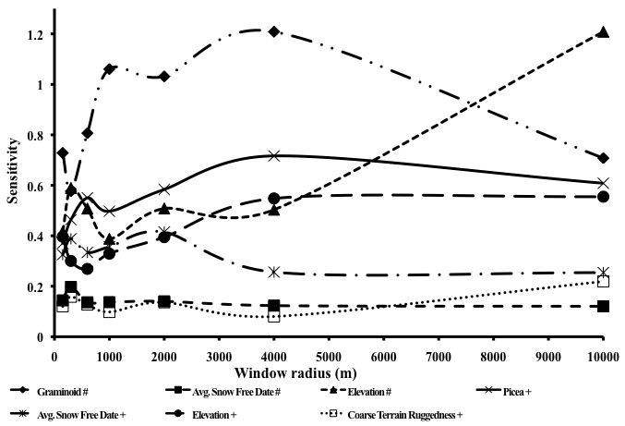
Figure 2: Covariate sensitivities vs. window radius (meters) from the best models for Denali Park (#) and Landsat (+) with the covariates held constant. Sensitivities indicate the covariates’s importance, measured as the change in the proportion of the range of the response (likelihood of caribou occurring) with a 1% change in the range of that covariate.

The Denali Park map showed the largest area of highest likelihood of caribou occurrence in the north-central area of the home range in the Toklat basin and several smaller areas of high likelihood of occurrence in west and west-central portions of the park (Fig. 4A). The likelihood of caribou occupancy was low in the northern portions of Denali N.P.P.

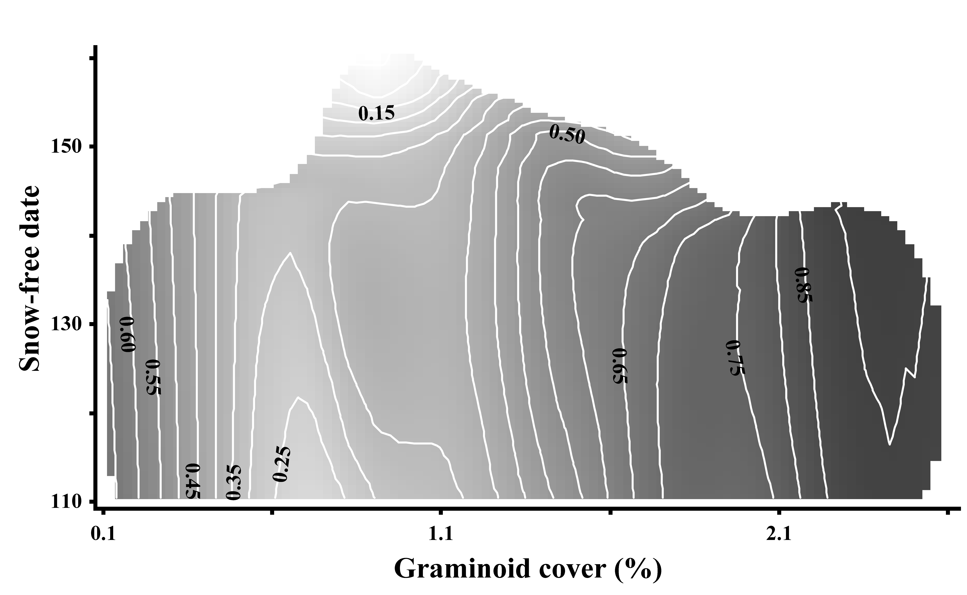
Figure 3: Contour surface of estimated likelihood of a caribou occurring in relation to percent graminoid cover and average snow-free date. The 3D surface was based on the tolerances selected for the three-predictor model using the 4000 m Denali Park dataset (Table 3). White background indicates areas where the model made no estimate. Darker areas indicate higher likelihood of a caribou occurring.

3.3 Landsat study area: Habitat selection with larger relocation extent and decreased covariate resolution
In the Landsat study area, Picea cover, average snow-free date, elevation and fine terrain ruggedness co-varied with the likelihood of caribou occurrence (4000 m window, cross-validated aveB = 1.14, p < 0.01). Based on sensitivity analysis, ranked predictor importance was mostly consistent across window sizes (e.g. Picea is always the single best predictor in Landsat across spatial scales) but absolute importance varied across spatial scales (i.e. predictor sensitivity varied across window sizes; Fig. 2). In the 4000 m Landsat dataset, Picea cover was the most important predictor (sensitivity = 0.59) followed by elevation (sensitivity = 0.49), average snow-free date (sensitivity = 0.32) and terrain ruggedness (sensitivity = 0.16). Elevation, average snow-free date and terrain ruggedness peaked in predictive ability at fine spatial scales (150-300 m) whereas Picea cover peaked in predictive ability at the 600 m scale. Snow-free date had another peak in predictive power at the 2000 m scale while Picea and elevation had a secondary peak at the 4000 m scale. At coarser scales (10,000 m), predictor importance was unchanged (Fig. 2). The Landsat map showed broadly similar patterns to the Denali Park map except that the likelihood of caribou occurrence was high all along the north slope of the Alaska range (Fig. 4B). The Landsat map also showed high likelihood of caribou occupancy just outside the southwest corner of Denali N.P.P.

Figure 4: Maps of the likelihood of caribou occupancy using a the three covariate model for the 4000 m Denali Park dataset (A), four covariate models for the 4000 m Landsat dataset (B) and Denali-Landsat difference (C). White background indicates areas where the model made no estimate or outside the winter homerange of the Denali Caribou Herd. Red colors indicate higher likelihood of a caribou occurring where blue areas are lower likelihood of caribou occurrence.

3.4 Spatiotemporal results
Habitat selection at the 4000 m scale varied strongly among years (A = 0.25, p < 0.001) for both the Denali Park and Landsat study areas despite the categorical variable for year not entering the regression models. ANOVAs of each habitat covariate blocked by season and grouped by year also showed that habitat selection varied significantly between years. For the Denali Park 4000 m dataset, variables that differed between years (p < 0.05) included usnic and usnlite lichens, graminoids, Picea, shrub, deciduous trees, slope, elevation and terrain ruggedness (both fine and coarse). Snow-free date and average snow depth also varied between years but had weaker statistical support (F_{2,20} = 1.17 for both, p = 0.07 and 0.08, respectively). Inter-annual differences in habitat variables were similar for the 4000 m Landsat dataset except usnlite lichens, deciduous tree and graminoids were not available and usnic lichens and average snow-free date was not statistically different.
Two-way cluster analyses showed three groups of years. Group A years included 1986-7, 1995, 1998, 2000-2 and 2005-6 (Appendix 1 Fig. A3). During these years caribou inhabited middle to low elevations with gentle terrain, variable snow, low lichen cover and few conifers but high graminoid and shrub cover (Fig. 5). Group B years included 1988-1994, 1999, 2003-4 and 2007 (Appendix 1 Fig. A3). During these years caribou inhabited middle to high elevation, rugged terrain with deep snow, moderate lichen and graminoid cover and some deciduous forests (Fig. 5). Group C years included only 1996-7 (Appendix 1 Fig. A3), where caribou frequented flat, low-elevation terrain with moderate snow depths and high lichen and Picea cover with few graminoids (Fig. 5). The only difference between 4000 m Denali Park and Landsat cluster analyses was 1993, where the clustering with the Denali Park dataset placed it in group A instead of B.

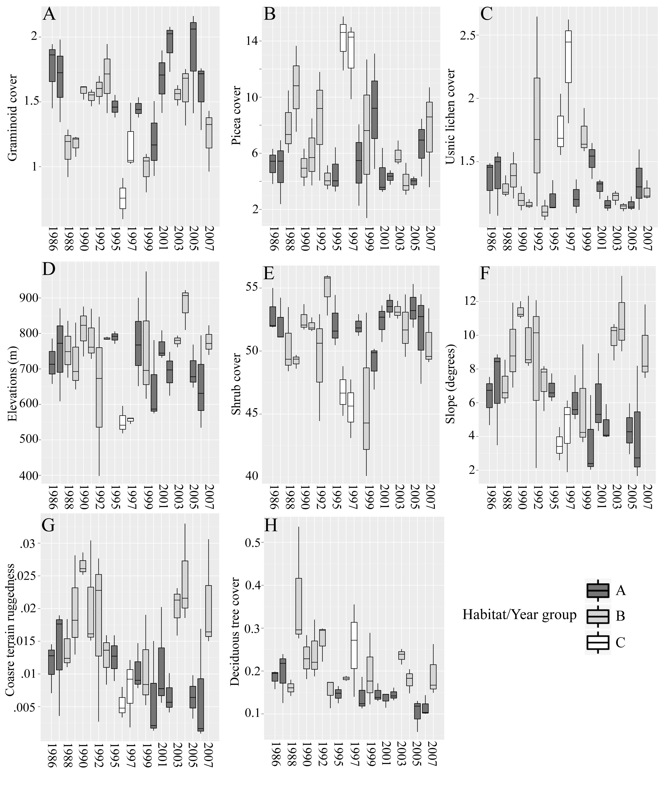
Figure 5: Boxplots of habitat variables averaged by bout/year for the 4000 m Denali dataset. Habitat variables shown are those that were significantly different between years as determined by ANOVA (see Table 1). Box shading indicates habitat year/groups, which are years with similar habitat as determined by two-cluster analysis (see Appendix 1 Fig. A2). A) Graminoids B) Picea C) Usnic lichen D) Elevation E) Shrub F) Elevation G) Coarse terrain ruggedness H) Deciduous tree. Y-axis units for A, B, C, E & H are percent cover. 1994 was excluded.
Selected habitat differed subtly in between seasons (early, mid and late winter) (A = 0.07, p < 0.001) using the 4000 m Denali Park dataset. Usnlite lichen and shrub cover, average snow-free date and average snow depth all differed between seasons (Fig. 6, p < 0.05). Average aspect off-180 (south facing-ness) differed marginally between seasons (Fig. 6, F_{2,20} = 2.9 and 3.0, respectively, both p = 0.06). Intra-annual habitat variation in the 4000 m Landsat dataset showed the same patterns except for measure of usnlite lichen cover, which was not available.

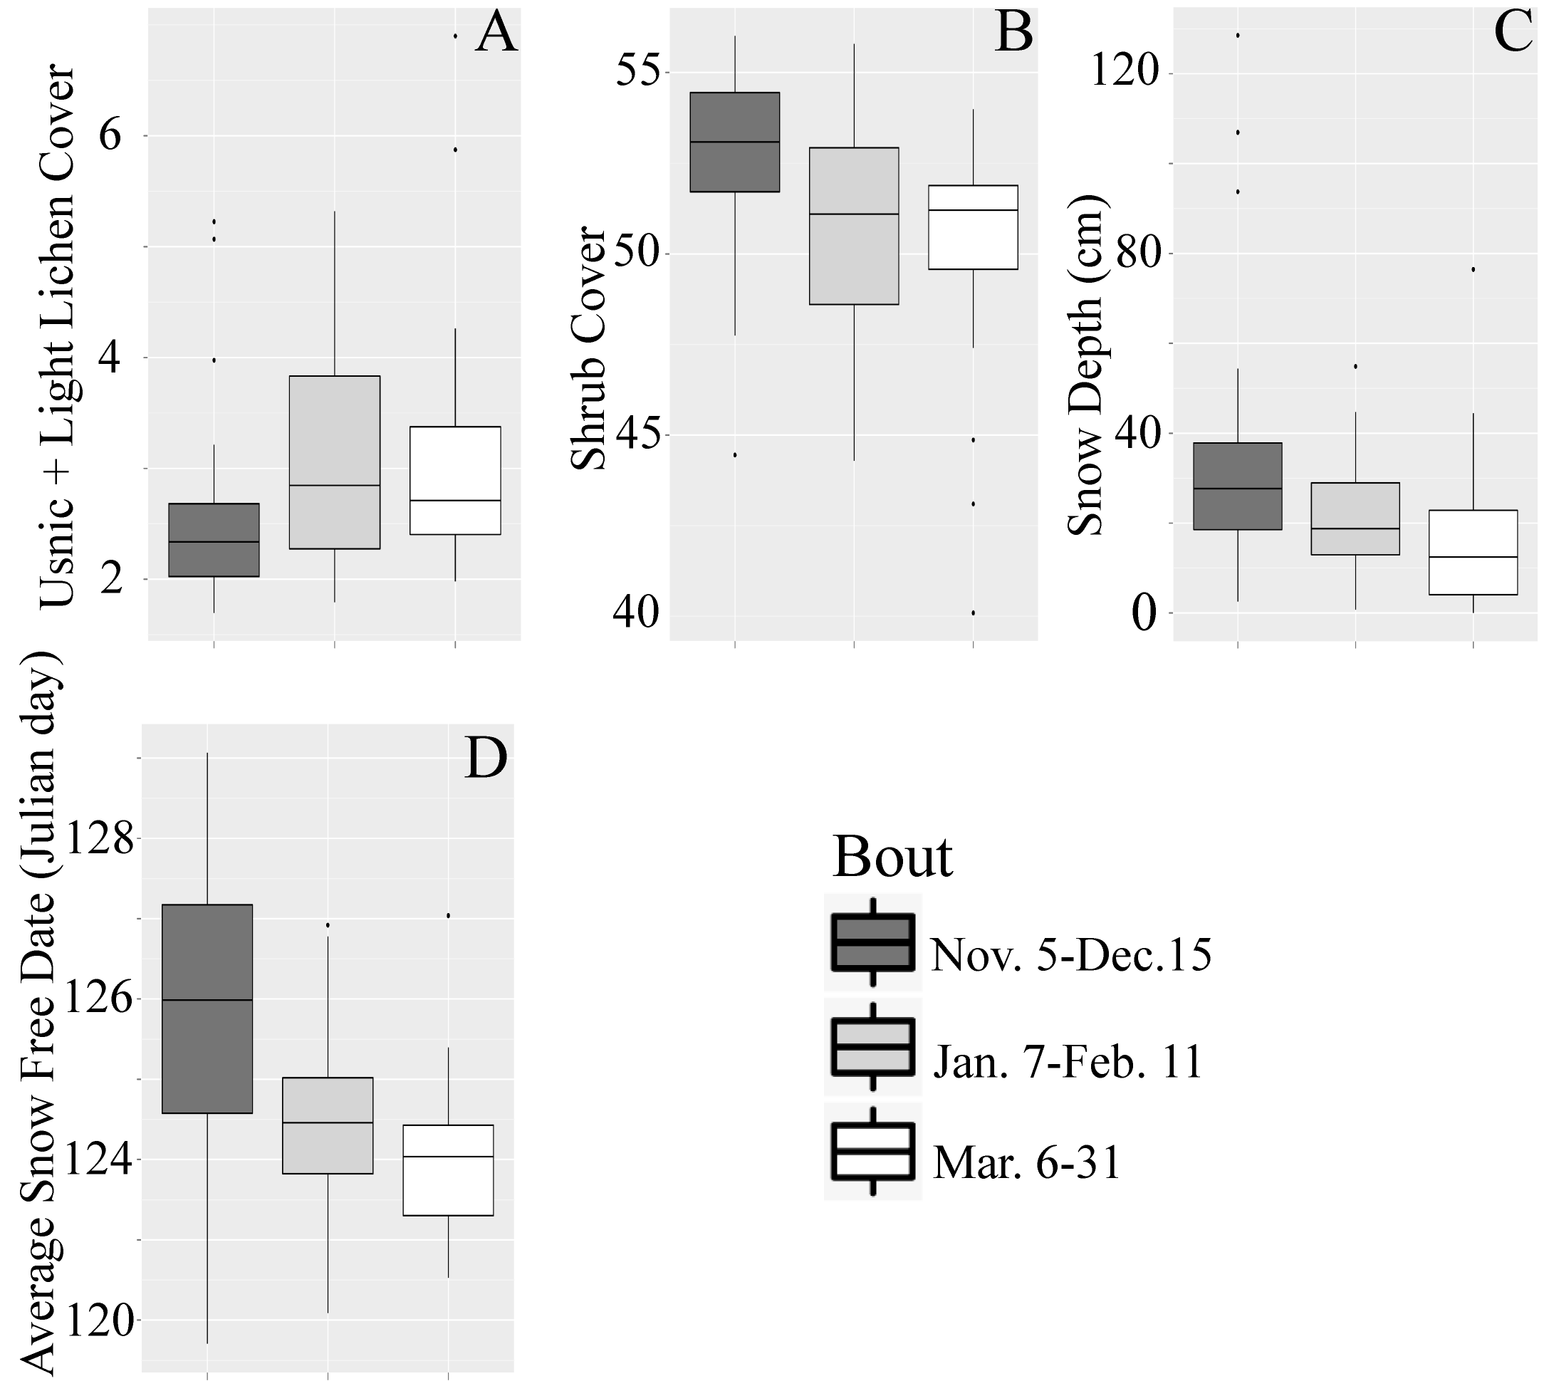
Figure 6: Boxplots of habitat variables averaged by bout for 4000 m Denali dataset. Habitat variables shown are those that were significantly different between bouts as determined by ANOVA (see Table 1). Box shading indicates bout. A) Usnlite lichens B) Shrub C) Snow depth D) Average snow free date.

4. Discussion
4.1 Relocation extent vs. covariate resolution
Researchers who determine their study area based solely on maximizing animal relocations, and thus potentially ignoring available higher resolution habitat covariates, would have chosen the Landsat study area. Based on this choice, these researchers would have concluded caribou avoid spruce forests in the winter. However, by using the Denali Park study area that had higher resolution explanatory covariates, we conclude that graminoids are the most important covariate of winter caribou habitat selection at decadal scales in this region. At every spatial scale, models from the Denali Park study area outperformed the Landsat models (Table 3). Similarly, within winters we found caribou selected higher lichen cover with each passing month when using the Denali dataset, which supports our broad hypothesis that animals would select habitat with more forage resources. Using the Landsat data would have again concluded that caribou select lower cover of spruce, which is far less informative than caribou selecting high lichen cover because lichens are the primary winter forage for caribou. The difference between the two analyses is based entirely on the relocation extent vs. covariate resolution trade-off. Had continuous graminoid cover been available for the entire Landsat study area, it is possible we would have arrived at the same conclusion (the importance of graminoids). Similarly, since lichen cover was not available for the Landsat study area, favoring more animal locations over covariates would have resulted in missing the pattern of caribou selecting higher lichen cover as the winter progressed. Both of these results clearly demonstrate the significant differences in ecological interpretation stemming from the covariate versus location trade-off. Interestingly, other studies (e.g., compare Barrier and Johnson 2012 and Avgar et al. 2013) have come to both of these somewhat conflicting ecological conclusions yet the covariate vs. location trade-off has never been suspected as a possible source of these differences. However, these studies occurred in somewhat different ecological contexts, so it is unclear how comparable the these studies may be to ours.
We believe, in this case, higher resolution habitat predictors (e.g., graminoid and lichen cover) available within the Denali Park study area outweighed the importance of ~ 500 additional caribou locations within the Landsat study area (Table 3) for modeling caribou habitat selection. The caribou relocations excluded from the Denali Park models were primarily in the Stampede corridor, which is the small rectangular area excluded from Denali Park in the northeastern corner frequently used by wintering caribou (Fig. 1). If these locations had been included in the Denali Park models, it likely would have further emphasized the predictors selected in the Denali Park model, especially graminoids, because the Stampede is very similar to main wintering area in the Toklat basin inside Denali N.P.P. (i.e., it is tussock tundra with high graminoid cover). Nonetheless, the relationship between caribou and graminoid cover was strong enough (see below) that the loss of information from excluding locations outside Denali Park did not dilute the relationship between caribou distribution and graminoids. However, the exclusion of a few locations far north of the Landsat scene did likely influence our ability to detect extreme migration events due to weather (Adams et al. 2005). Caribou strayed far out of the park in 1992, ostensibly because of unusually deep snow (Appendix 1 Fig. A1). We speculate that had those caribou relocations been included in our models, they likely would have made a better connection between climate variability and habitat selection.
Habitat selection models for the Denali dataset using only the lower resolution habitat covariates had very similar results in terms of model fit and rank order of covariate importance compared to the Landsat models (Appendix 2, Table A2), indicating little benefit in extending relocation extent. In contrast, the Landsat model had a much larger neighborhood size, indicating coarser spatiotemporal selection patterns (avoidance of spruce) were represented in the model rather than more nuanced variation seen in the Denali models with the higher resolution covariates. The Denali model using higher resolution covariates resolved habitat selection of higher graminoid cover across all years and the selection of higher usnlite lichen (white and yellow lichen) with each subsequent month per winter (see sections below). Researchers focusing on the relocation extent would have found caribou avoid spruce and overlooked the spatiotemporal variation in selection of known forage resources (graminoids and lichens).
4.2 Spatial variation in selected habitat variables
In the Denali Park study area, caribou strongly selected graminoids, especially at the 4000-8000 m scale (Fig. 2). Graminoid abundance peaks in open areas, such as tussock tundra, where snow can be blown away, making forage access, travel, and detecting predators easier for caribou. The strong positive association between caribou and graminoids generally affirms our hypothesis that they selected winter habitat based on availability of food resources (Fig. 3) because of the lower snow levels found in these areas and that graminoids are the second most important winter food (Boertje 1984, Heggberget et al. 1992, Joly et al. 2007). Graminoids were strongly correlated with caribou distribution because caribou tended to winter in the Toklat basin, also known as the eastern wintering area (Boertje 1985a), which is a slightly north facing, low-elevation area of tussock tundra underlain by permafrost with low lichen cover.
In both study areas, caribou avoided areas with a late snow-free date (Fig. 2), which is a proxy for deeper snow. Cratering for food and travel are both more difficult in deeper snow (Fancy and White 1985, Collins and Smith 1991), such as in low elevation forests where wind removes less snow and higher elevations where more snow accumulates. Average snow-free date was the second most important predictor of caribou occupancy in the Landsat study area, peaking in importance at 600 m and 4000 m scales. Conversely, snow-free date was much less important in Denali Park models, with a peak importance at the 300 m scale (Fig. 2). The open, flat terrain of the Toklat basin was conducive to snow removal, which may partially explain why graminoids captured much of the variation in the Denali Park models that was otherwise accounted for with snow-free date in the Landsat models where the graminoids layer was not available as a predictor.
It was somewhat surprising that average snow-free date derived from images over many years was a better predictor than monthly average maximum snow depth from the same year and month as the caribou location dates. The continuous climate record from Denali Park covering the time span of caribou locations (Appendix 1 Fig. A1) came from a single climate station at park headquarters on the eastern edge of the park and outside the high-use areas of the Denali Caribou Herd. Average maximum monthly snow depth at headquarters was less important as a predictor because climate and snow conditions in an area as large and topographically variable as Denali N.P.P. certainly varied drastically from the values recorded at headquarters. For example, headquarters is surrounded by large white spruce, which shelter it from winds that scour the open Stampede area. Alternatively, the Denali Caribou Herd likely responded to climatic patterns at finer spatiotemporal scales than the grain of either the climatic and caribou data. For example, much of the herd left their home range after an extreme snow event (Adams et al. 2005). Climatic events likely elicited caribou movements within the home range each year but were undetectable in our analysis using monthly locations of caribou and climate layers built on a solitary climate station.
The DCH generally selected habitat at coarse spatial scales (> 4000 m) but covariate importance varied across spatial scales, implying multiple scales of selection. In Denali N.P.P., caribou selected low-elevation areas with less snow at finer spatial scales (600 m) whereas graminoids were selected at coarser spatial scales (1000-4000 m). The importance of elevation at very fine spatial scales indicated caribou avoided narrow ridges and peaks with extreme elevation change (Fig. 2) where winter travel was likely treacherous. At coarse spatial scales (10,000 m), caribou selected low-elevation areas likely because of lower snow levels and higher abundance of food items, such as graminoids and lichens, relative to barren high country. After controlling for graminoids and average snow-free date, the importance of elevation rose dramatically at the coarsest spatial scales because the herd’s two main wintering areas (Boertje 1985a) were in middle-low elevations (Table 3, Fig. 2, Appendix 1, Fig. A4).
Differences between the Denali N.P.P. and Landsat likelihood of caribou occurrence maps visually demonstrate the impacts of the relocation extent vs. covariate resolution dilemma. In general, the Denali Park map recovered smaller patches of high likelihood of occurrence whereas the Landsat map showed broader areas of high likelihood of occurrence. For example, the Denali Park map recovered the known wintering grounds (both western and eastern) (Boertje 1985a), which are far less clearly defined in the Landsat map (Fig. 4B). The Denali map shows the wintering areas primarily in the peak of high likelihood of occurrence in the Toklat basin (Fig. 4A), the only large patch of tussock tundra in Denali N.P.P. The cause of the difference is the importance and narrow tolerance of graminoids in the Denali Park model (Table 3), which was not an available covariate for Landsat. Other differences between the two maps included several areas of high likelihood of occurrence in the Landsat map where the Denali Park models had low likelihood of occurrence, show in blue (Fig. 4C). Several of these are areas have moderate shrub cover, low Picea cover but lack graminoids. While Picea and graminoids tend to not co-occur, they aren't simply negative images of one another. Thus, the Picea habitat covariate does not account for all the variation that the graminoid covariate explains in the Denali Park model. While the Denali Park models recovered known wintering grounds, it did have one noteworthy artifact, caused by the fact that the graminoid layer was built using a categorical (e.g. polygon) predictor (Nelson et al. 2013). These appear as polygonal areas of estimated caribou occurrence shown as yellow areas in the west side of the park along the Alaska Range (Fig. 4A).

4.3 Temporal variation in selected habitat selection
Factors besides climate likely caused the inter-annual variation in habitat selection, since climate data did not come into the models nor did it differ significantly between years except weakly for average maximum monthly snow depths (F_{2,20} = 1.7, p = 0.08). Our ANOVA of climate data with season as the sample unit failed to detect the climatic differences between years likely because climatic variation can be quite high in short periods of time (day or weeks) in this region. There are many possible climatic lag effects or unmeasured factors that occurred outside the spatial or temporal grain of the location interval. Possible lag effects include summers where caribou failed to acquire enough body mass or fat content before winter or especially intense insect harassment or high parasite loads. Since caribou catabolize fat acquired in the summer to survive through the winter (Boertje 1984, Barboza and Parker 2008), it possible that a nutritional deficit from inadequate summer nutrition could have altered winter movements. Rain on snow events through the winter could have created hard snow layers that could have also caused the caribou to choose different habitat between years. Extremely hard snow layers can greatly increase energetic costs of traveling through snow (Fancy and White 1985, Collins and Smith 1991) but those snow conditions could have been ephemeral and changed between locations. Predation pressure could have also varied between years if wolves (Canis lupus) sought out caribou more actively in years with low moose (Alces alces) density. Wolves primarily hunt moose in the winter in Denali N.P.P. but variation in moose numbers could have caused a switch to heavier predation upon caribou resulting in shifts in caribou habitat selection. Detecting effects such as these at finer temporal grain would be aided by GPS collars, which are currently being deployed on the Denali Caribou Herd.
Caribou selected different habitat between seasons within a given winter (Fig. 6). As winter progressed, caribou congregated in areas with more lichens (Fig. 6A), less shrub cover (Fig. 6B), shallower snowpack (Fig. 6C) and earlier snow-free date (Fig. 6D). Shrubs and trees trap snow making more difficult conditions for movement and foraging. Snow accumulates over the course of the winter in Denali N.P.P. reaching maximum depths in late winter (i.e. April). Our interpretation is that caribou likely sought out higher lichen cover late in the winter because other food sources have been exhausted. Similarly, as snow depths increased over the winter, there was greater impetus to find areas of low snow where digging for lichens is less energetically taxing. In other words, changing habitat preferences (both intra- and inter-annually) may be a functional response to increasing snow depths. Energetic needs of pregnant caribou also increase in the spring (Boertje 1985b, Barboza and Parker 2008), which could have stimulated the collared animals (all females) to seek higher returns on foraging effort. Caribou have been shown avoid moose, which eat predominantly shrubs, to decrease predation risk (Cumming et al. 1996), which may explain why caribou avoided higher shrub cover. Seasonal variation in caribou habitat selection by herds in north-central Canada showed the slowest movement rates in the winter where estimated lichen volume was highest (Rickbeil et al. 2017). This is a similar pattern we observed, although measured not through movement rate as in that study but instead we compared lichen cover in buffered, used locations to random, buffered locations elsewhere in that winter’s home range. Both our approach and the movement rate approach (Rickbeil et al. 2017) indicated increase in use of higher lichen abundance (cover or volume) in the winter, supporting an overall trend of lichen being an important factor for winter habitat selection for the Denali and other herds.
5. Conclusions
Habitat selection studies depend on access to appropriate and precise habitat covariates as well as an adequate number of animal relocations across space and time. However, these covariates are not always available at the spatial extent of the animal locations. We have demonstrated that there may be trade-off between selecting less predictive covariates in place of more animal locations by comparing 22 years of caribou habitat selection using differing pools of animal locations and covariate datasets. We conclude that more predictive covariates were more ecologically informative than additional caribou locations. All covariates are not equally ecologically informative and each study must make a balanced decision when forced to choose between covariates and location numbers. In this case, the vegetation layers not available in the Landsat study area were key forage layers and omitting them resulted in very different conclusions as to the importance of winter forage in caribou habitat selection.
In terms of habitat selection by the DCH, graminoids, especially tussock tundra, played an important role in winter habitat for the Denali Caribou Herd. The Toklat basin, the primary wintering area with high graminoid cover, is the only feature of its kind in Denali N.P.P. By frequenting the Toklat basin, caribou in the Denali Caribou Herd selected for lower snow levels and better visibility to detect predators but with lower quality food instead of higher lichen cover but deeper snow to the west. However, as each winter progressed, caribou moved to areas with significantly higher lichen cover, indicating finer-spatial scale of higher-quality forage selection, below the temporal grain of the VHF radiotelemetry data. In the future, changes in snow cover (Derksen and Brown 2012) may release caribou from their travel limitation or access to lichen. However, others have indicated lichen cover may decrease due to increased wildfire frequency and extent, as well from shrub encroachment (Cornelissen et al. 2001, Joly et al. 2009, Joly et al. 2012, Gustine et al. 2014). Park managers should take into account the importance of the Toklat basin to wintering caribou when assessing any future management actions, such as building new infrastructure, while also understanding the risk of lichen cover decreases from wildfire and shrub encroachment elsewhere in the park in areas used by wintering caribou.

Acknowledgements
We dedicate this paper to the memory of Tom Meier, a long-time researcher of the wolves and other wildlife of Denali N.P.P., who participated in conversations during the conception and development of this study. Layne Adams (USGS) provided the caribou radio-telemetry data and useful discussions early on in the project. Dave Gustine (USGS) also provided useful and detailed comments of early drafts. Thanks to all the technicians and pilots who helped collect the caribou and vegetation data. We are grateful to Matt Macander (ABR, Inc.), who provided the map of average snow-free date and to Pam Sousanes (NPS) who provided the climate data from Denali N.P.P. HQ. Hawthorne Beyer provided useful advice in using his geospatial modeling environment tools. The National Park Service funded this research.

References
Adams, L. G., B. W. Dale, and G. H. Roffler. 2005. Extraordinary movements of the Denali caribou herd following the perfect storm. Rangifer 25:19–25.
Adams, L. G., and G. H. Roffler. 2010. Dynamics of the Denali caribou herd, Denali National Park, Alaska: Progress report. USGS Alaska Science Center, Anchorage, Alaska, USA.
Avgar, T., A. Mosser, G. S. Brown, and J. M. Fryxell. 2013. Environmental and individual drivers of animal movement patterns across a wide geographical gradient. Journal of Animal Ecology 82:96-106.
Barboza, P. S., and K. L. Parker. 2008. Allocating protein to reproduction in arctic reindeer and caribou. Physiological & Biochemical Zoology 81:835-855.
Barrier, T. A., and C. J. Johnson. 2012. The influence of fire history on selection of foraging sites by barren-ground caribou. Ecoscience 19:177-188.
Beyer, H. 2012. Geospatial Modeling Environment ver. 0.7. Spatial Ecology LLC.
Boertje, R. D. 1984. Seasonal diets of the Denali caribou herd, Alaska. Arctic 37:161-165.
Boertje, R. D. 1985a. Seasonal activity of the Denali caribou herd, Alaska. Rangifer 5:32-42.
Boertje, R. D. 1985b. An energy model for adult female caribou of the Denali herd, Alaska. Journal of Range Management 38:468-473.
Collins, W. B., and T. S. Smith. 1991. Effects of wind-hardened snow on foraging by reindeer (Rangifer tarandus). Arctic 44:217-222.
Comiso, J. C., and D. K. Hall. 2014. Climate trends in the Arctic as observed from space. WIREs Climate Change 5:389-409.
Cornelissen, J. H. C., T. V. Callaghan, J. M. Altalo, A. Michelsen, E. Graglia, A. E. Hartley, D. S. Hik, S. E. Hobbie, M. C., Press, C. H. Robinson, G. H. R. Henry, G. R. Shaver, G. K. Phoenix, D. Gwynn Jones, S. Jonasson, F. S. Chapin III, U. Molau, C. Neill, J. A. Lee, J. M. Melillo, B. Sveinbjörnsson, and R. Aerts. 2001. Global change and arctic ecosystems: is lichen decline a function of increases in vascular plant biomass? Journal of Ecology 89:984-994.
Cumming, H. G., D. B. Beange, and G. Lavoie. 1996. Habitat partitioning between woodland caribou and moose in Ontario: The potential role of shared predation risk. Rangifer 16:81-94.
Derksen, C., and R. Brown. 2012. Spring snow cover extent reductions in the 2008–2012 period exceeding climate model projections. Geophysical Research Letters 39:L19504.
Fancy, S. G., and R.G. White. 1985. Energy expenditures by caribou while cratering in snow. The Journal of Wildlife Management 49:987-993.
Fancy, S. G., and R. G. White. 1987. Energy expenditures for locomotion by barren-ground caribou. Canadian Journal of Zoology 65:122-128.
Garshelis, D. L. 2000. Delusions in habitat evaluation: Measuring use, selection, and importance. Pages 111–164 in L. Boitani, and T. K. Fuller, editors, Research techniques in animal ecology: controversies and consequences. Columbia University Press, New York, New York, USA.
Gustine, D. D., and K. L. Parker. 2008. Variation in the seasonal selection of resources by woodland caribou in northern British Columbia. Canadian Journal of Zoology 86:812-825.
Gustine, D. D., T. J. Brinkman, M. A. Lindgren, J. I. Schmidt, T. S. Rupp, and L. G. Adams. 2014. Climate-driven effects of fire on winter habitat for caribou in the Alaskan-Yukon Arctic. PLOS ONE 9:e100588.
Hall, D. K., G. A. Riggs, and V. V. Salomonson. 2001. Algorithm theoretical basis document (ATBD) for the MODIS snow and sea ice-mapping algorithms. Hydrological Sciences Branch NASA.
Hebblewhite, M. and D.T. Haydon. 2010. Distinguishing technology from biology: a critical review of the use of GPS telemetry data in ecology. Philosophical Transactions of the Royal Society of London B: Biological Sciences 365:2303-2312.
Heggberget, T. M., E. Gaare, and J. P. Ball. 1992. Reindeer (Rangifer tarandus) and climate change: importance of winter forage. Rangifer 22:13-31.
Hernandez, P. A., C. H. Graham, L. L. Master, and D. L. Albert. 2006. The effect of sample size and species characteristics on performance of different species distribution modeling methods. Ecography 29:773-785.
Holling, C. S. 1992. Cross-scale morphology, geometry, and dynamics of ecosystems. Ecological Monographs 62:447-502.
James, A. R. C., S. Boutin, D. M. Hebert, and A. B. Rippin. 2004. Spatial separation of caribou from moose and its relation to predation by wolves. The Journal of Wildlife Management 68:799-809.
Jandt, R., K. Joly, C. R. Meyers, and C. Racine. 2008. Slow recovery of lichen on burned caribou winter range in Alaska tundra: potential influences of climate warming and other disturbance factors. Arctic, Antarctic, and Alpine Research 40:89-95.
Johnson, C. J., K. L. Parker, and D. C. Heard. 2001. Foraging across a variable landscape: Behavioral decisions made by woodland caribou at multiple spatial scales. Oecologia 127:590-602.
Johnson, C. J., K. L. Parker, D. C. Heard, and M. P. Gillingham. 2002. A multiscale behavioral approach to understanding the movements of woodland caribou. Ecological Applications 12:1840–1860.
Joly, K. 2011. Modeling influences on winter distribution of caribou in northwestern Alaska through use of satellite telemetry. Rangifer Special Issue 19:75-85.
Joly, K., F. S. Chapin III, and D. R. Klein. 2010. Winter habitat selection by caribou in relation to lichen abundance, wildfires, grazing and landscape characteristics in northwest Alaska. Ecoscience 17:321-333.
Joly, K., M. J. Cole, and R. R. Jandt. 2007. Diets of overwintering caribou, Rangifer tarandus, track decadal changes in arctic tundra vegetation. Canadian Field-Naturalist 121:379-383.
Joly, K., P. A. Duffy, and T. S. Rupp. 2012. Simulating the effects of climate change on fire regimes in Arctic biomes: implications for caribou and moose habitat. Ecosphere 3:1-18.
Joly, K., R. R. Jandt, and D. R. Klein. 2009. Decrease of lichens in arctic ecosystems: The role of wildfire, caribou, reindeer, competition and climate in northwestern Alaska. Polar Research 28:433–442.
Joly, K., S. K. Wasser, and R. Booth. 2015. Non-invasive assessment of the interrelationships of diet, pregnancy rate, group composition, and physiological and nutritional stress of barren-ground caribou in late winter. PLOS ONE 10:e0127586.
Leblond, M., Frair, J., Fortin, D., Dussault, C., Ouellet, J.P. and R. Courtois. 2011. Assessing the influence of resource covariates at multiple spatial scales: an application to forest-dwelling caribou faced with intensive human activity. Landscape Ecology 26:1433-1446.
Lele, S. R., E. H. Merrill, J. Keim, and M. S. Boyce. 2013. Selection, use, choice, and occupancy: clarifying concepts in resource selection studies. Journal of Animal Ecology:1183–1191.
Mallory, F. F., and T. L. Hillis. 1996. Demographic characteristics of circumpolar caribou populations: Ecotypes, ecological constraints, releases, and population dynamics. Rangifer 18:49–60.
Masek, J. G., E. F. Vermote, N. E. Saleous, R. Wolfe, F. G. Hall, K. F. Huemmerich, Feng Gao, J. Kutler, and Teng-Kui Lim. 2006. A Landsat surface reflectance dataset for North America, 1990-2000. Geoscience and Remote Sensing Letters, IEEE 3:68–72.
Mayor, S. J., J. A. Schaefer, D. C. Schneider, and S. P. Mahoney 2007. Spectrum of selection: new approaches to detecting the scale-dependent response to habitat. Ecology 88:1634–1640
Mayor, S. J., J. A. Schaefer, D. C. Schneider, and S. P. Mahoney. 2009. The spatial structure of habitat selection: a caribou’s-eye-view. Acta Oecologica 35:253-260.
McCune, B., and M. J. Mefford. 2009. HyperNiche ver. 2.13. Non-parametric multiplicative habitat modeling. MjM Software Design, Gleneden Beach, OR, USA.
McCune, B., and M. J. Mefford. 2011. PC-ORD ver. 6.0. Multivariate analysis of ecological data. MjM Software Design, Gleneden Beach, Oregon, USA.
McGarigal, K., Wan, H.Y., Zeller, K.A., Timm, B.C. and S.A. Cushman. 2016. Multi-scale habitat selection modeling: a review and outlook. Landscape ecology 31:1161-1175.
Mielke, P. W., Jr., and K. J. Berry. 2001. Permutation Methods: A Distance Function Approach. Springer Science+Business Media, New York, New York, USA.
Mosnier, A., J. Ouellet, L. Sirois, and N. Fournier. 2003. Habitat selection and home range dynamics of the Gaspé caribou: a hierarchical analysis. Canadian Journal of Zoology 81:1174-1184.
Nagy, J. A., and W. Forsythe. 1995. Changes in the spatial distribution of Peary caribou and muskoxen on Banks Island 1982 to 1994: an assessment using a geographic information system. in 2nd Arctic Ungulate Conference, Fairbanks.
Nelson, P. R., C, Roland, M. J. Macander, and B, McCune. 2013. Detecting continuous lichen abundance for mapping winter caribou forage at landscape spatial scales. Remote Sensing of Environment 137:43-54.
Person, S. J. et al.1980. In vitro and nylon-bag digestibilities of reindeer and caribou forages. The Journal of Wildlife Management 44:613-622.
R Development Core Team. 2009. R: a language and environment for statistical computing. R Foundation for Statistical Computing, Vienna, Austria.
Rettie, W. J., and F. Messier. 2000. Hierarchical habitat selection by woodland caribou: its relationship to limiting factors. Ecography 23:466-478.
Rickbeil, G. J. M., T. Hermosilla, N. C. Coops, J. C. White, and M. A. Wulder. 2017. Estimating changes in lichen mat volume through time and related effects on barren ground caribou (Rangifer tarandus groenlandicus) movement. PLOS ONE 12:e0172669.
Roland, C.A. J. H. Schmidt, and E. F. Nicklen. 2013. Landscape-scale patterns in tree occupancy and abundance in subarctic Alaska. Ecological Monographs 83:19-48.
Rosenzweig, M. L. 1981. A theory of habitat selection. Ecology 62: 327-355.
Sappington, J., K. M. Longshore, and D. B. Thompson. 2007. Quantifying landscape ruggedness for animal habitat analysis: a case study using bighorn sheep in the Mojave desert. The Journal of Wildlife Management 71: 1419-1426.
Stockwell, D. R. and A. T. Peterson. 2002. Effects of sample size on accuracy of species distribution models. Ecological Modelling 148: 1-13.
Stone, R. S., E. G. Dutton, J. M. Harris, and D. Longenecker. 2002. Earlier spring snowmelt in northern Alaska as an indicator of climate change. Journal of Geophysical Research: Atmospheres 107:ACL 10-1–ACL 10-13.
Storeheier, P. V., S. D. Mathiesen, I. Schjelderup, and M. A. Olsen. 2002b. Utilization of nitrogen- and mineral-rich vascular forage plants by reindeer in winter. The Journal of Agricultural Science 139:151-160.
Storeheier, P. V., S. D. Mathiesen, N. J. C. Tyler, and M. A. Olsen. 2002a. Nutritive value of terricolous lichens for reindeer in winter. The Lichenologist 34:247-257.

