BA 302: Microsoft Dynamics NAV
ERP Exercise/Walkthrough

v 2.0

Michael Curry, Byron Marshall, VT Raja, René Reitsma, Kirk Wydner

Whether you enter the workforce as a sales manager, financial accountant or office admin, chances are that you will be working with some type of Enterprise Resource Planning (ERP) system. The purpose of this exercise/walkthrough is to familiarize you with a typical (although simplified) business process as it is commonly executed with the help of one of the leading ERP systems in the market today – Microsoft Dynamics NAV.

This exercise will walk you through the six steps of a typical sales process: 1) Creating a customer order; 2) Backordering an out-of-stock item; 3) Receiving the backordered item; 4) Shipping the customer the ordered items and invoicing the customer; 5) Receiving payment from the customer; 6) Making a payment to the vendor from whom we backordered.

The point of this exercise is that you should realize that in a real company this process would be executed by different people working in different departments. They all will interact with the ERP; i.e., they all retrieve information from the ERP and store new information in it, as the sales process progresses. In this exercise you take on the role of each of these people, giving you a sense of how the sales order is processed both by the company and by the ERP.

Note: Throughout this exercise you must occasionally remember several numbers to refer back to in later sections. Please have paper and pen ready to write these numbers down or have a place on your computer open to store these numbers.

Another note: You do not have to complete the entire exercise in a single sitting. You can come back to it at a later time and continue where you left off.

Final note: The system keeps track of the progress you make and your BA302 instructor can ask the system for a report on your progress. To receive ‘pass’ credit for this exercise, you must complete it.

Table of Contents

Section 1 – Signing In 3
Section 2 – Creating a Sales Order (Sales Dept.) 4
Task 2 – Completing the Sales Order 8
Section 3 – Backordering Items (Purchasing Dept.) 10
Section 4 – Receiving the PO Items (Receiving or Warehousing Dept.) 13
Section 5 – Ship to and Invoice the Customer (Sales & Shipping Dept.) 14
Section 6 – Receive Payment from the Customer (Accounting Dept.) 16
Section 7 – Paying the Vendor (Accounting Dept.) 20
Task 2 – Make payment to the vendor 20
Task 3 – Verifying the vendor payment 23

Section 1 – Signing In
- Open a web browser, preferably Google Chrome, and point it to
http://dynamics.bus.oregonstate.edu
- If you are logged into a machine with your ONID login, you should be signed in automatically. In case you are presented with a login window, your user name will be “ONID\” followed by your ONID login; i.e., ONID\your_ONID_login.
- Once signed in (this can take a few seconds), you will be presented with the following screen:
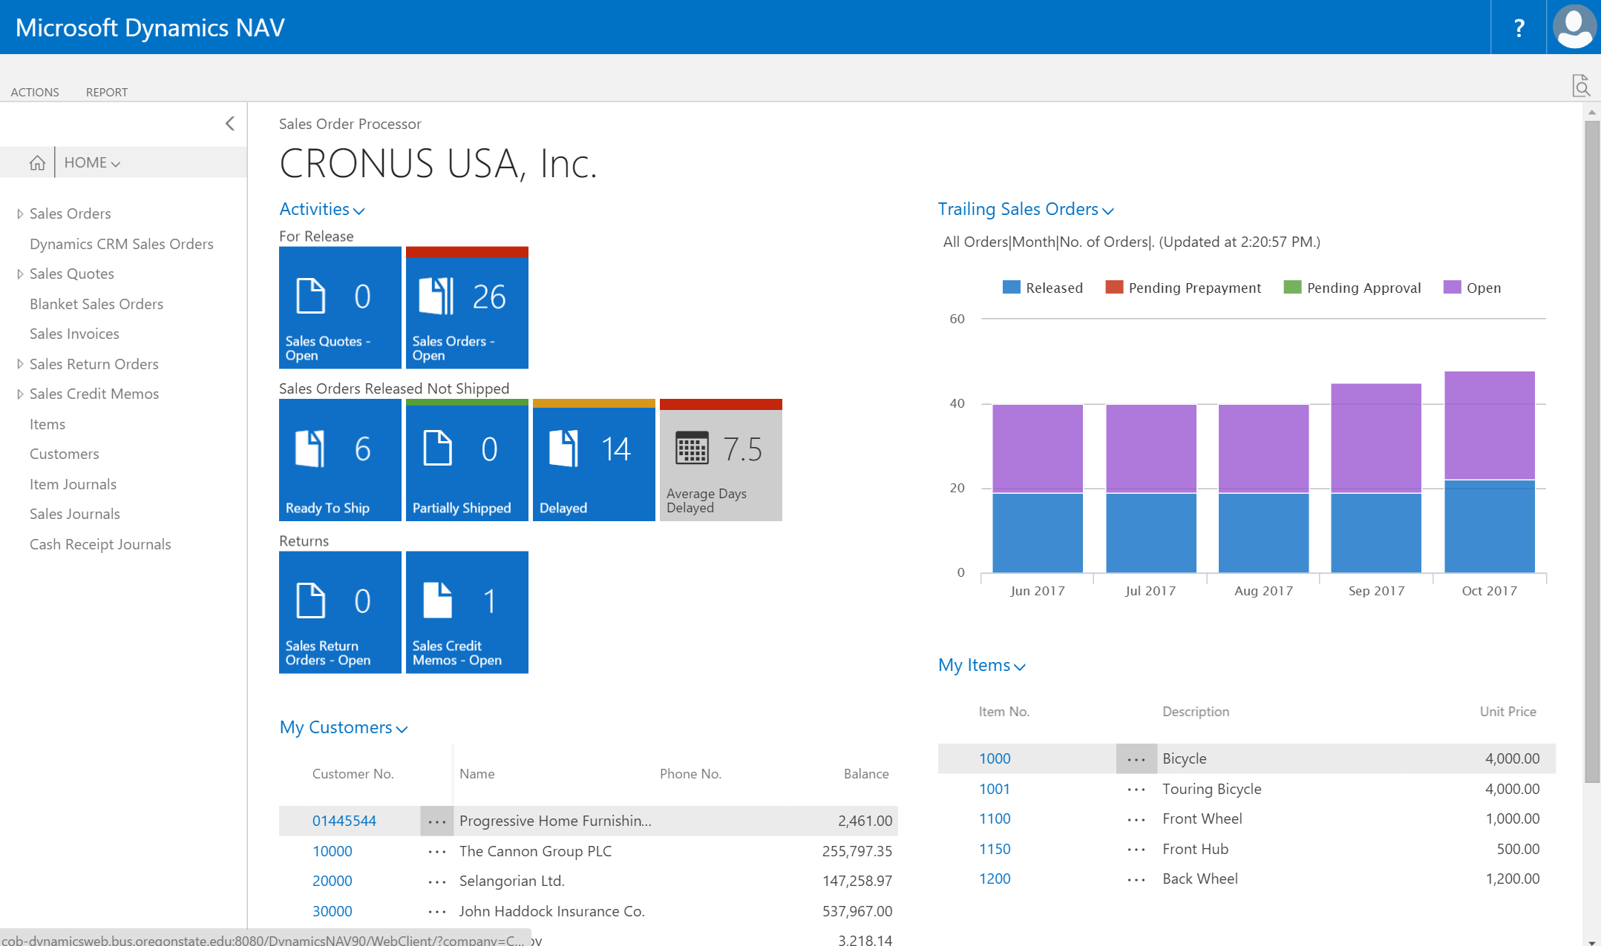

This is your HOME screen, also referred to as the ‘dashboard.’ The HOME screen provides you with statistics and figures that are relevant to your job, such as Open Sales Orders. The HOME screen also has links to frequently accessed customers and items. On the left-hand side of the HOME screen are links to the applications that are frequently used as part of your job. There are additional applications that we will be using during this exercise which are not found on the left-hand menu.

Section 2 – Creating a Sales Order (Sales Dept.)
The first task in this exercise is the creation of a sales order. This occurs when a customer places an order for an item and you must initiate the order. For that to take place, the system must know about the customer and about the item(s) being ordered. We start with the situation of dealing with a new customer; i.e., a customer not yet registered in the ERP.
- Click on the Sales Orders heading in the navigation column on the left-hand side of the screen. You should see a screen like the one below. This screen contains a list of all the Sales Orders which are currently open.
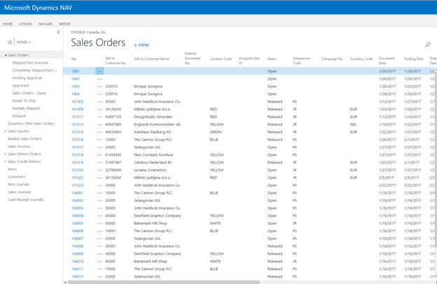

- We start the new order by clicking the +new link next to the Sales Orders heading. You will see a screen like the one below:
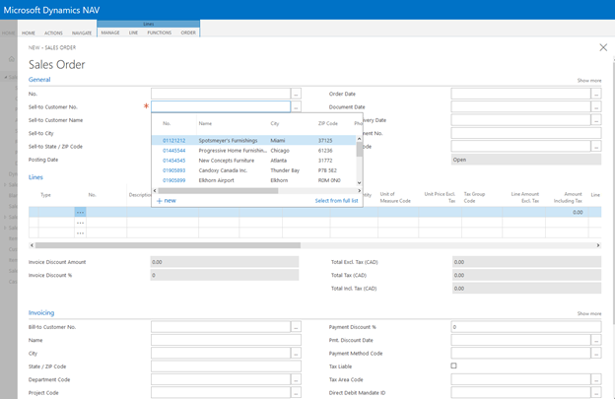
- To set the Sales Order number click on the ‘...’ button next to the first text box labeled No.
On the No. Series List that comes up, click on the S-ORD-1 option. This automatically populates an order number for this order that fits a designated number convention. (Note that the date specified for this order is a date in the future, not today’s date.)
NOTE: Write this order number down so that you can return to it in case the system times out.

Task 1 - Creating a new customer
- Since this order is coming from a new customer, we must first create that new customer. We will use you (your ONID login) as the new customer.
Click the ‘...’ button next to the second text box labeled Sell-to Customer No. Then click on the +new link in the bottom-left corner of the window that pops up. You will see the window below.
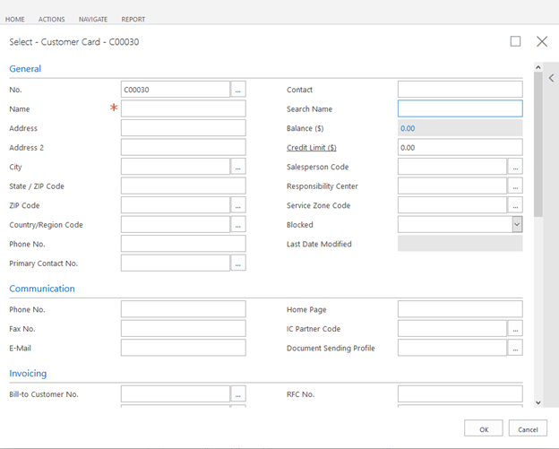
- On the Select - Customer Card window that comes up, click on the ‘...’ button next to the first text box labeled No.
- On the window that comes up, click on the CUST option. Just as with the Sales Order Number, this automatically populates a Customer Number that fits a designated number convention.
NOTE: Write this Customer Number down. You will use it again later.
- Enter the following information in the corresponding text fields:
  - Name: your_ONID_login (!!!PLEASE!!!! We need your ONID login here; not your student_OSU ID number; not your whole @oregonstate.edu email address. Make sure that you type your ONID login correctly, as it represents the new customer we are creating and we will need it again later)
  - State / ZIP Code: OR
  - Country/Region Code: US
- Click on the blue Invoicing section and it will expand. Enter a choice for the three Posting Groups that are marked with a red asterisk (*). For each, click on the ‘...’ button to the right of its corresponding text field.
  - Gen. Bus. Posting Group: select NATIONAL
  - Tax Bus. Posting Group: select NATIONAL
  - Customer Posting Group: select DOMESTIC
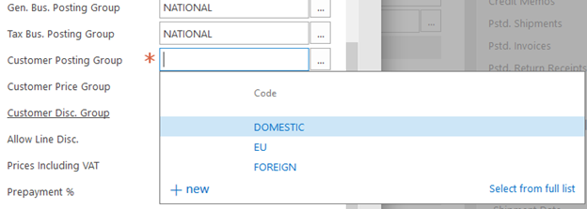
NOTE: National and Domestic are just two different terms for designating that this customer is located in the United States.
- Click on the Payments heading to expand it then click on the ‘...’ button next to Payments Terms Code and select the option for 14 DAYS
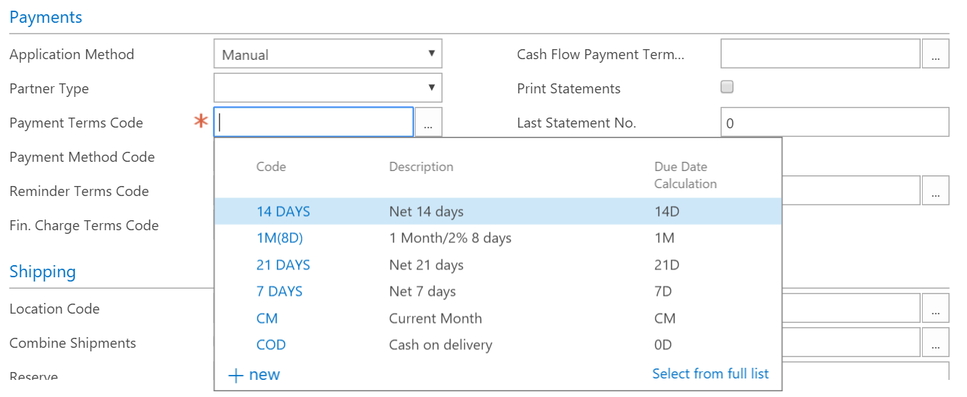
- Click the OK button in the bottom-right corner of the Customer Card.
The Sell-to Customer Name and Sell-to State fields should now be automatically populated as well as the Posting Date, Order Date and Document Date. They will be a date in the future, not today’s date.
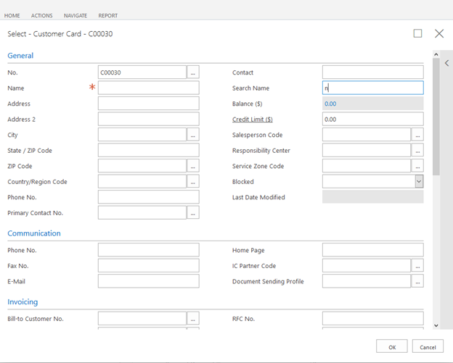

Task 2 – Completing the Sales Order
Now that we have created the new customer, we are ready to complete the sales order.
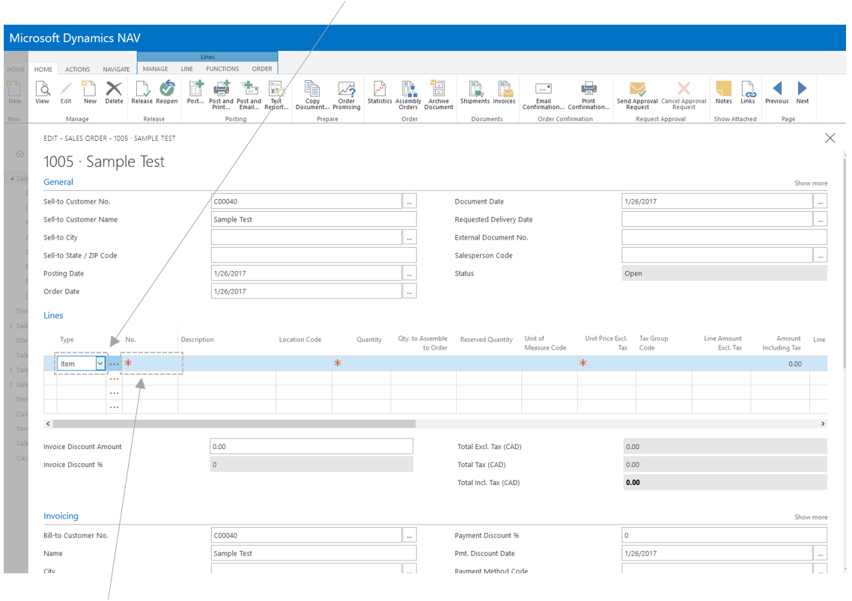
- Under the Lines section, click on the top cell in the Type column and select Item.
- In the top cell in the No. column, type your ONID login and you should see an item named ‘ITM-your_ONID_login’. Click on that item to add it to your order (NOTE: although under normal circumstances, different users of the ERP all see the same set of common items to sell, our exercise requires that all students participating in this exercise see a unique pool of company resources. Hence, we have named items to sell using your (unique) ONID login).
NOTE: If you do not see an item with your ONID login listed, contact your instructor.
- We will try to order 10 units, only to find out that we are short on stock. We will nevertheless still register the sale.
Enter a quantity of 10 and then press the Enter key. A notification pops up informing you that there is not enough stock in your inventory to cover this line in the Sales Order. Click the Yes button to indicate that you still want to register this sale.
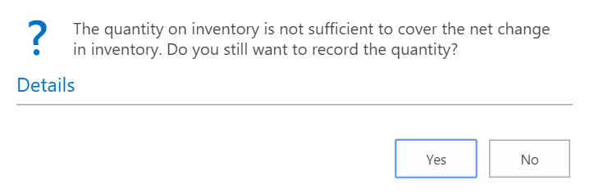
- You will see the Total Incl. Tax (USD) field update after entering the quantity.
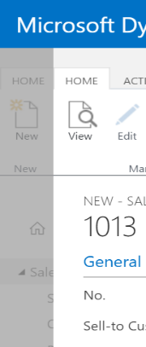
- Exit out of the Sales Order screen by clicking anywhere in the greyed-out space on the left-hand side of the screen, as in the highlighted area of the image to the right. The Sales Order will be automatically saved when you do this.
- You should now see your Sales Order in the list of orders. If you do not, refresh/reload your browser window ().

Section 3 – Backordering Items (Purchasing Dept.)
Now that we have created the Sales Order for our customer, we need to create a Purchase Order (or PO) with a vendor who supplies us with the out-of-stock items that the customer ordered so that we can fulfill the customer’s order.
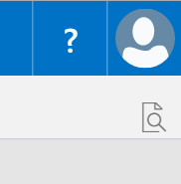
- Click on the search icon (the magnifying glass) in the upper-right corner of the screen.
- Type in ‘purchase order’ and select the top result.
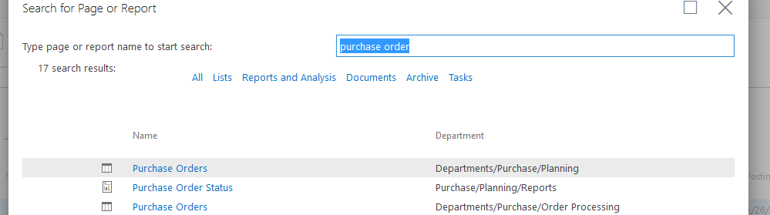

- We will create a new purchase order.
Click on the +new link at the top to create a new PO.
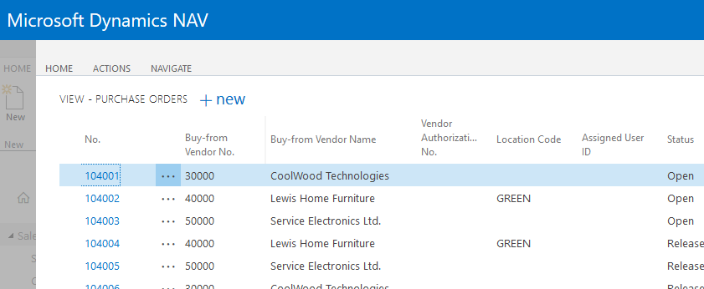
- Next, we must specify the vendor from whom we will order.
In the Buy-from Vendor No. field, type the vendor’s ID code: 50000. You should see the company name Service Electronics Ltd.
- Click on the blue 50000 link next to its name to add it to the Purchase Order.
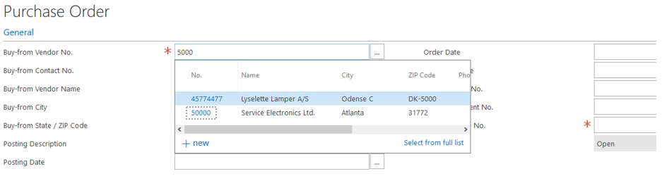
- Next, we must create a unique number for the vendor to use when invoicing us.
In the Vendor Invoice No. field, assign an invoice number for the order using the following format: INV-your_ONID_login-YYYYMMDD. For example, if today’s date is May 4th, 2021, you would enter INV-your_ONID_login-20210504.
NOTE: Write this invoice number down. You will use it again later to pay the vendor.
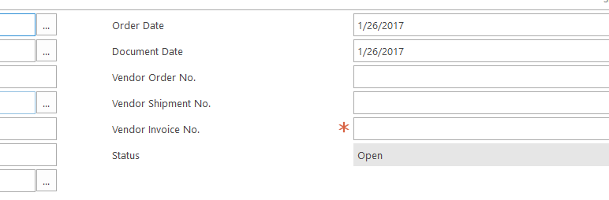
- Once we have created a Vendor Invoice Number, we can enter the details for the item we want to restock. Do the following for the top row in the Lines section:
  - Under Type, select Item.
  - Under No., enter the item number: ITM-your_ONID_login. This is telling the vendor which item we are ordering.
  - Under Quantity, enter the same number of items you listed on the Sales Order (10).
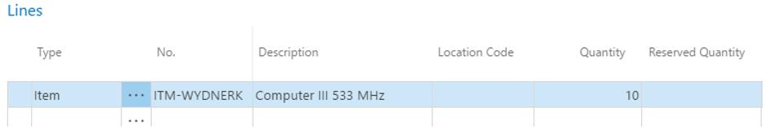
- Verify all the information you entered (vendor, item, quantity). It should look like the image above.
- To finalize the purchase order, click on the ACTIONS tab and then click the Release button. You will see the Status field change from Open to Released.
At this point, if this were a real company, you would email the Purchase Order to the vendor (alternatively, the ERP may do this automatically). For this exercise, however, we assume that these actions have been taken by the time we reach the next step.
NOTE: Keep this Purchase Order window pane open. We will use it in the next section.
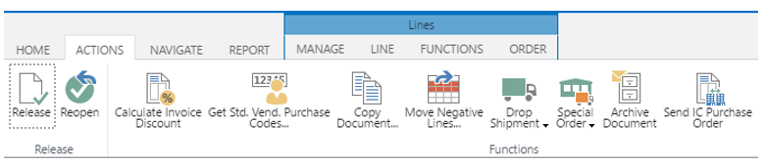
NOTE: Although what we just did ―backordering the exact number of items which we were short― is not unusual, it it likely to be rather inefficient and it also does not make customers happy. A more realistic scenario would be that the ERP will notify Purchasing when stocks are running low so that we can restock before running out. Another way of accomplishing this is to let the vendor monitor our stocks through our ERP and initiate restocking when needed. This last method is used by Walmart. What Walmart does in addition is that it does not take actual ownership of the items ―and hence does not pay for them!― until they are sold to the customer, making Walmart essentially into a very large consignment store.

Section 4 – Receiving the PO Items (Receiving or Warehousing Dept.)
Now imagine that you are working as a warehouse (aka ‘receiving’) associate and that the backordered items have arrived at the warehouse. To update this information in the ERP you would perform the following steps:
- Assuming that you still have the Purchase Order on your screen, click on the HOME tab at the top of the window and then click on the Post button, highlighted in the image below.
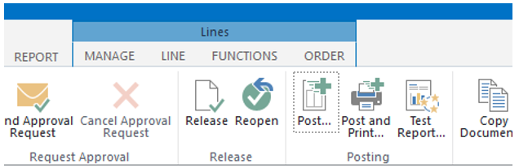
- Select ‘Receive and Invoice’ then click OK. Your PO has now been posted (registered) to the ERP.
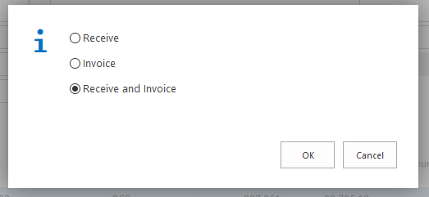
Exit out of the Purchase Order by clicking in the greyish area on the left-hand side of the screen. This will take you back to the Sales Orders list.

Section 5 – Ship to and Invoice the Customer (Sales & Shipping Dept.)
Now that we have received the backordered items, we can ship them and invoice the customer.

Task 1 - Verify that the items are in stock
- Find the order number you wrote down earlier. You will see it in the No. column next to your ONID login in the Sell-to Customer Name column, as in the image below. Once you have found your order number, click on it.
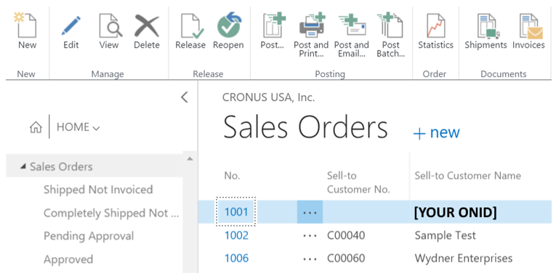
- Click on the HOME tab and then click on the Order Promising button in the Prepare section at the top of the screen.
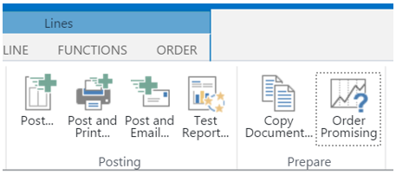
  - Scroll to the right and verify that the Unavailable Quantity value is now 0.
  - Nice! We have the backordered items in stock. We can now ship to the customer.

Task 2 – Complete the sales order
Now that we have verified that the items are available, we can complete the Sales Order. We will ship the items and invoice our customer.
- Return to your Sales Order if you clicked out of it.
- We will finalize the Sales Order and release the items for shipping.
Click on the ACTIONS tab and then click on the Release button. This changes the Status field to RELEASED. This.
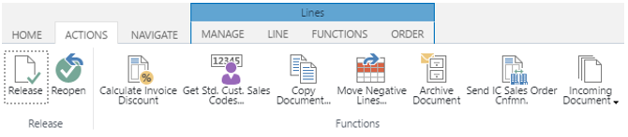

Task 3 – Invoicing the Customer
Although companies may choose to separate shipping and invoicing, in this exercise we will ship the items to the customer and send an invoice at the same time.
- Assuming that you have not exited out of the Sales Order, click on the HOME tab and then click on Post… in the Posting section. (Note: if this were a real customer, we might click on Post and Email… instead. This action would email the invoice to the customer using the email address on file in the system).
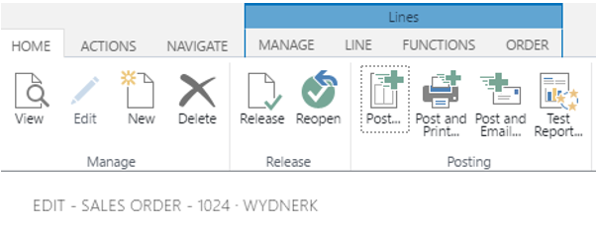
- When the information window pops up, click on Ship and Invoice.
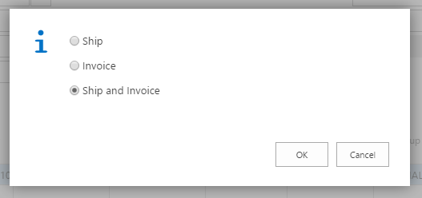

Section 6 – Receive Payment from the Customer (Accounting Dept.)
Congratulations on making it so far! By completing the steps above, you now have some insight into the work that goes on in the back office when a customer places an order with a company and how an ERP facilitates and coordinates this process. Now come the fun part ―getting paid― and the not-so-fun part ―paying your vendor. In this section, we will receive payment from the customer.

Task 1 – Find the sales invoice number and total
- Click on the Search button in the top-right corner of the window.
- Search for ‘posted sales invoices’ in the search bar and click on the top entry returned.
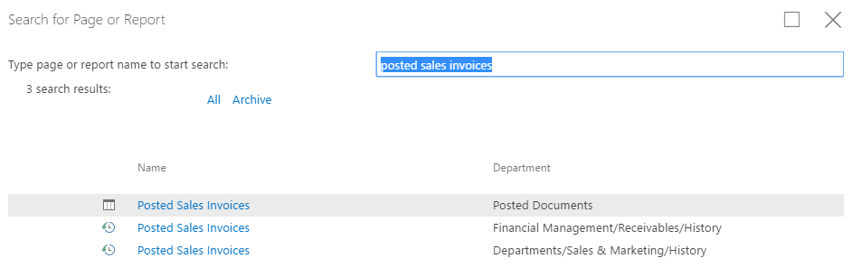
- Scroll down to the bottom of the list and look for your ONID login.
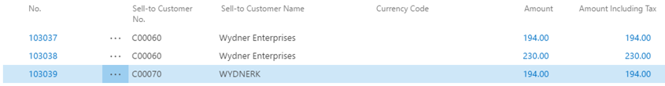
NOTE: Write down the sales invoice number (from the No. column) and the invoice total (from the Amount Including Tax column). We will use these numbers in the next step where we document cash received from the customer.

Task 2 – Create a receipt for the cash you received from the customer
Now that we have the sales invoice number and invoice total, we can create a receipt. For this example, we will assume that the customer has paid us with cash in full.
- Click in the greyed out area on the left-hand side of the screen to exit out of Posted Sales Invoices screen.
- Let’s register the receipt of cash:
Find the Cash Receipt Journals link on the left-hand side of the screen and then find your ONID in the list and click on it. Here we will register a receipt of cash. If we wanted to register a bank payment, we would click on BANK instead. (NOTE: The GIRO entry refers to bank-account-to-bank-account transfers made by the payer. This is mostly a European payment system)

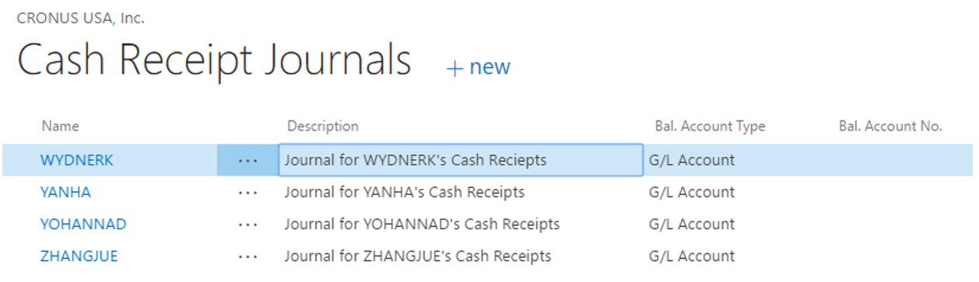
- Click on the top cell in the Posting Date column. A system-generated date in the future will be automatically populated for you.
- If the top cell in the Document Type column does not say Payment, click on it and select Payment. This indicates that we are documenting a payment that we received.
- If the top cell in the Document No. column already has a value (like ‘G02009’), then just leave it as that. If it is empty, type: ‘R-your_ONID_login-YYYYMMDD’. For example, if today’s date is May 4th 2021, you would enter: ‘R-your_ONID_login-20210504’.
- In the Account Type column, select Customer.
- Remember that way back in Section 2 you wrote down the Customer Number for the new customer you created? We’re finally going to use it! In the Account No. column, type in the Customer Number and then press the Tab key on your keyboard. The number should start with a ‘C’ followed by five digits; e.g., ‘C00030’. You should also see your ONID login appear in the Description column as in the image below.
- Under the Bal. Account Type, set it to G/L Account if it was not already set. ‘G/L’ stands for ‘general ledger,’ meaning that this is a general transaction.
- To indicate that this is a cash transaction, click on the empty cell in the Bal. Account No. column and then click on the ‘…’ button. Click on the blue link next to the option for Cash.
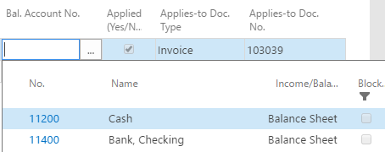
- To indicate that this cash payment was connected to an invoice, click on the empty cell in the Applies-to Doc. Type column and select Invoice.
- Click on the empty cell in the Applies-to Doc. No. column and then click on the ‘…’ button to bring up a new window showing the invoices for the customer.
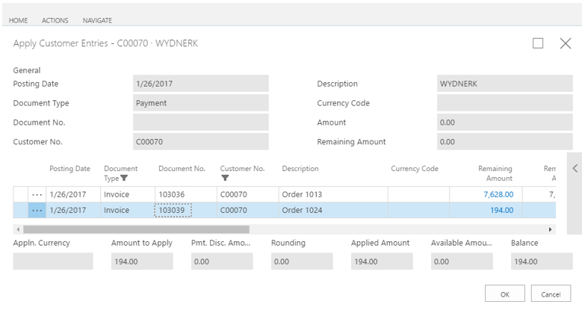
- Find the Sales Invoice Number you wrote down earlier (under Document No.). You should see the invoice listed on this screen. Verify that the figure in the Remaining Amount column matches the Invoice Total you wrote down earlier.
- Now, click once on the number in the Document No. column that corresponds to the Sales Invoice Number you wrote down earlier. You should see the Amount to Apply, Applied Amount, and Balance fields all update to match the Invoice Total.
- Click the OK button.
- Finally, we will post this cash receipts to the system.
Click on the first of the cells in the line you created, as in the image below, and then click on the HOME tab. Find and click on the Post button in the Posting section.
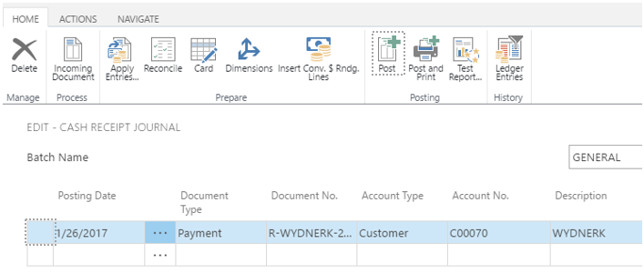
You should see the following message. Click on Yes.
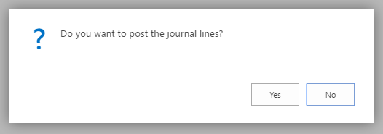
If you entered everything correctly, you should see this message.
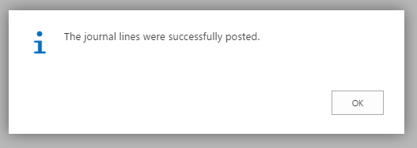

Section 7 – Paying the Vendor (Accounting Dept.)

Task 1 – Checking vendor information
- Click on the greyed-out area on the left-hand side of the screen to exit out of the Cash Receipts Journal.
- Click on the Search button in the top-right corner of the screen and search for ‘Vendors’. Click on the top option.
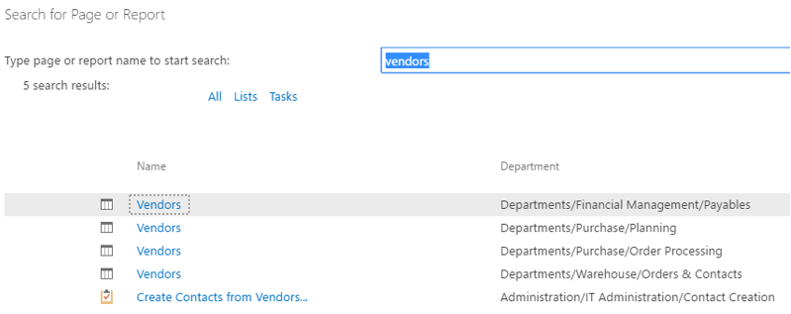
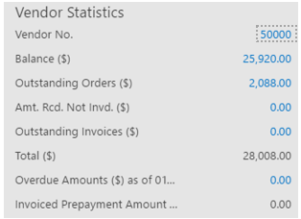
- Scroll down until you find the vendor named Service Electronics Ltd. Click on the vendor’s name (not its number!!!) and you will see the Vendor Statistics window on the right-hand side of the screen update.
NOTE: Write down the values for the Vendor No. and Total ($). The latter indicates our total outstanding debt to this vendor.

Task 2 – Make payment to the vendor
- Click on the greyed-out area on the left-hand side of the screen to exit out of the Vendors screen.
- Click on the Search button and type in Payment Journals. Click on the THIRD(!!) option, as shown in the image below.
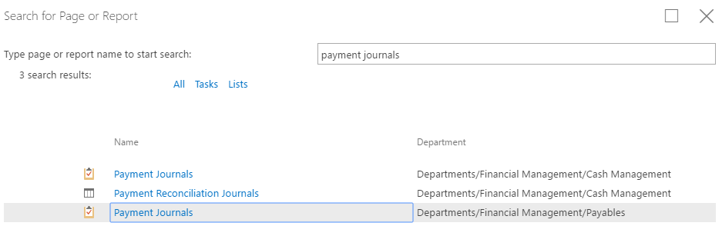
- Find the journal that contains your ONID login and then click on it.
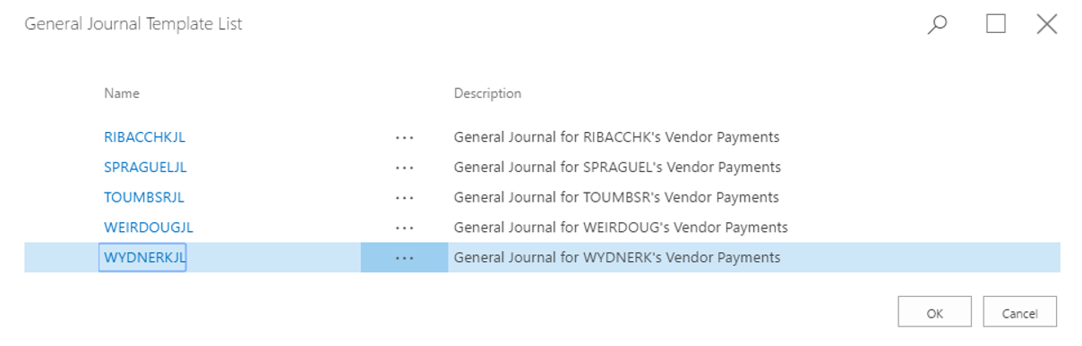
- To indicate that we will make a payment, click on the top cell in the Document Type column and
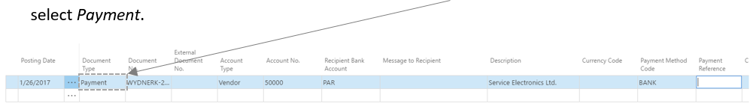
- Under the Document No. column, enter: ‘your_ONID_login-YYYYMMDD’. For example: ‘your_ONID_login-20210504’.
- Under the Account Type column, select Vendor. This indicates that this payment is going to a vendor.
- Under Account No., enter the vendor number (50000).
- Under Recipient Bank Account, select PAR. This is a fictitious bank created by the system named Park House Banking Group that our fictitious vendor uses.
- Under Payment Method Code, select BANK. This indicates that this payment will come from our company’s bank account.
- Scroll over to the right using the scrollbar at the bottom of the window to reveal additional columns.
- To indicates that we’re paying from a bank account, under the Bal. Account Type column, select Bank Account.
- To select the bank account, under the Bal. Account No. column, select WWB-Operations.
- To indicate that this payment is associated with a vendor invoice, under the Applies-to Doc. Type column, select Invoice.
- Click on the top cell under the Applies-to Doc. No. column and then click on the ‘…’ button. This will bring up a list of the invoices our company has with this vendor.

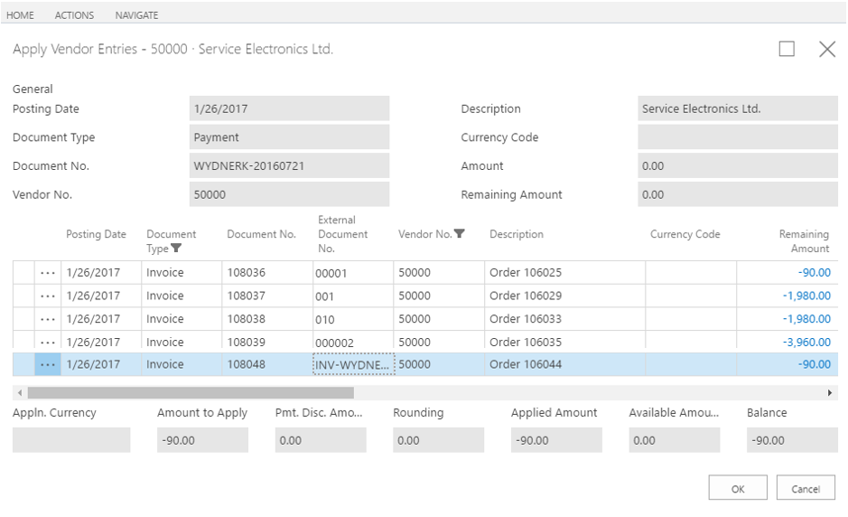
- Go back through your notes and find the vendor invoice number you created in Section 3. It should look like this: INV-your_ONID_login -YYYYMMDD. Once you find your invoice number, locate it on this screen under the External Document No. column. Click on the invoice number and you should see the following fields update at the bottom of the screen: Amount to Apply, Applied Amount, and Available Amount.
- Click on the OK button and you’ll return to the Payment Journal screen.
- Finally, we’ll post the payment to the system:
Click on the HOME tab and then click on the Post button in the Posting section.
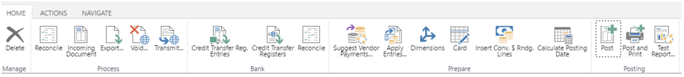
You will see the following notification:
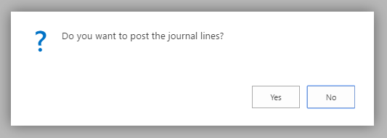
Click on Yes. You should now see the notification below:
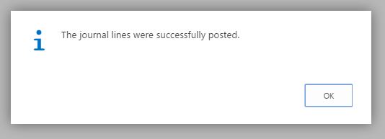

Task 3 – Verifying the vendor payment
- Click on the Search button and type in Vendors. Click on the top entry.
- Scroll down and find the vendor named Service Electronics Ltd.
Click on the vendor name and the values in the Vendor Statistics pane should update. Compare the new value for Total ($) to what you previously wrote down. You should see that they have both diminished. The difference between their previous and current value will be determined by your payment and orders placed and payments made by other BA302 students also working on this exercise.
- Now, click on the blue number next to the vendor name (should be 50000).
- Click on the Navigate tab and then click on the Ledger Entries button in the History section.
- Look for an entry that has Payment in the Document Type column and has the payment number you created previously in the Document No. column. The payment number should be in the format: your_ONID_login-YYYYMMDD
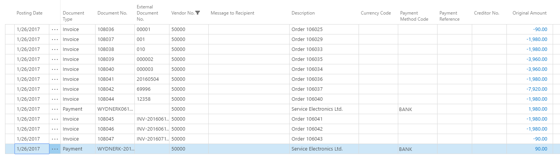
- If you see that entry, you have verified that the payment was made and you are done.

Congratulations! You completed the exercise. Now you have seen an example of how a sales order makes its way through the various functions of a company and how an ERP integrates these functions from an information flow point of view.
FINAL NOTE: You may have realized that we have skipped a few steps in this process. For instance, we never actually received and stored or shipped items in and from our warehouse. In reality, these steps would have to be carried out and their associated information; e.g., which warehouse holds which items, would be stored in the ERP. Similarly, in this exercise we only modeled a (simple) sales process. If we would be manufacturing the items we sold, we would have a whole manufacturing side to this, involving materials ordering, storage, production line setup, etc. We hope that you see how things will get complex quickly and how ERP-like systems help coordinating and streamlining this complex information landscape.

Mayer-Schönberger, V., Cukier, K. (2013) Big Data. John Murray Publishers, UK.

