Collaborating for Success: A Cross-Departmental Digitization Project

Sue Kunda

Oregon State University Libraries

Abstract
In 2007 Oregon State University Libraries acquired the personal collection of Gerald “Jerry” Williams, a native Oregonian and former national historian for the U.S. Forest Service. The collection contains personal papers, historic images, serials, monographs, oral histories, maps, moving images, political posters, ephemera, and artifacts of the U.S. Forest Service and Civilian Conservation Corps. Four library units collaborated to catalog, digitize, and make available online more than 1700 (and counting) photographs, postcards, magazines, books and ephemera from the collection. Included in this chapter are descriptions of the pre-digitization planning process, stand-alone and coordinated digitization workflows, and digitization policies and procedures. The author documents technical and procedural obstacles, methods used to overcome these difficulties and lessons learned in working through the barriers.

Collaborating for Success: A Cross-Departmental Digitization Project

Introduction
In 2007 the Oregon State University Libraries (OSUL) acquired the personal collection of Gerald “Jerry” Williams, a native Oregonian with a lifelong passion for Pacific Northwest history. Williams began his career with the U.S. Forest Service in 1979, working as a sociologist with the Umpqua National Forest located in southern Oregon. After stints with the Willamette National Forest and later the Pacific Northwest Regional Offices (where he was named regional sociologist), Williams was appointed, in 1999, national historian for the U.S. Forest Service. Throughout his career Williams was a prolific author and avid collector of Pacific Northwest historical documents, images, and artifacts.
According to the Oregon State University (OSU) University Archives website, the Gerald W. Williams Collection includes 35 years of Williams’ personal papers related to his more than 75 publications, 3100 monographs and serials, and over 6000 copies of documents from the papers of Gifford Pinchot, the first U.S. Forest Service chief. In addition, Williams collected more than 24,000 historic photographs, including photographic prints, postcards, stereographic images, and glass lantern slides. The voluminous collection also includes oral histories, maps, moving images, political posters, and ephemera from the U.S. Forest Service and the Civilian Conservation Corps. (2008). After inspecting the collection and consulting with on-campus stakeholders about its value to the OSU academic community, OSUL purchased everything but several works of art and a group of miscellaneous artifacts.
Once the collection was transported to OSU (it was originally located in Portland, OR, approximately 100 miles north of the OSU campus) library administrators agreed digitization of the textual items and historic images would take precedence over the digitization of other components of the collection. Many of the monographs and serials had no copyright restrictions and the OSUL Digital Production Unit (DPU) already had a well-established digitization workflow for printed matter. The historical photographs were compelling and had considerable potential value for researchers. In addition, University Archives and DPU worked together on a daily basis to digitize and make available online photographs and other images.

Digitization Project

Project Pre-Planning
With the help of Digital Access Services staff and student workers, the subject librarian for Forestry went through Williams’ shelf lists and notes for the library portion of the collection to ascertain which titles were currently owned by OSUL and/or which titles were possible candidates for digitization. The Forestry subject librarian created a detailed spreadsheet documenting this information and a more general digitization matrix (Figure 1) indicating the number of holdings at OSUL and number of items eligible for digitization. These documents were shared with an administrative team (University Archivist, Digital Access Services Head, Cataloging Unit Head, DPU Head, Digital Production Librarian) in order to gauge library resources needed to complete the project. The Cataloging Unit Head was assigned overall project manager while the University Archivist and Digital Production Librarian were given oversight of the digitization of the images and textual items, respectively.

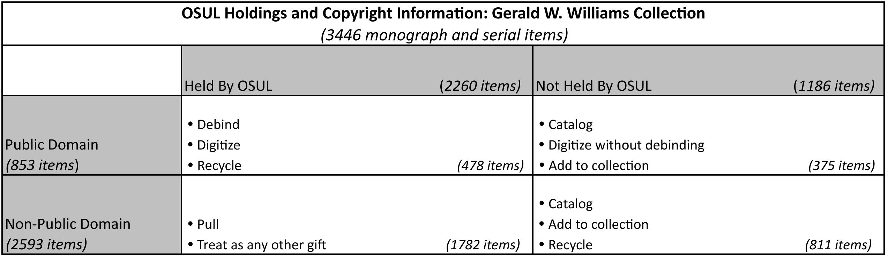

Figure 1. OSUL holdings and copyright information
The Cataloging Unit Head facilitated a meeting with Cataloging and DPU staff to hammer out workflows and responsibilities. Attendees brainstormed ideas, devised two separate cataloging workflows, and agreed to do a one-week pilot test of each set of procedures to determine which was more efficient. Workflow #1 required Cataloging staff to organize the library portion of the Gerald W. Collection into the four groups in the Digitization Matrix (Public Domain/Not Held at OSU, Public Domain/Held at OSU, Non-Public Domain/Not Held at OSU, Non-Public Domain/Held at OSU) before beginning the cataloging process. Workflow #2 allowed Cataloging staff to begin cataloging without organizing the collection according to the Digitization Matrix. DPU staff also developed digitization workflows that coordinated with cataloging workflows.
One last step remained before the actual work could begin. The University Archivist and Head of Special Collections perused the library portion of the collection and flagged items deemed rare and/or valuable. After processing, these items would reside in the OSUL Special Collections rather than the general circulating collection.

Digital Repository Platforms
OSUL currently supports two digital repository platforms: DSpace and CONTENTdm.

DSpace
DSpace, an open-source institutional repository platform developed by MIT and Hewlett-Packard, was originally designed to manage, archive, and provide access to textual documents making it an obvious choice for the monographs and serials in the collection. DSpace provides full-text searching through the Lucene search engine, which is especially conducive for print materials, and its contents are routinely crawled by search engine spiders. DSpace also offers permanent URLs, licensing, flexible metadata, and multiple digital preservation features.

CONTENTdm
CONTENTdm, a proprietary-based digital content management system first developed at the University of Washington and later purchased by OCLC Online Computer Library Center, was originally conceived to store and provide access to digital images. The software automatically generates thumbnails, JPEG, and JPEG2000s from TIFF digital files. Users can perform basic editing functions (resize, rotate, sharpen, crop), pan and zoom JPEG 2000 files, bookmark favorites, and create personal slideshows. Because of these more image-based capabilities, OSUL chose to use CONTENTdm to store and display the historic photographs, slides, and artifacts from the Gerald W. Williams Collection.

Metadata

Textual Items
The Digital Production Librarian created a data dictionary (Figure 2) for the Gerald W. Williams Collection’s textual items, which was appropriate for both monographic and serial titles.

Gerald W. Williams Collection Data Dictionary
Questions: Sue Kunda sue dot kunda at oregonstate dot edu
Revision History:
Field Label | Dublin CoreMetadata Element | Repeatable | Required | Description | Controlled Vocabulary
Authors | dc:creator | Y |  | Enter the names of the authors of the item below (Last name, First name M.I).
Title | dc:title | Y | Y | Capitalize the first word of the title and any personal, place and corporate names within the title. Other words in the title should not be capitalized.
Alternative Title | dc:title.alternative | Y |  | Same as Title
Place of Publication | dc:publisher | Y
Publisher | dc:publisher | Y |  | An entity that made the resource available: e.g. Oregon Department of Agriculture
Publication Date | dc:date.issued | Y |  | Date of formal issuance (e.g., publication) of the resource.
ISSN/ISBN/Gov.Doc.#/Other | dc:identifier | Y |  | If the item has any identification numbers or codes associated with it, enter the types and the actual numbers or codes.
Citation | dc:identifier.bibliographicCitation | Y |  | Used for articles. Enter a complete citation if the item has been published before. Use APA Format. | Refer to KnightCite (http://www.calvin.edu/library/knightcite/) to format citation
Table of Contents | dc:description.tableofcontents | N |  | Enter table of contents information.
Bounding Coordinates | dc:coverage.spatialboundingcoordinates | Y |  | Enter bounding coordinates. | (Oregon Explorer metadata)
Ecoregions | dc:coverage.spatialecoregion | Y |  | Select the ecoregion | Y (Oregon Explorer metadata)
Watershed Councils | dc:coverage.spatialwatershedcouncils | Y |  | Select the watershed council. | Y (Oregon Explorer metadata)
Counties | dc:coverage.spatialcounties | Y |  | Select the county. | Y (Oregon Explorer metadata)
Oregon Plan Basins | dc:coverage.spatialoregonplanbasins | Y |  | Select the Oregon Plan Basin. | Y (Oregon Explorer metadata)
States | dc:coverage.spatialstates | Y |  | Select the state. | Y (Oregon Explorer metadata)
Hydrologic Units in … | dc:coverage.spatialhydrologic_humboldt | Y |  | Select the hydrologic units. | Y (Oregon Explorer metadata)
 | dc:coverage.spatialhydrologic_northca | Y |  |  | Y (Oregon Explorer metadata)
 | dc:coverage.spatialhydrologic_lowercolumbia | Y |  |  | Y (Oregon Explorer metadata)
 | dc:coverage.spatialhydrologic_lowersnake | Y |  |  | Y (Oregon Explorer metadata)
 | dc:coverage.spatialhydrologic_middlecolumbia | Y |  |  | Y (Oregon Explorer metadata)
 | dc:coverage.spatialhydrologic_middlesnake | Y |  |  | Y (Oregon Explorer metadata)
 | dc:coverage.spatialhydrologic_northlahontan | Y |  |  | Y (Oregon Explorer metadata)
 | dc:coverage.spatialhydrologic_closedbasins | Y |  |  | Y (Oregon Explorer metadata)
 | dc:coverage.spatialhydrologic_coastal | Y |  |  | Y (Oregon Explorer metadata)
 | dc:coverage.spatialhydrologic_sacramento | Y |  |  | Y (Oregon Explorer metadata)
 | dc:coverage.spatialhydrologic_willamette | Y |  |  | Y (Oregon Explorer metadata)
Estuaries | dc:coverage.spatialestuary | Y |  | Select the estuary. | Y (Oregon Explorer metadata)
Subject Keywords | dc:subject
Other Keywords | dc:subject.other | Y |  | Add other keywords pertaining to the topic of the content of the resource.
Library of Congress Subject Headings | dc:subject.lcsh | Y |  | Library may add Library of Congress Subject Headings. | Y - LCSH
Abstract | dc:description.abstract | Y |  | Summary of the content.
Description | dc:description | Y |  | “Gerald W. Williams Collection” note added globally.
Sponsors | dc:contributor | Y |  | Enter the names of any sponsors and/or funding codes.
Series/Report No. | dc:relation.IsPartOfSeries | Y |  | When appropriate, enter the series and/or report number that the document is a part of: e.g. PNW Research Paper.
Relation | dc:relation | Y |  | Select appropriate Oregon Explorer relation field | Y (Oregon Explorer metadata)
Reports and Publications | dc:relation.reportsandpublications | Y |  | Select appropriate Oregon Explorer field | Y (Oregon Explorer metadata)
Photos and Videos | dc:relation.photosandvideos | Y |  | Select appropriate Oregon Explorer field | Y (Oregon Explorer metadata)
Statistics and Data | dc:relation.statisticsanddata | Y |  |  | Y (Oregon Explorer metadata)
URI | dc:identifier.uri | Y |  | Generated automatically. Contains a permanent handle URL
 | dc:identifier.other | Y
Type | dc:type | Y |  |  | DSpace default list
Language | dc:language.iso | Y |  | English (US) for all items | DSpace default list
Fields generated automatically by DSpace:
 | dc:date.accessioned | Y |  | Generated automatically.
 | dc:date.available | Y |  | Generated automatically.
 | dc:description.provenance | Y |  | Generated automatically. Contains information about document submitter, date submitted, number of bitstreams, file name, byte size, and checksum.
 | dc:description.provenance | Y |  | Generated automatically. Contains information about document approver, date approved, number of bitstreams, file name, byte size, and checksum.
 | dc:description.provenance | Y |  | Generated automatically. Contains information about the date the document was made available in archive, number of bitstreams, file name, byte size, and checksum.
 | dc:format.extent | Y |  | Generated automatically. Contains number of bytes.
 | dc:format.mimetype | Y |  | Generated automatically. Contains mimetype of file.
Appears in Collections |  | Y |  | Generated automatically. | Gerald W. Williams Collection

Figure 2. Gerald W. Williams data dictionary (textual material)
These approximately 900 titles would be housed in ScholarsArchive, OSUL’s instance of DSpace. Dspace supports the Qualified Dublin Core Metadata Schema. Most descriptive metadata for the collection was fairly standard (creator, title, date, etc.) but several adaptations were made to align this collection with OSUL unique needs.
While the Gerald W. Williams Collection’s titles were grouped under a collection by the same name in ScholarsArchive, OSUL also used the description field (dc.description) to add a note designating them as Gerald W. Williams Collection titles. By doing this, users finding an item through a search engine rather than entering directly through the ScholarsArchive user interface, would see the item came from the Gerald W. Williams Collection.
The Digital Production Librarian also added metadata elements specific to Oregon Explorer, OSUL’s natural resources digital library and its associated portals. Oregon Explorer metadata generally consists of geographic and spatial information relevant to the state of Oregon, but a relation field (dc.relation) also allows items to be pulled into the appropriate Oregon Explorer portal. For example, “Bohemia Mining District: A Brief History” was assigned the relation field “Explorer Site::Land Use Explorer”, allowing it to be included in search results in the Land Use Explorer.
Dspace automatically attaches administrative and structural metadata.

Images
The images from the Gerald W. Williams Collection are housed in CONTENTdm, which also supports the Dublin Core Metadata Schema; therefore, the metadata for this collection (Figure 3) is similar to the textual metadata. Standard descriptive metadata (creator, title, and date) was used, but OSUL also added geographic metadata such as Rivers and Streams, Hydrologic Unit Codes (HUC’s), and Longitude Latitude Identification (LLID).
Technical metadata describing the digitization process is found in the Transmission Data field and Administrative Metadata for this collection is found in the Restrictions and Contributing Institution fields.

Digitization Specifications

Textual Items
Textual items that could be debound were scanned in both tiff (600 dpi master files) and pdf (300 dpi access files) formats on a Canon DR-9080C. This production scanner has a feed capacity of 500 sheets and scans at rates of up to 90 pages-per-minute. Tiff files were scanned as individual files while pdf files were scanned as a single document. Doing this allows future manipulations of single tiffs, if necessary, and also provides a pdf file more appropriate for web viewing.
Textual items that could not be debound were scanned on a Bookeye 2® Planetary Book Scanner located in the Interlibrary Loan Department. Unlike the Canon DR-9080C, which can scan a document in either single-page or multi-page format, the Bookeye 2® can only scan documents as single images. In addition, this scanner does not have the capacity to scan at 600 dpi, the resolution OSUL normally requires for master (tiff) files. Because these files are used to recreate an access copy, if necessary, and not considered the preservation copy, a lower standard is acceptable. All textual pdf files were compressed and ocr’ed using cvision’s pdfcompressor™ 4.0.

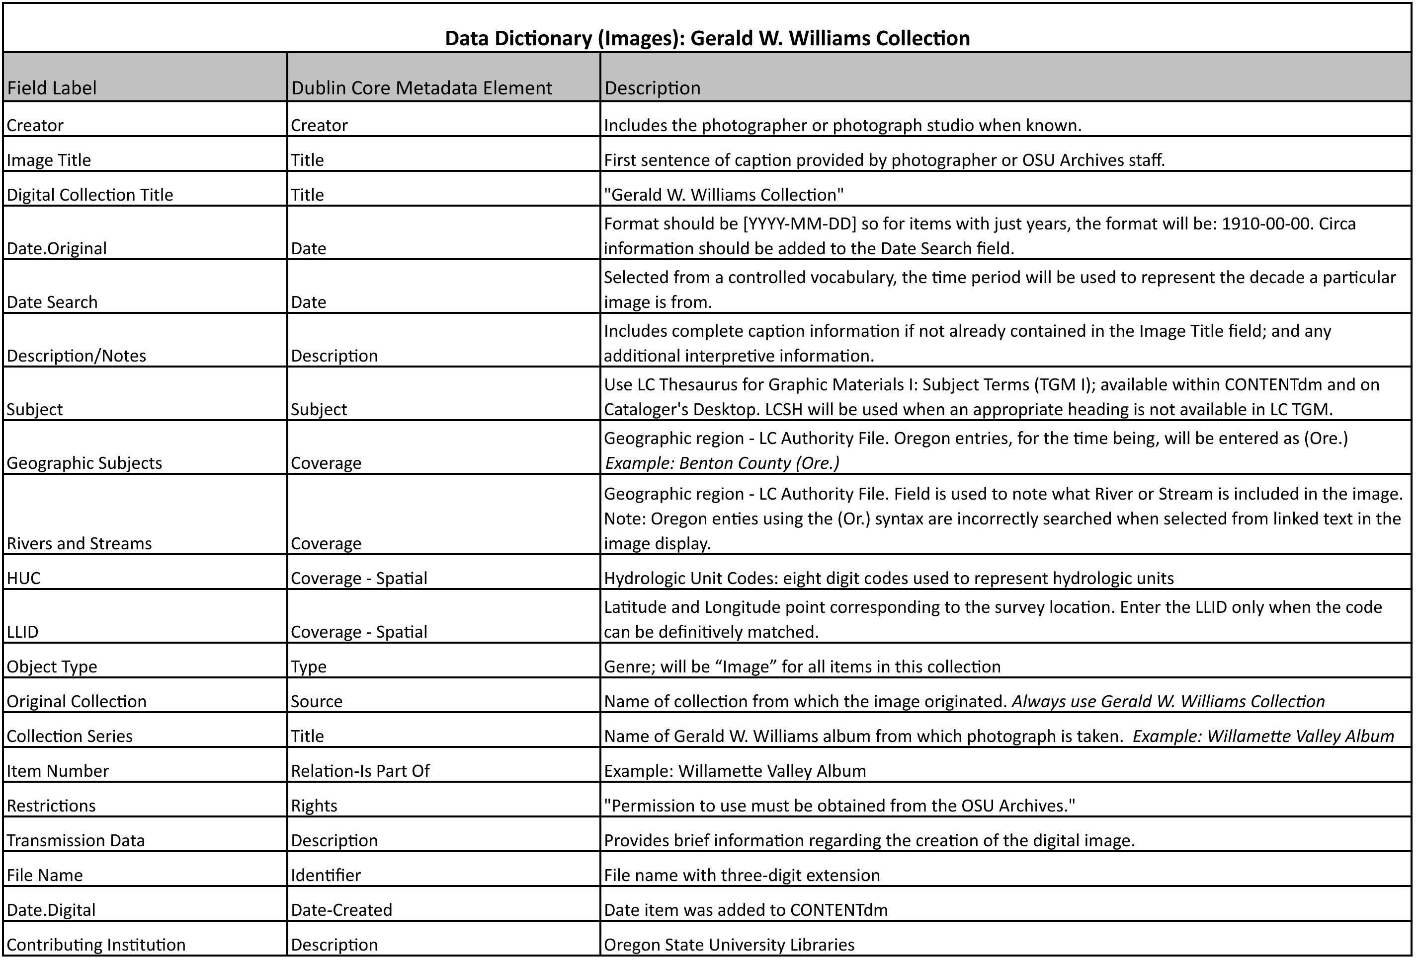

Figure 3. Gerald W. Williams data dictionary (images

Images
A University Archives volunteer used an HP4370 ScanJet to scan all images (photos, postcards, etc.) currently included in the Gerald W. Williams Collection. Items equal to or smaller than 3 x 5 inches were scanned at 800 dpi while items larger than 3 x 5 inches were scanned at 600 dpi. The volunteer created both grayscale and color tiff files for each item and the University Archivist chose the image he felt was of the highest quality. The volunteer used Adobe Photoshop Elements 4.0 to make any necessary edits.

Workflows

Cataloging
As mentioned previously, Cataloging staff had devised two possible workflows for processing the collection and planned to spend one week following each set of procedures to determine the most efficient workflow. It quickly became apparent that the more expedient workflow was the second one, which did not require any further organizing of the collection before cataloging. The first workflow was quickly dropped in favor of the second and the project began in earnest.
Library technicians responsible for adding monographs and serials to the library collection started by retrieving items, one book cart at a time, from University Archive compact shelving. Working from the book cart the cataloging technician checked the library OPAC to see whether or not the item was currently held at OSUL and, if not, cataloged the item. Additionally, the cataloging technicians used a variety of online sources (Google Books, Internet Archives, organizational websites) to ascertain whether or not the title had already been digitized elsewhere.
If a digital copy existed, and it met OSUL general quality standards, the cataloging technician inserted the appropriate information into the record and either sent the piece out to the circulating collection (items not held by OSUL) or the gift shelves (items already held by OSUL). The cataloging technician then placed items not found online or found online but of a very low quality, on a shelf marked “Gerald W. Williams Collection” outside the Digital Production Librarian’s office.

Either the Digital Production Librarian or a trained library technician checked each item’s copyright information to determine if it was eligible for digitization. Figure 5 (below) outlines the matrix used to determine each item’s digitization eligibility.

The Digital Production Librarian created a copyright manifest (Figure 6) to track copyright decisions and contact information. This Excel file was kept on a shared server so anyone involved with the project could access it at anytime.

Items not eligible for digitization, due to copyright restrictions, were returned to the original cataloger, who finished processing the item and sent it to be added to the collection. Items eligible for digitization were placed on one of two shelving units. If the title was new to OSUL, and could not be debound because it was going to be added to the collection, it was placed on a shelf for scanning on the planetary book scanner in ILL. Items already in the OSUL collection, and could therefore be debound, were placed on a shelving unit reserved for sheetfed scanning.

Textual Digitization
A DPU student scanner retrieved items that could be debound from the appropriate shelf. After debinding the item the student scanned the text block on the Canon sheetfed scanner and saved it as both individual tiff files and a multi-page pdf file. Hardback covers were also scanned and saved as individual tiff and pdf files. The student used Adobe Acrobat 9 Pro to combine the covers and text block to make one complete pdf file. The pdfs were then compressed and ocr’ed using cvision’s pdfcompressor™ 4.0.
An ILL student scanner retrieved items that could not be debound and needed to be scanned on the ILL planetary scanner from the appropriate shelf. The student scanned each single page and double-page spread into one tiff file and used BScan ILL 2.0 software (packaged with the Bookeye scanner) to split double page spreads, deskew any crooked pages, crop the borders, and remove any thumb images captured during the scanning process. The student checked the quality of the resulting tiff file, made any necessary modifications, and used Adobe Acrobat Pro to convert it to pdf. Both files were saved and placed into a folder on a DPU server.
Textual items, both bound and debound, were added to ScholarsArchive using the customized DSpace metadata form described above (see Figure 1). Because each item had already been cataloged and added to the library’s OPAC the student simply copied and pasted the information from the catalog into the metadata textboxes and attached the corresponding compressed and ocr’ed pdf file to the record.
After submitting the digital copy to ScholarsArchive the student returned the physical piece to the cataloger who had performed the initial work on the item. The cataloger checked the student submission, uploaded the item to the Internet, and added the ensuing URL to both the library’s OPAC and WorldCat catalog. Debound items were recycled while bound items were added to the library’s collection.
As of this writing all items destined for scanning on the sheetfed scanner have been digitized and added to the collection. Items that need to be scanned on the ILL planetary scanner continue to be added at a rate of approximately two per week.

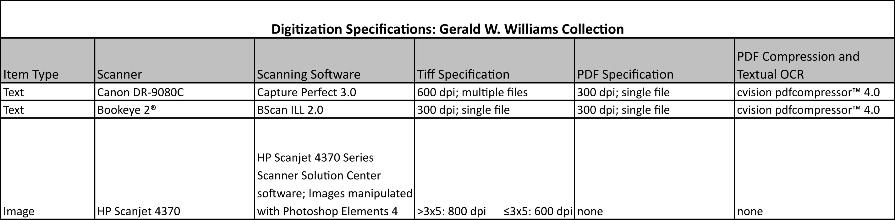

Figure 4. Digitization specifications
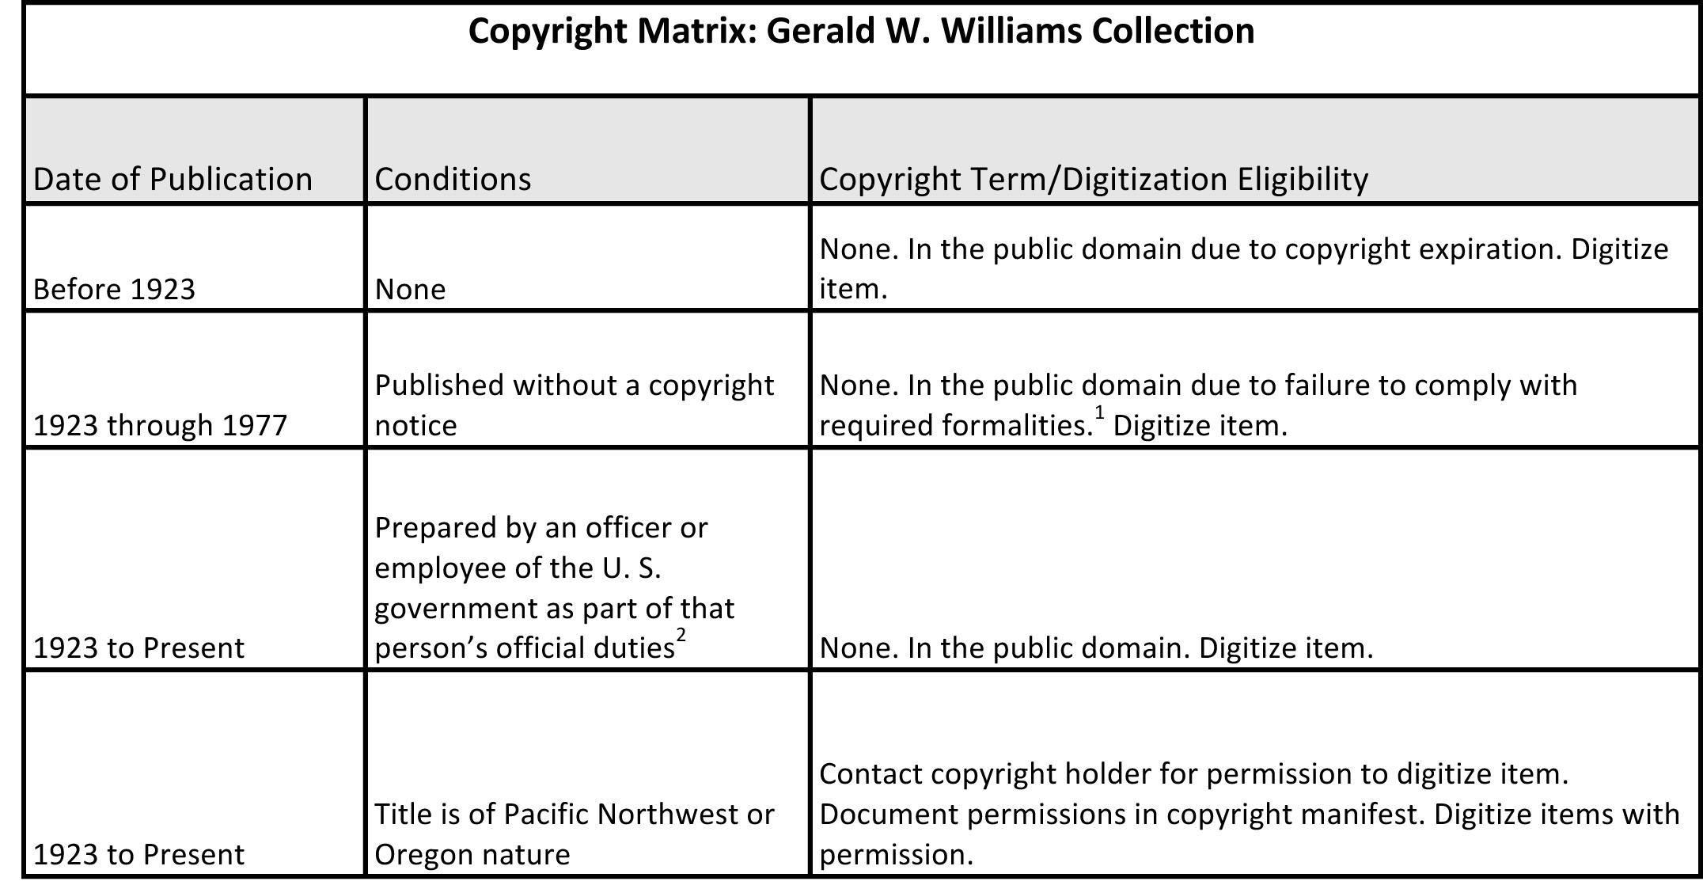

Figure 5. Digitization eligibility matrix

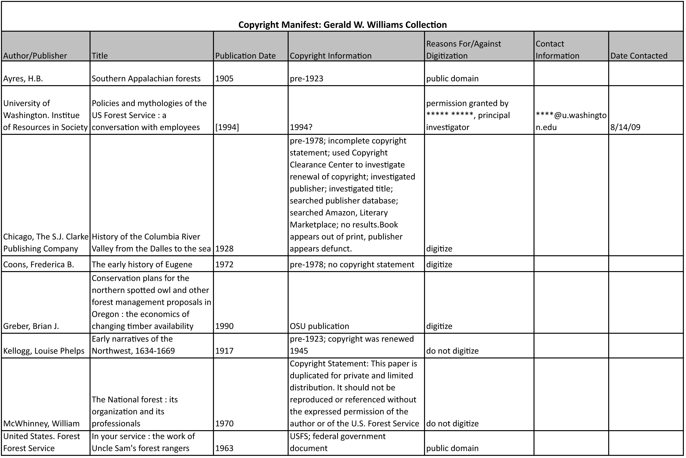

Figure 6. Copyright manifest (sample items)

Image Digitization
Each week the University Archivist pulled eight to fifteen images from the Gerald W. Williams Collection prior to the volunteer scanner’s arrival on Wednesday. He completed a Word table for each weekly session, which included the image file number (written on the back), scanner settings, and descriptive metadata. The volunteer created two or three digital files of each image based on the provided specifications, saved all images to a jump drive, and placed it on the University Archivist’s desk.
After the University Archivist reviewed the scans and chose the best images, a University Archives student worker gave the originals to a DPU staff member and copied the files to a shared drive located on a workstation in the DPU. Placing a copy of the files on this server allowed the DPU staff member to pull a copy of the file off the server and into CONTENTdm’s Acquisition Station. She used the original image when creating the necessary metadata, uploaded the item, returned the original to University Archives, and transferred the digital file to a permanent server.

Project Challenges, Successes and Lessons Learned

Challenges
It is impossible to take on a project of this magnitude and not encounter obstacles. Listed below are several challenges OSUL encountered during the process and the methods used to overcome those “bumps in the road”.
Challenge #1: The DPU had limited experience scanning older monographs such as those found in the Williams Collection. Image printing processes used during the production of the books made it difficult to produce a high-quality copy of both images and text using standard DPU procedures. Trying to balance the desire for high-quality images with a fast-paced production environment – and without appropriate software – frustrated student workers and staff.
Solution #1: Unfortunately, this is still an obstacle when scanning older monographs. Moiré patterns appear on some photographic images, making them less than ideal, but rarely does it affect whether or not an item can be viewed effectively. The Digital Production Librarian is now working to purchase scanning software that will lessen, or completely remove, these imperfections.
Challenge #2: Project organizers wanted all books eligible for digitization to be scanned, but the only DPU scanner that could be used for unbound books was a flatbed scanner. It would have been extremely inefficient if used for this purpose, especially with a number of books containing more than 300 pages.
Solution #2: DPU and ILL had a history of collaborating to solve digital access issues and of sharing student workers during calendar breaks. When approached by the Digital Production Librarian about the possibility of using the ILL planetary scanner for the Gerald W. Williams Collection, ILL staff agreed without hesitation. The two units worked out a schedule and workflow that allowed ILL students to digitize the books, edit the digital files, and save them to a DPU server.
Challenge #3: Student workers had limited access to the ILL planetary scanner due to its heavy usage during the workday and its continual malfunction.
Solution #3: Student workers were allowed to scan beyond the eight-to-five workday and on weekends. After repeated repairs the vendor eventually replaced the planetary scanner.
Challenge #4: Because of the complexity, detail, and number of people involved in the project, it was nearly impossible at times to remain consistent with workflow policies and procedures.
Solution #4: The project manager scheduled regular “check-in” meetings to review and, if necessary, update procedures. As the project progressed and staff became more familiar with practices and workflows, meetings were scheduled further and further apart until they were eventually discontinued altogether.
Challenge #5: Original workflow designs did not account for a copyright-checking step between catalogers and student workers nor identify a location for catalogers and students to place processed or digitized items.
Solution #5: Catalogers and DPU staff created additional workflow steps to include copyright checking and assigned shelves for items at various stages in the digitization process.

Successes
Digital Access Services, the department tasked with completing the vast majority of this project, is well known for managing and accomplishing large multi-step endeavors without much fanfare. The Gerald W. Williams Collection was no exception; the work was completed quickly and efficiently even as staff continued handling normal day-to-day responsibilities. Other measures of success include:
Success #1: Five library units (Cataloging, Digital Production, University Archives, Interlibrary Loan, and Special Collections), 17 staff members, and nine student workers collaborated to add more than 3,000 valuable, historic volumes to OSUL, 850 digitized monographs and serials to ScholarsArchive, and nearly 1000 images to the online Gerald W. Williams Collection. One would expect difficulties coordinating policies, procedures, and workflows with a collaboration of this size, but other than the complications surrounding the planetary scanner (mentioned above), few project disruptions occurred.
Success #2: Download statistics for the textual items in ScholarsArchive illustrate the amount of interest in this collection, both nationally and internationally. In 2009 the 686 items in the collection received nearly 40,000 downloads from more than 100 countries
Success #3: On February 14, 2009, timed to coincide with the 150th anniversary of Oregon’s statehood, OSUL made its debut in Flickr Commons with a launch of close to 125 images from the Gerald W. Williams Collection. The series, focusing on the Civilian Conservation Corps, was an instant hit with more than 8000 views within the first twenty-four hours. As of December 10, 2009, OSUL has added an additional 156 items and plans to continue increasing to the collection on a regular basis.
Success #4: Oregon Public Broadcasting twice visited OSUL University Archives to access historic pictures for two episodes of Oregon Experience. Civilian Conservation Corps chronicles the story of the New Deal program by the same name, and The Logger’s Daughter explores the history of African American loggers in northeast Oregon.

Lessons Learned
Every large digitization project brings with it a unique set of challenges and obstacles. Adhering to a few basic principles can often mitigate the impact of these barriers:
Lesson #1: Pre-plan, pre-plan, pre-plan. While it may be tempting to skip the pre-planning phase, especially if an organization has previously undertaken numerous digitization projects, this step cannot be overemphasized (see Lesson #5). For most sizable digitization projects OSUL organizes and completes an inventory of the items in the collection, creates one or more data dictionaries, establishes workflows, and conducts meeting to discuss policies and procedures with appropriate personnel.
Lesson #2: Involve those people responsible for completing the work in the pre-planning phase. Students and staff on the front lines often have a better understanding of, and a more efficient method for, completing tasks. Their insights can be invaluable.
Lesson #3: To identify potential obstacles, process a few “test” items through the entire workflow prior to formally starting a project. It is much less disruptive to modify policies and procedures before the project gets fully underway.
Lesson #4: Do not start a project of this magnitude at a time when key decision-makers are unavailable or out of the building. There are always questions to be answered and workflows that need modifying early in the process, and not having the person(s) with the authority to make those decisions close at hand not only disrupts progress, but can also frustrate workers.
Lesson# 5: Be (and stay) flexible. No two digitization projects are the same and each one has its own idiosyncrasies. Be prepared for policies and procedures from previous projects to fall short when applied to another. When obstacles do arise – and they will – encourage others’ suggestions and keep an open mind when considering possible solutions.
Lesson# 6: Ask for help. Many cultural heritage organizations have considerable experience with digitization projects and most are willing to share their strategies and techniques with others.

Future Plans
As of this writing, OSUL has approximately 125 volumes to scan and add to the Gerald W. Williams Collection in ScholarsArchive, which will bring the total number of items in the institutional repository to just less than 1000. The image collection in CONTENTdm now houses 910 images. Although the digitization of textual items will most likely be finished in 2010, OSUL will continue digitizing the more than 24,000 historic photographs for many years to come. As time permits the University Archives staff will pull together groupings deemed of interest based on professional judgment and patron requests, and place them in the standard digitization queue.
Another possible future digitization project from the Gerald W. Williams Collection includes Williams’ own personal papers. As a noted historian and forestry expert, his collected working papers, unpublished manuscripts, articles, and conference papers are valuable research documents in and of themselves. Finally, with Williams still collecting and now donating many of his acquisitions to OSUL, it appears the Gerald W. Williams Collection could be growing for a long, long time.

References
Oregon State University Libraries, University Archives (2008). Guide to the Gerald W. Williams Collection, 1855-2007. Retrieved November 27, 2009, from Oregon State University Libraries Web site: http://digitalcollections.library.oregonstate.edu/cdm4/client/gwilliams/
index.html
Peterson, K. (2009). OSU enrollment jumps more than 8 percent to nearly 22,000. Retrieved November 28, 2009, from Oregon State University, University Advancement, News & Communication Services Web site: http://
oregonstate.edu/ua/ncs/archives/2009/nov/
osu-enrollment-jumps-more-8-percent-nearly-22000
Simmons, T. (2006). OSU recognized as Oregon’s leading research university. Retrieved November 28, 2009, from Oregon State University Web site: http://oregonstate.edu/events/newsevents/carnegie.html
Springer, M., Dulabahn, B., Michel, P., Natanson, B., Reser, D., Woodward, D. et al. (2008). For the common good: The Library of Congress Flickr pilot project. Retrieved November 27, 2009, from http://www.loc.gov/rr/print/
flickr_report_final.pdf
Stauth, D. (2006). OSU College of Forestry viewed as number one in North America. Retrieved November 28, 2009, from Oregon State University, News and Communication Services Web site: http://oregonstate.edu/dept/nce/
newsarch/2006/Oct06/forestryrank.html
The Commons. (2009). Retrieved November 27, 2009, from flickr® Web site: http://www.flickr.com/Commons?GXHC_gx_session_id_=6afecb2055a3c52c

Endnotes 1 Copyright Information Center. (2009). Copyright term and the public domain in the United States, 1 January 2009. Retrieved November 2, 2009, from Cornell University, Copyright Information Center Web Site: http://copyright.cornell.edu/resources/publicdomain.cfm 2 United States Copyright Office. (2009). §101. Definitions, Copyright law of the United States of America and related laws contained in Title 17 of the United States Code. Retrieved November 2, 2009, from United States Copyright Office Web Site: http://www.copyright.gov/title17/92chap1.html#101 3Usage statistics retrieved December 10, 2009, from Gerald W. Williams Collection https://ir.library.oregonstate.edu/jspui/handle/1957/9112. Author Biography Sue Kunda received her MLS from Emporia State University School of Library & Information Management and works as the Digital Production Librarian for Oregon State University Libraries. As the head of the Digital Production Unit, Ms. Kunda oversees the digitization of library and university collections and manages the libraries’ institutional repository, ScholarsArchive@OSU. Her current interests include scan-on-demand digitization, institutional repositories, Open Access, and the future of scholarly communication. Contact Information: Sue Kunda Digital Production Librarian Oregon State University Libraries 121 The Valley Library Corvallis, OR 97370 541-737-7262 sue.kunda@oregonstate.edu Keywords: Gerald W. Williams ScholarsArchive@OSU Digitization Projects Collaboration Academic Libraries Institutional Repositories DSpace CONTENTdm Workflows Copyright Manifest Data Dictionary Dublin Core

