AN ABSTRACT OF THE THESIS OF

Edmond Francis O'Donnell III for the degree of Honors Baccalaureate of Science in Biochemistry and Biophysics presented on June 6, 2006. Title: Pathogenic Mechanisms of Cancer Causing hMLH1 Mutations.

Abstract Approved:
Andrew Buermeyer

DNA mismatch repair (MMR) is an evolutionary conserved process that functions to maintain genomic integrity through the correction of mismatches that have escaped proofreading. Mutations in the MMR gene Mlh1 are associated with approximately 50% of all cases of Lynch syndrome, a hereditary predisposition to colorectal cancer, through varying and largely unidentified mechanisms. Microsatellite instability (MSI) is a hallmark of such MMR deficient cancers, the identification of which is essential, as they may respond differently to chemotherapeutic drugs. The recent identification of the MLH1 variant D132H, which gives rise to Lynch syndrome cancers in the absence of MSI, makes this mutant an interesting target for analysis. In the present study, we developed a new screening assay - based on previous work with MLH1 deficient mouse embryonic fibroblasts - that allows for quick and efficient assessment of a variety of potential pathogenic mechanisms. The results from these assays, together with in vitro repair experiments, demonstrate that D132H is able to stabilize PMS2, repair base/base and insertion deletion loop mismatches, and promote the cytotoxicity of the DNA damaging agent 6-thioguanine, all of which suggest the D132H mutation does dramatically affect MMR activity. Our assay was also used to evaluate the effects of another pathogenic mutant, K616Δ, and suggest, consistent with some previous studies, that the mutation affects MLH1 expression in vivo.
Key Words: DNA Mismatch Repair, D132H, K616Δ, Lynch Syndrome, Cancer
Corresponding e-mail address: odonneed@onid.orst.edu

©Copyright by Edmond Francis O'Donnell III
June 6, 2006
All Rights Reserved
Pathogenic Mechanisms of Cancer Causing hMLH1 Mutations
by
Edmond Francis O'Donnell III

A PROJECT
submitted to
Oregon State University
University Honors College

In partial fulfillment of
the requirements for the
degree of

Honors Baccalaureate of Science in Biochemistry and Biophysics (Honors Scholar)

Presented June 6, 2006
Commencement June 2006

Honors Baccalaureate of Science in Biochemistry and Biophysics project of Edmond Francis O'Donnell III presented on June 6, 2006.

APPROVED:

Mentor, representing Environmental and Molecular Toxicology

Committee Member, representing Biochemistry and Biophysics

Committee Member, representing Chemistry

Chair, Department of Biochemistry and Biophysics

Dean, University Honors College

I understand that my project will become part of the permanent collection of Oregon State University, University Honors College. My signature below authorizes release of my project to any reader upon request

Edmond Francis O'Donnell III, Author
Acknowledgments

I wish to thank my mentor, Dr. Andrew Buermeyer, for his patience and guidance throughout my research experience. Thanks are also owed to Xin Hou, Azizah Mohd, Brett Palama, Karen Hippchen, Bryan Ing, and Dr. Stephanie Smith-Roe for their suggestions, humor, advice, assistance, and encouragement. Special thanks are owed to Scott Nelson for assistance with data collection, to Pete Hoffman for supplying the pRO1 plasmid construct, and to Kevin Ahern for his for his guidance and help securing research fellowships and scholarships. This work was partially supported by an Oregon State University URISC grant (Summer, 2003) and by the Howard Hughes Medical Institute undergraduate research fellowship (Summer 2003 and 2004).
To my friends and family for their support throughout the years: your kindness and generosity have helped me in ways I can not possibly describe, thank you. To my parents: thank you for all you have given. I love you both.

TABLE OF CONTENTS

Page
INTRODUCTION 1
MATERIALS AND METHODS 10
Cell culture 10

Expression Vectors 10

Functional Studies of MLH1 Expressing Clonal Cell Lines 11

Generation of Clonal Cell Lines 11
Preparation of Whole Cell Lysates 12
SDS-PAGE and Western Blotting 13
Western Blot Data Acquisition and Analysis 14
Measurement of Cytotoxic Response to 6-Thioguanine 15
Measurement of Forward Mutation Rate 16
Immunohistochemistry 17

Functional Studies of MLH1-Expressing Pooled Cell Cultures 18

Pooling Assay with Wildtype MLH1: Validation of Methods 18
MLH1 Variant Pooling Assay 20

In Vitro Repair Reactions 21

Substrate Preparation 21
Cytoplasmic Extracts 26
Repair Reactions 27

RESULTS 29
Functional Analyses of the MLH1 Mutant D132H in a Clonal Cell Line 29

Restoration of MMR Activity in Pooled Cell Lines Expressing hMLH1 32

Functional Analyses of the MLH1 Mutants D132H and K616Δ in
Pooled Cultures 37

In Vitro Repair Activity of D132H 42

TABLE OF CONTENTS (Continued)

Page
DISCUSSION 45
BIBLIOGRAPHY 52

LIST OF FIGURES

Figure Page
1. General mismatch repair pathway 2
2. MMR heterodimers and substrate specificities 4
3. MMR substrate preparation 22
4. D132H expression and sensitivity to 6-TG exposure. 30
5. MLH1 expression in cell lines generated by pooling colonies from a
Stable transfection of hMLH1 into mMlh1 -/- MEFs. 33

6. The MMR dependent response to the cytotoxic agent 6TG is restored in
cell lines generated by pooling colonies of Mlh1 -/- MEFs transfected with
hMLH1 cDNA 35

7. In vivo expression of the MLH1 variants D132H and K616Δ in
transfected Mlh1 -/- MEFs. 39

8. Immunohistochemistry staining of representative pooled cell lines with
hMLH1 antibody 40

8. Phenotypic consequences of D132H and K616Δ expression in
mMlh1 -/- MEFs. 41

10. In vitro mismatch repair assay. 43

11. The MLH1 D132H variant has repair activity similar to wildtype. 44

LIST OF TABLES

Table Page
1. Expression of D132H reduces mutation rates in MLH1-deficient MEFs 31
2. Spontaneous ouabainR mutant frequencies in cell cultures generated by
pooling colonies of Mlh1 -/- MEFs transfected with hMLH1 cDNA 36

LIST OF ABBREVIATIONS

6-TG 6-Thioguanine

CRC Colorectal cancer

CTH carboxy-terminal homology

h- Human

HNPCC Heriditary non-polyposis colorectal cancer

IDL Insertion / Deletion Loop

IHC Immunohistochemistry

m- Mouse

MEF Mouse embryonic fibroblast

MLH MutL homolog

MMR Mismatch Repair

MSH MutS homolog

MSI Microsatellite Instability

PMS Post-meiotic segregant

SDS-PAGE Sodium dodecyl sulfate polyacrylamide gel electrophoresis

INTRODUCTION

The fidelity of DNA replication alone has an intrinsic error rate that is insufficient to maintain genomic integrity. Post-replicative repair pathways decrease the error rate of replication to levels sufficient to maintain the genome; however, a loss of such repair activity can confer devastating phenotypic consequences in the form of cancer. Indeed, successful repair of errors in DNA replication, specifically base mismatches and insertion/deletion loops (IDL) via DNA mismatch repair (MMR) is essential for suppressing high levels of mutations and increased cancer risk (1-6).
DNA mismatch repair (MMR) is a chief component of the post replicative repair pathways, functioning to identify and repair DNA mismatches that have escaped proofreading (7). In addition, MMR components are active in a variety of cellular roles beyond error correction, such as induction of apoptosis in response to DNA damage and controlling cell cycle checkpoints (8). Loss of MMR activity results in increased spontaneous and DNA damage-induced mutation rates, reduced apoptotic responses, and is associated with carcinogenesis in a variety of spontaneous and hereditary forms of cancer. Thus an understanding of the structure and function of MMR components is essential for the continued advancement of cancer diagnosis and treatment methods.
The components of DNA MMR in E. coli have been identified, and their study has proved useful in understanding the mechanisms of eukaryotic MMR (9, 10). A general pathway for MMR (Figure 1), developed primarily by in vitro reconstitution of the MMR pathway with purified E. coli proteins, includes three homodimeric proteins (MutS, MutL, MutH), and additional components. MutS is an ATPase that identifies and binds mismatches. MutL forms a complex with MutS and is necessary to active the latent endonuclease, mutH. MutH specifically cleaves the transiently unmethylated nascent DNA at GATC motifs, introducing a nick in the mismatch containing strand. The nick can be in 5’ or 3’ orientation relative to the mismatch, and located up to approximately 1 kb away. The excision step requires the helicase UvrD, single strand DNA binding protein (SSB) and a 5’ to 3’ or 3’ to 5’ single strand exonuclease. Resynthesis is carried out by DNA polymerase holoenzyme, followed by DNA ligase, which seals the nick.

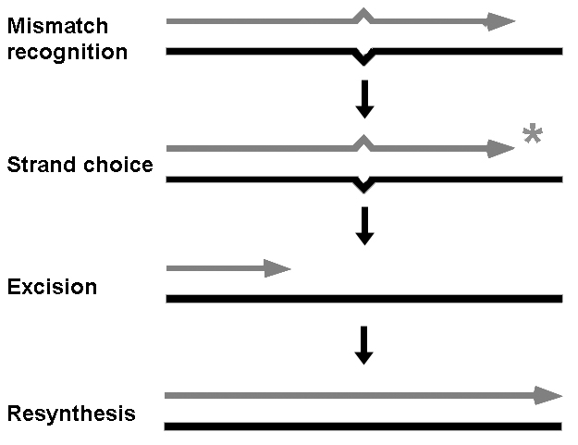

Figure 1. General mismatch repair pathway. Mismatches (base substitution or insertion/deletion loop) are recognized by the MutS family. Proper strand discrimination (*) involves the MutL family. Excision is carried out by various exonucleases. Resynthesis by replicative DNA polymerase restores the original sequence.

The MMR pathway is generally conserved in eukaryotes; however, the homodimeric MutS and MutL complex have evolved into several heterodimers (Figure 2). In mammalian MMR, the MutS family consists of two such heterodimeric complexes, MutSα (composed of MutS homolog (MSH) 2 and MSH6) and MutSβ (composed of MSH2 and MSH3). While the specificities of the two complexes overlap somewhat, MutSα activity is specific to base/base mismatches and single basepair insertion/deletion loops (IDLs) and MutSβ appears to act preferentially towards larger IDLs (7). The vast quantity of basepairs replicated during each round of DNA synthesis requires that the MutS family be extremely efficient in scanning and identifying mismatches (11); such specificity may require that MutS complexes recognize structural abnormalities associated with mismatches (12).
The MutL family is also present in eukaryotic MMR. In mammalian cells, three known heterodimeric complex exist: MutLα, MutLβ and MutLγ contain 1 subunit of MutL homolog (MLH) 1 and 1 subunit of PMS2, PMS1, and MLH3, respectively. MutLα appears to be the primary MutL complex involved in MMR (See references in (7)). Recent findings show that MLH3 from MutLγ is also active in MMR (13). The MutLα complex interacts with MSH2 (14) and proliferating cell nuclear antigen (PCNA) (15), suggesting the formation of a ternary complex of MutSα and MutLα that signals downstream repair events.
Unlike MMR in E. coli, the mechanism for strand discrimination has not been elucidated. Interestingly, no homolog of MutH, which creates the strand signal needed for excision in E. coli, has been identified in eukaryotes. In vitro repair studies have successfully used DNA nicks to direct repair (16), suggesting that nicks in the post-replicated strand may play a role in directing MMR machinery. Several models of strand discrimination have been proposed in the literature, although a universally accepted model has not yet been established.
The exonucleases EXO1, as well as the proofreading activity of DNA polymerases Polδ and Polε have been implicated in excision; synthesis is carried out by the latter two proteins. Of great importance to the MMR pathway is the multifaceted role of PCNA which appears to be involved at each step of MMR, possibly serving a scaffold for interacting components (17).

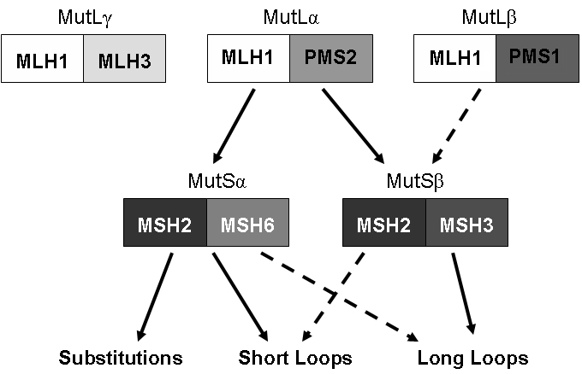

Figure 2. MMR heterodimers and substrate specificities. Interactions of MutL and MutS family proteins act on base substitutions, short (1 base) insertion/deletion loops (IDLs), and longer IDLs (2-16 nucleotide repeats). MutLα and MutSα mediated repair is responsible for the majority of MMR activity in eukaryotes. Solid lines represent definitive interactions, dashed lines represent partial interactions.

The recent reconstitution of eukaryotic MMR in vitro has provided insight into the essential components of MMR. MutSα or MutSβ, MutLα, RPA, EXO1, HMGB1, PCNA, RFC, polymerase δ, and ligase I are required for MMR activity. Consistent with previous studies, in vitro reconstituion shows that MutSβ acts more efficiently on long loop mismatches and does not contribute significantly to overall repair. Interestingly, MutLα is only required for terminating excision in vitro, and repair with nicked 5’ directed substrates is proficient without MutLα. However, the requirement for the MutLα heterodimer in vivo is not disputed, and it may play a role in generating the strand discrimination signal and or in additional functions that have not been elucidated (18).
The association of MMR with sporadic and hereditary cancers has greatly intensified research interests. MMR genes are tumor suppressors, and deficiencies in MMR genes can produce a mutator phenotype. Lynch syndrome (hereditary non-polyposis colorectal cancer, HNPCC) is one such hereditary cancer caused by inherited deficiencies in MMR. Lynch syndrome is characterized by the presence of early-onset (20-40 years of age) colorectal carcinoma (19) and accounts for approximately 5-7% of the total colorectal (CRC) cancer burden. Mutations in MSH2 and MLH1 are associated with 90% of Lynch syndrome cases (20, 21).
The study of MLH1 is especially important, as it is an essential MMR protein; some 50% of Lynch syndrome cancers harbor mutations in MLH1 (22). MLH1 is 756 amino acids in length and consists of an ATPase domain, a DNA binding domain, and a heterodimer interaction domain. Approximately 150 missense or nonsense mutations have been identified in MLH1 in various human cancers, along with over 100 deletion/insertion mutations (HGMD, online). Several mutations in specific domains have been well established and correlated with MMR deficiency and cancer through specific pathogenic mechanisms; such studies provide a framework from which to analyze new MLH1 mutations. Nonsense or misense mutations may destabilize MLH1, resulting in poor expression, or interfere with active sites of MLH1, resulting in inactivity. Mutations may also confer upon MLH1 an inability to form stable heterodimers, such as with PMS2, the resultant decrease or extinction of MutLα is pathogenic. While some mutations have been clearly associated with Lynch syndrome, the mechanism of pathogenicity for many missense mutations can be difficult to predict.
In vitro studies have indicated that several mutations, including K616Δ (which results in a deletion of a lysine amino acid 616), drastically reduce the ability of MLH1 to bind PMS2 relative to wildtype protein (23), although this result is in dispute ((24), unpublished data). Additionally, truncations in the C-terminus of MLH1 were recently shown to destabilize the MLH1/PMS2 interaction and disrupt MMR activity (25). Disruptions of the ATPase activity of MLH1, can also result in defective MMR (26).
Regardless of mechanism, deficiency in MMR usually results in high levels of both microsatellite instability (MSI), resulting from uncorrected IDLs (1, 27, 28), and base substitution mutations, resulting from uncorrected base mismatches. As such, MSI is a hallmark of MMR-deficient cancers such as Lynch syndrome (1-6). Clinical diagnosis of Lynch syndrome is accomplished through the use of immunohistochemistry to detect expression of MMR proteins, and more importantly, screening for MSI. However, the detection of Lynch syndrome is complicated, in that there are typically no physical manifestations of the disease until well after carcinogensis has occurred (29). Likewise, it is essential that MMR deficient cancers be identified early, as they may respond differently to chemotherapeutic agents (30). Thus, the success of the aforementioned screening methods in properly identifying MMR deficient cancers such as Lynch syndrome is important.
Despite the prevalence of MSI in MMR deficient cancers, several MLH1 mutations (V716M, E578G, K618A) associated with Lynch syndrome cancers that do not display MSI have been identified ((31), personal communication); how these cancers arose in the absence of MSI and their mechanisms of pathogenicity is currently unknown and a matter of dispute in the literature ((32) and references therein). Recently, the MLH1 variant D132H, has been identified as a fourth mutation associated with Lynch syndrome without MSI (32). Among eukaryotes, the amino acid D132 is highly conserved among Mlh1 genes, suggesting an importance in MLH1 function. Residing in the ATPase domain of MLH1, D132H may attenuate ATPase activity based on in vitro assays and modeling of the mutation on the crystal structure of MutL (32). The existence of MLH1 mutants that appear not to cause elevated MSI is especially intriguing because of the wide use of MSI screening in detection of MMR deficient cancers. While the MLH1 variant D132H does not appear to be a prevalent MLH1 mutation in the United States (33), it accounts for a significant portion of HNPCC cases in Israeli populations, and likely others as well (32).
The goal of this study was to examine the phenotypic effects of D132H in vivo to identify a mechanism of pathogenicity of this mutation. Several pathogenic mechanisms that account for the lack of MSI can be imagined. First, D132H may preferentially repair IDLs, but not base/base mismatches, which would result in pathogenic base substitution mutations but not MSI; a role for the MutL family preferentially acting on different substrate types has recently been suggested (34). Alternatively, D132H may be poorly expressed in vivo through an inability to form a heterodimer with PMS2, or an inherent instability of MLH1 caused by the amino acid substitution, and this lowered expression could reduce MMR efficiency moderately such that MSI is not present at detectable levels. Likewise, D132H may be expressed as well as wild type in vivo, but may have equally reduced repair activity on all substrates such that MSI is not detectable. Lastly, the D132H mutation may ability to trigger apoptosis in response to DNA damage or some other previously unidentified role of MMR without affecting the correction of replication errors. A modest effect on MMR activity would be consistent with the later age of cancer onset in patients with D132H.
As indicated above, evaluation of potential pathogenic mechanisms of MLH1 mutations requires analysis of a variety of MLH1 functions. To do these functional studies, two approaches were used. First, we transfected Mlh1 -/- mouse embryonic fibroblasts with hMLH1-D132H cDNA and isolated individual cell clones. Expression of D132H in the clones was determined, and functional assays were performed on a single line with high expression. Second, we transfected cells as above and pooled multiple clones, evaluating expression and functional characteristics of the mutant simultaneously. The latter method, which has not been previously attempted, was validated by transfecting wildtype MLH1 and ensuring that MMR activity could be restored, despite chance occurance of non or low expressing subpopulations. The pooling method was further bolstered by our observation that results from mutant studies with either approach generally agreed. We also performed the assay on K616Δ expressing cells, for which a mechanism of pathogenicity has been proposed (23).
In addition to cellular assays, we performed biochemical studies to determine if D132H has specificity for different substrates. We generated cell-free protein extracts of MEFs expressing D132H or wildtype MLH1 protein and performed in vitro repair reactions (16, 35) with substrates containing a base mismatch or a dinucleotide loop-out that presumably model the replication errors leading to base substitution mutations and MSI, respectively.
In this study, we present results from cellular assays that indicate that D132H is on average expressed at levels similar to wildtype, is able to reduce mutation rates, and is sensitive to the DNA damaging agent 6-TG, suggesting that the D132H mutation is either not pathogenic or may confer a very modest effect on protein expression. We also present preliminary results that D132H, at sufficient abundance, is active in vitro and repairs both base mismatch and loop substrates with the same efficiency as wildtype MLH1. We describe the development of a novel screening assay for detection of pathogenic MLH1 mutations, and using this technique, demonstrate for the first time that poor expression of K616Δ results in deficient MMR in vivo.

MATERIALS AND METHODS

Cell Culture

All cell culture assays in the present study were performed under a 5% CO₂ atmosphere at 38ºC in sterile culture flasks (Greiner Bio-One, Longwood, Fl). Cellgro media and reagents (Mediatech Inc, Herndon, Va) were used exclusively unless otherwise specified. Generation of cell lines expressing wildtype or variant MLH1 proteins was performed via transfection of MC2A cells (see below for details), an mMLH1 -/- mouse embryonic fibroblast cell line derived previously (36). Cells were maintained with 10% or 15% complete media (CM) (DMEM with 4.5 g/L L-glutamine, 1X non-essential amino acids, and 10% or 15% (v/v) fetal bovine serum (HyClone, Logan, UT), respectively). Media for stable clonal lines contained 0.5 μg/mL gentamycin sulfate; media for pooled clonal lines contained 100 U/mL penicillin and 100 μg/mL streptomycin (Invitrogen, USA). Media and buffers were sterilized with 0.22 micron vacuum filters prior to use. Cell lines were stored in liquid N₂, and all cell lines were passaged at least once prior to use in various assays.

Expression Vectors

pCMV-Bam-Neo expression vectors, containing various hMLH1 cDNA inserts, were available in the lab and were prepared with methods similar to those described previously(25, 36). Cells transfected with vector are herein referred to as CMV. Cells transfected with the wild-type hMLH1 cDNA are herein referred to as MLH1. Cells transfected with the hMLH1-D132H cDNA (which results in a change of amino acid 132 from an aspartic acid to a histidine) are herein referred to as D132H. Cells transfected with the hMLH- K616Δ cDNA (which results in a deletion of the lysine amino acid 616) are herein referred to as K616Δ.

Functional Studies of MLH1-Expressing Clonal Cell Lines

Generation of Clonal Cell Lines

Prior to transfection, 20 μg of expression vector containing the desired MLH1 wildtype or variant cDNA was linearized with Xmn1 (Fermentas, Hanover, MD) in Y+/Tango buffer in a reaction volume of 200 μL according to manufacturers suggested protocol. Linearized DNA was extracted via ethanol precipitation with 3M NaOAc pH 5.2, and resuspended in 20 uL TE Buffer; recovery was confirmed by analyzing a small aliquot of the final reaction on a 0.8% TAE agarose gel. All gels performed for this study contained 0.5 μg/mL ethidium bromide (ETBR). To generate clonal cell lines, MLH1 deficient MEF cells were transfected with linearized expression vector using a Gene Pulser Xcell electroporator (Bio-Rad, Hercules, Ca) as previously described (36). Briefly, 1x10⁷ MC2A cells in 1mL 15% complete media were placed in a 0.4 cM gap electroporation cuvette (Bio-Rad, Hercules, Ca), mixed with digested vector DNA, and pulsed at 350 volts with a capacitance of 500 µFD for approximately 7 msec. Following electroporation, surviving cells were immediately placed in 5 mL 37ºC 15% complete media, counted with a hemocytometer (Bright-Line 1492, Hausser Scientific Company, Horsham, PA), and plated at a density of 3x10⁵ cells/dish in 6 150 cm² tissue culture dishes containing 15% complete media. Selection was achieved by supplementing the media with 400 µg/mL G-418 sulfate (Mediatech Inc, Herndon, Va) one day after transfection; cultures were refed with G-418 media approximately 5 days post transfection. After allowing ample time for colony expansion and selection (approximately 10 days), 12 randomly selected colonies with good morphology were isolated and expanded as clonal cell lines. They were subsequently maintained, unless otherwise noted, in 10% complete media without G-418 selection. Freezer stocks and whole cell lysates were prepared after one round of cell passaging.

Preparation of Whole Cell Lysates

Cells in a T75 flask at 50-80% confluency were washed with PBS (Mediatech Inc, Herndon, Va) and removed with 2 mL trypsin (0.5 g/L porcine trypsin in 137 mM NaCl, 5 mM KCl, 6 mM dextrose, 7 mM sodium bicarbonate, 0.7 mM EDTA, and 5 μM phenol red) and agitation for approximately 30 sec. Depending on conditions and experimental needs, various aliquots of cells were passaged (usually 1:10). Remaining cells were then transferred to a 15 mL conical tube, pelleted at 1500 x g for 4 min in a 4ºC refrigerated centrifuge, resuspended in 5 mL cold PBS, pelleted, resuspended in 1 mL cold PBS, transferred to a 1.7 mL microcentrifuge tube, pelleted, and resuspended in an appropriate volume of PBS (~100 μl). The resuspended cells were lysed by adding an equal volume of 2X lysis buffer (10 mM Tris-Cl (pH 6.8), 2% SDS, 40% glycerol, with Complete Mini EDTA-free protease inhibitor cocktail (Roche)), boiled for approximately 5 minutes, and stored at -80ºC until needed.

SDS-PAGE and Western Blot

Protein concentrations of whole cell lysates were determined with a bicinchoninic acid assay (Pierce Biotechnology, Rockford, IL) using 1:10 diluted lysate samples according to manufactures suggested microplate assay protocol. Data was collected on a SpectraMax UV Plate reader and analyzed with Excel software (Microsoft). In general, protein gels were loaded with 20-30 μg total protein.
To generate samples for SDS-PAGE and Western Blot, appropriate volumes of whole cell lysate and 2X or 6X SDS-PAGE loading buffer were mixed such that the final sample was 200mM TrisCl (pH 6.8), 400mM DTT, 8% SDS, 0.4% Bromophenol blue, and 50% glycerol; these samples were boiled at 95ºC for 5 minutes. Samples were loaded onto 18-well Criterion 4–12% XT Bis-Tris Gel with a broad range prestained protein standard and broad range unstained protein standard (Bio-Rad, Hercules, CA). SDS-PAGE gels were run at 200 V for 55 min in a 1X MOPS buffer (Bio-Rad, Hercules, Ca). Following SDS-PAGE, gels were soaked in transfer buffer (25 mM Tris, 250 mM glycine pH 7.4, 10% v/v Methanol) for 15 minutes. Meanwhile, an Immobilon-P PVDF membrane (Millipore, Billerica, MA) was soaked in methanol for a few seconds, washed for five minutes in water, and soaked in transfer buffer for at least 10 minutes. Transfer was performed by combining the protein gel with the membrane in a Criterion blotter (Bio-Rad, Hercules, CA) according to manufactures suggested protocol. Electrophoretic transfer of proteins to the membrane was accomplished with 100 V for 30 min or 60 min for wire or plate style transfer devices, respectively. The Western blot (membrane) was washed for 1 hour in blocking solution (5% w/v powdered milk (7-11, Corvallis, OR) in TBST (90 mM NaCL, 1 mM KCl, 17 mM Tris, 0.1% Tween, pH 7.6)) and probed overnight at 4°C with 4 mL blocking solution containing anti-hMLH1 (51-1327 GR, BD Pharmingen, CA) and anti-mPMS2 (556415, BD Pharmingen, CA) monoclonal antibodies, both at a 1:500 dilution. Unbound primary antibody was removed by washing blots in TBST with several changes of buffer for approximately 1 hour. Secondary probing was performed for 1 hour in 18 mL blocking solution containing horseradish peroxidase (HRP)-conjugated goat anti-mouse IgG (Oncogene Research Products) at a 1:7,500 dilution with 1.2 μl Precision Streptactin-HRP Conjugate (Biorad Hercules, CA) added; washing, as above, was repeated. After imaging (described below) blots were re-probed with 1:4000 diluted anti-GAPDH mouse antibody (CB1001, Calbabiochem, La Jolla, CA) and developed as described above.

Western Blot Data Acquisition and Analysis

Western blots were developed by soaking the blot in 10 mL of SuperSignal West Pico chemiluminescent agent (Pierce Biotechnology, Rockford, IL) for 3 minutes. Images were collected by exposing the blot for approximately 45 minutes using a Chemi Genius Bio Imaging System with Gene Snap software (Synoptics LTD, Cambridge, England). Densitometry analysis was performed with Gene Tools software (Version 3.06, Synoptics LTD, Cambridge, England).

Measurement of Cytotoxic Response to 6-Thioguanine

Exponentially growing cell lines, derived via transfection as described above, that exhibited good morphology, expression, and stability were harvested with trypsin and counted with a hemocytometer. Serial dilutions were made such that 300 cells in a volume of approximately 200-300 μl could be plated into 12 P100 culture dishes containing 10 mL 15% CM. Cells were grown overnight, and the following day the culture dishes were randomized to eliminate any bias from cell plating. 10 mM 2-amino-6-mercaptopurine (Sigma Chemical Co., St. Louis, MO) (6-TG) in 0.1 N NaOH stored at -20ºC was diluted into 15% CM to give stocks of 0 (containing no 6-TG), 1, 3, and 6 μM 6-TG. Media from plates was aspirated and dosed with 7 mL of 6-TG containing media; 3 replicates were made for each of the four doses. Following 24 hours exposure, plates were aspirated, washed with 5 mL PBS, refed with 15% CM, and allowed to grow until colonies were visible on the 0 dose plate (usually 8-10 days). Colonies were fixed and stained by aspirating media and washing with 6% ethanol and 0.28% w/v methylene blue (Sigma Chemical Co., St. Louis, MO)). Colonies of >100 cells were counted and data was expressed as % survival at varying doses of 6-TG.

Measurement of Forward Mutation Rate

Forward mutation rates, as described by Luria and Delbruck (37), were measured with fluctuation assays using the method of the mean (38) as previously described (39). From a single, exponentially growing cell line, cells were harvested, counted, and diluted such that 500-1000 cells were plated into wells of a six well dish containing 1 mL 10% CM to generate 8-12 subcultures. These subcultures were grown for 7-9 days until approximately 60% confluent, harvested with trypsin, and each was transferred to a T75 culture flask containing 15 mL 10% CM. Flasks were grown for 2-3 days until approximately 60% confluent, harvested with trypsin, and counted. To account for plating efficiency (average # surviving colonies/# cells plated) in analysis of mutation rates, dilutions were made such that 300 cells were plated into 2 separate P100 dishes containing 10 mL 15% CM; plating efficient plates were allowed to grow for 8-10 days, fixed and stained as above, and colonies >100 cells were counted. To determine mutation rates, the contents of the expanded T75 flasks were divided equally and plated at a density of 0.8-1.0 x 10⁶ cells/plate into P150 culture dishes containing 30 mL 15% CM with 1 mM ouabain (Sigma Chemical Co., St. Louis, MO), yielding 4-6 plates on average. Cultures were refed 5 days later with 30 mL 15% CM with 1 mM ouabain. Fixing and staining of colonies was performed approximately 12-14 days after initial plating into ouabain as described above for the cytotoxicity assay. Mutation rates were calculated by counting the total number of ouabain resistant clones, and adjusting that number by the ratio of live colonies to plated cells from the plating efficiency measurements, which gives the number of oubain resistant colonies expected if plating efficiencies were 100%. The adjusted number of oubain resistant colonies, along with the total number of cells plated, was entered into a custom BASIC program available in the lab and mutation rates were calculated. The fluctuation assay was repeated twice, with 8 and 11 subcultures for the first and second repetitions, respectively.

Immunohistochemistry

A 12 well dish with 10% CM was seeded with approximately 1 x 10⁵ MEF cells per well and cultured overnight. The next day, media was aspirated and cells were fixed (10% formalin in a buffered saline solution (VWR)) for approximately 10 minutes. Endogenous peroxidases were destroyed by washing cells with 0.3% H₂O₂ in PBS for 10 minutes at room temperature. Unless otherwise noted, immunohistochemistry staining was performed with reagents from the PK-6102 VECTASTAIN ABC kit for mouse IgG (Vector Labs, Burlingame, CA). Membrane permeabilization and blocking of non-specific sites was achieved by washing cells with 1.5% normal horse serum and 0.05% Triton X-100 in PBS for 30 minutes with gentle agitation. The blocking solution was aspirated and cells were probed overnight with primary antibody (0.5 μg/mL anti-hMLH1 (51-1327 GR, BD Pharmingen, CA), 1.5% normal horse serum, and 0.05% Triton X-100 in PBS) at 4°C. Cells were then washed 3 times with PBS (5 min/wash), treated with secondary antibody (biotinylated horse anti-mouse IgG, from kit) diluted 1:500 in PBS for 1 hour with gentle agitation, washed as before, and bound with ABC complex for one hour according to the manufactures suggested protocol. Cells were washed as before, and developed for approximately 10 minutes with a 3,3’-diaminobenzidine/nickel solution (SK-41000, Vector Labs, Burlingame, CA) according to the manufactures suggested protocol; the reaction was quenched by washing cells several times with PBS. Counterstaining was performed by quickly washing cells twice with 70% ethanol, rinsing with an aqueous 0.5% w/v EosinY solution, and quickly washing with 95% ethanol twice. In some case it was desirable to plate the cells on coverslips, which were affixed to slides by rinsing with xylene and affixing with microscopy mounting fluid. Images of stained cells were obtained with a Zeiss Axiovert 100S system and MetaMorph Imaging software (Molecular Devices Corporation, Downingtown, PA).

Functional Studies of MLH1-Expressing Pooled Cell Cultures

Pooling Assay with Wildtype MLH1: Validation of Methods

Two transfections were performed with pCMV-Bam-Neo expression vectors containing wildtype MLH1 cDNA with and without the MLH1 5’ UTR; transfections conditions were the same as described for generation of clonal lines, with some modifications. Following transfection, cells were seeded into 10 P150 plates per transfection, and after 14 days of growth in G-418 selection, 3 plates were selected at random. Each of the selected plates per transfection set (6 total) were individually trypsinized, and all the colonies from a single plate were pooled into 6 mL 10% CM in a 15 mL conical tube, spun at 2,000 RPM for 4 min, and resuspended in 6 mL PBS. For each pooled culture, 4 mL of the cell suspension was made into a whole cell lysate, 1 mL was plated for immunohistochemistry analysis, and 1 mL was placed in a T75 flask with 15 mL 10% CM containing G-418; all passages from this point onward were made into T75 flasks. Immunohistochemistry and preparation of whole cell lysates was performed as described earlier. The passaged cells were expanded to 60-80% confluency, at which time they were passaged 1:10 into 10% CM; G-418 selection was ended at this point. The remaining cells were made frozen in two 1 mL stocks (10% DMSO in 10% CM).
The twice passaged cells were expanded to 60-80% confluencey as before, passaged 1:10 into 10% CM, and the remaining cells were used in a ouabain fluctuation assay as described above, with some modifications. Cells were counted and plated directly into 5 P150 culture dishes with 1 mM ouabain in 15% CM media, with no more than 1 x 10⁶ cells per plate; in some cases not all cells were plated. Plating efficiencies were determined as previously described. Mutation frequencies (number of ouabain resistant colonies/number of cells; adjusted for plating efficiencies) were subsequently determined.
The cytotoxic response of the pooled cultures was measured as previously described, with some modifications. Cells passaged immediately prior to ouabain plating were grown to 60-80% confluency, harvested with trypsin, and counted. 300 cells were plated into 6 P100 dishes to measure response to 6TG doses of 0, 1, and 3 μM 6-TG in duplicate. Cells not used in the cytotoxicity assay were maintained in the exponential growth phase and passed for a total of two weeks; an additional whole cell lysate was made after this time and the culture was terminated.

MLH1 Variant Pooling Assay

Four transfections were performed with pCMV-Bam-Neo expression vectors containing MLH1 cDNAs for wildtype MLH1, D132H, K616Δ, and vector without cDNA insert. Transfection conditions were the same as for generation of clonal cell lines, with some modifications. After electroporation, the cells were placed in 15% CM in a total volume of 6 mL and gently mixed; 1 mL of the cell suspension was added to each of 6 plates containing 25 mL 15% CM. G-418 containing media was added as previously described. Cells were allowed to grow grown for approximately 12 days, at which time colonies were semi-dense, but not peeling from the plate. All of the colonies from a single plate were pooled with trypsin, and the resulting cells were pelleted and gently resuspended in 5 mL 15% CM with G-418, which was then transferred to a T25 flask (Passage 1). Cells were grown until approximately 60% confluent (which usually took 1-2 days) and the entire flask was harvested and transferred to a T75 flask containing 15 mL 15% CM with G-418 (Passage 2). By this time the cells were usually well dispersed, with few dense patches from the original colony remaining. Due to the relatively short timespan of this assay, G-418 selection was maintained in all passages of cells; however, selection was not maintained in populations removed to perform functional assays (i.e. ouabain and 6-TG).
T75 flasks containing twice passaged cells were grown to 60-80% confluency, harvested, and passaged 1:10 (Passage 3). Remaining cells were counted and plated into ouabain as described for the previous pooling assay; plating efficiency plates were also seeded at this time.
T75 flasks containing thrice passaged cells were grown to 60-80% confluency, harversted, and passaged 1:10 (Passage 4). Remaining cells were counted and plated into 6-TG as previously described, with some modifications. 4 plates per transfection were seeded with 300 cells/plate and grown overnight. Plates were randomized, and doses of 0 and 1 μM 6-TG were analyzed in duplicate.
When the fourth passage of cells had reached 60-80% confluency, cells were harvested, counted, and passaged 1:10 (Passage 5). Remaining cells were counted, and 100,000 cells per cell line were plated for immunohistochemistry as described earlier. The number of remaining cells was determined, and a whole cell lysate was made as before, with an approximate density of 1x10⁴ cells/uL lysate (which, on average, produced a lysate with a final protein concentration of 2 mg/ml). Western blotting was performed as previously described. Statistical analyses were performed with GraphPad Prism version 4.00 (Windows, GraphPad Software, San Diego California USA).

In Vitro Repair Reactions

Substrate Preparation

Plasmid substrates containing either a synthetic G/T mismatch or CT-loop were constructed as previously described (40), with minor modifications (Figure 3A). A summary of the protocol is as follows: the pRO1 plasmid (Figure 3B) was treated with a nicking enzyme that recognized two sequence sites approximately 30 basepairs apart on the same strand. The plasmid was then denatured with heat in the presence of an oligo complementary to the gap sequence to remove the single strand between nicks, thus creating a gap. A non-native oligo was ligated into the gap such that the resultant substrate contained a synthetic mismatch at a unique diagnostic restriction endonuclease site, thus interfering with recognition of the restriction site. The final substrate (Figure 3C) contained a single nick approximately 130 basepairs 3’ of the mismatch in order to initiate MMR-dependent excision.
N.BstNB I nicking digest
Heat denature, reanneal with complimentary oligo
Complimentary oligo
Remove complimentary oligo (Centricon YM-100)
Mismatch oligo ligation, CsCl purification
N.BbvC IB nicking digest
pRO1 plasmid
Mismatch substrate
A
B
pRO1 - 2.1 kb
N.BstNB I - 60
N.BstNB I - 92
N.BbvC IB - 220
Xho I - 70
Pvu I ~1.6 kB

Figure 3. MMR substrate preparation. (A) Diagram of MMR substrate preparation and purification steps. (B) pRO1 plasmid map.
Given the time spent on generating the mismatch substrates, a more detailed account of the preparation is provided below. The plasmid pRO1 (Figure 3B) was obtained from the laboratory of Dr. John B. Hays in the Department of Environmental and Molecular Toxicology, Oregon State University. The plasmid was transformed into competent E. coli cells on LB-agar plates with ampicillin, grown overnight at 38ºC, and the following day 12 isolated colonies were selected and grown overnight in cultures containing 2 mL LB growth medium with 100 µg/mL ampicillin. Plasmids from each of the cultures were obtained using a Qiagen spin column mini kit, and analyzed on a 0.8% agarose TAE gel to access for the presence of impurities, anomalous DNA, and concatomers. The preparation with the least amount of nicked or concatomer plasmid was inoculated into 2 liters of LB with 100 µg/mL ampicillin, grown overnight, and pRO1 was purified with a QIAGEN Plasmid Mega Kit according to manufacturer’s instructions.
The purified pRO1 plasmid was concentrated with a Centricon YM-100 (Millipore, Billerica, MA). 400 μg of the plasmid was nicked with 1200 units of N.BstNB I (New England Biolabs, Ipswich, MA) in a 1.5 mL reaction with 1X NEB Buffer #3 for 4 hours at 55ºC. The enzyme was then heat inactivated at 80ºC for 20 minutes and washed by bringing the total volume to 2.5 mL with water in a centricon YM-100 and concentrating the volume to approximately 300 μL by spinning at 300 x g; the wash process was then repeated. Following washing, the nicking reaction, enzyme inactivation, and washing was repeated. The 32 basepair sequence located between the two newly created nicks was removed by combining the nicked plasmid (~300 picomoles) with a 75 molar excess of complementary oligo (5’- GAG CGA CTC GTT AAC TAA GCC TCG AGG TGA AT – 3’; MWG-Biotech, High Point, NC) in a reaction volume of 15 mL. The reaction was heated at 85 ºC for 15 min, slowly cooled to room temperature, and concentrated using a Centricon YM-100 filter at 300 x g until the final volume was ~2 mL. A diagnostic ligation (1 μg gapped plasmid, 1 μL HC T4 ligase (Invitrogen, USA), 1 μL 100 mM ATP, and 20 uL T4 5X reaction buffer (Invitrogen, USA) in a 100 μL volume) was performed overnight at 16ºC and analyzed on a 1.0% agarose TAE gel to confirm the purity of the gapped plasmid.
The gapped plasmids were converted to mismatch substrates by ligating an oligo with a non-native sequence into the gap. Gapped plasmid containing <1.0% contamination as determined by analytical gel electrophoresis was utilized for further preparation. To create a G/T mismatch substrate (underlined bold), the following oligo was ligated into the gap (5’ – ATT CAC CTC GGG GCT TAG TTA ACG AGT CGC TC -3’; MWG-Biotech, High Point, NC). To create a CT loop substrate (underlined bold), the following oligo was placed into the gap (5’ – ATT CAC CTC CTG AGG CTT AGT TAA CGA GTC GCT C– 3’; MWG-Biotech, High Point, NC). All mismatch oligos were HPLC purified and synthesized with a 5’ phosphate. To test whether ligation of the mismatch oligo would be possible, approximately 1.5 μg of gapped plasmid was combined with 1000 picomoles of mismatch generating oligo and 20 μL of 5X T4 ligase buffer (Invitrogen, USA) in a reaction volume of 100 μL, heated to 85ºC for 10 minutes, and cooled to room temperature. 1 U of T4 ligase (Invitrogen, USA) and ATP to a final concentration of 1 mM were added. The reaction was incubated at 16ºC for 2 hours. The ligation reaction was analyzed on a 1.0% agarose TAE gel; a ligation efficiency (as noted by the presence of a closed circle band of DNA that is the mismatch substrate) of approximately 50% was considered successful. A larger scale reaction (50 μg gapped plasmid, 200 μL 100 picomole/μL mismatch oligo, 300 μL 5X T4 ligase buffer (Invitrogen, USA) in a total volume of 1.5 mL) was heated and annealed as before; 20 U of T4 ligase (Invitrogen, USA), and ATP to a final concentration of 1 mM were added. The large scale reaction was incubated at 16ºC overnight. DNA was precipitated with ethanol and resuspended in 1 mL TE buffer.
To separate the mismatch substrate from gapped plasmid, cesium chloride banding was utilized. 1 g of cesium chloride was dissolved in 1 mL of a solution containing the mismatch substrate and non-ligated gap. A solution of 0.5 mL (10 mg/ml) ethidium bromide was added to the cesium chloride/DNA solution and mixed well. The solution was transferred to a tube suitable for a Beckmen Ti-65 rotor, heat sealed, and centrifuged under vacuum for 60,000 x g for 18.5 hours at 4ºC in a Beckman ultracentrifuge. Two bands (upper: gapped substrate, lower: supercoiled mismatch substrate) were visualized with a portable long-wave UV lamp and the upper band was removed with a #21 hypodermic needle. DNA was extracted by adding an equal volume of water saturated n-butanol to the cesium chloride solution, mixing, centrifuging at 1500 x g for 3 minutes, and isolating the aqueous phase which contained the mismatch substrate; the extraction process was repeated until the solution became clear (4-6 times), indicating that all ethidium bromide had been removed. The extracted DNA solution was dialyzed against several changes of TE pH 8.0 buffer at 4ºC and concentrated with a centricon YM-100 as described above. Purity of the substrate was determined with analytical gel electrophoresis (Figure 9A).
To generate the final substrate, a single site-specific nick was introduced 3’ to the mismatch by incubating the recovered mismatch substrate (~25 μg) with 500 U N.Bbvc IB (New England Biolabs, Ipswich, MA) at 37ºC for 2 hours; dialysis was performed overnight against several changes of TE buffer pH 8.0 and concentrated with a centricon YM-100 to give a final substrate concentration of 33 ng/μL.

Cytoplasmic Extracts

Cytoplasmic extracts (35) containing wildtype or mutant MLH1 protein were prepared from transfected MEF cultures as follows. Cells were harvested from 20 T150 flasks with cells at 80% confluency and diluted 1:2 into 40 P150 culture dishes and grown overnight until cells were near confluent. Cells were harvested with trypsin, pelleted by centrifugation (2,000 x g, 4 min) at 4ºC, and resuspended in 50 mL cold PBS. A cell count was performed at this time. Cells were pelleted as before, resuspended in 50 mL cold isotonic buffer (20 mM Hepes pH 7.9, 1.5 mM MgCl₂, 5 mM KCl, 250 mM sucrose) with 1 mM dithiothreitol (DTT), pelleted again, resuspended in 50 mL hypotonic buffer (20 mM Hepes pH 7.9, 1.5 mM MgCl₂, 5 mM KCl) with 1 mM DTT, and pelleted as before. Cells were resuspended in hypotonic buffer with 1 mM DTT and 0.5 mM phenylmethylsulfonyl fluoride (PMSF) at a density of 1.5 x 10⁸ cells/mL and transferred to a dounce homogenizer. Cells were incubated on ice for 15 min, where they became swollen, lysed with a tight fitting pestle B for 10 strokes and incubated on ice for an additional 30 minutes. The cytoplasmic extract was made by centrifuging the lysed cell solution at 2,000 x g for 10 minutes at 4ºC, centrifuging the supernatant for 10 minutes at 20,000 x g at 4ºC, and snap freezing the resultant supernatant in 50 μL aliquots with liquid nitrogen; the cytoplasmic extracts were stored at -80ºC until needed. When aliquots were removed for use, they were spun at 20,000 x g for 4 minutes at 4ºC to remove any remaining insoluble debris. Protein concentrations were determined with a BCA assay as described above.

Repair Reactions

Repair reactions were performed to measure repair activity of MLH1 proteins, and have been described previously (26). A repair reaction contained 100 ng of the mismatch substrate, 100 μg cytoplasmic extract, and reaction buffer (20 mM Tris, pH 7.5, 5 mM MgCl_{2,} 0.1 mM dNTPs, 4 mM ATP, 50 μg/mL bovine serum albumin, 1 mM glutathione, 50 mM KCl) in a total volume of 20 μL. Reactions were incubated at 37ºC for 15 minutes, stopped by adding 60 μL buffer (1.2% SDS, 25 mM EDTA) and heating at 65ºC for 10 minutes. 1 μL Proteinase K (10 mg/mL, Fermentas, USA) was added to the reaction, which was incubated for an additional 15 min at 37ºC. DNA was isolated with two phenol/ chloroform extractions using Phase Lock Gel (Eppendorf) and ethanol precipitation; it was important to resuspend the reaction in an aqueous buffer that did not contain BSA.
The isolated DNA from a repair reaction was digested with 5 U each of Xho I and Pvu I with reaction buffer R (Invitrogen, USA) in a volume of 20 uL at 37ºC for 1.5 hours. Reactions were analyzed with 1.0% agarose TAE gels run at 150 V for 30 minutes, stained in a dilute ETBR solution for 30 minutes, and washed in water for an additional 30 minutes. Unrepaired substrates were a single linear fragment that appeared at ~2.1 kb; repaired substrates were two linear fragments appearing at 1.5 and 0.6 kb. The gel was imaged with a Chemi Genius Bio Imaging System with Gene Snap software (Synoptics LTD, Cambridge, England). Densitometry analysis was performed with Gene Tools software (Version 3.06, Synoptics LTD, Cambridge, England). Repair efficiency (% repaired substrate) was determined by dividing the sum of the band intensities of the 1.5 and 0.6 kb fragments by the intensities of all three bands (2.1, 1.5, and 0.6 kb).

RESULTS

Functional Analyses of the MLH1 Mutant D132H in a Clonal Cell Line

We sought to characterize the MLH1 D132H variant to identify a mechanism by which Lynch syndrome cancers with this mutation might arise in the absence of MSI. We hypothesized that evaluation of the phenotype associated with D132H, through measurement of mutation frequency by resistance to ouabain, response to cytotoxic agents, protein expression, and ability to stabilize PMS2 abudance, may help explain this peculiar absence of MSI in D132H. Initially, we performed functional assays with Mlh1 -/- mouse embryonic fibroblasts transfected with a hMlh1 cDNA engineered to express a MLH1 containing the D132H mutation (36).
Following transfection and selection, isolated colonies were evaluated for MLH1 expression by western blot. Among 12 isolated colonies, expression of the mutant protein was generally lower relative to clones expressing the wildtype MLH1 cDNA from a previous transfection (data not shown). The cell line expressing D132H at the highest level (D132H-8) was selected and expanded for functional assays. D132H-8 cells expressed less than two control wildtype MLH1-expressing cell lines prepared at an earlier date, although D132H expressing did appear to increase the steady state level of PMS2 (Figure 3A). D132H was evenly expressed and nuclear in the population of cells analyzed (Figure 3B) as assessed by immunohistochemistry staining of fixed cells. Expression of D132H also significantly increased the sensitivity of cells to 6-TG, similar to the response seen with wildtype MLH1-expressing cells (Figure 4C).

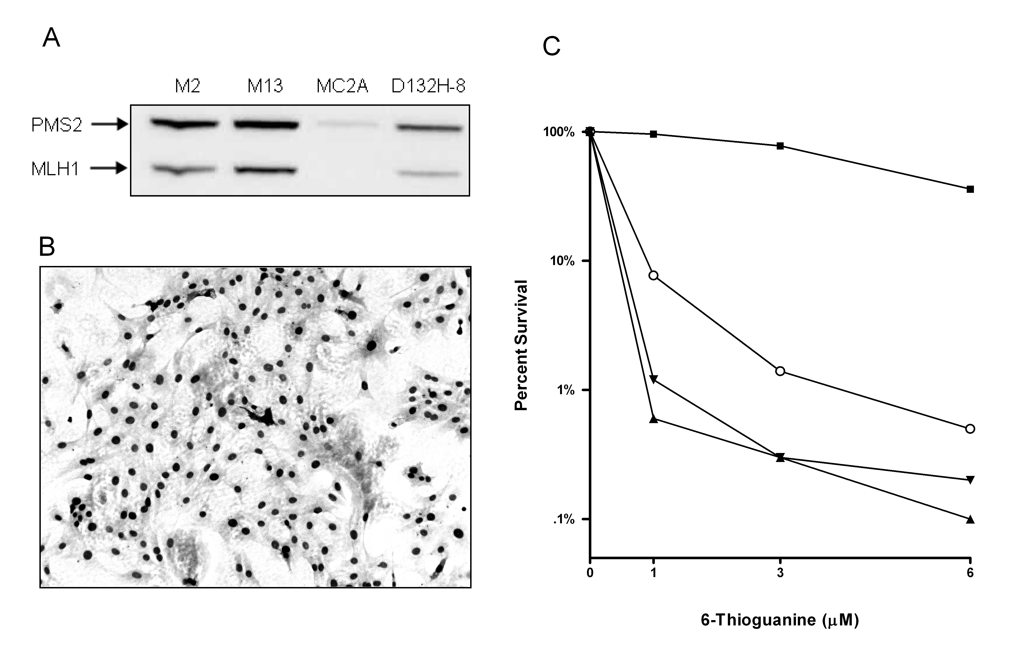
Figure 4. D132H expression and sensitivity to 6-TG exposure. (A) Western blot analysis of MLH1 and PMS2 expression from various transfected cell lines; 20 μg of protein was loaded per sample. MC2A is an mMlh1-/- cell line; M2 and M13 are mMlh1 -/- cell lines transfected with hMLH1 cDNA. (B) Immunohisto-chemistry of D132H-8 cells (C) Cytotoxic response of transfected cell lines after 24 hour exposure to varying doses of 6-Thioguanine. MC2A (), D132H-8 (○), M2 (▲), and M13 (▼); vertical error bars were excluded for clarity and did not exceed a half-log range.

The forward mutation rate to ouabain-resistance (41) of D132H-expressing expressing cells was determined by fluctuation assay (25, 36). Two separate assays on D132H-8 cells at approximately the same number of passages post transfection were performed. The calculated mutation rates from both assays were averaged, and presented in Table 2. Expression of D132H in Mlh1 -/ - MEFs reduced mutation rates to levels similar to those observed previously for MEFs expressing wildtype MLH1 (36). As mutation to ouabain resistance generally requires base substitutions, these data suggest that D132H is proficient in the repair of base/base mismatches.

Table 1. Expression of D132H reduces mutation rates in MLH1-deficient MEFs

Cell line Base substitution mutation rate (X 10⁻⁷) ^{A}

Wildtype ^{B} < 2

mMlh1 -/- + vector ^{C} 60

mMlh1 -/- + hMLH1 ^{C} < 1 – 2

mMlh1 -/- + hMLH1 D132H ^{D} < 1

^{A} Mutation rates (mutations/cell/generation) were calculated as described in materials and methods (39).
^{B} Rates calculated previously (39).
^{C} Rates calculated previously (36).
^{D} Mutation rate represents the combined results of two separate measurements of the D132H-8 cell line.

Overall, D132H appeared to act similar to wildtype MLH1 in a variety of functional assays. When expressed at levels comparable to (although slightly less than) wildtype MLH1 in Mlh1 deficient MEFs, D132H was able to increase PMS2 abundance, reduce mutation rates, and restore the MMR dependent cytotoxic response to 6-TG. Together, these results suggest that D132H does not dramatically interfere with MLH1 functions. However, the difficulty in obtaining multiple clones with high D312H expression suggested that the D132H mutation may have an on affect MLH1 protein stability.

Restoration of MMR Activity in Pooled Cell Lines Expressing hMLH1

The length amount of time associated with selecting and evaluating clonal lines, as well as the limited number of lines that can be simultaneously evaluated due to logistical considerations, provided the motivation to develop a new method for evaluating MLH1 mutants. In the approach developed, stable transfections were performed as previously described (36), but rather than selecting individual colonies for functional assays, a large number of G-418 resistant colonies (approximately 30-50, of which a significant majority presumably express MLH1) were pooled together for further experiments. In several previous transfections with wildtype MLH1, significant expression was detected in ≥90% of analyzed clones ((36), data not shown). We hypothesized that this approach, using the wildtype Mlh1 cDNA would result in a restoration of MMR activity in pooled cultures, despite the inevitable presence of non-expressing subpopulations.
We first attempted this approach using transfections of wildtype Mlh1 cDNA with and without the 5’ untranslated region (UTR) to determine if the 5’ UTR plays a role in stabilizing MLH1 expresison levels, as was suggested by some preliminary data (data not shown). Whole cell lysates made at the time of pooling and approximately 20 days after pooling showed no difference in average expression between MLH1 in cell lines with or without the 5’ UTR (Figure 5A). In fact, expression was generally slightly increased over the course of the experiment. The decrease in expression was correlated with a loss of MMR activity in various functional assays (see below, Figure 6, Table 2). To analyze the variation in expression of MLH1 in individual cells in the pooled cultures, IHC was performed. As expected, there were distinct subpopulations of cells with high, medium and low MLH1 expression; however, most cells appeared to express wildtype MLH1. A representative IHC image is shown in Figure 4B. In one pooled culture (hMLH1 + 5’ UTR #1), there was a significant decrease in MLH1 expression during the 20 days of growth throughout the population, suggesting that with the pooling approach such populations will arise occasionally. The loss of expressing in hMLH1 + 5’ UTR #1 was confirmed by IHC (not shown)
<<,We measured the response to 6-TG for each of the pooled cell lines to determine if the pooling approach with wildtype MLH1 restores sensitivity to cytotoxic agents similar to stably-expressing clonal lines. Cells were exposed to varying doses of 6TG for 24 hours and surviving cells, were allowed to expand to visible colonies. Despite the variable expression of MLH1 throughout the cell population (Figure 4B), a strong response to 6TG was observed at 1 μM 6-TG in most of the pooled cultures (Figure 5); in the +5’ UTR #1 cell line, which had low expression (Figure 4A) and variable MLH1 expression throughout the population (data not shown), the cytotoxic response was similar to that of the Mlh1 -/- parent cells (MC2A) (data not shown).

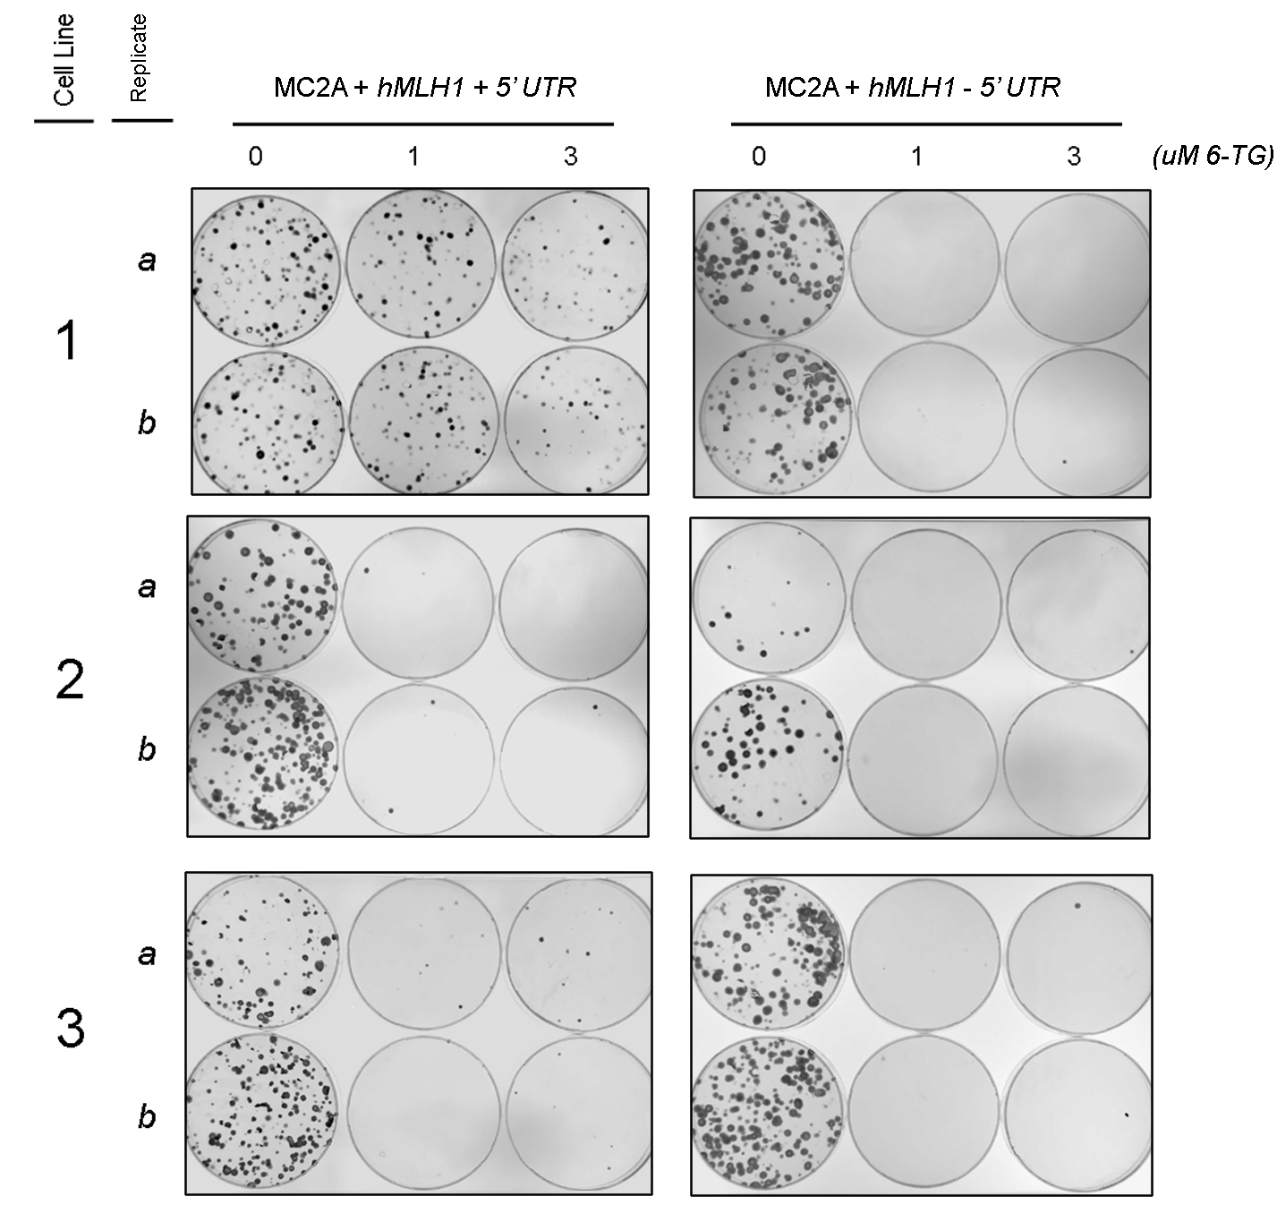

Figure 6. The MMR dependent response to the cytotoxic agent 6TG is restored in cell lines generated by pooling colonies of Mlh1 -/- MEFs transfected with hMLH1 cDNA. Cytotoxic response to 6TG was measured in duplicate (a,b) in each of the 6 MLH1-expressing cell cultures generated by colony pooling (3 with the 5’ UTR and 3 without the 5’ UTR) at doses of 0, 1, and 3 μM 6-TG.

To determine if expression of wildtype MLH1 in pooled cultures would reduce base substitution mutation rates, forward mutation assays (resistance to ouabain) were performed. Cells from an 80% confluent T75 flask (passage 3) were plated directly into ouabain without prior subdivision as in a fluctuation assay. We reasoned that growth of the culture from initial G-418-resistant to the expansion following pooling would approximate the initial growth period in a fluctuation assay. Calculation of mutation rates did not seem appropriate, given the variable expressivity of the population; however, mutant frequencies were calculated to estimate the phenotypic effects of MLH1 expression (Table 2). On average, mutant frequencies were much lower than expected for MLH1 deficient cell lines (on average ~100 x 10⁻⁷). A high mutation frequency observed in a one of the cultures (+5’ UTR #1 ) was consistent with low overall expression of MLH1 in the cell population. Together, the data indicate the expression of MLH1 in pooled cultures is generally high enough in a sufficient percentage of the population for the culture to phenotypically behave as MMR-proficient. Thus, this approach should allow for evaluation of phenotypic consequences of MLH1 mutations.

Table 2. Spontaneous ouabain^{R} mutant frequencies in cell cultures generated by pooling colonies of Mlh1 -/- MEFs transfected with hMLH1 cDNA

Cell line Mutant Frequency (X 10⁻⁷) ^{A}

Mlh1 -/- + hMLH1 + 5’ UTR
1 183 ^{B}
2 4
3 6
Mlh1 -/- + hMLH1 - 5’ UTR
1 2
2 3
3 18

^{A} Mutant frequencies were calculated by dividing the number of ouabain resistant mutant colonies by the adjusted number of cells plated as determined by plating efficiency measurements.
^{B} As noted in Figure 4, this cell line contained an abnormally large population of non MLH1 expressing cells.

Functional Analyses of the MLH1 Mutants D132H and K616Δ in Pooled Cultures

The pathogenicity and mechanism of pathogenicity of the MLH1 mutants D132H and K616Δ is unknown or in dispute. To identify the pathogenic mechanism of these two MLH1 mutants, we performed stable transfections and pooling assays with hMLH1 cDNAs engineered to express the two mutants. In addition, we included positive and negative controls of wildtype hMLH1 cDNA and vector without cDNA (CMV), respectively. Cells transfected with each expression vector (MLH1, D132H, K616Δ, CMV) were plated on 6 P150s, selected with G-418, and surviving colonies were pooled into 6 independent cultures for functional assays as described in the previous section. The transfections and functional assays were performed twice, generating a total of 12 pooled cell lines for each of the expression vectors analyzed.
To determine the effects of the K616Δ and D132H mutations on MLH1 expression and their ability to stabilize PMS2 levels, whole cell lysates were generated from each of the pooled cultures and expression of MLH1 and PMS2 was analyzed by quantitative western blotting (Figure 7). Unpaired, two tailed t-tests were used to evaluate differences in average expression; curve fitting was used to evaluate the ability of the MLH1 mutants to rescue PMS2 abundance (Prism 4.00, Graphpad Software).
The difference in average expression of D132H relative to wildtype MLH1 was not significant (P=0.168); however, expression of K616Δ was significantly decreased (P<0.0001) relative to wildtype. No MLH1 expression was detected in CMV cultures (data not shown). In wildtype MLH1 expressing cells (Figure 7C, □, solid curve), PMS2 abundance was increased with MLH1 as expected. A similar pattern was seen for D132H (Figure 7C, ○, dashed line); although levels of D132H were not sufficient to observe an inflection point in the curve of PMS2 expression. We were unable to evaluate whether expression of K616Δ (Figure 7C, ▲, solid line) could stabilize levels of PMS2, due to the low expression of K616Δ in the pooled cultures.
IHC for MLH1 was also performed for each of the cell cultures analyzed. Images from representative cultures are shown in Figure 8. Consistent with western blot results, MLH1 expression was not detected in CMV (vector only-transfected) cultures (upper left). MLH1 Expression was consistently high throughout MLH1 cultures (upper right), and D132H cultures had a pattern of expression similar to MLH1 cultures (lower left). MLH1 was poorly expressed in all 12 of the K616Δ pooled cultures (lower right).

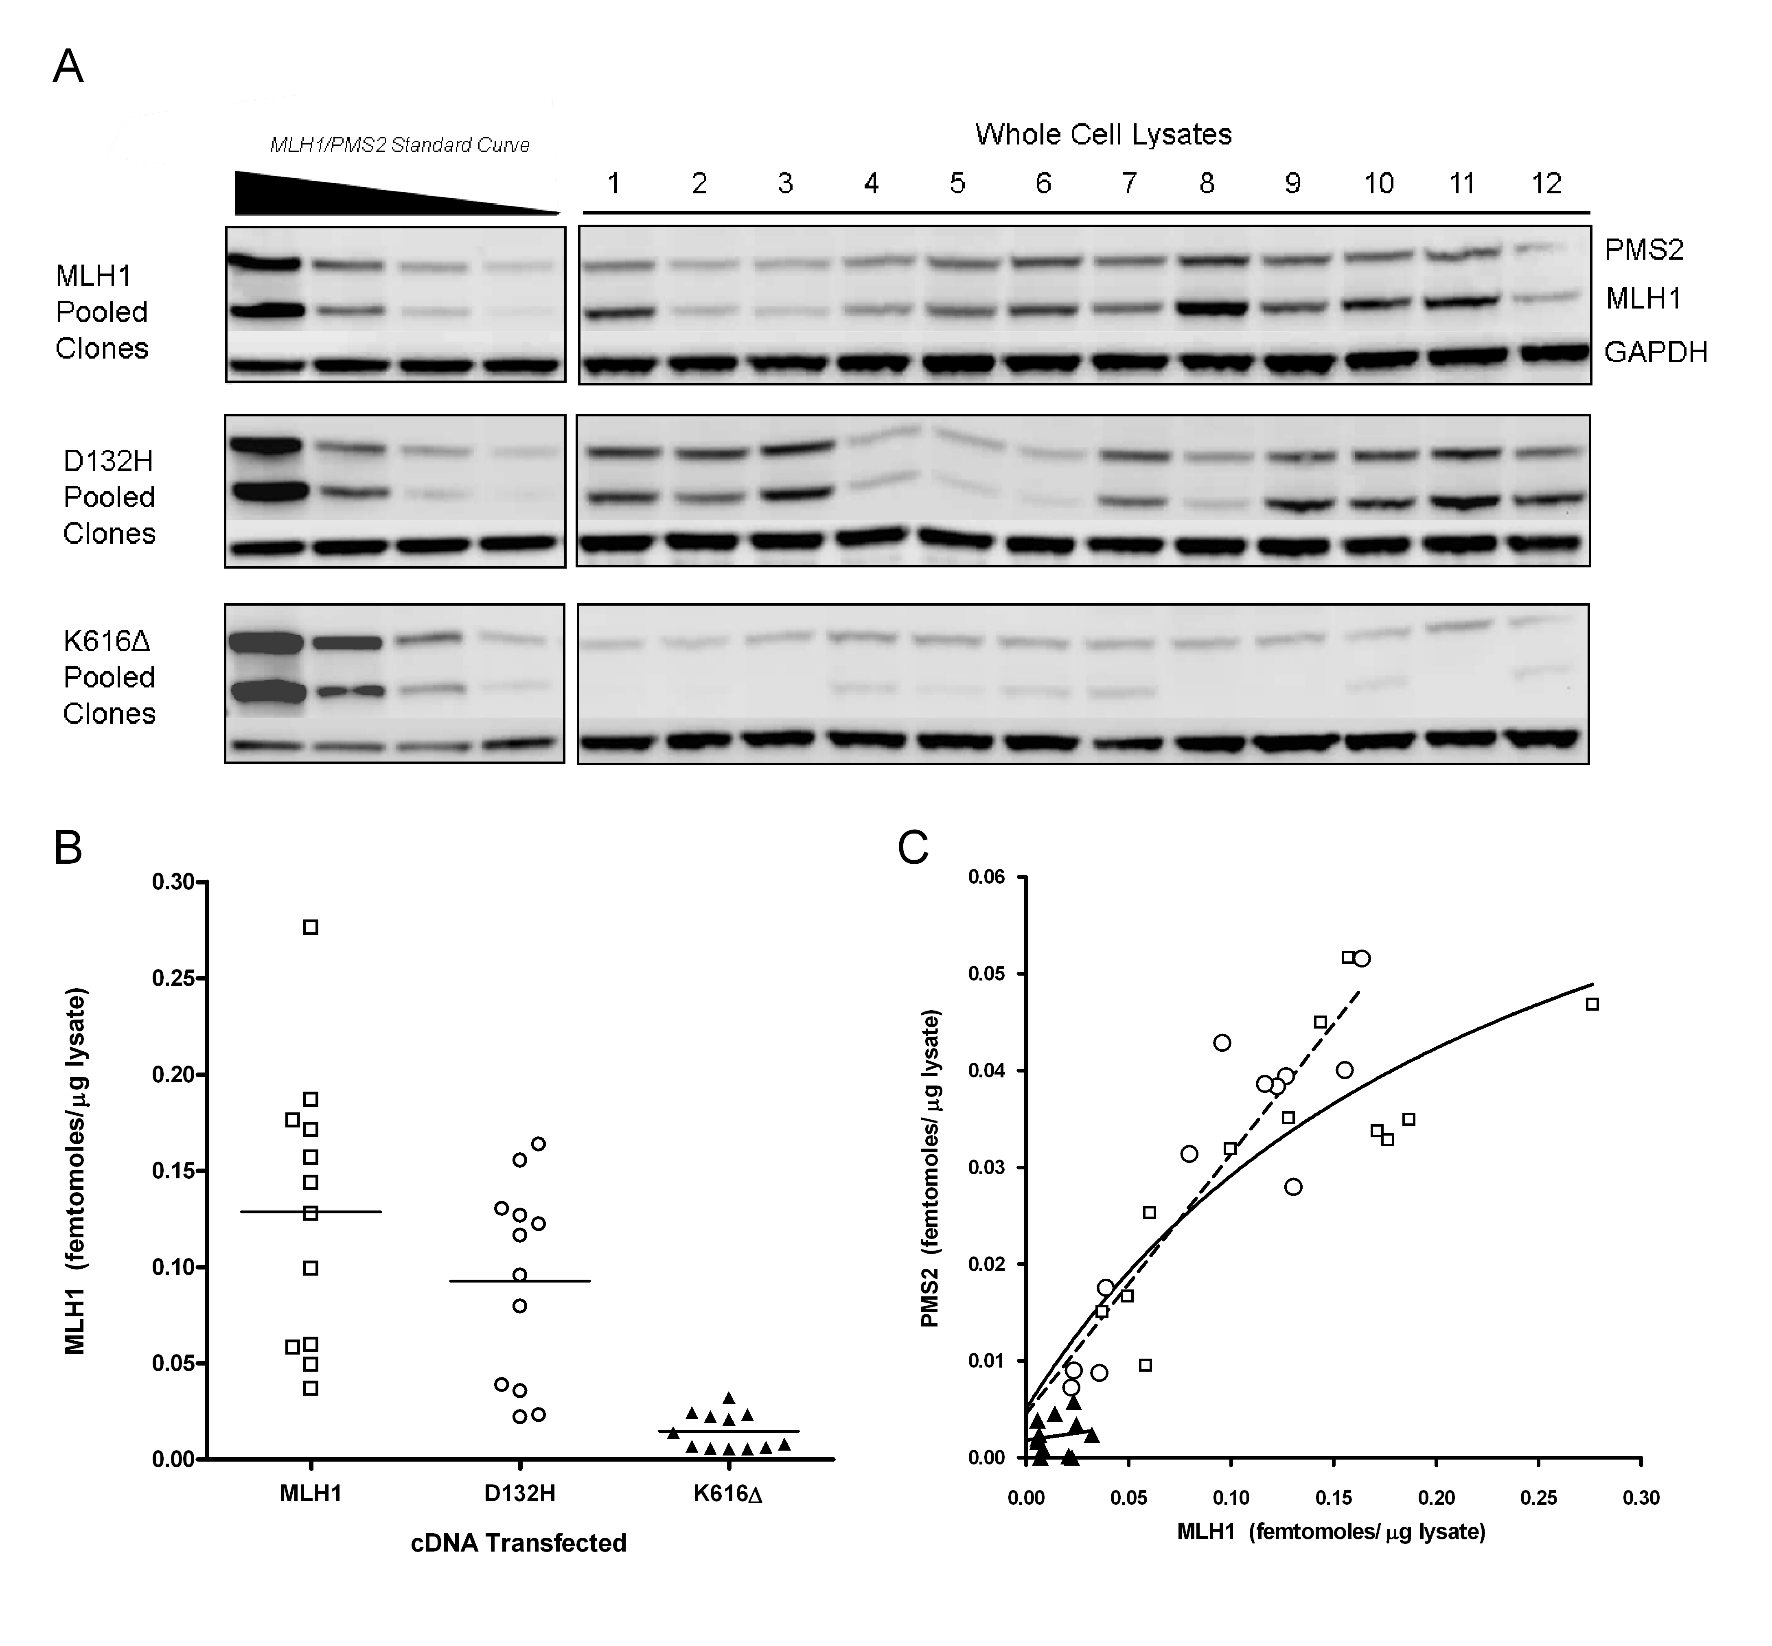
Figure 7. In vivo expression of the MLH1 variants D132H and K616Δ in transfected Mlh1 -/- MEFs. (A) Western blot of 25 μg of whole cells lysate (WCL) from 12 pooled transfection cultures expressing wildtype MLH1 (□), D132H (○), or K616Δ(▲); standard curves were created by diluting a whole cell lysate containing wildtype MLH1 cells, of which the concentrations of MLH1 and PMS2 had been previously determined. GAPDH was used to confirm to even protein loading (B) Plot showing the abundance of MLH1 from 12 pooled transfections in femtomoles/μg of protein lysate; averages are shown as horizontal bars. Values represent averages obtained from two western blot experiments with the same lysates. (C) Plot of MLH1 abundance versus PMS2 abundance in WCL from pooled transfections.

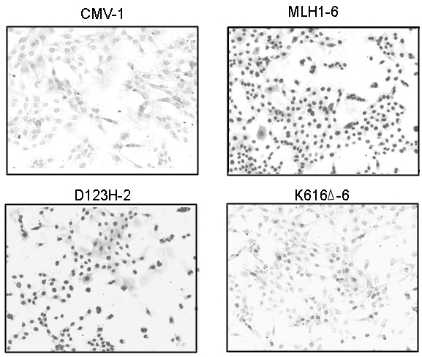

Figure 8. Immunohistochemistry staining of representative pooled cell lines with hMLH1 antibody. CMV1 (vector only transfected), upper left; MLH1-6, upper right; D132H-2, lower left; and K616Δ-6 cells, lower right.

To determine the ability of the MLH1 variants D132H and K616Δ to function in MMR-dependent error correction in vivo, mutant frequencies, as determined by resistance to ouabain, were measured (Figure 9A). Qualitative comparisons of mutant frequencies for each of the expression vectors analyzed were performed to asses the phenotypic consequences of the various MLH1 mutants analyzed. For wildtype-MLH1 and CMV controls, mutant frequencies in wildtype-MLH1 cultures were generally lower, certainly on average, but there is an overlap. Wildtype-MLH1 frequencies appeared higher than expected from fluctuation assays with stable lines, consistent with some non-expressing cells in the population. In D132H cultures, mutation frequencies were also lower, on average, than CMV; the two D132H cultures with higher frequencies were from cultures with lower expression. Consistent with results obtained from analysis of the clonal D132H-8 line, D132H, with sufficient expression, was able to suppress mutant accumulation, indicating that it is active in MMR. Mutant frequencies of K616Δ cultures were similar to CMV, which was consistent with the very low expression in cultures.
Response to 6-TG for 6 cultures each was measured at a 1 μM (Figure 9B), as this dose produced a significant response in wildtype cells in initial assays (Figure 6). As expected, MLH1 deficient MEFs were not sensitive to 6-TG, while cells transfected with wildtype MLH1 were highly sensitive. Generally, expression of D132H restored the MMR dependent cytotoxic response in transfected MLH1 deficient MEFs (one data point with ~100% survival contained a large population of non-expressing cells at the time of the assay). K616Δ cell lines, which had an extremely low average abundance of MLH1 (Fig 5B) exhibited a poor response to 6TG exposure, similar to CMV.

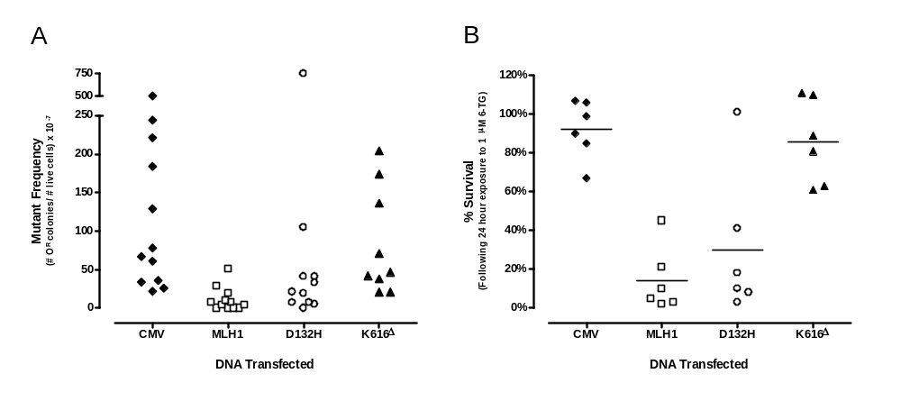
Figure 9. Phenotypic consequences of D132H and K616Δ expression in mMlh1 -/- MEFs. (A) Mutant frequencies (number of ouabain resistant colonies (O^{R})/number of live cells) were determined from 12 pooled transfection sets for CMV vector (♦), wildtype MLH1 (□), D132H (○), and K616Δ (▲). (B) Cytotoxic response of 6 pooled transfection sets for CMV vector (♦), wildtype MLH1 (□), D132H (○), and K616Δ (▲) after 24 hour exposure to 1 μM 6-TG. Averages are represented by horizontal bars.

These results suggest that K616Δ is poorly expressed in cells, and that this poor expression results in a phenotype consistent with MMR deficiency. Conversely, average expression of D132H was slightly, but not significantly, reduced. Functional assays indicated that D132H stabilized PMS2 as well as wildtype MLH1, reduced ouabain^{R} mutant frequencies relative to MLH1 deficient controls, and increased sensitivity to the cytotoxic agent 6-TG, all of which are consistent with proficient MMR activity.

In vitro repair activity of D132H

Functional analyses of the MLH1 variant D132H did not uncover a mechanism to explain its role in causing Lynch syndrome. We hypothesized that D132H might have a previously unidentified role in substrate specificity. To test this hypothesis, we created cytoplasmic extracts from wildtype MLH1 and D132H expressing cells (MLH1- 5’ UTR #3 and the clonal D132H-8 line, respectively) and performed in vitro repair reactions (Figure 10A) with mismatch containing substrates (Figure 11B). Plasmid substrates containing a G/T base mismatch, modeling a replication error that would generate a base substitution, or a CT loop, modeling a replication error that would generate an insertion or deletion similar to microsatellite instability (Figure 10B), were created and their purity were determined by agarose gel electrophoresis (Figure 11A). Repair reactions were incubated for 15 minutes to allow saturation of activity, and results were analyzed by analytical gel electrophoresis (Figure 11C). Repair was ~10% in all reactions, and D132H did not appear to discriminate between base mismatch and loop substrates. Repair activity was not observed in reactions lacking MLH1 protein (data not shown). While these results are preliminary, and do not exclude the possibility that D132H may alter the kinetics of repair at earlier time points or act differently in vivo, they suggest that the absence of MSI in cases of Lynch syndrome is not due to a differential specificity of D132H towards mismatch substrates.

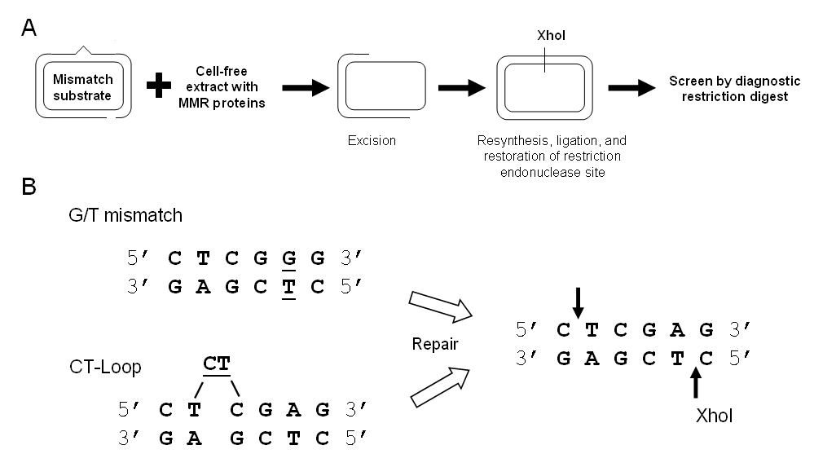
Figure 10. In vitro mismatch repair assay. (A) Steps of the in vitro mismatch repair reaction. (B) Sequence of the G/T and CT-Loop mismatch substrates (mismatch is underlined). Successful repair of either substrate results in the restoration of the recognition sequence for Xho1.

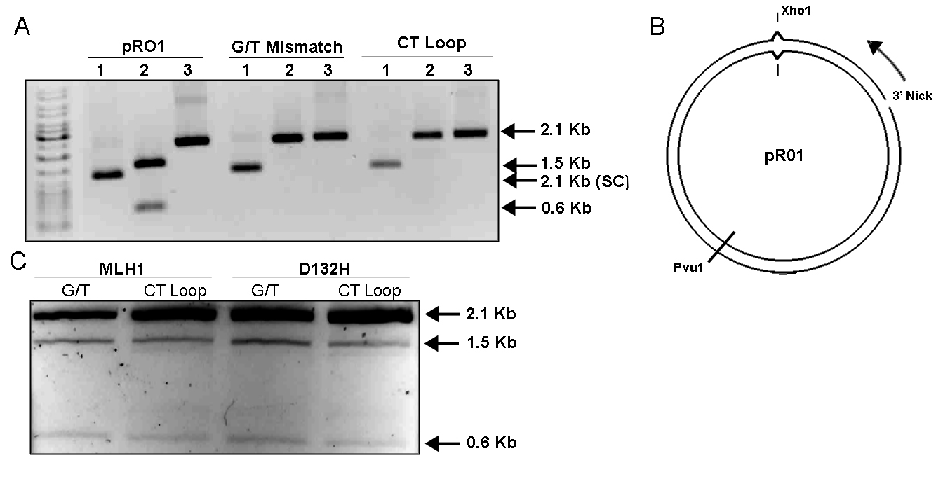

Figure 11. The MLH1 D132H variant has repair activity similar to wildtype. (A) 1 – supercoiled (SC) plasmid. 2 – Xho1/Pvu1 restriction digestion. 3 – N.BbvC 1B nicking digestion. G/T and CT loop mismatch substrates had no visible contamination. (B) Schematic diagram of the mismatch substrate. Repair associated excision is initiated from the 3’ nick in the indicated direction. The mismatch destroys the Xho1 recognition site; unrepaired substrates become single linear fragments at 2.1 Kb in a Xho1/Pvu1 digest; successful repair results in restoration of the Xho1 site and 2 linear fragments (1.5, 0.6 Kb) in a Xho1/Pvu1 digest. (C) Repair reactions containing approximately equivalent concentrations of MLH1 or D132H (data not shown) were carried out for 15 min to saturate repair activity.

DISCUSSION

DNA mismatch repair (MMR) is an evolutionary conserved process that functions to maintain genomic integrity by correcting mismatches that have escaped proofreading during replicative DNA synthesis. Several additional functions, such as cell cycle checkpoint regulation and apoptosis signaling also have been attributed to MMR. MMR deficiency has been implicated in sporadic and hereditary cancers, greatly intensifying research of MMR in the past decade. One such hereditary cancer that has been identified and studied is Lynch syndrome (hereditary non-polyposis colorectal cancer), which accounts for approximately 5% of all colorectal cancers. Approximately 90% of all Lynch syndrome cases can be attributed to mutations in two MMR genes, Msh2 and Mlh1 (20, 42). Research in the Buermeyer lab is focused on MLH1, in which over 150 germline mutations have been identified in humans. While many of the mutations of MLH1 have been linked Lynch syndrome as discussed above, the pathogenicity and pathogenic mechanisms of these mutations are unknown or in dispute. Determination of these mechanisms may aid in the development of new screening and treatment strategies.
Detection of MMR deficient cancers is especially important, as they may respond adversely to chemotherapeutic treatment strategies. The symptoms of Lynch syndrome are often not detected until late in carcinogenesis, making early detection important. Two common screening methods are currently used to detect MMR deficient cancers. IHC analysis makes use of the fact the MMR deficient cancers can show a loss of expression of certain MMR proteins, commonly MLH1 or MHS2. The inability of MMR deficient cancers to repair IDLs often leads to MSI, a hallmark of such cancers, thus making MSI detection a very useful screening tool. One can easily imagine the consequences of mutations in MMR genes that confer increased cancer risk but are not detectable by either of these two common screening methods. Indeed, four such MLH1 mutants (E578G, K618A, V716M, and D132H) have been identified in cases of HNPCC that do not have the levels of MSI typically associated with Lynch syndrome; how this occurs is currently unknown and is a matter of dispute.
For the present study, we were interested in the understanding the pathogenic mechanism of D132H, as it is located in a different region of the MLH1 protein from the other three mutations and may represent a new class of previously unidentified MLH1 mutation. Two general possibilities for how D132H may confer an increased cancer risk were imagined. First, the mutation may reduce the expression of the protein and thus limit the amount of MutLα available in vivo. Second, the mutation may not be proficient in one or more MMR functions, such as reducing mutation rate or inducing apoptosis in response to DNA damaging cytotoxic agents. Initially, we used a stable transfection approach as described in (36) to perform functional assays on MEFs expressing D132H. Difficulty in obtaining a clonal line expressing high levels of D132H hinted that protein expression may be affected by the mutation. However, two determinations of forward mutation rate of cells with the best expression of D132H indicated that D132H was able to reduce base substitution mutation rates as well wildtype MLH1. Further, these cells were sensitive to the cytotoxic agent 6-TG, suggesting that D132H is proficient in inducing apoptosis similar to wildtype.
Feeling that analysis of only one cell line would be insufficient to establish a mechanism to explain the pathogenicity of D132H, and hindered by the length of time to complete the required experiments, we developed a new assay, based on the methods described in (36), in order to quickly sample a larger data set. In this assay, a large number of transfected colonies were pooled into cultures and a variety of functional assays were subsequently performed within a 4 week time course. Results from the functional assays on pooled cultures with wildtype MLH1 indicated that MMR activity could be restored in pooled cultured of MLH1 expressing cells, despite the presence of subpopulations that do not express MLH1. Analysis of the results of pooled cultures (wildtype and mutant MLH1) should consist of two stages. First, average expression of the protein should be indicative of stability of the protein in vivo. Conveniently, the variation of expression in different cultures should also allow for evaluation of MLH1 variants to stabilize PMS2. The second stage of analysis pertains to functional assays. The phenotypic consequences of an MLH1 mutant can be observed by observing both average effects in all of the pooled cultures. Alternatively, the results from a single pooled culture with a desired level of MLH1 expression can be dissected from amongst the data to evaluate specific effects of the mutant. Thus, the occurrence of pooled cultures that, for some reason, have a large population of non expressing cells, are not problematic and indeed, may provide insight into the nature of the pathogenic mechanism of a mutant. The short time course of this approach, as compared to the time needed for isolation and analysis of clonal lines as in (36), allows for quick and effective analysis of a variety of candidate pathogenic mechanisms.

Having developed an assay that appeared to quickly and accurately provide information on a variety of potential pathogenic mechanisms, we analyzed the phenotypic consequences of D132H expression in vivo using positive (wildtype MLH1) and negative (vector only) controls. Assays were also performed for the mutant K616Δ, for which a pathogenic mechanism has been proposed (23), and the results of these experiments are discussed later. For D132H, our results indicated that on average, expression of D132H was slightly but not significantly, decreased; failure to detect a difference may have been due to the limited number of sample sets or, more likely, that the D132H mutation does not significantly affect protein expression. Previous work in the Buermeyer lab using transient transfections with D132H also indicate that the mutant is well expressed and is able to stabilize PMS2 (unpublished data); measurements of PMS2 and MLH1 abundance in our assay suggested a similar proficiency of D132H in PMS2 stabilization. These results are consistent with the mutation not affecting the primary heterodimer interaction domain (amino acids 506-756). Functional assays on pooled cell cultures expressing D132H indicate that the mutant is able to restore MMR activity to levels similar to wildtype MLH1. This was consistent with our results from functional analyses of a stable clonal line expressing D132H. We did not measure levels of MSI, although such measurements may provide information as to the frequency at which MSI occurs in D132H-expressing cells.
Having shown that D132H was not deficient in MMR activity by the limits of our detection, we attempted to identify a biochemical pathway to explain the curious presence of Lynch syndrome cancers that do not give rise to MSI. We hypothesized that D132H may alter a previously unidentified role of MLH1 in substrate discrimination. Our hypothesis was further strengthened by the recent findings in yeast, identifying two mutations in PMS1 (PMS2 in mammals) that preferentially interfere with the repair of primer strand loops, but not base mismatches, during DNA replication (34), which suggests that MutLα may play a role in substrate specificities in MMR. Using synthetic substrates modeling mismatches that lead to base substitution mutations or MSI, we performed in vitro repair assays. While our preliminary results, do not take into account time courses or potential effects of MLH1 abundance, they suggest that D132H does not discriminate between different mutations and results in repair of both substrate types with equal efficiency.
These results disagree somewhat with those of a previous study performed by Lipkin, et. al (32) who reported that the ATPase activity of D132H, as determined by an in vitro GST fusion protein assay, is attenuated. Given the important role of the ATPase activities in MLH1, and the fact that mutations affecting the ATPase activity result in decreased repair efficiency and thus higher mutation rates (26), we expected the in vivo activities of D132H to be attenuated as well; however, this was not the case. . Further, the aspartic acid amino acid 132 is highly conserved among mammals, suggesting an importance of the residue. However, in our functional assays in mammalian cells, we were unable to detect a significant deficiency in MMR associated with D132H, It may be that even though the ATPase activity of D132H is impaired, the level of activity is sufficient for in vivo MMR repair.
The late average age of cancer onset (~70 years old, compared with 20-40 with classic Lynch syndrome mutations) in patients with D132H-associated Lynch syndrome, along with the observation that such cancers are more consistent with sporadic cancers, supports the idea that D132H has a modest (and undetectable by our assay) effect on protein expression or repair activity, both of which could result in a weak mutator phenotype. The proposed, modest decrease in repair activity may also explain the lack of MSI observed in most of the D132H-associated cases of Lynch syndrome. The late age of onset is consistent with an increased length of time required to accumulate the mutations necessary for carcinogensis due to modest increase in mutation rate, and the presence of MSI in some individuals with D132H may have arisen from defects in additional MMR genes. We cannot dismiss the possibility that the D132H mutation affects some previously unidentified MMR function that confers the increased risk and lack of MSI associated with the observed cancers.
Our results indicate the D132H is not overtly pathogenic through any pathogenic mechanism analyzed. If D132H does indeed confer clinically significant cancer risk, our results indicate that screening methods should be revised. In our model system, D132H was expressed as well as wildtype in both western blot and IHC results, and thus IHC screening of cancerous cells from patients would likely be useless in the detection of a D132H-associated cancer. The D132H mutation may represent a previously unidentified class of pathogenic MLH1 mutations that do not cause MSI and may be well expressed in vivo. If this is indeed the case, screening for MMR deficient cancers by sequencing of MMR genes may be justified.
We also examined the phenotypic consequences of expression of K616Δ with the pooling assay. The pathogenicity of K616 Δ has been established (23, 24); however, there is disagreement in the literature as to the mechanisms of pathogenicity. Using an in vitro MLH1/PMS2 interaction assay, Guerrette et. al (23) showed that K616Δ has a >95% reduction in its ability to bind PMS2. Previous work in the Buermeyer lab with transient transfections capable of expressing K616Δ in vivo at high levels did not observe such a decrease; in fact, K616Δ appears to rescue PMS2 levels almost as well as wildtype MLH1 (unpublished data). A more recent study by Raevaara et. al.(24) showed that K616Δ has in vitro repair activity equivalent to wildtype-MLH1, but that the expression of K616Δ is greatly decreased or not-detectable in vivo, as assessed by immunohistochemistry of Lynch syndrome cancers with the K616Δ mutation. Interestingly, several cancers expressing K616Δ were identified that did not have MSI. In the present study, we observed a significant decrease in the ability of MEFs transfected with K616Δ cDNA to express MLH1, and that this decrease in expression produced a phenotype consistent with MLH1 deficient cells. These results are consistent with previous findings that K616Δ is pathogenic due to a decrease in MutLα abundance, and show for the first time the phenotypic effects of in vivo K616Δ expression. Measurement of the half-life of K616Δ may help to elucidate the exact pathogenic mechanism of this mutant.
Future determination of the structure of MLH1, combined with data from functional assays such as the one presented in this study, should greatly enhance our abilities to understand the pathogenic mechanisms and cancer risk associated with mutations of MLH1.

BIBLIOGRAPHY

(1) Aaltonen, L. A., Peltomaki, P., Leach, F. S., Sistonen, P., Pylkkanen, L., Mecklin, J. P., Jarvinen, H., Powell, S. M., Jen, J., Hamilton, S. R., and et al. (1993) Clues to the pathogenesis of familial colorectal cancer. Science 260, 812-6.

(2) Ionov, Y., Peinado, M. A., Malkbosyan, S., Shibata, D., and Perucho, M. (1993) Ubiquitous somatic mutations in simple repeated sequences reveal a new mechanism for colonic carcinogenesis. Nature 260, 558-561.

(3) Peinado, M. A., Malkhosyan, S., Velazquez, A., and Perucho, M. (1992) Isolation and characterization of allelic losses and gains in colorectal tumors by arbitrarily primed polymerase chain reaction. Proc Natl Acad Sci U S A 89, 10065-9.

(4) Peltomaki, P., Lothe, R. A., Aaltonen, L. A., Pylkkanen, L., Nystrom-Lahti, M., Seruca, R., David, L., Holm, R., Ryberg, D., Haugen, A., and et al. (1993) Microsatellite instability is associated with tumors that characterize the hereditary non-polyposis colorectal carcinoma syndrome. Cancer Res 53, 5853-5.

(5) Strand, M., Prolla, T. A., Liskay, R. M., and Petes, T. D. (1993) Destabilization of tracts of simple repetitive DNA in yeast by mutations affecting DNA mismatch repair. Nature 365, 274-6.

(6) Thibodeau, S. N., Bren, G., and Schaid, D. (1993) Microsatellite instability in cancer of the proximal colon. Science 260, 816-9.

(7) Buermeyer, A. B., Deschenes, S. M., Baker, S. M., and Liskay, R. M. (1999) Mammalian DNA mismatch repair. Annu Rev Genet 33, 533-64.

(8) Kunkel, T. A., and Erie, D. A. (2005) DNA mismatch repair. Annu Rev Biochem 74, 681-710.

(9) Jiricny, J. (1998) Replication errors: cha(lle)nging the genome. Embo J 17, 6427-36.

(10) Modrich, P., and Lahue, R. (1996) Mismatch repair in replication fidelity, genetic recombination, and cancer biology. Annu Rev Biochem 65, 101-33.

(11) Hays, J. B., Hoffman, P. D., and Wang, H. (2005) Discrimination and versatility in mismatch repair. DNA Repair (Amst) 4, 1463-74.

(12) Yang, W. (2006) Poor base stacking at DNA lesions may initiate recognition by many repair proteins. DNA Repair (Amst).
(13) Cannavo, E., Marra, G., Sabates-Bellver, J., Menigatti, M., Lipkin, S. M., Fischer, F., Cejka, P., and Jiricny, J. (2005) Expression of the MutL homologue hMLH3 in human cells and its role in DNA mismatch repair. Cancer Res 65, 10759-66.

(14) Prolla, T. A., Pang, Q., Alani, E., Kolodner, R. D., and Liskay, R. M. (1994) Interactions between the MSH2, MLH1 and PMS1 proteins during the initiation of DNA mismatch repair. Science 265, 1091-1093.

(15) Umar, A., Buermeyer, A. B., Simon, J. A., Thomas, D. C., Clark, A. B., Liskay, R. M., and Kunkel, T. A. (1996) Requirement for PCNA in DNA mismatch repair at a step preceding DNA resynthesis. Cell 87, 65-73.

(16) Wang, H., and Hays, J. B. (2002) Mismatch repair in human nuclear extracts. Quantitative analyses of excision of nicked circular mismatched DNA substrates, constructed by a new technique employing synthetic oligonucleotides. J Biol Chem 277, 26136-42.

(17) Lee, S. D., and Alani, E. (2006) Analysis of interactions between mismatch repair initiation factors and the replication processivity factor PCNA. J Mol Biol 355, 175-84.

(18) Zhang, Y., Yuan, F., Presnell, S. R., Tian, K., Gao, Y., Tomkinson, A. E., Gu, L., and Li, G. M. (2005) Reconstitution of 5'-directed human mismatch repair in a purified system. Cell 122, 693-705.

(19) Mendelsohn, J. (2001) The molecular basis of cancer, 2nd ed., Saunders, Philadelphia, PA.

(20) Bronner, C. E. (1994) Mutation in the DNA mismatch repair gene homologue hMLH1 is associated with hereditary nonpolyposis colon cancer. Nature 368, 258-261.

(21) Fishel, R., and Kolodner, R. D. (1995) Identification of mismatch repair genes and their role in the development of cancer. Curr Opin Genet Dev 5, 382-95.

(22) Peltomaki, P. (2003) Role of DNA mismatch repair defects in the pathogenesis of human cancer. J Clin Oncol 21, 1174-9.

(23) Guerrette, S., Acharya, S., and Fishel, R. (1999) The interaction of the human MutL homologues in hereditary nonpolyposis colon cancer. J Biol Chem 274, 6336-41.

(24) Raevaara, T. E., Vaccaro, C., Abdel-Rahman, W. M., Mocetti, E., Bala, S., Lonnqvist, K. E., Kariola, R., Lynch, H. T., Peltomaki, P., and Nystrom-Lahti, M. (2003) Pathogenicity of the hereditary colorectal cancer mutation hMLH1 del616 linked to shortage of the functional protein. Gastroenterology 125, 501-9.
(25) Mohd, A. B., Palama, B., Nelson, S. E., Tomer, G., Nguyen, M., Huo, X., and Buermeyer, A. B. (2006) Truncation of the C-terminus of human MLH1 blocks intracellular stabilization of PMS2 and disrupts DNA mismatch repair. DNA Repair (Amst) 5, 347-61.

(26) Tomer, G., Buermeyer, A. B., Nguyen, M. M., and Liskay, R. M. (2002) Contribution of human mlh1 and pms2 ATPase activities to DNA mismatch repair. J Biol Chem 277, 21801-9.

(27) Aaltonen, L. A., Peltomaki, P., Mecklin, J. P., Jarvinen, H., Jass, J. R., Green, J. S., Lynch, H. T., Watson, P., Tallqvist, G., Juhola, M., and et al. (1994) Replication errors in benign and malignant tumors from hereditary nonpolyposis colorectal cancer patients. Cancer Res 54, 1645-8.

(28) Das-Gupta, E. P., Seedhouse, C. H., and Russell, N. H. (2000) DNA repair mechanisms and acute myeloblastic leukemia. Hematol Oncol 18, 99-110.

(29) Vasen, H. F., and Boland, C. R. (2005) Progress in genetic testing, classification, and identification of Lynch syndrome. Jama 293, 2028-30.

(30) Aebi, S., Fink, D., Gordon, R., Kim, H. K., Zheng, H., Fink, J. L., and Howell, S. B. (1997) Resistance to cytotoxic drugs in DNA mismatch repair-deficient cells. Clin Cancer Res 3, 1763-7.

(31) Liu, T., Tannergard, P., Hackman, P., Rubio, C., Kressner, U., Lindmark, G., Hellgren, D., Lambert, B., and Lindblom, A. (1999) Missense mutations in hMLH1 associated with colorectal cancer. Hum Genet 105, 437-41.

(32) Lipkin, S. M., Rozek, L. S., Rennert, G., Yang, W., Chen, P. C., Hacia, J., Hunt, N., Shin, B., Fodor, S., Kokoris, M., Greenson, J. K., Fearon, E., Lynch, H., Collins, F., and Gruber, S. B. (2004) The MLH1 D132H variant is associated with susceptibility to sporadic colorectal cancer. Nat Genet 36, 694-9.

(33) Shin, B. Y., Chen, H., Rozek, L. S., Paxton, L., Peel, D. J., Anton-Culver, H., Rennert, G., Mutch, D. G., Goodfellow, P. J., Gruber, S. B., and Lipkin, S. M. (2005) Low allele frequency of MLH1 D132H in American colorectal and endometrial cancer patients. Dis Colon Rectum 48, 1723-7.

(34) Erdeniz, N., Dudley, S., Gealy, R., Jinks-Robertson, S., and Liskay, R. M. (2005) Novel PMS1 alleles preferentially affect the repair of primer strand loops during DNA replication. Mol Cell Biol 25, 9221-31.

(35) Thomas, D. C., Umar, A., and Kunkel, T. A. (1995) Measurement of Heteroduplex Repair in Human Cell Extracts. Methods 7, 187-197.
(36) Buermeyer, A. B., Patten, C. W.-V., Baker, S. M., and Liskay, R. M. (1999) The Human MLH1 cDNA Complements DNA Mismatch Repair Defects in Mlh1-deficient Mouse Embryonic Fibroblasts. Cancer Res 59, 538-541.

(37) Luria, S. E., Delbruck, M., and Anderson, T. F. (1943) Electron Microscope Studies of Bacterial Viruses. J Bacteriol 46, 57-77.

(38) Capizzi, R., and Jameson, J. (1973) A table for the estimation of the spontaneous mutation rate of cells in culture. Mutation Research 17, 147-148.

(39) Prolla, T. A., Baker, S. M., Harris, A. C., Tsao, J.-L., Yao, X., Bronner, C. E., Zheng, B., Gordon, M., Reneker, J., Arnheim, N., Shibata, D., Bradley, A., and Liskay, R. M. (1998) Tumour susceptibility and spontaneous mutation in mice deficient in Mlh1, Pms1 and Pms2 DMA mismatch repair. Nat Genet 18, 276-279.

(40) Wang, H., and Hays, J. B. (2000) Preparation of DNA substrates for in vitro mismatch repair. Mol Biotechnol 15, 97-104.

(41) Gupta, R. S., and Siminovitch, L. (1980) Genetic markers for quantitative mutagenesis studies in Chinese hamster ovary cells. Characteristics of some recently developed systems. Mut Res. 69, 113-126.

(42) Fishel, R. A. (1993) The human mutator gene homolog MSH2 and its association with hereditary nonpolyposis colon cancer. Cell 75, 1027-1038.

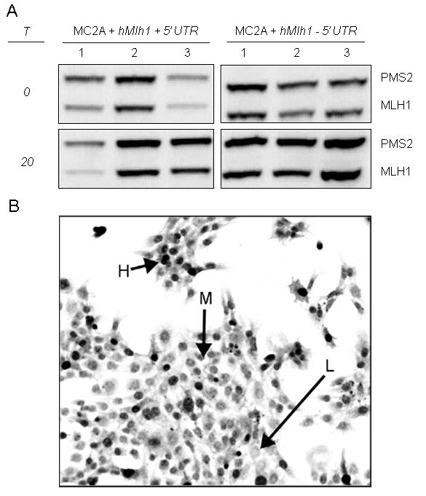

Figure 5. MLH1 expression in cell lines generated by pooling colonies from a stable transfection of hMLH1 into mMlh1 -/- MEFs. (A) Results are from two transfections with hMLH1 cDNA, one with and one without the 5’ UTR; for each transfection set, colonies from three P150 culture dishes were pooled into independent cultures. Lysates were made at the time of pooling (T=0) and at the end of the assay (T=20). Protein gels were loaded with 20 μg of protein (note: the T=0 -5’ UTR #3 sample contains 10 μg protein). (B) A representative MLH1 immunohisochemistry image of the -5’ UTR cell line. H, high expressing cell; M, medium expressing cell; L, minimal or non expressing cell.

