AN ABSTRACT OF THE THESIS OF

Adam G. Kirkpatrick for the degree of Honors Baccalaureate of Science in General Science presented on March 16, 2006. Title: Discovery and Identification of Antibacterial Agents for Dental Use.

Abstract approved:
______________________________________________________
Mark Zabriskie

Dental disease is a very prevalent and costly disease in which the symptoms, not the disease, are currently being treated. The disease is caused by pathogenic oral bacteria, many of which are a part of the Mutans Streptococci. The objective of this thesis was to find a natural substance that is antibacterial towards the Mutans Streptococci and could have possible uses as a dental disease inhibitor. Crude and prefractionated extracts, as well as purified compounds, from marine organisms were screened against Streptococcus mutans and Streptococcus sobrinus for antibacterial activity using standard antibiotic susceptibility testing. Several antibacterial extracts were identified as well as one very potent pure compound, allolaurinterol. The Minimum Inhibitory Concentration (MIC) of allolaurinterol against Streptococcus mutans and Streptococcus sobrinus was found to be 5 µg/mL and the Minimum Bactericidal Concentration (MBC) was found to be 10 µg/mL. Once the mammalian cell cytotoxicity is determined, the therapeutic window will be known and the possible use of allolaurinterol as a consumer product can be explored.

©Copyright by Adam G. Kirkpatrick
March 16, 2006
All Rights Reserved

Discovery and Identification of
Antibacterial Agents for Dental Use
by
Adam G. Kirkpatrick

A PROJECT
submitted to
Oregon State University
University Honors College

in partial fulfillment of
the requirements for the
degree of
Honors Baccalaureate of Science in General Science (Honors Scholar)

Presented March 16, 2006
Commencement September 2006
Honors Baccalaureate of Science in General Science project of Adam G. Kirkpatrick presented on March 16, 2006.

APPROVED:

________________________________________________________________________

Mentor, representing Pharmaceutical Sciences

________________________________________________________________________

Committee Member, representing Biological Sciences

________________________________________________________________________

Committee Member, representing Pharmaceutical Sciences

________________________________________________________________________

Dean, University Honors College

I understand that my project will become part of the permanent collection of Oregon State University, University Honors College. My signature below authorizes release of my project to any reader upon request.

________________________________________________________________________

Adam G. Kirkpatrick, Author
ACKNOWLEDGEMENTS

I wish to acknowledge those who helped me so much along the way.

I would like to thank my initial mentor, Dr. Bill Gerwick, for helping me to define my project, working with me in the lab, helping fund my research and letting me use his equipment.

I would like to thank those in Dr. Gerwick’s lab, including: Carla Sorrels, Dr. Roger Linington, Jennifer Kepler, Mirjam Musafija-Girt, Eric Adrianosolo, Dr. Harry Gross and Aishu Ramakrishnan for their guidance and help with my project.

I would like to thank the Howard Hughes Medical Institute for helping fund my project.

I would like to thank Dr. Mark Zabriskie, my mentor, for his immense help. Not only did he make his lab available for me to finish my research when the Gerwick lab moved, but he spent a substantial amount of his time giving me guidance, helping me figure out the process of my project and helping me to understand the depth of my project.
TABLE OF CONTENTS

Page

INTRODUCTION........................................................................................................... 1

The Dental Caries Epidemic...................................................................................... 1

What are the harmful oral bacteria?........................................................................... 3

Experimental Design.................................................................................................. 5

The Gerwick Lab....................................................................................................... 5

Why Natural Products?.............................................................................................. 5

MATERIALS, METHODOLOGY AND RESULTS...................................................... 7

Project Overview....................................................................................................... 7

S. mutans Freezer Stock............................................................................................. 7

S. sobrinus Freezer Stock........................................................................................... 8

Media......................................................................................................................... 8

Agar Plates................................................................................................................. 8

S. mutans Working Stock........................................................................................... 9

S. sobrinus Working Stock........................................................................................ 9

Testing Substances Used............................................................................................ 10

Antibiotic Susceptibility Testing Methods................................................................ 11

Allolaurinterol Proposed Biosynthetic Pathway........................................................ 17

Allolaurinterol Possibility as a Consumer Product....................................................18

MIC/MBC Methods................................................................................................... 19

DISCUSSION.................................................................................................................. 25

BIBLIOGRAPHY............................................................................................................ 28
TABLE OF CONTENTS (Continued)

Page

APPENDICES................................................................................................................. 30

LIST OF FIGURES

Figure Page

1. The Dental Caries Epidemic………...........................................................……. 1

2. Dilution of Bacteria Powder………...........................................................……. 8

3. Allolaurinterol Structure...................................................................................... 10

4. Antibiotic Susceptibility Testing……................................................................. 11

5. Bacterial Growth Streak………..............................................................………. 12

6. Impregnation of Compounds onto Discs.........................................................… 13

7. TLC Plate…………………...............................................................………….. 13

8. MIC Tube Pellet………………..........................................................…………. 21

9. MIC Tube Visual Densities…………...........................................................….. 21

10. MBC Colony Count………...............................................................………….. 23

11. S. mutans MBC Final Colony Count..............................................................…. 23

12. S. sobrinus MBC Final Colony Count.............................................................… 24

13. Therapeutic Window………..............................................................………….. 25
LIST OF TABLES

Table Page

1. The Mutans Streptococci Species.........................................................…..……. 3

2. Known Activity of Allolaurinterol….........................................................…….. 18

3. UV Extinction Coefficient Data for Allolaurinterol....................................…… 20

4. MIC Tube OD₆₀₀…........................................................................................….. 21

5. Culture Counting Results…...........................................................................….. 23
LIST OF APPENDICES

Appendix Page

1. Evaporation Time for 1:1 ethanol: isooctane………..........………...............….. 31

2. Antibiotic Susceptibility Test Results……………..........……...............…..…... 32

3. Most Active Fractions from Antibiotic Susceptibility Testing............................ 41

4. TLC Plates from Most Active Fractions…………..........………................…… 43

5. ¹H NMR Graphs of Most Active Fractions.......................................................... 45

6. Pure Compounds Tested...................................................................................... 53

7. Proposed Biosynthesis for Allolaurinterol…...........................................……… 54

8. MIC Methods……………………………............……...............……………… 56

9. MBC Calculations…………………........……………...............………………. 57

10. MBC Plates………………………..……………...............……………………. 59

To my loving and supporting wife, Kelsie.
You inspire me in ways no one else can.

Discovery and Identification of Antibacterial Agents

for Dental Use

INTRODUCTION

The Dental Caries Epidemic
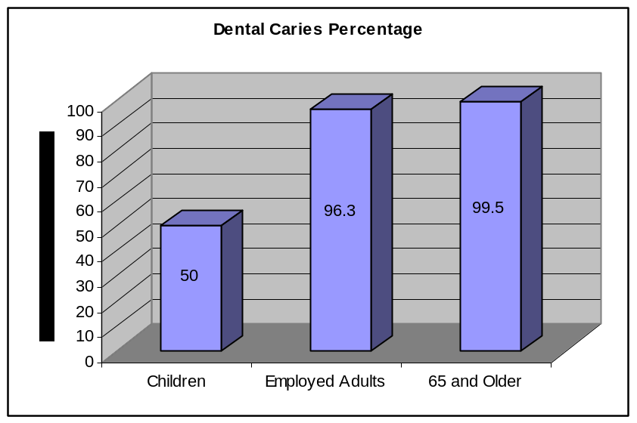
Dental disease is a huge problem world wide. According to 1993 Public Health Reports [1], “more than 50% of U.S. children, 96.3% of employed U.S. adults and 99.5% of Americans 65 years and older have experienced dental caries…” [1] (See Figure 1) It is for this reason that dental caries has been said to be the most common bacterial infection in humans. [2] In 1992, $38.7 billion was spent on dental services nationwide [1] and in 2000 that number increased to $203.6 billion. [3] That is a 500% increase in just 8 years! This growing problem is a large burden on consumers, as shown by the fact that, in 1992, over 90% of this expenditure was paid for either out-of-pocket or by dental insurance. [1] In fact, tooth decay may be the most expensive infection that most people have to battle
Figure 1: The Dental Caries Epidemic
Percentage of children, employed adults and people 65 and older who have experienced dental caries. Information from [1]
over their lifetime [4] because it is so constantly reoccurring. Dental disease is constantly reoccurring because of the present treatment method. Currently, only the symptoms are treated for this disease instead of the disease itself and there are only a few practical preventative methods aimed at controlling the bacterial factors involved in the decay. [4] This means that your dentist is treating only the symptoms, doing little to rid you of your disease and it is only a matter of time before the symptoms come back. Instead of fighting back the bacteria that cause this infection, current dental care, both at the professional and consumer level, is allowing them to live happily in the mouth. Consumers and professionals alike are fighting only with methods to disturb the colonies, not remove them. Brushing your teeth merely disturbs the bacterial colonies that cause dental decay but does not prevent it from happening. [4] Unless patients had professional cleaning and fluoride treatments every two weeks, the disease would not stop. [4] According to Walter J. Loesche in the article “Role of Streptococcus mutans in Human Dental Decay”, “This level of professionally delivered tooth debridement is so labor intensive that its cost would make it economically unavailable to most individuals.” [4] This lack in proper dental care comes mostly from the fact that there are only a few practical preventative methods aimed at controlling the bacterial factors involved in decay. [4] A more practical way to prevent this disease would be for dentists to identify “infected” individuals (which would be almost everyone in the beginning) and then, using antimicrobial treatment, eliminate or suppress the disease-causing bacteria in the mouth, [4] while allowing harmless bacteria to grow in its place. As of 2002, there are no drugs available to prevent dental caries. [2] The aim of this thesis is to identify possible drugs or natural extracts that would target the harmful oral bacteria in hopes of creating a better way to control the dental caries epidemic.

What are the harmful oral bacteria?

There are many bacteria in the mouth. In fact, there are 200-300 species of bacteria [4] living in this optimal environment that has water, nutrients, a suitable pH and suitable temperature for growth. [2] Many of those species are harmless or even helpful, but there are a few that are harmful. These harmful bacteria are known as dental pathogens, or odontopathogens. [4] These odontopathogens are responsible for tooth decay, or dental caries (which in Latin means rottenness). [2] Of the odontopathogens, there are a few species from the genus Streptococcus, termed the Mutans Streptococci and these are the bacterial focus of this thesis. They are so named because in 1924 a scientist named Clarke isolated what he thought was a single species of bacteria from tooth decay and named it Streptococcus mutans. Clark associated S. mutans with tooth decay but other scientists were unable to find the bacteria, so at the time, the organism was not further studied. It was later rediscovered and concluded to be associated with tooth decay. [4] It was also discovered that S. mutans was not just a single species of bacteria but consisted of eight different serotypes and four genetic groups, which were declared species. S. mutans was the name given to the species that most resembled Clarke’s original isolation (See Table 1). [4] The S. mutans serotype c accounts for 70% to 100% of the Mutans Streptococci and is most frequently associated with tooth decay. S. sobrinus is the second most prevalent and is the second most associated with tooth decay. [4] Referring again to Loesche, “The MS are not particularly good colonizers of the tooth surface,” [4] yet, “S. mutans is among the first MS to colonize infants shortly after their teeth erupt and in one study was the only MS isolated from caries-active infants.” [4] Our bodies, however, have a natural defense against these harmful bacteria. There is a net negative charge on the tooth surface as well as on most bacteria, which causes repulsion between the two. When plaque forms, however, this natural barrier breaks down. [2] Dental plaque adheres to the different surfaces of the teeth with varying affinity based on the morphology of the tooth [4] and causes a sequestered environment where the acid produced by the bacteria can eat away at the tooth. Tooth decay occurs when the bacteria breach the hard enamel, invade the dentin and pulp and eventually cause the death of the tooth. [2] If the patient is lucky, the dentist will catch the decay at the dentin stage so the tooth does not die, but this does not have to be the way it is treated. A treatment strategy that delays, inhibits or eliminates the colonization of the Mutans Streptococci would cause a reduction in decay, ultimately leading to less tooth damage. [4] My project was aimed at targeting a drug that would suppress or eliminate the Mutans Streptococci from the mouth. It was focused on the two most harmful, and most different, Mutans Streptococci strains: S. mutans and S. sobrinus.
 | The Mutans Streptococci
Species |  | Serotype | Host
S. mutans |  | c, e, f | Human
S. sobrinus |  | d, g | Human
S. cricetus |  | a | Human, animal
S. ferus |  | - | Rat
S. ratti (rattus) |  | b | Human, rodents
S. macacae |  | - | Monkey
S. downei |  | h | Monkey
Table 1: The Mutans Streptococci Species
Species, serotypes and hosts of the Mutans Streptococci. Information from [4]

Experimental Design

The research that I performed involved the discovery of antibacterial compounds active towards the group of cariogenic bacteria known as the Mutans Streptococci. As mentioned before, this group of bacteria has a strong correlation to dental caries and discovering a substance that is antimicrobial to these bacteria yet harmless to humans could have significant importance in the prevention of tooth decay.
The goal of this study was to discover potential Mutans Streptococci suppressants through the exploration of the antimicrobial activity of marine natural products.

The Gerwick Lab

The lab that I started working in, the Gerwick Lab, is involved in tapping the products of biodiversity to make useful products for humans. One facet of this is collecting marine organisms – algae and cyanobacteria – extracting substances from the organism, purifying that substance, testing it for useful activity, and solving its molecular structure. My research was involved with testing these substances from the Gerwick Lab for potential antimicrobial activity against oral pathogenic bacteria.

Why Natural Products?

Using natural products has many benefits for my project. First, they are readily available in Dr. Gerwick’s lab and there is much diversity among them. Second, they have consumer appeal because, if a consumable product were created from them, it is possible to consider it a “natural product” or “natural extract” instead of a “drug”. Third, the process by which to harvest the substance is usually less costly than synthesizing it. This is because the marine organisms already produce the substance and it just has to be harvested. Finally, most extracts of natural materials are often more easily introduced to the market because they usually do not fall under FDA regulations.

MATERIALS, METHODOLOGY AND RESULTS

Project Overview

Instead of testing each extract on every strain of the Mutans Streptococci, which would not be practical, the extracts were tested for antibiotic activity on Streptococcus mutans first. S. mutans was used because it has a low hazard level, is relatively inexpensive, is the most studied of the Mutans Streptococci and is the bacterium primarily associated with dental caries. Extracts that showed antimicrobial activity were then further tested on the other strains.
The aforementioned antimicrobial testing sought out antimicrobial activity but it did not reveal exactly how potent each substance was. In order to determine this, the minimum inhibitory concentration (MIC) and minimum bactericidal concentration (MBC) were determined.

S. mutans Freezer Stock

When S. mutans (ATCC # UAB 308) arrived in powder form, liquid Brain Heart Infusion (BHI) media was made and the freeze-dried bacteria were mixed in, according to the instructions that came with the bacteria. After overnight growth at 37 ºC, the culture was vortexed and 800 µL aliquots were transferred into 10, 1.5 mL plastic vials with a small amount left that was placed into an 11th. To help avoid lysis, 200 µL of 100% glycerol was added to each tube and they were vortexed. The vials were then placed in liquid nitrogen to quickly freeze the bacteria and the vials were stored at -80 ºC.

S. sobrinus Freezer Stock


When S. sobrinus (ATCC # 33478) arrived in powdered form, a small amount of the dry powder was sprinkled onto one edge of an agar plate. It was then “diluted” by spreading out edges of the streak in succession until finally spreading it into the middle of the plate with a sterile toothpick. (See Figure 2) This was done to isolate a single colony so that there was no possibility of genetic variation in the S. sobrinus bacterial stock. After 24 hours, one single colony was picked from the plate with a sterile toothpick and incubated with shaking in 3 mL BHI media for 24 hours. After 24 hours, 500 µL of 50% glycerol was added to 500 µL of the BHI/S. sobrinus broth and placed in the -80 ºC freezer.
Figure 2: Dilution of Bacteria Powder
Method of “diluting” bacterial powder

Media

The media used for both S. mutans and S. sobrinus was Brain Heart Infusion (DIFCO). It was prepared following the supplier’s instructions.

Agar Plates

The agar plates used for the antibiotic sensitivity testing were poured with 1.5% DIFCO agar in liquid Brain Heart Infusion media, prepared according to the supplier’s instructions. Approximately 25 mL of the agar was poured aseptically into 9 cm sterile Petri dishes to produce the agar plates, and they were stored at 4º C.

S. mutans Working Stock

The S. mutans working stock was aseptically inoculated from the freezer stock into 10 mL BHI media. It was determined that using the sterile loop worked better than inoculating with the sterile toothpick because the inoculated broth not only had a higher optical density (0.98946 for the loop vs. 0.73926 for the toothpick) but the loop was also easier to work with and could be flame sterilized. The inoculated broth was incubated at 37 ºC in a shaking incubator at 250 rpm. The working stock could be stored in a variety of tubes and all storage methods showed sufficient growth of bacteria to use in the tests. Working stocks were maintained (reinoculated) every day when needed, with the exception of weekends. No working stocks more than three days old were used. As a negative control, a tube of uninoculated BHI media was incubated with the other inoculated tubes to ensure no contamination had taken place. Working stocks, when no longer needed, were disposed of by mixing with bleach, allowing to sit and the contents were poured down the drain.

S. sobrinus Working Stock

The S. sobrinus working stock was aseptically inoculated from the freezer stock with a sterile loop into BHI media. It was incubated at 37 ºC and shaken at 250 rpm. This working stock was otherwise treated the same as the S. mutans working stock. S. sobrinus tended to aggregate more than S. mutans and, instead of making the media turbid, it “clumped up” and created sediment on the bottom. Once properly mixed, however, the solution became turbid.

Testing Substances Used

The substances used were from various marine algae and cyanobacteria from the Gerwick lab collections. Of them, 300 were crude and prefractionated extracts and 21 were pure compounds. In the testing of the crude and prefractionated extracts, the most recent and easily accessible ones were used. For a list of these compounds, see Appendix 2.
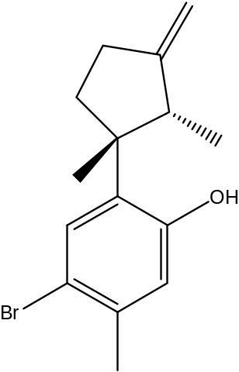
In testing the already known pure compounds, the substances used were chosen by Dr. Gerwick as the ones he felt most likely had antibiotic activity. From those chosen, the ones that were the most abundant and accessible were selected for antibiotic susceptibility testing. Out of the pure substances tested for antimicrobial activity, the most interesting was allolaurinterol, which was collected from the red alga Martensia (Ceramiales Rhodophyta). This compound has a molecular weight of 295.24 g/mol (C₁₅H₁₉OBr) and, like the others, was stored at -20 ºC. The structure is shown in Figure 3.

Figure 3: Allolaurinterol Structure

Antibiotic Susceptibility Testing Methods

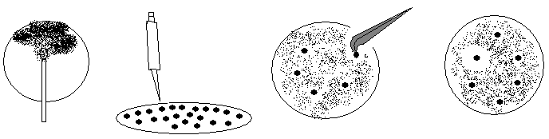
The substances described above were tested for antibiotic activity on the cultured bacteria via antibiotic susceptibility testing, as shown in Figure 4.
Figure 4: Antibiotic Susceptibility Testing
1) Agar plates are streaked with bacteria 2) paper discs are impregnated with the sample 3) the discs are placed on the plates 4) after 24 hours, the antibiotic samples will show a zone of inhibition.
1
2
3
4

After being allowed to warm to room temperature, agar plates were streaked tri-directionally with sterile cotton-tipped applicators that had been dipped in the working stock. The cotton-tipped applicator was dipped before each directional swab and a new cotton-tipped applicator was used for each plate. The substances being tested, either the crude extract, fractions or pure compounds, were dissolved, impregnated on the sterile paper discs and allowed to dry. The solvent that was used to dissolve the crude and pre-fractionated extracts was 1:1 ethanol: isooctane. Evaporation time of this solvent was determined to be 15 minutes by weighing 10 sterile paper discs, placing solvent on them, and plotting their weights at 0, 5, 10, 15 and 35 minutes. When the weight of the discs stopped changing or when they equaled their original weight, the evaporation time was determined (See Appendix 1). At 15 min, the weight stopped declining. The sterile paper discs that were used had a 6 mm diameter and were commercially available from VWR. There were six paper discs placed on each plate. The positive controls used in the testing were pre-impregnated discs with 10 units of Penicillin G (commercially available from VWR). These were stored at 4 ºC according to the manufacturer’s instructions. There were two negative controls: the first was sterile paper discs with nothing on them and the second was sterile paper discs that had solvent placed on them and then were allowed to evaporate. After allowing sufficient drying time for the impregnated discs, they were placed face-down onto the streaked agar plates to ensure the substance in question was in contact with the bacteria. The agar plates were then placed face-down in a stationary 37º C incubator overnight to allow the bacteria to grow without allowing condensation to form on the agar surface. They were then examined the next day (usually 24 hours) for clear zones of inhibition.
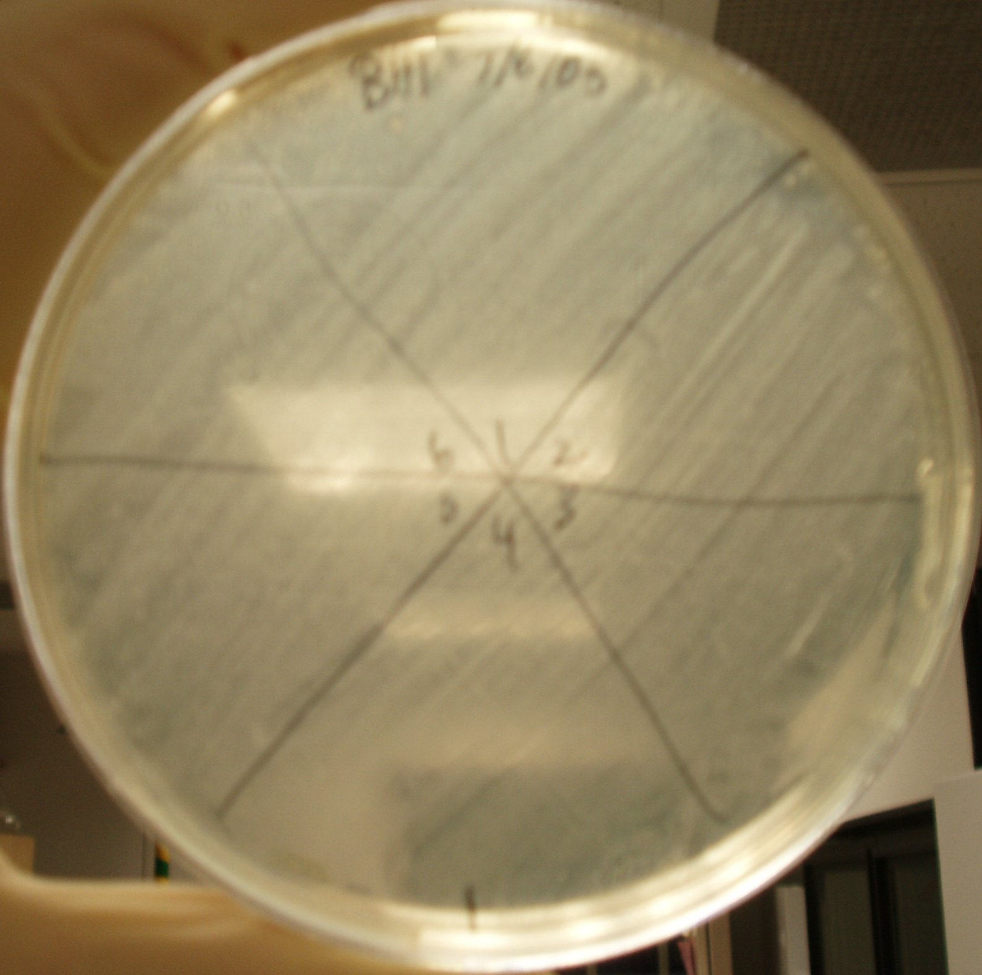
An initial test was performed to make sure the bacteria would grow on the agar-surfaced plate when stored at 37 ºC in an incubator overnight. The results showed that S. mutans did grow and make a strong lawn with good coverage (See Figure 5).
Figure 5: Bacterial Growth Streak
Blank streak of S. mutans
A second test was performed to test the negative controls. After approximately 18 hours, the plate was examined: the blank paper discs did not inhibit growth but the solvent-impregnated discs were questionable. Another experiment therefore had to be performed.
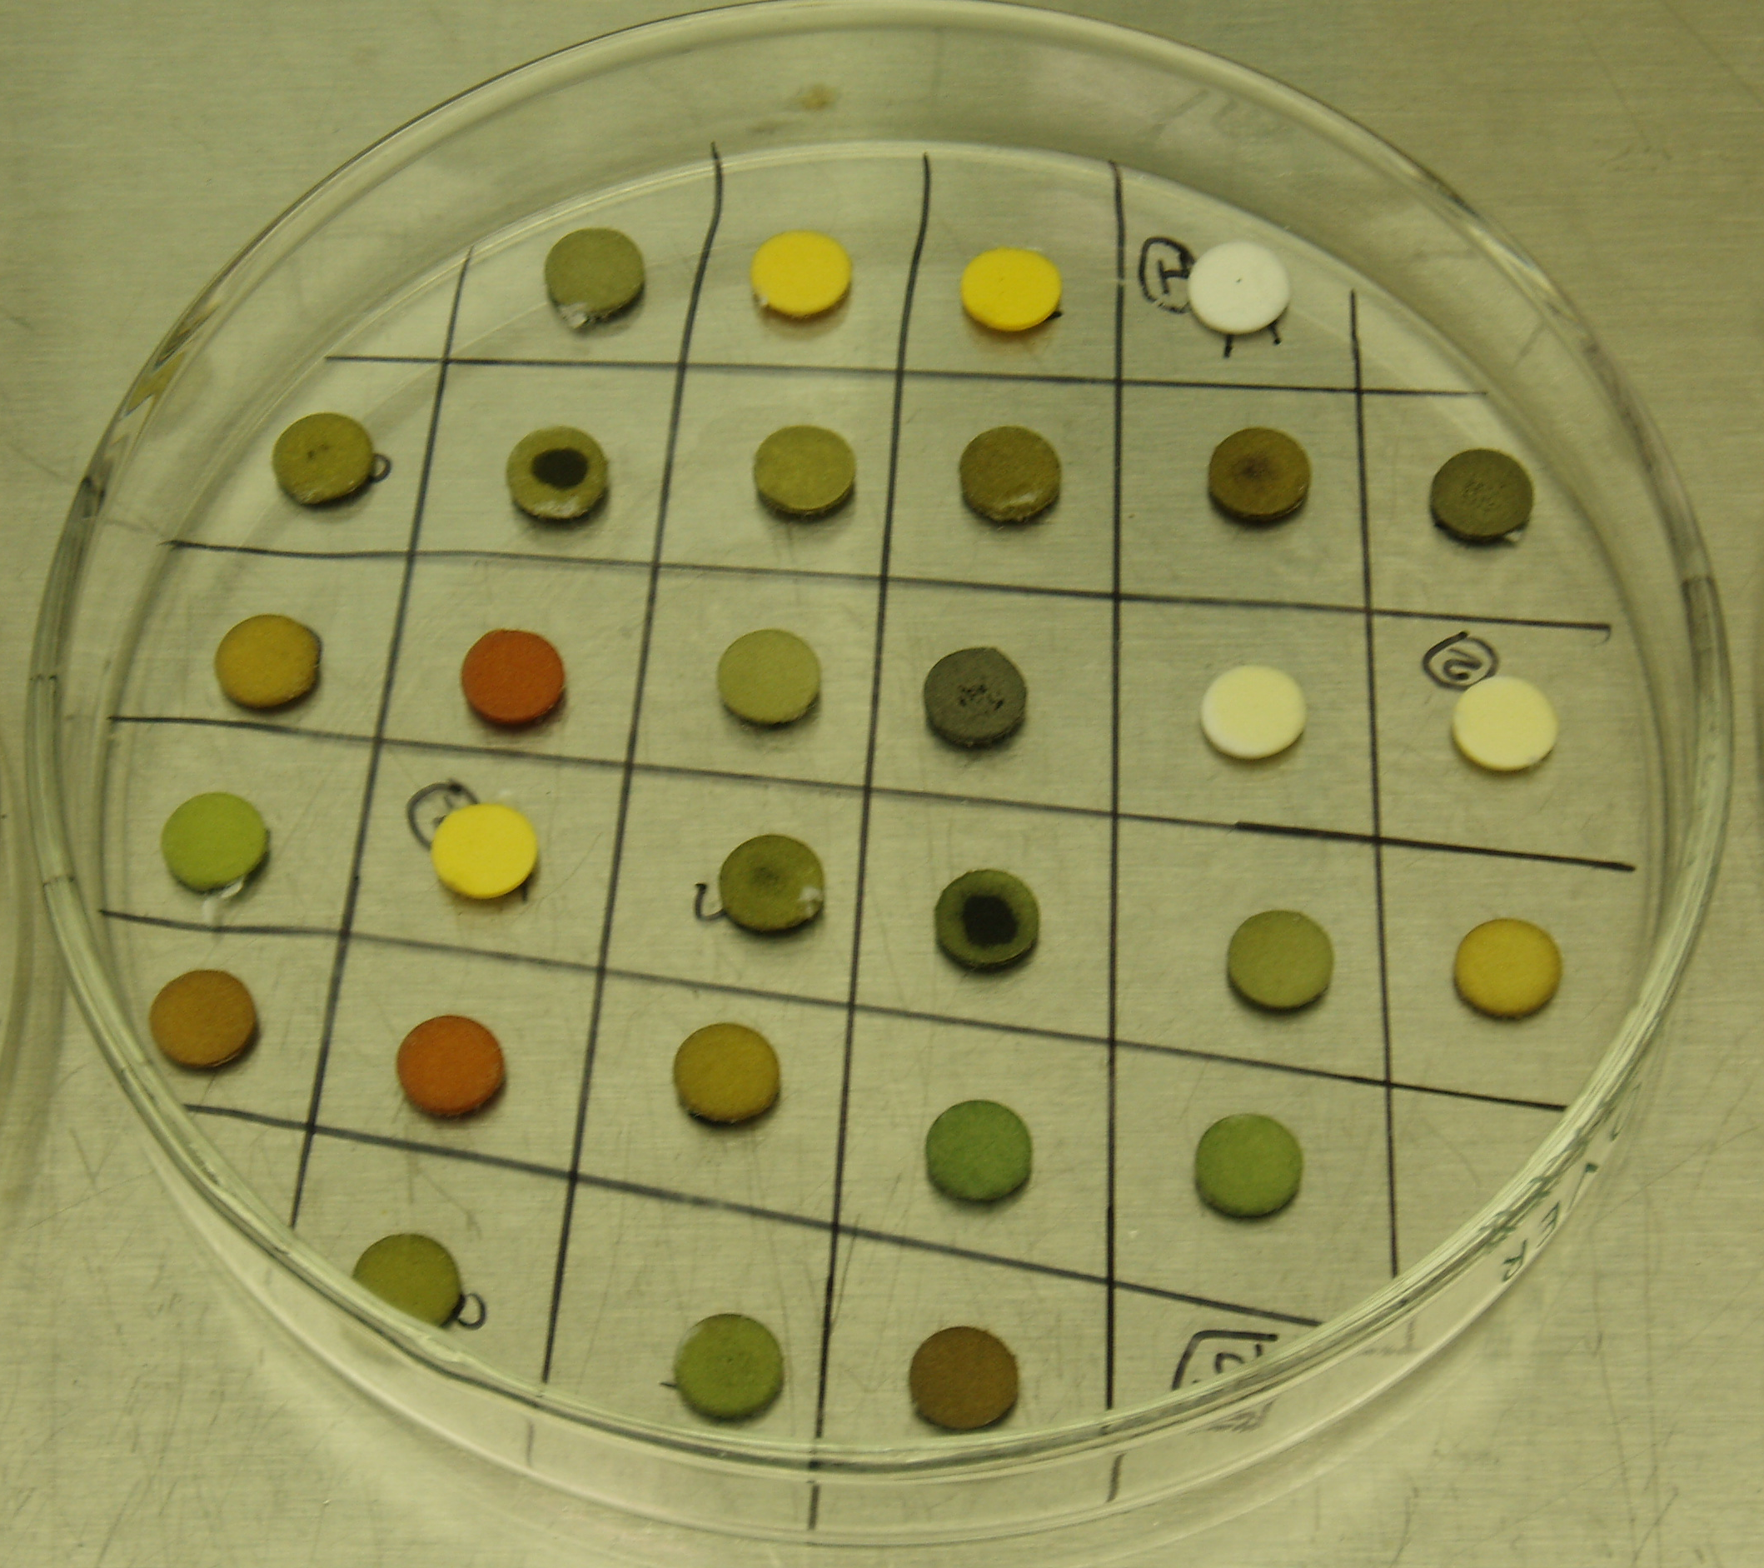
The next test was to determine both the positive and negative controls for accuracy. After approximately 18 hours of incubation, the lawn was found to be fainter than the initial viability test yet strong enough to see that both the positive and negative controls were reliable.
With the crude and prefractionated extracts that were tested, the stock concentration was 100 mg/mL and 5 µL was impregnated on to the discs. Therefore, 500 µg of extract were on each disc. The discs were allowed to dry for at least 30 minutes in each of the tests, even though the solvent evaporation time was shown to be 15 minutes. (See Figure 6) The substance tests were performed identically to the control tests except that the plates were read after 24 hours instead of 18 hours. In the antibiotic susceptibility test, a zone of inhibition around the impregnated discs indicates an antibacterial compound. For test results, see Appendix 2.
Figure 6: Impregnation of Compounds onto Discs
6 mm paper discs impregnated with compounds.
During antibiotic susceptibility testing a problem arose in the area of bacterial growth – no lawns were being produced. Investigation and troubleshooting was done to solve this problem. Firstly, more agar plates were poured in case the agar was the source of the problem. A blank test was performed on the newly poured agar plates to see if there was better growth and it still showed no lawn. That meant that the agar was not necessarily the cause of the problem and also that just having the compounds on the plate was not the cause of bad growth. Secondly, new working stock was inoculated from the freezer stock in case it was the issue. The OD₆₀₀ of the new working stock versus the old working stock were compared and found to be similar, which meant that both had viable bacteria. The possibility of contamination was also explored. New cotton-tipped applicators were autoclave-sterilized and a blank streak test comparing them to the old cotton-tipped applicators was performed. Neither plate showed a good lawn, but the freshly sterilized cotton-tipped applicators showed better results than the old ones. The old cotton-tipped applicators were then disposed of to ensure no contamination would take place. Glass tubes were tried instead of plastic ones because they could be flame-sterilized. A blank streak test was performed comparing the two working stocks simultaneously with the old and new agar, and all of the lawns grew. The new agar showed better results than the old agar, and the new working stock showed better results than the old working stock, but they all showed usable lawns. For some reason, the bacteria seemed to just grow and it did not appear to be because of any variable we explored. Then, on the next day, the bacteria did not grow on the plates, even though it was tested on the new agar and with the new working stock – the best tested system yet. The variables that were changed, however, were that the working stock was in glass tubes instead of plastic tubes and it was incubated without shaking. New working stocks were then inoculated (one in a glass tube and one in a plastic tube) and compared. A new working stock was inoculated from the freezer stock and incubated without shaking. The growth phase of the bacteria being streaked was also questioned, so 24 hour and 48 hour working stocks were streaked to see if one grew better, yet both grew faint lawns. The method of streaking was also explored and was not found to be the issue. Two 8-hour working stocks were also streaked (one from a glass tube and one from a plastic tube) and neither of them showed a complete lawn, although the one from the glass tube showed a stronger lawn. From these tests, none of the lawns were ideal – a thick, homogeneous lawn. Another test, using the already streaked and incubated plates, was done where they were re-streaked to try to spread out the bacterial colonies. After re-incubation for 24 hours, they showed a faint, filmy looking lawn and some of the plates had dried out. New plates were streaked using the newly inoculated working stock and placed in a plastic bag to keep from drying out and they showed good growth. The solution to this dilemma, therefore, appeared to be in the use of a newly inoculated working stock from the freezer stock.
After the plates showed good growth again, the pure compounds were tested. Antibiotic susceptibility testing was performed on 21 pure compounds (see Appendix 6) and compound 1, allolaurinterol, showed potent antimicrobial activity. It was the only pure compound to show antibacterial activity. An antibiotic susceptibility test was also performed with allolaurinterol on S. sobrinus to make sure it showed a spectrum of activity. The results showed that allolaurinterol was antibacterial against S. sobrinus as well.
The benefit of the antibiotic susceptibility test is that many compounds can be tested quickly and efficiently but the drawback is that diffusion of the compounds into the agar is necessary. Therefore, a larger zone may indicate a more potent compound, a compound with a good diffusion rate or a combination of both. This means that a larger zone is not necessarily attributable to the compound being more potent. However, because of the large number of antibacterial extracts, they needed to be prioritized in my project for practicality. The method used in this experiment to prioritize the antibacterial extracts was based on their zone of inhibition size and in some cases, the clarity of the zone of inhibition. A list of the most active crude and prefractionated extracts tested is presented in Appendix 3. Out of these, priority was also given to extracts that did not likely contain fatty acids or sulfur. Fatty acids can act as detergents that have non-specific antimicrobial activity and most of them are already known, which makes them less interesting. Thiols are also compounds known to have antibacterial properties and were not a priority to test.
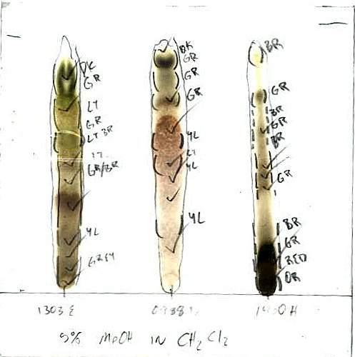
For selected prefractionated extracts (1303E, 0988D, 1512A, 1500A, 1460 crude, 1460H and 1460I), Thin Layer Chromatography (TLC) was performed to determine whether or not fatty acids or thiols were constituents (See Appendix 4). The plates were analyzed by marking and labeling the colored spots under normal light conditions and circling the spots observed under short wavelength UV light. They were also sprayed with 50% sulfuric acid to expose colorless substances, allowed to dry, placed on a hot plate and the spots that charred were marked with a √ (See Figure 7). After 24 hours (to avoid the damaging properties of the sulfuric acid), the plates were taped over with clear packing tape to preserve them. These selected prefractionated extracts (0988D, 1500A, 1512A, 1460H, 1303E) were also dried down, dissolved in chloroform and analyzed by ¹H NMR spectroscopy to determine their constituent compounds. These ¹H NMR spectra are included in Appendix 5. The chloroform was first filtered through a pipette with basic alumina packed in it to remove any acid in the chloroform. One of the compounds appeared to contain a carotenoid, and considerable time was spent trying to dereplicate the structure using ¹H NMR data comparisons. However, no matching carotenoid was found.
Figure 7: TLC Plate
An example of a TLC plate after analysis
Bioautography was also performed on selected extracts (1500A, 1512A, 0988D, 1303E and 1460H) to try and pinpoint the antibiotic component. Two TLC’s of 500µg were performed for each extract, one for bioautography and one for marking and comparing. The TLC plates were placed in sterile, square Petri dishes and molten 1.5% agar in BHI media was poured on top of the plates. Air bubbles from the Thin Layer Chromatography (TLC) plate came up through the molten agar and made it “cloudy”. They were allowed to cool, streaked with bacteria, and were incubated for 24 hours at 37 ºC. No visible bacterial growth was observed and therefore no visible zones of inhibition were found. The results of this experiment were inconclusive and it was not repeated.
The results from the crude and prefractionated extract antibiotic susceptibility tests showed a few extracts that may be interesting, yet the testing of the pure compounds yielded the discovery of the potent antimicrobial agent allolaurinterol. This compound showed the most promise as a potential for a consumable product, and therefore the remainder of the research focused on allolaurinterol.

Allolaurinterol Proposed Biosynthetic Pathway

The discovery of allolaurinterol as a potent antimicrobial agent prompted curiosity about its biosynthesis. No biosynthesis of the compound is known so the possible mechanisms were proposed. One possible method for biosynthesis of allolaurinterol, proposed by Dr. Gerwick, is shown in Appendix 6.

Allolaurinterol Possibility as a Consumer Product

Many questions would need to be investigated to determine if allolaurinterol would be a good candidate for a consumer product. These questions are: has it been tested before, does it work, how potent is it, does it harm humans, is it currently in use, how easy is it to synthesize, how can it be harvested, and what about its taste? Before this research, allolaurinterol had not been tested against S. mutans but it had been tested against other bacteria. A summary of the previous known activity of allolaurinterol is shown in Table 2.
Table 2: Known Activity of Allolaurinterol
The known activity of allolaurinterol and its literature reference.
Literature reference | Activity
[5] | - Bactericidal activity against three strains of MRSA and three strains of vancomycin-susceptible Enterococcus in small concentrations  - Activity against Gram-positive bacteria including MRSA, penicillin-resistant Streptococcus pneumoniae and vancomycin-resistant Enterococcus faecalis and E. faecium  - Activity against VCM-susceptible strains was overwhelming, less [concentrated] than that of VCM  - Showed antibacterial activity against all enterococcal strains tested, regardless of VCM-resistant pattern  - Did not exhibit antibacterial activity against Gram-negative pathogens except against Moraxella catarrhalis  - Demonstrated potent bactericidal activity against methicillin-resistant S. aureus (MRSA) at a concentration of 2x MIC value (6.25 µg/mL), and its activity was more potent than that of VCM  - Bactericidal against VCM-susceptible E. faecium, although VCM was bacteriostatic
[6] | - Responsible for the pharmacological activity of the dichloromethane extract in Laurencia obtusa  - Moderate antifungal and antibacterial (against Gram-positive bacteria) properties, [and is] antialgal
[7] | - Active against Mycobacterium tuberculosis
There is no current data on the efficacy, potency and toxicity to humans for allolaurinterol. Determination of the Minimum Inhibitory Concentration (MIC) and Minimum Bactericidal Concentration (MBC) of allolaurinterol is one way to test its efficacy and potency. Also, to ascertain its effectiveness for dental use, it needs to be tested against other strains of the Mutans Streptococci. Once its potency and efficacy are determined, it needs to be tested for its toxicity to humans. The appropriate method used to determine this is mammalian cell cytotoxicity testing.

MIC/MBC Methods

The next step for determining allolaurinterol’s use as a consumer product was determining just how potent this substance is. As mentioned before, agar diffusion methods test both the diffusion rate and potency of the compound but testing in liquid media tests the potency of the compound without the added diffusion rate variable. For this reason, the Minimum Inhibitory Concentration, MIC, and Minimum Bactericidal Concentration, MBC, were determined for allolaurinterol. The MIC is, “the lowest concentration of the agent that inhibits visible growth.” [8] The MBC is “the lowest concentration of an agent which kills a defined proportion (usually 99.9%) of the population after incubation for a set time.” [8].
The testing of allolaurinterol against different bacterial strains would show its efficacy for many bacteria. Due to the high cost of purchasing pure bacterial cultures, only one other strain was selected – the most different from S. mutans of the Mutans Streptococci. 16S rDNA as well as phylogeny data showed that S. sobrinus was the least like S. mutans of the Mutans Streptococci [9] so it was the second strain of bacteria used. Also, aside from S. mutans, S. sobrinus is the most cariogenic of the Mutans Streptococci and would therefore show its efficacy against all of the other strains of the Mutans Streptococci. [4]
UV Extinction Coefficient Data For Allolaurinterol
Vial | Dilution | 283 nm Abs | µg/µL | Total µg | 289 nm Abs | µg/µL | Total µg | Average
V1: | 50 fold | 0.442 | 3.05 | 60.98 | 0.426 | 2.97 | 59.33 | 60.155 | Final
V2 original: | 1000 fold | 0.524 | 72.29 | 1445.85 | 0.512 | 71.3 | 1426.06 | 1435.955
 | 2000 fold | 0.313 | 86.36 | 1727.29 |  |  |  | 1727.29
V2 diluted (25 fold) | 50 fold | 0.153 | 1.06 | 527.71 | 0.163 | 1.14 | 567.5 | 547.605 | Final
In the Gerwick lab, there was a limited amount of allolaurinterol available, and therefore an accurate mass needed to be determined. This was done using the UV extinction coefficient (ε), the Beer-Lambert Law (A=εbc) and known values for allolaurinterol. In the Beer-Lambert Law, the A value corresponds to absorbance (no units), ε corresponds to molar absorbtivity, a.k.a. extinction coefficient, (L·mol⁻¹·cm⁻¹), b corresponds to the path length of the sample (usually 1 cm) and c corresponds to the concentration of the compound in the solution (mol·L⁻¹). The λ_{max} for allolaurinterol is at 283 and 289 nm, and the corresponding ε values are 2140 and 2120, respectively. [10] After a series of dilutions, the absorbance at 283 and 289 nm were measured and compared with the known ε values in the Beer-Lambert Law. The amount and concentration of allolaurinterol was then determined, after many measurements (see Table 3).
Table 3: UV Extinction Coefficient Data for Allolaurinterol
A spectrophotometer was used to measure the absorbance of allolaurinterol dilutions in ethanol and, using the Beer-Lambert Law and known values, the amount contained was calculated.
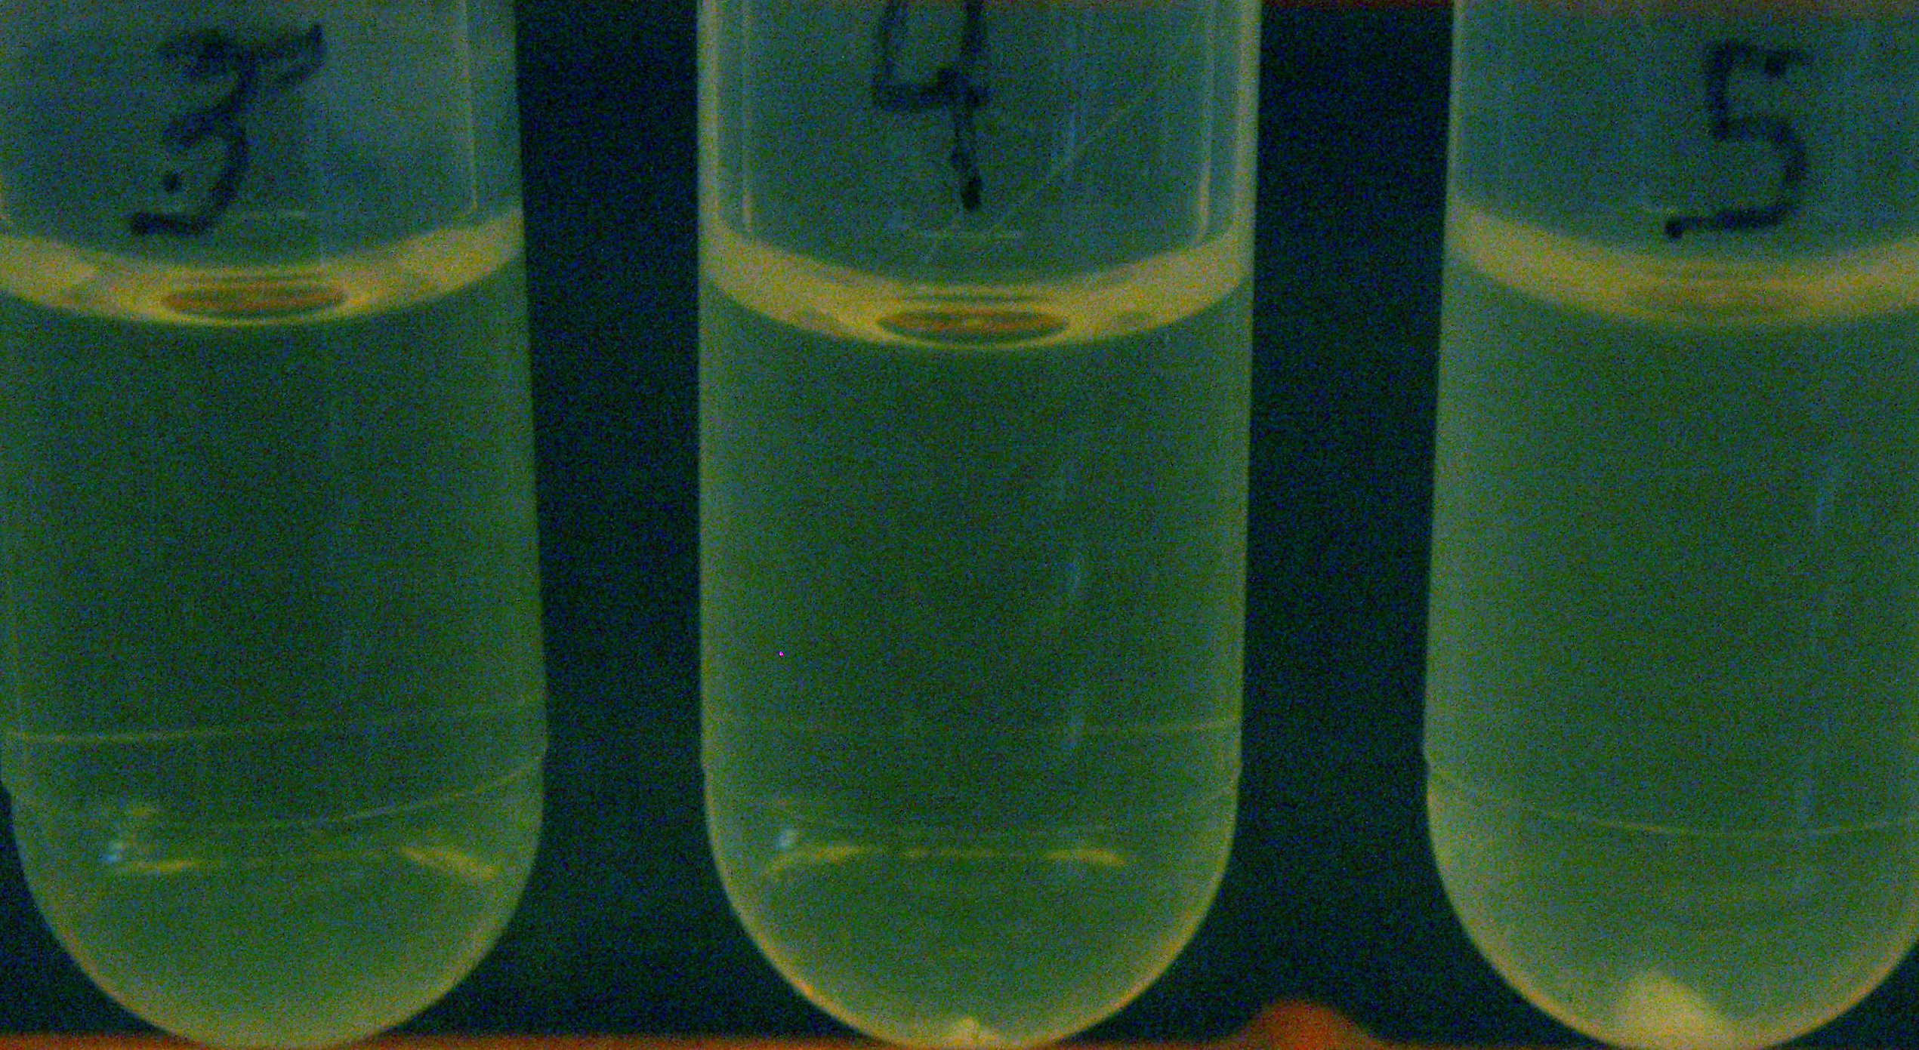
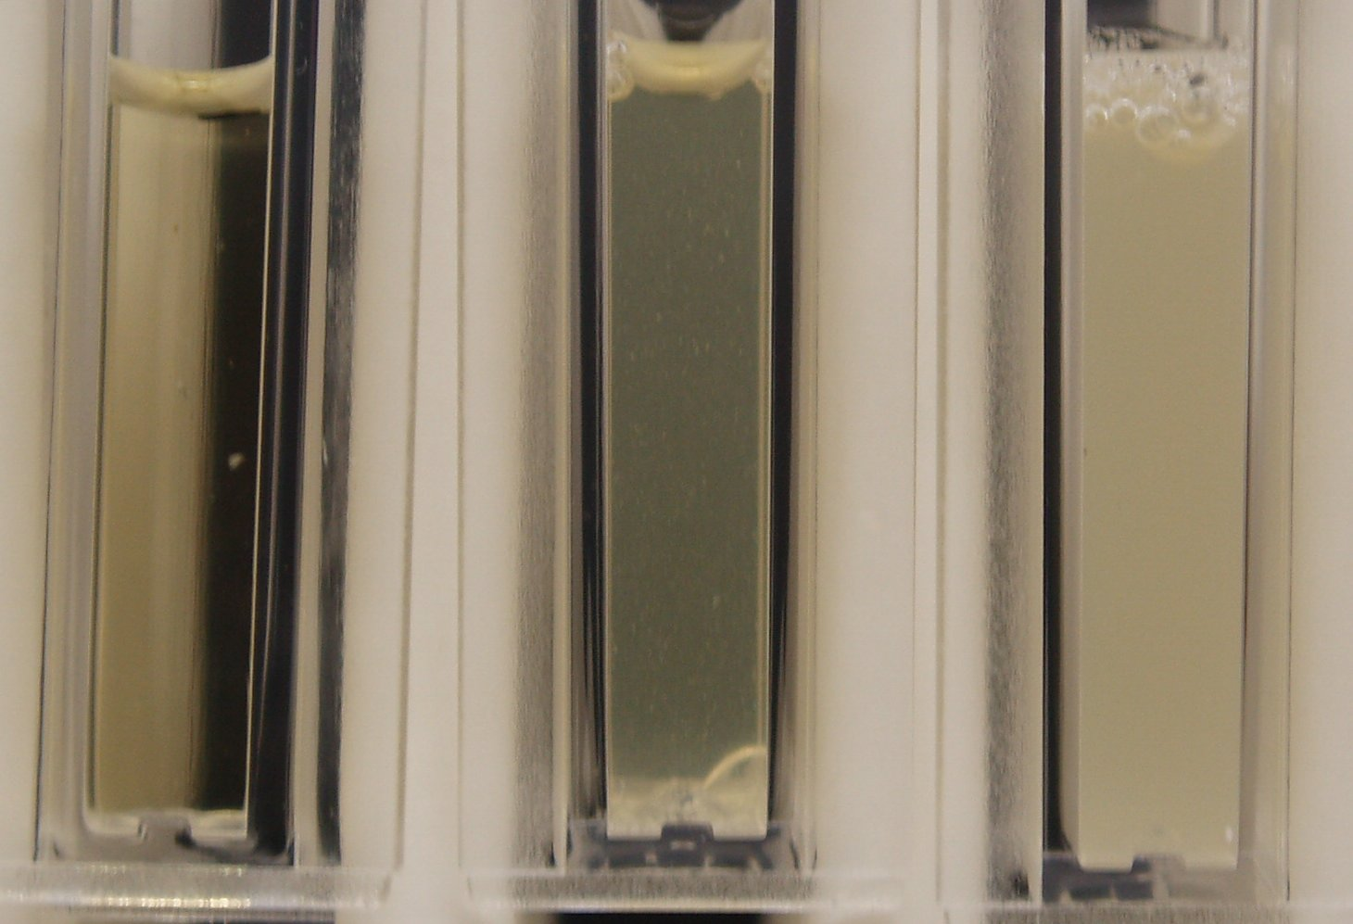
Once the exact amount of allolaurinterol was measured, the MIC and MBC tests could continue. The MIC was performed by adding serial two-fold dilutions of allolaurinterol to 1 mL of a 10³ dilution of an 18 hour bacterial broth (see Appendix 7). Tubes were shaking-incubated (250 rpm) at 37 ºC for 24 hours before observation. Two separate MIC tests were performed because the MBC could not be determined from the first MIC test. For the first Minimum Inhibitory Concentration (MIC) test, a pellet of bacteria had formed in the bottom of tubes 5 – 9 and a small pellet formed in tube 4, yet there was no pellet formed in tube 3 (as shown in Figure 8). After the tubes were disturbed to break apart the pellet, the OD₆₀₀ of the MIC broths were read (see Table 4) and 5 µg/mL was determined to be the MIC for allolaurinterol against S. mutans. (see Figure 9 for visual densities)
MIC Tube OD₆₀₀
Tube | µg/mL | OD₆₀₀
1 | 20 | 0.002
2 | 10 | 0.003
3 | 5 | 0.009
4 | 2.5 | 0.261
5 | 1.25 | 1.28
6 | 0.625 | 0.817
7 | 0.313 | 0.924
8 | 0.156 | 1.173
9 | growth | 1.35
Table 4: MIC Tube OD₆₀₀
OD₆₀₀’s of the first round MIC tubes.
Figure 8: MIC Tube Pellet
No pellet was formed in tube 3, a small pellet was formed in tube 4 and a larger pellet was formed in tube 5.
3
4
5
The Minimum Bactericidal Concentration (MBC) methods that were used after the first MIC test were inaccurate and only dealt with S. mutans but will be discussed briefly to show their flaw. For this test, 100 µL of broth from all of the clear MIC tubes was transferred via a 10-fold dilution into 1 mL of fresh, antibiotic free BHI media. The MIC tubes were then stored at 4 ºC to prevent further bacterial growth. The MBC tubes were allowed to incubate and, after 24 hours, there was observable growth of varying degrees in all of the tubes. After 48 hours, however, all of the tubes had developed substantial growth. The flaw of this first MBC experiment was that there was no quantitative way of determining the MBC, because eventually all of the tubes showed growth. This test created a concern that S. mutans developed resistance to allolaurinterol but, when antibiotic susceptibility testing was done with allolaurinterol on the turbid MBC tubes, it was still found to have potent antibacterial activity. The correct MBC method was then used for the final MBC test.
Figure 9: MIC Tube Visual Densities
Tube 3 is completely clear, tube 4 is slightly turbid and tube 5 is completely turbid.
4
5
Another growth problem was encountered for the final MIC/MBC test. S. sobrinus had not grown, so a new working stock was inoculated from the freezer stock to combat this problem. Also, from the previous working stock, aliquots of 10 and 20 µL, as well as a sterile loop inoculation were placed in BHI media and compared. The final conclusion for this S. sobrinus growth issue was that the sterile loop worked well and the problem was that the old working stock lacked viable cells. Once the freezer stock was used to inoculate, proper growth returned.
The final MIC was performed on both S. mutans and S. sobrinus. The MIC protocol from above was followed, but this time subcultures of dilutions from the MIC-inoculating working stock were streaked for counting on the same day. This count provided the initial number of cells inoculated into the MIC tests. The dilutions were 10³, 10⁵, 10⁶ and 10⁷ of the working stock for both bacteria. According to the protocol from Hacek et al [11], they were streaked by placing a 100 µL aliquot in a line down the center of an agar plate, allowing it to dry and streaking the plate in a motion
perpendicular to the line with a sterile cotton-tipped
Culture Counting Results
S. sobrinus
Dilution | Colonies
10³ | lawn
10⁵ | 534
10⁶ | 134
10⁷ | 0
S. mutans
Dilution | Colonies
10³ | lawn
10⁵ | 85
10⁶ | 7
10⁷ | 0
Table 5: Culture Counting Results
Number of cultures on each dilution plate of bacteria.
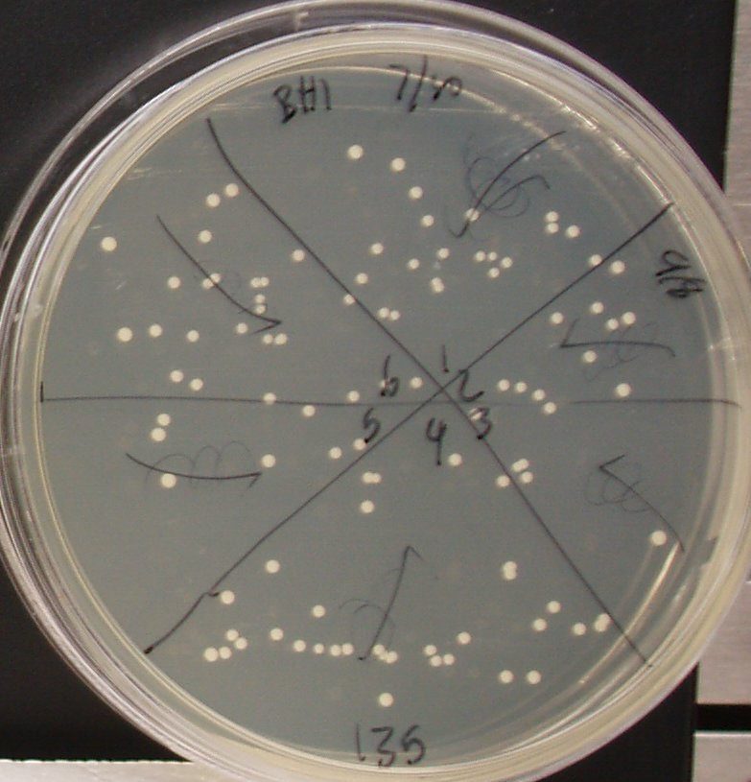
applicator. After incubation at 37 ºC for 24 hours, the cells on the surface of the plate were counted and multiplied by the appropriate dilution factor to determine the total colony forming units (CFU’s) per mL of the working stock. The optimal dilutions for practical colony counting were 10⁵ for S. mutans and 10⁶ for S. sobrinus (see Table 5 and Figure 10).
Figure 10: MBC Colony Count
Initial colony count for S. sobrinus 10⁶ dilution
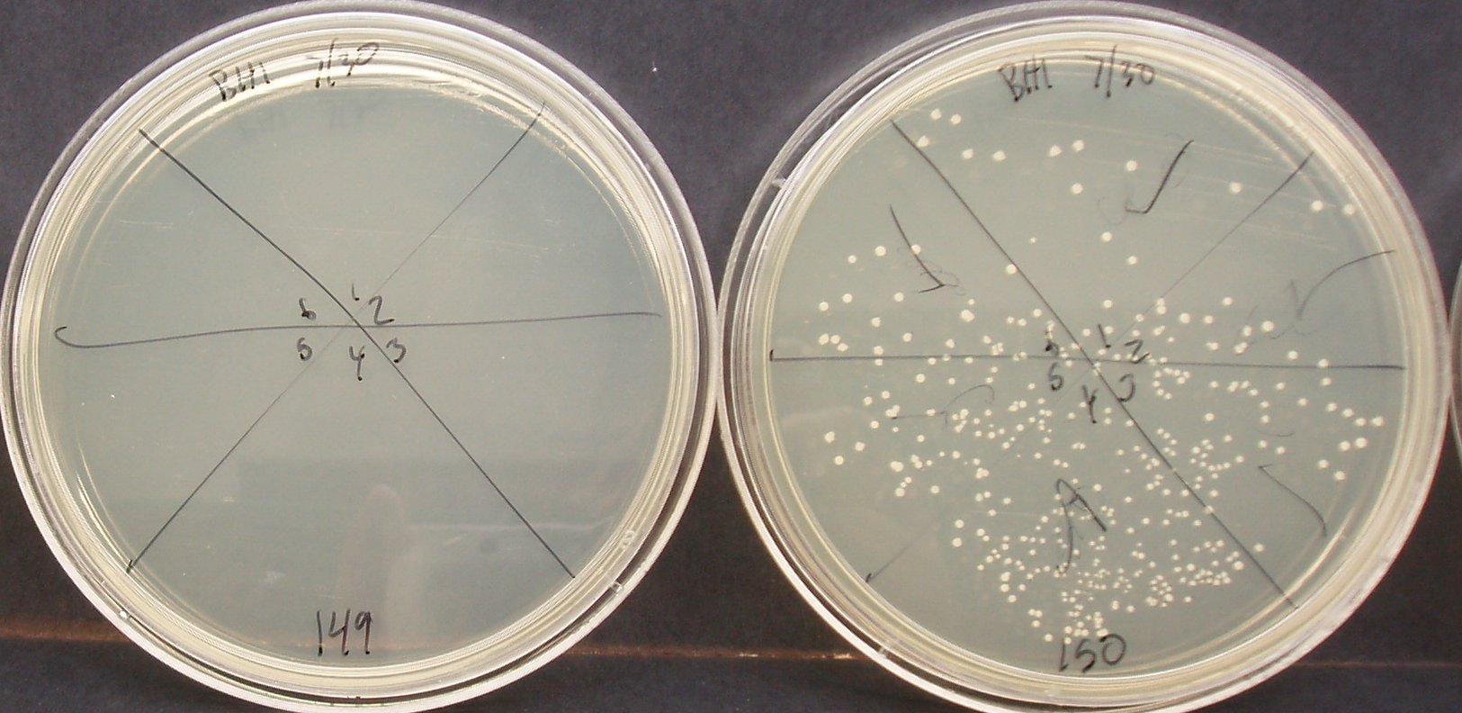
The Minimum Inhibitory Concentration (MIC) results for both S. mutans and S. sobrinus showed that 5 µg/mL is the MIC. The Minimum Bactericidal Concentration (MBC) was performed on all of the clear MIC tubes as well as the first turbid tube, a growth control and a sterile control. Each tube was flushed with a micropipette and, in the same manner as above, a 100 µL aliquot was applied in a line down the center of an agar plate. This aliquot was allowed to dry (to minimize the activity of the antimicrobial agent) and streaked perpendicularly to the line with a sterile, cotton-tipped applicator. After 24 hours, the cultures on the plates were counted and the MBC was the plate that had less than 99.9% of the original inoculating bacteria on it (See Appendix 8 for calculations).
Figure 11: S. mutans MBC Final Colony Count
Final colony count for S. mutans. Plate 149 (left) has 10 µg/mL and 0 colonies. Plate 150 (right) has 5 µg/mL and has 170 colonies
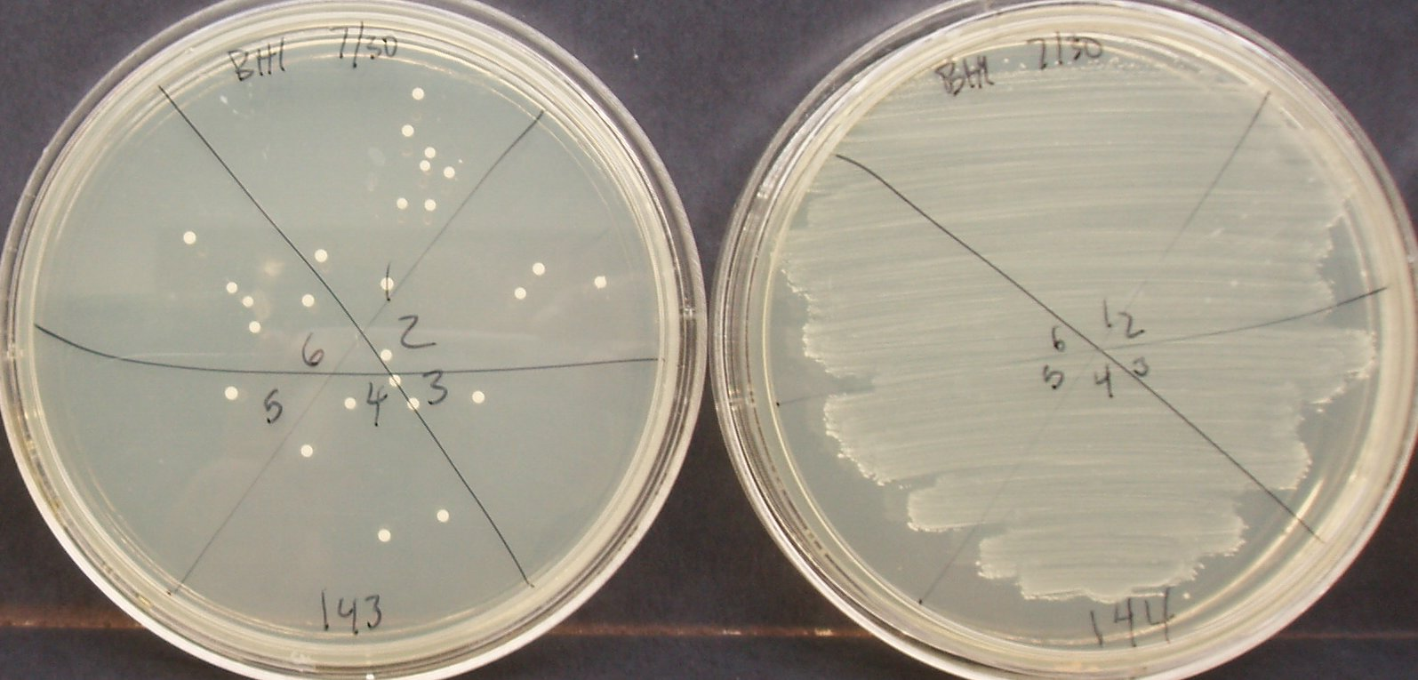
From these results, the Minimum Inhibitory Concentration (MIC) of allolaurinterol for both S. sobrinus and S. mutans is 5 µg/mL and the Minimum Bactericidal Concentration (MBC) is 10 µg/mL (see Figure 11 and Figure 12). See Appendix 9 for MBC plates. These values are most likely similar for the other Mutans Streptococci because S. mutans and S. sobrinus were the most different bacteria of the Mutans Streptococci. Also, the active concentration is relatively low and therefore shows promise as a useful antimicrobial agent.
Figure 12: S. sobrinus MBC Final Colony Count
Final colony count for S. sobrinus. Plate 143 (left) has 10 µg/mL and 26 colonies. Plate 144 (right) has 5 µg/mL and has a lawn.

DISCUSSION

The results of this project are very informative. First, allolaurinterol is a potent antibacterial substance – with an MIC of only 5 µg/mL and MBC of only 10 µg/mL. It is active against two of the most common and harmful strains of the Mutans Streptococci. These two strains are the most different members of the Mutans Streptococci, therefore allolaurinterol is likely active against the other strains as well. This means that it has potential to be used as an oral antibacterial agent.
In order to realize the potential for allolaurinterol as an oral antibacterial agent, several aspects must be explored. First, the therapeutic window must be determined. The therapeutic window is the concentration of a drug that is toxic to the target pathogen but non-toxic to the host organism. This project has already determined the potency – or “bottom end” – of the therapeutic window for allolaurinterol. What needs to be determined next is the human toxicity – or “top end” – for allolaurinterol so its use as a human product can be explored (See Figure 13).
Amount of Drug Needed
Toxicity to host organism
Toxicity to pathogen
Therapeutic
Window
Figure 13: Therapeutic Window
The amount of drug that is toxic to the pathogen but non-toxic to the host organism.
Second, the practicality of harvesting allolaurinterol needs to be evaluated. A search for any U.S. patents on allolaurinterol came up with no results, which shows that no one has the exclusive rights to allolaurinterol. Allolaurinterol has been synthesized [12] but it is a complicated process and synthesis does not appear to be a practical method for production. Allolaurinterol is produced naturally by marine algae, which may provide the most practical method for harvesting. There are three important allolaurinterol-containing species of Laurencia red algae. The first, Laurencia filiformis f. heteroclada, is from Australia and has 60% allolaurinterol in its crude extract, a very substantial amount. [10] This could provide an efficient method of obtaining allolaurinterol, but it is from outside of the United States and would need to be imported, which may cause difficulty. The second, Laurencia obtuse, is from the Caribbean island of Dominica, has 33.5% allolaurinterol in its crude extract and allolaurinterol is reported to be the substance responsible for the extract’s activity. [6] This could also provide an efficient method of obtaining allolaurinterol and has the added benefit that the substance responsible for the extract’s activity is known to be allolaurinterol, but again, it is from outside of the United States and would need to be imported. The third, Laurencia subopposita, is from La Jolla beach near San Diego, CA and has 0.11% allolaurinterol in its crude extract. [13] The benefit of this species is that it is within the United States, so it would presumably be less difficult to obtain, but its concentration in the extract is so low that a harvesting method would probably be inefficient. These aspects must be explored further in order to determine the most efficient harvesting method.
One possible harvesting process, proposed by Dr. Bill Gerwick, includes the use of water waste from shrimp farms to grow species of marine algae that synthesize allolaurinterol and extract the substance from them. Collaboration with shrimp farms may provide an optimal environment for growing Laurencia, therefore providing ample amounts of allolaurinterol for harvesting.
Alternatively, research could be done to determine the biosynthetic pathway for allolaurinterol production as well as its mechanism of antibiotic action. This exploration may give light to the specific region of allolaurinterol responsible for the activity and possibly aid in finding other oral antimicrobial agents.
Part of determining the practicality of harvesting allolaurinterol is the extraction process. An extraction process needs to be devised so that the most allolaurinterol possible is extracted from the algae without making it pure allolaurinterol. The reason for this is that, according to Dr. Gerwick, a “natural extract” has fewer regulations than a “pure compound”, and would therefore be more easily introduced in the consumer market.
The final step in making allolaurinterol available as a consumer product is the licensing of the harvesting process, and the selling of that license to a manufacturing company. From there, a mouthwash or other type of oral application can be made and sold to the public.

BIBLIOGRAPHY
1. Anonymous. “Toward improving the oral health of Americans: an overview of oral health status, resources, and care delivery. Oral Health Coordinating Committee, Public Health Service.” Public Health Rep. Washington, D.C. 1993 Nov-Dec. 108(6), 657-72.

2. Prescott, Lansing M. “Microbiology, 5th ed.” McGraw-Hill. New York, 2002.

3. House DR, Fry CL, Brown LJ. “The economic impact of dentistry”. J Am Dent Assoc. 2004 Mar; 135(3):347-52. PMID: 15058625 [PubMed - indexed for MEDLINE]

4. Loesche, Walter J. 1986. Role of Streptococcus mutans in Human Dental Decay. Microbiol Rev. 50(4) 353-380.

5. Vairappan, Charles Santhanaraju. “Potent Antibacterial Activity of Halogenated Compounds against Antibiotic-Resistant Bacteria.” Planta Med. (2004), 70(11), 1087-1090.

6. Konig, Gabriele M. and Wright, Anthony D. “Sesquiterpene Content of the Antibacterial Dichloromethane Extract of the Marine Red Alga Laurencia obtuse.” Planta Med. 1997 63(2), 186-187.

7. Konig, Gabriele M.; Wright, Anthony D.; Franzblau, Scott G. “Assessment of antimycobacterial activity of a series of mainly marine derived natural products.” Institute for Pharmaceutical Biology, University of Bonn, Bonn, Germany. Planta Med. (2000), 66(4), 337-342.

8. Collins, C.H; Lyne, Patricia M.; Grange, J.M.. “Collins and Lyne’s Microbiological Methods, 7th ed.” Butterworth-Heinemann Ltd. Oxford, 1995.

9. Schlegel, Laurent; Grimont, Francine; Grimont, Patrick A.D. and Bouvet, Anne. “Identification of Major Streptococcal Species by rrn-Amplified Ribosomal DNA Restriction Analysis”. J Clin Microbiol. (February 2003). 41(2), 657-666.

10. Kazlauskas, Rymantas; Murphy, Peter T.; Quinn, Ronald J.; Wells, Robert j. “New laurene derivatives from Laurencia filiformis.” Roche Res. Inst. Marine Pharmacol., Dee Why, Australia. Aust J Chem. (1976), 29(11), 2533-9.

11. Hacek, Donna M.; Dressel, Dana C.; Peterson, Lance R. “Highly Reproducible Bactericidal Activity Test Results by Using a Modified National Committee for Clinical Laboratory Standards Broth Macrodilution Technique.” J Clin Microbiol. 37(6) 1881-1884.
12. Gewali, Mohan B. and Ronald, Robert C. “Synthesis of Allolaurinterol.” Dep. Chem., Washington State Univ., Pullman, WA, USA. J Org Chem. (1982), 47(14), 2792-5.

13. Wratten, Stephen J.; Faulkner, D. John. Scripps Inst. Oceanogr., La Jolla, CA, USA. J Org Chem. (1997), 42 (21), 3343-9

Appendices
Appendix 1: Evaporation Time for 1:1 ethanol: isooctane

Time (m) | Weight (g)
0 | 2.5041
5 | 2.432
10 | 2.3991
15 | 2.3962
35 | 2.3965
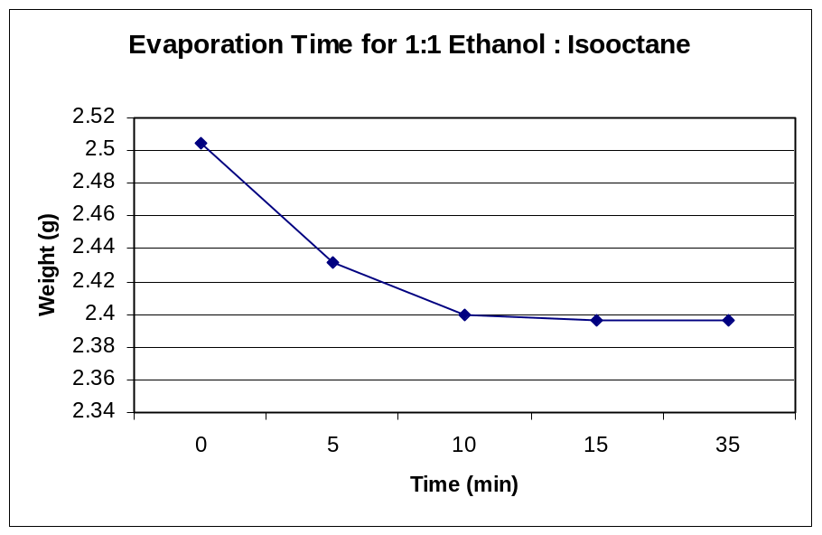

After 35 minutes, there was theoretically ~1.9% of the solvent left on the discs, according to the recorded molecular weights of isooctane and ethanol. This extra mass may have been dust from the atmosphere.
Appendix 2: Antibiotic Susceptibility Test Results

Crude Tests

Test 1 Results
Compound | Result (+/-) | ZOI Diameter (mm) | Comments
P10 | + | 23
Solvent Blank | -
Blank | -
Blank | -
Solvent Blank | -
P10 | + | 23
1303A | -
B | -
C | - |  | Possible small zone
D | + | 11
E | + | 13.5
F | + | 11
G | + | 12
H | + | 10
I | -
CRD | + | 10
1298A | -
B | -
C | - |  | funny streak
D | -
E | -
F | -
G | -
H | -
I | + | 8
CRD | -
1539A | -
B | -
C | -
D | -
E | + | 8 | very slight
F | + | 8 | very small
G | -
H | -
I | -
CRD | -
0988A | + | 7 | very slight, questionable
B | -
C | + | 9
D | + | 13
E | + | 9
F | -
G | -
H | -
I | -
CRD | + | 8
0906A | -
B | + | 8
C | + | 8
D | + | 8
E | + | 8.5
F | + | 10.5
G | -
H | -
I | -
CRD | + | 7
1513A | -
B | -
C | + | 8
D | + | 9.5
E | + | 10
F | + | 7
G | + | 7
H | -
I | -
CRD | -

Test 2 Results
Compound | Result (+/-) | ZOI Diameter (mm) | Comments
P10 | + | 21
Blank | -
Solvent Blank | -
P10 | + | 21
Blank | -
Solvent Blank | - |  | awful growth
1515A | -
B | + | 7
C | + | 9.5
D | + | 9.5
E | -
F | + | 7
G | -
H | + | 7
I | -
CRD | + | 8.5 | uneven
1512A | + | 14.5
B | + | 7.5
C | -
D | -
E | + | 8
F | + | 8
G | + | 9.5
H | -
I | + | 8
CRD | + | 7
1325A | -
B | -
C | -
D | -
E | -
F | -
G | - |  | zone of growth stimulation - 19.5 mm  Plate redone
H | - |  | Plate redone
I | - |  | Plate redone
CRD | - |  | zone of growth stimulation - 14 mm  Plate redone
1397A | + | 34 | no bacteria on this side of the plate  Plate redone
B | + | 28 | very interesting  Plate redone
C | + | 50 | Plate redone
D | - |  | 12.5 mm ZOS  Plate redone
E | + & - | 9 | 22 mm ZOS  Plate redone
F | - |  | 20.5 mm ZOS  Plate redone
G | - |  | 12.5 mm ZOS  Plate redone
H | - |  | 10 mm ZOS  Plate redone
I | -
CRD | -
1390A | + | 8 | lopsided
B | -
C | -
D | -
E | + | 7
F | + | 8
G | + | 7
H | -
I | -
CRD | - |  | Plate redone
1491A | + | 12 | Plate redone
B | + | 10 | Plate redone
C | - |  | Plate redone
D | + | 8.5 | Plate redone
E | + and - | 10 | 25 mm ZOS  Plate redone
F | + and - | 9.5 | 20 mm ZOS  Plate redone
G | - |  | 6 mm ZOS  Plate redone
H | - |  | 17 mm ZOS  Plate redone
I | - |  | 10 mm ZOS  Plate redone
CRD | - |  | 14 mm ZOS  Plate redone

Test 3 Results
Compound | Result (+/-) | ZOI Diameter (mm) | Comments
P10 | + | 20.5
Blank | -
Solvent Blank | -
P10 | + | 20
Blank | - |  | lacks growth above it
Solvent Blank | -
1493A | -
B | -
C | -
D | -
E | -
F | -
G | -
H | -
I | -
CRD | -
1500A | + | 12
B | -
C | -
D | + | 8
E | + | 9
F | + | 7
G | -
H | + | 8
I | -
CRD | -
1501A | -
B | -
C | -
D | -
E | + | 7
F | -
G | -
H | -
I | -
CRD | -
1502A | -
B | -
C | -
D | -
E | -
F | -
G | + | 7.5
H | -
I | -
CRD | -
1511A | -
B | - |  | ZOS a little
C | + and - | 7.5 | 27 ZOS
D | + and - | 8 | 34 ZOS
E | + | 11
F | + | 10
G | -
H | - |  | 19 ZOS
I | + | 7 | 16 ZOS  Plate redone
CRD | + | 7 | 25 ZOS  Plate redone
1509A |  |  | No growth  Plate redone
B |  |  | No growth  Plate redone
C |  |  | No growth  Plate redone
D |  |  | No growth  Plate redone
E | + | 8.5 | 27 ZOS
F | + | 8
G | + | 10
H | -
I | -
CRD | -

Test 4 Results
Compound | Result (+/-) | ZOI Diameter (mm) | Comments
P10 | + | 20
Blank | -
Solvent Blank | -
P10 | + | 21.5
Blank | -
Solvent Blank | -
P10 | + | 21
Blank | -
Solvent Blank | - |  | Funny blotch around disc
P10 | + | 23
Blank | -
Solvent Blank | -
Solvent Blank | -
1537A | -
B | -
C | -
D | -
E | + | 8
F | + | 9
G | -
H | -
I | -
CRD | -
1534A | -
B | -
C | -
D | -
E | + | 8
F | + | 8
G | + | 7
H | -
I | -
CRD | -
1320A | -
B | -
C | -
D | -
E | + | 7.5
F | -
G | -
H | -
I | -
CRD | -
0576A | -
B | -
C | -
D | -
E | + | 8
F | + | 8
G | -
H | -
I | -
CRD | -
1411A | -
B | -
C | -
D | -
E | -
F | -
G | -
H | -
I | -
CRD | -
1458A | + | 8.5
B | -
C | -
D | + | 8
E | + | 8
F | -
G | -
H | -
I | -
CRD | -
1460A | + | 12.5
B | -
C | -
D | + | 8
E | + | 9.5
F | + | 8.5
G | -
H | + | 11 | Very clear ZOI
I | + | 11 | Very clear ZOI
CRD | + | 10 | Very clear ZOI
1421A | -
B | -
C | -
D | -
E | + | 7.5
F | -
G | - |  | Funny blotch around disc
H | -
I | - |  | Funny blotch around disc
CRD | -
0911A | + | 8 | Funny blotch around disc
B | + | 8
C | + | 8
D | + | 7.5
E | + | 8
F | -
G | -
H | -
I | -
CRD | + | 8.5
0564A | -
B | - |  | sharp circle of bacteria around disc
C | -
D | -
E | -
F | -
G | -
H | -
I | -
CRD | -
0013A | -
B | -
C | -
D | + | 10.5
E | -
F | + | 7
G | -
H | -
I | -
CRD | -
0502A | -
B | -
C | -
D | + | 7
E | -
F | -
G | -
H | -
I | -
CRD | -
1325G | + | 9 | lopsided; funny blotches  Odd Growth
H | - |  | Odd Growth
I | - |  | Odd Growth
CRD | - |  | Odd Growth
1397A | + | 9 | lopsided; funny blotches  Odd Growth
B | + | 9 | lopsided; funny blotches  Odd Growth
C | -
D | -
E | -
F | -
G | -
H | -
1390CRD | -
1491A | + | 8.5
B | -
C | -
D | -
E | + | 8
F | -
G | -
H | -
I | -
CRD | -
1511I | -
CRD | -
1509A | -
B | -
C | -
D | -

Appendix 3: Most Active Fractions from Antibiotic Susceptibility Testing

Collection # | Organism | Stock # | Zone Diameter (mm) | Amount Available (mg)
PNGE12-7/Dec/99-7 | Red Alga | 1303
 |  | D | 11 | 33.3
 |  | E | 13.5 | 15.2
 |  | F | 11 | 5.3
 |  | G | 12 | 7
 |  | H | 10 | 108.7
 |  | CRD | 10 | 63.9
HST-21/Jun/93-01 | Laminaria | 988
 |  | C | 9 | 39.3
 |  | D | 13 | 15.3
 |  | E | 9 | 6.4
Gle-26/Jul/95-04 | Dictyota | 906
 |  | F | 10.5 | 330.7
PNG-12/13/03-5 | Dark Green Cyano | 1513
 |  | D | 9.5 | 25.7
 |  | E | 10 | 14.9
PNG-5/28/02-11 | Lyngbya | 1515
 |  | C | 9.5 | 9.2
 |  | D | 9.5 | 8.4
MNT-17APR00-4 | Brown Tufts | 1512
 |  | A | 14.5 | 6.8
 |  | G | 9.5 | 9.5
PNG-12/16/03-4 | Symploca | 1500
 |  | A | 12 | 15.9
 |  | E | 9 | 97.9
PNG-12/13/03-4 | Caulerpa | 1511
 |  | E | 11 | 7.2
 |  | F | 10 | 16.2

PNG-6/1/02-8 | Red Brown fuzzy | 1460
 |  | A | 12.5 | 31.5
 |  | E | 9.5
  164.5
 |  | H | 11 | 218.7 | Very
 |  | I | 11 | 452.2 | clear
 |  | CRD | 10 | 90.1
STM-18/Dec/93-07 | Bryopsis | 13
 |  | A | 10.5 | 34.6

Appendix 4: TLC Plates from Most Active Fractions

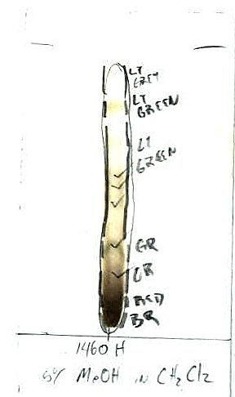
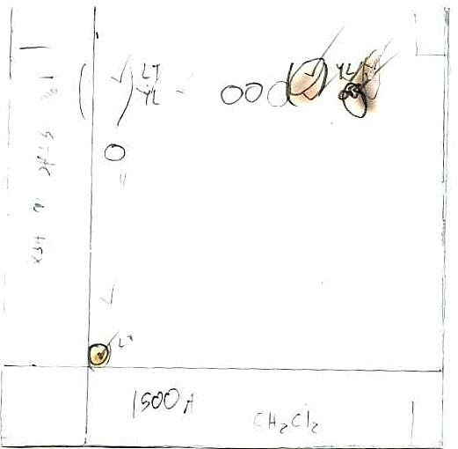
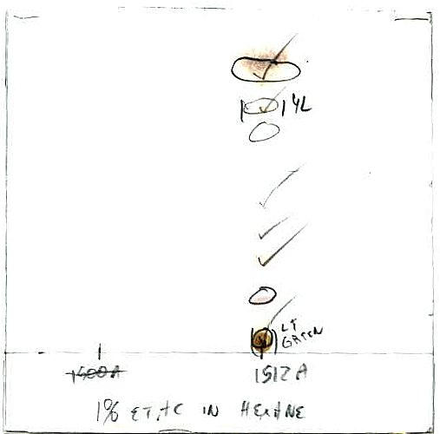
5% MeOH in CH₂Cl₂
Left: 1303E
Center: 0988D
Right: 1460H
Extract 1460H
5% MeOH in CH₂Cl₂

Extract 1500A
Bottom: CH₂Cl₂
Left: 1% EtAc in Hex

Extract 1512A
1% EtAc in Hex

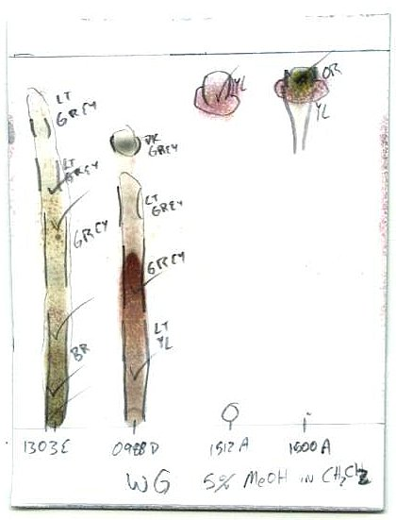
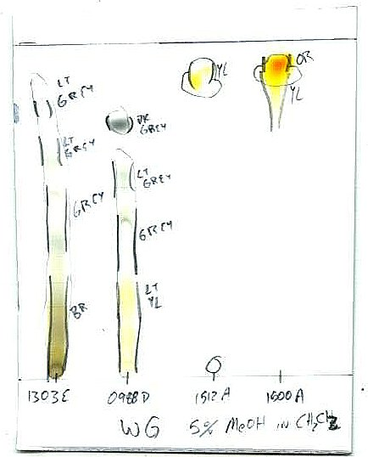
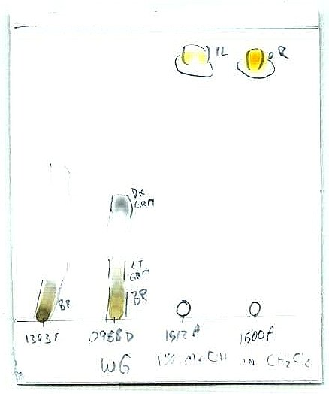
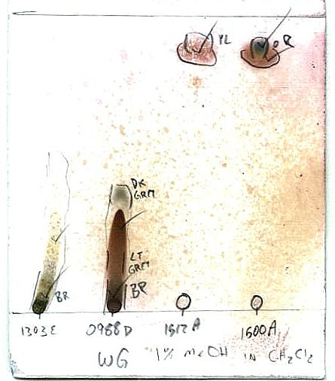

1% MeOH in CH₂Cl₂
Left to Right: 1303E, 0988D, 1512A, 1500A
Before char
1% MeOH in CH₂Cl₂
Left to Right: 1303E, 0988D, 1512A, 1500A
After char
5% MeOH in CH₂Cl₂
Left to Right: 1303E, 0988D, 1512A, 1500A
Before char

5% MeOH in CH₂Cl₂
Left to Right: 1303E, 0988D, 1512A, 1500A
After char

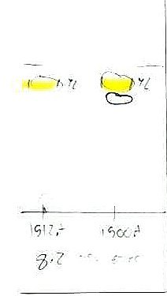
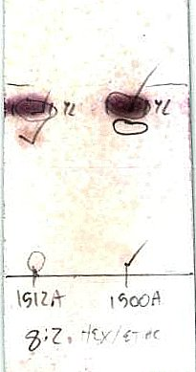
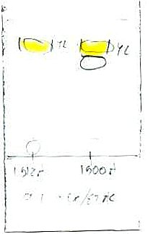
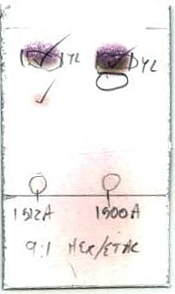
8:2 Hexane: EtAc
Left: 1512A
Right: 1500A
Before char

8:2 Hexane: EtAc
Left: 1512A
Right: 1500A
After char

9:1 Hexane: EtAc
Left: 1512A
Right: 1500A
Before char

9:1 Hexane: EtAc
Left: 1512A
Right: 1500A
After char

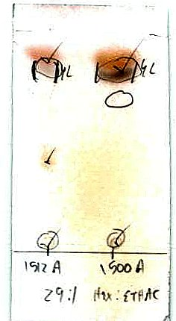
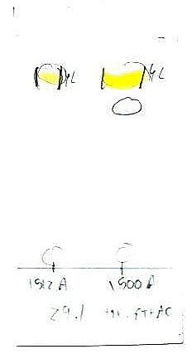
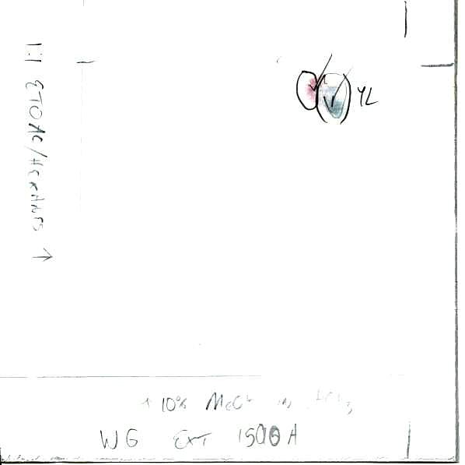
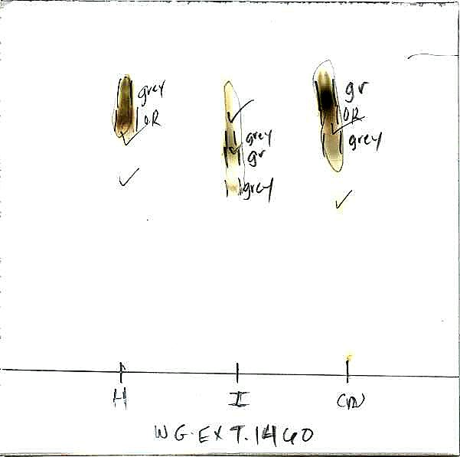
29:1 Hexane: EtAc
Left: 1512A
Right: 1500A
After char

29:1 Hexane: EtAc
Left: 1512A
Right: 1500A
Before char

Extract 1500 A
Bottom: 10% MeOH in CHCl₃
Left: 1:1 EtOAc/Hexanes

5% MeOH in CH₂Cl₂
Left to Right: 1460H, 1460I, 1460crude

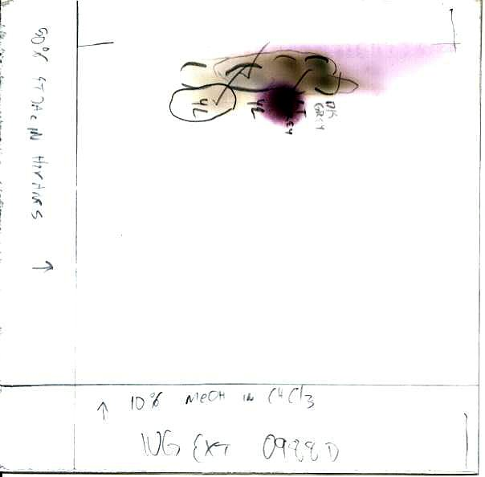
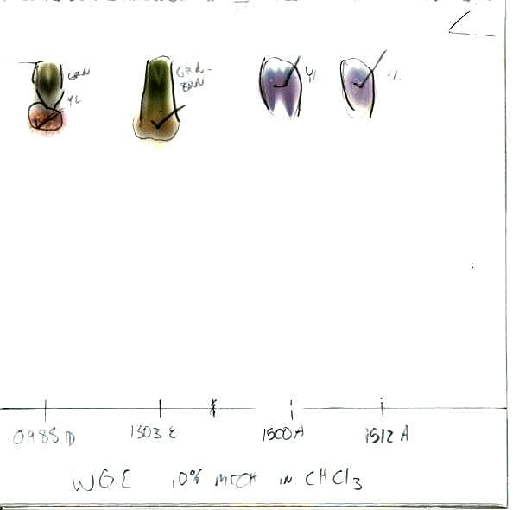
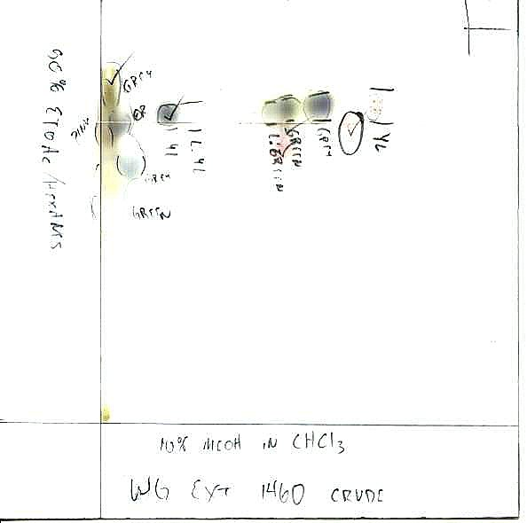
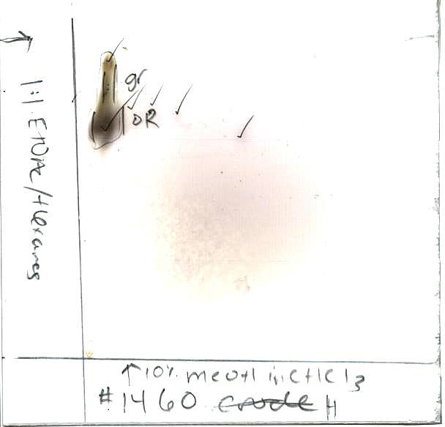
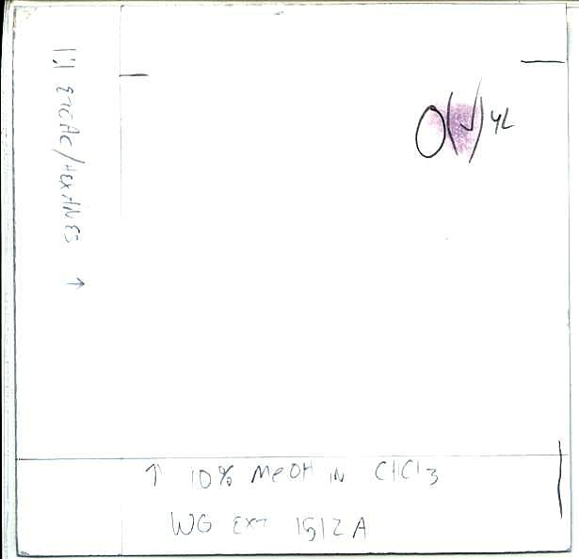
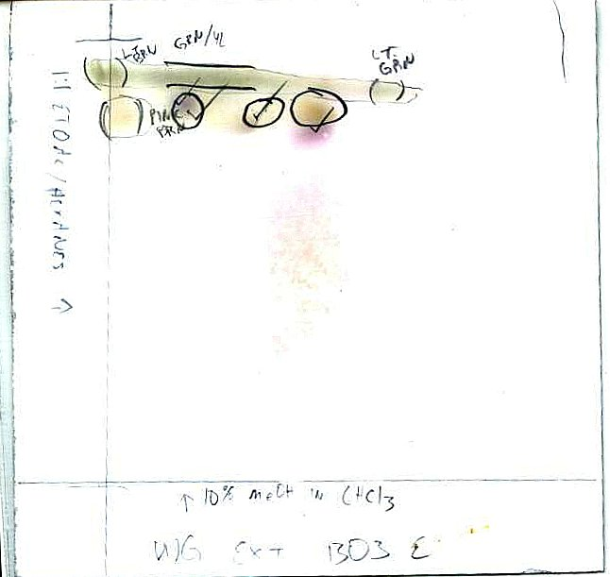
Extract 0988D
Bottom: 10% MeOH in CHCl₃
Left: 1:1 EtOAc/Hexanes

10% MeOH in CHCl₃
Left to Right: 0988D, 1303E, 1512A, 1500A

Extract 1460 crude
Bottom: 10% MeOH in CHCl₃
Left: 1:1 EtOAc/Hexanes

Extract 1460H
Bottom: 10% MeOH in CHCl₃
Left: 1:1 EtOAc/Hexanes

Extract 1512A
Bottom: 10% MeOH in CHCl₃
Left: 1:1 EtOAc/Hexanes

Extract 1303E
Bottom: 10% MeOH in CHCl₃
Left: 1:1 EtOAc/Hexanes

Appendix 5: ¹H NMR Chromatograms of Most Active Fractions
0988D, 1500A, 1512A, 1460H and 1303E

0988D Fraction
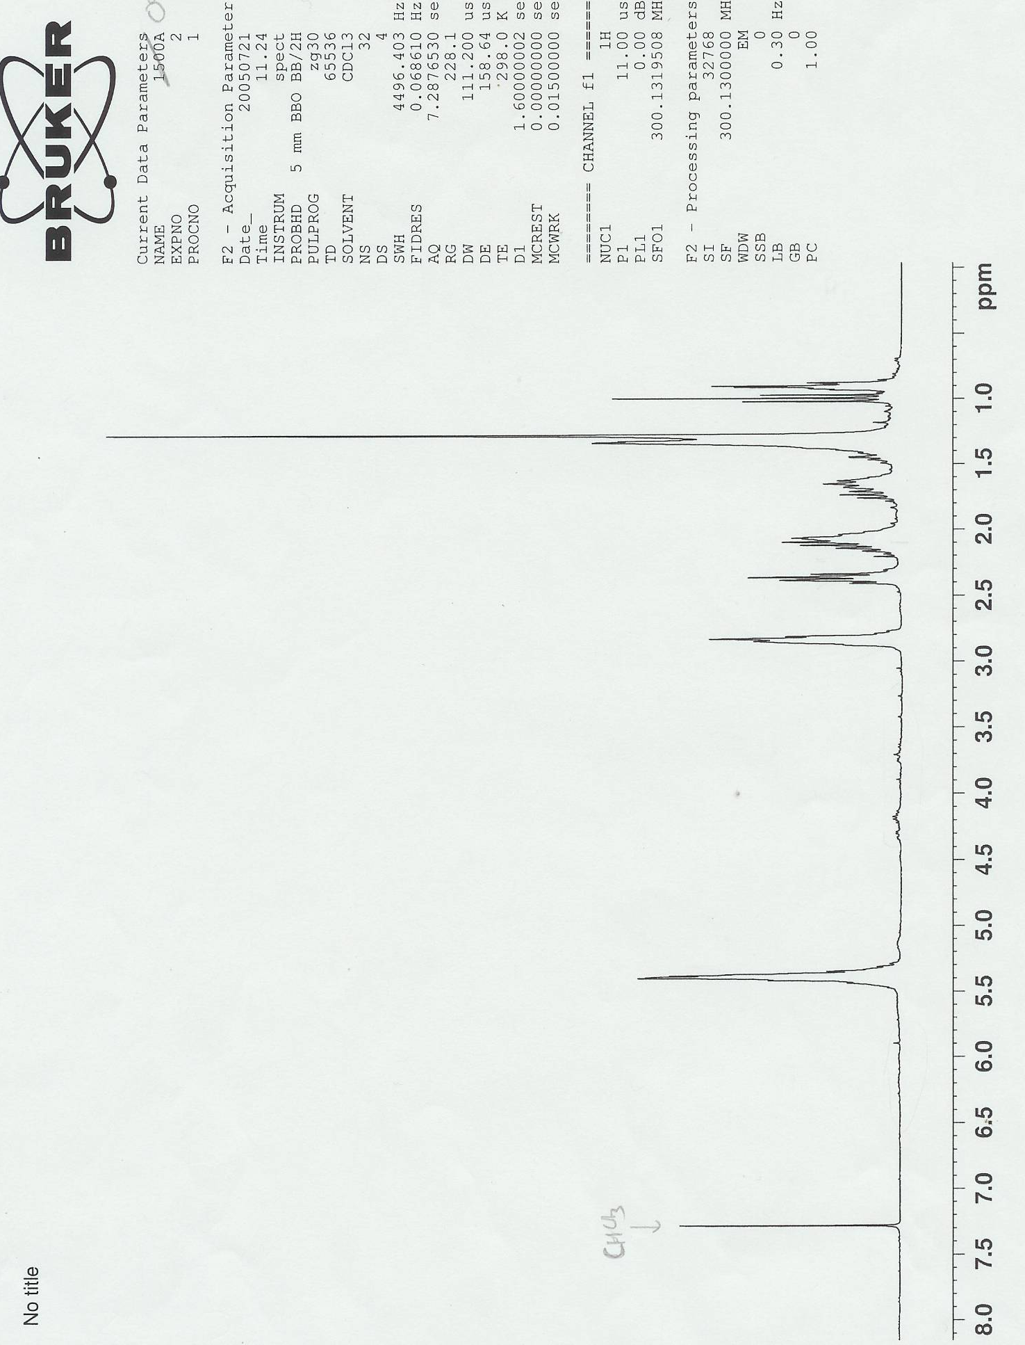

0988D Fraction (magnified)
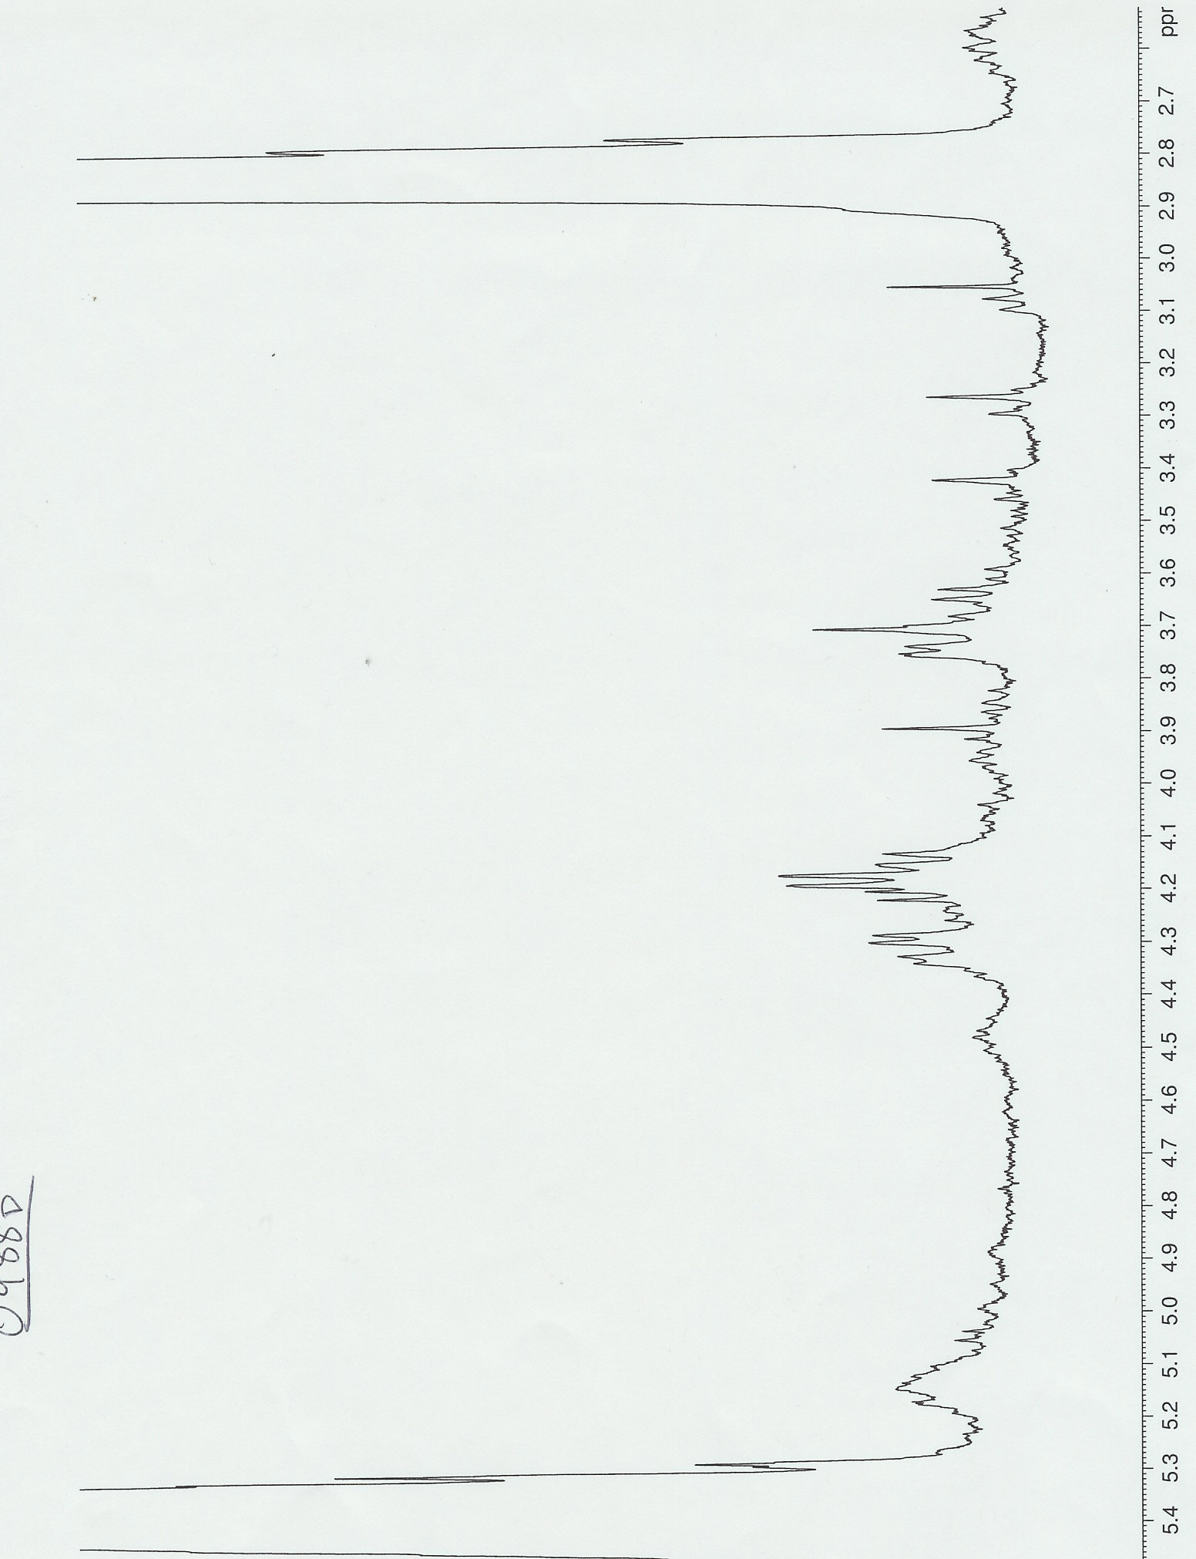

1500A Fraction
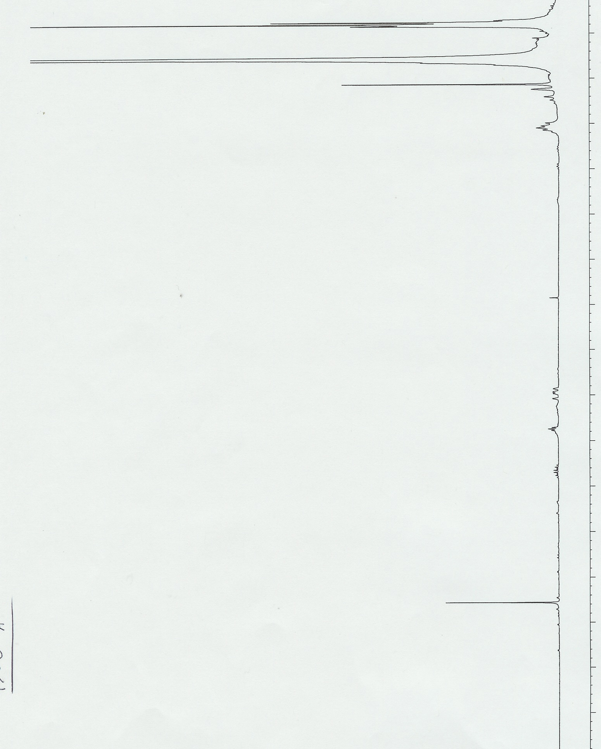
1500A Fraction (magnified)
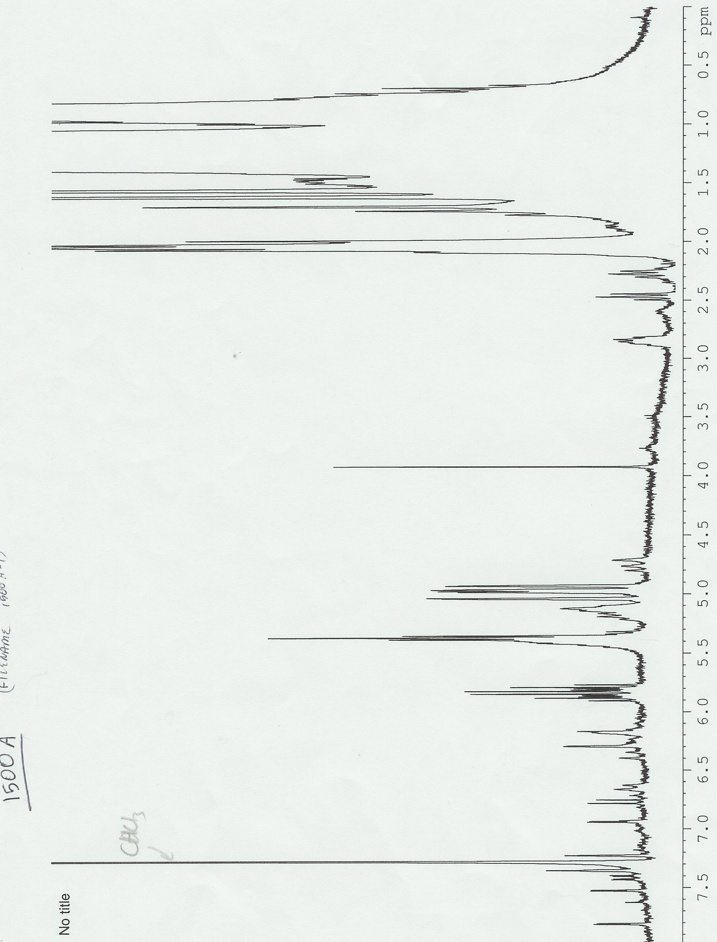
1512A Fraction
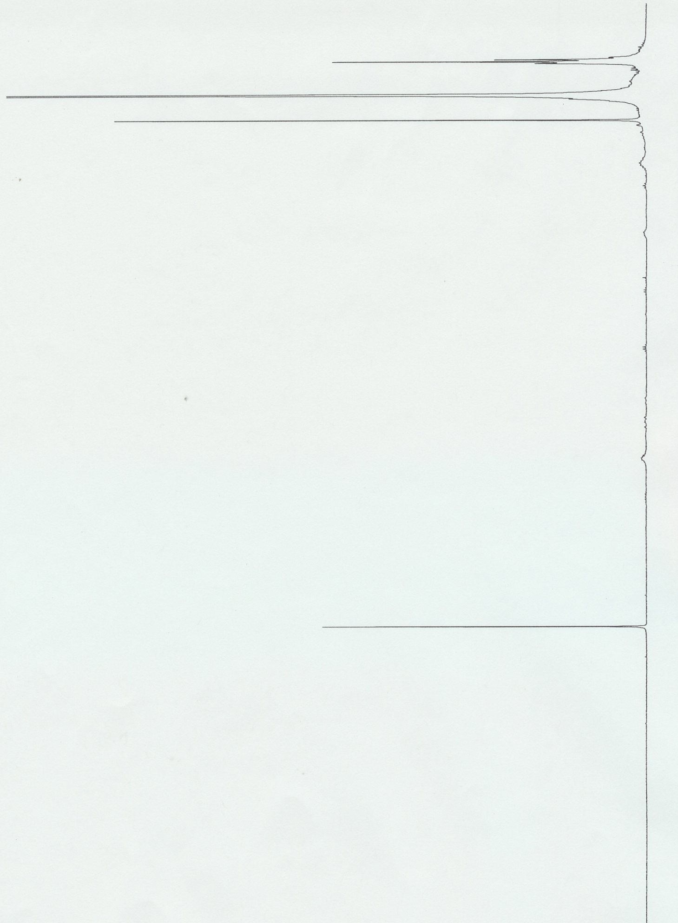
1512A Fraction (magnified)
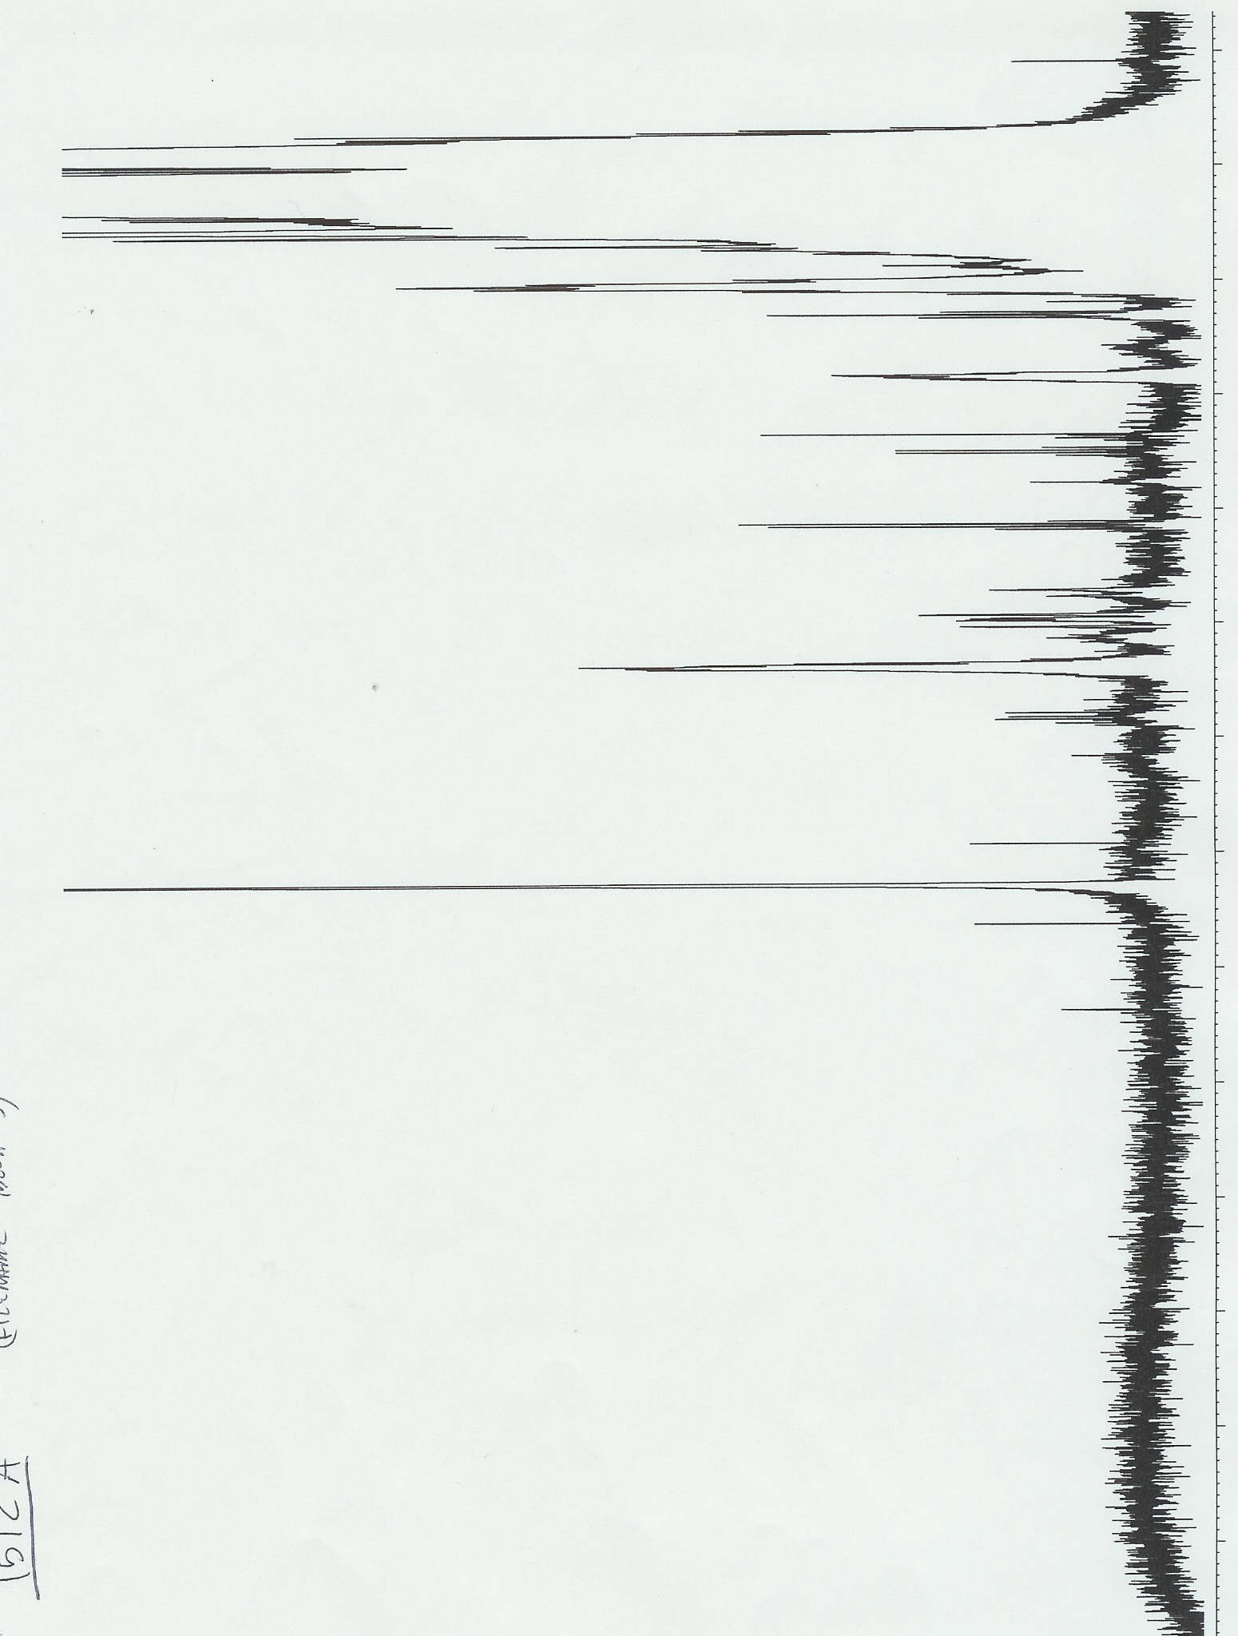
1460H Fraction
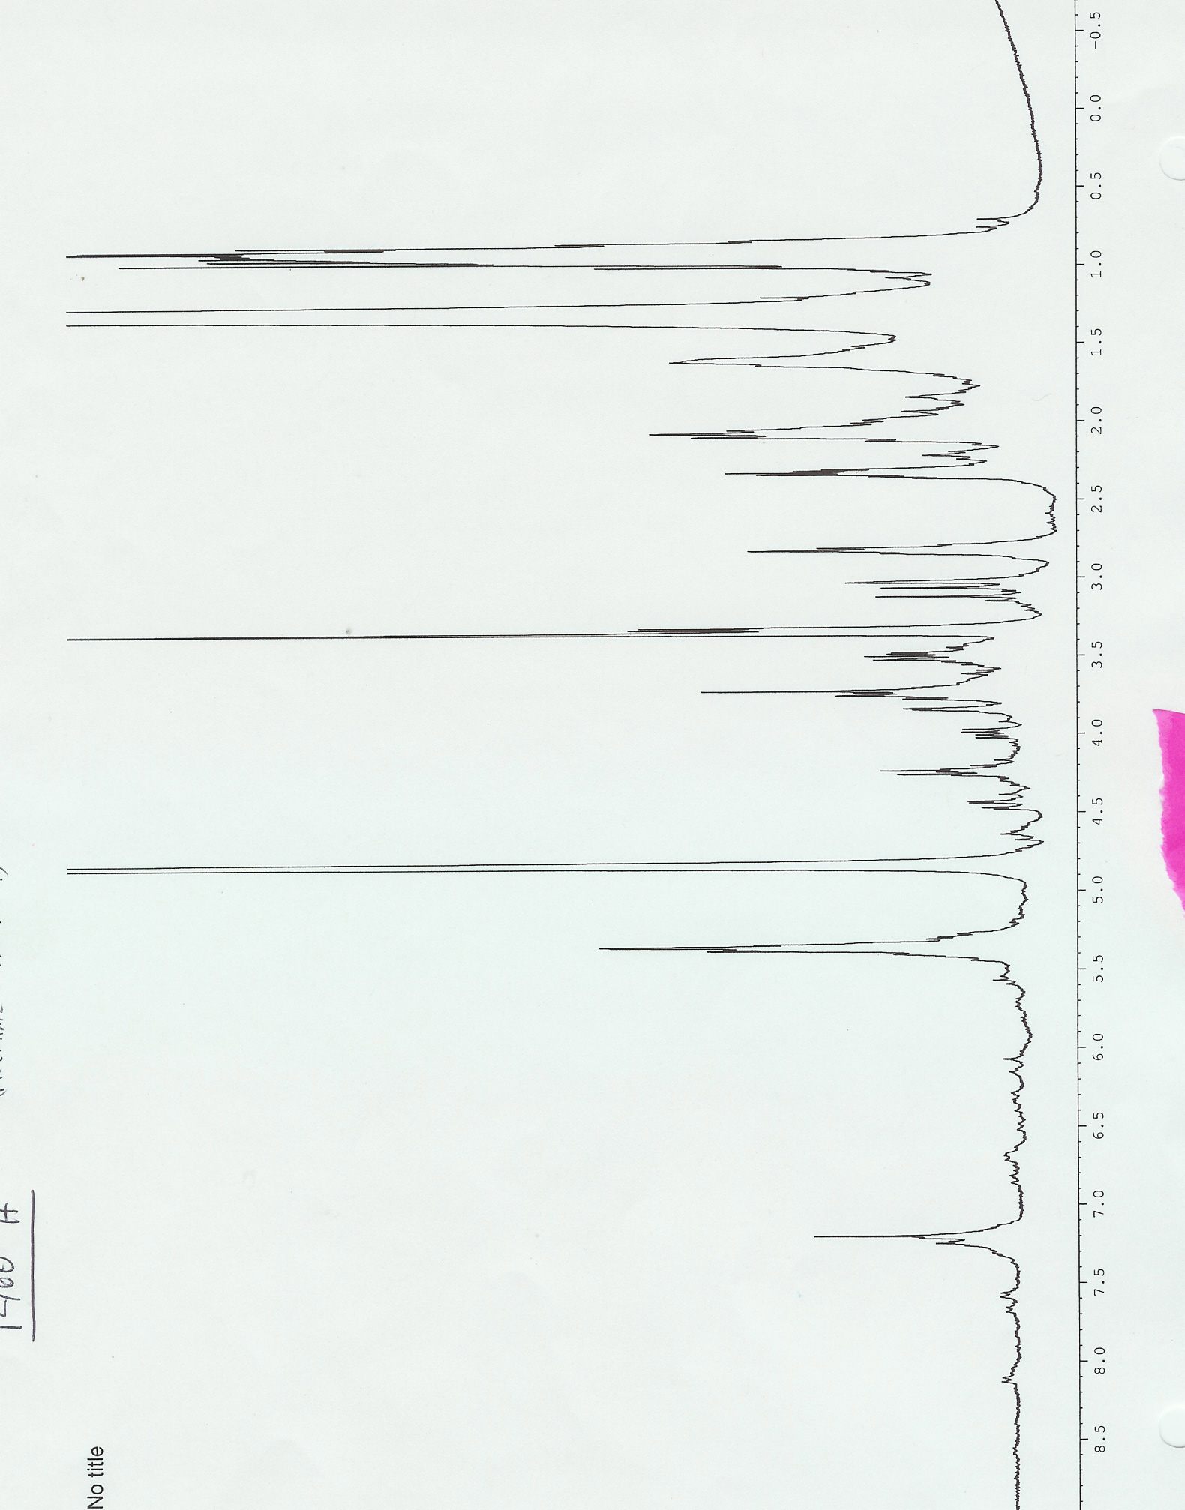
1303E Fraction
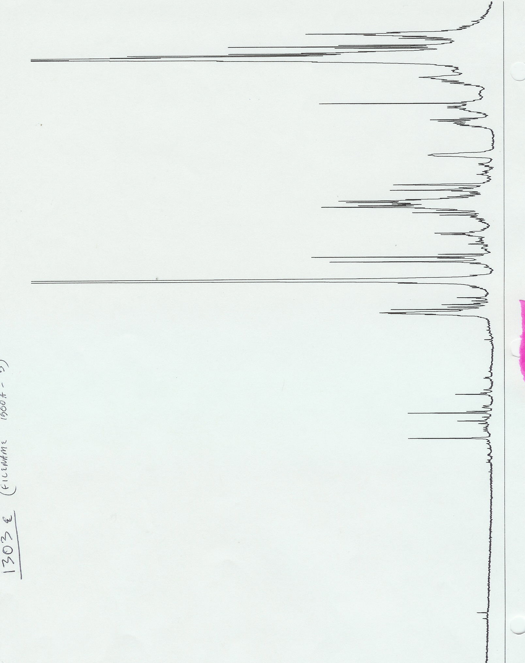
Appendix 6: Pure Compounds Tested

Compound Name (description) | Compound Number | Zone of Inhibition Diameter (mm)
Penicillin control (avg.) |  | 22
Allolaurinterol | 1 | 20
Avrainvilleol methyl ether | 24 | 0
Avrainvilleol | 27 | 0
Prepacifenol | 30 | 0
Ecklonialactone A | 36 | 0
Constanolactone A | 41 | 0
Obtusol | 56 | 0
Cynathere lactone | 64 | 0
Homothamnione | 67 | 0
Scytonemin | 73 | 0
Martensia indole | 78 | 0
Vidalia compound | 91 | 0
Vidalia compound | 95 | 0
Dictyodial | 112 | 0
Tanikolide | 119 | 0
Quinoline Alkaloid | 138 | 0
Jamaicamyde A | 141 | 0
Wewakazole | 142 | 0
Antanapeptin A | 143 | 0
Somacystinamide A | 144 | 0
Quinoline Derivative | 145 | 0
Appendix 7: Proposed Biosynthesis for Allolaurinterol

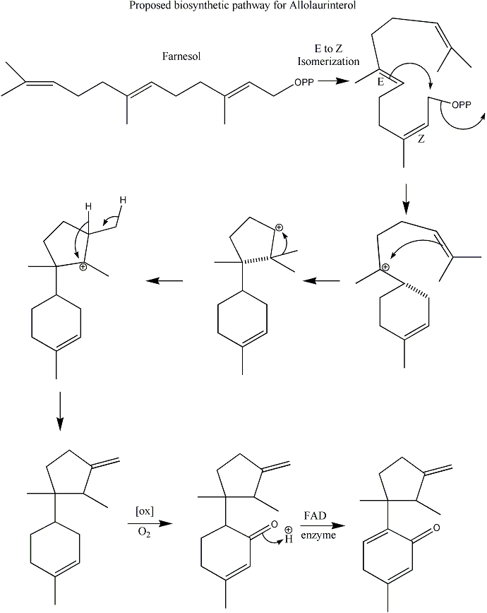
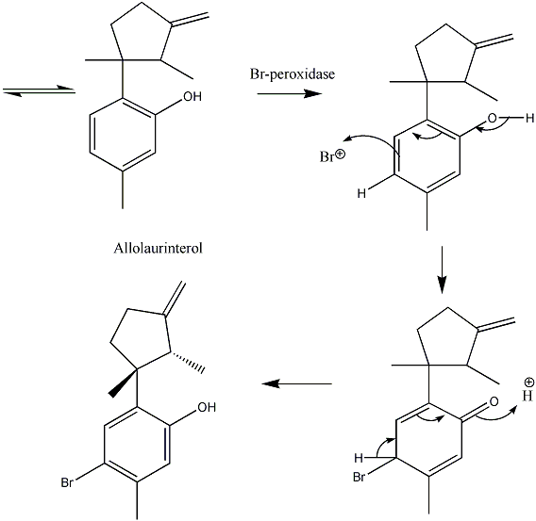
Appendix 8: MIC Methods

Serial Dilution of Allolaurinterol
Stock solution (1 µg/µL) 20 µL in Tube 1 (20 µg/mL)

30 µL EtOH
30 µL 2 x dilution 20 µL in Tube 2 (10 µg/mL)

30 µL EtOH
30 µL 2 x dilution 20 µL in Tube 3 (5 µg/mL)

30 µL EtOH
30 µL 2 x dilution 20 µL in Tube 4 (2.5 µg/mL)

30 µL EtOH
30 µL 2 x dilution 20 µL in Tube 5 (1.25 µg/mL)

30 µL EtOH
30 µL 2 x dilution 20 µL in Tube 6 (0.625 µg/mL)

30 µL EtOH
30 µL 2 x dilution 20 µL in Tube 7 (0.313 µg/mL)

30 µL EtOH
30 µL 2 x dilution 20 µL in Tube 8 (0.156 µg/mL)

Bacterial Aliquot
18-hour culture (50 µL)
1 mL
10³ dilution MIC Tubes

BHI media (50 mL)
Appendix 9: MBC Calculations

S. mutans

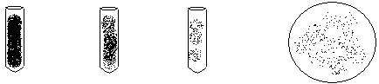
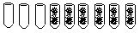
Working Stock
10³ Dilution
10⁵ Dilution
850 CFU/mL
8.5x10⁴ CFU/mL
85 colonies in 100 µL
850 CFU/mL
MIC Tubes

There was calculated to be 8.5x10⁴ CFU’s/mL in the MIC tubes, and 0.1% of that corresponds to 85 colonies. Using the equation recommended by Anhalt and colleagues [12] that includes the 95% confidence limits for 99.9% killing (n + 2√n), the allowed number of colonies on the MBC plate is 10 or less. The plate with 10 µg/mL had no colonies and the next dilution, 5 µg/mL, had 235 colonies, so 10 µg/mL is the MBC. The dilution plate was counted four days later and the MBC plates were counted three days later with the colonies being more pronounced and easier to read but the possibility for contamination and natural bacterial spreading being greater. After this time period, the MBC changed from 10 µg/mL to 5 µg/mL.

S. sobrinus

Working Stock
10³ Dilution
MIC Tubes

10⁶ Dilution

134 colonies in 100 µL
1,340 CFU/mL
1,340 CFU/mL
1.34x10⁶ CFU/mL

There was calculated to be 1.34x10⁶ CFU’s/mL in the MIC tubes, and 0.1% of that corresponds to 134 colonies. Using the equation recommended by Anhalt and colleagues [12] that includes the 95% confidence limits for 99.9% killing (n + 2√n), the allowed number of colonies on the MBC plate is 157 or less. The plate with 10 µg/mL had no colonies and the next dilution, 5 µg/mL, had a lawn, so 10 µg/mL is the MBC. The dilution plate was counted four days later and the MBC plates were counted three days later with the colonies being more pronounced and easier to read but the possibility for contamination and natural bacterial spreading being greater. After this time period, there was no change in MBC.
Appendix 10: MBC Plates

S. mutans Concentration S. sobrinus
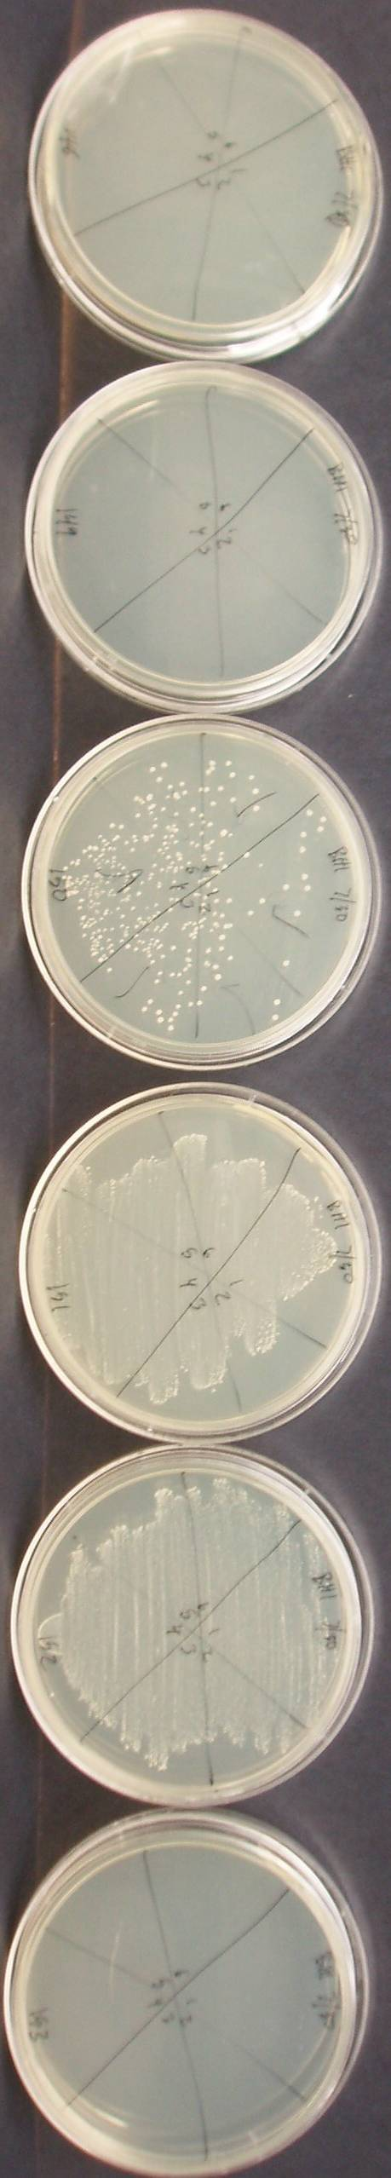
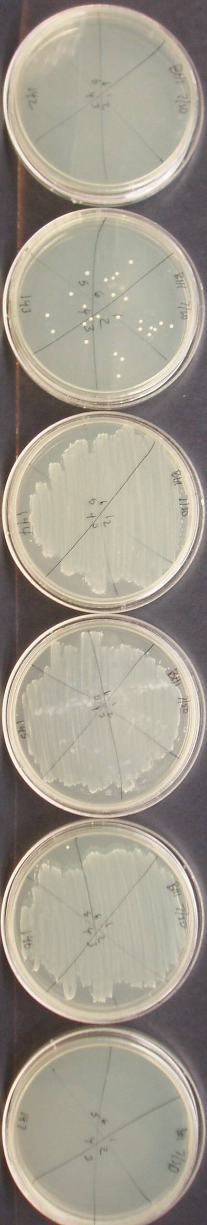
(µg/mL)
20
10
5
2.5
Growth Control
Sterile
Control

0 Colonies
0 Colonies
0 Colonies
26 Colonies
170 Colonies
Lawn
Lawn
Lawn
Lawn
Lawn
0 Colonies
0 Colonies

